PROJECT REPORT
COURSE CODE: 24ADI204
COURSE TITLE:DATA SCIENCE AND VISUALIZATION
ANALYSIS OF FLIGHT DELAYS
SUBMITTED BY
AKHSHAYA M - 25BAD005
SUGANTHAN – 25BAD118
SURYA S – 25BAD121
ZAARA N – 25BAD132

DEPARTMENT OF ARTIFICIAL INTELLIGENCE AND DATA SCIENCE
KUMARAGURU COLLEGE OF TECHNOLOGY
(Autonomous Institution)
COIMBATORE – 641 049

INTRODUCTION
Flight delays and cancellations are common problems in the aviation industry. They can cause inconvenience to passengers and affect airline operations. Delays may happen due to weather conditions, airline operations, air traffic, and other reasons.
In this project, we analyze flight data from 2024 to understand flight delays and cancellations. We use Python to examine the dataset, check data quality, clean the data, and create different visualizations. We also use feature engineering and Principal Component Analysis (PCA) to prepare the numerical data and study its important patterns.
The main aim of this project is to understand flight delay patterns and identify useful information from the available data.
DOMAIN
Aviation and Flight Data Analysis
PROBLEM STATEMENT
Flight delays and cancellations create problems for passengers and airlines. Without proper analysis, it can be difficult to understand the patterns behind these delays.

The main problem is to analyze flight data and study departure delays, arrival delays, cancellations, diversions, and other flight details. The data may also contain missing values and unusual delay values, which need to be checked before analysis.
This project uses data cleaning, Exploratory Data Analysis (EDA), feature engineering, and dimensionality reduction to study the dataset and understand its important patterns.
ABSTRACT
This project focuses on analyzing flight delays and cancellations using flight data from 2024. The dataset contains information such as flight dates, airline details, departure and arrival times, delays, flight distance, cancellations, and diversions.
The project begins with understanding the dataset and checking its quality. Missing values, duplicate records, flight status, and unusual delay values are examined during the data-cleaning stage. EDA is then performed using graphs and statistical methods to study delay distributions and relationships between different variables.
Feature engineering is used to create a day-of-year feature and scale selected numerical columns. Finally, PCA is applied to eight numerical features to study how the data can be represented using a smaller number of components while retaining most of its variance.
The project helps us understand the dataset and identify patterns that may be useful for further flight delay analysis.

OBJECTIVES
- To understand the flight dataset and its columns.
- To identify missing values and other data-quality issues.
- To check duplicate records and flight information.
- To study departure and arrival delay patterns using graphs.
- To compare average arrival delays among selected airline carriers.
- To create useful features from the existing data.
- To apply feature scaling to numerical columns.
- To use PCA for dimensionality reduction.
- To understand the variance explained by the principal components.
- To summarize the important observations from the analysis.
- Then create an interactive Dashboard

CHALLENGES
- Handling missing values in the flight dataset.
- Checking the consistency of cancelled and diverted flight records.
- Identifying unusual values in departure and arrival delays.
- Working with a large dataset.
- Understanding the relationship between departure and arrival delays.
- Scaling numerical features with different ranges.
- Undrstanding the results of PCA and explained variance.

WEEK 1: TEAM FORMATION AND DATASET SELECTION
Objective
The objective of the first week was to form the team, select a project topic, and find a suitable dataset for analysis.
Project Selection
We selected flight delay and cancellation analysis as our project topic. The project focuses on understanding flight delays, cancellations, diversions, and other details related to airline operations.
About the Dataset
The selected dataset contains flight information from 2024. It includes details such as flight date, airline carrier, flight number, origin airport, destination airport, scheduled and actual departure times, scheduled and actual arrival times, delays, flight distance, cancellation status, and diversion status.
The dataset also contains delay-related information such as carrier delay, weather delay, air traffic system delay, security delay, and late aircraft delay.
These columns help us study different aspects of flight operations and understand the data before starting the analysis.
Work Done
- Selected flight delay and cancellation analysis as the project topic.
- Identified a suitable flight dataset.
- Reviewed the available columns and their relevance to the project.

Dataset link: https://www.kaggle.com/datasets/hrishitpatil/flight-data-2024/data?utm_source=chatgpt.com
Team Contribution
- AKHSHAYA M – Helped select the project topic and dataset.
- SUGANTHAN – Reviewed the dataset and its available columns.
- SURYA S – Helped organize the project and plan the analysis.
- ZAARA N – Helped identify the project objectives and requirements.

WEEK 2: KNOW YOUR DATA
Objective
The objective of this week was to understand the structure and contents of the flight dataset before performing data cleaning and analysis.
Packages and Methods Used
Packages: Pandas and NumPy
Methods used: read_csv(), shape, head(), info(), describe(), isnull(), and sum().
Work Done
First, we loaded the flight dataset into Python using Pandas. We examined the number of rows and columns to understand the size of the dataset.
We checked the column names and data types to understand what information was available. We also used statistical summaries to examine the numerical columns.
Missing values were checked to find columns that did not contain complete information. We also examined important columns such as departure delay, arrival delay, cancellation status, and diversion status.
Interpretation
The dataset contains both numerical and categorical information. Numerical columns include departure delay, arrival delay, taxi times, air time, and distance. Categorical columns include airline carrier, origin airport, destination airport, and cancellation code.
The statistical summary helps us understand the range and distribution of numerical values. Checking missing values also helps us identify which columns require further investigation.
This stage gave us a basic understanding of the dataset and helped us plan the next steps.

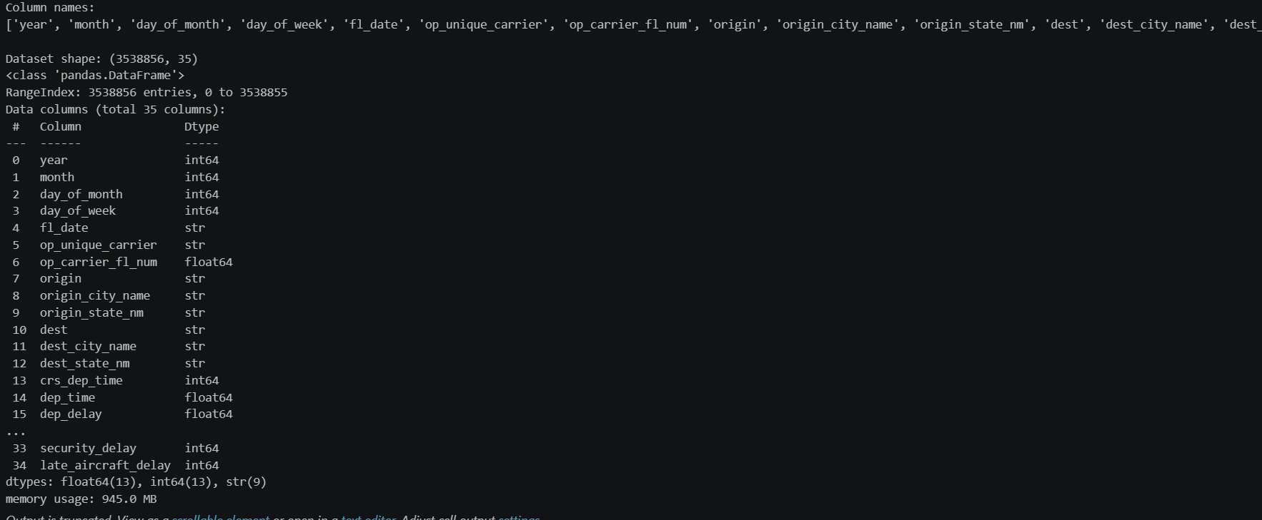

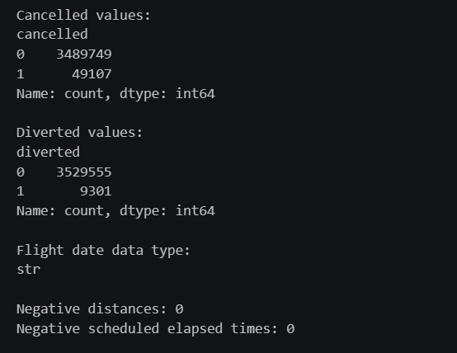

Team Contribution
- AKHSHAYA M – Examined the dataset structure and column names.
- SUGANTHAN – Checked data types and statistical summaries.
- SURYA S – Checked missing values and recorded observations.
- ZAARA N – Reviewed the dataset and helped interpret the results.

WEEK 3: THE CLEANING SPRINT
Objective
The objective of this week was to examine data-quality issues and check whether the flight records were suitable for further analysis.
Packages and Methods Used
Packages: Pandas, NumPy, Matplotlib, and Seaborn
Methods used: isnull(), sum(), groupby(), value_counts(), duplicated(), dropna(), and the IQR method.
Work Done
We checked missing values in important flight columns, including departure delay, arrival delay, departure time, arrival time, and cancellation code.
We grouped flights according to their cancellation and diversion status to understand how missing delay values were related to flight status. We also checked cancellation codes to identify possible inconsistencies.
Duplicate records were examined in two ways. First, we checked for completely duplicated rows. Next, we checked repeated combinations of flight date, airline, flight number, origin, and destination.
We then used the Inter Quartile Range (IQR) method to identify unusual values in departure and arrival delays. Boxplots were created to visualize these values.
Interpretation
The checks recorded in our notebook did not identify exact duplicate rows or repeated combinations of the selected flight identifiers.
The analysis also showed why missing values need to be considered along with flight status. For example, an actual arrival delay may not be available for a cancelled flight.
The IQR method identified a large number of potential outliers in the departure and arrival delay columns. These values were investigated rather than automatically removed because some extreme delays may represent real flight disruptions.
This stage helped us understand the data-quality issues that need to be considered during the remaining analysis.
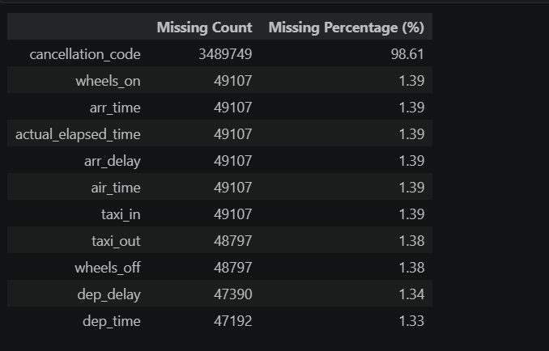
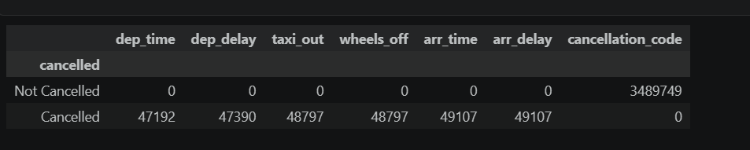
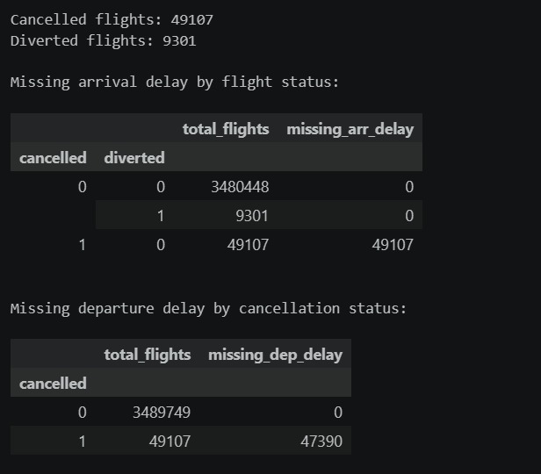

Team Contribution
- AKHSHAYA M – Checked missing values and flight status.
- SUGANTHAN – Checked duplicate records and cancellation codes.
- SURYA S – Used the IQR method to examine outliers.
- ZAARA N – Reviewed the cleaning results and documented findings.

WEEK 4: EDA DEEP DIVE
Objective
The objective of this week was to explore the flight dataset using statistical methods and visualizations. The analysis focused on delay distributions, the relationship between departure and arrival delays, and differences between airline carriers.
Packages and Methods Used
Packages: Pandas, Matplotlib, and Seaborn
Methods used: sample(), mean(), histplot(), scatterplot(), corr(), value_counts(), and groupby().
Work Done
We selected a random sample of 50,000 flights for the EDA plots. This made it easier to perform the visual analysis.
First, histograms were created to examine the distributions of departure and arrival delays. These graphs helped us observe how delay values were spread across the selected sample.
Next, we created a scatter plot to study the relationship between departure delay and arrival delay. We also calculated the correlation between these two variables.
Finally, we selected the ten most frequent airline carriers in the sample and calculated their average arrival delays. A bar chart was created to compare the results.
Interpretation
The histograms provide a simple way to understand the distribution of departure and arrival delays. They also help identify the spread of delay values and the presence of unusually large delays.
The scatter plot helps us examine whether flights with larger departure delays also tend to have larger arrival delays. The correlation value gives a numerical summary of the linear relationship between the two variables.
The carrier comparison shows how average arrival delays differ among the selected airlines. However, the graph alone does not explain the reasons for those differences.
Overall, this stage helped us explore the data visually and identify relationships that can be studied further.
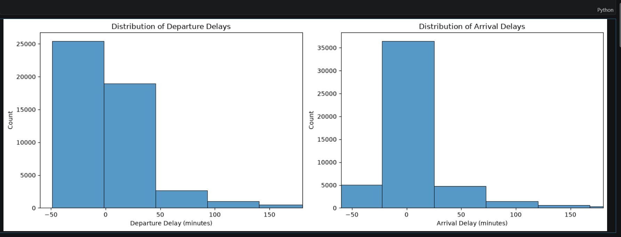
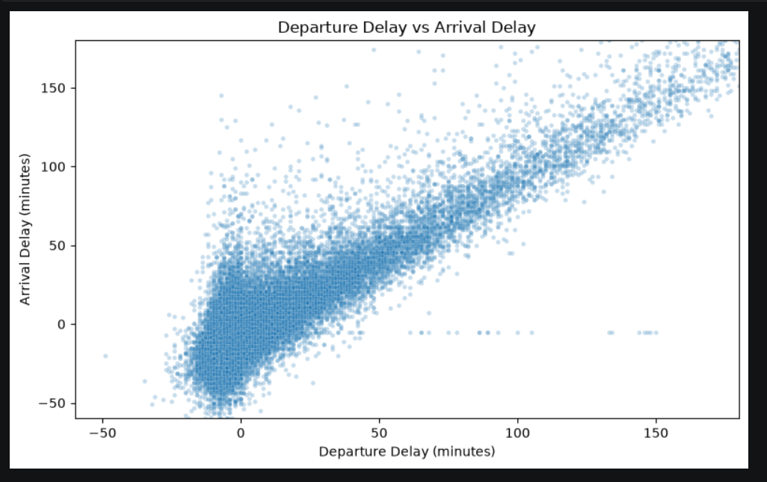
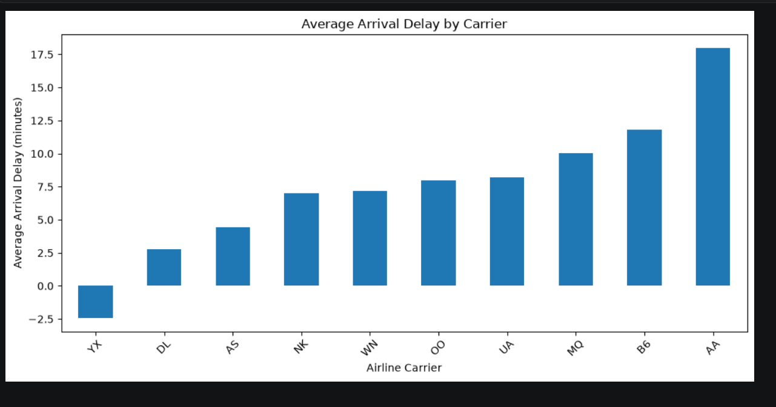

Team Contribution
- AKHSHAYA M – Created departure and arrival delay histograms.
- SUGANTHAN – Examined the relationship between departure and arrival delays.
- SURYA S – Compared average arrival delays among selected carriers.
- ZAARA N – Reviewed the visualizations and summarized observations.

WEEK 5: FINDINGS AND DATA AUDIT
Objective
The objective of this week was to review the data-quality checks and EDA work and record the important observations from the analysis.
Packages and Methods Used
Packages: Pandas, NumPy, Matplotlib, and Seaborn
Methods used: shape, describe(), isnull(), sum(), duplicated(), and the IQR method.
Work Done
We reviewed the dataset structure, missing-value counts, flight-status information, and duplicate checks.
We also examined the statistical summaries of the departure and arrival delay columns. The outlier results from the IQR method were reviewed to understand how many values fell outside the calculated boundaries.
The EDA graphs were considered along with these checks to understand the patterns present in the dataset.
Important Observations
Missing delay values need to be interpreted along with cancellation and diversion status.
- The duplicate checks in the cleaning notebook did not identify exact duplicate rows.
- The IQR method identified many potential outliers in departure and arrival delays.
- The histograms help us understand the distribution of delay values.
- The scatter plot helps examine the relationship between departure and arrival delays.
- The carrier comparison chart helps compare average arrival delays among the ten most frequent carriers in the sample.
These observations are based on the checks and visualizations performed in the notebooks. The exact strength of the correlation and the carrier rankings should be taken from the actual output of the EDA notebook.
Interpretation
The audit and EDA stages showed that understanding data quality is important before drawing conclusions from flight data. Missing values may have a valid reason, and unusual delay values should not be treated as errors without further checking.
The visualizations also help us examine the relationships between different flight variables. These observations provide a useful basis for the next stages of feature engineering and dimensionality reduction.
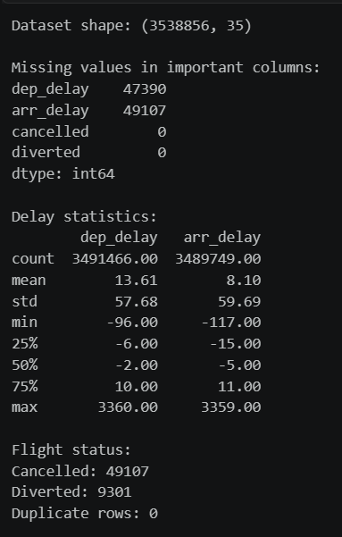
TEAM CONTRIBUTION
AKHSHAYA M – Reviewed the data-quality checks.
SUGANTHAN – Summarized missing values and duplicate-check results.
SURYA S – Reviewed delay distributions and EDA findings.
ZAARA N – Recorded the main observations and organized the evidence.

WEEK 6: FEATURE ENGINEERING
Objective
The objective of this week was to create a useful feature from the flight date and prepare selected numerical columns for further analysis.
Packages and Methods Used
Packages: Pandas, NumPy, and Scikit-learn
Methods used: to_datetime(), dayofyear, dropna(), sample(), StandardScaler(), and MinMaxScaler().

Work Done
We converted the flight date column into a datetime format. Using this column, we created a new feature called day_of_year, which represents the day number within the year.
For the scaling process, we selected six numerical features: departure delay, arrival delay, taxi-out time, taxi-in time, air time, and distance.
Rows with missing values in these selected features were removed for this part of the analysis. We then selected a random sample of 50,000 rows.
StandardScaler was used to standardize the numerical features. MinMaxScaler was also applied to scale the values between 0 and 1.
We checked the mean values of the standardized features and the minimum and maximum values of the Min-Max scaled features to verify the transformations.
Interpretation
The day_of_year feature represents flight dates using a numerical value, which can be useful when examining changes over the year.
Standardization brings the numerical features to a common scale by centering them around zero and scaling their spread. Min-Max scaling transforms the selected features to a range between 0 and 1.
These methods help prepare numerical data for analysis and techniques that are affected by differences in feature scales.
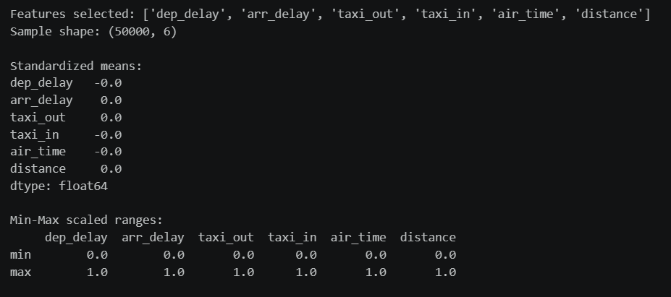

Team Contribution
- AKHSHAYA M – Created the day-of-year feature.
- SUGANTHAN – Selected numerical features and prepared the sample.
- SURYA S – Applied StandardScaler and MinMaxScaler.
- ZAARA N – Checked the scaling results and documented the process.

WEEK 7: DIMENSIONALITY REDUCTION
Objective
The objective of this week was to apply Principal Component Analysis (PCA) to the selected numerical features and study how much variance could be retained using a smaller number of components.
Packages and Methods Used
Packages: Pandas, NumPy, Matplotlib, and Scikit-learn
Methods used: dropna(), sample(), StandardScaler(), PCA(), fit_transform(), explained_variance_ratio_, and cumsum().
Work Done
We selected eight numerical features: departure delay, arrival delay, taxi-out time, taxi-in time, air time, distance, scheduled elapsed time, and actual elapsed time.
Rows with missing values in these features were removed, and a random sample of 50,000 rows was selected.
Before applying PCA, we standardized the selected features using StandardScaler. This was necessary because the features have different numerical ranges.
We then applied PCA to the standardized data. The explained variance ratio was calculated for each principal component, and the cumulative explained variance was calculated to understand how much variance was retained as more components were included.
Finally, we plotted the individual and cumulative explained variance. A 95% reference line was included to help identify the number of components required to reach that level.
Interpretation
PCA transforms the original numerical features into a set of principal components. These components represent different directions of variation in the data.
The explained variance ratio shows how much variation is captured by each component. The cumulative explained variance shows how much is captured by the components combined.
The graph helps us identify how many components are needed to explain at least 95% of the variance in the selected sample. The exact number of components and the explained variance percentages should be reported from the output generated by the notebook.
This stage helped us understand how PCA can represent the selected numerical data using fewer components while retaining a large proportion of its variance.
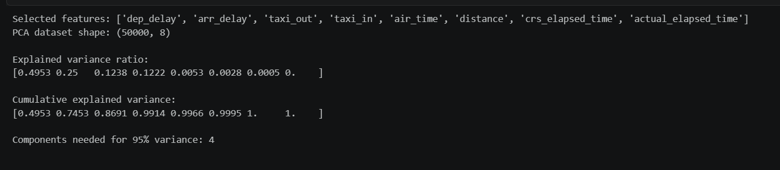
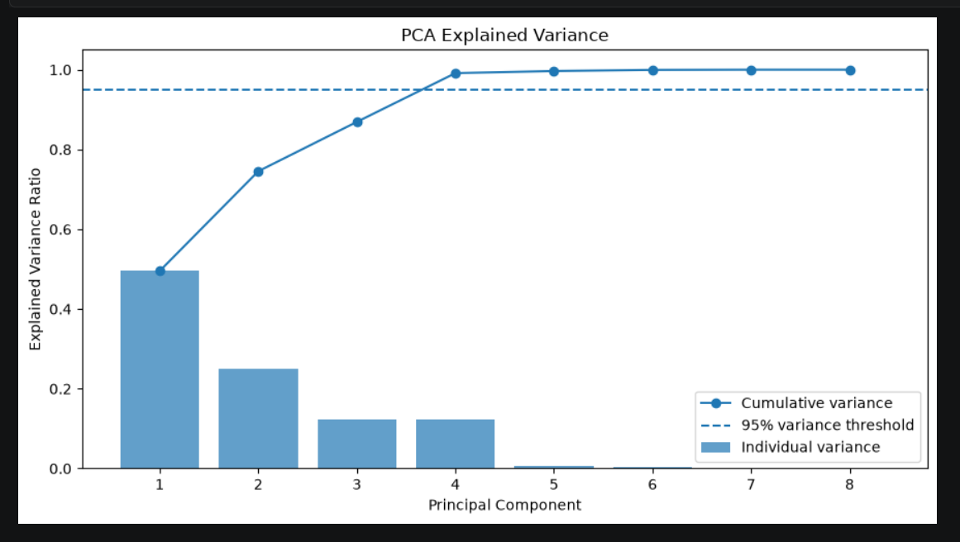

Team Contribution
- AKHSHAYA M – Selected the numerical features for PCA.
- SUGANTHAN – Standardized the features and applied PCA.
- SURYA S – Calculated explained variance and cumulative variance.
- ZAARA N – Prepared the PCA graph and summarized the results.
CONCLUSION
In this project, we analyzed flight data to understand delays, cancellations, and other flight-related information. We started by studying the dataset and checking its structure, data types, and missing values .
We then investigated data-quality issues, including duplicate records, cancellation information, and unusual delay values. EDA helped us examine delay distributions, the relationship between departure and arrival delays, and differences in average arrival delays among selected airline carriers.
During feature engineering, we created a day-of-year feature and applied two scaling methods to selected numerical columns. Finally, we used PCA to study the variance explained by principal components.
Through this project, we gained practical experience in handling a dataset, checking data quality, creating visualizations, preparing numerical features, and applying dimensionality reduction techniques using Python.

