WEEK 8 REPORT
DASHBOARD CONSTRUCTION
Flight Operations & Delay Analysis

Course | 24ADI204 – Data Science and Visualization
Project Team | Team 14
Team Members | Akhshaya M. (25BAD005), Surya S. (25BAD121), Suganthan S. R. (25BAD118), Zaara Nausheen (25BAD132)
Faculty | Ms. Rupashini P. R.
Week | Week 8 – Dashboard Construction

Dashboard tool: Microsoft Power BI

1. Introduction
Week 8 focuses on constructing an interactive dashboard that brings the analysis of flight operations together in a clear and understandable form. The project, titled “Flight Operations & Delay Analysis”, uses flight records to examine airline activity, departure and arrival delays, route performance, cancellations and diversions. Microsoft Power BI is used to present the analysed information through interactive visuals and filters.

2. Objectives
- Present important flight-operation metrics in one dashboard.
- Compare flight activity and delay performance across airlines, airports and routes.
- Communicate patterns in departure and arrival delays.
- Highlight operational disruptions such as cancellations and diversions.
- Allow users to explore the results using dashboard filters and slicers.
- Arrange the visuals in a logical sequence so that the dashboard communicates a connected story.

3. Dashboard Development Approach
The dashboard was developed in Microsoft Power BI using the project dataset and the results of the earlier data-cleaning and exploratory-analysis stages. Relevant measures and visualisations were organised into dashboard pages. Slicers and filters support focused comparisons, while chart titles, labels and KPI cards help users understand the information being displayed.
The dashboard is intended to move from an overall view of flight operations to more focused views of airline performance, delay behaviour and operational disruptions. This structure helps users interpret individual charts as part of a broader operational picture.

4. Dashboard Structure and Narrative

4.1 Flight Operations Overview
The overview page acts as the starting point of the dashboard. It presents high-level flight performance indicators and summary visuals, allowing users to understand the overall operating picture before examining specific categories. Filters such as airline and airport selections can be used to narrow the displayed results, where available in the report.

Figure 1. Flight Operations Overview
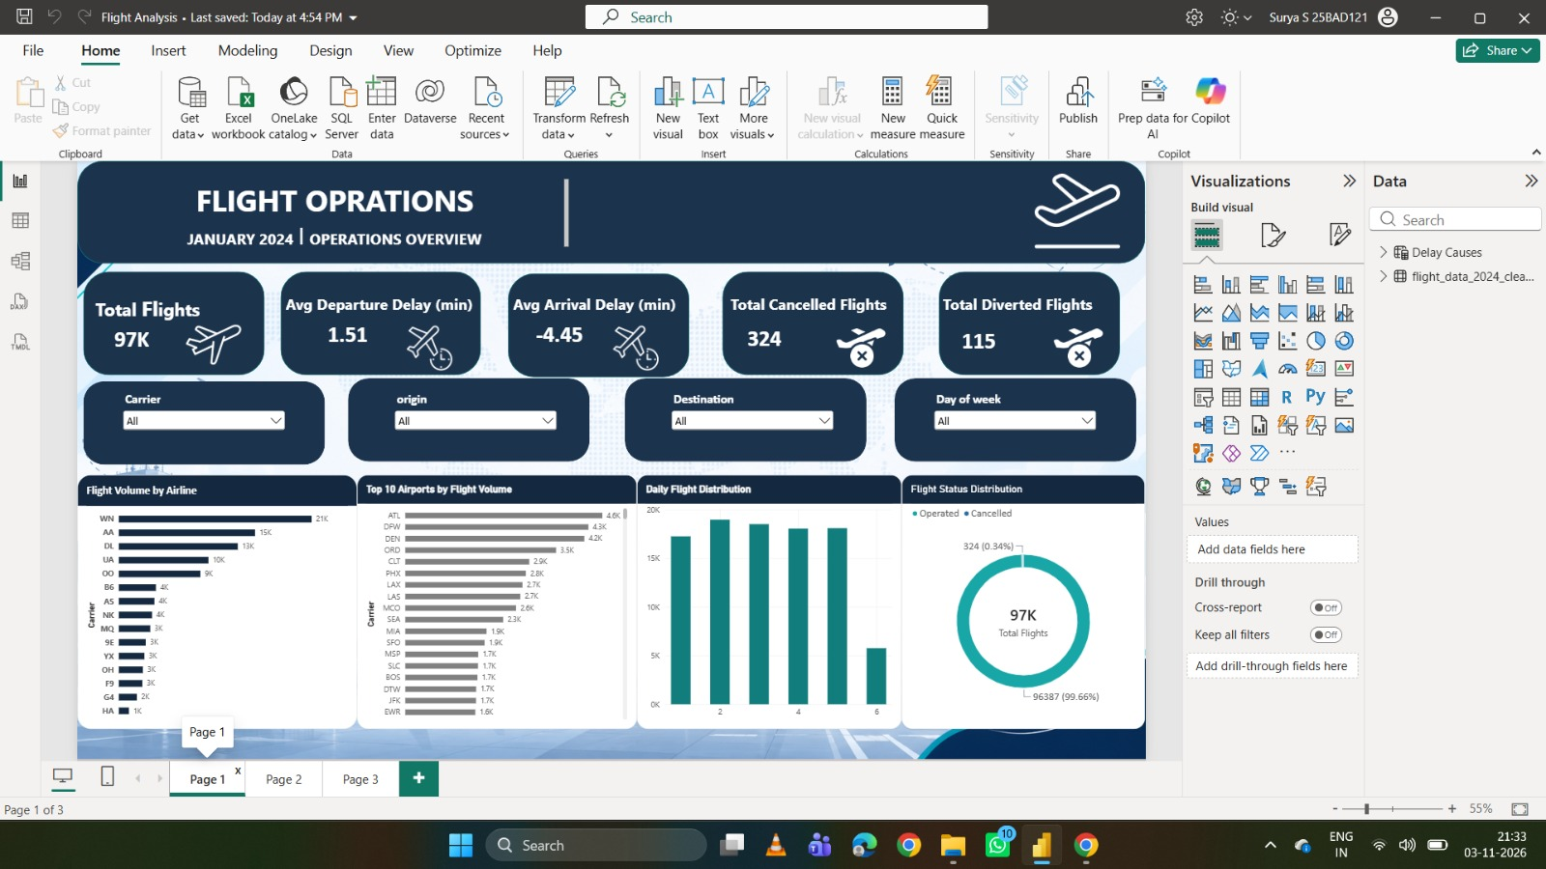

4.2 Airline and Airport Performance
The performance analysis page supports comparisons between airlines and/or airports. It helps identify differences in flight activity and delay performance across selected operators or locations. The visuals should be read together with the selected slicer values so that comparisons are made within the same filter context.

Figure 2. Airline and Airport Performance
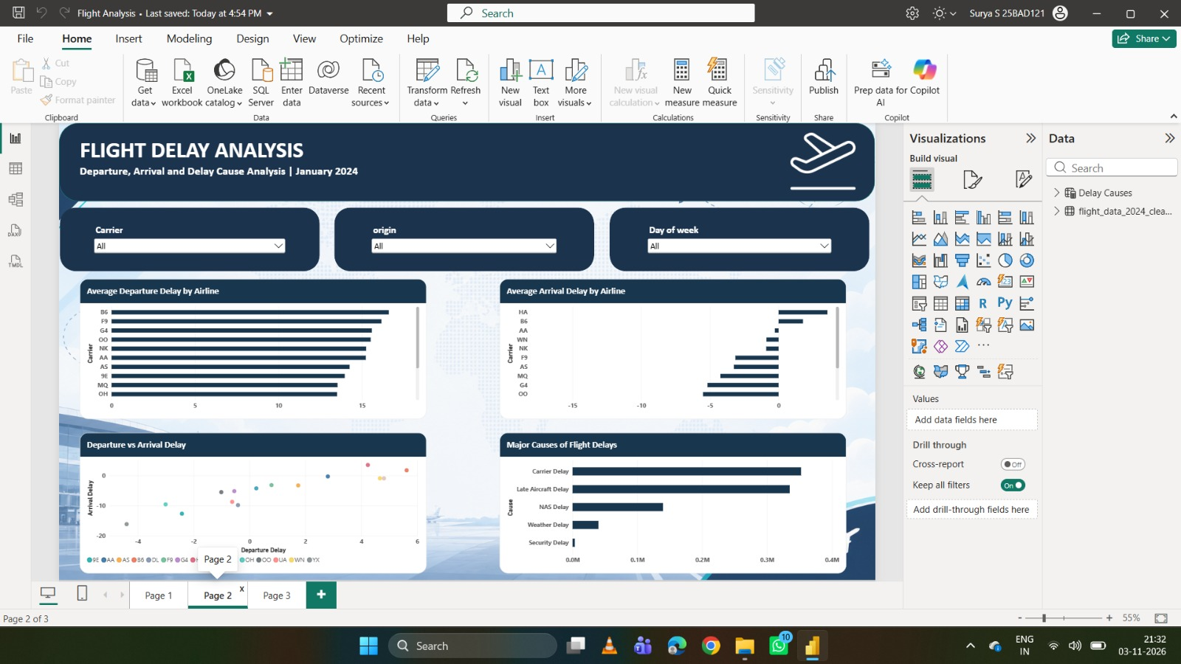

4.3 Delay and Disruption Analysis
The delay and disruption view focuses on departure delays, arrival delays and operational events. The project analysis found a very strong positive relationship between departure and arrival delays (correlation coefficient r = 0.9665). This indicates that flights with larger departure delays generally also tend to have larger arrival delays. Cancellations and diversions are also important when assessing overall operational performance.

Figure 3. Delay and Disruption Analysis
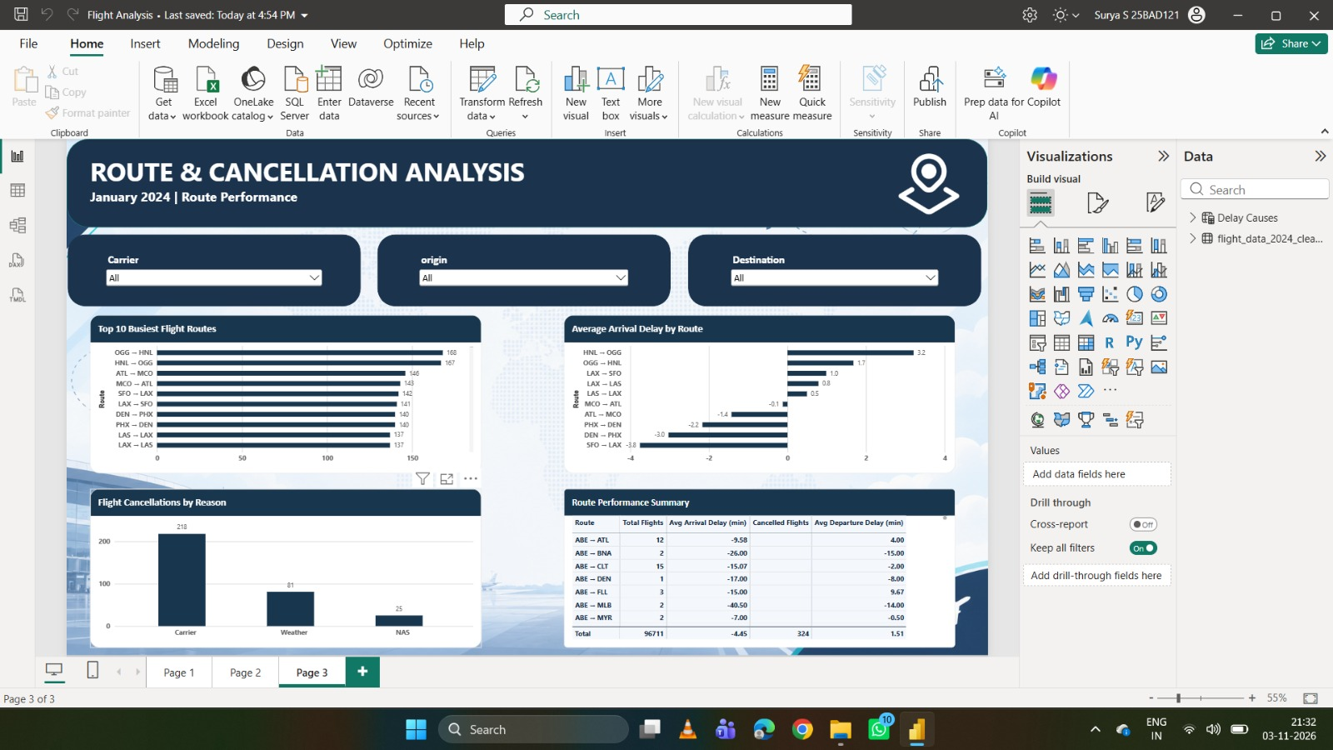

5. Key Findings Communicated by the Dashboard
- Flight activity and delay patterns vary across airlines, airports and operational factors.
- The distribution of delays is right-skewed: many flights have relatively low delays, while a smaller number experience much larger delays.
- Departure delay and arrival delay have a very strong positive correlation (r = 0.9665).
- Average arrival delay differs across airlines, indicating variation in carrier-level delay performance.
- Cancellations and diversions are important operational disruptions and should be considered alongside delay measures.
The project presentation reports 324 cancelled flights and 115 diverted flights in the dashboard findings. These values should be checked against the final Power BI filter state and dataset scope before submission.

6. Interactivity and Usability
Power BI slicers and filters allow users to focus on selected airlines, origin airports, destination airports or other available categories. When a filter is changed, the related visuals respond to the selection, helping users compare subsets of the flight data without creating separate static charts. Clear page titles, consistent labels and readable chart layouts improve navigation and interpretation.

7. Limitations
- The project presentation describes the analysed period as January 1–6, 2024; the findings should therefore not be treated as representative of a full year.
- A short study period may not capture seasonal changes or longer-term operational patterns.
- Average delay values can be affected by extreme delays and differences in flight volume.
- Interpretation depends on the documented data-cleaning and validation decisions.

8. Conclusion
The Week 8 dashboard brings the flight-operation analysis together in an interactive Power BI report. It presents airline and airport activity, delay behaviour and operational disruptions in a connected visual format. The dashboard makes the analysis easier to explore and communicate, while the study period and data limitations remain important context when interpreting the results.

9. Final Submission Checklist
- Insert final screenshots for every dashboard page in the spaces provided.
- Ensure that all slicers and visual interactions work correctly.
- Check that titles, axis labels, legends and KPI values are readable.
- Verify the reported cancellation and diversion counts against the final dashboard.
- Save the final Power BI report (.pbix) alongside the Week 8 report and screenshots.
- Add the completed Week 8 folder and final dashboard file to the project GitHub repository.

— End of Week 8 Report —

