Methods: Preprocessing and ComBat Batch Correction (SLE Multi-Dataset Expression)

1. Dataset
We assembled a gene-expression dataset of 1,211 bulk-tissue samples from six GEO series (GSE10325, GSE32591, GSE38351, GSE39088, GSE45291, GSE72747) measured on four Affymetrix platforms (GPL96, GPL570, GPL13158, GPL14663). Samples were labelled Healthy Control (n = 199), SLE (n = 443) or Other/Unknown (n = 569) according to the source annotations. Thirteen candidate genes were analysed: MTHFR, TYMS, MTR, MTRR, CYP1A1, GSTM1, GSTT1, GSTP1, TLR2, TLR4, TLR7, TLR9 and STAT4.
[Add how gene-level values were derived from probes, and any preprocessing applied before this stage, including how GSE39088 and GSE72747 were centered.]

2. Batch definition
Samples measured on different platforms differ technically even within one GEO series. We therefore defined batch as series × platform. GSE38351 contains samples on GPL570 and GPL96, giving seven batches:
Batch | Samples | Healthy | SLE | Other/Unknown
GSE10325_GPL96 | 67 | 28 | 39 | 0
GSE32591_GPL14663 | 93 | 29 | 0 | 64
GSE38351_GPL570 | 40 | 36 | 0 | 4
GSE38351_GPL96 | 34 | 12 | 14 | 8
GSE39088_GPL570 | 142 | 64 | 78 | 0
GSE45291_GPL13158 | 805 | 20 | 292 | 493
GSE72747_GPL570 | 30 | 10 | 20 | 0
Disease is unevenly spread across batches. For example, two batches contain no SLE samples, and GSE45291 contributes 292 of the 443 SLE samples.

3. Scale harmonization
Per-batch summaries of the values showed three scales:
- Raw intensities (GSE10325, GSE38351): medians in the tens to hundreds and maxima in the thousands.
- Log-scale values (GSE32591, GSE45291): medians around 3–10.
- Values centred near zero (GSE39088, GSE72747): medians near zero with negative values.
ComBat assumes batches are on comparable scales, so we harmonized as follows:
- Flag values. Values of −1.00 in the raw-intensity datasets had no within-batch variance and acted as missing-value flags. We set these, and any other non-positive values in those datasets, to missing.
- Log2 transformation. The two raw-intensity datasets were transformed as log2(x) with no pseudocount. The other four datasets were left on their original scale. The two centred datasets cannot be returned to the log2 scale, and their location difference from the other batches is handled by ComBat's mean adjustment.
The resulting expression values are on a harmonized, log2-like scale. They are not z-scores and not in original units.

5. Gene filtering
ComBat cannot estimate batch parameters for a gene with zero variance or missing values in a batch. A gene was excluded if, in any batch, its standard deviation was zero or undefined, or if it had any missing value. TLR9 and GSTM1 met this condition, leaving 11 genes. No samples were removed.

6. ComBat batch correction
Batch effects were corrected with ComBat (Johnson et al., 2007), an empirical Bayes method that estimates a location (mean) and optionally a scale (variance) adjustment for each gene in each batch. It shrinks these batch parameters toward a prior estimated across genes, which stabilizes estimates for small batches. We used the Python implementation pyComBat in inmoose [version], with parametric priors (the default).
Disease state was passed as a covariate so ComBat would estimate and preserve biological group differences while removing batch effects. The design matrix contained dummy variables for "SLE" and "Other/Unknown", with Healthy Control as the reference level. The batch variable was the seven-level series × platform variable.
PCA showing the differences before and after combat
(next page)
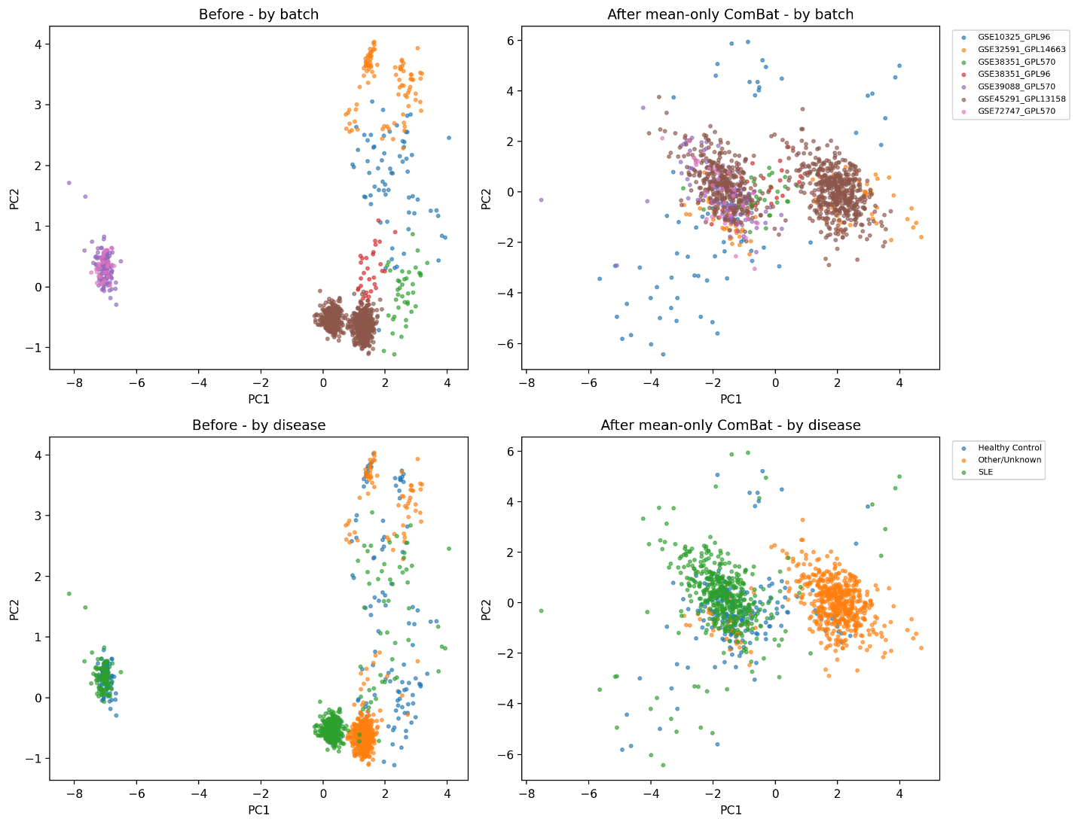
We compared two variants:
- Full ComBat (location and scale adjustment).
- Mean-only ComBat (location adjustment only, variance left unchanged).
Full ComBat distorted within-dataset effects. It produced an implausible standardized SLE-vs-Healthy effect (Cohen's d = −13.4) for CYP1A1 in GSE45291, which we attribute to unstable scale estimates from only 11 genes. Mean-only ComBat was therefore the primary correction, and full ComBat is reported as a sensitivity analysis.
Optional sensitivity analysis: to confirm that outcome labels did not influence preprocessing, mean-only ComBat was also run without the disease covariate (batch only) [include only if you report it].

7. Evaluation of batch correction
Correction was assessed before and after on the 11 retained genes:
- Variance explained by batch (R²). For each gene, R² = SS_between / SS_total from a one-way ANOVA on batch. We report the mean across genes. We also computed batch R² for each of the first two principal components, where PCA was run on the gene-standardized matrix (each gene scaled to mean 0, SD 1 across all samples).
- Silhouette score. Computed with Euclidean distance on the gene-standardized data, once with batch labels and once with disease labels (three classes). A batch silhouette near zero or negative means batches are no longer separable.
- Variance explained by disease. The same R² calculation with disease labels, to check that biological signal was retained.
- Within-dataset effect sizes. In each batch with at least three Healthy and three SLE samples (GSE10325_GPL96, GSE38351_GPL96, GSE39088_GPL570, GSE45291_GPL13158, GSE72747_GPL570), Cohen's d for SLE vs Healthy was computed per gene with a pooled SD, and compared across correction methods to check that correction did not distort within-batch disease effects. We also computed the sign concordance of the effect across batches.

8. Results
Metric | Before | Full ComBat | Mean-only ComBat
Mean batch R² (genes) | 0.919 | 0.057 | 0.137
Mean disease R² (genes) | 0.177 | 0.285 | 0.265
PC1 batch R² | 0.970 | 0.138 | 0.204
PC2 batch R² | 0.938 | 0.016 | 0.062
Silhouette (batch) | 0.404 | −0.110 | 0.063
Silhouette (disease) | 0.139 | 0.105 | 0.232
SD of Cohen's d across datasets | 0.576 | 1.096 | 0.576
Before correction, batch explained 91.9% of the variance of the average gene. Mean-only ComBat reduced this to 13.7%, with PC1 batch association falling from 0.970 to 0.204 and the batch silhouette from 0.404 to 0.063, while disease-related structure was retained (disease silhouette 0.139 → 0.232). Full ComBat removed more batch variance but inflated the dispersion of within-dataset effect sizes. Mean-only correction leaves within-batch effect sizes unchanged by construction, which is why its Cohen's d values match the uncorrected ones.

9. Limitations
- Only 11 genes were available, which limits ComBat's empirical Bayes shrinkage. This is why full ComBat was unstable.
- Disease is partly confounded with batch. Two batches have no SLE samples, and one batch contributes most SLE samples. Adjusting for batch can bias group differences in such designs (Nygaard et al., 2016).
- Residual batch variance (about 14%) partly reflects differing disease composition between batches, and some between-dataset heterogeneity reflects real cohort or platform differences, not technical batch.
- The two centred datasets could not be placed on the log2 scale, so cross-platform comparability relies on ComBat's location adjustment.
- ComBat was fitted on all samples at once, so any downstream cross-validation uses data whose correction saw all samples. Disease labels were also included as a covariate.

10. References
- Johnson WE, Li C, Rabinovic A. Adjusting batch effects in microarray expression data using empirical Bayes methods. Biostatistics 2007;8(1):118–127.
- Nygaard V, Rødland EA, Hovig E. Methods that remove batch effects while retaining group differences may lead to exaggerated confidence in downstream analyses. Biostatistics 2016;17:29–39.
- Chen C, et al. Removing batch effects in analysis of expression microarray data: an evaluation of six batch adjustment methods. PLoS ONE 2011.
- Behdenna A, et al. pyComBat, a Python tool for batch effects correction in high-throughput molecular data using empirical Bayes methods. BMC Bioinformatics 2023 [from memory, so verify the citation].

