M&A Strategy Session: Agenda

Thursday, November 13, 2026 · 12:00 to 2:00 pm CT · Alyssa, Charlie, Cate
Two hours on the whole M&A program: the strategy, the markets, the targets, the machine that finds and converts them, and the five key decisions that will guide 2027. We walk the dashboards live; the pages behind this one are the reference copy.

Time | Min | Block | Owner | Outcomes Desired
12:00 | 10 | Goals for the session and for Wildcat  This page | Charlie | Session goals agreed: align on the strategy, see the targets and the machine, make five decisions. Wildcat goals agreed: get Wildcat behind the 2027 pace and capital; show the machine well enough to earn more room between updates.
12:10 | 20 | Strategy Overview  Pages 2 to 3 | Charlie | Strategy statement confirmed or edited; edits captured for the Wildcat version.
12:30 | 30 | Markets: where we are focused and how we score them  Page 4; hub MSA Scoring | Cate | Four market tiers and the qualitative factors beside the score agreed.
1:00 | 30 | Venue Targets + Our Machine  Pages 5 to 13; live dashboards | Cate, Charlie | You know what each stage measures, which targets are closest, and where conversion leaks.
1:30 | 15 | Current Initiatives  Page 14 | Cate | Plan and timing aligned; your view on what to pull forward.
1:45 | 15 | Decisions Required | All | Each decision made, or given an owner and a date.
M&A Strategy Overview
Enter markets with attractive fundamentals and 5-15+ venue potential · 1 of 2
Goal: 5 to 15+ venues in every market we enter, so each venue shares our catering, floral, and bakery hubs, one regional sales and planning team, and one marketing engine.
- Pick markets where density is possible: strong wedding demand, fragmented ownership, sensible land cost.
- Pursue the market's leading venues and the infill venues together; owners sell when they are ready, so we take the best of what comes available.
- Enter three ways (buy, lease, manage), in the rural and suburban estates we know and the urban venues we do not.
WHY DENSITY PAYS
$6,370  ancillary revenue per event, +15% Y/Y, 76% attach  Hubs make the margin; one venue cannot fill a hub, five to fifteen can | ~90 min  hub reach for catering, floral, and bakery  Infill venues get the full product on day one (Hadden: vendor packages within weeks) | 37  contracts per salesperson, +39% Y/Y; $1,487 CAC  Sales, marketing, and overhead scale by market, not by venue | 1 + N  a leading venue plus infill  The best venue sets the brand and the price ladder; infill sells off it

WHAT WE BUY: THREE LANES  Traditionally Walters (rural and suburban)  - Estates, chapels, barns, gardens; 75 to 200 events  - Owned real estate priced on earnings  - Caney Creek, Hadden, Meadows  Urban  - Industrial, loft, and historic venues with a corporate mix; usually leased  - Engine Room, West Midtown, VisionLoft, Wilburn Street  Platforms  - Multi-venue groups: density in one deal  - D'Amico (12), BTTS (7 to 8), Spaces in the City (5), LM (5), Little River Farms (4), Holly Vault (4) | THREE ACQUISITION MODELS  Buy the business and the real estate  - Leading venues; land priced on earnings  - EPRT sale-leaseback recycles the capital  - Firefly Lane, Hadden, Caney Creek  Lease the real estate, buy the business  - When the seller values land above our number, or for urban sites  - Under 1x in; exits after years 1 and 2; FMV option; ROFR  - Engine Room, Meadows  Manage or partner  - Owner keeps the asset; we run sales, planning, and ancillary for a fee plus service exclusivity  - Little River Farms (2 venues), LM
WHERE WE'RE FOCUSED AND WHY
Tier | Markets | Why
Home markets (43 venues) | DFW ~18, Houston ~10, Hill Country ~10, Atlanta 2 (+ Engine Room), Nashville 1 | Hubs built; every infill adds ancillary on day one; 58 of the 95 uncontacted top-tier venues are here
Focused expansion (10) | Nashville, Atlanta, Cleveland, Indianapolis, Chicago, Orlando, Detroit, Cincinnati, Minneapolis, Columbus | A platform or leading-venue candidate in dialogue; the MSA score; owners answer
Next wave (8) | Phoenix, Greenville, Memphis, Louisville, Pittsburgh, Birmingham, Buffalo, Hartford; Knoxville in dialogue | One region a week to Jan 18; fragmented supply, cheap to test
Paused | Miami (land $2.8M/acre), Salt Lake (few venues), NC and CO (Wedgewood), Kansas City, New Orleans, Tyler | High score is not enough without a path to 5 venues
Broker-led | DC, Philadelphia, New Jersey, Baltimore, Virginia Beach, Richmond | Direct outreach fell short; brokers bring the deals
Markets are scored on eight weighted criteria, less 3% per Wedgewood venue (DFW 4.08, Houston 4.04, Austin 3.54, Orlando 3.48, Atlanta 3.39, Nashville 3.22). Full ranking and the qualitative factors on page 4.
M&A Strategy Overview
The funnel, the activity behind it, and where it leaks · 2 of 2
2026 FUNNEL THROUGH NOV 4  Hub universe: 8,748 venues scored, 4,866 own-path targets. 95 top-tier (80+) venues in the 20 target MSAs not yet contacted. | OUTREACH ACTIVITY, 2026  Touchpoints per week (new, follow-up, active). Weekly chart is on the Touchpoints tab of the Pipeline tracker (Dashboard 3).  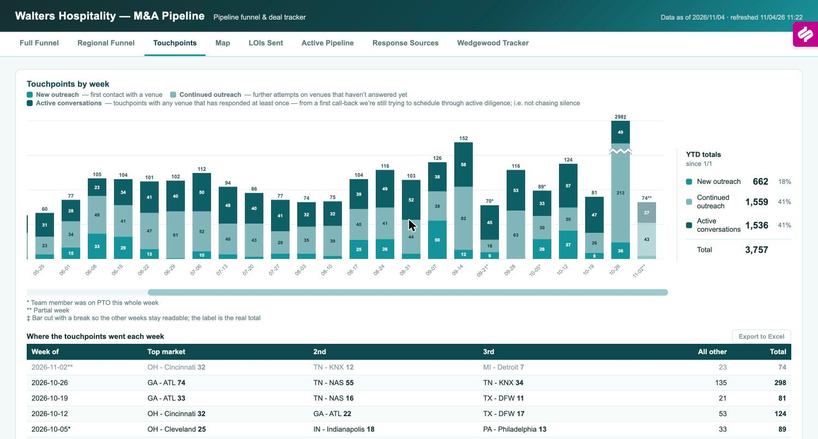  3,757 touchpoints YTD (662 new, 1,559 follow-ups, 1,536 active). 70+ venues toured; 14 of 16 market visits done.  LOIS SENT IN 2026 BY MARKET (19)  11 Texas, 8 outside. 2 closed (Firefly Lane, Hadden), 2 signed (Caney Creek, Engine Room), 11 declined, 4 other.
  Stage | Count | Of contacted
  Contacted | 1,202
  Responded | 653 | 54%
  Confirmed interest | 140 | 12%
  Shared data | 112 | 9%
  Reviewed / offered | 87 | 7%
  LOIs sent (2026) | 19 | 1.6%
  Accepted | 5
  Closed | 2
  Where it leaks: valuation, not interest
  - Of 87 venues reviewed or offered, we passed on 59 and sellers declined 23
  - Nearly every decline was price: owners anchored on real-estate value or a prior offer (Canyonwood, Videre, Emerson, Edible Ideas, Westwood and Sixpence)
  - One lost to an all-cash buyer (Elle); one wanted an offer before sharing data
  - Through October, 29 real offers produced 4 acceptances; only 1 deal has died after an LOI
  - The fix: earlier and clearer valuation conversations, not more volume at the top
  2027 Goals placeholder, decide 11/13
  - LOIs: 20+ (2026: 19 through October; 9 planned November to March)
  - Closes: 4 to 6 single venues plus one platform (2026: 2 closed, 2 closing by mid-December)
  - Density: every market shows a credible path to 5 venues within 18 months, or we stop spending there
  - New markets: 8 outreach waves by Jan 18; 18 region overviews to Wildcat by Nov 23; 2 to 3 new markets reach a leading-venue conversation by Q2
  - Middle of funnel: confirmed interest to data shared above 80%; offers accepted above 1 in 3
  Market | Closed | Signed | Declined | Other
  Nashville | 1 |  | 3
  Houston |  | 1 | 2 | 1
  DFW |  |  | 2 | 2
  Hill Country |  |  | 3
  Atlanta | 1 | 1
  Indianapolis |  |  | 1
  Orlando |  |  |  | 1
  Middle of the funnel: the program and early results
  - Quarterly Venue Trends one-pager to 145 venues: 67% open, 6% reply and counting
  - Coffee Chat gift cards to 40 top-priority targets: 80% open, 3% reply
  - Seller references from the Firefly Lane and Hadden owners; Hadden referral program proposed Nov 4
  - Value Snapshot and Deal Options two-pager after every first meeting
  - Next: acquisition announcements (Nov 30), Alyssa video (Dec), holiday gift test (ship Dec 11), CPA and advisor channel (Jan), WIPA (Feb), two-week sweep of the 48 venues stuck at "responded"
  Decisions required on Nov 13
  - Fewer, better deals or more market deals (we cannot have both)
  - 2027 target acquisitions and capital availability
  - What makes a target MSA
  - Wildcat involvement and sign-off rules
  - Alyssa's go-forward involvement
How we pick markets and venues: the selection criteria behind the funnel
MSA SCORE (1 TO 5): EIGHT WEIGHTED CRITERIA, LESS 3% PER WEDGEWOOD VENUE | VENUE SCORE (0 TO 100): TEN CRITERIA, OBSERVABLE BEFORE CONTACT
  Criterion | Weight | What it measures
  Weddings per 1,000 residents | 18 | Wedding intensity, including destination pull
  Revenue pool | 16 | Annual venue dollars in the market
  Growth rate | 16 | Population growth
  Walters fit | 16 | Strategic fit with our expansion plans
  Competition | 14 | Venues per 100k residents, inverted
  Land $ per acre | 8 | Crexi land value; lower is better
  Median wedding spend | 6 | The Wedding Report metro median
  Population | 6 | Metro size
  Criterion | Weight | What it measures
  Physical-plant fit | 18 | 150+ seated, rain plan, multi-room
  Review rating | 16 | Google, The Knot, WeddingWire, Zola average
  Recent reviews, 12 months | 16 | Recency and momentum
  Capacity fit | 12 | 150 to 250 seated scores highest
  MSA / market score | 12 | From the table at left
  Events per year | 8 | Actual throughput where known
  Venue-type fit | 8 | Barn, estate, ballroom over restaurant, hotel
  Ancillary hub coverage | 6 | Catering, floral, bakery within ~90 min
  Lodging nearby | 5 | Guest lodging within 5 miles
  Review volume | 4 | Lifetime reviews, log-scaled
THE RANKING TODAY (56 MSAS SCORED; TOP 24 SHOWN)
  # | MSA | Score | Venues | Status
  1 | Dallas-Fort Worth | 4.08 | 653 | Home
  2 | Houston | 4.04 | 531 | Home
  3 | Miami-Ft. Lauderdale | 3.86 | 164 | Paused
  4 | Tampa | 3.54 | 134 | Future
  5 | Austin | 3.54 | 271 | Home
  6 | Orlando | 3.48 | 148 | Focused
  7 | Atlanta | 3.39 | 422 | Home
  8 | San Antonio | 3.38 | 263 | Home
  9 | Nashville | 3.22 | 263 | Home
  10 | Salt Lake City | 3.18 | 107 | Paused
  11 | Washington DC | 3.16 | 304 | Broker-led
  12 | Raleigh | 3.10 | 142 | Paused
  # | MSA | Score | Venues | Status
  13 | Jacksonville | 3.10 | 99 | Future
  14 | Charlotte | 2.99 | 201 | Paused
  15 | Charleston | 2.98 | 130 | Active
  16 | Minneapolis | 2.96 | 138 | Focused
  17 | Seattle | 2.88 | 129 | Future
  18 | Columbus | 2.82 | 110 | Focused
  19 | Cleveland | 2.82 | 118 | Focused
  20 | New York | 2.80 | 373 | Not pursued
  21 | New Jersey | 2.80 | 109 | Broker-led
  22 | Indianapolis | 2.78 | 131 | Focused
  23 | Virginia Beach | 2.78 | 95 | Broker-led
  24 | Greenville | 2.76 | 75 | Next wave
Score 80+ puts a venue in the top tier for outreach. Pipedrive then adjusts rank within each market: a Top deal tier lifts a venue to the upper quartile, Low caps it at the bottom, WH Passed drops out of the top 25.
Qualitative considerations that sit beside the score
- Path to 5+ venues. Fragmented ownership, owners who answer, and several venues of the quality we would own.
- A leading venue we could own. One top-15% venue plausibly for sale within 24 months; without it, infill has nothing to infill around.
- Hub economics. A catering, floral, and bakery hub reachable within about 90 minutes, or buildable soon.
- Who else is at the table. Wedgewood (Phoenix 9, Denver 8, Charlotte 4), PE-backed caterers that manage venues, regional groups buying the same targets.
- Operability. Liquor licensing and permitting timelines, labor market, travel from Texas leadership, and whether our lead engine already pulls couples from the metro.
Our Machine: how we identify targets and drive the funnel
Stage | As of Nov 4 | Tool | What happens here
1 · Identify and score | 8,748  VENUES SCORED | Venue Prioritization hub; owner enrichment; Market Intel brief | 8,069 operating venues plus 679 conversion candidates, scored on ten criteria; 4,866 on the own path, 1,827 partner, 1,073 refer; owner email verified on 3,070. MSA scoring ranks 56 markets; the map shows 90-minute reach from our hubs; the Monday brief flags news and listings on the top 1,000.
2 · Contact | 3,757  TOUCHPOINTS YTD | Pipedrive; funnel tracker (Touchpoints, Response Sources) | 1,202 venues contacted all time, 421 active, 662 new this year; one new region a week through Jan 18. Calls get answered 24 times per 100 vs 17 for email; responders answer by the second touch, so low-tier email stops at touch 2 and the phone goes to top and mid tier.
3 · Engage | 140  CONFIRMED INTEREST | Funnel tracker stages; mid-funnel program; Deal Factors | 653 responded, 140 confirmed, 112 shared data. Trends one-pager (67% open), Coffee Chat cards (80% open), seller references, announcements, Value Snapshot. Deal Factors tests every Saturday which factors predict a response and an LOI.
4 · Evaluate and offer | 19  LOIS SENT IN 2026 | Active Pipeline; LOI ledger; data books; region overviews; Review Intel | 55 live targets scored 0 to 10 with LTM and PF-Y2 economics; every offer with terms and outcome; 18 region overviews to Wildcat by Nov 23; public reviews compiled before any LOI; Wildcat reviews before signature.
5 · Diligence and close | 2  UNDER CONTRACT | Deal Command Center; Daily Deal Status email | Legal, diligence, and integration workstreams per deal with third parties on point (Quarles, Whitley Penn, WTW, BL, Matthews). Caney Creek: 8 streams running, close week of Nov 30. Engine Room: 5 running, close Dec 15.
6 · Integrate and measure | 2  CLOSED IN 2026 | 120-day tracker; integration dashboard; post-close vs underwriting slide; post-mortem scorecard | Firefly Lane Q3: contracts 118% of goal. Hadden September: contracts 140%, revenue 97%; 92 contracts against a 190 goal, 15 ahead of pace; vendor packages booked within weeks of launch. Every deal measured against its underwriting at 100 days and 12 months.
THE NUMBERS THROUGH THE MACHINE
Stage | Count | Of prior | Of contacted
Hub records scored | 8,748
Own-path targets | 4,866
Contacted (all time) | 1,202 | 25%* | 100%
Responded | 653 | 54% | 54%
Confirmed interest | 140 | 21% | 12%
Shared data | 112 | 80% | 9%
Reviewed or offered | 87 | 78% | 7%
LOIs sent in 2026 | 19 | 22% | 1.6%
Accepted | 5 | 26% | 0.4%
Closed (+2 under contract) | 2 | 40% | 0.2%
*Of the 4,866 own-path targets. Counts as of Nov 4.
Where the pace is set. The two steps that depend on price are the weak ones: reviewed to LOI (22%) and LOI to accepted (26%). Everything above them converts at 54% or better, so the fix is valuation conversations earlier, not more outreach.
Dashboards and Agents Overview
DASHBOARDS
Stage | Dashboard | What it shows
1 · Identify | Venue Prioritization hub | 8,748 venues scored and ranked; MSA scoring; map with hub rings; operator census; owner contacts; live Pipedrive stage
2 to 3 · Contact, engage | M&A Pipeline tracker | Full and regional funnels (1,202 contacted, 653 responded, 140 confirmed), venue lists by stage, map, Wedgewood tracker; the page Wildcat sees
2 · Contact | Outreach analytics | 3,757 touchpoints by week and market; which channel gets answered (calls 36%, email 29%, broker 19%)
4 · Evaluate, offer | LOI ledger and Active Pipeline | All 19 offers with terms and outcomes; 55 live targets scored 0 to 10 with LTM and PF-Y2 economics
5 · Diligence, close | Deal Command Center | Every deal under contract: workstreams, milestones, third parties, seller questions, permanent change log
All | Priorities workplan | Seven workstreams from now to March: LOIs, regions, overviews, conversion ideas, trips
1 and 4 | Region overviews and operator intel | Market by market evidence and buckets; 18 overview packs for Wildcat; census of 67 multi-venue groups
AGENTS
Agent | What it does
Owner enrichment | Finds owner name, phone, and verified email for a target on demand from the hub (Hunter, Intelius, NeverBounce); 3,070 verified
Market Intel | Every Monday: news, for-sale listings, and rates matched to the top 1,000 hub venues and the watchlist; reports only what changed; Wedgewood tracked every run
Daily Deal Status | Every weekday morning: what moved on every deal under contract, from the Command Center log
Action Triage | Every morning: turns open threads into the day's M&A actions
Deal Factors | Every Saturday: tests which measurable factors predict a response, an LOI, and an acceptance; scores open targets for the week; grades its own predictions
CFO Scorecard | Every Saturday: 4-week funnel trend of touchpoints, pre-LOI deals, LOIs submitted vs the 20 goal, and closes YTD
Review Intel | Every Sunday and on demand: every public review of our venues and 65 nearby competitors, tagged on 25 themes; one-click pre-LOI review screen for any target
Dashboard 1 · Venue Prioritization hub: the universe, scored
Venue Prioritization hub · password-gated web app · Pipedrive refreshed live
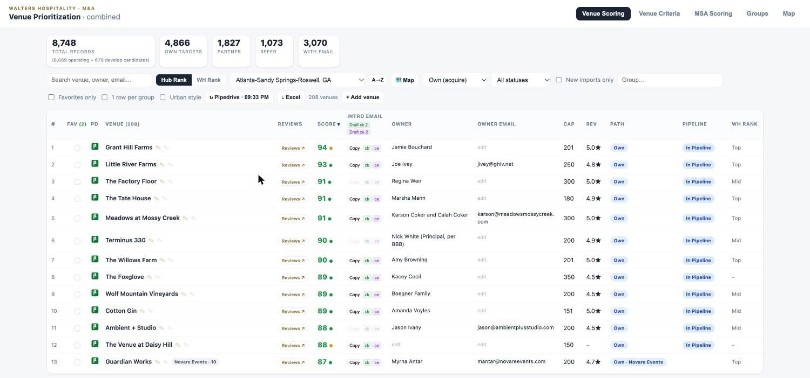
Atlanta, sorted by score: the market's leading venues are already in the pipeline.
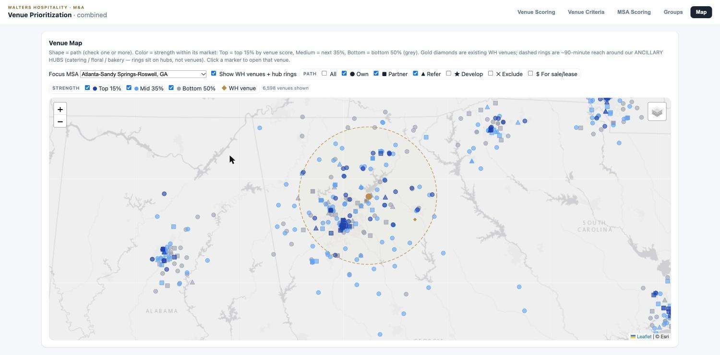  Atlanta map: our venues (gold), the 90-minute hub ring, every target by strength. | What it is  Every venue we could own, partner with, or refer: 8,748 records, 4,866 on the own path, owner email verified on 3,070. Each row carries the ten-factor score, reviews, capacity, MSA, path, and live Pipedrive stage. Tabs for venue criteria (weights editable), MSA scoring, the operator census, and a map with our venues and the 90-minute hub rings. A Develop lens tags lodges, churches, warehouses, and banquet halls that could become venues.

Why it matters  Density is planned here. Filtered to Atlanta, the top of the list is the market's leading venues (Grant Hill Farms 94, Little River Farms 93, Meadows 91), all already in the pipeline, and the map shows which of the 208 Atlanta venues sit inside the hub ring. | How we use it  Laura and Karlee work each market's list from the top, drafting intro emails from the row. Before an LOI, the Reviews button compiles every public review. Before a visit, the map and Groups tab set the itinerary.

Built by Charlie and Cate with Claude Code; deployed from a shared repo with automatic front-end deploys. Weights revised with Cate in August.
Dashboard 2 · M&A Pipeline tracker: the funnel, by market
M&A Pipeline tracker · the page Wildcat sees · Pipedrive export refreshed daily
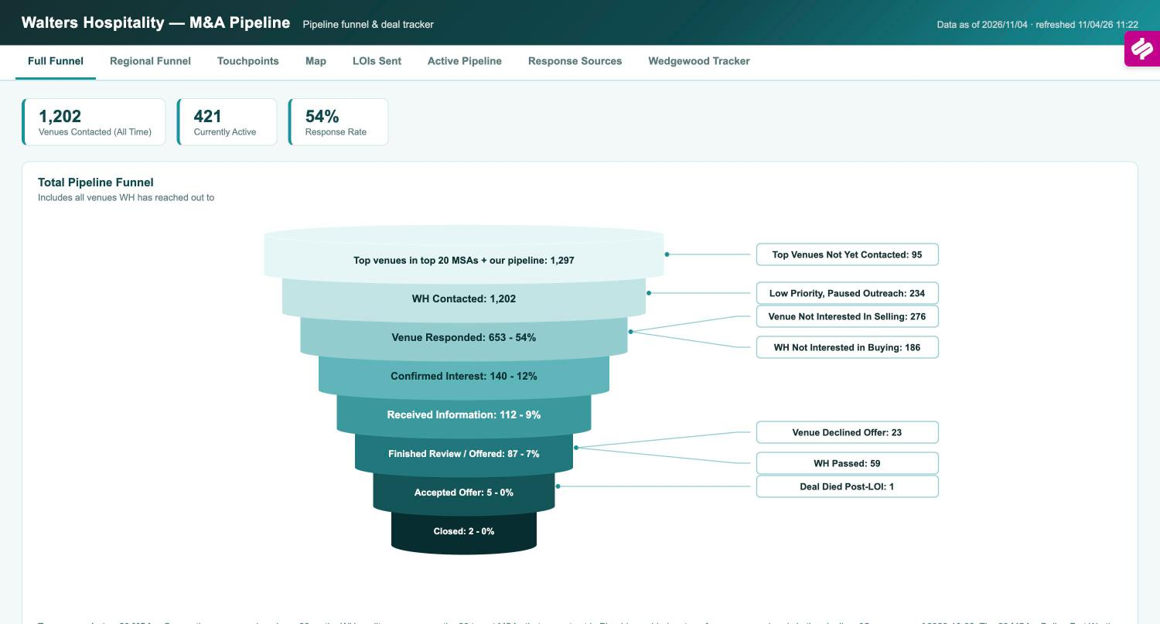
Total funnel with every exit labeled.
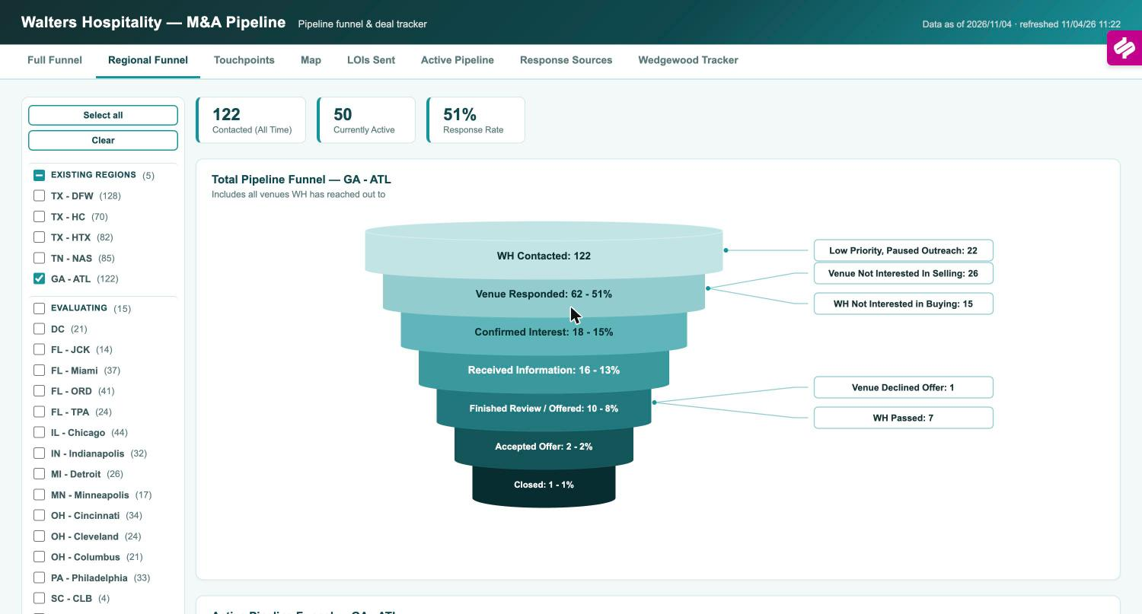  Atlanta: 122 contacted, 51% response, 18 confirmed interest. | What it is  Cate's live Pipedrive export: 1,202 contacted, 421 active, 54% response, every stage with its exits labeled (234 paused, 276 not selling, 186 we passed early, 23 declined our offer, 59 we passed after review). The Active funnel shows live work only: 315 awaiting response, 51 determining interest, 28 yet to share data, 25 under review. Regional Funnel cuts the same view for 44 regions with every venue listed under its stage.

Why it matters  This is the scoreboard for the strategy: whether a market produces conversations and where they stall. Atlanta: 122 contacted, 51% response, 18 confirmed, 10 reviewed, 2 accepted, 1 closed. Nashville responds at 69%, Minneapolis at 65%. The 95 top-tier venues not yet contacted are listed by market. | How we use it  Anchors the Tuesday M&A Update to Wildcat and the Thursday deal review. The stage lists drive the two-week sweeps of stuck venues.

Built by Cate with Claude Code. The October analytics (call first, screen valuation early, sweep the stuck 'responded' venues, run groups on their own cadence) became the mid-funnel program.
Dashboard 3 · Outreach analytics: touchpoints and how sellers reach us
M&A Pipeline tracker, Touchpoints and Response Sources tabs · refreshed daily
Weekly touchpoints by type; YTD 3,757.
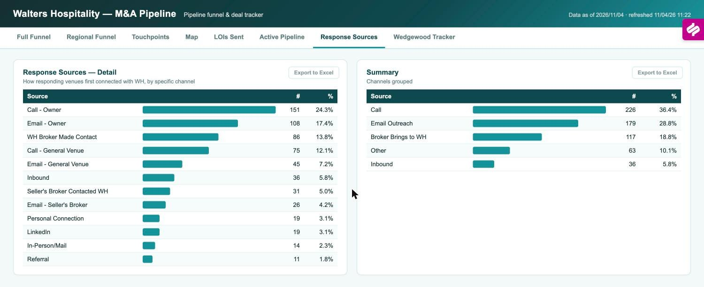  First-response channel for 621 responding venues. | What it is  Touchpoints by week since May, split into new outreach, follow-ups on silence, and active conversations: 3,757 YTD (662, 1,559, 1,536). The week of Oct 26 hit 298. Below the chart, where the touchpoints went by market. Response Sources shows how 621 responding venues first connected: calls 36%, email 29%, broker 19%, inbound 6%.

Why it matters  Outreach is the input we control, so this page proves the machine is running and tells us where to point it. Calls are answered 24 times per 100 vs 17 for email, and responders answer by the second touch, so the team calls first and stops chasing low-tier venues by email after touch 2. | How we use it  Thursday call sets next week's market focus; monthly check that new-region waves land on schedule; quarterly board trend (+36% Q2 to Q3).

Response attribution uses Claude to read each logged touchpoint and judge whether it was answered, giving a true response rate rather than a logged-activity count.
Dashboard 4 · LOI ledger and Active Pipeline: every offer and every live target
M&A Pipeline tracker, LOIs Sent and Active Pipeline tabs · deal terms shown; internal only
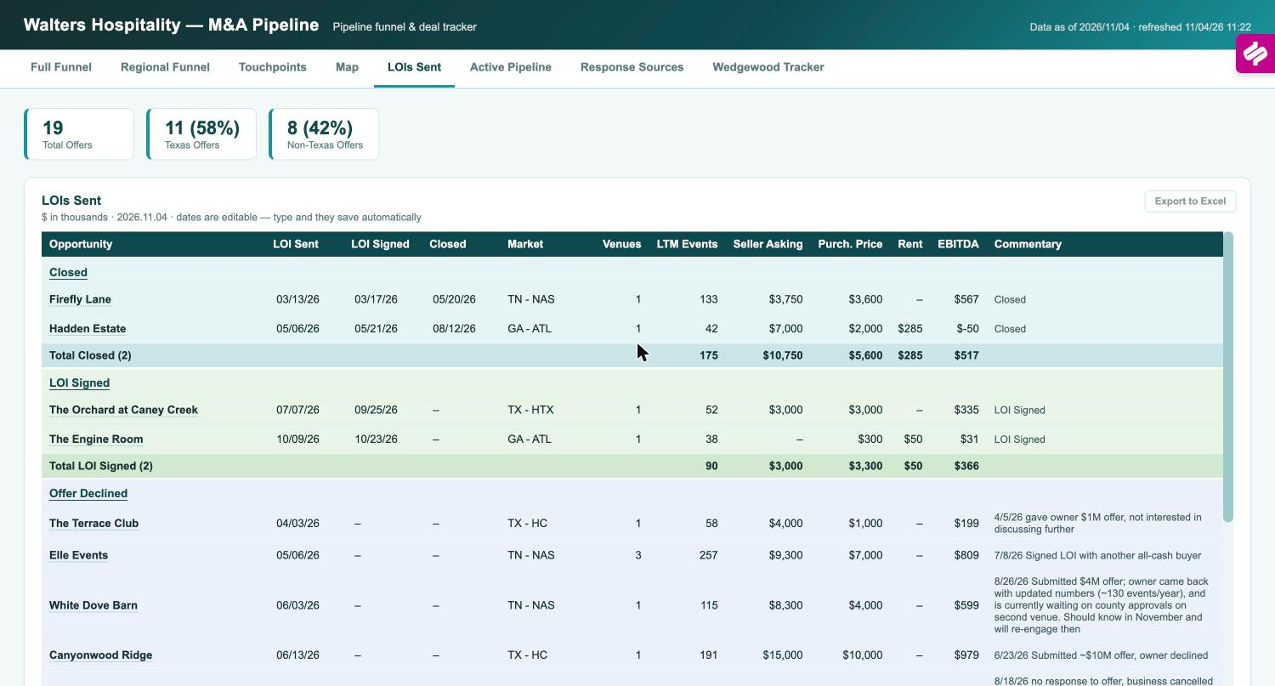
All 19 LOIs with terms and outcomes.
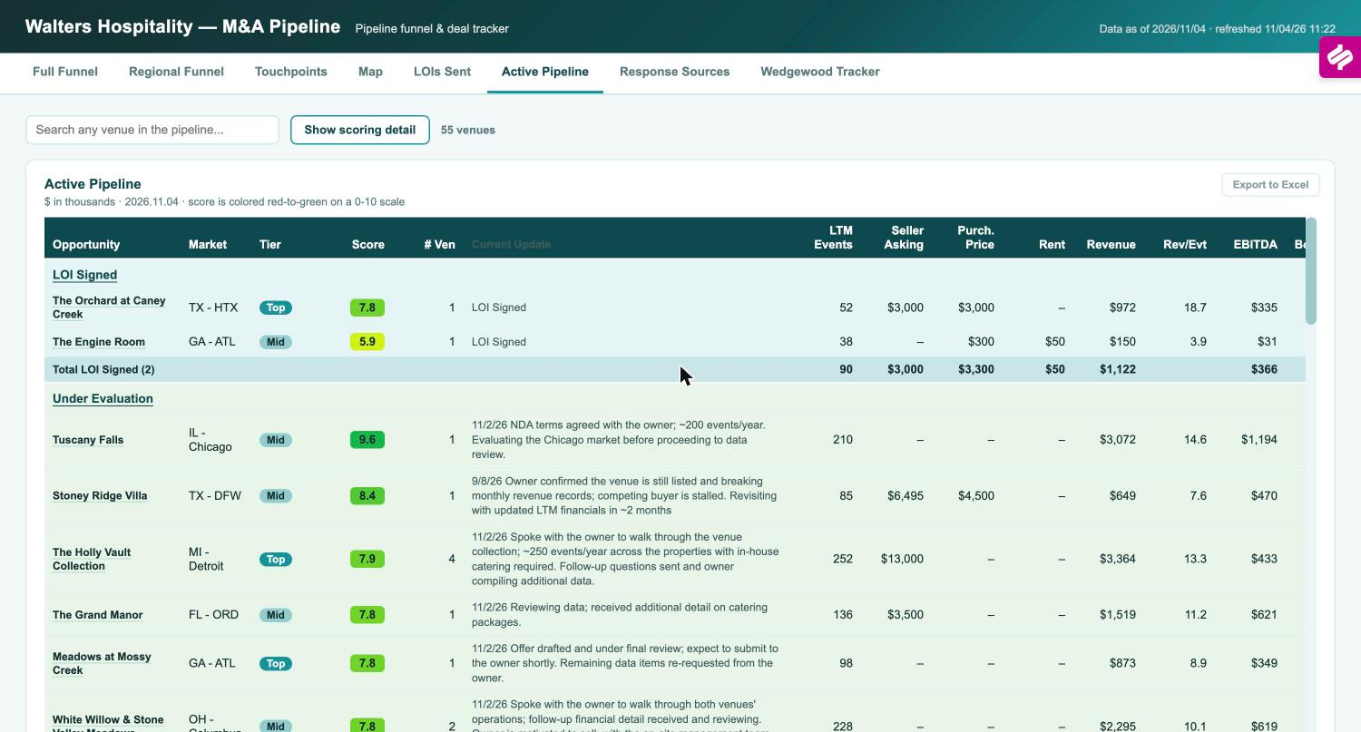  55 live targets scored 0 to 10 with economics. | What it is  The ledger lists all 19 offers with dates, market, LTM events, asking price, our price, rent, EBITDA, and outcome: 2 closed, 2 signed, 11 declined, 4 other; 11 Texas, 8 outside. The Active Pipeline scores the 55 live targets 0 to 10 with LTM and pro-forma year-2 revenue and EBITDA, future bookings, and the latest note.

Why it matters  This is where valuation discipline shows. The commentary records why deals die: Canyonwood declined ~$10M, Videre priced business plus land far above earnings, Emerson needed $3.5M against $1.5M, Edible Ideas called $16M '100%+ off'. One lost to an all-cash buyer (Elle). Next LOIs in order: Meadows, D'Amico, Lillian Gardens, The Revere, Tuscany Falls (210 events, score 9.6). | How we use it  Before every offer, the ledger sets comparables and the pipeline score frames the data book. It feeds the quarterly board slide and the Saturday scorecard (LOIs vs the 20 goal).

The 0 to 10 pipeline score is Cate's rubric on quality, economics, and fit, built in September alongside the venue scoring rubric reported to the board.
Dashboard 5 · Deal Command Center: from signed LOI to close
Deal Command Center · shared board, edits save for everyone · feeds the 7 am Daily Deal Status email
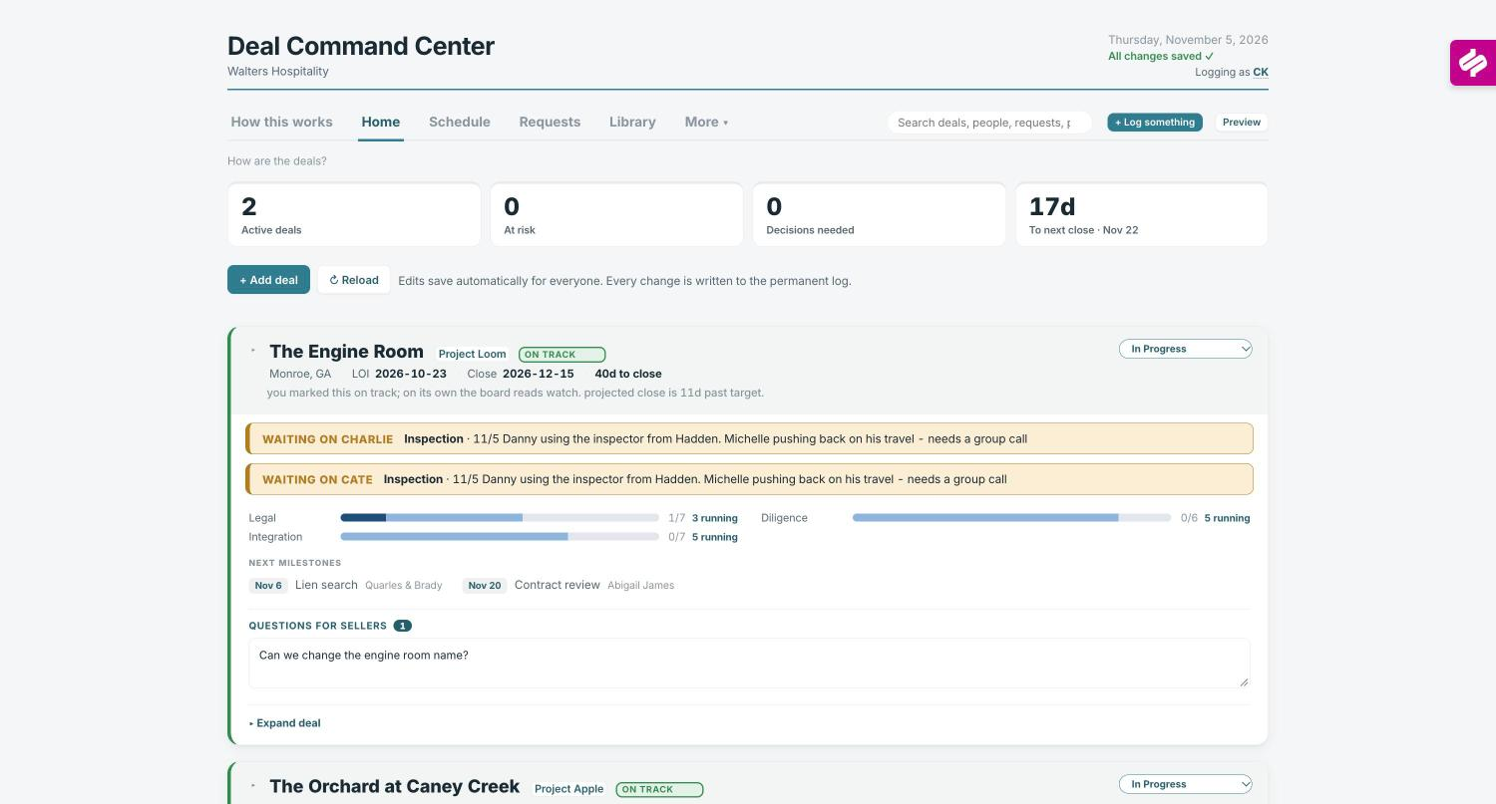
Home: 2 active deals, 0 at risk, next close in 17 days.
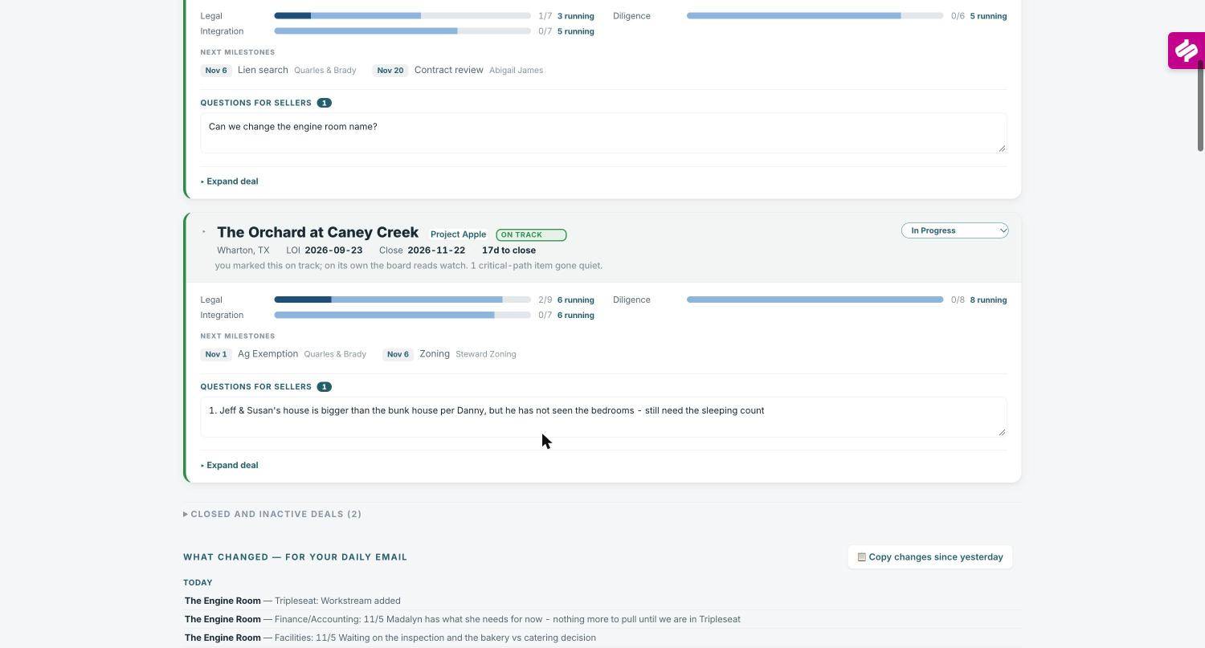  Per deal: workstreams, milestones, owners, open questions. | What it is  Autumn's board for every deal under contract: LOI and close dates, days to close, status with the board's own read beside ours, legal, diligence, and integration workstreams, next milestones with the third party on point, what is waiting on whom, and open seller questions. Schedule, Requests, and Library hold the calendar, request lists, and documents. Every change is logged.

Why it matters  Closing is where strategy becomes venues. Caney Creek: LOI Sept 23, legal 2 of 9, 8 streams running, close week of Nov 30, subdivision approval the open risk. Engine Room: LOI Oct 23, close Dec 15, alcohol license handled in the lease. Integration starts here, not at close. | How we use it  The 7 am email comes from this log; the counsel all-hands works off the milestones; at close the integration workstream hands to Abigail with the history intact.

Built by Autumn in October with Claude Code, replacing threads and a spreadsheet. The board's own 'watch' read comes from milestone aging, so a deal cannot drift quietly.
Dashboard 6 · Priorities workplan: what the team does from now to March
Priorities workplan · M&A team · updated weekly
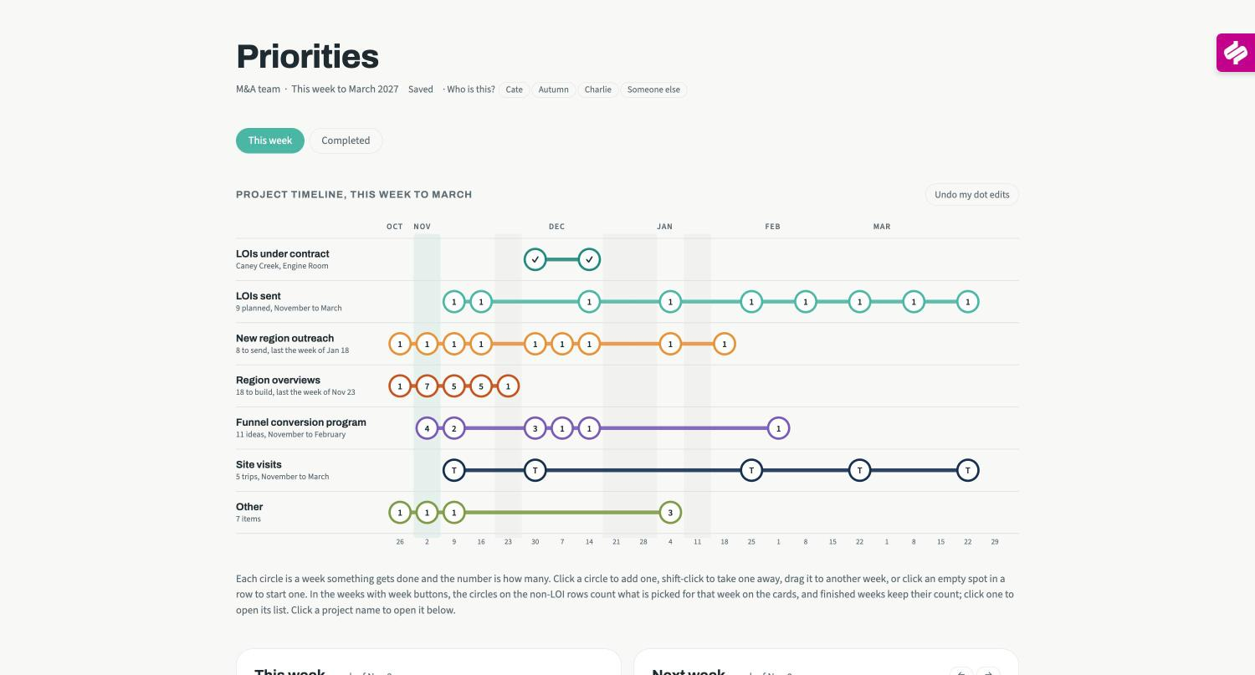
Timeline: seven workstreams to March 2027.
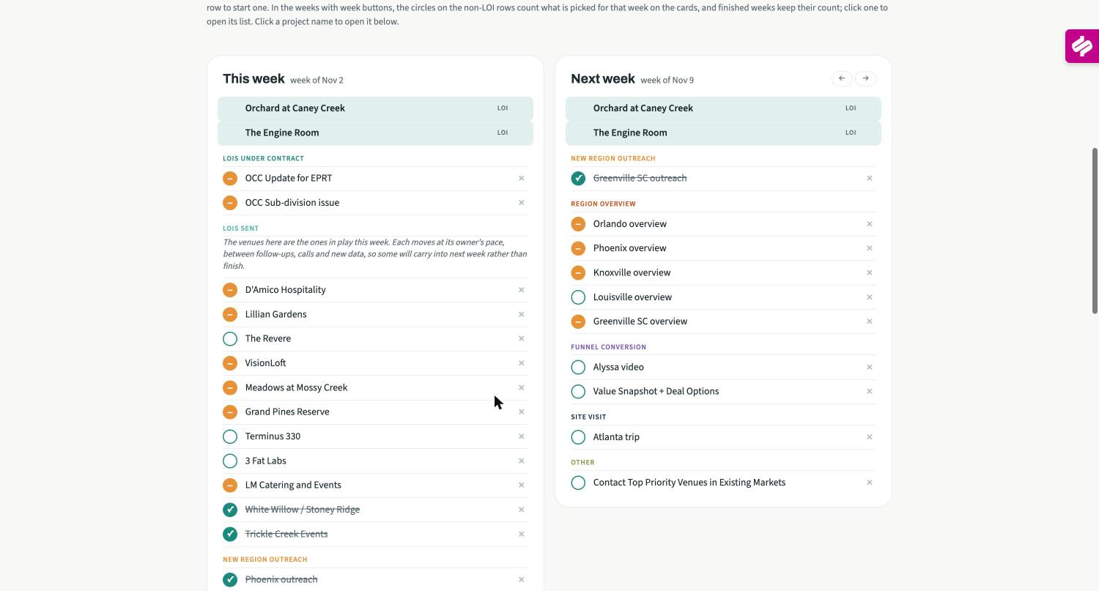  This week and next week: venues in play, overviews, conversion steps. | What it is  Seven workstreams on one timeline to March 2027: two deals under contract, 9 LOIs planned from 19 venues with data in hand, 8 new regions (one a week to Jan 18), 18 region overviews for Wildcat (by Nov 23), 11 conversion ideas, 5 site visits, and 7 other items. This-week and next-week cards list the venues and tasks; each deal carries a status.

Why it matters  The strategy with dates on it. Capacity and priority are visible before they collide, and the trade-off is explicit: pushing conversion ideas forward slows data packs or new-region outreach. | How we use it  Cate sets the week on Monday; the 'LOIs sent' list is Thursday's agenda; monthly, Charlie and Cate check the timeline against the 2027 targets.

Built by Cate in early November after Charlie asked for one view of everything the team carries. Nothing under 50 events gets analysis time.
Dashboard 7 · Region overviews and operator intelligence
Region Review (Cate, Oct 2026) · overview packs (Autumn) · hub Groups tab
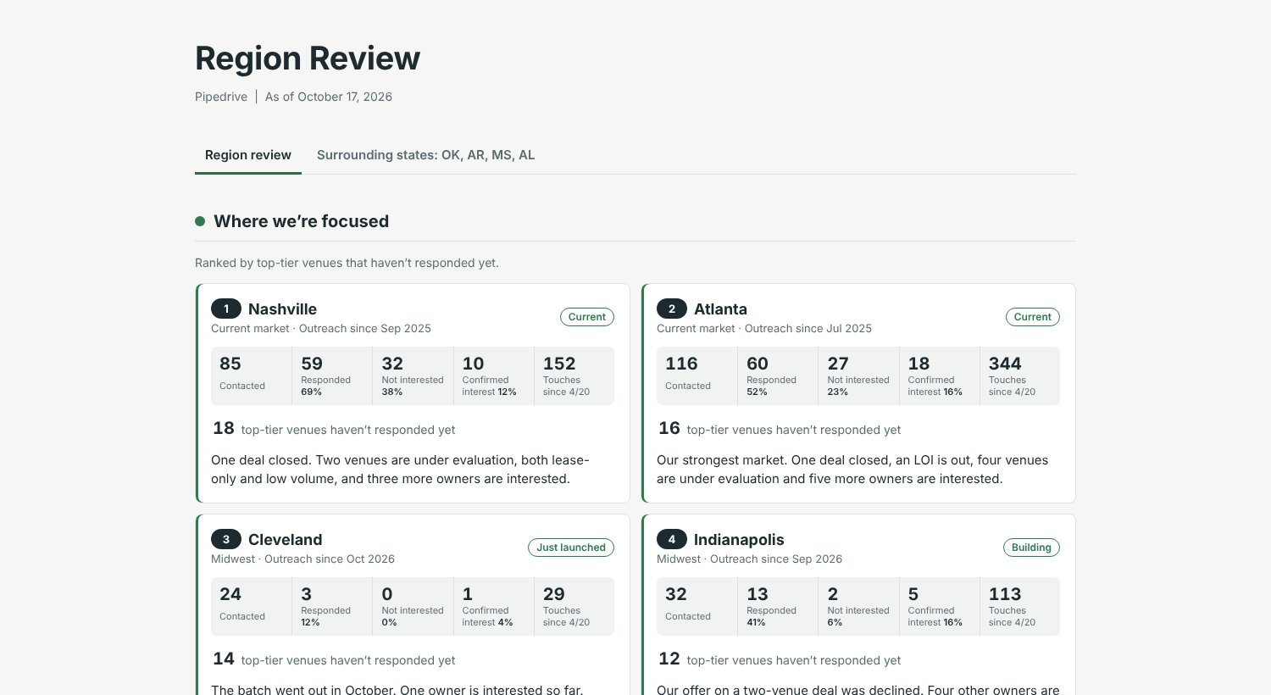
Region Review: where we're focused, ranked by top-tier venues not yet responding.
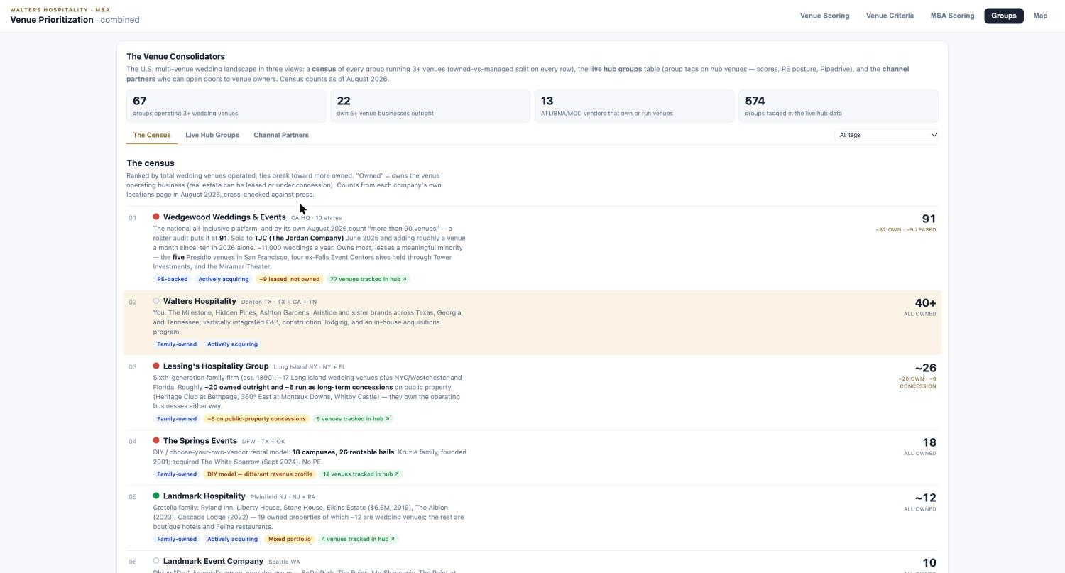  Groups census: 67 multi-venue operators, owned vs leased. | What it is  The Region Review ranks every market by top-tier venues not yet responding, with contacted, responded, confirmed interest, and touches for each, plus the paused and broker-led lists with reasons. Each focused market gets an overview pack for Wildcat: what owners are telling us, what offsets the negatives, weddings per 1,000, a county map, and the competitive set with ratings and drive times. The Groups tab is the census of 67 multi-venue operators (Wedgewood 91: about 82 owned, 9 leased) and the caterers and planners who open doors.

Why it matters  This keeps the market list honest: each market carries its own evidence, and the census shows who else is consolidating and which groups are platforms we could buy. | How we use it  Before the Wildcat packet (Nov 23) and before every market visit; the Region Review's team questions are the agenda for decision 3.

Built by Cate and Autumn with Claude from Pipedrive, the hub, The Wedding Report, and owner-call transcripts. Columbus is done; 17 more by Nov 23.
Current initiatives: November 2026 to March 2027
MIDDLE-OF-FUNNEL CONVERSION PROGRAM (11 IDEAS) AND EARLY RESULTS
Initiative | What it is | Status and results | Done by
Quarterly Venue Trends one-pager | Key market trends sent to target owners as a reason to talk | Sent to 145 venues in October: 67% open, 6% reply and counting. Next edition Q1. | Running
Coffee Chat email | $10 Starbucks card to top-priority non-responders | 40 top-tier venues over two weeks: 80% open, 3% reply and counting. | Running
Prior seller references | Firefly Lane and Hadden owners as references and intro sources in their markets | Both engaged; Hadden referral program proposed Nov 4 (paid reference and intro calls, success fee on a close). | Week of Nov 2
Acquisition announcements | Hadden to GA venues, Firefly Lane to TN venues, with an offer to speak to the seller | Drafts with marketing. | Week of Nov 30
Updated outreach PDFs | Owner brochure and partner flyer refreshed | v2 built Nov 4; website acquisitions page gains owner quotes. | Week of Dec 7
Value Snapshot + Deal Options | Two-pager after the first meeting: what is in it for them, multiples, how our process and valuation work | Drafting; moves the valuation conversation earlier. | Set date
Alyssa video | Short CEO message embedded in invites and announcements | Record in December. | Set date
Holiday gift A/B test | 25 watercolors or hats, ship by Dec 11, follow-up calls in January | Readout in February. | Week of Dec 7
Quarterly owner note | Marketing produces, M&A reviews; January, April, July, October | Draft by mid-December. | Week of Dec 14
CPA and advisor channel | 2 to 3 firms each in Atlanta and Nashville, then Houston and Dallas in March | January. | Week of Jan 4
Association meetings | WIPA pilot in Atlanta and Nashville | February. | Week of Feb 1
Also running from the October pipeline analysis: call-first outreach with email stopping at touch 2 for low-tier venues; a two-week sweep of the 48 venues stuck at "responded" and the 16 confirmed-interest venues older than 60 days, one specific ask each; a multi-venue operator track with Charlie or Cate on the call (121 groups, 423 venues in the funnel, 57% response).
THE REST OF THE WORKPLAN
Workstream | Scope | Timing
Deals under contract | Caney Creek (subdivision approval, EPRT update, inspection costs); The Engine Room (APA and lease with Quarles, alcohol license, environmental, inspection) | Close week of Nov 30 and Dec 15
LOIs sent | 19 venues with data in hand; next most likely Meadows at Mossy Creek, Lillian Gardens, The Revere, D'Amico; also VisionLoft, Tuscany Falls, LM, Grand Pines, Holly Vault, BTTS, Little River Farms | 9 planned, November to March
Region overviews for Wildcat | Minneapolis, Cincinnati, Indianapolis, Detroit, Chicago, Cleveland this month; Greenville, Orlando, Phoenix, Knoxville, Louisville, Pittsburgh, Birmingham, Buffalo, Memphis, Hartford next; packet finalized | 18 by the week of Nov 23
New-region outreach | Phoenix (sent), Greenville, Memphis, Louisville, Pittsburgh, Birmingham, Buffalo, Hartford: rank the venues, confirm the owners, load Pipedrive, send | One a week, last Jan 18
Site visits | Atlanta (Nov 9: West Midtown, Little River Farms, The Revere, Engine Room), Knoxville (Nov 30), then January, February, March | About one a month
Other | Nashville vendor-partner outreach; contact the 58 top-priority venues in existing markets; venue database (every data book side by side); Pipedrive clean-up; post-close dashboard (projections vs actuals); improve the Atlanta response rate (51%) | November to Jan 4
Decisions required
1. Fewer, better deals, or more market deals? We cannot have both.
 | Fewer, better deals | More market deals
What it means | The market's leading venues at full price: top-15% quality, 100+ events, owned real estate where it makes sense. Two to four closes a year. | Density fast: mid-tier infill, leases, platforms, conversions at earnings value. Six to ten closes a year across several structures.
Density | Slower to 5 per market; each venue pulls the market's lead pool and sets the price ladder. | Faster to 5 per market; hub economics arrive sooner; brand set by the best of a mixed portfolio.
Capital and risk | More capital per deal, more real estate, higher multiples (Firefly Lane 6.3x LTM). Fewer, larger bets. | Less capital per deal, more leases and earnouts, more integration load. More, smaller bets; more can go wrong at once.
The team | Deep work on 20 to 30 named targets; less new-region outreach; Charlie and Cate on every owner call. | Outreach at full pace; standard lease and management terms; integration capacity added before deal capacity.
We stop | Chasing sub-$500k EBITDA venues and most lease-only urban product. | Paying up for anchors when infill is available at earnings value.
Wildcat hears | Judgment and selectivity; a slower unit count. | Pace and density; more structure questions on every LOI.

We need: the default. Decisions 2 to 5 follow from it.
2. 2027 target acquisitions and capital availability
2026 pace: 19 LOIs, 2 closed, 2 closing by mid-December, roughly $9M of purchase price across the four; 9 more LOIs planned by March. This number sets headcount and capital in the 2027 budget (Dec 4).
Hold the 2026 pace  4 closes, 20 LOIs; capital from EPRT sale-leasebacks and the MidCap delayed draw. | Step up  6 to 8 closes including one platform (D'Amico 12, BTTS 7 to 8); needs an equity or platform-financing answer. | Platform-led  One platform plus 2 to 3 singles; fewer transactions, more capital in one place.

We need: the close and LOI count by structure (buy, lease, manage, platform) and the capital line behind it.
3. What makes a target MSA
Today: the hub's eight-factor score with the Wedgewood haircut, plus the five qualitative factors on page 4.
Score only  Rank by the composite; work the list top down. | Score plus gates  A leading-venue candidate in sight, a path to 5+, hub reach within 90 minutes, a 60-day response test before more spend. | Gates plus a cap  The gates, plus a maximum number of new markets open at once (the team's own question).

We need: which gates apply, whether high-score paused markets (Miami 3.86, Raleigh 3.10) stay paused, and the cap.
4. Wildcat involvement and sign-off rules
Today: weekly update email and call; Wildcat comments on LOIs before they go out. Meadows moved after Wildcat's last look; a written rule is expected.
Pre-signature review  Every LOI to Wildcat before signature; material changes after their last look go back (thresholds on price, rent, obligations). | Threshold-based  Deals under a size or structure threshold proceed on our sign-off; above it, Wildcat pre-signature. | Cadence  Update call every other week instead of weekly; one named owner of the Wildcat M&A relationship.

We need: the rule and thresholds in writing before the Nov 12 call, and who owns the relationship day to day.
5. Alyssa's go-forward involvement
Own the Wildcat M&A relationship  The update cadence and the board M&A section; Charlie and Cate present the deals. | Join market visits and closing calls  One trip a quarter (Knoxville, week of Nov 30, is next); the seller meeting on every LOI-stage deal. | Sponsor integration  Own the 120-day plan with Abigail; the deal team hands off at close.

We need: which of these you take on, and from when.

