Some of the codes are come from the textbook written by professor Kang Zhang

**Part1. How to execute the program**

For all 6 the problems (with bonus 2%)

Execute the java file:

1.Find the file that stores all the java files;

2.Type javac PointInPolygon.java in the terminal;

3.Type java PointInPolygon;

**Part2. The result about the assignment**

2.1 The result of the Lower End

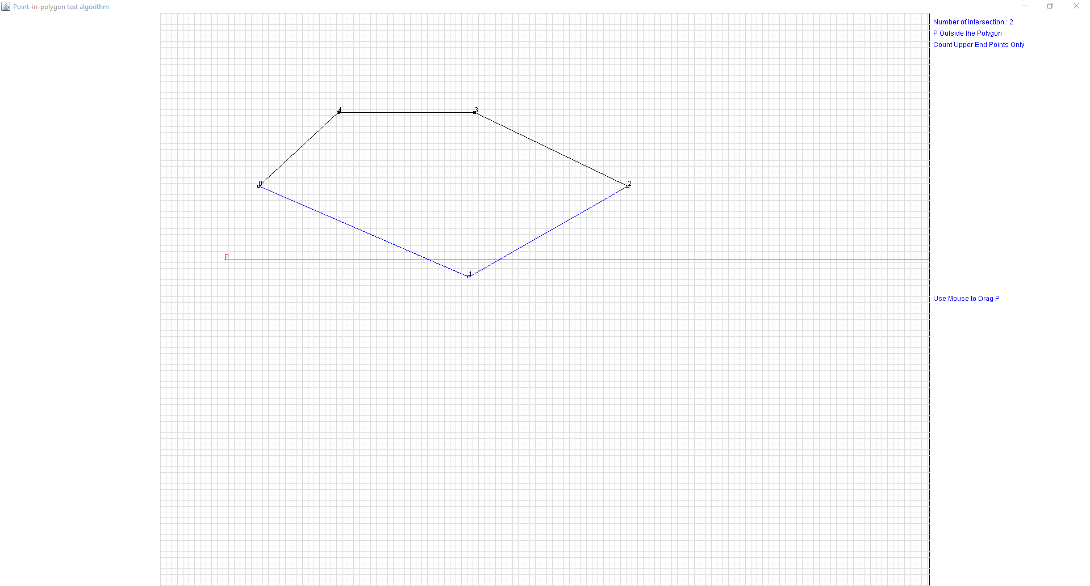

2.2 The result of the Upper End

