Experiment result:

|  |  |  |  |  |  |  |  |  |  |  |
| --- | --- | --- | --- | --- | --- | --- | --- | --- | --- | --- |
| lambda | 1 | 2 | 3 | 4 | 5 | 6 | 7 | 8 | 9 | 10 |
| ThLow1 | 1.879 | 3.755 | 5.613 | 7.508 | 9.386 | 11.237 | 13.153 | 15.001 | 16.876 | 18.756 |
| ThLow2 | 1.502 | 3.005 | 4.490 | 6.000 | 7.510 | 8.983 | 10.522 | 12.005 | 13.49 | 15.007 |
| ThHigh1 | 0.249 | 0.502 | 0.742 | 0.998 | 1.256 | 1.505 | 1.761 | 1.979 | 2.234 | 2.500 |
| ThHigh2 | 0.500 | 1.004 | 1.486 | 1.999 | 2.510 | 3.003 | 3.510 | 3.968 | 4.491 | 5.004 |
| ELow1N | 0.081 | 0.175 | 0.289 | 0.429 | 0.601 | 0.816 | 1.107 | 1.499 | 2.060 | 3.044 |
| ELow2N | 0.039 | 0.081 | 0.126 | 0.176 | 0.231 | 0.291 | 0.355 | 0.429 | 0.506 | 0.599 |
| EHigh1N | 0.010 | 0.020 | 0.030 | 0.041 | 0.052 | 0.063 | 0.075 | 0.085 | 0.098 | 0.111 |
| EHigh2N | 0.012 | 0.025 | 0.038 | 0.052 | 0.066 | 0.081 | 0.095 | 0.110 | 0.126 | 0.142 |
| ETLow1 | 0.043 | 0.046 | 0.051 | 0.057 | 0.064 | 0.072 | 0.084 | 0.099 | 0.122 | 0.162 |
| ETHigh1 | 0.040 | 0.040 | 0.041 | 0.041 | 0.041 | 0.042 | 0.043 | 0.043 | 0.044 | 0.044 |

Throughput Low priority Queue1:

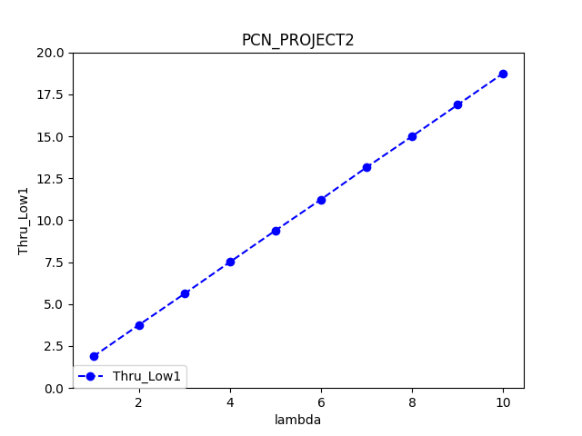

Throughput Low priority Queue2:

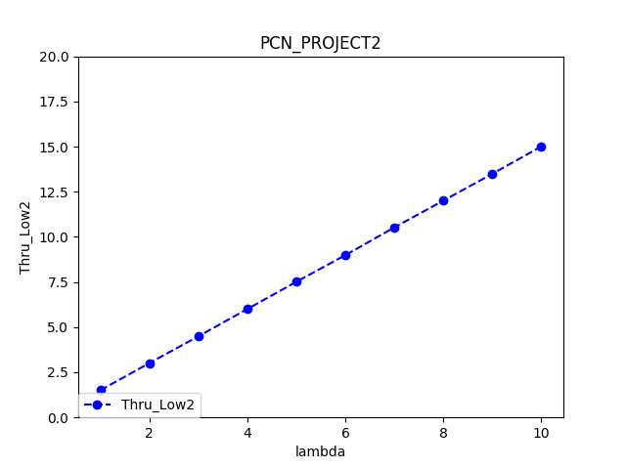

Throughput High priority Queue1:

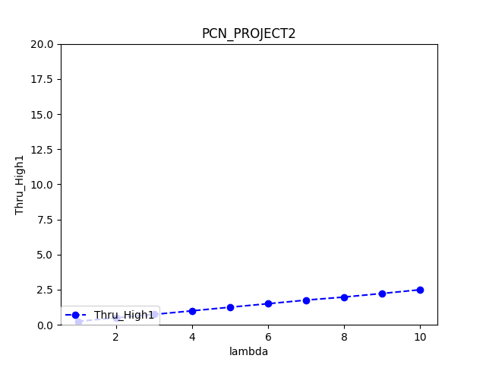

Throughput High priority Queue2:

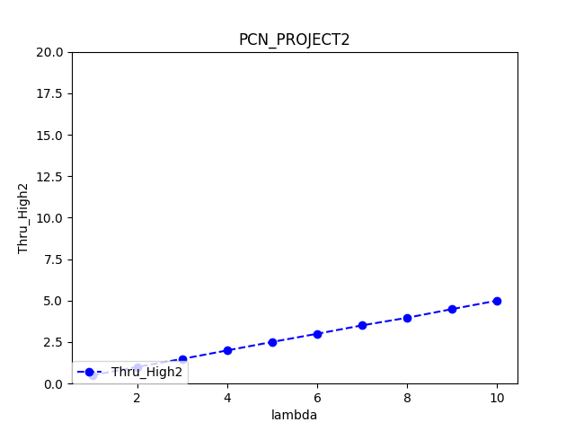

E[N] for low priority Queue 1:

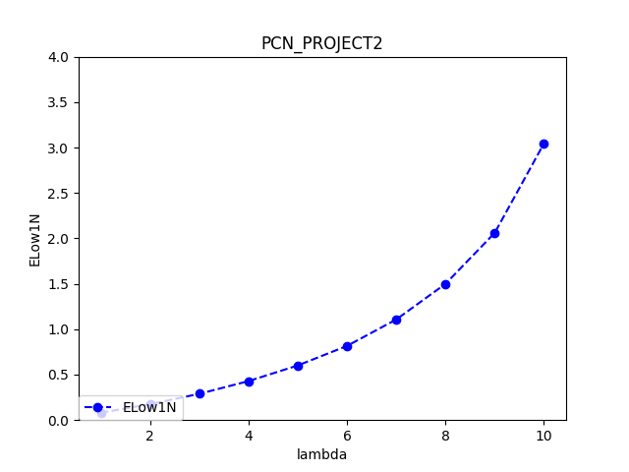

E[N] for low priority Queue 2:

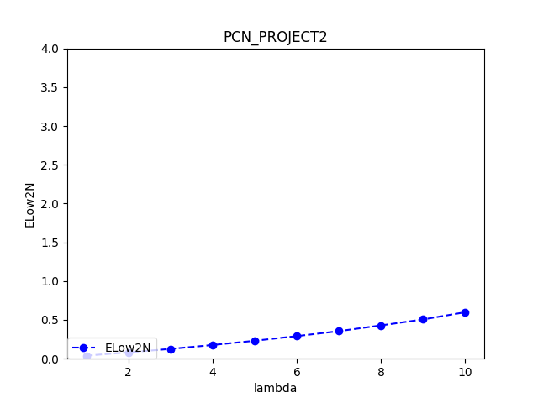

E[N] for high priority Queue 1:

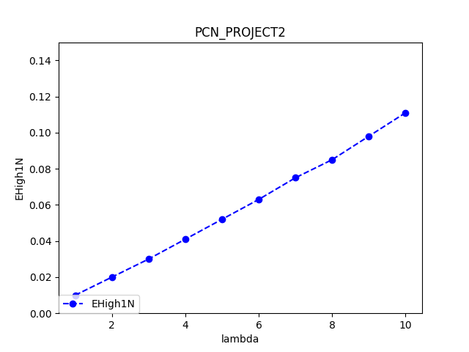

E[N] for high priority Queue 2:

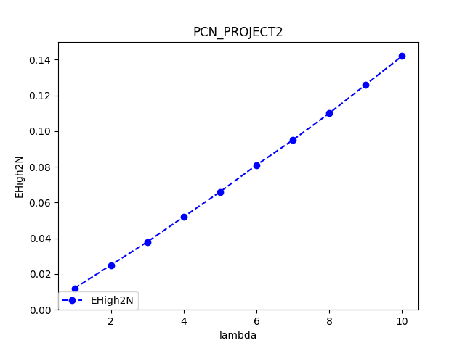

E[T] for low priority Queue 1:

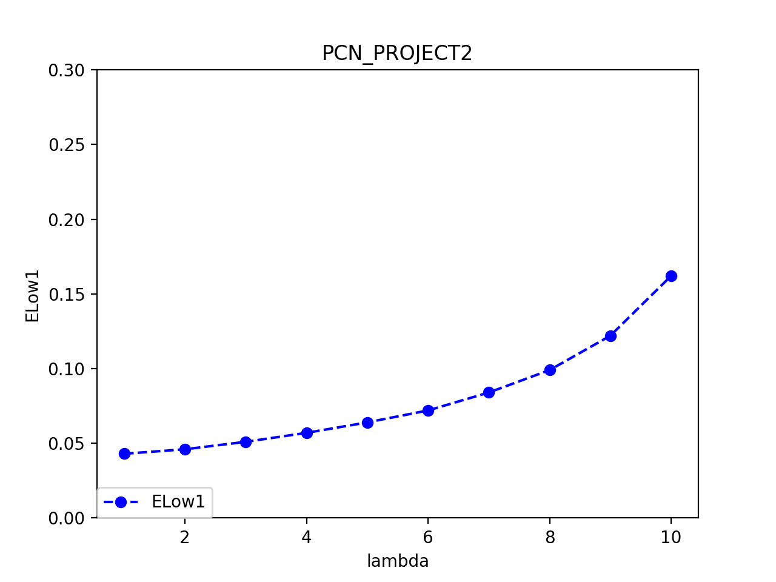

E[T] for high priority Queue 1:

