PROJECT 2 REPORT
Descriptive Statistics and Exploratory Data Analysis (EDA)
Prepared by: CYNTHIA C WANJIRU
Organization: DecodeLabs
Tool Used: Microsoft Excel

1. Introduction
The purpose of this project was to perform Descriptive Statistics and Exploratory Data Analysis (EDA) on a cleaned online store dataset using Microsoft Excel. The analysis was conducted to summarize the data, identify patterns, and gain insights into customer purchasing behaviour.
2. Objectives
The objectives of this project were to:
- Calculate descriptive statistics for the dataset.
- Summarize the main characteristics of the data.
- Identify trends and patterns.
- Interpret the results.
- Present meaningful business insights.

3. Descriptive Statistics
Descriptive statistics were calculated for the following variables:
- Quantity
- Unit Price
- Items in Cart
- Total Price
The statistical measures calculated included Count, Mean, Median, Minimum and Maximum. These measures helped summarize the dataset and provided a clear understanding of customer purchasing behaviour.
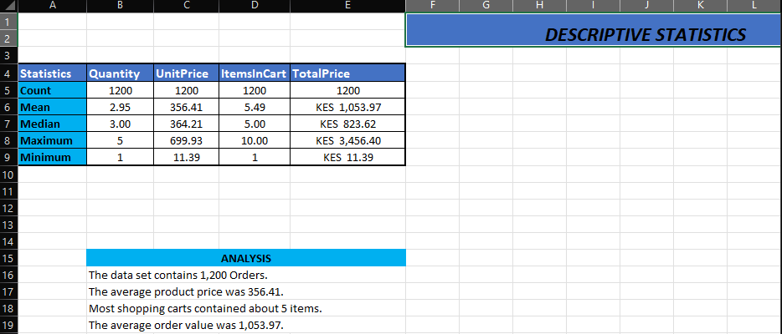

4. Exploratory Data Analysis (EDA)
The exploratory data analysis provided the following business insights:
- Chair generated the highest sales revenue of KES 195,620.11.
- Phone generated the lowest sales revenue of KES 151,722.39.
- Cancelled orders were the most common order status with 250 orders.
- Delivered orders were the least common with 231 orders.
- Credit Card generated the highest revenue among all payment methods.
- Instagram generated the highest referral revenue.
- FREESHIP also generated the highest revenue among all coupon codes.
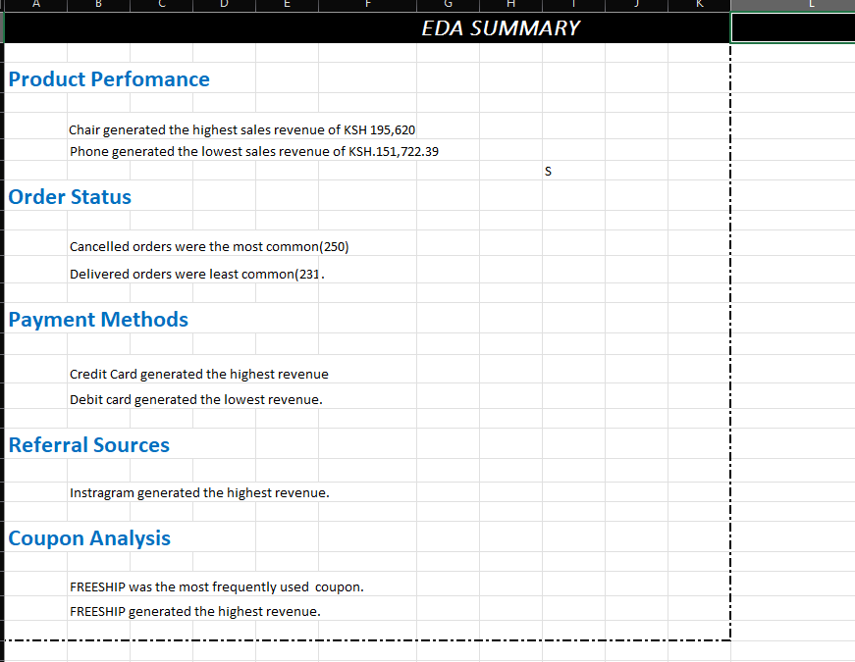

5. Key Findings
The analysis showed that chairs were the best-performing product, while phones generated the lowest sales revenue. Credit Card was the highest-performing payment method, and Instagram was the leading referral source. The FREESHIP coupon was both the most frequently used and the highest revenue-generating coupon. The descriptive statistics also showed that the dataset contained 1,200 customer orders, with an average product price of KES 356.41 and an average order value of KES 1,053.97.

6. Conclusion
This project successfully applied descriptive statistics and exploratory data analysis to summarize the online store dataset and identify important business insights. The findings highlighted product performance, payment methods, referral sources, coupon usage, and customer purchasing patterns. Overall, the analysis demonstrated how Microsoft Excel can be used to support data-driven business decisions.

