Adaptive 工程编译环境问题集

1. 编译libper时，找不到RapidJSON问题:

wsj@wsj-HP-Z640-Workstation:~/workspace/vector_ap/DATA/BSW/libper/build$ cmake ..

-- The CXX compiler identification is GNU 5.4.0

-- Check for working CXX compiler: /usr/bin/c++

-- Check for working CXX compiler: /usr/bin/c++ -- works

-- Detecting CXX compiler ABI info

-- Detecting CXX compiler ABI info - done

-- Detecting CXX compile features

-- Detecting CXX compile features - done

-- -------------------------------------------------------------

-- C Compiler used:

-- C++ Compiler used: /usr/bin/c++

-- C++ Standard used: 11

-- C++ Compiler options: -Wall -Werror -Wextra -Wnon-virtual-dtor -Wconversion -Wold-style-cast -pedantic -Wshadow -Wl,--no-as-needed

-- CMAKE_BUILD_TYPE:

-- -------------------------------------------------------------

CMake Error at CMakeLists.txt:42 (find_package):

By not providing "FindRapidJSON.cmake" in CMAKE_MODULE_PATH this project

has asked CMake to find a package configuration file provided by

"RapidJSON", but CMake did not find one.

Could not find a package configuration file provided by "RapidJSON" with

any of the following names:

RapidJSONConfig.cmake

rapidjson-config.cmake

Add the installation prefix of "RapidJSON" to CMAKE_PREFIX_PATH or set

"RapidJSON_DIR" to a directory containing one of the above files. If

"RapidJSON" provides a separate development package or SDK, be sure it has

been installed.

-- Configuring incomplete, errors occurred!

See also "/home/wsj/workspace/vector_ap/DATA/BSW/libper/build/CmakeFiles/CmakeOutput.log".

**A:** 从github上下载RapidJSON，编译并安装到系统。

<https://github.com/Tencent/rapidjson>

2. 找不到Doxygen问题

CMake Error at /usr/share/cmake-3.5/Modules/FindPackageHandleStandardArgs.cmake:148 (message):

Could NOT find Doxygen (missing: DOXYGEN_EXECUTABLE)

Call Stack (most recent call first):

/usr/share/cmake-3.5/Modules/FindPackageHandleStandardArgs.cmake:388 (_FPHSA_FAILURE_MESSAGE)

/usr/share/cmake-3.5/Modules/FindDoxygen.cmake:107 (FIND_PACKAGE_HANDLE_STANDARD_ARGS)

doc/CMakeLists.txt:3 (find_package)

-- Configuring incomplete, errors occurred!

See also "/home/wsj/workspace/vector_ap/DATA/BSW/libper/build/CmakeFiles/CmakeOutput.log".

**A:** git clone https://github.com/doxygen/doxygen.git

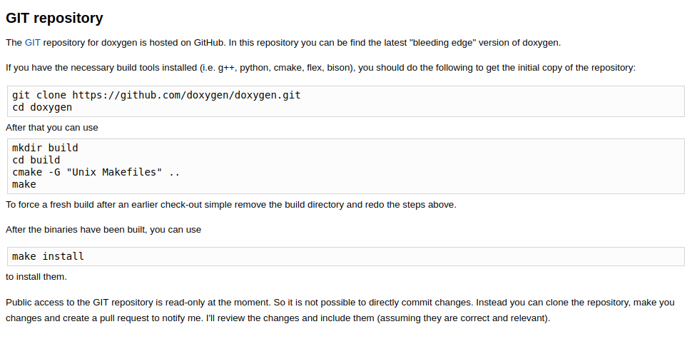

3. Could NOT find FLEX (missing: FLEX_EXECUTABLE) 问题

**A: 安装flex**

sudo apt-get install flex

sudo apt-get install bison

4. 无法找到ara-logging问题

Could not find a package configuration file provided by "ara-logging" with

any of the following names:

ara-loggingConfig.cmake

ara-logging-config.cmake

A: 在ara-logging路径下

Doc/R17-10/APDemonstrator/APD_R17-10/ara-api/log/