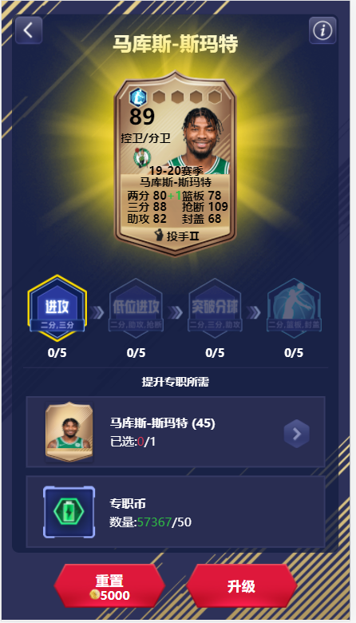
在这个页面再运行代码，专职满之后刷新下页面手动重置选择下路线再次运行。
代码在下一页

(function () {
setInterval(() => {
if (document.getElementsByClassName('cards_wrap').length) {
angular.element(document.getElementsByClassName('cards_wrap')[0].children[0])
.triggerHandler(
'click')
angular.element(document.getElementsByClassName('cards_wrap')[0].children[1])
.triggerHandler(
'click')
angular.element(document.getElementsByClassName('cards_wrap')[0].children[2])
.triggerHandler(
'click')
let timer = setTimeout(() => {
clearTimeout(timer)
angular.element(document.getElementsByClassName('career-bottom')[1].children[1])
.triggerHandler(
'click')
}, 500);
let timer1 = setTimeout(() => {
clearTimeout(timer1)
angular.element(document.getElementsByClassName('career-bottom')[0].children[1])
.triggerHandler(
'click')
}, 1000);
} else {
angular.element(document.getElementsByClassName('card-career-needlist')[0]).triggerHandler(
'click')
}
}, 2000);
}())

