**Dagger in the dark**

**Level Design**

**CS4075 Computer Games Programming – Tools & Techniques**

**19/10/2014**

**Group 5**

|  |  |  |  |
| --- | --- | --- | --- |
| Cathal Lenihan | Niklas Lӧscher | Mark White | Eamonn O Neill |
| 13132334 | 14046016 | 13148427 | 0774324 |

Contents

Major Events 1

Map 3

NPCs 4

Stages 6

Flow Chart 6

Stages description 7

Dialogues 12

Gloria 12

William 13

Thomas 15

Josef 17

Donald 19

Arthur 20

# Major Events

* *Ragnar Lothbrok* wakes up in the Sheasta Inn in his room hearing noises coming from outside
* Ragnar interacts with the people in the inn and discovers that someone was murdered in the town square
  + Talks to *Gloriana Brom* and she tells him that there was a murder in the town square. After that she can give Ragnar background information or directions.
* Finds the body surrounded by people, searches the body for evidence to find a key. Talks to villagers and meets the town elder *William Cornwallis* to find out that the victim’s name is *Destrian Krea* and where he lived. *William* says that this murder must be the worst event since the incident and eventually tells him about a family that was stabbed decades ago and the little boy that got away.
* Searches the house to find a desk that can be opened with the key he found when searching the body. The desk contains a *Destrian’s diary* which informs him about the secret cult that exists in the village and learns that the cult was responsible for his families death
* Once *Ragnar* leaves the house of *Destrian* a guard, *Thomas Leofrick,* is waiting to confront him about his private investigation. After earning his trust in the dialogue Thomas informs *Ragnar* that he suspects *Josef Doran* to be the killer
  + If *Ragnar* fails to earn *Thomas*’ trust he won’t get that information
* When talking to *Josef* he refuses to talk to *Ragnar* about the cult and the murder in public and wants to meet him behind the church in the night
* Behind the church you either kill/arrest *Josef* suspecting him to be the murderer or trust him to find out that *Arthur Bryce* is the leader of the cult
  + If you kill him the town drunk *Donald* is waiting for you at the exit of the “one-way” behind the church, talks weird random stuff at first but eventually you find out that he used to be involved with the cult and started drinking away his sorrow. Then he would tell you that *Arthur Bryce* is the leader of the cult.
* *Arthur* denies being in the cult and says he is a respected member of the community, the town elder *William Cornwallis* would certainly vouch for him
* In the conversation with *William* he recognizes who *Ragnar* is and hands him the key to the abandoned house of his family – *William* vouches for *Arthur*
* In his family’s home *Ragnar* finds a letter hidden in his parents bedroom from *Geoffrey Bryce* naming his son *Arthur* the new leader of the secret cult together with a number of rules for the guide, including one that states that you are not able to leave the cult
  + Diary entry: “My parents were in the cult; they must have decided to leave and got killed. *Arthur* is responsible for this!”
  + Also finds the sword of his father that he picks up
* *Ragnar* can either decide to go to *William Cornwallis* to inform him about the secret cult and to put *Arthur* to justice or he can go confront *Arthur* again to get in a fight with him
* After Arthur is killed the game ends (the main game continues with finding and eliminating the rest of the cult)

# Map

The linear map layout is for demonstration purpose only and will be more spread out in the actual design.

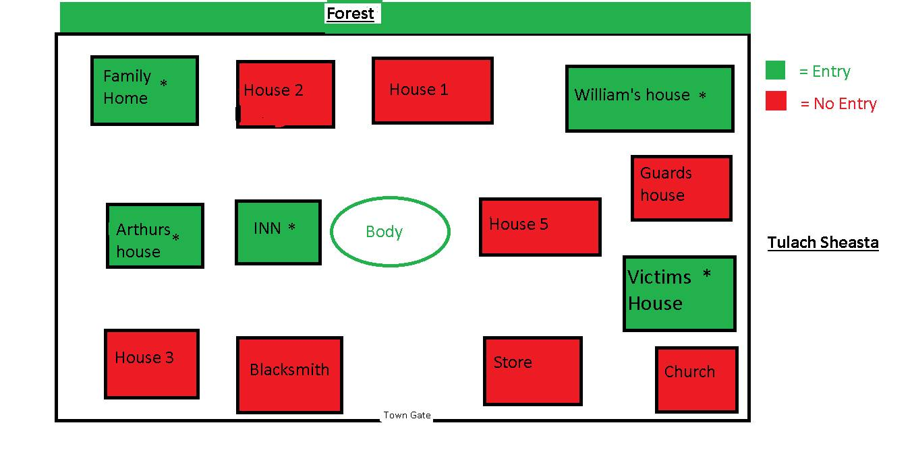

# NPCs

**Gloriana Brom**

|  |  |
| --- | --- |
|  | Gloriana is the first NPC you interact with. She is the Inn keeper that has information about the village itself and the different characters. She will tell Ragnar about the murder and the location of the body. After that she is a general information character (go-to-person) that does not further the story.  Location during the whole game: Sheasta Inn |

**William Cornwallis**

|  |  |
| --- | --- |
|  | William is the town elder who is the unofficial leader of the village. Everyone trusts him and he is well-known. He is the connection to Ragnars past.  The first location the player meets William is in the town square near the body. After that his default location is his house. |

**Thomas Leofrick**

|  |  |
| --- | --- |
|  | A guard that also investigates the murder and is very serious about the investigation and does not want Ragnar to interfere with his investigation. He can either help the player or try to stop him from investigating on his own.  The first location is outside Destrian’s house (the victim’s house). After that he will stay near the town gate. |

**Josef Doran**

|  |  |
| --- | --- |
|  | Josef has information about the cult and suggests a secret meeting behind the church. Depending on the previous choices the player makes he may be suspected as the murderer.  The player first meets him in front of the store and later behind the church. |

**Donald**

|  |  |
| --- | --- |
|  | Donald is the town drunk that the player gets the information from about Arthur Bryce being the leader of the secret cult if he didn’t get it from Josef.  Ragnar meets him at the exit of the secret meeting spot behind the church. Other than that he remains in the inn. |

**Arthur Bryce**

|  |  |
| --- | --- |
|  | Arthur is the leader of the secret cult. He pretends not to be involved with the murder or the cult and is a friend of Williams.  The only place the player gets to meet Arthur is in his house. |

# Stages

## Flow Chart

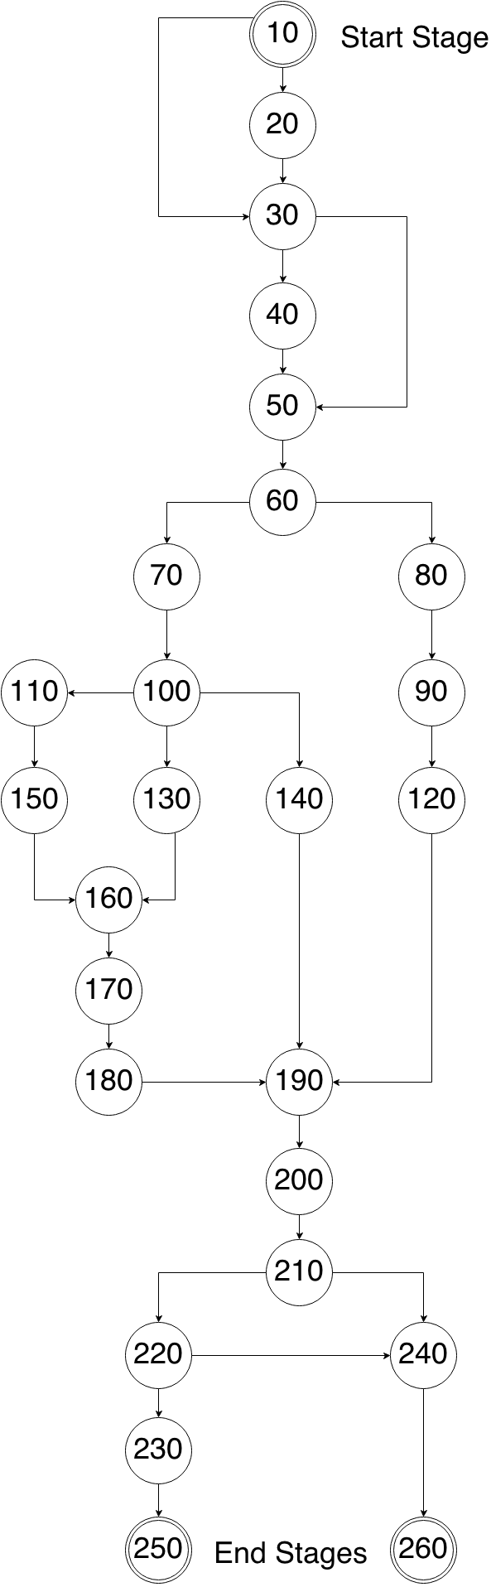

## Stages description

**10 INT. Ragnar’s bedroom in the Sheasta Inn**

*Ragnar Lothbrok* wakes up in the Sheasta Inn in his room hearing noises from outside.

Journal: *What are those noises? I better find someone who knows what’s going on.*

**20 INT. Sheasta Inn**

Talks to *Gloriana Brom* to find out that there was a murder in the town square.

Journal: *Someone has been murdered in the town square. I should go see what happened.*

**30 EXT. Town square**

Finds the body surrounded by people, searches the body for evidence to find a key.

Journal: *A key with an engraving “D.K.” – Would that be the key to the victims house? Maybe some of the villagers can tell me more.*

**40 EXT. Town square**

Talks to villagers and meets the town elder *William Cornwallis* to find out that the victim’s name is *Destrian Krea* and where he lived. *William* says that this murder must be the worst event since the incident and eventually tells him about a family that was stabbed decades ago and the little boy that got away.

Journal: *Destrian Krea. That matches with the engraving on the key. Maybe I can find something in his house that helps me solve the murder. At some point I should tell the town elder that I am the lost son, but I have to resolve this murder first.*

**50 INT. Destrian Krea’s house**

Opens the door to the house with the key he found while searching the body to find a desk that contains a diary of *Destrian* which informs him about a secret cult that exists in the village and learns that the cult was responsible for the murder of the family.

Journal: *A cult! So they are responsible for the death of my family. Destrian must have tried to warn me and was killed because someone found out.*

**60 EXT. Outside Destrian Krea’s house**

Once *Ragnar* leaves the house of *Destrian* a guard, *Thomas Leofrick,* is waiting to confront him about his private investigation.

Journal: NO JOURNAL ENTRY

**70 EXT. Outside Destrian Krea’s house**

If Ragnar earns Thomas’ trust in the dialogue he informs *Ragnar* that he suspects *Josef Doran* to be the killer. Thomas will act friendly towards Ragnar from this point on.

Journal: *Thomas suspects Josef Doran to be the killer. That would mean he is involved with the cult as well… I better go find him.*

**80 EXT. Outside Destrian Krea’s house**

If Ragnar fails to earn Thomas’ trust in the dialogue he won’t get any information from the guard and Thomas will act hostile towards Ragnar.

Journal: *That Thomas guy does not trust me. I better be careful around him. I should find someone else to get information from.*

**90 EXT. In front of the town store**

Ragnar meets *Josef Doran* and tries to get information about the cult. *Josef* refuses to talk to *Ragnar* about the cult and the murder in public and wants to meet him behind the church in the night.

Journal: *Josef refused to talk to me about the cult in public… He knows something about it though and wants to meet me behind the church tonight.*

**100 EXT. In front of the town store**

Ragnar meets *Josef Doran* and is suspicious about him. *Josef* refuses to talk to *Ragnar* about the cult or anything other in public and wants to meet him behind the church in the night.

Journal: *Josef is involved with the cult – maybe Thomas was right and he did it. He wants to meet me behind the church tonight. I don’t know whether that’s safe. I might get the guard to come with me.*

**110 EXT. Town gate**

Meet the guard to inform him about the secret meeting with Josef in the night behind the church. The guard agrees to come with you.

Journal: *I’ll meet Thomas at the victims’ house tonight and we’ll head to the church together to meet Josef.*

**120 EXT. Behind the church – night time**

Meet Josef behind the church by yourself. He informs you about the secret cult in the village and lets you know that *Arthur Bryce* is the leader of the cult.

Journal: *Arthur Bryce is the leader of the secret cult. I should go find his house and find out whether he killed Destrian and my family.*

**130 EXT. Behind the church – night time**

Meet Josef behind the church by yourself. You believe him to be the murderer and kill him.

Journal: *Josef won’t be a problem anymore. To some degree I doubt that he really was the murderer…*

**140 EXT. Behind the church – night time**

Meet Josef behind the church by yourself. You believe him to be the murderer but he convinces you about his innocent and finally tells you about *Arthur Bryce* being the leader of the cult.

Journal: *The guard was wrong about Josef. Josef told me that Arthur Bryce is the leader of the leader of the cult and that he also murdered Destrian. I’ll have to find him. Maybe he was also involved with the murder of my family…*

**150 EXT. Behind the church - night time**

Meet Josef behind the church with the guard. Josef is disappointed in you and doesn’t tell you anything, the guard takes him away.

Journal: *Josef won’t bother anyone anymore. I wonder whether he was really responsible for the murder though…*

**160 EXT. Exit of the church secret meeting spot**

You didn’t find out about Arthur Bryce. On the way out you meet the town drunk. He talks random stuff and asks you to buy him a beer.

Journal: *Donald claims to have knowledge about the murder. I might give it a shot and buy him a beer.*

**170 INT. Sheasta Inn**

Buy a beer for Donald.

Journal: *Now back to that drunkard to see what he got for me…*

**180 EXT. Exit of the church secret meeting spot**

After handing the beer to Donald he reveals that he used to be in the cult and that Arthur Bryce is the leader.

Journal: *Donald says that Arthur Bryce is the leader of the secret cult. Not sure how much that information is worth, but I’ll better go find that Arthur guy to find out.*

**190 INT. Arthur Bryce’s house**

You confront Arthur about his involvement in the cult. He denies being in the cult and says he is a respected member of the community and that the town elder *William Cornwallis* would certainly vouch for him.

Journal: *Arthur denied everything and says the town elder William Cornwallis would vouch for him. I do not trust that guy. I’ll check back with William.*

**200 INT. William Cornwallis’ house**

William finally recognizes Ragnar to be the young boy that got away from the incident and hands him the key to the abandoned house of his family – *William* vouches for *Arthur*

Journal: *Now my identity is no longer a secret. William trusts Arthur, so maybe he is innocent and I am on the wrong track. I’ll see what I can find in my family’s home.*

**210 INT. Family home – abandoned house**

In his family’s home *Ragnar* finds a letter hidden in his parents’ bedroom from *Arthur Bryce*, signed as the new leader of the secret cult together with a number of guidelines, including one that states that you are not able to leave the cult. He also finds a little note from his father *John* to his wife *Alice* informing her that they would leave in the night to start a new life. Near the bed he finds his father’s sword that he picks up.

Journal: *My parents were in the cult?! They must have decided to leave it and got killed because someone found out. So Arthur really is the leader of the cult! He is responsible for this! I will put him to justice, with or without William’s approval.*

**220 INT. William Cornwallis home**

Ragnar informs William about Arthur’s true identity and his involvement in both murders and presents evidence to back up his accusation. William, Thomas and Ragnar go to arrest Arthur.

Journal: *We will put Arthur to justice. I’ll meet William and Thomas in front of Arthur’s house.*

**230 INT. Arthur’s house**

Ragnar meets Thomas and William in front of the victim’s house and confront him with the evidence. Arthur gets killed by either Thomas or Ragnar while resisting arrest.

Journal: *Arthur is dead. But the village and my life remain in danger until I reveal all of the cult’s members and their past. I’ll talk to William.*

**240 INT. Arthur’s house**

Ragnar decides to confront Arthur again with the new evidence. They fight and Arthur gets killed. Ragnar finds conclusive proof of the involvement of Arthur in his family’s death and the murder in the town square that also connects him to the secret cult.

Journal: *Arthur is dead. With the proof I found there is no more doubt about his involvement with the murders. I’ll present that to William to close the case.*

**250 INT. Arthur’s house – the end 1**

William accepts you as a member of the community and welcomes you back to the village.

Journal: *I did it. The remaining cult members are still out there though…*

**260 INT. William Cornwallis home – the end 2**

The player tells him that he killed Arthur in a fight. William than accepts him as a member of the community.

Journal: *I did it. The remaining cult members are still out there though…*

# Dialogues

## Gloria

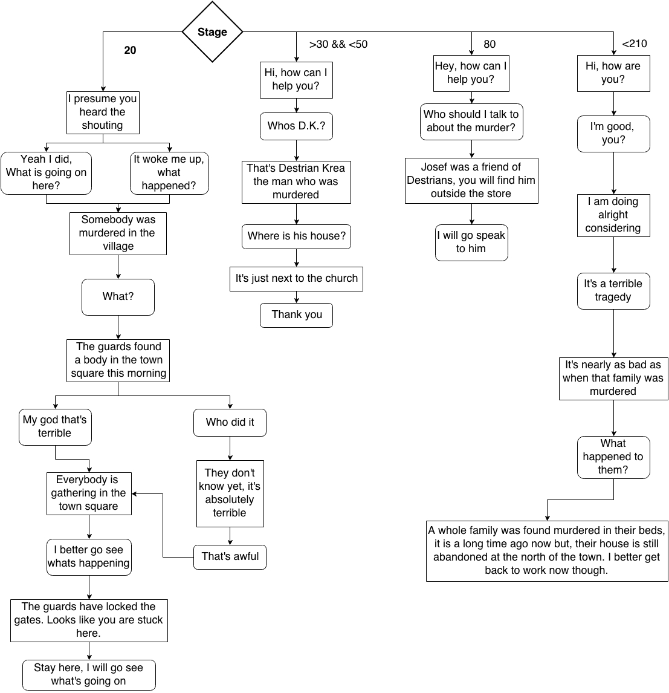

## William

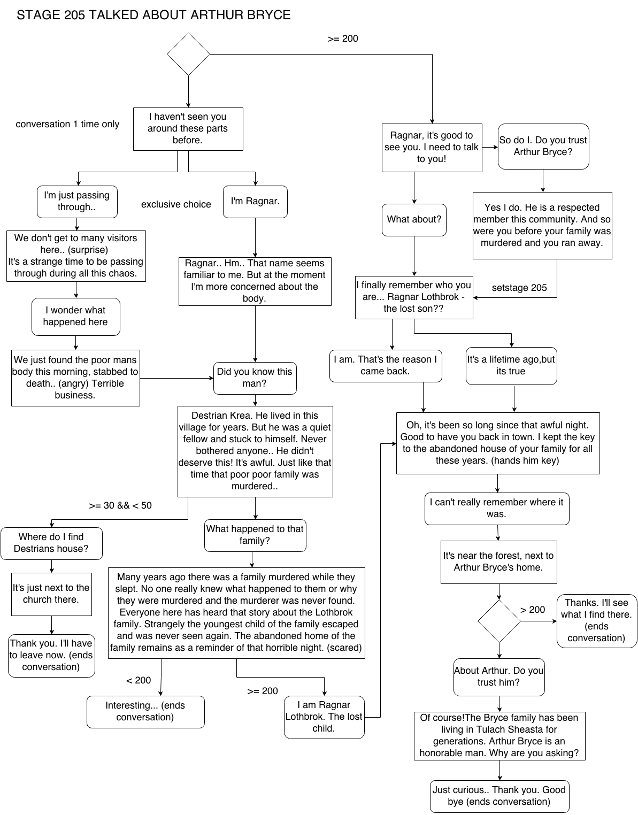

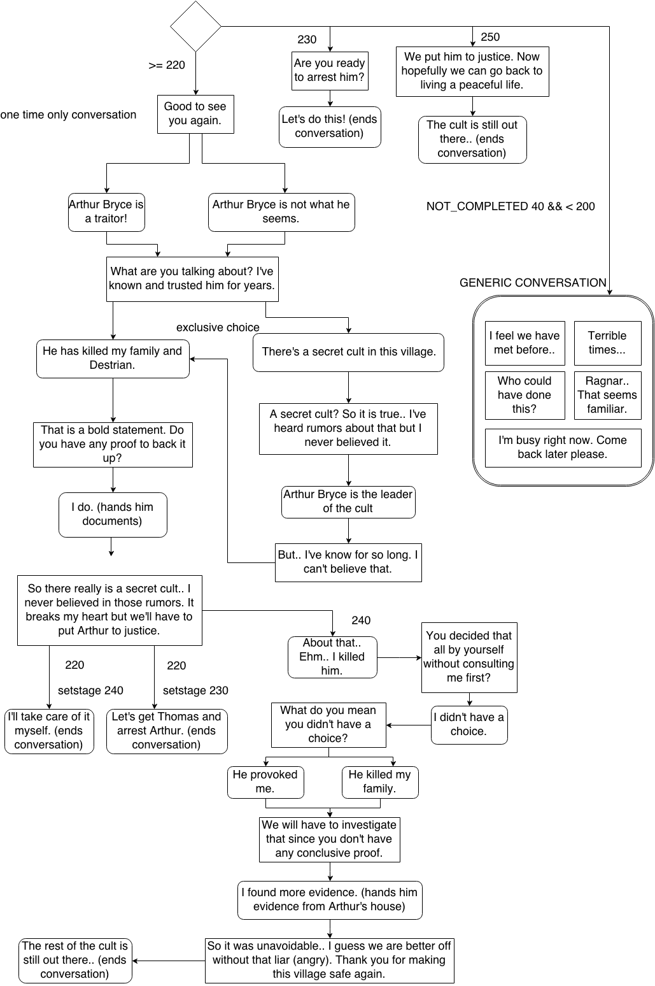

## Thomas

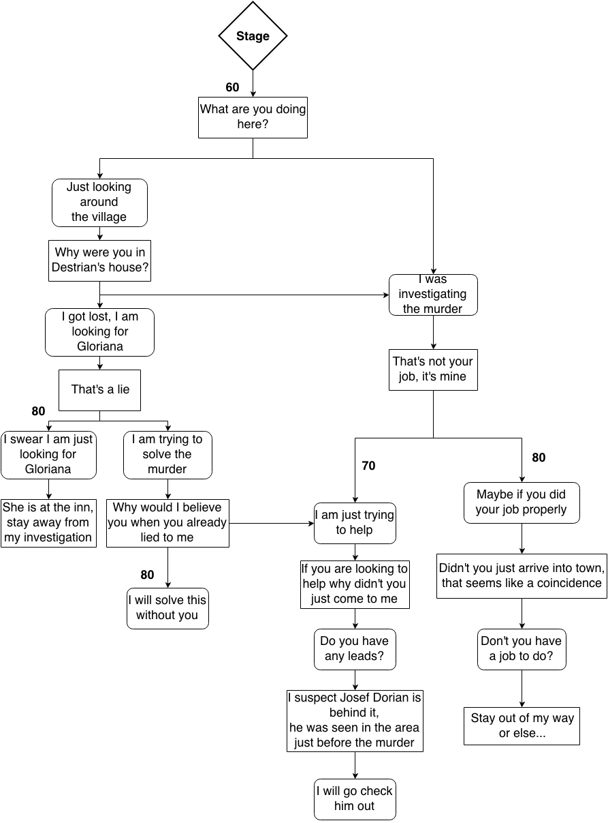

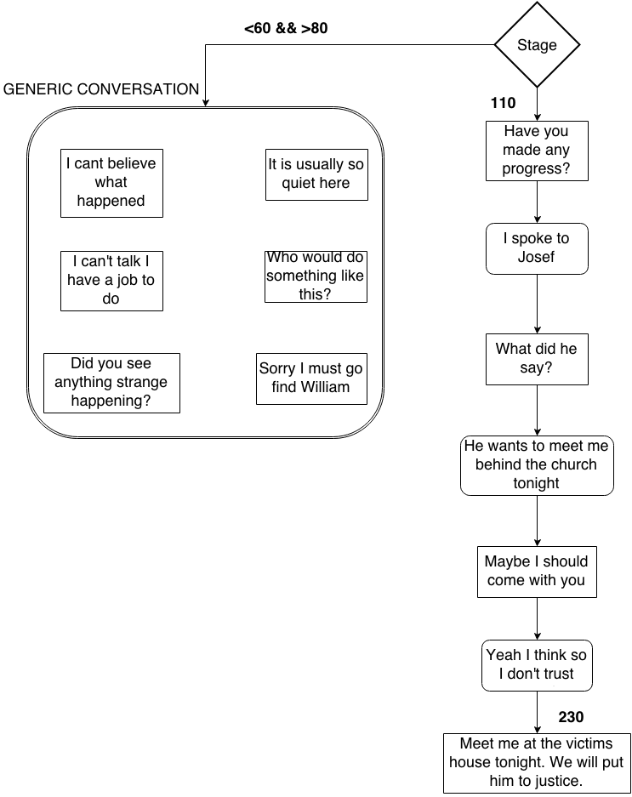

## Josef

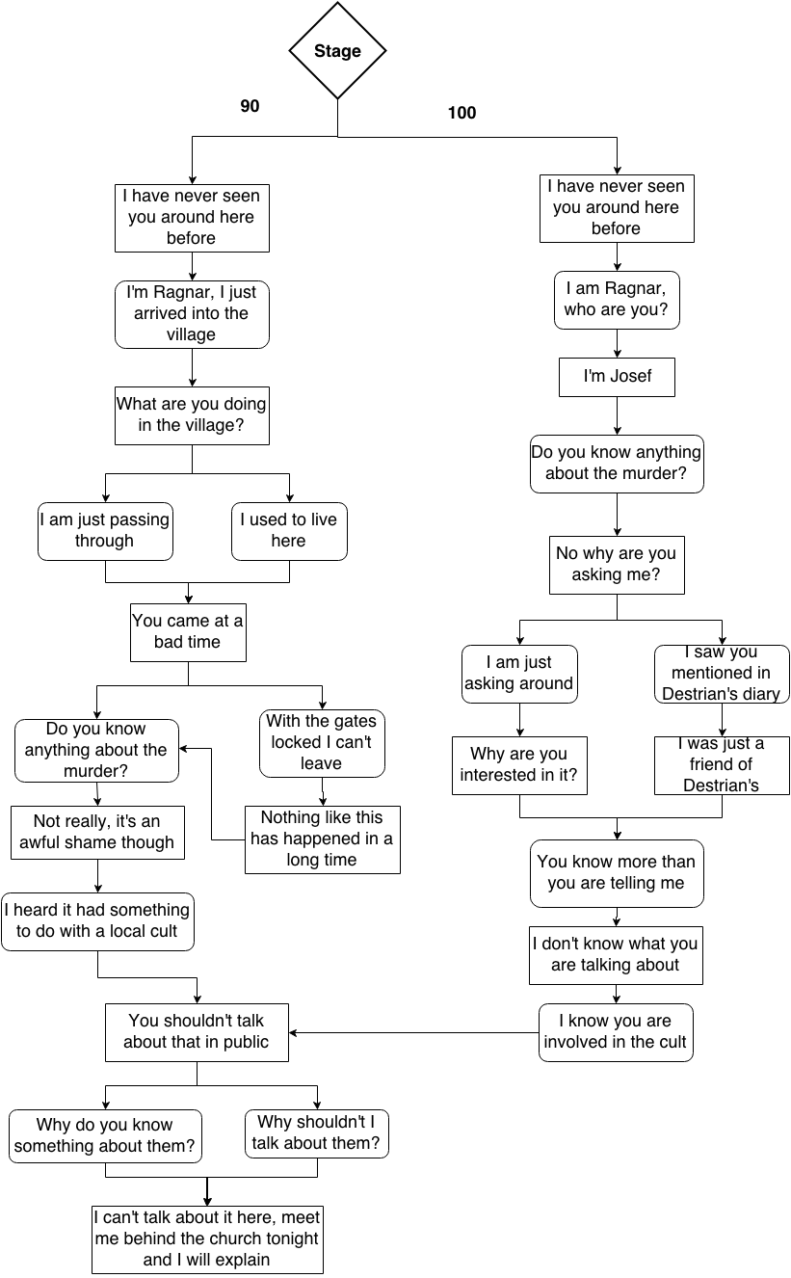

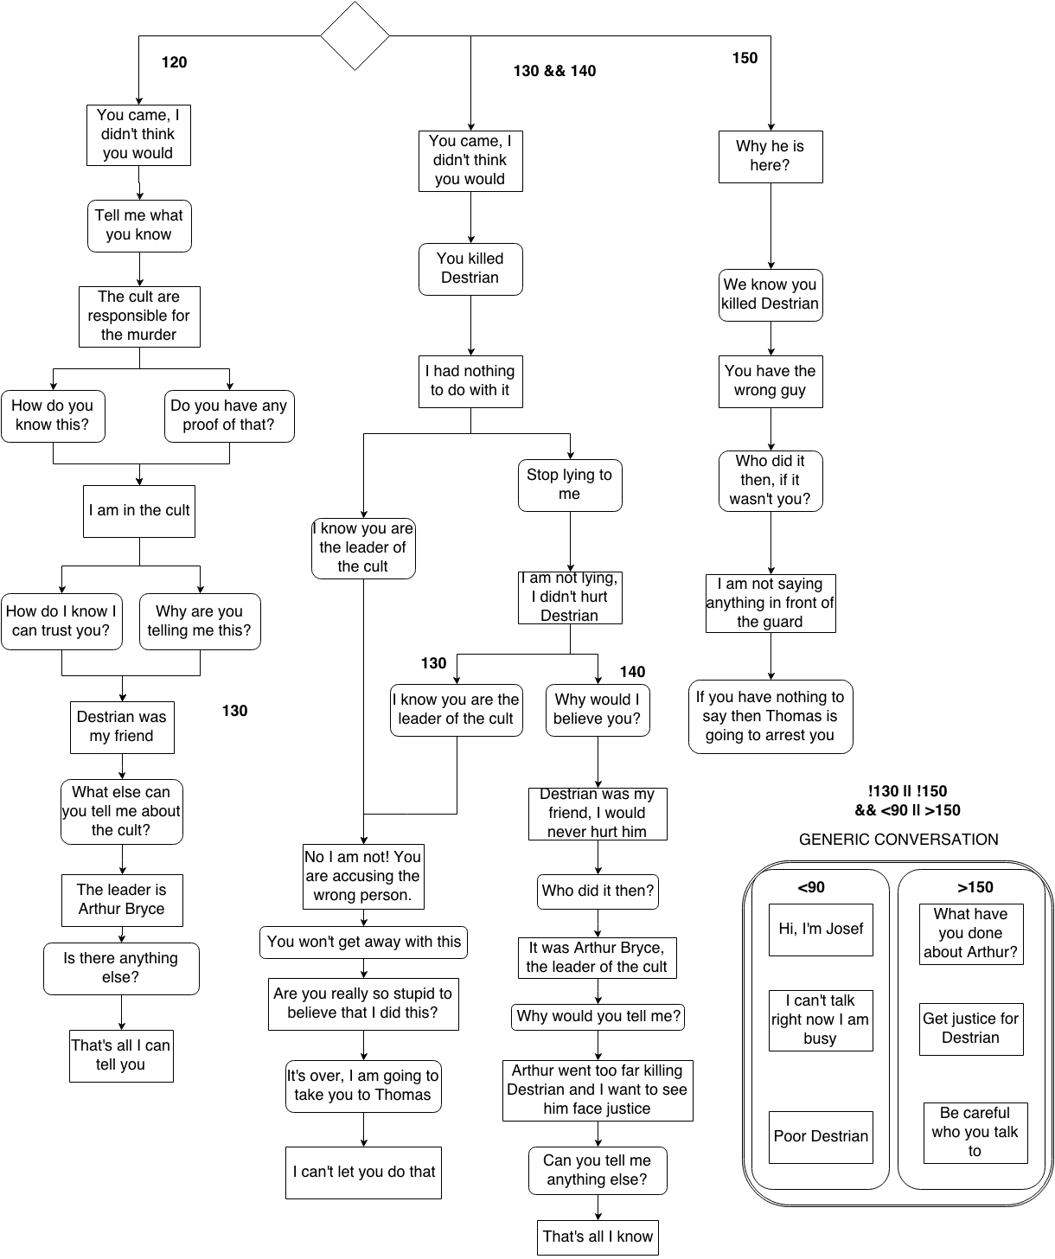

## Donald

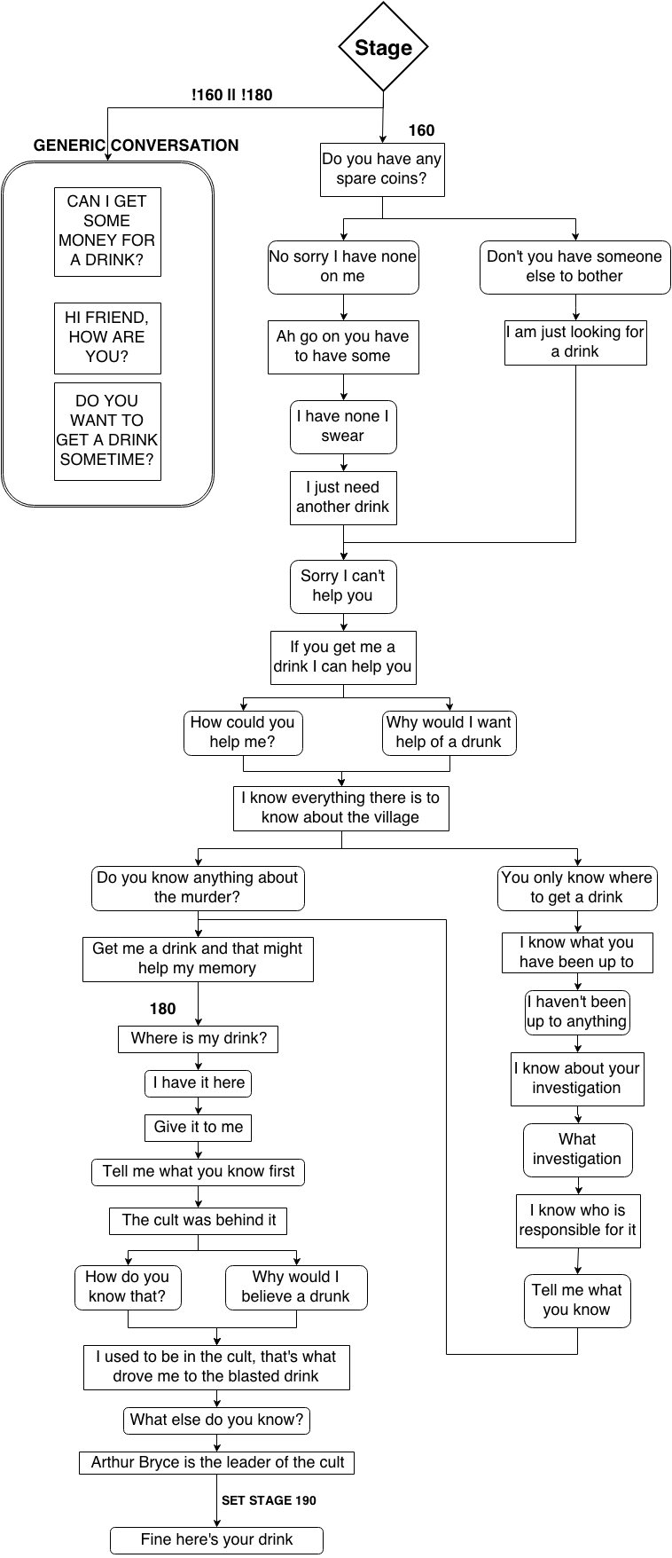

## Arthur

