Restoring Trust: A Structured Approach to Healing and Rebuilding Relationships After Betrayal
1. Introduction to the Safety Check Process:
- Purpose: The safety check is a structured dialogue designed to manage emotions and facilitate communication between the betrayer and the partner. The primary goal is to create a safe space for both parties to express their feelings, acknowledge the breach, and begin the healing process.
- Phases of Recovery: The recovery process is divided into four phases, with each phase having specific goals and timeframes. Phase one involves immediate safety and crisis management, while subsequent phases address longer-term recovery and rebuilding trust. The process transitions from daily dialogues in the early stages to less frequent check-ins as the relationship heals.
2. Structured Dialogue Components:
- Timing Check: The betrayer initiates a safety check by asking if it's a good time to talk. This ensures that both parties are mentally and emotionally prepared for the conversation. The partner must feel free to decline if it’s not a suitable time, with the option to reschedule the discussion.
- Accountability (Total Apology): The betrayer must take full responsibility for their actions, offering a sincere apology for the pain caused. This step is crucial for acknowledging the hurt and setting the stage for genuine remorse and reconciliation. The apology should be specific and highlight the significance of the breach.
- Feelings Expression: Both the betrayer and the partner express their emotions. The betrayer shares the emotions they have felt during the week, while the partner highlights when they felt most safe or most vulnerable. This step should focus on the feelings rather than the stories behind them, to avoid triggering further conflict.
3. Expressing and Addressing Learning and Restoration:
- Betrayer's Self-Reflection: The betrayer shares what they have learned about themselves, emphasising personal growth and understanding of their behaviour. This reflection should be specific and linked to both the breach and the therapy work, demonstrating a clear commitment to change.
- Restoration Plan: The betrayer outlines specific actions they have taken and plan to take to restore the relationship. This includes tangible steps aimed at rebuilding trust and demonstrating a commitment to change. These actions should be concrete and measurable, avoiding vague statements.
4. Partner's Response and Requests:
- Safety Number: The partner provides a safety level rating, helping both parties gauge the current emotional state and progress in the relationship. Using a numerical rating encourages a more rational assessment of safety, engaging the part of the brain responsible for self-reflection.
- Acknowledgement and Requests: The partner acknowledges when they felt safest and makes specific requests to help them feel more secure in the relationship moving forward. These requests should be tangible, actionable, and able to be fulfilled within the next 24 to 48 hours.
5. Practical Considerations and Challenges:
- Managing Emotional Reactions: The dialogue is structured to prevent emotional outbursts and ensure that both parties feel heard without escalating conflict. The process is intentionally not mirrored to avoid further tension and to keep the conversation focused.
- Avoiding Contamination of Dialogue: It’s crucial to keep the dialogue focused and constructive, avoiding scenarios where one party dominates or the dialogue becomes counterproductive. Careful attention is needed to ensure that the dialogues remain a safe and productive space for both parties.
6. Continuous Process of Dialogue and Recovery:
- Frequency of Safety Checks: Initially, safety checks may be conducted daily, with the frequency decreasing as trust is rebuilt. Regular check-ins are crucial for ongoing relationship recovery. The expected frequency at different phases transitions from daily in Phase 1 to weekly or even less frequent in later phases, eventually becoming a monthly or bi-monthly practice as the relationship stabilises.
- Long-term Goal: The ultimate aim is to transition from frequent, structured dialogues to more organic, supportive conversations as the relationship heals and strengthens over time.
7. Application in Therapy and Beyond:
- Role of the Therapist: The therapist’s role is to guide the couple through this process, ensuring that the dialogues are productive and that both parties are making progress. It is also important to coach the couple on how to conduct these dialogues outside of sessions, with regular check-ins to monitor progress.
- Customised Approach: The process might need adaptation in cases of bilateral breaches or different types of betrayals, taking into account the unique dynamics of each relationship. Flexibility is key, especially in scenarios where both partners have engaged in breaches, which may require a reworking of the process.

Script
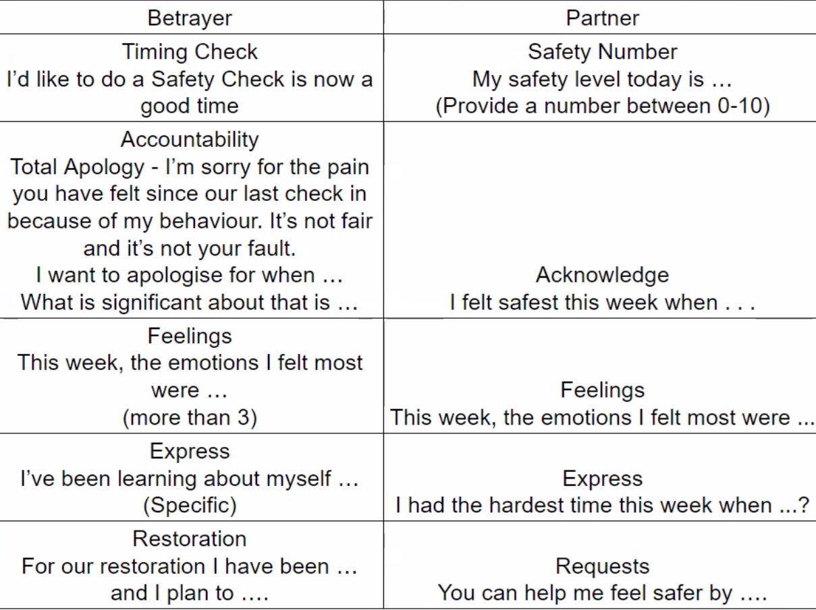
Additional Insights:
- Emotional Safety and Acknowledgement: Emotional safety is paramount in these dialogues, and even minimal increases in safety (e.g., moving from a -5 to a -1) are significant. The dialogue should help both parties track and acknowledge these small but important shifts.
- Learning and Accountability: The process of learning and accountability is continuous, and the betrayer must demonstrate ongoing self-awareness and improvement. This continuous learning should be evident in each safety check, reinforcing the betrayer’s commitment to change.
This framework provides a comprehensive approach to managing relationship breaches through structured communication, emphasising accountability, emotional expression, and the restoration of trust.

