The Relationship Journey – Coach4U Client Workbook
This workbook is designed to support couples in exploring their evolving relationship using the Coach4U ‘Winding Road’ model. Each stage is explained with practical reflection prompts and insights. Use this workbook alongside your SharePoint resource hub and personal coaching sessions.

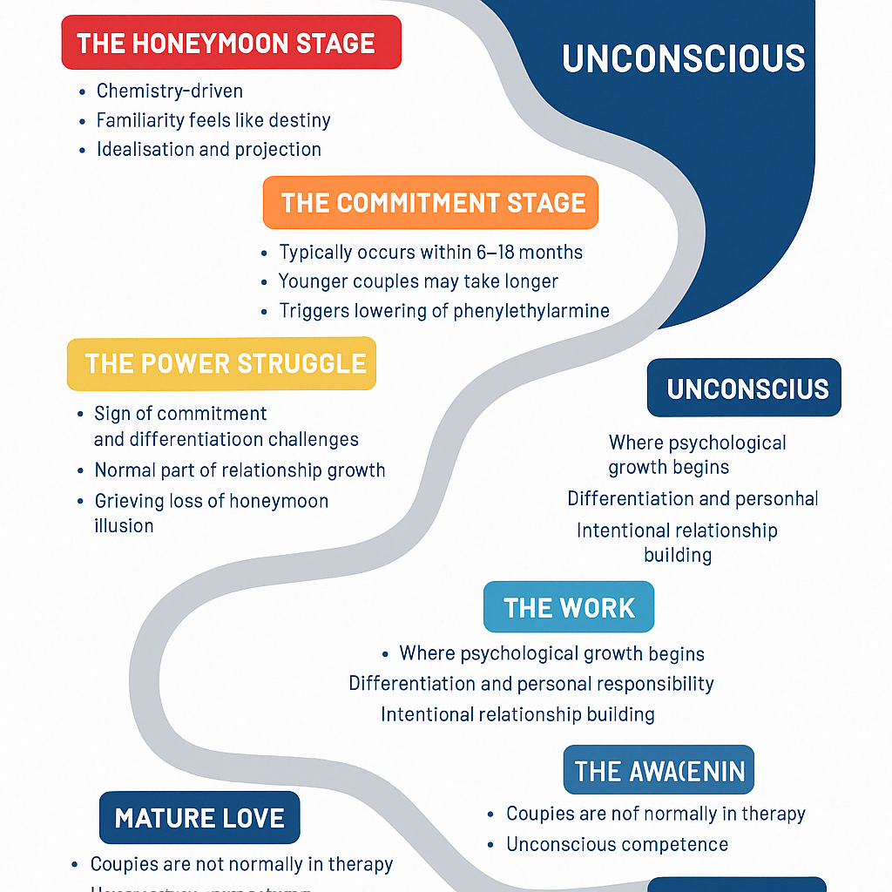

Workbook Content (See Full Reflection Questions)
This workbook includes:
- Stage descriptions
- Coaching insights
- Reflection prompts
Use this resource to support session prep, couple check-ins, and deeper conversations.

