**Elevation's Benefit to NBA Teams**

By Derek Catherine

Sports commentators, during the duration of the NBA Playoffs, always made comments about how the Denver Nuggets play at a high elevation and that it plays to their favor because their opponent is not used to it. It made me ask the question if altitude really does play a role in a team’s success at home. Does it really play into a team's favor that they play in a city with high elevation? How much of a role does elevation play in a team's success at home, if any? In my research, I started with all 30 NBA teams, but cut it down to the five teams that play in the highest elevations and the five teams that play in the lowest elevations to see if there really is a difference in how these teams play at home based on the city's elevation. The teams that were chosen to take part in this project are as follows:

Team Home City Elevation

Denver Nuggets Denver, Colorado 5,276 feet

Utah Jazz Salt Lake City, Utah 4,265 feet

Oklahoma City Thunder Oklahoma City, Oklahoma 1,198 feet

Phoenix Suns Phoenix, Arizona 1,086 feet

Atlanta Hawks Atlanta, Georgia 1,050 feet

New Orleans Pelicans New Orleans, Louisiana -7 feet

Washington Wizards Washington DC 0 feet

Miami Heat Miami, Florida 6 feet

Sacramento Kings Sacramento, California 26 feet

New York Knicks New York City, New York 33 feet

In this case, I looked at each team's home vs road splits when it came to wins, scoring, opponent's scoring, shooting percentage, and opponent's shooting percentage.

**Win Differential**

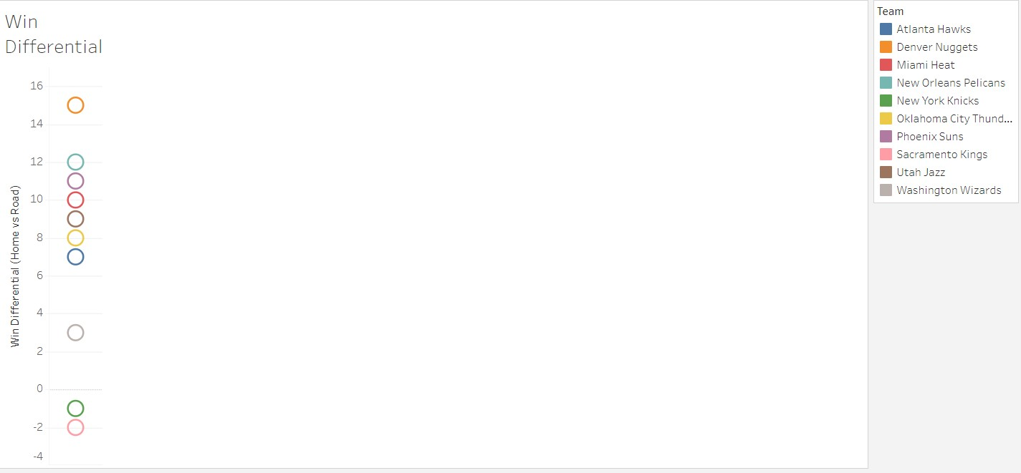

When thinking about what success a team has playing in a city with high elevation, first thing that came to my mind was win differential.These were calculated by subtracting the number of home wins from the number of road wins showing how many more wins the teams had at home versus on the road. As you can see, the Denver Nuggets had a win differential of 15 so they are the highest on the chart. The surprising thing is the next highest win differential was the New Orleans Pelicans, who play in the city with the lowest elevation, had a win differential of 12.

**Scoring Differential**

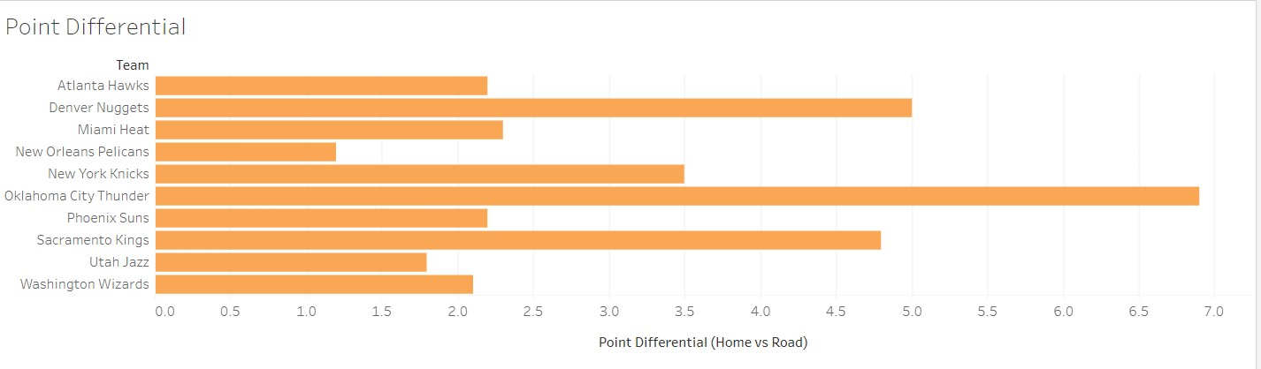

The next thing I wanted to look at is scoring differential. This was calculated by subtracting the team's home scoring average from their away scoring average. As you can see the two highest differential are the Thunder and the Nuggets, who are #3 and #1 in the highest elevation respectively but as you can see, the third ranked team in scoring differential is the Kings who play in the 4th lowest elevation.

**Opponent Scoring Differential**

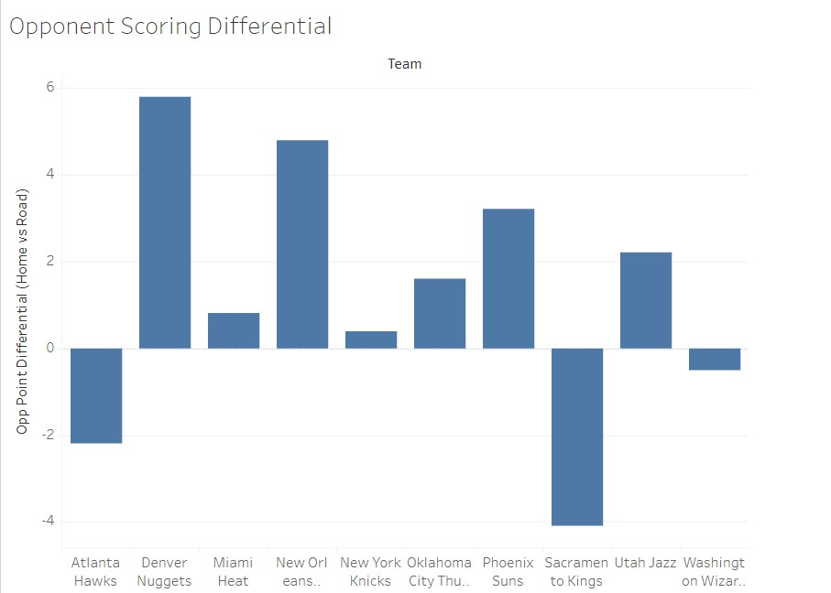

When looking at how much more teams score per game in their home arena as compared to on the road, it is important to also look at the differential in the opponents’ scoring as well. As you can see, the Nuggets have the highest scoring differential given up at 5.8.

**Shooting Percentage Differential**

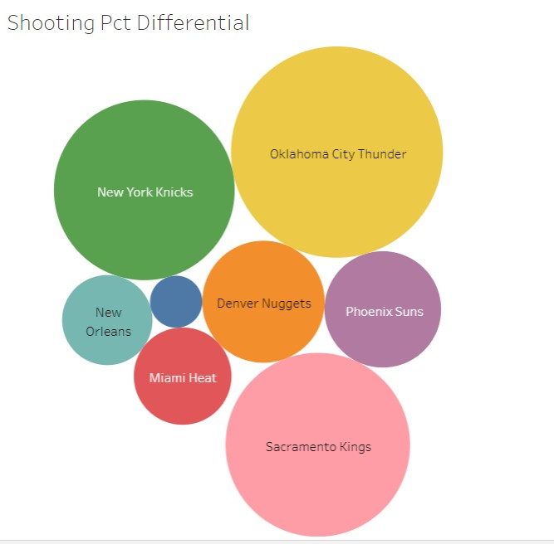

Another area to look at is shooting percentage to see if teams shoot differently at home than on the road. When looking at the data, the Oklahoma City Thunder have the highest differential at 3.3% while the Knicks and Kings (two of the 5 lowest elevations) shoot 2.4% and 2.5% respectively better at home than on the road. The two teams that are not shown in this chart are the Jazz and Wizards. That is because the Jazz actually shoot better on the road than at home while the Wizards have the average the same percentage both at home and on the road.

**Opponents Shooting Percentage Differential**

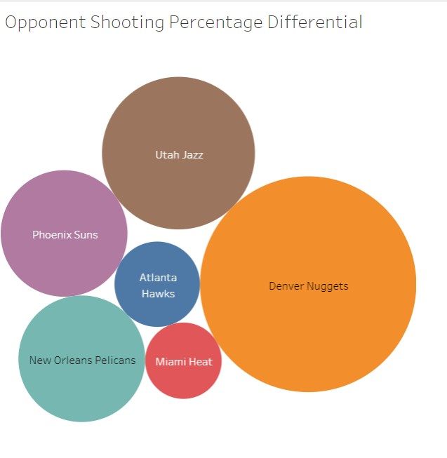

Like with the scoring differential, it is important to look at how opposing teams shoot in the arena as well. This shows opponents of the Denver Nuggets have the biggest percentage differential by shooting 3.2% better on their home floors than in Denver. As you see, there are 4 teams that are not shown, the Knicks, Thunder, Kings, and Wizards. That is because teams actually shoot better on their home floors against them than when those teams are playing in the opposing arena.

**Conclusion**

In conclusion, it can be seen the elevation of a city has an effect on the opposing teams that are not used to playing there all of the time. The Denver Nuggets, who won the NBA championship this past season, play in the city with the highest elevation in the league and opponents have the largest differential in home vs road scoring and home vs road shooting percentage.

Sources

Worldwide Elevation Map Finder

https://elevation.maplogs.com/

ESPN – NBA 2022-23 Regular Season Standings

https://www.espn.com/nba/standings/_/group/league

NBA Stats – NBA Team Points Per Game

https://www.teamrankings.com/nba/stat/points-per-game

NBA Stats – NBA Opp Team Points Per Game

https://www.teamrankings.com/nba/stat/opponent-points-per-game

All visualizations were created using Tableau

https://public.tableau.com/app/profile/derek.catherine