

T H E M A I N T I T L E O F T H E PROJECT

PROJECT ID

Y O U R N A M E 1, Y O U R N A M E 2 , Y O U R N A M E 3 , Y O U R N A M E 4

INSTRUCTORS
dr. Julija Vaitonyte

LOCATION
Tilburg University
School of Humanities and Digital Sciences
Department of Cognitive Science & Artificial Intelligence
Tilburg, The Netherlands

WORD COUNT
[include word count here]

T H E M A I N T I T L E O F T H E PROJECT
PROJECT ID

Member 1 (student number 1), Member 2 (student number 2),…

The report must be at most four pages. Anything beyond this limit will not be graded.

Problem definition
State problem definition here.

Methods

Describe the methodological approach here.

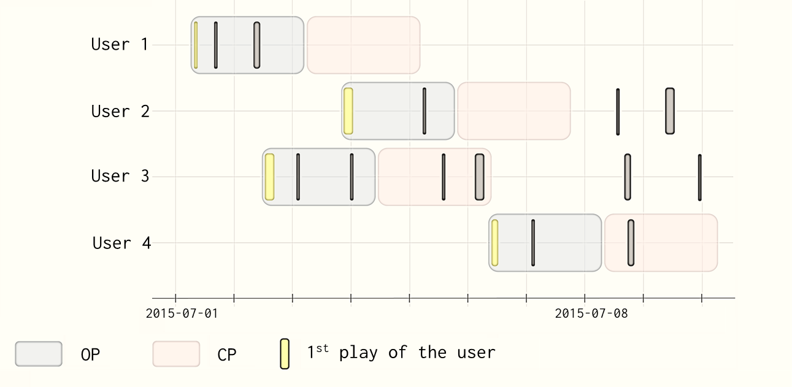

Figure 1: Visual depiction of defining the Observation Period and the Churn Prediction Period.

Results
Report your results here.

Discussion

Provide a critical discussion and reflection of the obtained results here.

Conclusion
State concise conclusions as drawn from the discussion here.

References

Include your final reference list here (if applicable).

Declarations statement
State here what each team member contributed toward completing the project, indicating the name and the surname of the team member where applicable.
Conceptualization: Member 1, Member 2, …
Methodology: Member 1, Member 2, …
Analysis: Member 1, Member 2, …
Writing – Original Draft: Member 1, Member 2, …
Writing – Review & Editing: Member 1, Member 2, …
Visualization: Member 1, Member 2, …
State here your use of Generative AI tools (which specific ones were used, if any, and what you used them for).

