**Comp 3005 Fall 2022**

**Project Report**

Completed by:

Catherine Li

student ID:101209708

Table of Content

Conceptual Design 2

Reduction to Relation Schemas 3

Normalization of Relation Schemas 3

Bonus Features 3

GitHub Repository 3

Appendix I 3

# Conceptual Design

ER-diagram:

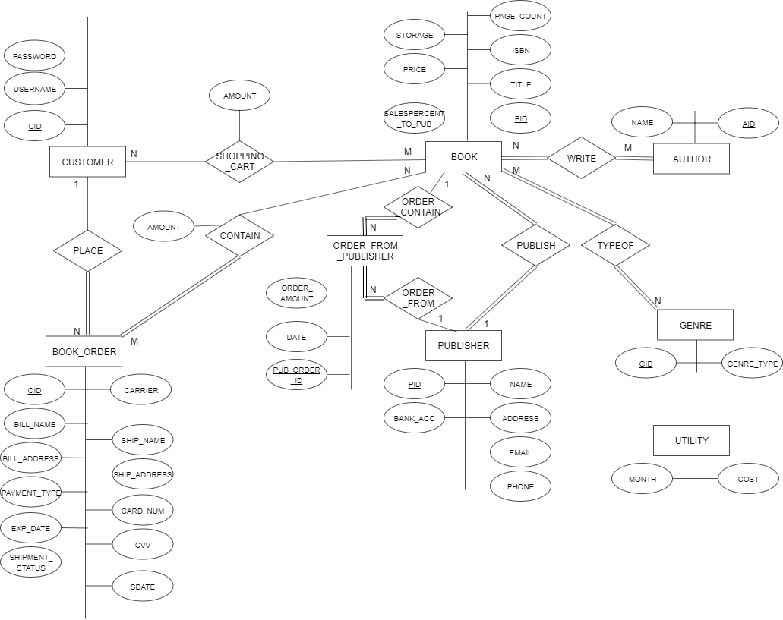

Assumptions regarding the ER diagram:

1. assume each book is published by only one publisher, one publisher can publish many books.
2. assume books may have same title
3. assume the ISBN of book is unique and the ISBN is 13 digits, stored as varchar type
4. assume the address in the database is stored within one attribute as varchar type
5. assume all publisher stored in database must publish a book
6. assume all author stored in database must write a book
7. assume authors could have the same name
8. assume one author can write many books, one book can have more than one author.
9. assume publisher have unique name, but could have same bank account, same address, same phone and email (owed by same boss/person)
10. assume customer username must be unique

Other assumptions:

1. assume utility entity is updated every year, that is, database only save the utility for the current year
2. assume the bookstore opened the date of 2022/01/01
3. assume only the owner can only review the reports in the current year

# Reduction to Relation Schemas

PUBLISHER

|  |  |  |  |  |  |
| --- | --- | --- | --- | --- | --- |
| PID | BANK_ACC | NAME | ADDRESS | EMAIL | PHONE |

BOOK

|  |  |  |  |  |  |  |  |
| --- | --- | --- | --- | --- | --- | --- | --- |
| BID | TITLE | ISBN | PAGE_COUNT | STORAGE | PRICE | SALESPERCENT_TO_PUB | PID |

GENRE

|  |  |
| --- | --- |
| GID | GENRE_TYPE |

TYPEOF

|  |  |
| --- | --- |
| GID | BID |

AUTHOR

|  |  |
| --- | --- |
| AID | NAME |

WRITE

|  |  |
| --- | --- |
| AID | BID |

CUSTOMER

|  |  |  |
| --- | --- | --- |
| CID | USERNAME | PASSWORD |

SHOPPING_CART

|  |  |  |
| --- | --- | --- |
| CID | BID | AMOUNT |

BOOK_ORDER

|  |  |  |  |  |  |  |
| --- | --- | --- | --- | --- | --- | --- |
| OID | CARRIER | SHIP_NAME | SHIP_ADDRESS | BILL_NAME | BILL_ADDRESS | CARD_NUM |
| CVV | SDATE | EXP_DATE | PAYMENT_TYPE | SHIPMENT_STATUS | CID |  |

CONTAIN

|  |  |  |
| --- | --- | --- |
| OID | BID | AMOUNT |

ORDER_FROM_PUBLISHER

|  |  |  |  |  |
| --- | --- | --- | --- | --- |
| PUB_ORDER_ID | PID | BID | DATE | ORDER_AMOUNT |

UTILITY

|  |  |
| --- | --- |
| MONTH | COST |

# Normalization of Relation Schemas

Here I denote set of functional dependencies as F for each schema

PUBLISHER TABLE:

F={PID -> BANK_ACC, NAME, ADDRESS, EMAIL, PHONE

NAME - > BANK_ACC, PID, ADDRESS, EMAIL, PHONE}

pid is superkey for publisher table, name is superkey for publisher table. Therefore, BCNF holds.

BOOK TABLE:

F={BID ->TITLE, ISBN, PAGE_COUNT, STORAGE, PRICE, SALESPERCENT_TO_PUB, PID

ISBN -> TITLE, BID, PAGE_COUNT, STORAGE, PRICE, SALESPERCENT_TO_PUB, PID}

BID is superkey for BOOK table, ISBN is superkey for BOOK table. Therefore, BCNF holds.

GENRE TABLE

F={GID -> GENRE_TYPE

GENRE_TYPE->GID}

GID is superkey for GENRE table, GENRE_TYPE is superkey for GENRE table. Therefore, BCNF holds.

TYPEOF TABLE

F= $∅$, functional dependencies is empty for TYPEOF table, BCNF holds

AUTHOR TABLE

F={AID -> NAME}

AID is superkey for AUTHOR table. Therefore, BCNF holds

WRITE TABLE

F= $∅$, functional dependencies is empty for WRITE table, BCNF holds

CUSTOMER

F={CID -> USERNAME, PASSWORD

USERNAME -> CID, PASSWORD}

CID is superkey for CUSTOMER table, USERNAME is superkey for CUDTOMER table. Therefore, BCNF holds.

SHOPPING_CART TABLE

F={CID, BID -> AMOUNT}

(CID,BID) is superkey for SHOPPING_CART table. Therefore, BCNF holds.

BOOK_ORDER TABLE

F={OID -> CARRIER,SHIP_NAME, SHIP_ADDRESS, BILL_NAME, BILL_ADDRESS, CARD_NUM,

CVV, SDATE, EXP_DATE, PAYMENT_TYPE, SHIPMENT_STATUS, CID

CARD_NUM -> CVV, EXP_DATE, PAYMENT_TYPE, BILL_NAME, BILL_ADDRESS}

OID is superkey for BOOK_ORDER table.

However, CARD_NUM+ = CVV, EXP_DATE, PAYMENT_TYPE, BILL_NAME, BILL_ADDRESS

We know that is not superkey for BOOK_ORDER table. This table needs to be decomposed.

Let R be the old table book_order

Let result = R, α = CARD_NUM, *β =* CVV, EXP_DATE, PAYMENT_TYPE, BILL_NAME, BILL_ADDRESS

*FIRST LOOP:*

*result* = (*R – β*) ∪ (α, *β ) =*

*(*OID, CARRIER, SHIP_NAME, SHIP_ADDRESS, SDATE, SHIPMENT_STATUS, CID, CARD_NUM) ∪ (CARD_NUM, CVV, EXP_DATE, PAYMENT_TYPE, BILL_NAME, BILL_ADDRESS)

Check if (*R – β*) in BCNF:

Since OID -> CARRIER, SHIP_NAME, SHIP_ADDRESS, SDATE, SHIPMENT_STATUS, CID, CARD_NUM,

OID is the superkey of (*R – β*). Therefore, (*R – β*) is in BCNF

So, BOOK_ORDER TABLE is decomposed to

BOOK_ORDER:

|  |  |  |  |  |  |  |  |
| --- | --- | --- | --- | --- | --- | --- | --- |
| OID | CARRIER | SHIP_NAME | SHIP_ADDRESS | CARD_NUM | SDATE | SHIPMENT_STATUS | CID |

PAYMENT_CARD:

|  |  |  |  |  |  |
| --- | --- | --- | --- | --- | --- |
| CARD_NUM | CVV | EXP_DATE | PAYMENT_TYPE | BILL_NAME | BILL_ADDRESS |

CONTAIN TABLE

F={OID,BID->AMOUNT}

(OID,BID) is superkey for CONTAIN table. Therefore, BCNF holds.

ORDER_FROM_PUBLISHER TABLE

F={ PUB_ORDER_ID->PID, BID, DATE, ORDER_AMOUNT}

PUB_ORDER_ID is superkey for CONTAIN table. Therefore, BCNF holds.

UTILITY TABLE

F={MONTH -> COST}

MONTH is superkey for UTILITY table. Therefore, BCNF holds.

**Database Schema Diagram**

This section should show the final schema diagram for the database of the bookstore. This diagram should besimilar to the schema diagram of the university database that we study in this course

**Implementation**

# Bonus Features

# GitHub Repository

# Appendix I