Comparative Study of Explainable AI Techniques (SHAP vs LIME) in Network Intrusion Detection

Su, Kai-Wen
Registration No. 2508241

A thesis submitted for the degree of Master of Science in Applications of Artificial Intelligence

Supervisor: Dr Muhammad Tariq Sadiq
School of Computer Science and Electronic Engineering
University of Essex

August 2026

Table of Contents
Abstract 3
Introduction 4
1.1 Background and Motivation 4
1.2 Research Questions and Hypotheses 5
1.3 Contributions 5
Literature Review 7
2.1 Background: Machine Learning–based Intrusion Detection 7
2.2 The Black-Box Problem and the Rise of Explainable AI 8
2.3 SHAP and LIME: Foundations 9
2.4 Explainable AI Applied to Intrusion Detection 10
2.5 Methodological Challenges in Comparing XAI Methods 11
2.6 Research Gap and Positioning 12
Methodology 14
3.1 Dataset 14
3.2 Preprocessing 14
3.3 Classifiers 15
3.4 Explanation Methods 15
3.5 Evaluation Metrics 16
3.6 Sample Selection and Reproducibility 17
3.7 Summary 18
Results 19
4.1 Classification Performance 19
4.2 Feature-Attribution Agreement 20
4.3 Top-10 Feature Composition 22
4.4 LIME Stability 23
4.5 Computational Cost 24
4.6 Per-Attack-Family Analysis 25
Discussion 27
5.1 Why SHAP and LIME Disagree 27
5.2 Cross-Model Divergence: The Model as the Dominant Factor 28
5.3 Implications for IDS Practice 29
5.4 Comparison to Prior IDS XAI Studies 30
5.5 Limitations 31
Conclusion 33
6.1 Summary of Findings 33
6.2 Implications 33
6.3 Future Work 34
References 35
Appendix — Source Code 37

Abstract
Intrusion-detection systems increasingly depend on complex machine-learning models, and SHAP and LIME have become two of the most widely used methods for explaining their predictions. The two methods are often treated as interchangeable, but limited research systematically compares how much they disagree, and what causes that disagreement, within a common IDS experimental setting. This dissertation systematically compares SHAP and LIME on the NSL-KDD dataset across three classifiers: Random Forest, Boosted Trees and SVM. It employs four complementary measures: top-10 Jaccard overlap as the primary agreement metric, a secondary full-vector Spearman rank correlation, cross-seed stability and computational cost, together with a breakdown by attack family. The primary top-10 Jaccard overlap was modest for every model and, contrary to a common assumption, was highest for the two tree ensembles (0.280 for Boosted Trees and 0.248 for Random Forest) and lowest for the SVM (0.040). A Friedman test confirmed significant differences between models (χ² = 60.05, p < 0.001), and a linear mixed model found the classifier to be the dominant source of variation while also identifying a significant effect of attack family and a significant model-by-family interaction. These results indicate that SHAP and LIME are not interchangeable for IDS decisions and that any explanation claim should state both the model and the explanation method. Agreement between different explainers does not equal accuracy.

Introduction

1.1 Background and Motivation
Intrusion-detection systems are a crucial component of contemporary cyber-security infrastructure. Their task is to detect malicious activity in network traffic to prevent it from escalating into unauthorised access, service disruption, data loss or other types of damage. As network environments have grown larger, noisier and more varied, intrusion detection has increasingly been utilising machine-learning models to detect complex and new attack patterns. These models can be trained on high-dimensional traffic features and are generally more effective than simple signature matching when encountering attacks that do not exactly fit a known rule. However, the same properties that make modern classifiers appealing for intrusion detection also make them difficult to analyse. Many high-performing models operate as black boxes, producing a label or probability without a transparent account of why a specific alert has been raised.
This lack of transparency is not merely an academic inconvenience. In a security operations environment, analysts must often decide whether an alert should be escalated, dismissed, investigated manually or used as evidence in a broader forensic reconstruction. Thus, predictive accuracy alone is not sufficient. A classifier may flag a connection as malicious, but the analyst must understand and trust the reasoning behind that decision before taking action. Explanations can help analysts triage alerts, identify suspicious traffic properties, detect potential model failures, and create an auditable record of automated evidence interpretation. This practical need has motivated the application of explainable AI in intrusion detection, particularly post-hoc methods aim to explain an already-trained model without replacing it.
Among these methods, SHAP and LIME have emerged as two of the most used local explanation approaches. Both can be applied after model training and both present feature-level attributions for a specific prediction making them attractive for intrusion-detection scenarios where an analyst needs to understand why a specific traffic instance was flagged. But in practice, the two methods are often treated as interchangeable, or one is selected for convenience because it is familiar, available in software, or visually intuitive. SHAP and LIME optimise different objectives. SHAP decomposes a prediction into Shapley-style feature contributions based on a background distribution, whereas LIME creates a local surrogate model around the instance being explained. These different procedures do not necessarily produce the same features in the same order.
That gap provided the motivation for this dissertation. If SHAP and LIME produce conflicting explanations for the same alert, it is unclear which account an analyst should trust, or whether the disagreement itself should be interpreted as evidence of explanatory uncertainty. Existing research on IDS XAI has demonstrated that both methods can be applied to intrusion-detection models, but there is limited work directly comparing their levels of disagreement, what causes that disagreement, and whether the results differ across models or attack types within a consistent experimental framework on NSL-KDD. This dissertation addresses that gap by comparing SHAP and LIME across three classifiers on the NSL-KDD dataset, using agreement, stability and computational cost as supporting evidence instead of relying on a single explanation metric.

1.2 Research Questions and Hypotheses
This dissertation is driven by three research questions. First, can SHAP and LIME rank feature importance consistently enough to be used interchangeably for the same intrusion-detection decisions (RQ1)? Two explanations may contain similar features but rank them differently or may agree in rank only after selecting different feature sets. Second, is the level of disagreement driven mainly by the model being explained or by the analysed attack family (RQ2)? This question is crucial because the consequences of a method-driven or model-driven explanation failure are different than those of an attack-specific failure. Third, how do SHAP and LIME trade-off stability and computational cost when applied to the same IDS models (RQ3)? This question connects methodological comparison to practical deployment, where explanation methods must be reproducible and feasible at operational scale.
The expectation was that agreement between SHAP and LIME would be limited, and that variation in agreement would be driven mainly by the model rather than by the attack type. A further expectation was that SHAP would be more stable, especially for tree-based models, while LIME would be more variable because of its dependence on local perturbations and surrogate fitting. Throughout the dissertation, the top-10 Jaccard overlap is the primary agreement measure and the Spearman rank correlation is used only to describe the degree of correspondence between methods, not to judge which explanation is more accurate. This distinction crucial because there is no independent ground-truth ranking of feature importance for the IDS predictions discussed here.

1.3 Contributions
This dissertation contributes in four ways. First, it proposes a controlled, multi-metric comparison of SHAP and LIME using three credible and distinct classifiers on NSL-KDD: Random Forest, Boosted Trees and SVM. Instead of using a single model or a single example to evaluate explanation methods, the study combines top-feature overlap, rank correlation, cross-seed stability and computational cost in one framework. The models also maintain meaningful discriminative performance on held-out data, with F1 scores between 0.753 and 0.780 and AUC values between 0.903 and 0.964, so the explanation comparison is not based on classifiers that have clearly failed to generalise.
Second, the dissertation shows that the level of SHAP-LIME agreement is model-level rather than attack-family driven. The per-attack analysis indicates that the classifier is the dominant factor, but a significant model-by-family interaction shows that the attack family also matters, most clearly for the kernel model. This separation is supported statistically by a Friedman test (χ² = 60.05, p < 0.001) and a linear mixed model in which the classifier, the attack family and their interaction are all significant. The contribution is framed narrowly: it identifies the model as the main reasons of disagreement under a common experimental setting, dataset and evaluation protocol.
Third, the dissertation explains why LIME's stability and its agreement with SHAP point in opposite directions across model families. For the tree ensembles, LIME is the least stable across random seeds, but it shows the greatest overlap with SHAP; for the smooth kernel model the pattern reverses, although it is the most stable, its overlap with SHAP is the smallest. This divergence is attributed to the sparsity of LIME's fitted coefficients and to the decision geometry of each model, rather than to any software fault or a random anomaly.
Fourth, the dissertation converts these findings into practical recommendations for using IDS. It argues that explanation claims should be qualified by both the model and the explanation method. Additionally, disagreement should be shown as explanation uncertainty rather than hidden by choosing a single visualisation. Lastly, deployment choices should consider both auditability and latency. The study also emphasises two important cautions: agreement is not the same as fidelity, and rank correlation describes disagreement rather than proving which explanation is correct. These contributions position the work as a systematic evaluation of explanation behaviour in IDS, not as a claim that one post-hoc method dominates the other.

Literature Review

2.1 Background: Machine Learning–based Intrusion Detection
A network intrusion detection system (NIDS) is an essential part of contemporary cybersecurity infrastructure, designed to identify malicious activity through the monitoring of packets, flows and other evidence from the network. Detection methods are generally divided into two types of intrusion detection systems: signature-based intrusion detection systems (SIDS), which compare observations with known attack patterns, and anomaly-based intrusion detection systems (AIDS), which construct a profile of normal behaviour and flag significant deviations [1]. Signature matching is efficient and often precise for recognised threats, but it has the disadvantage of relying on predefined rules and being unable to identify previously unseen or zero-day attacks. Anomaly detection can overcome this limitation through statistical, knowledge-based or machine-learning models, but it might increase false-positive alarms due to unusual legitimate behaviour. The introduction of NSL-KDD aims to address the issues of redundancy and evaluation weaknesses in KDD Cup 99, provided a widely used benchmark for comparing machine-learning-based NIDS models in a consistent experimental environment [2].
Supervised machine learning became a major approach in NIDS research because it can identify complex differences between labelled normal and malicious traffic without requiring a specific signature for every attack variant. A wide variety of methods have been applied in the field, including decision trees, random forests, support vector machines, Bayesian approaches, artificial neural networks and ensemble classifiers. A major survey documents both the variety of these applications and the increasing importance of data mining in cyber-intrusion detection [3]. These methods do not solve the problem of novel attacks, since their performance still depends on how representative the training data is, but they provide more ability than fixed signatures to generalise from previously observed patterns. With increasing computational resources and the amount of data, deep learning extended this trend by learning multi-level representations directly from the data. For example, a deep-neural-network intrusion-detection system was evaluated across several public datasets and reported competitive detection performance relative to traditional machine- learning-based methods [4]. This progress was accompanied by the loss of interpretability: as feature transformations, interactions and model depth increase, it becomes increasingly more difficult to directly inspect why an observed network event is classified in a certain way.
Recent reviews confirm the expansion of data-driven NIDS and the difficulty in interpreting their decisions. An overview of journal research published between 2017 and early 2020 identifies rapid development across machine-learning and deep-learning approaches, along with persistent challenges involving data quality, class imbalance, false alarms and the detection of new attacks [5]. In addition to accuracy, there are therefore other criteria that need to be met for a system to be considered useful in practice. When a classifier labels a connection as malicious, a security analyst must also determine whether the alert is credible, which evidence needs investigation and what response is appropriate. An output score without explanations offers limited support for those tasks. The shift from fixed signatures to learned models of increasingly complexity thus introduces an important tension: improved representational power can increase detection flexibility while making individual decisions less transparent. This conflict between accuracy and transparency is a principal reason why explainable artificial intelligence has gained prominence in cybersecurity, and it motivates the subsequent study of the black-box problem.

2.2 The Black-Box Problem and the Rise of Explainable AI
As machine learning models are increasingly used for consequential decisions, their lack of transparency has become a concern for accountability rather than an engineering issue. A persistent tension between predictive performance and explainability, where many flexible models that capture non-linear interactions, including deep neural networks and large ensembles, lack the ability to expose their decision process [6]. This is particularly important when an output needs to be challenged, audited or translated into action, which is common with security alerts. For high-stakes applications, a stronger case can be made for using inherently interpretable models when feasible, since a post-hoc explanation can approximate a black box rather than revealing the decision-making process itself [7]. While cybersecurity faces different challenges compared to healthcare and criminal justice, the warning still applies: a convincing explanation can create confidence without proving that it accurately represents the classifier. Therefore, the resulting research question is not simply whether an explanation can be produced, but whether explanations generated after prediction are sufficiently reliable to support operational judgement.
Explainable artificial intelligence (XAI) encompasses the approaches developed to help humans understand. A common way to categorise these methods is to separate transparent or easily interpretable models from post-hoc methods. Transparent models include sparse linear models and small decision trees, while post-hoc methods provide explanations for predictions made by existing predictors [8]. Post-hoc methods can be classified based on scope and access requirements: local techniques explain a single prediction, global techniques summarise the behaviour of the overall model, model-specific techniques utilise internal structure, and model-agnostic techniques simply query the model's input–output interface. TreeSHAP is model-specific as it relies on the branching structure of tree ensembles, whereas LIME and KernelSHAP can be applied without access to model internals. Among the many available techniques, SHAP and LIME have become prominent because both generate feature-level attributions, support local explanations and are implemented in mature software ecosystems [9][10]. Their similar output format allows for easy comparison, while their distinct mathematical foundations make that comparison methodologically informative.
Within cybersecurity, the evaluation of XAI remains less developed than its technical adoption. Three relevant stakeholder groups (model users, model designers and adversaries) and four different objectives for explanations, ranging from user assistance and model verification to robustness assessment and offensive use [11]. That review finds that only 14% of the cases surveyed included a user study to evaluate explanations, and many applications gave limited attention to integration with analyst workflows. Consequently, the presence of a SHAP plot or LIME feature list does not prove that the explanation is faithful, reproducible or useful for a specific stakeholder. The widespread use of both methods does not indicate that their explanations of the same decision are interchangeable. The present study addresses this narrower unresolved problem by comparing SHAP and LIME across several discriminative models on NSL-KDD, using agreement, stability and computational cost as supporting evidence. Before examining those applications and evaluation challenges, the mathematical foundations of the two methods must first be distinguished.

2.3 SHAP and LIME: Foundations
Local Interpretable Model-agnostic Explanations (LIME) was one of the first widely used methods for explaining model predictions after the fact. For a target instance, LIME generates altered observations around that instance, obtains predictions from the black-box model and weighs these synthetic observations based on how close they are to the target instance. LIME fits an interpretable surrogate, usually a sparse linear model, with a weighted loss design to approximate the black box within that neighbourhood [10]. Local feature importance is reported as fitted coefficients, with sign indicating the direction of influence in the surrogate and magnitude indicating relative strength. The same general method can explain a tree ensemble, kernel machine or neural network, since the procedure only requires queries to the original predictor. However, the explanation depends on various implementation choices, such as the perturbation distribution, locality kernel, kernel width, number of samples and sparsity constraint. The random generation of neighbourhoods means that the same input may have different repeated explanations unless the sampling process is controlled, a property evaluated directly in Chapter 4.
SHAP provides an additive framework for attribute-based explanations that is based on the Shapley value from cooperative game theory. The value was developed as a principled allocation to distribute a coalition's total payoff among its participants depending on their contributions across possible coalitions [12]. That construction was adapted by treating input features as players and the model output as the quantity to be distributed. SHAP computes the difference between an expected baseline output and the observed model output for an individual prediction across the available features [9]. Among additive feature-attribution methods, the framework is characterised by three key properties: the attributions sum to the explained output relative to the baseline, absent features receive no attribution, and a feature's attribution should not decrease when a model changes so that the feature contributes more. For the model-agnostic case, KernelSHAP implements a specially weighted linear regression to sampled feature coalitions. Hence, it can be used with classifiers such as SVMs, but its estimates rely on the sampling of coalition, the representation of a missing feature and the choice of background data.
The high cost of calculating exact Shapley-value and the expense of repeatedly querying a model led to specialised SHAP algorithms. TreeSHAP exploits the paths, split probabilities and leaf values of decision trees to efficiently compute SHAP values for tree-based models without explicitly enumerating all feature coalitions [13]. For a fixed tree model and a specific input and explanation configuration, the calculation is deterministic and substantially more tractable than a general sampling method. In the present study, the same family of explainers can operate through different computational mechanisms: Random Forest and Boosted Trees are explained using TreeSHAP, whereas the SVM requires the model-agnostic KernelSHAP approximation. This distinction impacts both the runtime and the interpretation of cross-model comparisons. Variations in explanations may reflect the different predictive functions being explained, the different SHAP algorithms used, or both. It is crucial to retain the correct model–explainer pairing when reporting results.
The additive feature scores from both SHAP and LIME estimates different objects. SHAP distributes a model output based on an expected background by averaging marginal contributions over coalitions; LIME calculates the coefficients of a locally weighted surrogate fitted to a sampled neighbourhood. Thus, their agreement is not a rule or a clear sign of correct implementation. A bias–variance framework analysis of a high-sparsity recommendation task proposed that SHAP's completeness constraint can serve as a regulariser, trading additional bias for reduced variance, whereas LIME's unconstrained local fit may suffer from higher variability [14]. That study is not an IDS and should not be considered as direct proof of behaviour in network data, but it provides a useful approach to formulating the stability comparison in this dissertation. SHAP and LIME are chosen specifically because they are prominent in IDS research, produce similar feature-attribution outputs, and represent two contrasting styles of explanation: coalition-based decomposition and neighbourhood-based approximation.

2.4 Explainable AI Applied to Intrusion Detection
The research of XAI for intrusion detection has grown rapidly, initially concentrating on integration of local and global explanations to otherwise black-box classifiers. An explainable machine-learning framework based on SHAP was proposed and evaluated on NSL-KDD [15]. That framework applied local explanations to identify the features that supported individual decisions and global summaries to show important variables and their relationships with attack types. It also contrasted the one-versus-all and multiclass classifiers interpretations. This work was crucial in demonstrating that Shapley-based explanations could be incorporated into an IDS and displayed at multiple levels of analysis. However, its primary contribution was feasibility and interpretive presentation rather than a systematic evaluation of whether there would be agreement on different methods of explanation or whether they would be stable across repeated runs or would support equivalent analyst conclusions. The distinction is significant because creating an intelligible visualisation and proving reliability of the attribution are separate research tasks.
SHAP has also been applied to IDS research for purposes other than explaining individual alerts. For example, SHAP-based feature selection has been used within a hybrid bagging-and-boosting architecture, using attribution scores to build a more compact predictive representation before ensemble classification [16]. These results illustrate the potential of XAI methods in facilitating feature engineering, model development and post-hoc communication. The optimisation goal in such work is predictive, using attribution to identify a useful subset, reduce dimensionality or improve an ensemble. By contrast, an explanation for an analyst must be evaluated in relation to the original prediction, considering its local fidelity, stability and intended user. A feature-selection pipeline can increase accuracy without proving that the same attribution method provides a faithful explanation of individual alerts, like how stable global ranking does not guarantee a valid local account. Thus, this dissertation treats SHAP-based feature selection as an important but independent direction of IDS XAI research.
Some smaller studies make direct comparisons between SHAP and LIME. Reports indicate Top-feature Jaccard overlaps of 0.82 for XGBoost and 0.65 for TabNet on UNSW-NB15, suggesting substantial agreement between the two methods [17]. That study intentionally examines explainers on models that fail to generalise well, and the study identifies that the problem is caused by overfitting: the reported macro AUC values of the initial models are 0.37 and 0.43. That design provides information about explanation behaviour when the model fails, but it limits any conclusion that high agreement reflects reliable reasoning about attacks. It also emphasises the importance of analytical level: a set-overlap score describes whether two methods share the same features, but it cannot show whether those overlapping features are ranked, signed or weighted in the way for each individual alert. A further comparison of LIME and SHAP for a multilayer-perceptron IDS measures explanations by altering selected features and includes a small user study, bringing evaluation beyond visual inspection [18]. Random Forest, SVM and Gradient Boosting are combined with SHAP and LIME on NSL-KDD and CICIDS2017, focusing on predictive performance, fidelity and scalability [19]. Combined, these studies establish the practical relevance of both methods in various datasets and model types, but do not offer a unified metric that addresses the issues of per-instance rank agreement, aggregate feature overlap, repeated-seed stability, computational cost and attack-family variation. They also do not clarify whether changes in agreement mainly come from the explainer, the predictive model or the attack category being studied.
One of the common methodological concerns in this literature is the evaluation of explanations over a predictive model that is not adequately validated. A CICIDS2017 stacking model claims 100% accuracy, precision, recall and F1 [20]. Perfect metrics alone are not sufficient evidence of leakage or overfitting, and the result cannot be dismissed without examining the data split, duplicates and preprocessing. Nevertheless, this kind of performance is a warning sign in intrusion detection because the test results might be optimistic due to leakage caused by duplication, random splitting of record, leakage due to label features and others. In general, high predictive performance and high agreement among explainers do not imply security-relevant structure learning. Explanation studies should first establish the credibility of the held-out discrimination and should make it explicit whether their test data contain new environments, time intervals or attack classes. This ordering is methodologically significant because predictive validation is used to determine whether the function under explanation has any external utility, and then explanation diagnostics can assess how the function is represented to a human. Without this foundation, an explanation may accurately reflect a model that is not reliable in real-world scenarios.
The IDS XAI literature demonstrates wide application, with its evaluation varying. Much of the work focuses on accuracy, showcases methods or highlights specific examples, while the few direct SHAP–LIME comparisons use different models, datasets and definitions of explanation quality. Three questions are relatively undeveloped: whether the methods select the same features, whether they rank those features similarly within individual alerts, and whether any agreement observed remains consistent across reruns and attack types. Existing studies also rarely report computational cost alongside agreement, even though latency is vital for practical IDS deployment.
Addressing these questions requires various measures instead of a single overlap score, and it requires classifiers with credible held-out performance so that disagreements are substantively meaningful.

2.5 Methodological Challenges in Comparing XAI Methods
Disagreement between post-hoc explanation methods is a well-documented phenomenon, not just a problem specific to intrusion detection. In natural-language-processing tasks, a comparison of attention-based explanations with LIME, Integrated Gradients, DeepLIFT and SHAP variants found that these methods generally did not agree [21]. Crucially, that study claims that rank correlation should not be interpreted as a measure of explanation quality. Two methods might estimate different explanatory objects, so agreement does not prove faithfulness, and disagreement does not identify which method is incorrect. This objection can be a basis for the utilisation of Spearman correlation is used in the present study. The coefficient is a measure of direction and degree of correspondence between SHAP and LIME feature rankings but is not used to declare one method superior or to treat a higher correlation as proof that either explanation is correct. The analysis therefore concerns interchangeability between outputs, not the quality of ground-truth explanation.
A second challenge is that explanation outputs rely on the predictive model, feature representation and sampling assumptions. A tabular biomedical case study indicates that SHAP and LIME are strongly influenced by the chosen machine-learning model and by the degree of correlation between the predictor variables [22]. Even when predictions remain similar, correlated or substitutable variables may split attribution differently, while model geometry changes how well a local surrogate represents the decision surface. Reliability concerns are not limited to the simple instability. Post-hoc methods, such as LIME and SHAP implementations that infer behaviour from synthetic queries, can be adversarially manipulated, a scaffolded classifier can maintain biased predictions on the distribution of the data but produce harmless explanations for perturbed samples [23]. This finding does not mean that all explanations are deceptive, but it shows that apparent plausibility cannot replace validation. Thus, disagreement and instability should be interpreted as consequences of method assumptions and model interaction, rather than software noise.
A third difficulty is the choice of comparison metric, since different metrics convey different information. A top-k Jaccard index measures whether two methods select the same features, but ignores their order, attribution magnitude and sign. Rank correlation preserves the relative order for a common set of features and can reveal systematic reversal, but it does not indicate whether the most frequently selected top-k sets are disjoint. Repeated-run dispersion captures random stability without fidelity, while runtime addresses deployment feasibility not explanatory correctness. When there is no ground-truth feature attribution, thresholds for acceptable agreement are more like operational conventions than universal standards. Their purpose is to make a comparison explicit and reproducible, not to turn agreement into correctness. Therefore, no single value can represent agreement, reliability and operational usefulness. This dissertation combines per-instance Spearman correlation, aggregate top-10 Jaccard overlap, repeated-seed coefficient of variation and per-instance computation time. The measures are interpreted in a joint and descriptive way: convergence across them reinforces a claim about non-interchangeability, while divergence between them reveals which aspect of explanation behaviour requires further exploration.

2.6 Research Gap and Positioning
The literature reviewed above exposes three related gaps. First, much of the IDS XAI research provides an explanation or uses attribution to enhance predictive performance but does not systematically assess the explanation as an object to be stable, reproducible and appropriate for a user. Second, the few existing direct comparisons between SHAP and LIME often rely on a single agreement measure or relate the comparison to models with uncertain generalisation. If the underlying classifier lacks credible discrimination, then high top-k overlap cannot reveal rank inversion, and correlation cannot reveal complete separation of aggregate feature sets, and neither is meaningful. Third, previous studies rarely test whether the level of disagreement changes with the predictive model or with the attack category being explained. This gap is important because classifiers with similar predictive scores may use different decision functions and lead to different attribution patterns. As a result, the literature does not clarify whether inconsistent explanations are primarily stem from the methods themselves, their interaction with model families, or varying types of intrusions. These gaps justify a controlled comparison that distinguishes the relevant sources of variation without claiming that agreement alone defines the quality of an explanation.
To fulfil the need, this study introduces a multi-model, multi-metric design on NSL-KDD. Random Forest, Boosted Trees and an RBF SVM offer distinct predictive functions while maintaining credible discrimination on held-out data. This design allows for comparing explanation behaviour without assuming that similar predictive performance means similar reasoning. The models have the same preprocessing pipeline, target definition and explanation sample, so any changes in agreement can be interpreted using a controlled experimental basis. SHAP and LIME are evaluated across four complementary dimensions: per-instance rank correspondence, aggregate top-feature overlap, repeated-seed stability and computational time. The analysis is then decomposed by normal traffic and four attack families to test whether the level and direction of disagreement relate more to model choice or attack type. The design does not establish which explainer is correct, because no ground-truth feature attribution exists. Instead, it determines whether the two methods can be treated as interchangeable and under what conditions that assumption fails.

Methodology
This chapter describes the experimental design used to compare SHAP and LIME on a binary network-intrusion-detection task. The design follows the research questions from Chapter 1 and aims to enable a controlled comparison rather than maximising benchmark performance. Three types of classifiers are used; two explanation methods are applied to each. The resulting explanations are evaluated based on four metrics: feature-importance agreement, top-10 set overlap, stability across random seeds, and computational cost. The benchmark, model configurations, and evaluation procedures are described in sections below.

3.1 Dataset
All experiments use the NSL-KDD dataset. This dataset is the refined version of the original KDD Cup 1999 benchmark created by [2]. It removes redundant records and rebalances the class distribution. Two predefined partitions are used: KDDTrain+_20Percent (25,192 records) for training and KDDTest+ (22,544 records) as a held-out test set.
A key characteristic of NSL-KDD, which bears on the interpretation of the results, is the deliberate distribution shift between the two partitions. KDDTest+ contains 17 attack subtypes that are not found in the training set; for example, the training set has the DoS subtypes neptune and smurf, while the test set also includes apache2 and processtable. When the labels are collapsed to {normal, attack}, this difference is not apparent at the label level, but it alters the feature distribution that the classifier encounters during testing. Therefore, KDDTest+ is a generalisation stress test and not a same-distribution held-out sample.
Each attack record in the dataset is also classified into one of four standard NSL-KDD families: Denial of Service (DoS), Probe (reconnaissance), Remote-to-Local (R2L), and User-to-Root (U2R). Normal records constitute a fifth category alongside the four attack families. The family mapping uses the standard attack-name lookup tables from the NSL-KDD documentation.

3.2 Preprocessing
Three categorical features in NSL-KDD, protocol_type, service, and flag, cannot be used directly with the tree ensembles and kernel-based classifiers because they have string values with no natural order. These three columns are one-hot encoded, expanding the original 41 features to 118 numeric predictors. To avoid test-informed feature engineering, the one-hot vocabulary is fitted on the training partition only and then applied unchanged to KDDTest+; a category that appears in the test set but not in the training vocabulary is represented as an all-zero one-hot group rather than adding a new column, and every such case is recorded in a preprocessing audit.
Class labels have been reduced from the original 5-class (normal, DoS, Probe, R2L, U2R) form to a binary {normal, attack} target. This reflects the study's focus on attack detection rather than attack-type classification and ensures sufficient positive-class support for the per-family explanation analyses performed in this work.
For the SVM classifier, all 118 features are z-score-normalised to prevent the radial basis function (RBF) kernel from being affected by features with large numerical scales. The z-score transform is fitted only on the training set, and the same transform is applied to the test set. For SVM cross-validation, the z-score transform is re-fitted within each fold rather than computed once on the full training set, preventing any leakage of fold-specific statistics leak into the training folds. The effect on cross-validation accuracy is negligible.

3.3 Classifiers
Three classifiers are trained, summarised in Table 3.1. They are selected to cover three structurally different model families and to allow a comparison between the two main SHAP variants.
Model | Configuration | Explainer
Random Forest | fitcensemble Bag, 100 trees, default depth | TreeSHAP + LIME
Boosted Trees | fitcensemble LogitBoost, 100 cycles | TreeSHAP + LIME
SVM | fitcsvm RBF, KernelScale auto, fitPosterior, z-scored | KernelSHAP + LIME
Table 3.1. Three classifiers and their corresponding SHAP variants. All classifiers share the same training set and one-hot vocabulary. SVM additionally uses z-scored features. Training is seeded with rng(1) for reproducibility.
Random Forest is trained as a bagging ensemble of 100 decision trees. It serves as the bagging baseline; the trees are independent in their training subsets and predictions are aggregated by majority vote. Boosted Trees uses LogitBoost with 100 boosting cycles, fitting each tree to the residual of the cumulative ensemble; it thus constitutes the boosting counterpart. SVM is trained with a radial basis function (RBF) kernel, KernelScale set to MATLAB's automatic heuristic, and a posterior calibration step via fitPosterior to convert decision values into probabilities. The SVM is the kernel baseline. SHAP must use the model-agnostic KernelSHAP variant instead of the tree-specific TreeSHAP.
Hyperparameters are kept at MATLAB's default settings except for the choices mentioned above. This study aims to compare the two explanation methods, SHAP and LIME, rather than improve classifier performance. The three classifiers were trained using their default parameters. Keeping the tuning constant ensures that any differences in explanation behaviour come from the interaction between the models and the explainer, not from hyperparameter tuning. This approach also places the three model families on a similar basis for comparison. The goal is not to achieve absolute best classification performance on NSL-KDD, but to obtain three credible classifiers independently with an area under the ROC curve (AUC) above 0.90 on the held-out test set and different enough to expose how SHAP and LIME perform under various decision boundaries.

3.4 Explanation Methods
SHAP and LIME are applied to each trained classifier using MATLAB's built-in shapley() and lime() functions, both found in the Statistics and Machine Learning Toolbox.
SHAP is a method that decomposes the prediction made by a model into the features' Shapley values, which are the average marginal contribution of a feature when adding it to all possible subsets of the remaining features [9][12]. The exact computation is exponential in the number of features and is therefore intractable for 118 features. Both major SHAP variants approximate or specialise this calculation. TreeSHAP is here used for Random Forest and Boosted Trees and exploits the tree structure to compute exact Shapley values in polynomial time [13]. KernelSHAP, used for SVM since there is no tree structure available, samples random feature coalitions and fits a weighted linear regression to estimate Shapley values. MATLAB's shapley() function automatically chooses the appropriate variant based on the model type. Timing is reported separately for the two variants to measure the cost of relying on KernelSHAP.
For each test instance, SHAP feature importance is taken from the attack-class Shapley values reported by MATLAB, which provides class-specific outputs for classification models. If only one column is available, the absolute Shapley value is used directly. The top-10 features by absolute Shapley value are retained for further comparison.
LIME explains the same attack-class output as SHAP: for each test instance it fits a weighted linear surrogate to a synthetic neighbourhood and reports the surrogate coefficients as the local feature importance [10]. To keep both methods on the same target, LIME is run in regression mode on the model's attack-class score rather than as a separate classification surrogate. Because the 118 predictors include mutually exclusive one-hot groups, the synthetic neighbourhood is generated by resampling real training records instead of perturbing each column independently; this preserves the one-hot constraints, and the proportion of invalid synthetic records was zero by construction. Across all three models, the first 2,000 training rows serve as the reference pool; since KDDTrain+ is not class-ordered, the overall normal-to-attack proportion is retained. The surrogate is fitted over all predictors but assigns a non-zero coefficient only to those it selects, and the features with the highest absolute coefficients are retained for comparison.
Both explainers are queried with the same set of test instances per classifier, so that any difference in their outputs result from the explanation method, not the data.

3.5 Evaluation Metrics
Classifier quality is measured using accuracy, precision, recall, F1 score, and AUC, evaluated both through 5-fold stratified cross-validation on the training set and on the held-out KDDTest+ set. The dual reporting serves to distinguish the deliberate train-test distribution shift from implementation overfitting; the argument rests on the pattern of high precision and lower recall on the test set, which is preserved despite the gap in F1.
The canonical KDDTrain+/KDDTest+ partition was retained instead of using a random split for two reasons. First, it is consistent with most of the previous work on NSL-KDD, which makes the comparison of results easy. Second, KDDTest+ intentionally contains attack subtypes that are absent from the training set, which provides a stronger test of generalisation to novel attacks than a random split would. To ensure that the model is as stable as possible, the 5-fold cross-validation was performed within the training partition, without contaminating the held-out test set.
Explanation comparison uses two complementary metrics. The top-10 Jaccard index is the primary measure: it is the size of the intersection of the two methods' top-10 feature sets divided by the size of their union, so it captures whether SHAP and LIME select the same features, regardless of order. As a secondary description, the Spearman rank correlation (ρ) between the two attribution vectors is reported; ρ ranges from -1 (perfectly anti-correlated) through 0 (uncorrelated) to +1 (perfectly aligned). Because no ground-truth attribution is available, there is no validated standard for an interchangeability cut-off, and so no fixed ρ threshold is imposed; ρ is used only to describe the degree of correspondence, and it is sensitive to the sparsity of the LIME coefficients. Both metrics are reported together, with Jaccard as the headline measure and ρ as a supporting diagnostic.
LIME stability is measured as the coefficient of variation (CV) of LIME's feature-importance scores over 20 independent random seeds on the same test instance. CV is the standard deviation divided by the mean of the absolute coefficients, so larger values indicate that the explanation depends more strongly on its random initialisation. SHAP stability was not measured empirically in this study; TreeSHAP is deterministic by construction for a fixed model and input [13], so only LIME's repeated-run dispersion is reported. The stability test is run on five attack instances per classifier, giving 100 LIME refits per classifier. Normal-sample stability is not evaluated in this study; this is a known limitation of the present design.
Computational cost is measured as wall-clock seconds per explanation over 50 separately sampled test instances for each (model, method) pair, with five timed repeats per instance after one warm-up call, and is reported as the mean with a 95% confidence interval. The SHAP-to-LIME ratio for each classifier is the main figure, and the additional cost of KernelSHAP relative to TreeSHAP is reported separately. A model-method-instance case is excluded unless all of its planned repeats succeed.

3.6 Sample Selection and Reproducibility
Analysis | Samples per classifier | Use
Main agreement | 40 (20 normal, 20 attack) | Top-10 Jaccard (primary), Spearman ρ
Per-attack family | 60 (20 normal, 10 per family) | Jaccard heatmap
Stability | 5 attack samples x 20 LIME seeds | LIME coefficient of variation
Timing | 50 test instances (5 repeats each) | Wall-clock seconds per explanation
Different parts of the analysis require different sample sets, summarised in Table 3.2.
Table 3.2. Sample sizes for each analysis. Sample selection is seeded with rng(42); training is seeded with rng(1).
Sample selection draws without replacement from the relevant test-set strata using a fixed random seed (rng(42) followed by randperm), rather than taking the first records: 20 normal and 20 attack instances of KDDTest+ for the main agreement analysis, and a balanced draw of 10 records per family for the per-attack analysis. If a family had fewer than 10 test records (none does in this dataset), the available subset would be taken. The random seed is set before each draw to ensure that the same instances are selected in each run.
For agreement metrics, the explanation analysis used 20 instances per class (40 total), and the stability analysis used 5 instances across 20 random seeds. These sizes strike a balance between representativeness and the computational cost of explaining instances, which reaches 1.863 seconds per instance on the SVM using KernelSHAP. The stability analysis focused only on attack instances; this limitation is discussed in Section 5.5.
All experiments were run in MATLAB R2025b on an Apple M1 laptop with 8 logical cores and 8 GB of memory. Random Forest, Boosted Trees and SVM are trained from the Statistics and Machine Learning Toolbox, and SHAP and LIME use the shapley() and lime() functions from the same toolbox. Reproducibility relies on several fixed seeds rather than a single one: model training uses rng(1), sample selection rng(42), and the explanation, stability and timing stages each set their own fixed seed so that every stage is independently reproducible. On this hardware the main pipeline completes in approximately 25 minutes and the per-attack pipeline in roughly 5 to 10 minutes.

3.7 Summary
This chapter has described a pipeline that trains three different classifiers on NSL-KDD, applies SHAP and LIME to each, and evaluates the resulting explanations along four dimensions. The main design decisions are: (i) using three classifier families to include TreeSHAP and KernelSHAP; (ii) using top-10 Jaccard as the primary agreement measure and Spearman ρ as a secondary, sparsity-sensitive diagnostic; (iii) the use of an explicitly designed novel-attack test set to reveal generalisation behaviour rather than hiding it; and (iv) measuring LIME stability through experiments rather than assuming it as a known property of the method.

Results

4.1 Classification Performance
Before comparing the explanations, the performance of the three classifiers was evaluated to confirm that each was a credible model rather than a degenerate one. Under 5-fold stratified cross-validation on the training set, all three achieved very high accuracy: 99.7% for Random Forest, 99.8% for Boosted Trees, and 98.9% for SVM, with standard deviations below 0.2 percentage points. The three models in the training distribution were almost equally strong.
Model | CV Accuracy | Test Accuracy | Precision | Recall | F1 | AUC
Random Forest | 0.997 | 0.770 | 0.968 | 0.617 | 0.754 | 0.964
Boosted Trees | 0.998 | 0.770 | 0.968 | 0.617 | 0.753 | 0.923
SVM | 0.989 | 0.783 | 0.923 | 0.675 | 0.780 | 0.903
Performance on the held-out KDDTest+ set was substantially lower. F1 fell to 0.754 for Random Forest, 0.753 for Boosted Trees, and 0.780 for SVM, and test accuracy dropped by 20.6 to 22.8 percentage points relative to cross-validation. SVM achieved the best accuracy, recall and F1 on the test set, whereas Random Forest and Boosted Trees achieved the highest precision and Random Forest attained the highest AUC (0.964). These results are summarised in Table 4.1, and Figure 1 shows the test-set scores side by side.
Table 4.1. Cross-validation (CV) and held-out test performance for the three classifiers. CV columns report 5-fold stratified cross-validation accuracy on the training set; all other columns are computed on KDDTest+. AUC = area under the ROC curve.
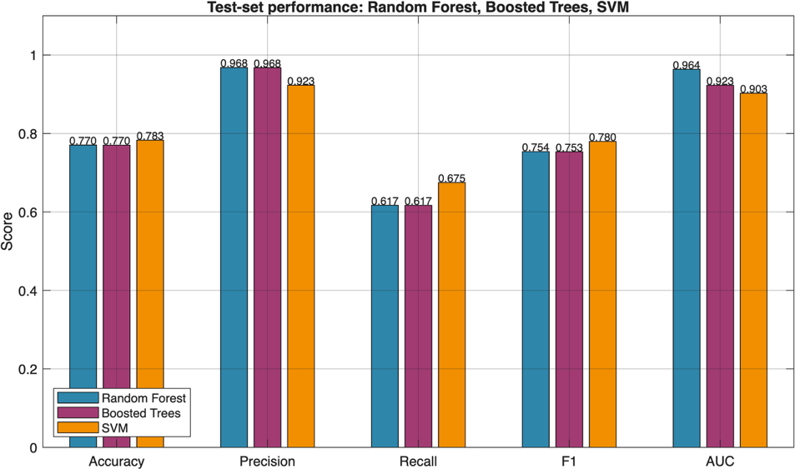
Figure 1. Test-set performance of the three classifiers across Accuracy, Precision, Recall, F1 and AUC.
The structure of this gap provides useful insights. Precision remained high across all three models, ranging from 0.923 to 0.968, while recall was substantially lower between 0.617 and 0.675. This means that when a model labelled a connection as an attack, it was almost always correct, but each model missed a large portion of the attacks in the test set. This pattern is consistent with the composition of KDDTest+, which contains 17 attack subtypes that were not part of the training set. The models struggled to recognise unfamiliar attacks, which reduced recall, while maintaining high precision on the attack types they did identify. A model that was only over-fitted would be expected to lose precision and recall together, which is not what was observed.
This interpretation is supported by the AUC values. All three models retained an AUC of at least 0.90, with scores of 0.964, 0.923, and 0.903 respectively, indicating that their underlying ranking of attack and normal traffic was still strong; the drop in recall reflects the fixed 0.5 decision threshold rather than a failure in distinguishing ability. Figure 2 illustrates the gap in accuracy between cross-validation and test results. The implications of this train-test gap for explanation comparison are discussed in Chapter 5.
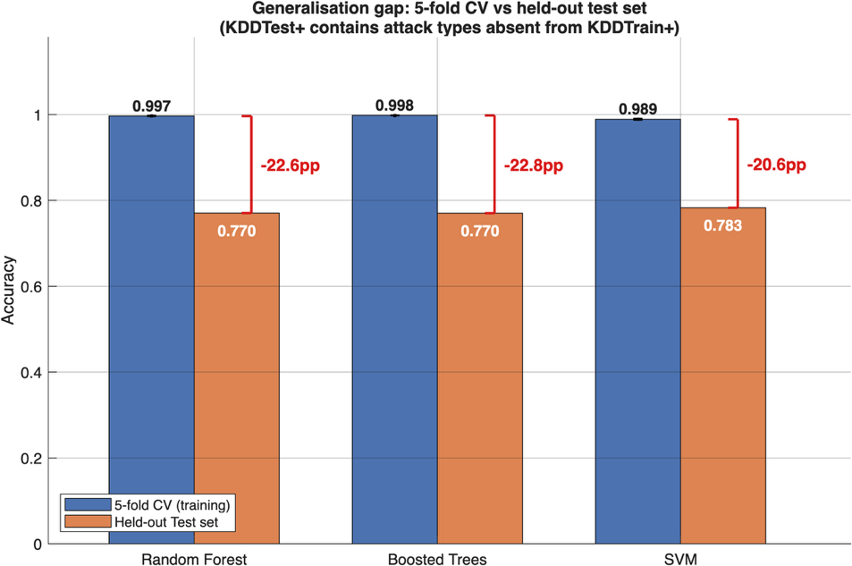
Figure 2. Generalisation gap between 5-fold cross-validation accuracy on the training set and accuracy on the held-out KDDTest+ set.

4.2 Feature-Attribution Agreement
The main question of this research is whether SHAP and LIME agree on which features are important. Agreement is assessed primarily through the per-instance top-10 Jaccard overlap between the two methods' attributions, with the full-vector Spearman rank correlation retained only as a secondary, sparsity-sensitive description; both are reported in Table 4.2. On the primary measure the overlap was modest for every classifier, and it depended strongly on the model being explained.
Model | Top-10 Jaccard (mean +/- SD) | LIME non-zero (of 118) | Spearman ρ (secondary)
Random Forest | 0.248 +/- 0.063 | 6 | 0.781
Boosted Trees | 0.280 +/- 0.055 | 7 | 0.782
SVM | 0.040 +/- 0.063 | 106 | 0.157
Table 4.2. Per-instance top-10 Jaccard overlap between SHAP and LIME attributions (primary agreement measure), the number of non-zero LIME coefficients out of 118 predictors, and the secondary full-vector Spearman ρ, per classifier. Jaccard and Spearman values are mean +/- standard deviation across 40 instances.
Figure 3 shows the per-instance top-10 Jaccard overlap for the three classifiers. The overlap was highest for the two tree ensembles and much lower for the kernel model: Boosted Trees reached a mean Jaccard of 0.280 (95% CI [0.263, 0.298]) and Random Forest 0.248 ([0.228, 0.268]), whereas SVM fell to 0.040 ([0.020, 0.060]). Even the highest value indicates that, on average, SHAP and LIME shared only a minority of their top-ranked features. The narrow confidence intervals show that these patterns were stable across instances rather than caused by a few outliers.
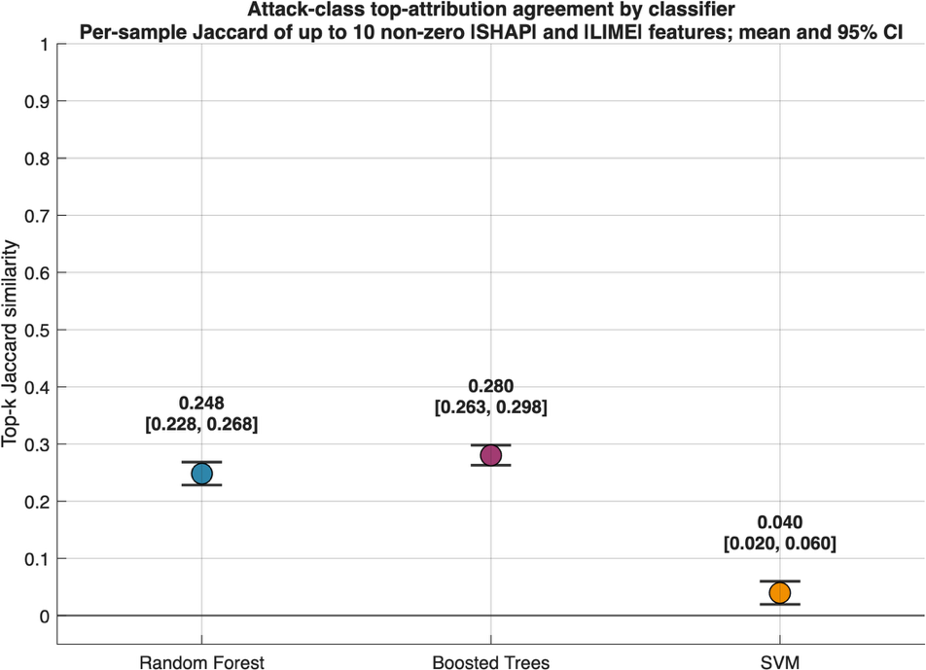
Figure 3. Mean per-instance top-10 Jaccard overlap between SHAP and LIME attributions, per classifier. Markers show the mean and error bars the 95% confidence interval across 40 instances. No fixed agreement threshold is imposed; the full-vector Spearman ρ is reported separately in Table 4.2 as a secondary, sparsity-sensitive measure.
The three models were compared with a Friedman test, which is appropriate because the same 40 instances were explained under every classifier. It confirmed significant between-model differences in top-10 Jaccard overlap (χ² = 60.05, df = 2, p < 0.001, n = 40). Wilcoxon signed-rank post-hoc comparisons with Holm correction indicated that SVM overlapped significantly less than both tree ensembles (both adjusted p < 0.001), whereas Random Forest and Boosted Trees differed only marginally (adjusted p = 0.041). The secondary full-vector Spearman ρ was high for the two tree models (0.781 and 0.782) and weak for SVM (0.157); however, LIME returned only six and seven non-zero coefficients for Random Forest and Boosted Trees respectively, against 106 for SVM, so these tree-model correlations are inflated by the many shared zero attributions and are treated only as a sparsity-sensitive diagnostic rather than as evidence of agreement.
This result is important because it shows that the choice between SHAP and LIME is not a minor implementation detail. On the same model and the same data, the two methods select largely different top-ranked features, and the degree of overlap depends on the classifier being explained. The reasons for this model-dependent pattern, and in particular why the kernel model shows the weakest overlap, are examined in Chapter 5.

4.3 Top-10 Feature Composition
The Jaccard index measures whether the two methods select the same features, regardless of the order in which they rank them, and is used here as the primary agreement measure. The full-vector Spearman correlation, reported alongside it in Table 4.2, instead describes rank order across the whole attribution vector, but is sensitive to the sparsity of the LIME coefficients. The two metrics are complementary: Jaccard measures the overlap of the sets, while Spearman captures relative ordering.
Figure 4 shows the top-10 feature selections from SHAP and LIME side by side for each classifier, with overlapping features highlighted: for reference, Figure 5 shows SHAP's top-10 features. Aggregate overlap was low throughout, but it was highest for the tree ensembles. Boosted Trees had the largest overlap, with a Jaccard of 0.308 on attack instances, corresponding to four shared features out of a union of thirteen. Random Forest followed at 0.231, corresponding to three shared features out of thirteen, while SVM had the lowest overlap at 0.111, corresponding to only two shared features out of a union of eighteen.
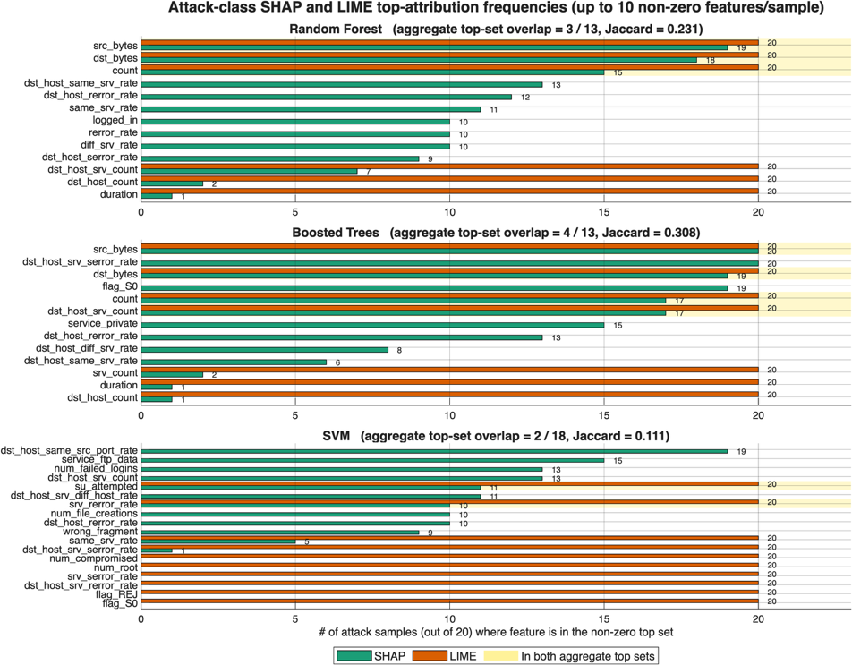
Figure 4. Top-attribution features selected by SHAP and LIME across attack samples for each classifier, using up to ten non-zero features per sample. Feature counts give the number of samples (out of 20) in which each feature appeared in a method's top set; overlapping features are highlighted in yellow.
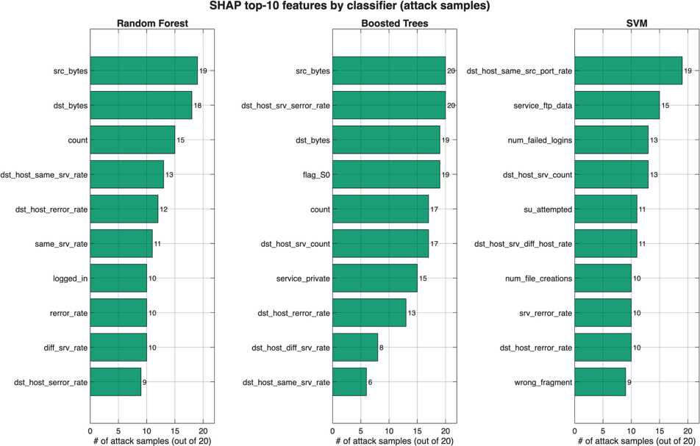
Figure 5. SHAP top-10 features per classifier on attack samples, showing how the most frequently selected features differ across model families.
These two metrics operate at different levels, so they describe complementary aspects of agreement. The per-instance Jaccard compares the feature sets selected for each individual alert, whereas the aggregate view in Figure 4 compares the most frequently selected features across all attack instances. For the two tree ensembles the two views agree: their per-instance and aggregate overlaps are the highest of the three models, even though LIME selects only six or seven non-zero features per instance. For SVM both views place it lowest, because LIME spreads its coefficients across many more features and therefore shares fewer of its top-ranked features with SHAP. Combined, the measures show that shared feature membership between SHAP and LIME is limited for every model and weakest for the kernel classifier.

4.4 LIME Stability
A practical concern with LIME is that its explanations depend on random sampling from the local neighbourhood, so repeated runs on the same instance can produce different rankings [10]. To measure this variation, LIME was executed 20 times with different random seeds for five attack instances per classifier, and the coefficient of variation (CV) of the top-10 importance scores was recorded. SHAP stability was not measured empirically in this study; TreeSHAP is deterministic by construction for a fixed model and input [13], and only LIME's repeated-run dispersion is reported here.
Figure 6 shows that LIME was least stable on the tree ensembles: the mean coefficient of variation was 2.74 for Boosted Trees and 1.51 for Random Forest but fell to 0.27 for SVM. A coefficient of variation exceeding one indicates that the standard deviation of the importance scores was higher than their mean, so for both tree ensembles LIME's explanations changed substantially from run to run on the same input. On SVM the dispersion was far smaller, indicating that LIME reproduced a much more consistent explanation across seeds.
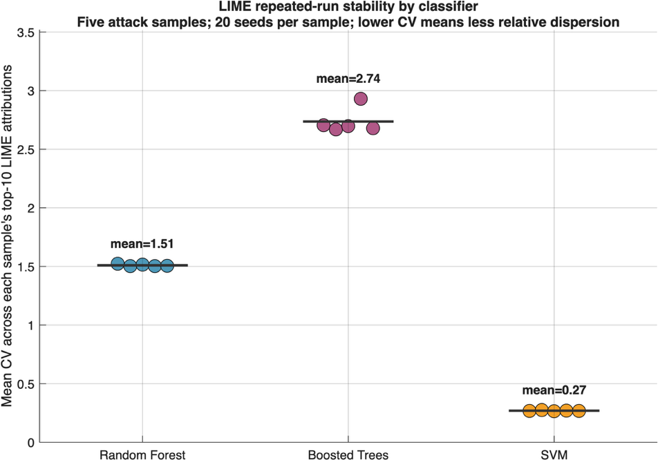
Figure 6. LIME explanation stability. Each dot is one attack sample explained with 20 random seeds; the y-axis is the coefficient of variation of the top-10 importance scores across seeds (lower is more stable). The horizontal line marks each model's mean.
These results are consistent with the expectation that LIME's neighbourhood sampling makes its explanations less reproducible, and markedly so on some models. The instability is clearest on the tree ensembles, where a user re-running LIME would frequently obtain a different set of important features. Because TreeSHAP is deterministic by construction, it would return the same attribution on each run for the tree models; SHAP's empirical stability was not measured here and is therefore not compared directly. The much higher stability of LIME on SVM is notable and is discussed further in Chapter 5 in relation to the smoother decision surface of the kernel model.

4.5 Computational Cost
Stability is not the only side of the trade-off; the other side is computational cost. Wall-clock time per explanation was measured over 50 test instances for each model and method, with five timed repeats per instance after a warm-up call, and the mean and SHAP-to-LIME ratio are reported in Table 4.3. For the two tree models, where SHAP uses the specialised TreeSHAP algorithm, SHAP cost between about 1.3 and 2.5 times as much as LIME. For SVM, where SHAP relies on the model-agnostic KernelSHAP, the ratio increased to approximately 3.5.
Model | SHAP (s) | LIME (s) | SHAP/LIME ratio
Random Forest | 0.568 | 0.228 | 2.5x
Boosted Trees | 0.523 | 0.412 | 1.3x
SVM | 1.863 | 0.531 | 3.5x
Table 4.3. Per-instance explanation time (mean over 50 instances with five timed repeats each) and the SHAP-to-LIME ratio. SHAP uses TreeSHAP for the tree models and KernelSHAP for SVM.
Figure 7 shows the timing for each instance. The pattern reflects the algorithms rather than the models. TreeSHAP exploits the structure of decision trees to compute Shapley values efficiently [13], so SHAP remained inexpensive on Random Forest and Boosted Trees. KernelSHAP has no such structure to exploit and must repeatedly query the model on sampled feature coalitions, which is why SHAP on SVM was roughly three to four times slower per instance than SHAP on the tree models, while LIME's cost remained almost constant across all three.
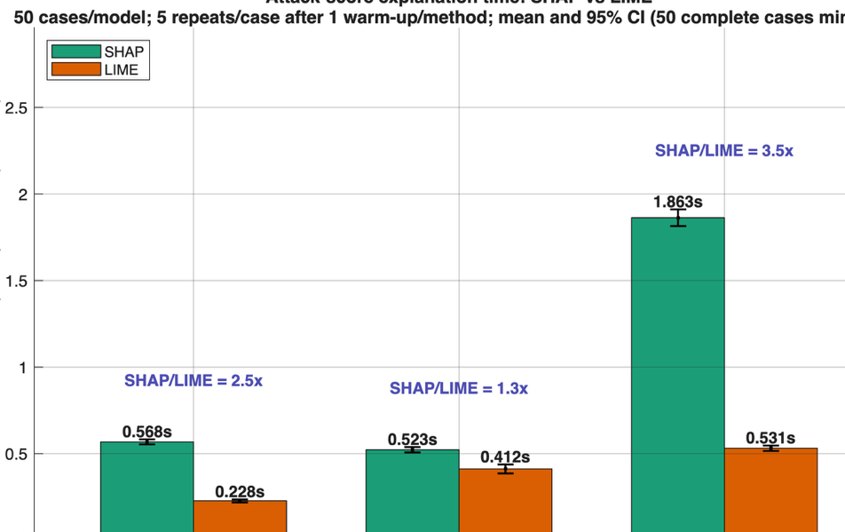
Figure 7. Wall-clock time per explanation, averaged over 50 test instances per (model, method) pair with five repeats each; error bars show the 95% confidence interval. SHAP/LIME ratios are shown above each pair of bars; SHAP uses TreeSHAP for the tree models and KernelSHAP for SVM.
This supports the second hypothesis that SHAP costs more than LIME, but with an important qualification: the overhead is modest when a model-specific SHAP variant is available and becomes larger when the model-agnostic implementation must be used. In practical terms, the cost of SHAP depends on the model family as much as on the explainer itself.

4.6 Per-Attack-Family Analysis
Model | Normal | DoS | Probe | R2L | U2R
Random Forest | 0.273 | 0.223 | 0.272 | 0.264 | 0.285
Boosted Trees | 0.266 | 0.319 | 0.234 | 0.283 | 0.336
SVM | 0.003 | 0.133 | 0.108 | 0.023 | 0.050
The agreement results in Section 4.2 were aggregated across all attack families. An intuitive question is whether the overlap between SHAP and LIME is uniform across families or varies with the type of traffic. To test this, the mean per-instance top-10 Jaccard was computed separately for each NSL-KDD family and for normal traffic, for each classifier. The results are shown in Table 4.4 and visualised as a heatmap in Figure 8.
Table 4.4. Mean per-instance top-10 Jaccard overlap between SHAP and LIME, computed separately within each attack family and for normal traffic, for each classifier.
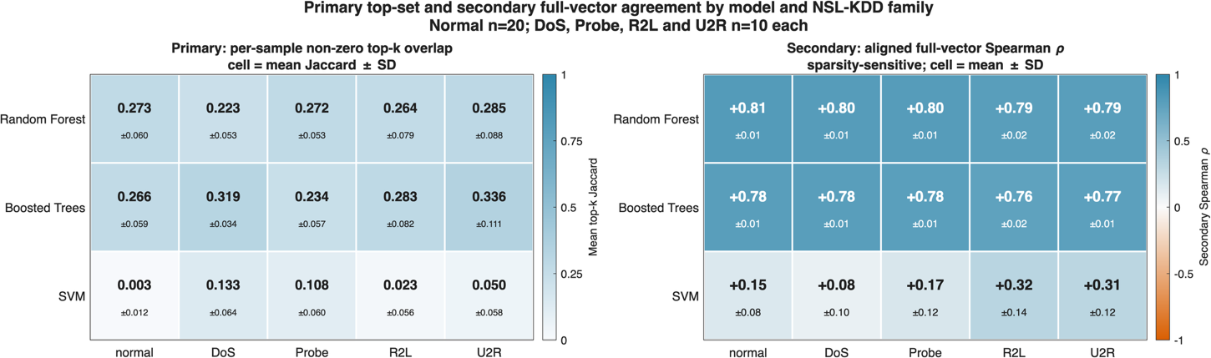
Figure 8. Per-attack-family SHAP-LIME agreement. The left panel shows the mean per-instance top-10 Jaccard overlap (primary measure) for each (model, family) cell; the right panel shows the secondary full-vector Spearman ρ, which is sparsity-sensitive.
The pattern differs markedly between the tree ensembles and the kernel model. For Random Forest and Boosted Trees the overlap was relatively stable across families, remaining between roughly 0.22 and 0.34. For SVM, however, the overlap varied considerably with family, from near zero for normal and R2L traffic (0.003 and 0.023) to appreciably higher for DoS and Probe (0.133 and 0.108). Reading down any column, the tree ensembles consistently overlapped more than SVM. Therefore, the overlap depends on the model and, especially for the kernel model, on the attack family.
A linear mixed model with attack family and classifier as fixed effects and a random intercept per instance was fitted to the per-instance Jaccard to separate these sources of variation. All three terms were significant: the classifier (F = 26.03, p < 0.001), the attack family (F = 4.85, p = 0.001) and, importantly, their interaction (F = 7.04, p < 0.001). The classifier was the largest single source of variation, but the significant interaction shows that its effect is not independent of attack family, most visibly for SVM, whose overlap changed substantially across families. The third hypothesis, which anticipated that disagreement would be driven by attack family, is therefore only partially supported: the classifier is the dominant factor, but attack family and its interaction with the classifier also contribute significantly, so the disagreement cannot be described as purely model-level.

Discussion
This chapter interprets the results in relation to the main research question: whether SHAP and LIME provide sufficiently consistent accounts of the same intrusion-detection decisions to be used interchangeably. The results show that they do not. Across three classifiers the primary measure, per-instance top-10 Jaccard overlap, remained modest (Random Forest 0.248, Boosted Trees 0.280 and SVM 0.040), so the two methods shared only a minority of their top-ranked features even in the best case. The disagreement was not a minor implementation issue, and it was largest for the kernel model, where SHAP and LIME selected almost entirely different features.
The chapter's main argument is that the level of agreement between SHAP and LIME depends mainly on the model being explained, while the attack family and its interaction with the model also contribute. The chapter describes disagreement as a sign that two explanations are not interchangeable. It does not claim that either method is necessarily correct, only that they can give materially different accounts of the same decision.

5.1 Why SHAP and LIME Disagree
The first question is why SHAP and LIME assign different importance to the same prediction. On the primary top-10 Jaccard measure the overlap was modest for every model and lowest for the SVM (0.040, against 0.248 and 0.280 for the tree ensembles). It is expected that SHAP and LIME will optimise different mathematical objectives and do not measure the same quantity. SHAP decomposes the difference between a model's output for an instance and a reference expectation into a sum of feature contributions, using Shapley values from cooperative game theory [9]. Its additive explanation satisfies local accuracy, often referred to as completeness: the baseline prediction and the sum of all feature attributions reconstruct the model output for the instance. In contrast, LIME fits a locally weighted linear surrogate to a sampled neighbourhood, and its coefficients describe the model's behaviour only within that neighbourhood [10]. In simple terms, SHAP distributes a prediction relative to a background, whereas LIME finds a linear direction in the neighbourhood; the former is a coalition-based decomposition, the latter a neighbourhood approximation. If their explanations agree, this can support the argument, but such agreement is not built into the formal definitions of the two methods.
The completeness constraint also helps explain LIME's variability. Analysing LIME and SHAP through a bias-variance lens in a high-sparsity recommendation setting, SHAP's completeness condition acts as a regulariser, trading higher bias for lower variance [14]. That study is not an IDS, so it is a theoretical comparison rather than direct proof, but it is consistent with the present pattern. LIME's mean coefficient of variation across repeated runs was 1.51 for Random Forest, 2.74 for Boosted Trees and 0.27 for SVM; SHAP stability was not measured empirically here, but TreeSHAP is deterministic by construction for a fixed model and input [13]. Because LIME generates its neighbourhood through random sampling, the fitted coefficients change when the sample changes, and for both tree ensembles the dispersion exceeded the mean attribution magnitude, so repeated runs on the same alert could lead to substantially different explanations. Stability and agreement are separate properties: as shown below, the tree ensembles proved the least stable while nonetheless displaying the highest SHAP-LIME overlap.
Model geometry determines how well this local approximation holds. LIME assumes that the classifier can be adequately approximated by a linear function within the weighted neighbourhood.
Tree ensembles produce piecewise-constant, staircase-like responses that change abruptly at split boundaries. When sampled points fall on opposite sides of several splits, a single linear surrogate must summarise behaviour that is discontinuous and shaped by feature interactions, which is why LIME's coefficients were least stable on Random Forest and Boosted Trees. This instability nevertheless coexisted with a relatively high top-10 overlap with SHAP: because LIME assigned a non-zero coefficient to only six or seven predictors on these models, the features it selected tended to be the dominant ones that SHAP also ranked highly. The interpretation is mechanistic rather than causal, since the experiment did not manipulate the kernel width or directly measure the curvature of the local decision boundary.
The RBF SVM behaves differently. Its decision function is continuous and smooth, which makes a local linear approximation more justifiable, and LIME was correspondingly the most stable on this model (mean CV 0.27), with its five stability samples far more consistent than on the tree ensembles. Despite this stability, agreement with SHAP did not improve: the SVM returned the lowest top-10 overlap (0.040), because LIME assigned non-zero coefficients to 106 of the 118 predictors, distributing its attributions across many features that SHAP did not rate highly. The 118-dimensional one-hot feature space complicates both methods: because the service, protocol and flag indicators are mutually exclusive and the rate and count variables are correlated, credit can be reassigned among interchangeable predictors without materially changing a prediction, making top-10 cut-offs sensitive to small ranking changes. SHAP and LIME are known to be sensitive to model choice and collinearity [22]. The disagreement is therefore best viewed as the natural outcome of two different explanatory targets interacting with model geometry, attribution sparsity and feature dependence, rather than as evidence that either method is miscalculated.

5.2 Cross-Model Divergence: The Model as the Dominant Factor
The per-attack analysis shows that agreement depends on the model, but not on the model alone. Reading across the two tree ensembles in Figure 8, the overlap was fairly stable across normal, DoS, Probe, R2L and U2R traffic, remaining roughly between 0.22 and 0.34. For the SVM, however, showed wide variation in overlap between family, from near zero for normal and R2L traffic to considerably higher for DoS and Probe. The earlier expectation that well-separated attacks such as DoS would produce more consistent explanations than the rare U2R cases was only partly borne out, and only for the kernel model. The model is therefore the dominant influence on the level of agreement, but for the SVM the attack family is an additional factor.
This is confirmed statistically. A Friedman test on the per-instance Jaccard found significant differences between the three classifiers (χ² = 60.05, p < 0.001), and Holm-corrected Wilcoxon signed-rank comparisons showed that the SVM overlapped significantly less than both tree ensembles. A linear mixed model separated the sources of variation and found the classifier to be the largest effect (F = 26.03, p < 0.001), but also a significant effect of attack family (F = 4.85, p = 0.001) and a significant model-by-family interaction (F = 7.04, p < 0.001). The model is thus the dominant factor, but its effect is not independent of the attack family.
This pattern follows from the mechanism in Section 5.1. LIME's behaviour depends on the interaction between its locally linear surrogate and the geometry of the fitted decision function, which is set mainly by the model family and its learned parameters. Because each attack family samples a different region of the same surface, the family can modulate how well the local surrogate fits, which is consistent with the significant model-by-family interaction and is most visible for the SVM. Model dependence in both SHAP and LIME has been reported in related settings [22]. A further model-family contrast comes from an IDS built on a multilayer perceptron, where the two methods were compared and validated through perturbation, and where explanation behaviour again proved conditional on the model, data and validation design [18]. These studies support the present interpretation without independently proving it.
The cross-model SHAP results reinforce this: even with the explainer fixed, the three models did not share the same important features. Random Forest and Boosted Trees shared five of their top-ten SHAP features, whereas the SVM shared only one with Random Forest and two with Boosted Trees, and it emphasised authentication and service indicators. Similar AUC values therefore did not mean the classifiers had learned the same predictive route. TreeSHAP and KernelSHAP both approximate the same additive framework but by different means; the more fundamental point is that the functions being explained differ, since SHAP's consistency property applies within a specified model and does not require a feature to receive the same importance across models. Changing the model can thus change the explanation even when the data, task and nominal XAI method are unchanged, which is why explanation claims in IDS should always state both the model and the explainer.

5.3 Implications for IDS Practice
An IDS analyst faces a decision problem when agreement is low. When SHAP and LIME highlight different sets of traffic variables, with a top-10 Jaccard overlap of only 0.04 to 0.28, neither visualisation can be treated as a self-authenticating explanation of why an alert was raised, and the analyst's conclusion about whether an event is credible may change with the chosen model or explainer. The existing literature does not address this adequately: a security-XAI review that distinguished three stakeholder groups and four explanation objectives found that user evaluation appeared in only 14% of surveyed cases [11]. This matters because an explanation suited to a developer's debugging task may not satisfy the needs of an analyst engaged in triage, audit or forensic analysis, and it implies that technical agreement metrics cannot replace evidence that an explanation improves human decision-making.
The timing and stability results support a specific deployment choice for each model. For Random Forest and Boosted Trees, TreeSHAP required roughly 0.52 to 0.57 seconds per instance, between about 1.3 and 2.5 times the cost of LIME, and it is deterministic by construction [13]. That reproducibility is likely worth the modest additional latency for post-alert investigation and auditable reporting. On the SVM, KernelSHAP required about 1.86 seconds per instance, approximately 3.5 times slower than LIME, so in a high-volume or near-real-time pipeline LIME may be preferable for first-pass triage, particularly as it was the most stable explainer on this model. However, this does not make the two explanations equivalent: the SVM showed the lowest agreement of the three models, with a top-10 Jaccard of only 0.040.
To develop a defensible workflow, different methods should be cross-checked rather than relying on a single explanation technique. The system should first verify that the local surrogate reflects the model at the target point, then repeat stochastic explanations across multiple random seeds, and flag materially unstable or disjoint feature rankings for analyst review. For high-consequence alerts, SHAP can provide a stable attribution while LIME can be used to assess whether a simple local account is available. Any disagreement between the two methods should be reported as explanatory uncertainty rather than obscured by selecting the more intuitive visualisation. To support traceability and reproducibility, the forensic record should document the model and preprocessing versions, the class under explanation, the background or perturbation settings, the LIME kernel width, the random seed, and the original feature values. This traceability is essential when one-hot names must be returned to network fields, and when the same alert may be audited later.
SHAP also has other roles beyond case explanation. For example, it has been used for feature selection in an ensemble IDS [16]. This objective is distinct from the present comparison of SHAP and LIME explanations, since the selection of a compact predictive subset does not demonstrate that an attribution is faithful to the model or useful to an analyst. More broadly, feature importance should be interpreted as evidence of which variables the fitted model used to support its prediction, rather than as proof of causation for the intrusion itself. Consequently, operational decisions should integrate attribution with packet-level evidence, host logs, threat intelligence, and temporal context. The practical recommendation is conditional: SHAP should be preferred where auditability allows and a stable, model-specific explanation is desirable; LIME may be used where lower latency is the priority, provided that its fidelity and repeatability are assessed; and the model-method pair used to generate each explanation should always be explicitly reported.

5.4 Comparison to Prior IDS XAI Studies
The most obvious difference appears when comparing a recent forensic IDS study on UNSW-NB15, which reports SHAP–LIME Jaccard scores of 0.82 for XGBoost and 0.65 for TabNet, much higher than the 0.04 to 0.28 range found here [17]. However, their predictive results affect the interpretation of that agreement. Validation accuracy was 97.8% for XGBoost and 97.68% for TabNet, but test accuracy dropped down to 85.91% and 84.41%, and the authors reported macro AUC scores of 0.37 and 0.43 and noted issues with overfitting. The authors presented the low discrimination as a deliberate design choice, arguing that it is methodologically valuable to examine how explainability methods behave when applied to models that generalise poorly. While that approach is reasonable, it does not mean the explanations are reliable. When a model has a macro AUC of only 0.37, high SHAP–LIME overlap mainly indicates that both explainers reflect the same poor performance rather than that their shared explanation reveals true attack-relevant structure. A subsequent tuning analysis improved macro AUC to 0.65 and 0.66, but this does not change the interpretation of the originally reported comparison of explanation quality.
The current models are not perfect, but they provide a stronger basis for the comparison, with held-out AUC values ranging from 0.903 to 0.964 and F1 scores between 0.753 and 0.780 under KDDTest+'s deliberate shift to novel attacks. The AUC figures are not directly comparable: the ten-class macro AUC reported for those models is based on different criteria than the 0.903 to 0.964 obtained here, which is computed over a binary normal-versus-attack target [17]. The important point is the authors' acknowledgement of overfitting and weak discrimination, not the raw numerical difference. In this study, low SHAP–LIME agreement is observed on classifiers that still credibly rank normal and attack traffic, rather than failing at chance-level discrimination. This situation does not make low agreement better than high agreement, nor does it prove the models have learned correct security concepts. It makes the disagreement substantively informative: a model can generalise reasonably well even when two accepted explanation methods provide conflicting explanations. This contrast supports a methodological rule: predictive validity must be established before explanation agreement is interpreted, and agreement is not a substitute for accuracy [17].
The two agreement measures also capture different things. The per-instance Jaccard compares which features each method selects, whereas the full-vector Spearman ρ compares rank order across the whole attribution vector. The two need not agree: for the tree ensembles the full-vector ρ was high (about 0.78) while the top-10 Jaccard was only moderate, because LIME assigned a non-zero coefficient to just six or seven predictors and the long tail of shared zero attributions inflates the rank correlation. For this reason the Jaccard overlap is treated as the primary measur and ρ as a secondary, sparsity-sensitive diagnostic. Reporting Jaccard, ρ, repeated-seed CV and timing together provide a more complete description than any single number.
A second caution comes from a CICIDS2017 stacking model that reports 100% accuracy, precision, recall and F1 across classes [20]. Such results do not alone prove leakage or overfitting, and they should not be dismissed without examining the split and preprocessing; However, they present a strong validation warning in intrusion detection, where duplicate flows, random splitting and feature leakage can make nominal test performance optimistic. Operational conclusions based on explanation of perfect metrics require independent validation - preferably temporal or cross-dataset. This reinforces the present study's focus on a held-out set that includes attack subtypes absent from training.
The study most closely related to the method presented combines Random Forest, SVM and Gradient Boosting with SHAP and LIME on NSL-KDD and CICIDS2017 [19]. That study focuses on predictive performance, fidelity and scalability, but does not combine repeated-seed CV analysis, per-instance agreement, aggregate Jaccard comparison and attack-family decomposition within a single systematic design. A further study extends the evidence to an MLP (Multilayer Perceptron), incorporated perturbation-based validation, and included a small user study, but it addressed a different model family and adopted a different evaluative emphasis [18]. Therefore, this contribution is not the first use of SHAP or LIME in IDS. Instead, it is the controlled, multi-metric demonstration across three credible model families. This shows that disagreement and stability carry a strong model-level signature, although the level of agreement also varies with attack family, most clearly for the kernel model. That result fills the gap between accuracy-oriented frameworks and small illustrative comparisons.

5.5 Limitations
This contribution has several limitations. First, it is not novel to compare SHAP and LIME. The novelty is the combination of three model families with credible held-out discrimination, complementary agreement, stability and cost measures, and a per-attack analysis that identifies the model as the dominant source of variation while also finding a significant attack-family interaction. That contribution is analytical rather than algorithmic, and it needs replication before the pattern can be generalised.
Second, the analysis does not impose a fixed agreement threshold, because in the absence of a ground-truth attribution there is no validated standard for an interchangeability cut-off. Agreement is therefore described directly through the primary top-10 Jaccard and a secondary Spearman ρ rather than through a categorical boundary. Rank correlation should not be treated as a measure of an explanation method's quality [21]; accordingly ρ is used only to describe correspondence, and no inference is drawn that a higher ρ makes either SHAP or LIME more correct, faithful or useful. The full-vector ρ is also sensitive to LIME's sparsity, which is a further reason to report it only as a supporting diagnostic.
Third, there is no ground-truth feature attribution against which to judge either method. The local fidelity of the LIME surrogate was recorded as the difference between the black-box and surrogate attack-scores at each query point, but it was not analysed in depth, the synthetic samples were checked only for one-hot validity rather than broader plausibility, and no analyst study established which output better supported triage. Any explanation based on decision-boundary geometry should therefore be treated as an observational interpretation rather than a formally established causal account, and these gaps prevent any claim that SHAP is fundamentally correct because it is more constrained. Future work should combine quantitative fidelity diagnostics with analyst-centred tasks to address the evaluation gap in security XAI [11].
Fourth, the scope and sampling are limited. NSL-KDD is an old benchmark, the labels were combined into binary classes, and only three models were examined. The main agreement sample was modest, and LIME stability used five attack instances over 20 seeds. The U2R results are particularly uncertain because that type of attack is rare, and stability for normal instances was not evaluated. The classifiers used mostly default MATLAB hyperparameters. The one-hot vocabulary is fitted on the training partition only and applied unchanged to the test set, and all numerical normalisation statistics are estimated from the training set alone, so neither test labels nor test-derived statistics enter model fitting. Top-10 truncation can exaggerate small differences around the cut-off, and the coefficient of variation can increase when the mean attribution magnitude is close to zero. These choices do not create the observed differences between models, but they do limit claims at the population level and cross dataset.
Finally, the 20.6 to 22.8 percentage-point gap between cross-validation and test results should not be ignored. KDDTest+ deliberately contains attack subtypes absent from training [2]. Given this design, the combination of higher test precision (approximately 0.92 to 0.97), lower recall (approximately 0.62 to 0.68) and AUC above 0.90 is more indicative of challenges in detecting novel attacks at a fixed threshold than of a complete model failure seen in some prior comparisons. This does not provide conclusive proof against overfitting; cross-dataset and temporal tests are still necessary. Future research should repeat the design using contemporary datasets, retrain models with different seeds, evaluate matched correct and incorrect cases, test realistic variations and alternative backgrounds, clarify how local geometry impacts LIME, and include Anchors or counterfactual methods. For neural models, Integrated Gradients should also be included. These extensions would explore the limits of the main conclusion rather than weaken it. In this experiment, disagreement remained systematic and model-dependent, but it could not determine which explanation was objectively correct.

Conclusion

6.1 Summary of Findings
The question addressed in this dissertation was whether SHAP and LIME provide explanations consistent enough to be treated as interchangeable for the same intrusion-detection decisions. Across three classifiers with similar held-out performance, the two methods selected largely different top-ranked features. The held-out F1 scores ranged from 0.753 to 0.780 and the AUC values from 0.903 to 0.964. On the primary measure, per-instance top-10 Jaccard overlap, agreement was modest for every model and, contrary to a common assumption, highest for the two tree ensembles (0.248 for Random Forest and 0.280 for Boosted Trees) and lowest for the SVM (0.040). The secondary full-vector Spearman correlation was high for the tree models (about 0.78) but is inflated by the sparsity of LIME's coefficients and is therefore reported only as a supporting diagnostic; the low Jaccard overlap shows that the two methods were often not even selecting the same explanatory features.
The central contribution of the study is that the level of agreement was model-level rather than attack-family driven. The per-attack analysis showed that the two tree ensembles overlapped fairly consistently across normal, DoS, Probe, R2L and U2R traffic (roughly 0.22 to 0.34), whereas the SVM varied considerably with family, from near zero for normal and R2L traffic to higher for DoS and Probe. A Friedman test confirmed significant differences between classifiers (χ² = 60.05, p < 0.001), and a linear mixed model found the classifier to be the dominant effect while also identifying a significant attack-family effect and a significant model-by-family interaction. In practical terms, the pattern of agreement depended more on the classifier than on the attack type, but for the kernel model the attack family also mattered, so the disagreement cannot be described as purely model-level.
The analysis of stability and timing reinforces this conclusion. LIME's repeated-run coefficient of variation was 1.51 for Random Forest, 2.74 for Boosted Trees and 0.27 for SVM, so it was least reproducible on the tree ensembles; SHAP stability was not measured empirically, but TreeSHAP is deterministic by construction. Cost showed a different trade-off: on the tree ensembles TreeSHAP required roughly 0.52 to 0.57 seconds per instance, about 1.3 to 2.5 times the cost of LIME, whereas KernelSHAP on the SVM required about 1.86 seconds per instance, approximately 3.5 times the cost of LIME. Overall, the results show that SHAP and LIME are not interchangeable tools for explaining IDS decisions, and any claim based on a post-hoc explanation should be qualified by both the model being explained and the explanation method used.

6.2 Implications
For IDS practice, low rank agreement combined with low feature-set overlap means that a single explanation visualisation cannot be treated as a self-authenticating account of an alert. If an analyst receives one SHAP plot and one LIME plot for the same decision, the difference between them should not be hidden by selecting whichever output is easier to narrate. A defensible workflow should cross-check methods and expose disagreement as explanatory uncertainty. SHAP is useful where stable, auditable attribution is required, especially for tree-based IDS models where TreeSHAP is relatively efficient. LIME may still be useful as a fast local diagnostic, particularly when latency dominates, but it should be accompanied by checks that the local surrogate reflects the model around the alert. In operational reporting, the model family, preprocessing version, background sample, random seed and explanation configuration should be recorded alongside the explanation itself.
The study emphasises the importance of interpreting explanation agreement in a broader validation framework for the XAI methodology. Predictive validity must be established before interpreting agreement, because agreement between explainers is not meaningful if the underlying classifier has not learned a reliable decision function. Also, agreement is not the same as fidelity. Two methods may agree while both fail to accurately describe the model or disagree because they answer different explanatory questions. For this reason, no single measure captures explanation behaviour. Spearman correlation shows rank alignment, Jaccard overlap indicates shared feature membership, CV measures repeated-run stability and timing reflects deployment cost, so these metrics were interpreted together. Rank correlation was applied only to quantify disagreement between explanations, not to declare that SHAP or LIME is superior. This distinction is crucial because the study lacks ground-truth feature attributions for NSL-KDD. It can show systematic divergence, but it cannot determine which explanation is objectively correct.

6.3 Future Work
The limitations lead to several directions. First, the analysis should be repeated on more contemporary intrusion-detection datasets, such as CICIDS2017 and UNSW-NB15, and in a multi-class scenario. NSL-KDD remains useful for controlled comparison and continuity in literature, but it is an old benchmark, and the binary normal/attack framing limits the detail of the security task. Second, future work should include more model families, a larger explanation sample and stability testing on both normal and attack instances. Retraining classifiers with multiple random seeds would also help distinguish variation due to the explanation method from variation caused by model training. These extensions would test whether the model-level pattern observed here persists under broader modelling and sampling conditions.
Third, quantitative agreement should be accompanied by stronger fidelity and usefulness evaluations. Future studies should systematically measure local surrogate fidelity, examine whether perturbed samples remain realistic network records and test whether explanations help analysts make better triage decisions. An analyst-centred user study would resolve the evaluation gap in cybersecurity XAI research, where user evaluation remains uncommon [11]. Finally, the comparison could be extended by further explanation methods. Anchors and counterfactual explanations could be used to evaluate rule-based and contrastive alternatives, while Integrated Gradients would be relevant for neural IDS models. A formal analysis of the relationship between fidelity of LIME and local decision-boundary geometry would also strengthen the mechanistic interpretation presented in this dissertation. The disagreement remained systematic, model-dependent and impossible to interpret as the quality of ground-truth explanations.

References
[1] A. Khraisat, I. Gondal, P. Vamplew, and J. Kamruzzaman, "Survey of intrusion detection systems: techniques, datasets and challenges," Cybersecurity, vol. 2, art. 20, 2019.
[2] M. Tavallaee, E. Bagheri, W. Lu, and A. A. Ghorbani, "A detailed analysis of the KDD CUP 99 data set," in Proc. IEEE Symp. Computational Intelligence for Security and Defense Applications (CISDA), 2009, pp. 1–6.
[3] A. L. Buczak and E. Guven, "A survey of data mining and machine learning methods for cyber security intrusion detection," IEEE Communications Surveys & Tutorials, vol. 18, no. 2, pp. 1153–1176, 2016.
[4] R. Vinayakumar, M. Alazab, K. P. Soman, P. Poornachandran, A. Al-Nemrat, and S. Venkatraman, "Deep learning approach for intelligent intrusion detection system," IEEE Access, vol. 7, pp. 41525–41550, 2019.
[5] Z. Ahmad, A. Shahid Khan, C. Wai Shiang, J. Abdullah, and F. Ahmad, "Network intrusion detection system: a systematic study of machine learning and deep learning approaches," Transactions on Emerging Telecommunications Technologies, vol. 32, no. 1, art. e4150, 2021.
[6] A. Adadi and M. Berrada, "Peeking inside the black-box: a survey on explainable artificial intelligence (XAI)," IEEE Access, vol. 6, pp. 52138–52160, 2018.
[7] C. Rudin, "Stop explaining black box machine learning models for high stakes decisions and use interpretable models instead," Nature Machine Intelligence, vol. 1, no. 5, pp. 206–215, 2019.
[8] A. Barredo Arrieta, N. Díaz-Rodríguez, J. Del Ser, A. Bennetot, S. Tabik, A. Barbado, S. García, S. Gil-López, D. Molina, R. Benjamins, R. Chatila, and F. Herrera, "Explainable artificial intelligence (XAI): concepts, taxonomies, opportunities and challenges toward responsible AI," Information Fusion, vol. 58, pp. 82–115, 2020.
[9] S. M. Lundberg and S.-I. Lee, "A unified approach to interpreting model predictions," in Advances in Neural Information Processing Systems (NeurIPS), vol. 30, 2017, pp. 4766–4777.
[10] M. T. Ribeiro, S. Singh, and C. Guestrin, "‘Why should I trust you?’: explaining the predictions of any classifier," in Proc. 22nd ACM SIGKDD Int. Conf. Knowledge Discovery and Data Mining, 2016, pp. 1135–1144.
[11] A. Nadeem, D. Vos, C. Cao, L. Pajola, S. Dieck, R. Baumgartner, and S. Verwer, "SoK: explainable machine learning for computer security applications," arXiv preprint arXiv:2208.10605, 2022.
[12] L. S. Shapley, "A value for n-person games," in Contributions to the Theory of Games, Vol. 2, H. W. Kuhn and A. W. Tucker, Eds. Princeton, NJ, USA: Princeton Univ. Press, 1953, pp. 307–317.
[13] S. M. Lundberg, G. Erion, H. Chen, A. DeGrave, J. M. Prutkin, B. Nair, R. Katz, J. Himmelfarb, N. Bansal, and S.-I. Lee, "From local explanations to global understanding with explainable AI for trees," Nature Machine Intelligence, vol. 2, no. 1, pp. 56–67, 2020.
[14] C. V. Roberts, E. Elahi, and A. Chandrashekar, "On the bias-variance characteristics of LIME and SHAP in high sparsity movie recommendation explanation tasks," arXiv preprint arXiv:2206.04784, 2022.
[15] M. Wang, K. Zheng, Y. Yang, and X. Wang, "An explainable machine learning framework for intrusion detection systems," IEEE Access, vol. 8, pp. 73127–73141, 2020.
[16] U. Ahmed, Z. Jiangbin, A. Almogren, M. Sadiq, A. U. Rehman, M. T. Sadiq, and J. Choi, "Hybrid bagging and boosting with SHAP based feature selection for enhanced predictive modeling in intrusion detection systems," Scientific Reports, vol. 14, art. 30532, 2024.
[17] P. Hermosilla, S. Berrios, and H. Allende-Cid, "Explainable AI for forensic analysis: a comparative study of SHAP and LIME in intrusion detection models," Applied Sciences, vol. 15, no. 13, art. 7329, 2025.
[18] D. Gaspar, P. Silva, and C. Silva, "Explainable AI for intrusion detection systems: LIME and SHAP applicability on multi-layer perceptron," IEEE Access, vol. 12, pp. 30164–30175, 2024.
[19] M. F. Khan, M. M. Hassan, S. Ferdous, I. Hussain, L. Akter, and A. B. Gupta, "Explainable AI and machine learning models for transparent and scalable intrusion detection systems," Journal of Information Systems Engineering and Management, vol. 9, no. 4s, pp. 1576–1588, 2024.
[20] I. Uysal and U. Kose, "Analysis of network intrusion detection via explainable artificial intelligence: applications with SHAP and LIME," in Proc. 2024 Cyber Awareness and Research Symp. (CARS), 2024, pp. 1–6.
[21] M. Neely, S. F. Schouten, M. J. R. Bleeker, and A. Lucic, "Order in the court: explainable AI methods prone to disagreement," arXiv preprint arXiv:2105.03287, 2021.
[22] A. M. Salih, Z. Raisi-Estabragh, I. B. Galazzo, P. Radeva, S. E. Petersen, K. Lekadir, and G. Menegaz, "A perspective on explainable artificial intelligence methods: SHAP and LIME," arXiv preprint arXiv:2305.02012, 2023.
[23] D. Slack, S. Hilgard, E. Jia, S. Singh, and H. Lakkaraju, "Fooling LIME and SHAP: adversarial attacks on post hoc explanation methods," in Proc. AAAI/ACM Conf. AI, Ethics, and Society (AIES), 2020, pp. 180–186.

Appendix — Source Code
The complete MATLAB implementation is hosted on the University of Essex CSEE GitLab repository and has been shared with the supervisor and second assessor:
https://cseegit.essex.ac.uk/ks25980/ce901-shap-lime-ids
The repository (branch main) contains the following files:
File | Purpose
main.m | Main pipeline: one-hot encoding, trains Random Forest, Boosted Trees and SVM, applies SHAP and LIME, and computes Spearman ρ, top-10 Jaccard overlap, LIME stability (CV) and per-instance timing. Writes result CSVs to results/.
main_per_attack.m | Per-attack-family analysis: computes SHAP–LIME agreement separately for normal, DoS, Probe, R2L and U2R traffic. Writes per-family CSVs to results/.
make_figures.m | Reads the result CSVs and generates Figures 1-8.
results/ | Output CSVs: classification metrics, Spearman/Jaccard agreement, LIME stability, timing and per-attack-family agreement.
figures/ | Generated figures used in Chapter 4.
Reproducibility: the pipeline uses several fixed seeds - model training with rng(1) and sample selection with rng(42), with the explanation, stability and timing stages each setting their own fixed seed - and all experiments were run in MATLAB R2025b on an Apple M1 laptop.

