Homework solutions for Paul Delaney Presentation

\*Please note that your graph may be slightly different for the ones shown here, but you should still only have six groups and the patterns should be relatively the same.

2.

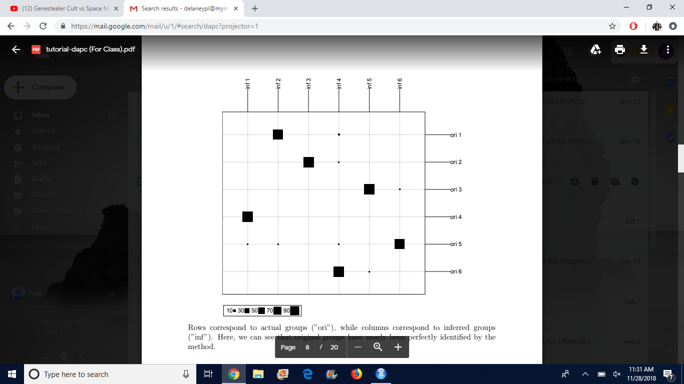

3.

