**Country Wealth Increases Life Expectancy**

Recent data analysis has found a positive correlation between the gross domestic product (GDP) of a country and the life expectancy at birth of its inhabitants.

**Introduction**

The GDP of a country is the total value of all goods and services produced by a country over a specific period of time, thereby providing a measure of the wealth and economic health of a country.

Data obtained from the following sources:

* GDP Source: World Bank national accounts data, and OECD National Accounts data files.
* Life expectancy Data Source: World Health Organization

was analysed to probe the relationship between GDP and life expectancy at birth for 6 countries: United States of America, Germany, China, Chile, Mexico and Zimbabwe over the time period 2000 to 2015.

**Data analysis**

**GDP**

Over the time period studied, the GDP was found to increase over time for each country, with the most noticeable changes observed for the United States of America and China. Interestingly, the growth was initially slow for China until a dramatic rate increase from 2006 onwards.

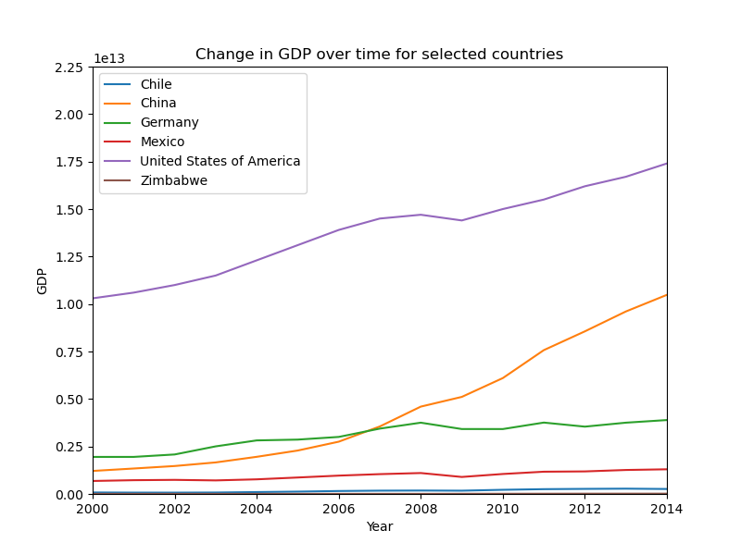

When the countries are plotted independently, the true pattern of their growth can be observed. Most of the counties experienced a steady increase in GDP overtime with the exception of Germany where a plateau was observed from 2008 onwards. Zimbabwe also experienced a plateau prior to a rapid increase in growth.

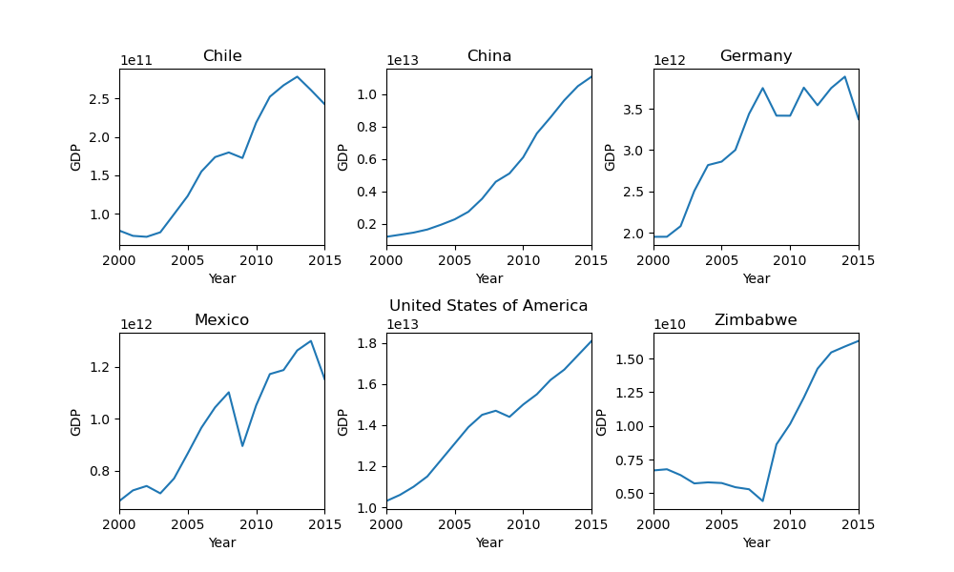

**Life expectancy**

Zimbabwe was found to have a reduced life expectancy compared to the other countries studied and experienced a steady decrease until 2004. Each of the other countries experienced life expectancies between 70 and 80 years that steadily increased over the 15 years of the study.

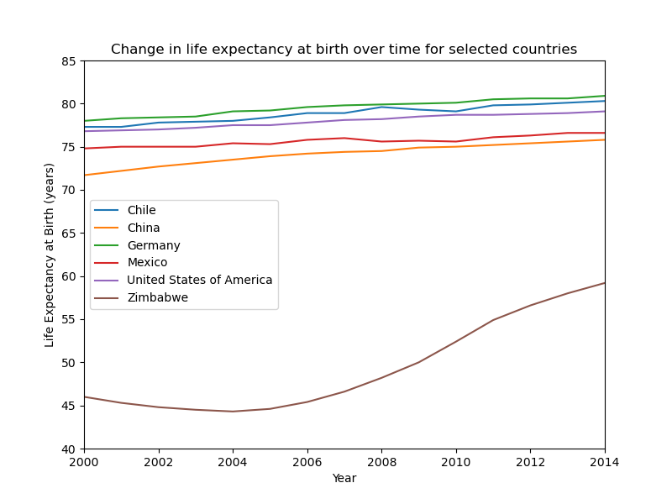

As seen in the combined plot, the majority of countries experienced a steady increase in life expectancy over time. Mexico, however, saw a drop between 2007 and 2010 before it began to steadily increase again.

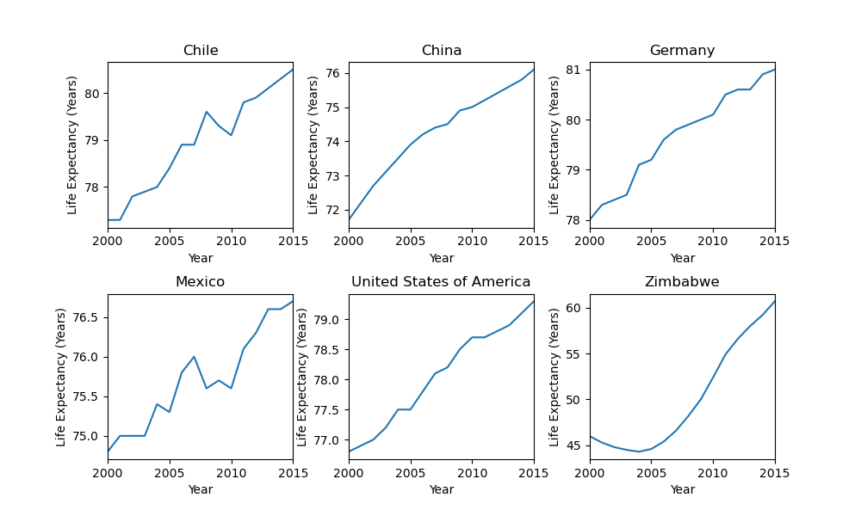

**Correlation between life expectancy and GDP**

No overall trend was observed between life expectancy and GDP and instead it was found to be country dependant. Compared to the other countries, Zimbabwe has seen a large rise in life expectancy despite little change to the GDP. China and the United States of America display a very similar relationship between life expectancy and GDP whereas Germany, Chile and Mexico have seen a greater rise in life expectancy for each dollar of wealth.

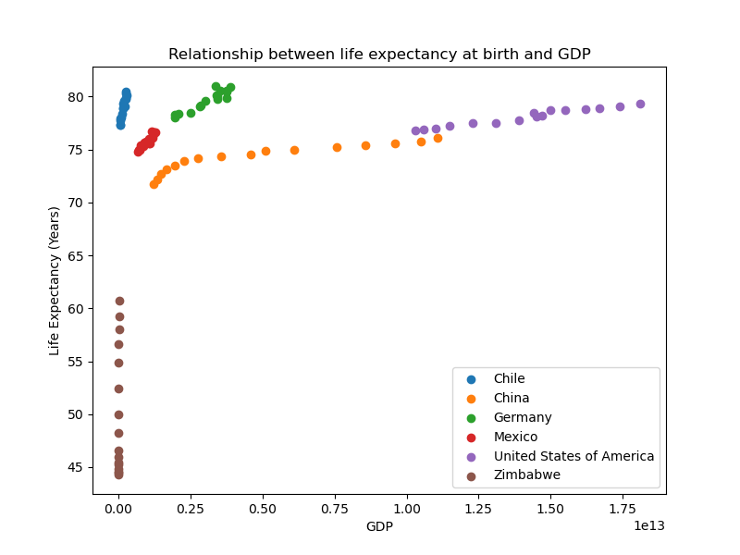

The individual plots provide more detail on the relationship between life expectancy and GDP. Germany, Chile, Mexico and the United States of America all have a positive linear correlation whereas China has a more exponential relationship. At low levels of GDP, Zimbabwe has a negative correlation with life expectancy but as the wealth is increased further a positive linear relationship is observed.

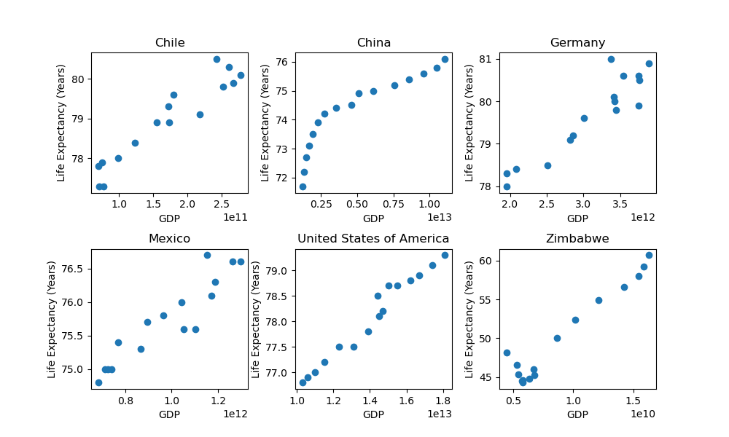

**Conclusions**

* The GDP was observed to increase over time for each country with the greatest growth experience by the United States of America and China.
* The majority of countries experienced a steady increase in life expectancy over time. Mexico, however, saw a drop between 2007 and 2010 before it began to steadily increase again.
* The United States of America was found to have the highest GDP, followed by China. Chile and Zimbabwe were found to have a much lower GDP that the other countries.
* The majority of the countries experienced a life expectancy between 70 and 80 years, with Germany having the highest values. However, the life expectancy in Zimbabwe was notably lower at below 60 years by the end of the study.
* There is no overall correlation between life expectancy and GDP although China and the United States of America do display a similar relationship. The correlation is highly dependent on the country with Zimbabwe displaying a rapid increase in life expectancy despite little change in GDP. Germany, Chile, Mexico and the United States of America all have a positive linear correlation between life expectancy and GDP, whereas China has a more exponential relationship.