**What makes a top athlete?**

What biometrics contribute to becoming an Olympian and what external factors increase your chance of winning a medal?

Catherine Kelly

20/08/24

The modern Olympics sees athletes from around the world competing in a wide variety of sports.

Visually there are numerous differences between athletes such as powerful weightlifters and slight gymnasts but what biometrics make an Olympian?

Additionally, do external factors play a part in how successful an athlete is?

In the charts below, I explore how the age, height, weight and BMI of athletes from a given sport compare to the biometrics of the average Olympian. The effect of the location of the Olympics and population and GDP of a country on the number of medals won is also evaluated. The data evaluated is taken from 2004 to 2016 as the pandemic in 2020 hindered data collection. The biometrics section focusses only on male athletes in non-team sports.

**Olympian biometrics**

The average age of an Olympian between the selected years was 27. The youngest was Tom Daley who was just 14 when he competed in the 10 m Syncho diving in 2008. The oldest was Japanese dressage rider, Hiroshi Hoketsu, who competed at the 2012 Olympics age 71.

The shortest competitor, at 140 cm, was Tuvalu athlete, Tuau Lapua who competed in the weightlifting in 2012. The tallest competitor was judo heavyweight, Renat Saidov at 210 cm tall. The average height of the Olympians was 179 cm.

Cao Yuan, another diver, was the lightest competitor (42 kg) in the Olympics between 2004 and 2016 and judo heavyweight Ricardo Blas, Jr the heaviest (214 kg). The average weight of the athletes was 76 kg.

Not surprisingly, this resulted in a judo heavyweight, Ricardo Blas, Jr also having the highest BMI of 63.9. The athlete with the lowest BMI (14.9) was archer Sultan Duzelbayev whereas the average BMI was 23.6.

Histograms showing the spread in each biometric across the Olympians.

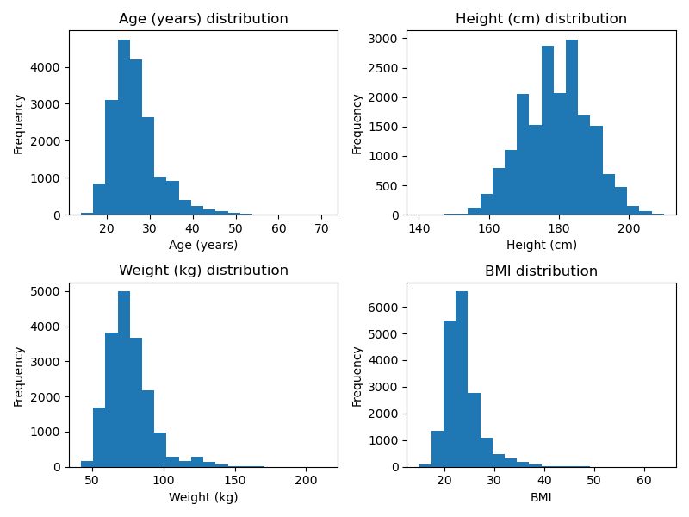

**Equestrian – Eventing**

The average biometrics for male eventers are:

Age: 37

Height: 179 cm

Weight: 72 kg

BMI: 22.5

Data analysis found that male eventers are older and lighter that the average Olympian with a lower BMI. However, their height is not statistically different. Eventing requires a large amount of knowledge and experience to succeed which may explain why the Olympic eventers are generally older.

Histograms comparing the distribution of each biometric between male eventers and Olympians competing in other sports.

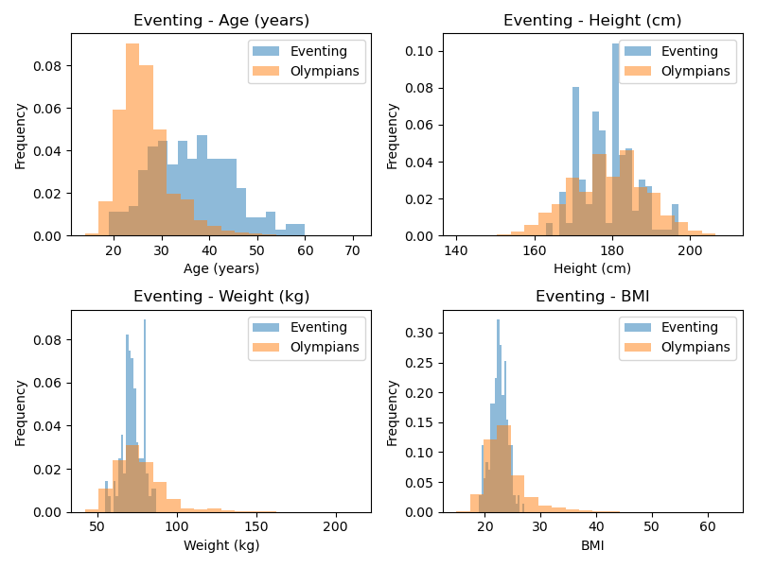

**Men’s 100 m**

The average biometrics for male 100 m runners are:

Age: 25

Height: 178 cm

Weight: 75 kg

BMI: 23.8

Male 100 m runners are statistically younger and shorter than the average Olympian.

Histograms comparing the distribution of each biometric between male 100 m runners and Olympians competing in other sports.

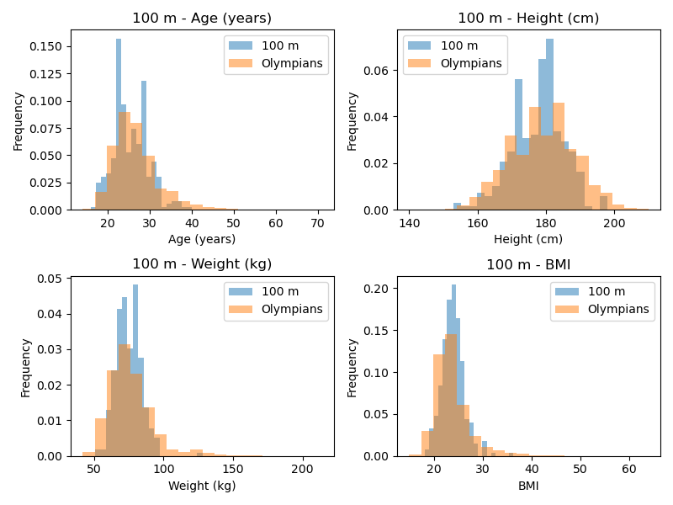

**Men’s marathon**

The average biometrics for male marathon runners are:

Age: 31

Height: 173 cm

Weight: 60 kg

BMI: 20.0

Male marathon runners are statistically older than the average Olympian but smaller, lighter and with a lower BMI.

Histograms comparing the distribution of each biometric between male marathon runners and Olympians competing in other sports.

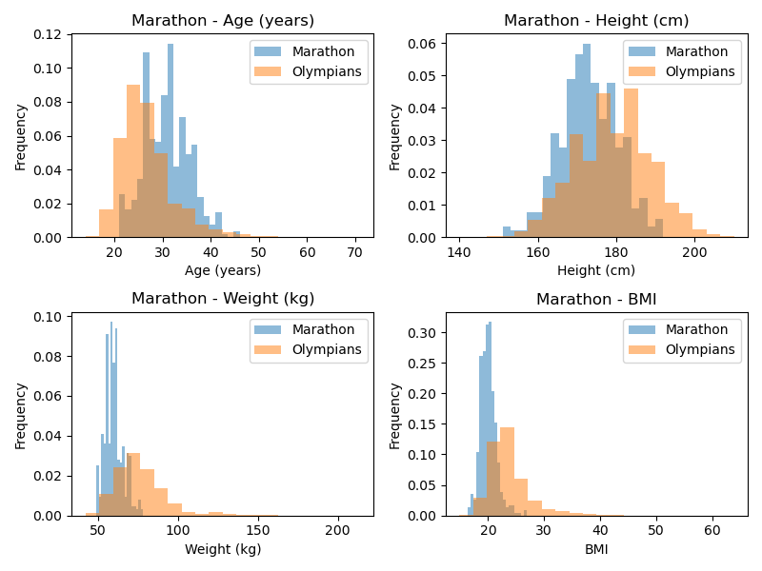

**Men’s shot put**

The average biometrics for male shot putters are:

Age: 28

Height: 192 cm

Weight: 127 kg

BMI: 34.6

Olympians competing in the shot put are statistically older, taller, heavier and with a higher BMI than the average Olympian. The shot put requires a lot of upper body strength and power and therefore a more muscular, heavier body. In addition, a greater height may facilitate a longer flight time.

Histograms comparing the distribution of each biometric between male shot putters and Olympians competing in other sports.

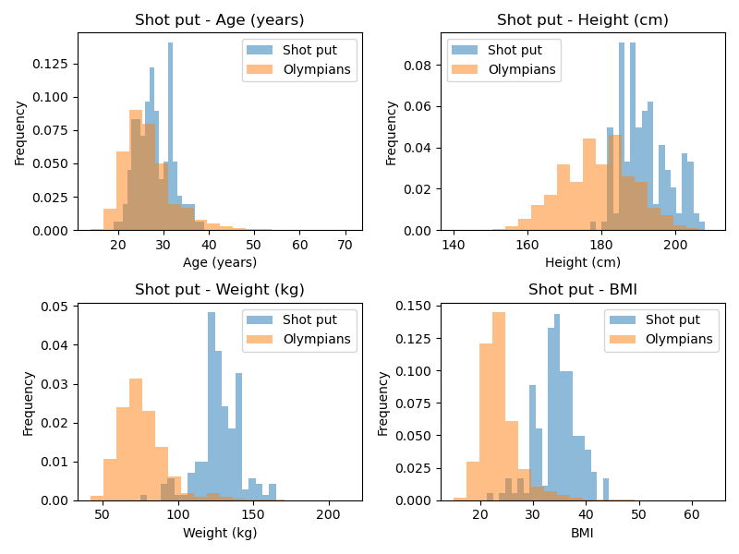

**Men’s high jump**

The average biometrics for male high jumpers are:

Age: 26

Height: 192 cm

Weight: 77 kg

BMI: 20.7

High jumpers are younger, taller and have a lower BMI than the average Olympian.

Histograms comparing the distribution of each biometric between male high jumpers and Olympians competing in other sports.

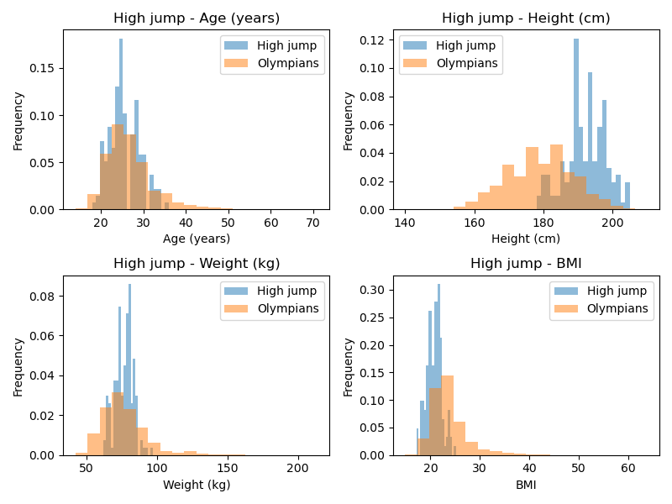

**Comparison across selected sports**

Plots showing how each biometric varies across the different sports analysed.

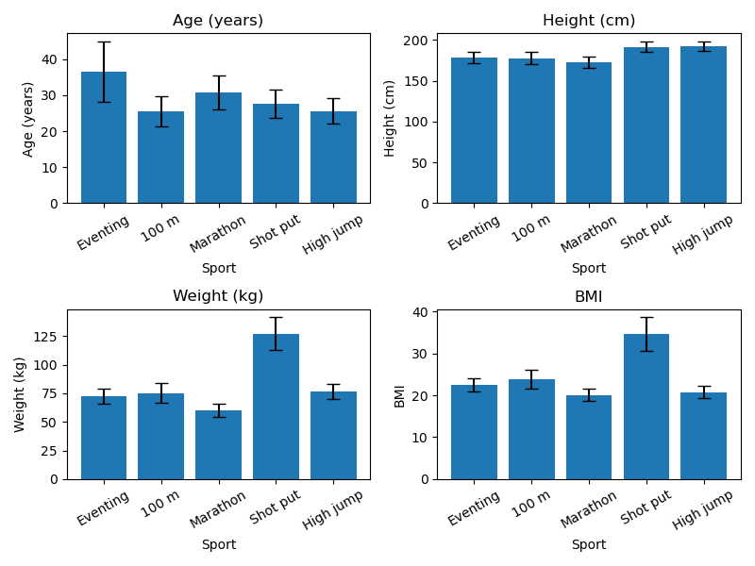

**Olympic games’ location**

A peak in the number of medals, and specifically gold medals, was observed when a country held the Olympic games.

Total medals:

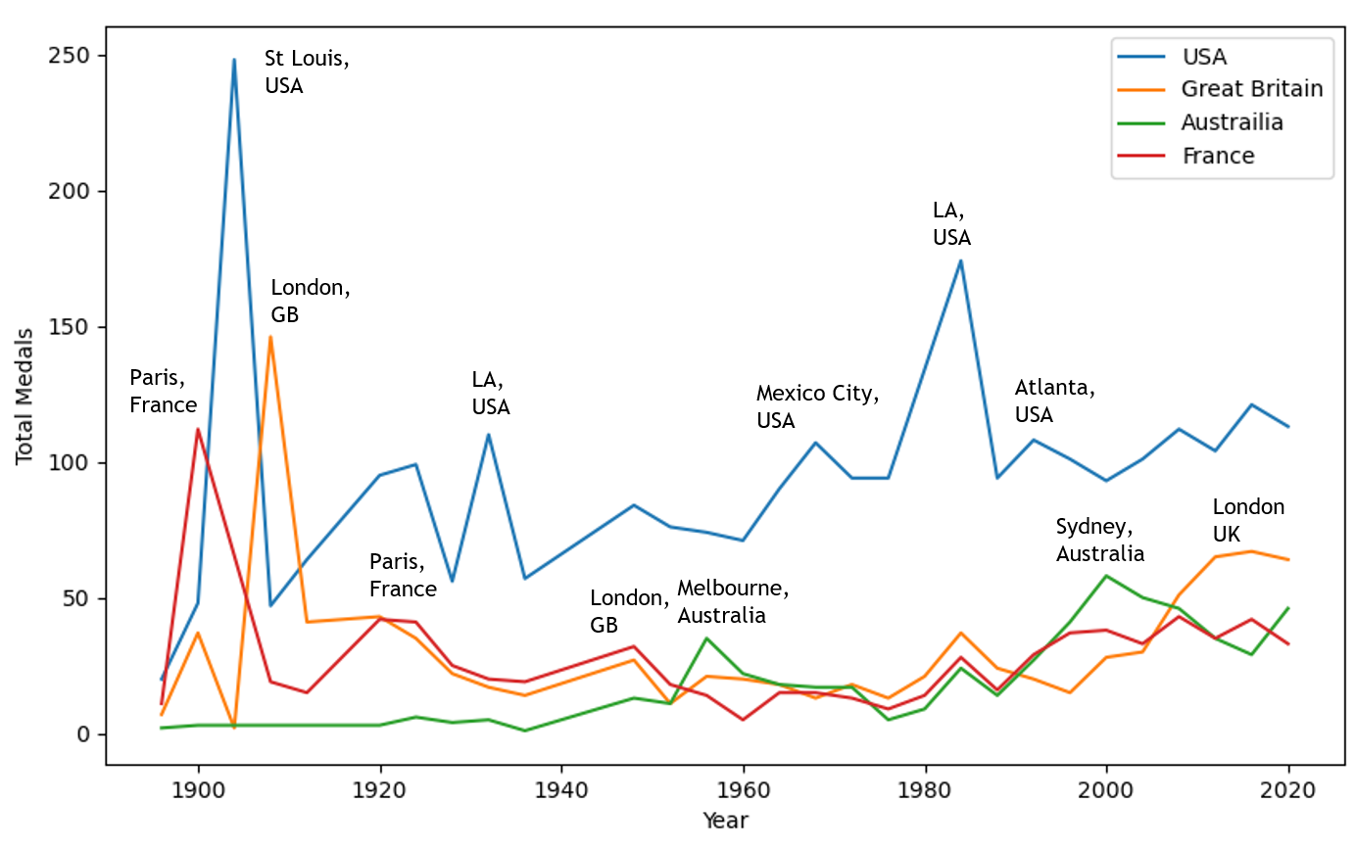

Gold medals:

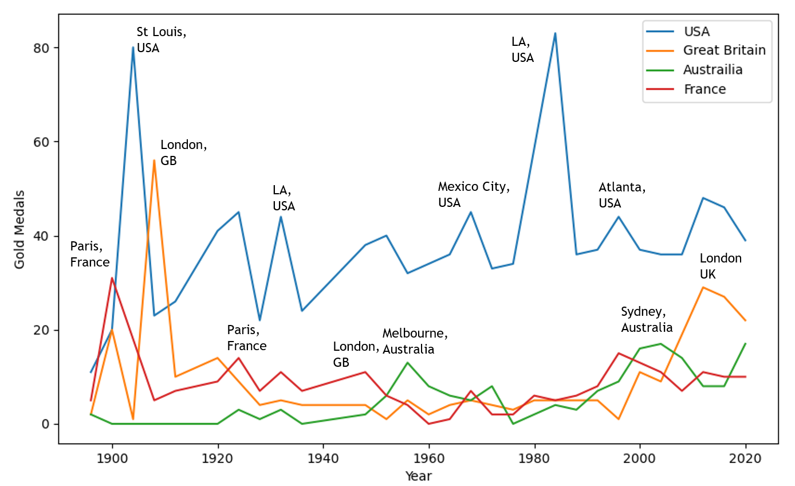

**Population**

A positive correlation was found between the population of a country and the number of total and gold medals gained with larger countries generally achieving more medals. There were 8 outliers found in the results which were attributed to the People’s Republic of China and India. As these countries have very large populations the results were omitted. This increased the Pearson correlation from 0.41 to 0.59 for the total number of medals and 0.46 to 0.58 for gold medals showing a stronger association.

Total medals:

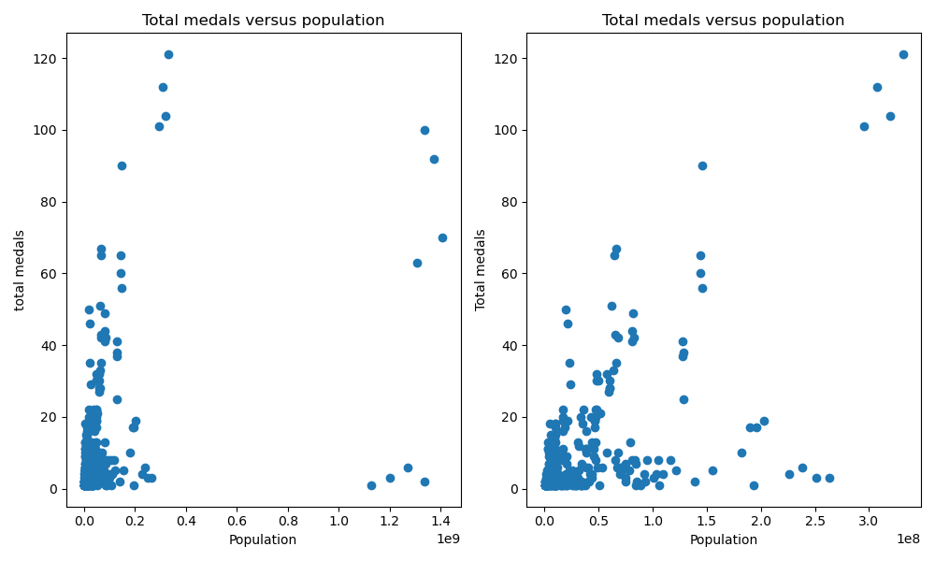

Gold medals:

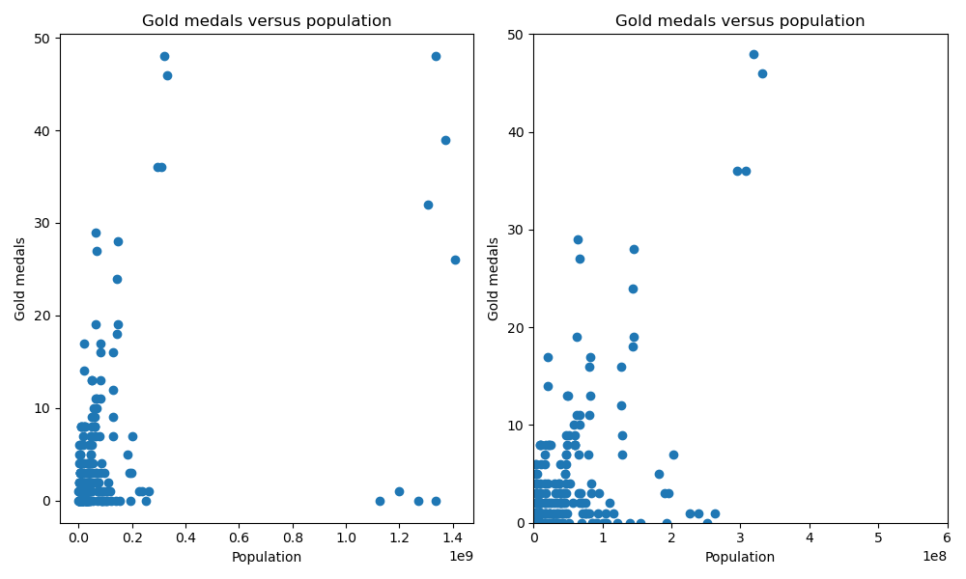

**GDP**

A positive correlation was also found between the GDP of a country and the number of total and gold medals obtained with wealthier countries generally achieving more medals. Pearson correlations of 0.80 (total medals) and 0.79 (gold medals) were calculated highlighting a strong correlation between the variables.

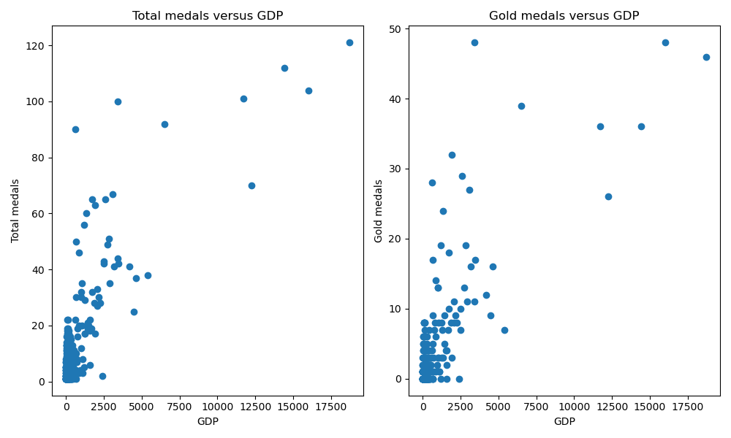

**Conclusions**

Based on the analysis above, to have the greatest chance of winning a medal you must:

* Have the correct biometrics for your chosen sport
* Compete when the Olympics is being held in your country
* Be from a wealthy country with a large population