|  |
| --- |
|  |

**LITTLE TERRESTRIAL SUPPORT FOR CARBON CYCLING IN LAKES OF INTERIOR ALASKA**

**MODERN ENDOGENOUS ORGANIC MATTER DOMINATES THE CARBON FLOW IN LAKES OF NORTH CENTRAL ALASKA**

Matthew J. Bogard1, Catherine Kuhn1, Gordon W. Holtgrieve2, Robert Striegl3, Mark Dornblaser3, David E. Butman1,4

**Affiliations:**

**1** School of Environmental and Forest Sciences, College of the Environment, University of Washington, Seattle, WA, U.S.A.

2 School of Aquatic and Fisheries Science

3USGS

4College of Engineering

**Corresponding author:** M.J. Bogard. (Ph: +1-206-402-7011; Email: bogard.matt@gmail.com)

Title: 15 words

Abstract: 270 words

Text (1500): 2143 words

Refs (30): too many

Legends (100 each): 114, 48, 90

Figs: 3

Methods (3000): not done yet

**Keywords:** Alaska, lake, carbon cycle, metabolism, permafrost, organic carbon

**ABSTRACT**

**Warming and hydrologic changes have led to a decadal-scale increase in greenhouse gas (GHG) emissions from northern landscapes underlain by organic carbon (OC)-rich permafrost (Walter-Anthony et al. 2016; Commane et al. 2017; European ref.). Such shifts may represent a destabilization of the vast (Tarnocai et al. 2009) northern OC-stores, however the coupling between atmospheric warming and terrestrial OC mineralization is poorly constrained, and efforts to forecast future C-climate feedbacks are hindered by uncertainties in the fate of OC stored in the circumpolar landscape (Mishra and Riley 2012; Schuur et al. 2015) and in particular, the export and processing of terrestrial OC in aquatic networks (Battin et al. 2009; Tranvik et al 2009; Vonk et al. 2015; Butman et al. 2016; Stackpoole et al. 2017).** **Here, we help constrain this uncertainty with the first direct assessment of whole ecosystem metabolism (food web OC processing) in lakes of the discontinuous-permafrost zone of the Alaskan interior. We combine metabolic estimates with limnological, geochemical, and remote-sensing data to show lakes in this transitional zone currently process little terrestrial OC, receive little influence from ancient permafrost-derived OC, and contribute < 1% to the integrated watershed net C balance. Though not hotspots of terrestrial OC cycling as is commonly assumed, most study lakes synchronously generated then remineralized massive quantities of endogenous OC over the complete annual cycle, underscoring their importance as critical habitat and sites of material and energy provision to food webs in an otherwise low-productivity terrestrial environment. The shallow, hydrologically-disconnected, and nutrient-rich nature of these, and likely many other high-latitude lakes may render them insensitive and comparatively inactive in the global C-climate feedback.**

**TEXT**

Roughly half of the planet’s below-ground organic carbon (OC) is stored in northern circumpolar landscapes, over 85% within permanently frozen (permafrost) soils (Tarnocai et al. 2009). Atmospheric warming and changes to landscape structure and hydrology (Rouse et al. 1997; Bouchard et al. 2015 Science) are increasingly thawing permafrost soils (Schuur et al. 2013), and in some regions, mobilizing both ancient and modern terrestrial OC, which was previously stored for decades to millennia, into the hydrologic network (Tranvik et al. 2002?; Vonk et al. 2015; Walter Anthony 2016). As aquatic ecosystems cover up to ~23% of the northern landscape (Verpoorter et al. 2014; Vonk et al. 2015), they are often closely connected to terrestrial environments and actively bury, decompose, and transform terrestrial OC upon entering the hydrologic network (Kling et al. 1991; Battin et al. 2009; Tranvik et al. 2009; Vonk et al. 2015), thereby reducing estimates of terrestrial OC storage capacity in some cases by up to ~30% (Butman et al. 2016; Stackpoole et al. 2017). Therefore, a major source of uncertainty in explaining high-latitude OC cycling lies in coupling aquatic and terrestrial OC cycles.

Studies of OC processing in circumpolar aquatic ecosystems have focused on thermokarst (define) lakes, epically those found in unique, Yedoma (define)-rich regions of Siberia and northern Alaska. Thawing of Yedoma induces lake expansion and incorporation and decomposition of massive quantities of ancient terrestrial OC at lake margins, resulting in directly scalable increases in atmospheric methane (CH4) (Walter-Anthony 2106). The generalizability of these findings to broader arctic/subarctic aquatic C cycling is unclear, however, because Yedoma is confined to X% of the high-latitude landscape, soil OC content is much lower in most northern regions (< ~1%; Zimov et al. 2009; Tarnocai et al ?), C-sequestration by aquatic photosynthesizers is seldom considered alongside OC mineralization (Walter Anthony et al. 2016b), and because non-Yedoma regions are under-represented in high-latitude aquatic C sampling efforts. Most laterally connected (wording?), temperate and southern boreal lakes tend to be heterotrophic, receiving large inputs of terrestrial OC that sustain heterotrophic OC processing and rates of ecosystem respiration above rates of ecosystem gross primary production (R > GPP) (Solomon et al. 2013; Yang et al. 2015; Bogard & del Giorgio 2016). But lakes in topographically flat permafrost regions often lack persistent in- or outflows and can have longer hydraulic residence times (Anderson paper; hydrology paper?), characteristics that are associated with reduced capacity to process terrestrial OC (Algesten et al. 2005; Catalan et al. 2016). Consequently, for the vast majority of the circumpolar landscape, the role of lakes in regional OC processing is unknown.

Here, we present the first direct survey of ecosystem metabolic patterns in remote northern Alaskan lakes (in the Yukon River Basin; YRB; Fig. S1). The YRB is nearly 106 km2 in area, and constitutes the 4th largest drainage basin in North America (ref). Some detail on the basin, lake hydrology, and generalizability to other boreal/subarctic regions…. Transition zone underlain by continuous and discontinuous permafrost. To establish a baseline understanding of the rates, patterns, and controls of lake OC processing, we quantified biotic processing of OC, the major driver of OC cycling in lakes (Koehler et al. 2014ish; Graneli et al. 1996), defined as net ecosystem production (NEP), with NEP = GPP – R (where R is the sum of auto- and heterotrophic respiration) (Lovett et al. 2006). Where NEP is > or < 0, the lake food web is auto- or heterotrophic, and represents a respective net source or sink of OC during a given measurement period (Lovett et al. 2006). The 20 lakes sampled spanned an environmental gradient representative of the conditions found in the vast majority of YRB lakes (Add supporting limnology table), ranging from extremely shallow, eutrophic, OC-rich lakes in the Yukon River Flats at low elevation (~100m asl, and the dominant lake type in contribution to total basin-wide lake area [Fig. S2]) to comparatively nutrient- and DOC-poor foothill lakes of moderate depth (up to ~300m asl). Lakes were visited once each in June and September of 2016, and a subset (n=15) during the ice-covered period of April, 2017.

Extreme, cross-season shifts in DO chemistry observed here are among the largest reported in the literature for pristine lakes, underscoring the extreme seasonality in metabolism and food-web OC processing in YRB lakes. Spring DO pools were mostly oversaturated and isotopically depleted relative to atmospheric equilibrium (Fig. 1a; spring DO mean = X, S.D. = Y; 18O-DO mean = X, S.D. = Y). By fall, DO pools were exclusively undersaturated and isotopically enriched relative to spring 18O (fall DO mean = X, S.D. = Y; 18O-DO mean = X, S.D. = Y). This trend continued into winter, as under-ice DO pools often reached extreme undersaturation and isotopic enrichment (winter DO mean = X, S.D. = Y; 18O-DO mean = X, S.D. = Y).

Mass-balance estimates of metabolism revealed dramatic seasonality in GPP, but not R, which induced a synchronous, regional shift from auto- to heterotrophy among lakes over the comparatively short (~4-5 month) ice-free period. Spring GPP ranged considerably (stats; Fig. 1b), reaching rates comparable to heavily impacted, hyper-eutrophic lakes found in human-dominated regions (Solomon et al. 2013). By fall, rates of GPP were X-fold lower than in spring. Rates of R in spring were also high relative to global lake estimates (stats and refs), but typically < GPP (Fig. 1c). These rates were sustained into the fall, shifting lakes all to a heterotrophic state, with GPP:R < 1 (Fig. S3) and NEP < 0 (Fig. 1d). Extreme heterotrophic ratios of GPP:R persisted through the winter (i.e., < 0.5, Fig. S2), with consistently low, but negative rates of NEP (inset, Fig. 1d). Agreement between the isotopic approach and high-frequency estimates of surface DO saturation in two study lakes of contrasting metabolic and limnological characteristics (Fig. S3) indicates that point isotopic samples effectively captured diverse metabolic conditions that were sustained over multi-week windows of time among YRB lakes. The spatially synchronous seasonal shift among the lakes from spring auto- to fall heterotrophy shown using isotopic (Fig. 1d, Fig. S3b) and high-frequency (Fig. S3a) approaches was also reflected in seasonal trends of remotely sensed blue:green ratios of…details…, a proxy of lake autotrophic growth in our 20 lakes (report synchrony value for seasonal blue:green trend; Fig. S4). The extreme rates and spatially synchronous nature of metabolism underscores the importance of the many YRB lakes as key sites on the landscape for OC recycling, energy mobilization, and broader food-web support, especially given the relatively unproductive nature of the surrounding terrestrial environment (ref).

Model intercepts from regression of R against GPP (Fig. 2) were used to infer regional, seasonal baseline rates of R driven by heterotrophic community consumption of terrestrial OC, independent from cycling of endogenous (lake-derived) OC (del Giorgio & Williams 2005; Solomon et al. 2013). Rates of baseline R were greatest in spring (1.7 g O2 m-2 d-1, or X g C m-2 d-1, assuming a respiratory quotient of 1 [Solomon et al. 2013]), and declined by fall (0.7 g O2 m-2 d-1, or X g C m-2 d-1). This seasonality of terrestrial OC consumption is consistent with the seasonality of terrestrial OC influx into boreal/sub-arctic lakes, with most input occurring during the spring freshet (refs), followed by little summer/fall runoff and reduced influx of mineralizable exogenous materials to the lakes (which is especially true for the precipitation-poor YRB [Stackpoole et al. 2017]) YRB. When scaled to the whole YRB, lake mineralization rates of terrestrial OC currently represent a minor term (X Tg OC yr-1, using spring baseline R and lake area of X km2 [Stackpoole et al. 2017]). Had we missed CH4 released from thawing lake margins, it would not have amounted to much extra OC (potential amount estimated by Stackpoole et al. (2017)), and radio-isotope composition of lake OC (14C-DOC) confirmed little current input of ancient terrestrial OC in a subset of study lakes (Fraction modern statistics; Fig. S5). Clearly, YRB lakes collectively mineralized little terrestrial OC relative to endogenous (lake-derived) OC, and the lakes are not hot-spots of terrestrial C processing and transformation, as is commonly assumed for northern lakes (refs).

Autotrophic production was so efficient in spring that a major fraction of endogenous OC escaped heterotrophic mineralization (i.e., spring slope of R vs. GPP << 1, fig. 2), in turn fuelling the massive shift to fall heterotrophy, as indicated by the largest seasonal shifts in metabolic balance occurring in lakes with the highest spring GPP, and the fact that 13C signatures of fall DIC approximated those of aquatic vegetation (i.e., X per mille Fig. S6). These findings show a striking deviation from the comparatively well-studied boreal and north-temperate lakes for which terrestrial inputs widely sustain ecosystem heterotrophy (Karlsson et al. 2007; Tranvik et al. 2009; Bogard & del Giorgio 2016), lending support to the hypothesis that autotrophy may be common in many high-latitude lakes, which potentially exert an atmospheric cooling effect via net OC accumulation over decadal to century-long timescales (Walter-Anthony et al. 2016 Nature paper here).

Spring NEP, GPP, and R showed no connection to gradients in either dissolved organic carbon (DOC; Fig. 3a, S7) concentration or specific ultraviolet absorbance of DOC (SUVA), an indicator of OC aromaticity used as a proxy for terrestrial OC contribution to the DOC pool (Fig 3b, S7). Instead, the highest rates of NEP occurred in shallow lakes (< ~ 5m deep) that were large relative to their depth (Fig. 3c; stats with and without the high-elevation outlier), located at lower elevations in the Yukon River flats (< XXX m asl; Fig. S7; Fig. S2). The most autotrophic lakes were actually those with limited light penetration (Fig. 3d; *r* = -0.57, *p* = 0.03). Despite brown-water conditions and reduced Secchi disk depths in some lakes, the photic zone still extended to the sediment layer at >70% of our fall deep-water measurement sites (Fig. S8). The shallow, well mixed, nutrient rich (Heglund & Jones 2003) and well-lit growing environment explains how most lakes in the YRB can support extreme autotrophic growth and biomass, a conclusion supported by the consistently green nature of most of the > 10,000 lakes surveyed remotely for plant pigment… details for figure S4B remote sensing. Although fall shifts to heterotrophy (Fig. 1d; Fig. 2) were most intense in DOC-rich lakes (Fig. 3a; *r* = X, *p* = 0.00X), this OC was of low aromaticity (Fig. 3b, *r* = X, *p* = Y), further supporting our conclusion that endogenous OC generated in the spring likely drove this net metabolic shift. Rates of fall NEP were unrelated to either lake morphometry or the light climate (Fig. 3c,d), but tended to be most heterotrophic in the most hydrologically-disconnected lakes (Fig. 3e; *r* = X, *p* = 0.00X). Taken together, our findings indicate that the shallow nature and slow flushing of lakes in the YRB, and likely many other northern areas (Fig. S1) may render a large proportion of high-latitude systems less metabolically sensitive to climate-driven increases in terrestrial OC input (Larsen et al. 2012ish) and shading-induced losses in areal rates of phytoplankton or benthic autotrophic growth that potentially threaten net metabolic balances of comparatively deeper, nutrient poor, dark water, OC-rich systems in Boreal Shield and Boreal/Sub-Arctic Scandinavian regions (Ask et al. 2012). Instead, the synchronous nature of metabolic patterns across the YRB (Fig. 1, Fig. S4) are consistent with findings in other arid, northern regions (Finlay et al. 2015) that show lake C cycling patterns may be strongly regulated by broad scale climatic drivers that regulate the influx of energy into lakes.

Our direct observation of widespread and extreme autotrophic growth in YRB lakes is consistent with other Arctic observations (Tank et al. 2009ish; Walter-Anthony et al. 2016), and suggests that many boreal and subarctic lakes deviate from the comparatively unproductive and commonly heterotrophic nature of dilute northern lakes (Tranvik et al. 2009; Ask et al. 2012; Bogard et al. in prep). Unlike the latter, we inferred little terrestrial OC mineralization in our comparatively flat basin study lakes with long hydraulic residence times, a conclusion in line with syntheses showing aquatic remineralization of terrestrial OC scales inversely with residence time (Algesten et al. 2005; Catalan et al. 2016). We also found little evidence for lake processing of ancient, permafrost-derived terrestrial OC. These findings collectively imply that in many northern regions, lakes may not currently be hotspots of terrestrial OC processing. Rather, the arid, topographically-flat, and relatively unproductive terrestrial setting (refs) within which lakes of the YRB, and other comparable circumpolar environments are found, underscores the importance of these lakes as regional energy exchange hubs and key habitats generating massive quantities of endogenous materials to provide energy and habitat for both local (ref) and migrant (ref) components of the northern food web. Concluding sentence tying it back to climate change… direct effects from climatic shifts may have the biggest effect on lake metabolism and OC processing in these lakes.

**FIGURE LEGENDS**

**Figure 1. Seasonality in oxygen and metabolism in YRB lakes.** **a**) Cross-lake patterns in dissolved oxygen (DO) saturation relative to isotopic composition. **b**) Mass balance estimates of gross primary production (GPP), **c**) ecosystem respiration (R), and **d**) net ecosystem production (NEP) with under ice NEP (inset) estimated under ice in winter 2017, with grey horizontal line denoting NEP = 0. Log axis scales in boxplots?

**Figure 2. Relationship between areal ecosystem respiration (R) and gross primary production (GPP) among lakes and seasons.** Lines summarize the major axis regression models, with spring R = mX + b (*r*2 = X; *p* = X) and fall R = mX + b (*r*2 = X; *p* = X).

**Figure 3.**  **Linking areal rates of net ecosystem production (NEP) to limnological features among lakes and seasons.** Lake NEP as a function of **a**) dissolved organic carbon (DOC) concentrations, **b**) specific ultra-violet (254nm) absorbance of DOC (SUVA), **c**) the ratio of lake surface area (km2) to total depth at the sampling site (Zmax; m), **d**) vertical light penetration as measured by Secchi disk depth profiles taken in the fall of 2016, and **e**) lake hydrology fig. Spring and fall denoted by green and blue symbols as in Figs. 1 and 2. Correlation results shown only for significant relationships (i.e., *p* < 0.05).

**FIGURES**

**Figure 1**

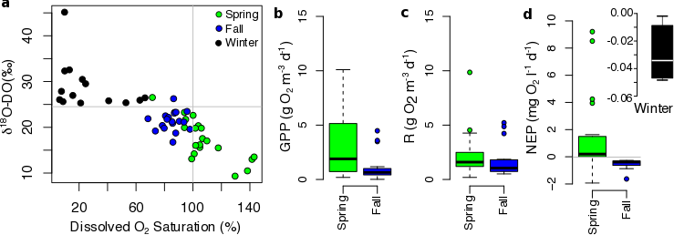

**Figure 2**

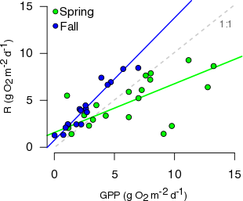

**Figure 3**

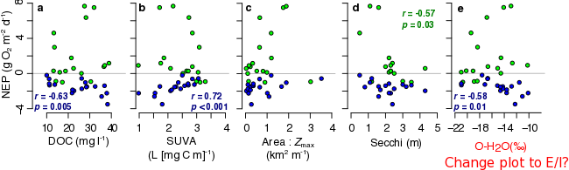

**METHODS**

**Study Site**

**Field Sampling**

**Laboratory Analyses**

**Stable and Radio Isotopes**

**Oxygen isotopic modeling approach**

To estimate GPP and R, DO fluxes and isotopic effects are combined in a series of mass balance equations originally presented by Quay et al. (1995) and Bender and Grande (1987). Assuming no vertical exchange with the deeper layers, temporal changes in surface waters concentrations of DO (*d*DO/*d*t) depend on rates of GPP, R, (here in mg O2 m-3 d-1) and rates of *F* relative to mixed layer depth (*Z*mix):

*d*DO / *d*t = *F* / *Z*mix + GPP – R (2)

Temporal changes in the concentration of 18O in DO (*d*18O-DO/*d*t) depend on the same processes as DO concentration, but additionally depend on the isotopic ratios (18:16O) of each oxygen pool, and fractionation factors associated with each process:

*d*18O-DO / *d*t = *k*O2 × *g* × (DOsat × 18:16Oair × *s* – DO × 18:16ODO) / Zmix + (3)

(GPP × 18:16OH2O × *p*) – (R × 18:16ODO × C)

Here DO and DOsat are ambient and saturation DO concentrations, respectively, and isotopic ratios of DO, of atmospheric O2 and oxygen in water are given as 18:16ODO, 18:16Oair , and 18:16OH2O, respectively. Terms *g*, *s* and *p* represent fractionation effects during kinetic gas exchange at the air-water interface, gas solubility effects, and photosynthesis, respectively.

We used a new term in equation 3 (C), the combined, ecosystem-level isotopic fractionation during DO uptake, which integrates the individual effects of pelagic R (PEL-R), sedimentary R (SED-R), and photochemical DO consumption (PHOTO) on 18O-O2 (Fig. 1). Though sediment R has been considered in metabolic models for bottom waters (Quiñones-Rivera et al. 2007), most studies have estimated surface water metabolic rates or GPP:R assuming pelagic R (with associated PEL-R ~0.982 – 0.970) is the only process consuming DO in the water column (Quay et al. 1995; Luz et al. 2002; Russ et al. 2004; Quiñones-Rivera et al. 2007, 2015; Bocaniov et al. 2012, 2015). This assumption can yield reasonable model outputs consistent with *in-vitro* results in large, open aquatic systems that are dominated by pelagic R (Bocaniov et al. 2012). Yet this may not be suitable in other lakes (e.g., small, dystrophic northern systems; Chomicki and Schiff 2008), since sedimentary R and photo-oxidation of OM often contribute significantly to DO uptake (Granelli et al. 1996; den Heyer and Kalff 1998; Kortelainen et al. 2006; Vachon and del Giorgio 2014). Evidence from marine and lotic habitats dominated by sediment R have shown that SED-R can importantly affect ecosystem-level fractionation effects, estimated to be ~0.994 in coastal bottom waters (Quiñones-Rivera et al. 2007; Lehmann et al. 2009). Consequently, values of C may be larger (i.e., a smaller fractionation effect) than PEL-R, and the implications for this difference are discussed below.

Assuming no net change in either DO concentration or 18O-O2 over a diurnal cycle, equations 2 and 3 can be combined, rearranged, and solved for GPP and R individually (Bocaniov et al. 2012, 2015), generating equations 4 and 5:

GPP = (*k*O2 / Zmix) × [ DO× (*b* - *c*) - DOsat× (*a* - *c*) ] / *d* - *c* (4)

R = (*k*O2 / Zmix) × [ DO× (*b* - *d*) - DOsat× (*a* - *d*) ] / *d* - *c* (5)

Where, following the notation of Bocaniov et al. (2012), *a* = 18:16Oair × *s* × *g*, *b* = 18:16ODO × *g*, *c* = 18:16ODO × *C*, and *d* = 18:16OH2O × *p*.

**High frequency metabolic modeling approach**

**Statistical analyses**

**SUPPORTING FIGURES**

**Figure S1.** Map of study lakes in the Alaska portion of the Yukon River Basin. Update map with watershed boundary, elevation contours with different colors, and redo the NASA ABoVE map.

Add a B panel with circumpolar topography, soil C content, and runoff to identify arid flat zones similar to much of YRB.

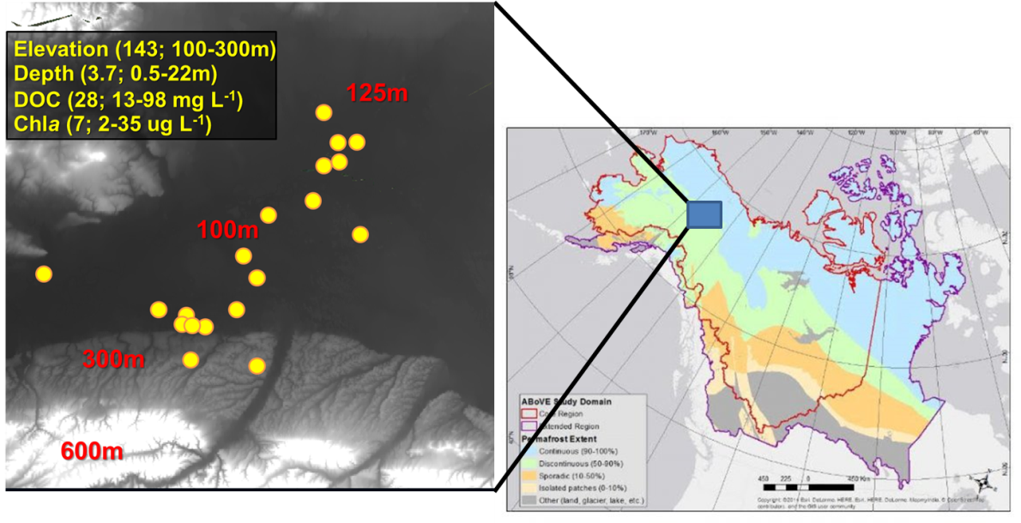

**Figure S2.** YRB lake area % contribution scaled by elevation.

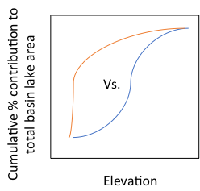

**Figure S3.** **a**) Hourly estimates of surface layer dissolved oxygen (DO) saturation (left Y axis) were recorded in 2016 in two study lakes, shown as 4-day moving averages (black line: Canvasback lake; dashed red line: Boot lake), and are compared to point estimates of GPP:R derived from spring and fall sampling, as described in the methods (right Y axis; circles: Canvasback Lake; triangles: Boot Lake). Both techniques captured extreme spring auto-, and fall heterotrophy in Canvasback Lake (our shallow, productive, DOC-rich lowland site), and the finer-scale metabolic shifts in Boot Lake (deeper, nutrient and DOC-poor, upland site; see mapped lake locations in Figure S1 and limnological features in Table SX). **b**) Mass balance estimates of GPP:R for all lakes among seasons. Grey circles are extreme outliers (GPP:R = X and Y). Add n = to each box in b

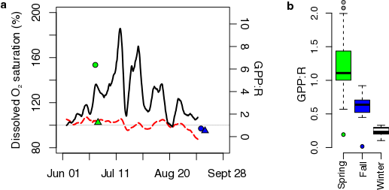

**Figure S4. Remote Sensing Figures -> A) compute synchrony of seasonal ratio patterns in the 20 lakes. B)**

**Panel A will be the timeseries for our lakes for 2016, cleaned up and with synchrony values calculated**

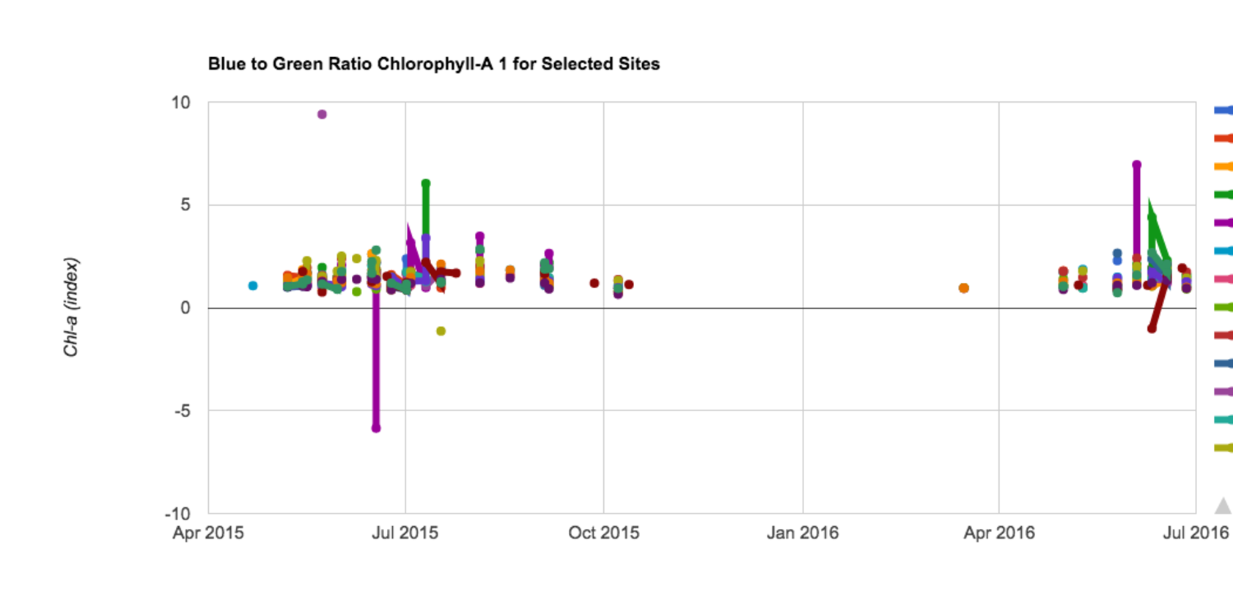

**Panel B will be a histogram of mid-summer blue:green for our lakes overlaid on the basin-wide histogram for a randomly selected subset of 10,000 lakes. THE POINT: To show that most lakes in the YRB turn into jungles in the summer and we didn’t cherry pick.**

**Figure S5.** Isotopic composition of dissolved organic carbon (DOC) in a subset of the study lakes.

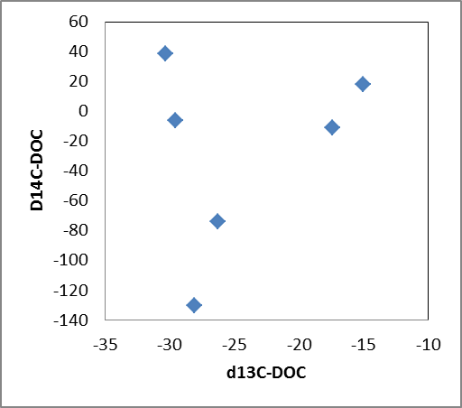

**Figure S6.** DIC-C13 data

**Figure S7.** Isotopic composition of dissolved organic carbon (DOC) in a subset of the study lakes.

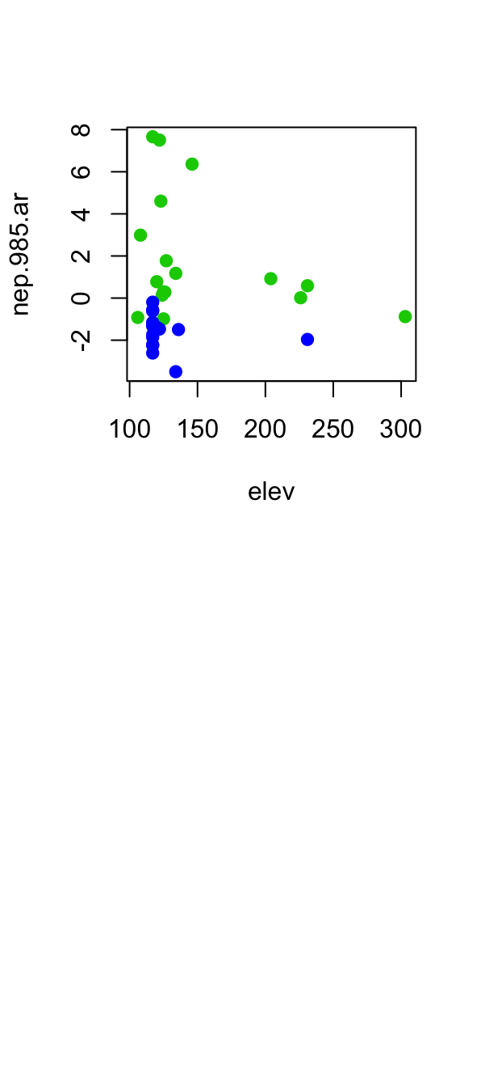

**Figure S8.** Assessing the light availability in the benthic zone of lakes. Here we compare the measured maximum depth at the sampling site (Zmax) to the ratio of euphotic zone depth (Zeu; derived from multiplying secchi disk depth by 2.7) to Zmax for each lake in fall 2016. A ratio > 1 indicates light fully reached the sediment layer at the sampling site.

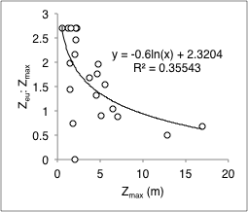

**Figure S9.** Limnological correlates of lake GPP and R, divided by 2016 spring (green) and fall (blue) sampling periods. Clean up and add stats

