Cruise data analysis: Radiometric properties and AOPs.

Processing assignments:

Generate dark corrected and surface irradiance reference corrected (profiled measurements only) radiometric quantities. Use the median surface irradiance over the cast for the latter normalization. Filter out high tilts (e.g., > 5 deg) and all upcasts in the profiled data. Compute surface PAR and PAR(z) from these radiometric quantities. Generate several depth-binned versions of the profiles using a different vertical bin size for each (from 20 cm to 2 m). Visually verify that the vertically binned data accurately represent the un-binned profiles. Subsample the depth profiles further to simulate data collected on a buoy or mooring by retaining data at only 1, 4, and 9 m.

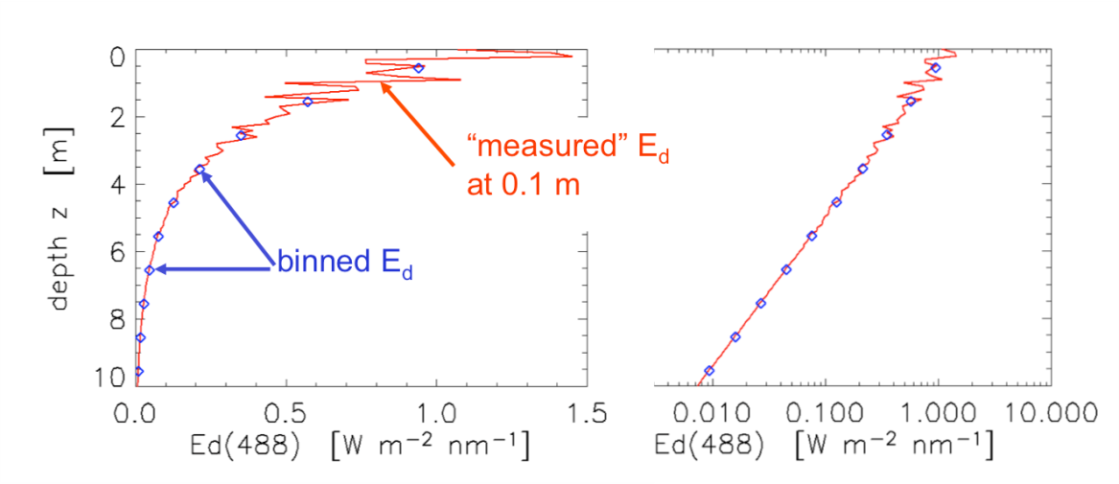

Assignments:

For simplicity and clarity, you may choose to focus on three RGB wavelengths, e.g., 443, 555, and 670 nm. Derive Kd(z), KLu(z), and Kpar(z) for each of the vertically binned profiles, including the 1/4/9 m mooring simulation. How do they relate? Are Kd(z) and KLu(z) similar? Are Kd(z) and Kpar(z) similar? Using a single method to calculate K, derive average Kd, KLu, and Kpar for three water column thickness: the very near surface layer, the first optical depth (37% light level), and the second optical depth (13% light level). How do they relate? For one of the vertical profiles, re-derive these average values using different calculation techniques: averaging Kd(z), linear fitting to log(Ed) vs. z, and a nonlinear fitting to Ed vs. z. How do they relate? For the latter two, recall that Ed(z) = Ed(0-) exp(-Kd z) and that you did very similar curve fitting in your absorption and attenuation labs.

Calculate Lw, Ed(0+), and Rrs for the HyperPRO profiles. Do so using vertically binned and un-binned data. How do the Rrs compare? Over which depth intervals did you calculate K’s to extrapolate to near-surface values? Do these values have spectral dependence? Do you get similar Rrs if you use K’s calculated over larger depth intervals (e.g., first and second optical depths)? (Unfortunately, recall that the HyperPRO data below 22 m cannot be used because of a problem with the pressure sensor.) How do the Ed(0+) extrapolated from Ed(z) compare with Ed(0+) from the surface reference sensor?

Generate a profile where you haven’t filtered for high tilt. How do the derived K’s and Rrs compare? Calculate Rrs using profiles collected in the ship shadow and with an inaccurate pressure tare. How do the derived K’s and Rrs compare? Generate a profile (one with a patchy sky, probably from Cruise 1) where you haven’t normalized the in-water data to the reference surface irradiance. How do the derived K’s and Rrs compare? For all of the above, how do these Ed(0+) extrapolated from Ed(z) compare with Ed(0+) from the surface (above-water) reference sensor? Comment on the need for accurate pressure tares and knowledge of the offsets between the Lu, Ed, and pressure sensors.

Calculate Lw and Rrs for the HyperSAS and HTSRB. How do these values compare with those from the vertical profile? Did either the HTSRB or HyperSAS observe changes in Rrs with time? Do you see tilt and roll effects in the HTSRB data? Can you identify times when the HyperSAS was pointed too close to the plane of the sun (e.g., < 90 deg azimuth)? Using the HyperPRO data in buoy mode (cruise 2), calculate R. How does R compare with Rrs (the HTSRB was collecting data simultaneously)? Using the HyperPRO data in buoy mode, calculate Q. How does Q vary spectrally compared with pi?

Calculate a(z), b(z), c(z), and bb(z) for the slow-drop and wired profiles (note: add salt water contribution). How do they compare? Kd is proportional to (a + bb). Model Kd(z) using your IOPs – for example, following Gordon 1989, which describes Kd = 1.0395 * (a + bb) / mu_w, where mu_w is cos(solar zenith angle *in water*). Other methods include Kirk 1984, Morel and Loisel 1998, and Lee et al. 2005. How does Kd(z) derived from AOPs compare with that derived from IOPs? Calculate optically-weighted, average IOPs for the first optical depth using the appropriate Kd (following, e.g., Smith 1981). How do IOPs collected at the surface and near a deep Chl maximum compare with depth-weighted IOPs? How do the median IOPs for the first optical depth compare with their optically weighted averages?