Python Tutorial

First, you need to import several important Python packages for data manipulation and scientific computing. The pandas package is helpful for data manipulation and the NumPy package is helpful for scientific computing.

import pandas as pd  
import numpy as np

In Python, comments are indicated in code with a "#" character, and arrays and matrices are zero-indexed.

# 1 Reading in Data and Basic Statistical Functions

## 1.1 Read in the data.

The following demonstrate importing data in Python given 3 different data formats. The pandas package is able to read all 3 formats, as well as many others, using [Python IO tools](http://pandas.pydata.org/pandas-docs/version/0.20/io.html).

### a) Read the data in as a .csv file.

student = pd.read_csv('/Users/class.csv')

### b) Read the data in as a .xls file.

# Notice you must specify the file location, as well as the name of the sheet   
# of the .xls file you want to import  
student_xls = pd.read_excel(open('/Users/class.xls', 'rb'),   
 sheetname='class')

### c) Read the data in as a .json file.

student_json = pd.read_json('/Users/class.json')

## 1.2 Find the dimensions of the data set.

The dimensions of a DataFrame in Python are known as an attribute of the object. Therefore, you can state the data name followed by ".shape" to return the dimensions of the data.

print(student.shape)

## (19, 5)

## 1.3 Find basic information about the data set.

Information about a DataFrame is available by calling the ".info()" function on the data.

# Notice that student is a DataFrame object  
print(student.info())

## <class 'pandas.core.frame.DataFrame'>  
## RangeIndex: 19 entries, 0 to 18  
## Data columns (total 5 columns):  
## Name 19 non-null object  
## Sex 19 non-null object  
## Age 19 non-null int64  
## Height 19 non-null float64  
## Weight 19 non-null float64  
## dtypes: float64(2), int64(1), object(2)  
## memory usage: 840.0+ bytes  
## None

## 1.4 Look at the first 5 observations.

The first 5 observations of a DataFrame are available by calling the ".head()" function on the data. By default, head() returns 5 observations. To return the first *n* observations, pass the integer *n* into the function. The tail() function is analogous and returns the last observations.

print(student.head())

## Name Sex Age Height Weight  
## 0 Alfred M 14 69.0 112.5  
## 1 Alice F 13 56.5 84.0  
## 2 Barbara F 13 65.3 98.0  
## 3 Carol F 14 62.8 102.5  
## 4 Henry M 14 63.5 102.5

## 1.5 Calculate mean of numeric variables.

# By default, the mean() function returns the mean of numeric variables of   
# the data only  
print(student.mean())

## Age 13.315789  
## Height 62.336842  
## Weight 100.026316  
## dtype: float64

## 1.6 Compute summary statistics of the data set.

Summary statistics of a DataFrame are available by calling the ".describe()" function on the data.

print(student.describe())

## Age Height Weight  
## count 19.000000 19.000000 19.000000  
## mean 13.315789 62.336842 100.026316  
## std 1.492672 5.127075 22.773933  
## min 11.000000 51.300000 50.500000  
## 25% 12.000000 58.250000 84.250000  
## 50% 13.000000 62.800000 99.500000  
## 75% 14.500000 65.900000 112.250000  
## max 16.000000 72.000000 150.000000

## 1.7 Descriptive statistics functions applied to variables of the data set.

# Notice the subsetting of student with [] and the name of the variable in   
# quotes   
print(student["Weight"].std())

## 22.773933493879046

print(student["Weight"].sum())

## 1900.5

print(student["Weight"].count())

## 19

print(student["Weight"].max())

## 150.0

print(student["Weight"].min())

## 50.5

print(student["Weight"].median())

## 99.5

## 1.8 Produce a one-way table to describe the frequency of a variable.

### a) Produce a one-way table of a discrete variable.

# columns = "count" indicates to make the descriptive portion of the table   
# the counts of each level of the index variable  
print(pd.crosstab(index=student["Age"], columns="count"))

## col_0 count  
## Age   
## 11 2  
## 12 5  
## 13 3  
## 14 4  
## 15 4  
## 16 1

### b) Produce a one-way table of a categorical variable.

print(pd.crosstab(index=student["Sex"], columns="count"))

## col_0 count  
## Sex   
## F 9  
## M 10

## 1.9 Produce a two-way table to describe the frequency of two categorical or discrete variables.

# Notice the specification of a variable for the columns argument, instead   
# of "count"

## Sex F M  
## Age   
## 11 1 1  
## 12 2 3  
## 13 2 1  
## 14 2 2  
## 15 2 2  
## 16 0 1

[crosstab()](https://pandas.pydata.org/pandas-docs/stable/generated/pandas.crosstab.html)

## 1.10 Select a subset of the data that meets a certain criterion.

females = student.query('Sex == "F"')  
print(females.head())

## Name Sex Age Height Weight  
## 1 Alice F 13 56.5 84.0  
## 2 Barbara F 13 65.3 98.0  
## 3 Carol F 14 62.8 102.5  
## 6 Jane F 12 59.8 84.5  
## 7 Janet F 15 62.5 112.5

[query()](http://pandas.pydata.org/pandas-docs/stable/generated/pandas.DataFrame.query.html)

## 1.11 Determine the correlation between two continuous variables.

height_weight = pd.concat([student["Height"], student["Weight"]], axis = 1)  
print(height_weight.corr(method = "pearson"))

## Height Weight  
## Height 1.000000 0.877785  
## Weight 0.877785 1.000000

[corr()](https://pandas.pydata.org/pandas-docs/stable/generated/pandas.DataFrame.corr.html)

# 2 Basic Graphing and Plotting Functions

The Matplotlib PyPlot package is a standard Python package to use for plotting. For more information on other Python plotting packages, please see the Appendix Section 2.

import matplotlib.pyplot as plt

## 2.1 Visualize a single continuous variable by producing a histogram.

# Notice how the bin endpoints are set so the histogram is the same  
# as that produced by SAS and R  
# Also notice the labeling of the axes  
plt.hist(student["Weight"], bins=[40,60,80,100,120,140,160])  
plt.xlabel('Weight')  
plt.ylabel('Frequency')  
plt.show()

Output: 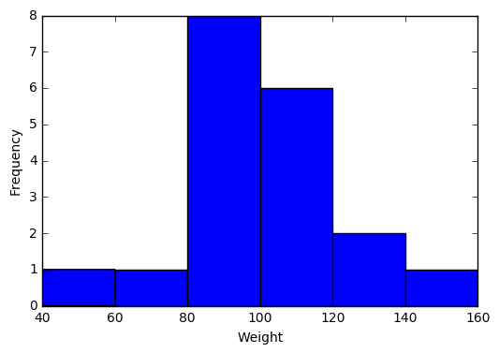

## 2.2 Visualize a single continuous variable by producing a boxplot.

# showmeans=True tells Python to plot the mean of the variable on the boxplot   
plt.boxplot(student["Weight"], showmeans=True)  
 # prevents Python from printing a "1" at the bottom of the boxplot  
plt.xticks([]) # prevents Python from printing a "1" at the bottom of the boxplot  
plt.ylabel('Weight')  
plt.show()

Output: 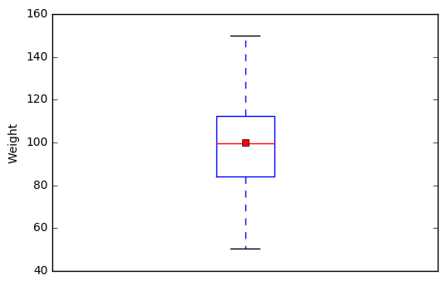

## 2.3 Visualize two continuous variables by producing a scatterplot.

# Notice here you specify the x variable first followed by the y variable   
plt.scatter(student["Height"], student["Weight"])  
plt.xlabel("Height")  
plt.ylabel("Weight")  
plt.show()

Output: 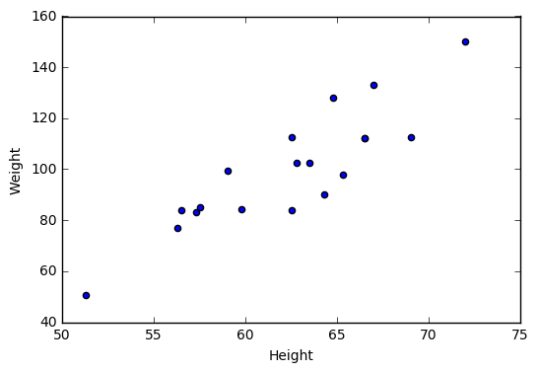

## 2.4 Visualize a relationship between two continuous variables by producing a scatterplot and a plotted line of best fit.

x = student["Height"]  
y = student["Weight"]  
  
# np.polyfit() models Weight as a function of Height and returns the   
# parameters  
m, b = np.polyfit(x, y, 1)  
plt.scatter(x, y)  
  
# plt.text() prints the equation of the line of best fit, with the first two   
# arguments specifying the x and y locations of the text, respectively   
# %f indicates to print a floating point number, that is specified following  
# the string  
plt.text(51, 140, "Line: y = %f x + %f"% (m,b))  
plt.plot(x, m*x + b)  
plt.xlabel("Height")  
plt.ylabel("Weight")  
plt.show()

Output: 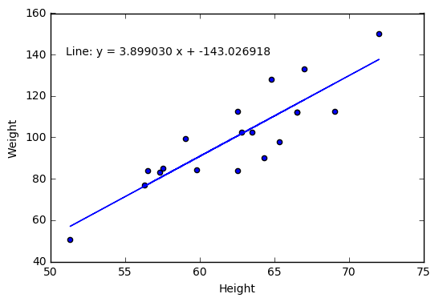

[NumPy polyfit()](https://docs.scipy.org/doc/numpy/reference/generated/numpy.polyfit.html)

## 2.5 Visualize a categorical variable by producing a bar chart.

# Get the counts of Sex   
counts = pd.crosstab(index=student["Sex"], columns="count")  
  
# len() returns the number of categories of Sex (2)  
# np.arange() creates a vector of the specified length  
num = np.arange(len(counts))  
plt.bar(num,counts["count"], align='center', alpha=0.5)  
  
# Set the xticks to be the indices of counts  
plt.xticks(num, counts.index)  
plt.xlabel("Sex")  
plt.ylabel("Frequency")  
plt.show()

Output: 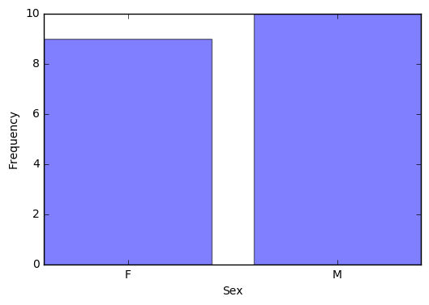

[NumPy arange()](https://docs.scipy.org/doc/numpy/reference/generated/numpy.arange.html)

## 2.6 Visualize a continuous variable, grouped by a categorical variable, by producing side-by-side boxplots.

### a) Simple side-by-side boxplot without color.

# Subset data set to return only female weights, and then only male weights   
Weight_F = np.array(student.query('Sex == "F"')["Weight"])  
Weight_M = np.array(student.query('Sex == "M"')["Weight"])  
Weights = [Weight_F, Weight_M]  
  
# PyPlot automatically plots the two weights side-by-side since Weights   
# is a 2D array  
plt.boxplot(Weights, showmeans=True, labels=('F', 'M'))  
plt.xlabel('Sex')  
plt.ylabel('Weight')  
plt.show()

Output: 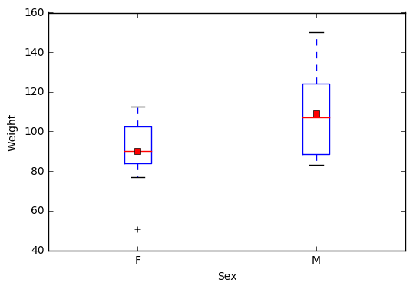

### b) More advanced side-by-side boxplot with color.

import seaborn as sns  
sns.boxplot(x="Sex", y="Weight", hue="Sex", data = student, showmeans=True)  
plt.show()

[seaborn boxplot](http://seaborn.pydata.org/generated/seaborn.boxplot.html)

seaborn

Output: 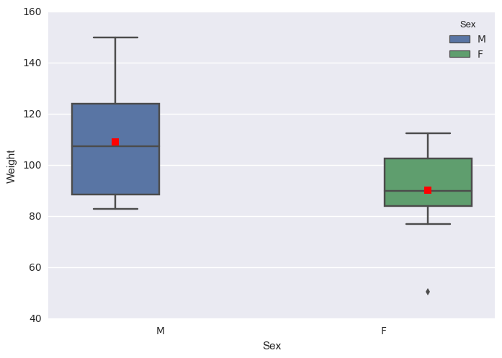

# 3 Basic Data Wrangling and Manipulation

## 3.1 Create a new variable in a data set as a function of existing variables in the data set.

# Notice here how you can create the BMI column in the   
# data set just by naming it   
  
student["BMI"] = student["Weight"] / student["Height"]**2 * 703  
print(student.head())

## Name Sex Age Height Weight BMI  
## 0 Alfred M 14 69.0 112.5 16.611531  
## 1 Alice F 13 56.5 84.0 18.498551  
## 2 Barbara F 13 65.3 98.0 16.156788  
## 3 Carol F 14 62.8 102.5 18.270898  
## 4 Henry M 14 63.5 102.5 17.870296

## 3.2 Create a new variable in a data set using if/else logic of existing variables in the data set.

# Notice the use of the np.where() function for a single condition   
student["BMI Class"] = np.where(student["BMI"] < 19.0, "Underweight", "Healthy")  
print(student.head())  
NA

## Name Sex Age Height Weight BMI BMI Class  
## 0 Alfred M 14 69.0 112.5 16.611531 Underweight  
## 1 Alice F 13 56.5 84.0 18.498551 Underweight  
## 2 Barbara F 13 65.3 98.0 16.156788 Underweight  
## 3 Carol F 14 62.8 102.5 18.270898 Underweight  
## 4 Henry M 14 63.5 102.5 17.870296 Underweight

[NumPy where()](https://docs.scipy.org/doc/numpy/reference/generated/numpy.where.html)

## 3.3 Create new variables in a data set using mathematical functions applied to existing variables in the data set.

Using the log() function, the exp() function, the sqrt() function, and the abs() function.

student["LogWeight"] = np.log(student["Weight"])  
student["ExpAge"] = np.exp(student["Age"])  
student["SqrtHeight"] = np.sqrt(student["Height"])  
student["BMI Neg"] = np.where(student["BMI"] < 19.0, -student["BMI"], student["BMI"])  
student["BMI Pos"] = np.abs(student["BMI Neg"])  
  
# Create a boolean variable  
student["BMI Check"] = (student["BMI Pos"] == student["BMI"])  
print(student.head())

## Name Sex Age Height Weight BMI BMI Class LogWeight \  
## 0 Alfred M 14 69.0 112.5 16.611531 Underweight 4.722953   
## 1 Alice F 13 56.5 84.0 18.498551 Underweight 4.430817   
## 2 Barbara F 13 65.3 98.0 16.156788 Underweight 4.584967   
## 3 Carol F 14 62.8 102.5 18.270898 Underweight 4.629863   
## 4 Henry M 14 63.5 102.5 17.870296 Underweight 4.629863   
##   
## ExpAge SqrtHeight BMI Neg BMI Pos BMI Check   
## 0 1.202604e+06 8.306624 -16.611531 16.611531 True   
## 1 4.424134e+05 7.516648 -18.498551 18.498551 True   
## 2 4.424134e+05 8.080842 -16.156788 16.156788 True   
## 3 1.202604e+06 7.924645 -18.270898 18.270898 True   
## 4 1.202604e+06 7.968689 -17.870296 17.870296 True

## 3.4 Drop variables from a data set.

# axis = 1 indicates to drop columns instead of rows  
student = student.drop(["LogWeight", "ExpAge", "SqrtHeight", "BMI Neg",   
 "BMI Pos", "BMI Check"], axis = 1)  
print(student.head())

## Name Sex Age Height Weight BMI BMI Class  
## 0 Alfred M 14 69.0 112.5 16.611531 Underweight  
## 1 Alice F 13 56.5 84.0 18.498551 Underweight  
## 2 Barbara F 13 65.3 98.0 16.156788 Underweight  
## 3 Carol F 14 62.8 102.5 18.270898 Underweight  
## 4 Henry M 14 63.5 102.5 17.870296 Underweight

## 3.5 Sort a data set by a variable.

### a) Sort data set by a continuous variable.

# Notice the kind="mergesort" which indicates to use a stable sorting   
# algorithm   
student = student.sort_values(by="Age", kind = "mergesort")  
print(student.head())

## Name Sex Age Height Weight BMI BMI Class  
## 10 Joyce F 11 51.3 50.5 13.490001 Underweight  
## 17 Thomas M 11 57.5 85.0 18.073346 Underweight  
## 5 James M 12 57.3 83.0 17.771504 Underweight  
## 6 Jane F 12 59.8 84.5 16.611531 Underweight  
## 9 John M 12 59.0 99.5 20.094369 Healthy

### b) Sort data set by a categorical variable.

student = student.sort_values(by="Sex", kind = "mergesort")  
# Notice that the data is now sorted first by Sex and then within Sex by Age   
print(student.head())

## Name Sex Age Height Weight BMI BMI Class  
## 10 Joyce F 11 51.3 50.5 13.490001 Underweight  
## 6 Jane F 12 59.8 84.5 16.611531 Underweight  
## 12 Louise F 12 56.3 77.0 17.077695 Underweight  
## 1 Alice F 13 56.5 84.0 18.498551 Underweight  
## 2 Barbara F 13 65.3 98.0 16.156788 Underweight

## 3.6 Compute descriptive statistics of continuous variables, grouped by a categorical variable.

print(student.groupby(by = "Sex").mean())

## Age Height Weight BMI  
## Sex   
## F 13.222222 60.588889 90.111111 17.051039  
## M 13.400000 63.910000 108.950000 18.594243

## 3.7 Add a new row to the bottom of a data set.

# Look at the tail of the data currently  
print(student.tail())

## Name Sex Age Height Weight BMI BMI Class  
## 0 Alfred M 14 69.0 112.5 16.611531 Underweight  
## 4 Henry M 14 63.5 102.5 17.870296 Underweight  
## 16 Ronald M 15 67.0 133.0 20.828470 Healthy  
## 18 William M 15 66.5 112.0 17.804511 Underweight  
## 14 Philip M 16 72.0 150.0 20.341435 Healthy

student = student.append({'Name':'Jane', 'Sex':'F', 'Age':14, 'Height':56.3,   
 'Weight':77.0, 'BMI':17.077695,   
 'BMI Class': 'Underweight'},   
 ignore_index=True)  
  
# Notice the change in the indices because of the ignore_index=True option   
# which allows for a Series, or one-dimensional DataFrame, to be appended   
# to an existing DataFrame

## Name Sex Age Height Weight BMI BMI Class  
## 15 Henry M 14 63.5 102.5 17.870296 Underweight  
## 16 Ronald M 15 67.0 133.0 20.828470 Healthy  
## 17 William M 15 66.5 112.0 17.804511 Underweight  
## 18 Philip M 16 72.0 150.0 20.341435 Healthy  
## 19 Jane F 14 56.3 77.0 17.077695 Underweight

## 3.8 Create a user defined function and apply it to a variable in the data set to create a new variable in the data set.

def toKG(lb):  
 return (0.45359237 * lb)  
  
student["Weight KG"] = student["Weight"].apply(toKG)  
print(student.head())

## Name Sex Age Height Weight BMI BMI Class Weight KG  
## 0 Joyce F 11 51.3 50.5 13.490001 Underweight 22.906415  
## 1 Jane F 12 59.8 84.5 16.611531 Underweight 38.328555  
## 2 Louise F 12 56.3 77.0 17.077695 Underweight 34.926612  
## 3 Alice F 13 56.5 84.0 18.498551 Underweight 38.101759  
## 4 Barbara F 13 65.3 98.0 16.156788 Underweight 44.452052

[apply()](https://pandas.pydata.org/pandas-docs/stable/generated/pandas.DataFrame.apply.html)

## 3.9 Caste a Data Frame to a different object type.

student_num = pd.concat([student["Age"], student["Height"],

## Age Height Weight  
## 0 14.0 69.0 112.5  
## 1 13.0 56.5 84.0  
## 2 13.0 65.3 98.0  
## 3 14.0 62.8 102.5  
## 4 14.0 63.5 102.5

[astype()](https://pandas.pydata.org/pandas-docs/stable/generated/pandas.DataFrame.astype.html)

# 4 More Advanced Data Wrangling

## 4.1 Drop observations with missing information.

# Notice the use of the fish data set because it has some missing   
# observations   
fish = pd.read_csv('/Users/fish.csv')  
  
# First sort by Weight, requesting those with NA for Weight first   
fish = fish.sort_values(by='Weight', kind='mergesort', na_position='first')  
print(fish.head())

## Species Weight Length1 Length2 Length3 Height Width  
## 13 Bream NaN 29.5 32.0 37.3 13.9129 5.0728  
## 40 Roach 0.0 19.0 20.5 22.8 6.4752 3.3516  
## 72 Perch 5.9 7.5 8.4 8.8 2.1120 1.4080  
## 145 Smelt 6.7 9.3 9.8 10.8 1.7388 1.0476  
## 147 Smelt 7.0 10.1 10.6 11.6 1.7284 1.1484

--

new_fish = fish.dropna()  
print(new_fish.head())

## Species Weight Length1 Length2 Length3 Height Width  
## 40 Roach 0.0 19.0 20.5 22.8 6.4752 3.3516  
## 72 Perch 5.9 7.5 8.4 8.8 2.1120 1.4080  
## 145 Smelt 6.7 9.3 9.8 10.8 1.7388 1.0476  
## 147 Smelt 7.0 10.1 10.6 11.6 1.7284 1.1484  
## 146 Smelt 7.5 10.0 10.5 11.6 1.9720 1.1600

[dropna()](http://pandas.pydata.org/pandas-docs/stable/generated/pandas.DataFrame.dropna.html)

## 4.2 Merge two data sets together on a common variable.

### a) First, select specific columns of a data set to create two smaller data sets.

# Notice the use of the student data set again, however we want to reload it  
# without the changes we've made previously   
student = pd.read_csv('/Users/class.csv')  
student1 = pd.concat([student["Name"], student["Sex"], student["Age"]],   
 axis = 1)  
print(student1.head())  
NA

## Name Sex Age  
## 0 Alfred M 14  
## 1 Alice F 13  
## 2 Barbara F 13  
## 3 Carol F 14  
## 4 Henry M 14

--

student2 = pd.concat([student["Name"], student["Height"], student["Weight"]],   
 axis = 1)  
print(student2.head())

## Name Height Weight  
## 0 Alfred 69.0 112.5  
## 1 Alice 56.5 84.0  
## 2 Barbara 65.3 98.0  
## 3 Carol 62.8 102.5  
## 4 Henry 63.5 102.5

### b) Second, we want to merge the two smaller data sets on the common variable.

new = pd.merge(student1, student2, on="Name")  
print(new.head())

## Name Sex Age Height Weight  
## 0 Alfred M 14 69.0 112.5  
## 1 Alice F 13 56.5 84.0  
## 2 Barbara F 13 65.3 98.0  
## 3 Carol F 14 62.8 102.5  
## 4 Henry M 14 63.5 102.5

### c) Finally, we want to check to see if the merged data set is the same as the original data set.

print(student.equals(new))

## True

[merge()](https://pandas.pydata.org/pandas-docs/stable/generated/pandas.DataFrame.merge.html)

## 4.3 Merge two data sets together by index number only.

### a) First, select specific columns of a data set to create two smaller data sets.

newstudent1 = pd.concat([student["Name"], student["Sex"], student["Age"]],   
 axis = 1)  
print(newstudent1.head())

## Name Sex Age  
## 0 Alfred M 14  
## 1 Alice F 13  
## 2 Barbara F 13  
## 3 Carol F 14  
## 4 Henry M 14

newstudent2 = pd.concat([student["Height"], student["Weight"]], axis = 1)  
print(newstudent2.head())

## Height Weight  
## 0 69.0 112.5  
## 1 56.5 84.0  
## 2 65.3 98.0  
## 3 62.8 102.5  
## 4 63.5 102.5

### b) Second, we want to join the two smaller data sets.

new2 = newstudent1.join(newstudent2)  
print(new2.head())

## Name Sex Age Height Weight  
## 0 Alfred M 14 69.0 112.5  
## 1 Alice F 13 56.5 84.0  
## 2 Barbara F 13 65.3 98.0  
## 3 Carol F 14 62.8 102.5  
## 4 Henry M 14 63.5 102.5

### c) Finally, we want to check to see if the joined data set is the same as the original data set.

print(student.equals(new2))

## True

[join()](https://pandas.pydata.org/pandas-docs/stable/generated/pandas.DataFrame.join.html)

## 4.4 Create a pivot table to summarize information about a data set.

# Notice we are using a new data set that needs to be read into the   
# environment   
price = pd.read_csv('/Users/price.csv')  
  
# The following code is used to remove the ',' and '$' characters from   
# the ACTUAL colum so that the values can be summed   
from re import sub  
from decimal import Decimal  
def trim_money(money):  
 return(float(Decimal(sub(r'[^\d.]', '', money))))  
  
price["REVENUE"] = price["ACTUAL"].apply(trim_money)  
table = pd.pivot_table(price, index=["COUNTRY", "STATE", "PRODTYPE",   
 "PRODUCT"], values="REVENUE", aggfunc=np.sum)  
print(table.head())

## COUNTRY STATE PRODTYPE PRODUCT  
## Canada British Columbia FURNITURE BED 197706.6  
## SOFA 216282.6  
## OFFICE CHAIR 200905.2  
## DESK 186262.2  
## Ontario FURNITURE BED 194493.6  
## Name: REVENUE, dtype: float64

sub

Decimal

[pivot_table()](https://pandas.pydata.org/pandas-docs/stable/generated/pandas.pivot_table.html) for more information on the pandas pivot_table() function

[pivot()](https://pandas.pydata.org/pandas-docs/stable/generated/pandas.DataFrame.pivot.html)

# 5 Regression & Modeling

The following sections focus on the Python sklearn package.

## 5.1 Pre-process a data set using principal component analysis.

from sklearn.decomposition import PCA  
  
# Notice we are using a new data set that needs to be read into the   
# environment   
iris = pd.read_csv('/Users/iris.csv')  
features = iris.drop(["Target"], axis = 1)  
  
pca = PCA(n_components = 4)  
pca = pca.fit(features)  
print(np.transpose(pca.components_))

## [[ 0.36158968 0.65653988 -0.58099728 0.31725455]  
## [-0.08226889 0.72971237 0.59641809 -0.32409435]  
## [ 0.85657211 -0.1757674 0.07252408 -0.47971899]  
## [ 0.35884393 -0.07470647 0.54906091 0.75112056]]

[PCA](http://scikit-learn.org/stable/modules/generated/sklearn.decomposition.PCA.html#sklearn.decomposition.PCA)

## 5.2 Split data into training and testing data and export as a .csv file.

from sklearn.model_selection import train_test_split  
  
target = iris["Target"]  
  
# The following code splits the iris data set into 70% train and 30% test  
X_train, X_test, Y_train, Y_test = train_test_split(features, target,   
 test_size = 0.3,   
 random_state = 29)  
train_x = pd.DataFrame(X_train)  
train_y = pd.DataFrame(Y_train)  
test_x = pd.DataFrame(X_test)  
test_y = pd.DataFrame(Y_test)  
  
train = pd.concat([train_x, train_y], axis = 1)  
test = pd.concat([test_x, test_y], axis = 1)  
  
train.to_csv('/Users/iris_train.csv', index = False)  
test.to_csv('/Users/iris_test.csv', index = False)

[train_test_split](http://scikit-learn.org/stable/modules/generated/sklearn.model_selection.train_test_split.html)

## 5.3 Fit a logistic regression model.

# Notice we are using a new data set that needs to be read into the   
# environment   
tips = pd.read_csv('/Users/tips.csv')  
  
# The following code is used to determine if the individual left more   
# than a 15% tip   
tips["fifteen"] = 0.15 * tips["total_bill"]  
tips["greater15"] = np.where(tips["tip"] > tips["fifteen"], 1, 0)  
  
import statsmodels.api as sm  
  
# Notice the syntax of greater15 as a function of total_bill   
res = sm.formula.glm("greater15 ~ total_bill", family=sm.families.Binomial(),   
 data=tips).fit()  
print(res.summary())

## Generalized Linear Model Regression Results   
## ==============================================================================  
## Dep. Variable: greater15 No. Observations: 244  
## Model: GLM Df Residuals: 242  
## Model Family: Binomial Df Model: 1  
## Link Function: logit Scale: 1.0  
## Method: IRLS Log-Likelihood: -156.87  
## Date: Wed, 07 Jun 2017 Deviance: 313.74  
## Time: 16:27:29 Pearson chi2: 247.  
## No. Iterations: 6   
## ==============================================================================  
## coef std err z P>|z| [95.0% Conf. Int.]  
## ------------------------------------------------------------------------------  
## Intercept 1.6477 0.355 4.646 0.000 0.953 2.343  
## total_bill -0.0725 0.017 -4.319 0.000 -0.105 -0.040  
## ==============================================================================

A logistic regression model can be implemented using sklearn, however [statsmodels.api](http://www.statsmodels.org/stable/glm.html#technical-documentation) provides a helpful summary about the model, so it is preferable for this example.

## 5.4 Fit a linear regression model on training data and assess against testing data.

# Notice we are using new data sets that need to be read into the environment   
train = pd.read_csv('/Users/tips_train.csv')  
test = pd.read_csv('/Users/tips_test.csv')  
  
# Fit a linear regression model of tip by total_bill on the training data   
from sklearn import linear_model  
regr = linear_model.LinearRegression()  
# If your data has one feature, you need to reshape the 1D array  
model = regr.fit(train["total_bill"].reshape(-1,1), train["tip"])  
  
# Predict the tip based on the total_bill given in the testing data   
prediction = pd.DataFrame()  
prediction["tip_hat"] = regr.predict(test["total_bill"].reshape(-1,1))  
  
# Compute the squared difference between predicted tip and actual tip   
prediction["diff"] = (prediction["tip_hat"] - test["tip"])**2  
  
# Compute the mean of the squared differences (mean squared error)   
# as an assessment of the model  
mean_sq_error = np.mean(prediction["diff"])  
print(mean_sq_error)

## 1.08759363430702

[LinearRegression](http://scikit-learn.org/stable/modules/generated/sklearn.linear_model.LinearRegression.html)

## 5.5 Fit a decision tree model on training data and assess against testing data.

### a) Build a model, assess the model against the training data, plot the tree, and determine variable importance.

# Notice we are using new data sets that need to be read into the environment   
train = pd.read_csv('/Users/breastcancer_train.csv')  
test = pd.read_csv('/Users/breastcancer_test.csv')  
  
from sklearn import tree  
  
# random_state is used to specify a seed for a random integer so that the   
# results are reproducible  
clf = tree.DecisionTreeClassifier(criterion='entropy', random_state=29)  
clf = clf.fit(train.drop(["Target"], axis = 1), train["Target"])  
  
# Prediction on training data  
scored = pd.DataFrame(clf.predict(train.drop(["Target"], axis = 1)))  
scored["Target"] = train["Target"]  
  
# Determine how many were correctly classified   
scored["correct"] = (scored["Target"] == scored[0])

## col_0 count  
## correct   
## True 398

Output: 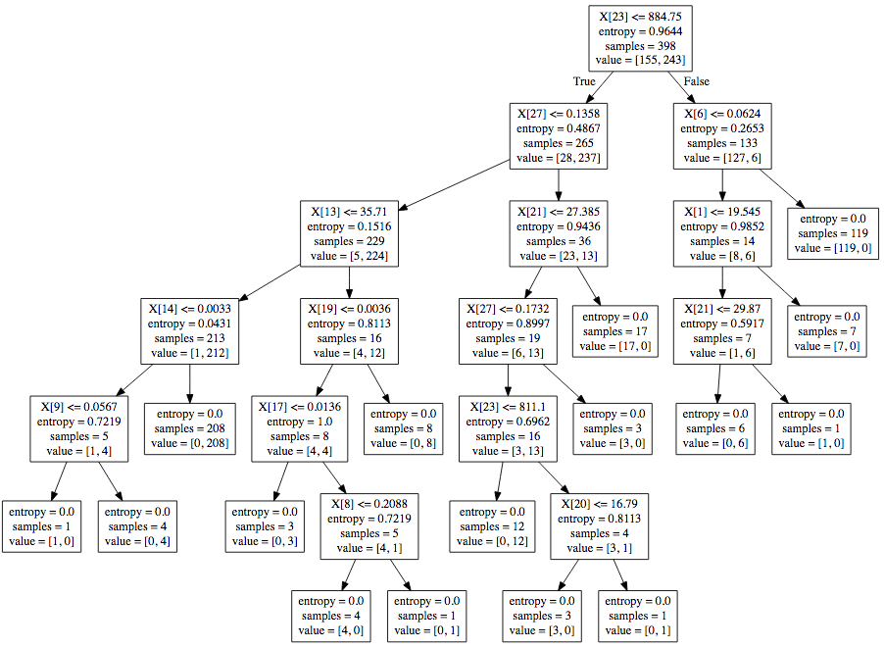

# Determine variable importance  
var_import = clf.feature_importances_  
var_import = pd.DataFrame(var_import)  
var_import = var_import.rename(columns = {0:'Importance'})  
var_import = var_import.sort_values(by="Importance", kind = "mergesort",   
 ascending = False)  
print(var_import.head())

## Importance  
## 23 0.592658  
## 27 0.172561  
## 6 0.055977  
## 21 0.054751  
## 13 0.032737

### b) Assess the model against the testing data.

# Prediction on testing data  
scored = pd.DataFrame(clf.predict(test.drop(["Target"], axis = 1)))  
scored["Target"] = test["Target"]  
  
# Determine how many were correctly classified  
scored["correct"] = (scored["Target"] == scored[0])  
print(pd.crosstab(index=scored["correct"], columns="count"))

## col_0 count  
## correct   
## False 9  
## True 162

[DecisionTreeClassifier](http://scikit-learn.org/stable/modules/generated/sklearn.tree.DecisionTreeClassifier.html)

## 5.6 Fit a random forest classification model on training data and assess against testing data.

### a) Build a model, assess the model against the training data, and determine variable importance.

# Notice we are using new data sets that need to be read into the environment   
train = pd.read_csv('/Users/iris_train.csv')  
test = pd.read_csv('/Users/iris_test.csv')  
  
from sklearn.ensemble import RandomForestClassifier  
  
clf = RandomForestClassifier(random_state=29)  
clf = clf.fit(train.drop(["Target"], axis = 1), train["Target"])  
  
# Prediction on training data  
scored = pd.DataFrame(clf.predict(train.drop(["Target"], axis = 1)))  
scored["Target"] = train["Target"]  
  
# Determine how many were correctly classified  
scored["correct"] = (scored["Target"] == scored[0])  
print(pd.crosstab(index=scored["correct"], columns="count"))

## col_0 count  
## correct   
## True 105

--

# Determine variable importance  
var_import = clf.feature_importances_  
var_import = pd.DataFrame(var_import)  
var_import = var_import.rename(columns = {0:'Importance'})  
var_import = var_import.sort_values(by="Importance", kind = "mergesort",   
 ascending = False)  
print(var_import.head())

## Importance  
## 2 0.515197  
## 3 0.388860  
## 0 0.080865  
## 1 0.015078

### b) Assess the model against the testing data.

# Prediction on testing data  
scored = pd.DataFrame(clf.predict(test.drop(["Target"], axis = 1)))  
scored["Target"] = test["Target"]  
  
# Determine how many were correctly classified  
scored["correct"] = (scored["Target"] == scored[0])  
print(pd.crosstab(index=scored["correct"], columns="count"))

## col_0 count  
## correct   
## False 3  
## True 42

[RandomForestClassifier](http://scikit-learn.org/stable/modules/generated/sklearn.ensemble.RandomForestClassifier.html)

## 5.7 Fit a random forest regression model on training data and assess against testing data.

### a) Build a model and assess the model against the training data.

# Notice we are re-using data sets but it is good to re-read the original   
# version back into the environment  
train = pd.read_csv('/Users/tips_train.csv')  
test = pd.read_csv('/Users/tips_test.csv')  
  
from sklearn.ensemble import RandomForestRegressor  
  
clf = RandomForestRegressor(random_state=29)  
clf = clf.fit(train.drop(["tip"], axis = 1), train["tip"])  
  
# Prediction on training data  
scored = pd.DataFrame(clf.predict(train.drop(["tip"], axis = 1)))  
scored["Target"] = train["tip"]  
  
# Determine mean squared error  
scored["diff"] = (scored["Target"] - scored[0])**2  
print(scored["diff"].mean())

## 0.2177569846153845

### b) Assess the model against the testing data.

# Prediction on testing data  
scored = pd.DataFrame(clf.predict(test.drop(["tip"], axis = 1)))  
scored["Target"] = test["tip"]  
  
# Determine mean squared error  
scored["diff"] = (scored["Target"] - scored[0])**2  
print(scored["diff"].mean())

## 1.182229489795918

[RandomForestRegressor](http://scikit-learn.org/stable/modules/generated/sklearn.ensemble.RandomForestRegressor.html)

## 5.8 Fit a gradient boosting model on training data and assess against testing data.

### a) Build a model and assess the model against the training data.

# Notice we are re-using data sets but it is good to re-read the original   
# version back into the environment  
train = pd.read_csv('/Users/breastcancer_train.csv')  
test = pd.read_csv('/Users/breastcancer_test.csv')  
  
from sklearn.ensemble import GradientBoostingClassifier  
  
# n_estimators = total number of trees to fit which is analogous to the   
# number of iterations  
# learning_rate = shrinkage or step-size reduction, whereas a lower   
# learning rate requires more iterations  
# min_samples_leaf = minimum number of observations in the trees   
# terminal nodes  
  
clf = GradientBoostingClassifier(random_state = 29, learning_rate = .01, min_samples_leaf = 20, n_estimators = 2500)  
clf = clf.fit(train.drop(["Target"], axis = 1), train["Target"])  
  
# Prediction on training data  
scored = pd.DataFrame(clf.predict(train.drop(["Target"], axis = 1)))  
scored["Target"] = train["Target"]  
  
# Determine how many were correctly classified  
scored["correct"] = (scored["Target"] == scored[0])  
print(pd.crosstab(index = scored["correct"], columns = "count"))

## col_0 count  
## correct   
## True 398

### b) Assess the model against the testing data.

# Prediction on testing data  
scored = pd.DataFrame(clf.predict(test.drop(["Target"], axis = 1)))  
scored["Target"] = test["Target"]  
  
# Determine how many were correctly classified  
scored["correct"] = (scored["Target"] == scored[0])

## col_0 count  
## correct   
## False 4  
## True 167

[GradientBoostingClassifier](http://scikit-learn.org/stable/modules/generated/sklearn.ensemble.GradientBoostingClassifier.html)

## 5.9 Fit a support vector classification model.

### a) Build a model and assess the model against the training data.

# Notice we are re-using data sets but it is good to re-read the original   
# version back into the environment  
train = pd.read_csv('/Users/breastcancer_train.csv')  
test = pd.read_csv('/Users/breastcancer_test.csv')  
  
# First we need to scale the data  
from sklearn.preprocessing import StandardScaler  
  
train_features = train.drop(["Target"], axis = 1)  
scaler = StandardScaler().fit(np.array(train_features))  
train_scaled = scaler.transform(np.array(train_features))  
train_scaled = pd.DataFrame(train_scaled)  
train_scaled["Target"] = train["Target"]  
  
test_features = test.drop(["Target"], axis = 1)  
scaler = StandardScaler().fit(np.array(test_features))  
test_scaled = scaler.transform(np.array(test_features))  
test_scaled = pd.DataFrame(test_scaled)  
test_scaled["Target"] = test["Target"]  
  
# Fit a support vector classification model  
from sklearn.svm import SVC  
clf = SVC(random_state = 29, kernel = 'linear')  
clf = clf.fit(train_scaled.drop(["Target"], axis = 1), train_scaled["Target"])  
  
# Evaluation on training data  
predictions = pd.DataFrame()  
predictions["predY"] = clf.predict(train_scaled.drop(["Target"], axis = 1))  
  
# Determine how many were correctly classified  
predictions["actual"] = train_scaled["Target"]  
predictions["correct"] = (predictions["actual"] == predictions["predY"])  
print(pd.crosstab(index = predictions["correct"], columns = "count"))

## col_0 count  
## correct   
## False 6  
## True 392

### b) Assess the model against the testing data.

# Evaluation on testing data  
predictions = pd.DataFrame()  
predictions["predY"] = clf.predict(test_scaled.drop(["Target"], axis = 1))  
  
# Determine how many were correctly classified  
predictions["actual"] = test_scaled["Target"]  
predictions["correct"] = (predictions["actual"] == predictions["predY"])  
print(pd.crosstab(index = predictions["correct"], columns = "count"))

## col_0 count  
## correct   
## False 7  
## True 164

## 5.10 Fit a support vector regression model.

### a) Generate random data based on a sine curve.

# Generate the time variable  
t = np.linspace(start = 0, stop = 0.5*np.pi, num = 100)  
  
# Generate the sine curve with uniform noise  
y1 = 5*np.sin(3*t) + np.random.uniform(size=100)  
  
# Create a data frame for the generated data  
random_data = pd.DataFrame()  
random_data["X"] = t  
random_data["Y"] = y1  
  
# Plot the generated data

Output: 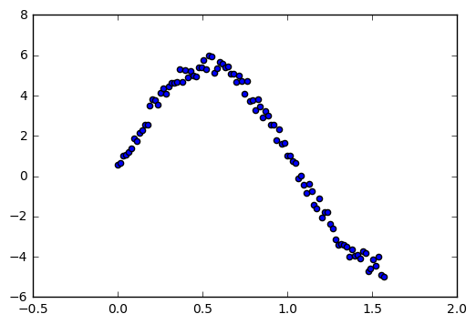

[np.linspace()](https://docs.scipy.org/doc/numpy/reference/generated/numpy.linspace.html) [np.sin()](https://docs.scipy.org/doc/numpy-1.10.4/reference/generated/numpy.sin.html) [np.random.uniform()](https://docs.scipy.org/doc/numpy/reference/generated/numpy.random.uniform.html)

### b) Fit a support vector regression model to the data.

from sklearn.svm import SVR  
clf = SVR()  
clf = clf.fit(random_data["X"].reshape(-1,1),random_data["Y"])  
predictions = pd.DataFrame()  
predictions["predY"] = clf.predict(random_data["X"].reshape(-1,1))

plt.scatter(t,y1,color="black")  
plt.scatter(t,predictions["predY"],color="r")  
plt.show()

Output: 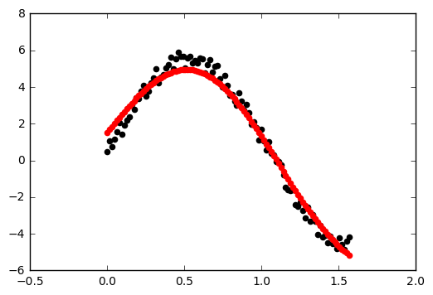

[SVR](http://scikit-learn.org/stable/modules/generated/sklearn.svm.SVR.html)

predictions["actual"] = random_data["Y"]  
predictions["sq_diff"] = (predictions["predY"] - predictions["actual"])**2  
print(predictions["sq_diff"].mean())

## 0.20626922373052764

### c) Fit a linear regression model to the data.

from sklearn import linear_model  
linMod = linear_model.LinearRegression()  
linMod = linMod.fit(random_data["X"].reshape(-1,1), random_data["Y"])  
predictions = pd.DataFrame()  
predictions["predY"] = linMod.predict(random_data["X"].reshape(-1,1))

plt.scatter(t,y1,color="black")  
plt.scatter(t,predictions["predY"],color="r")  
plt.show()

Output: 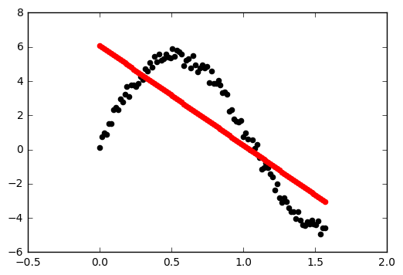

[LinearRegression](http://scikit-learn.org/stable/modules/generated/sklearn.linear_model.LinearRegression.html)

predictions["actual"] = random_data["Y"]  
predictions["sq_diff"] = (predictions["predY"] - predictions["actual"])**2  
print(predictions["sq_diff"].mean())

## 4.753313156881628

# 6 Model Evaluation & Selection

## 6.1 Evaluate the accuracy of regression models.

## a) Evaluation on training data.

# Notice we are re-using data sets but it is good to re-read the original   
# version back into the environment  
train = pd.read_csv('/Users/tips_train.csv')  
test = pd.read_csv('/Users/tips_test.csv')  
  
# 1. Linear Regression Model  
from sklearn.metrics import r2_score  
from sklearn import linear_model  
linMod = linear_model.LinearRegression()  
linMod = linMod.fit(train.drop(["tip"], axis = 1), train["tip"])  
  
# Evaluation on training data  
pred_lin = linMod.predict(train.drop(["tip"], axis = 1))  
  
# Determine coefficient of determination score  
r2_lin = r2_score(train["tip"], pred_lin)  
print("Linear regression model r^2 score (coefficient of determination): %f" % r2_lin)

## Linear regression model r^2 score (coefficient of determination): 0.496730

--

# 2. Random Forest Regression Model  
from sklearn.ensemble import RandomForestRegressor  
rfMod = RandomForestRegressor(random_state=29)  
rfMod = rfMod.fit(train.drop(["tip"], axis = 1), train["tip"])  
  
# Evaluation on training data  
pred_rf = rfMod.predict(train.drop(["tip"], axis = 1))  
  
# Determine coefficient of determination score  
r2_rf = r2_score(train["tip"], pred_rf)  
print("Random forest regression model r^2 score (coefficient of determination): %f" % r2_rf)

## Random forest regression model r^2 score (coefficient of determination): 0.892204

## b) Evaluation on testing data.

# 1. Linear Regression Model (linMod)  
  
# Evaluation on testing data  
pred_lin = linMod.predict(test.drop(["tip"], axis = 1))  
  
# Determine coefficient of determination score  
r2_lin = r2_score(test["tip"], pred_lin)  
print("Linear regression model r^2 score (coefficient of determination): %f" % r2_lin)

## Linear regression model r^2 score (coefficient of determination): 0.270945

--

# 2. Random Forest Regression Model (rfMod)  
  
# Evaluation on testing data  
pred_rf = rfMod.predict(test.drop(["tip"], axis = 1))  
  
# Determine coefficient of determination score  
r2_rf = r2_score(test["tip"], pred_rf)  
print("Random forest regression model r^2 score (coefficient of determination): %f" % r2_rf)

## Random forest regression model r^2 score (coefficient of determination): 0.163330

The sklearn metric [r2_score](http://scikit-learn.org/stable/modules/model_evaluation.html#r2-score-the-coefficient-of-determination) is only one option for assessing a regression model. Please go [here](http://scikit-learn.org/stable/modules/model_evaluation.html#regression-metrics) for more information about other sklearn regression metrics.

## 6.2 Evaluate the accuracy of classification models.

### a) Evaluation on training data.

# Notice we are re-using data sets but it is good to re-read the original   
# version back into the environment  
train = pd.read_csv('/Users/breastcancer_train.csv')  
test = pd.read_csv('/Users/breastcancer_test.csv')  
  
# 1. Decision Tree Classification Model  
from sklearn import tree  
from sklearn.metrics import accuracy_score  
treeMod = tree.DecisionTreeClassifier(criterion='entropy', random_state=29)  
treeMod = treeMod.fit(train.drop(["Target"], axis = 1), train["Target"])  
  
# Evaluation on training data  
scored = pd.DataFrame(treeMod.predict(train.drop(["Target"], axis = 1)))  
scored["Target"] = train["Target"]  
  
# Determine accuracy score  
accuracy_tree = accuracy_score(scored["Target"], scored[0])  
print("Decision tree model accuracy: %f" % accuracy_tree)

## Decision tree model accuracy: 1.000000

--

# 2. Random Forest Classification Model  
from sklearn.ensemble import RandomForestClassifier  
from sklearn.metrics import accuracy_score  
rfMod = RandomForestClassifier(random_state=29)  
rfMod = rfMod.fit(train.drop(["Target"], axis = 1), train["Target"])  
  
# Evaluation on training data  
scored = pd.DataFrame(rfMod.predict(train.drop(["Target"], axis = 1)))  
scored["Target"] = train["Target"]  
  
# Determine accuracy score  
accuracy_rf = accuracy_score(scored["Target"], scored[0])  
print("Random forest model accuracy: %f" % accuracy_rf)

## Random forest model accuracy: 0.997487

--

# 3. Gradient Boosting Classifcation Model  
from sklearn.ensemble import GradientBoostingClassifier  
from sklearn.metrics import accuracy_score  
gbmMod = GradientBoostingClassifier(random_state = 29, learning_rate = .01, min_samples_leaf = 20, n_estimators = 2500)  
gbmMod = gbmMod.fit(train.drop(["Target"], axis = 1), train["Target"])  
  
# Evaluation on training data  
scored = pd.DataFrame(gbmMod.predict(train.drop(["Target"], axis = 1)))  
scored["Target"] = train["Target"]  
  
# Determine accuracy score  
accuracy_gbm = accuracy_score(scored["Target"], scored[0])  
print("Gradient boosting model accuracy: %f" % accuracy_gbm)

## Gradient boosting model accuracy: 1.000000

### b) Evaluation on testing data.

# 1. Decision Tree Classification Model (treeMod)  
  
# Evaluation on testing data  
scored = pd.DataFrame(treeMod.predict(test.drop(["Target"], axis = 1)))  
scored["Target"] = test["Target"]  
  
# Determine accuracy score  
accuracy_tree = accuracy_score(scored["Target"], scored[0])  
print("Decision tree model accuracy: %f" % accuracy_tree)

## Decision tree model accuracy: 0.947368

--

# 2. Random Forest Classification Model (rfMod)  
  
# Evaluation on testing data  
scored = pd.DataFrame(rfMod.predict(test.drop(["Target"], axis = 1)))  
scored["Target"] = test["Target"]  
  
# Determine accuracy score  
accuracy_rf = accuracy_score(scored["Target"], scored[0])  
print("Random forest model accuracy: %f" % accuracy_rf)

## Random forest model accuracy: 0.964912

--

# 3. Gradient Boosting Classifcation Model (gbmMod)  
  
# Evaluation on testing data  
scored = pd.DataFrame(gbmMod.predict(test.drop(["Target"], axis = 1)))  
scored["Target"] = test["Target"]  
  
# Determine accuracy score  
accuracy_gbm = accuracy_score(scored["Target"], scored[0])  
print("Gradient boosting model accuracy: %f" % accuracy_gbm)

## Gradient boosting model accuracy: 0.976608

Note: The sklearn metric [accuracy_score](http://scikit-learn.org/stable/modules/generated/sklearn.metrics.accuracy_score.html) is only one option for assessing a classification model. Please go [here](http://scikit-learn.org/stable/modules/model_evaluation.html#classification-metrics) for more information about other sklearn classification metrics.

## 6.3 Evaluation with cross validation.

### a) KFold

# Notice we are using a new data set that need to be read into the   
# environment   
breastcancer = pd.read_csv('/Users/breastcancer.csv')  
  
from sklearn import model_selection  
from sklearn.ensemble import RandomForestClassifier  
  
X = breastcancer.drop(["Target"], axis = 1)  
Y = breastcancer["Target"]  
  
kfold = model_selection.KFold(n_splits = 5, random_state = 29)  
model = RandomForestClassifier(random_state = 29)  
results = model_selection.cross_val_score(model, X, Y, cv = kfold)  
  
print("Accuracy: %.2f%% +/- %.2f%%" % (results.mean()*100,   
 results.std()*100))

## Accuracy: 94.38% +/- 2.39%

### b) ShuffleSplit

shuffle = model_selection.ShuffleSplit(n_splits = 5, random_state = 29)  
model = RandomForestClassifier(random_state = 29)  
results = model_selection.cross_val_score(model, X, Y, cv = shuffle)  
  
print("Accuracy: %.2f%% +/- %.2f%%" % (results.mean()*100,   
 results.std()*100))

## Accuracy: 95.09% +/- 0.70%

# Appendix

## 1 Built-in Python Data Types

* Boolean

### Numeric types:

* int
* long
* float
* complex

### Sequences:

* str
* bytes
* byte array
* list
* tuple

### Sets:

* set
* frozen set

### Mapping:

* dictionary

## 2 Python Plotting Packages

### Bokeh

### PyPlot

### Seaborn

# Alphabetical Index

## Array

A NumPy array is a data type implemented by the NumPy package in which the elements of the array are all of the same type. Please see the following example of array creation and access:

import numpy as np  
my_array = np.array([1, 2, 3, 4])  
print(my_array)

## [1 2 3 4]

print(my_array[3])

## 4

For more information, please see [NumPy Arrays](https://docs.scipy.org/doc/numpy/reference/generated/numpy.array.html).

## Bokeh

[Bokeh](http://bokeh.pydata.org/en/latest/) is a Python package which is useful for interactive visualizations and is optimized for web browser presentations.

## Boolean

A [Boolean](https://docs.python.org/2/library/stdtypes.html#boolean-values) value is either True or False, and represents the truth of an expression or statement.

## Bytes & Byte arrays

A [byte](https://docs.python.org/3.1/library/functions.html#bytes) is a sequence of integers which is immutable, whereas a [byte array](https://docs.python.org/3.1/library/functions.html#bytearray) is its mutable counterpart.

## complex

A [complex number](https://docs.python.org/2/library/functions.html#complex) includes a real part and an imaginary part, both of which are floating point numbers.

## Data Frame

A [Pandas Data Frame](http://pandas.pydata.org/pandas-docs/stable/generated/pandas.DataFrame.html) is a two-dimensional tabular structure with labeled axes (rows and columns), where data observations are represented by rows and data variables are represented by columns.

## datetime

The [datetime](https://docs.python.org/2/library/datetime.html) Python module includes tools for manipulating data and time objects.

## Decimal

[Decimal](https://docs.python.org/2/library/decimal.html) is a Python package which provides tools for decimal floating point arithmetic.

## Dictionary

A [dictionary](https://docs.python.org/2/tutorial/datastructures.html#dictionaries) is an associative array which is indexed by keys which map to values. Therefore, a dictionary is an unordered set of key:value pairs where each key is unique. Please see the following example of dictionary creation and access:

import pandas as pd  
student = pd.read_csv('/Users/class.csv')  
for_dict = pd.concat([student["Name"], student["Age"]], axis = 1)  
class_dict = for_dict.set_index('Name').T.to_dict('list')  
print(class_dict.get('James'))

## [12]

## float

A [float](https://docs.python.org/2/library/functions.html#float) is a decimal point number.

## int

An [int](https://docs.python.org/3/library/functions.html#int) is a natural number. In Python, you can convert to an int from a float by using the int() function. Python stores ints with at least 32 bits of precision.

## List

A [list](https://www.tutorialspoint.com/python/python_lists.htm) is a sequence of comma-separated objects that need not be of the same type. Please see the following example of list creation and access:

list1 = ['item1', 102]  
print(list1)

## ['item1', 102]

print(list1[1])

## 102

Python also has what are known as ["Tuples"](https://www.tutorialspoint.com/python/python_tuples.htm), which are immutable lists created in the same way as lists, except with paranthesis instead of brackets.

## Long

A [long](https://docs.python.org/2/library/functions.html#long) is a type of integer with unlimited precision. In Python, you can convert to a long using the long() function.

## NumPy

[NumPy](http://www.numpy.org/) is a Python package which is useful for scientific and mathematical computing.

## pandas

[pandas](http://pandas.pydata.org/) is a Python package which is useful for working with data structures and performing data analysis.

## PyPlot

[PyPlot](https://matplotlib.org/api/pyplot_api.html) is a Python package which is useful data plotting and visualization.

## Seaborn

[Seaborn](https://seaborn.pydata.org/) is another Python package which is useful for data plotting and visualization. In particular, Seaborn includes tools for drawing attractive statistical graphics.

## Series

A [Pandas Series](https://pandas.pydata.org/pandas-docs/stable/dsintro.html) is a one-dimensional data frame, which is also called an array in R. Please see the following example of Series creation and access:

import pandas as pd  
my_array = pd.Series([1, 3, 5, 9])  
print(my_array)

## 0 1  
## 1 3  
## 2 5  
## 3 9  
## dtype: int64

print(my_array[1])

## 3

## Sets & Frozen Sets

A set is a unordered collection of immutable objects. The difference between a [set and a frozen set](http://www.python-course.eu/sets_frozensets.php) is that the former is mutable, while the latter is immutable. Please see the following example of set and frozen set creation and access:

s = set(["1", "2", "3"])  
print(s)  
# s is a set, which means you can add or delete elements from s

## {'3', '1', '2'}

fs = frozenset(["1", "2", "3"])  
print(fs)  
# fs is a frozenset, which means you cannot add or delete elements from fs

## frozenset({'2', '3', '1'})

## sklearn

scikit-learn, or more commonly known as [sklearn](http://scikit-learn.org/stable/), is a Python package which is useful for basic and advanced data mining, machine learning, and data analysis. sklearn includes tools for classification, regression, clustering, dimensionality reduction, model selection, and data pre-processing.

## str

[Strings](https://www.tutorialspoint.com/python/python_strings.htm) are a list of characters, though characters are not a type in Python, but rather a string of length 1. Strings are indexable like arrays. Please see the following example of String creation and access:

s = 'My first string!'  
print(s)

## My first string!

print(s[5])

## r

Please go [here](https://docs.python.org/3.1/library/functions.html#str) for more information on the str() function.

## sub

[sub](https://docs.python.org/2/library/re.html) is a function of the re Python package useful for replacing a pattern in a string.

For more information on Python packages and functions, along with helpful examples, please see [Python](https://www.python.org/).