DRAFT: Final Project

Katie Perez

2024-02-29

Line graph This data visualization illustrates the fluctuations in enrollment over time through this visualization. To elucidate the trends, I propose focusing on selected colleges and universities. From the plot, it’s evident that both UO and OSU have experienced enrollment growth, whereas other institutions depict a marginal decline. I’ve assigned distinct colors to each line based on the official brand hex codes of the respective institutions. By analyzing this data visualization, policymakers and educators and gain valuable insights in to the factors influencing Oregonian students’ decisions to pursue higher education, ultimaely guiding future strategies for improving access and fostering educational growth in the region. As far as designing this visualization adding annotations with school names could enhance clarity, I am concerned it might overly clutter the visualization.

## File .here already exists in /Users/kperez/Documents/Winter 2024/EDLD 652/Final project

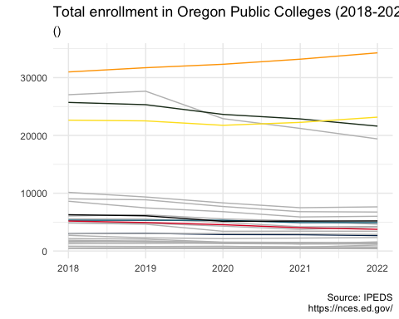

Paired bar chart applicants and enrolled

This paired bar graph illustrates both applicants and enrollees, highlighting the shift in numbers between the two categories. The transition from applicants to enrollees presents an intriguing insight. Furthermore, the total number of applicants each institution receives holds its own significance. Discrepancies between the two bars may indicate factors such as selectivity of universities, changes in application preferences, or shifts in demographics. This visualization could serve as a valuable tool for university administrators and policymakers to assess the effectiveness of recruitment strategies, understand the dynamics between application numbers and actual enrollments, and making informed decisions to enhance student recruitement and retention efforts for the future. To further enrich the analysis, it would be beneficial to incorporate the number of acceptances into the visualization. Applicant and enrollment data was not available for the 2-year institutions, so I omitted them from this visualization.

## unitid institution.name year HD2022.State.abbreviation  
## 1 208275 Blue Mountain Community College 2022 Oregon  
## 2 208318 Central Oregon Community College 2022 Oregon  
## 3 208390 Chemeketa Community College 2022 Oregon  
## 4 208406 Clackamas Community College 2022 Oregon  
## 5 208415 Clatsop Community College 2022 Oregon  
## 6 208646 Eastern Oregon University 2022 Oregon  
## HD2022.Sector.of.institution ADM2022.Applicants.total ADM2022.Enrolled.total  
## 1 Public, 2-year NA NA  
## 2 Public, 2-year NA NA  
## 3 Public, 2-year NA NA  
## 4 Public, 2-year NA NA  
## 5 Public, 2-year NA NA  
## 6 Public, 4-year or above 1015 252  
## EF2022D.Full.time.fall.2021.cohort  
## 1 238  
## 2 493  
## 3 1161  
## 4 509  
## 5 89  
## 6 244  
## EF2022D.Students.from.the.full.time.adjusted.fall.2021.cohort.enrolled.in.fall.2022  
## 1 145  
## 2 281  
## 3 726  
## 4 279  
## 5 51  
## 6 165  
## EF2022D.Full.time.retention.rate..2022  
## 1 61  
## 2 57  
## 3 63  
## 4 55  
## 5 57  
## 6 68

## institution.name year ADM2022.Applicants.total  
## 6 Eastern Oregon University 2022 1015  
## 26 Oregon State University-Cascades Campus 2022 2097  
## 17 Southern Oregon University 2022 2126  
## 21 Western Oregon University 2022 3262  
## 11 Oregon Institute of Technology 2022 4570  
## 15 Portland State University 2022 7926  
## ADM2022.Enrolled.total  
## 6 252  
## 26 188  
## 17 567  
## 21 563  
## 11 463  
## 15 1634

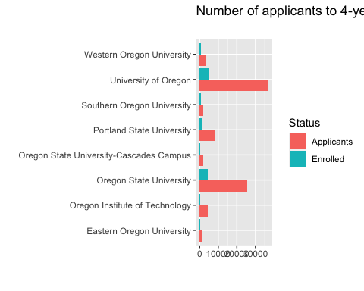

Bar Plot

In this plot, I analyze the retention rates of Oregon’s public universities. Although I categorized the institutions into 2-year and 4-year groups in the dataset, this grouping did not translate into the plot. It reveals the differences is retention precentages between the two types of institutions, showcasing varying levels of student success and cimmitment to completing their programs. Higher retentionrats in 4-year colleges suggest stronger institutionsl support, academic resources and a more structured academic environment conducive to student success. Conversely, lower retetion rates in 2-year colleges could indicate challenges such as financial constraints, lack of support services or a higher rate of student transferring to other institutions. Analyzing this bar plot could provide valuable insghts for policymakers and educators to identify areas for imporvement in student retention strategies, ultimately enhancing the educational experience and success rates in both 2-year and 4-year colleges across Oregon. I will continue refining my code to accurately represent these distinctions. To enhance the informative value of this visualization, I propose expanding the timeframe to encompass multiple years. Facet wrapping across several years could offer a comprehensive view. Additionally, it’s crucial to note that the retention rates presented are proportions. I anticipate that examining retention rates alongside data on applicants and enrollees will provide valuable insights into enrollment dynamics.

## unitid institution.name year HD2022.State.abbreviation  
## 1 208275 Blue Mountain Community College 2022 Oregon  
## 2 208318 Central Oregon Community College 2022 Oregon  
## 3 208390 Chemeketa Community College 2022 Oregon  
## 4 208406 Clackamas Community College 2022 Oregon  
## 5 208415 Clatsop Community College 2022 Oregon  
## 6 208646 Eastern Oregon University 2022 Oregon  
## HD2022.Sector.of.institution ADM2022.Applicants.total ADM2022.Enrolled.total  
## 1 Public, 2-year NA NA  
## 2 Public, 2-year NA NA  
## 3 Public, 2-year NA NA  
## 4 Public, 2-year NA NA  
## 5 Public, 2-year NA NA  
## 6 Public, 4-year or above 1015 252  
## EF2022D.Full.time.fall.2021.cohort  
## 1 238  
## 2 493  
## 3 1161  
## 4 509  
## 5 89  
## 6 244  
## EF2022D.Students.from.the.full.time.adjusted.fall.2021.cohort.enrolled.in.fall.2022  
## 1 145  
## 2 281  
## 3 726  
## 4 279  
## 5 51  
## 6 165  
## EF2022D.Full.time.retention.rate..2022  
## 1 61  
## 2 57  
## 3 63  
## 4 55  
## 5 57  
## 6 68

