Benefit – Cost Analysis

Name: Catherine Smereena Dommaty

**Introduction:**

In the realm of corporate decision-making, selecting among various projects is a critical task that directly impacts the organisation's growth and success. To make informed choices, corporations employ benefit-cost analysis, a methodical approach that assesses the financial viability and potential returns of each project under consideration. This report delves into the intricacies of benefit-cost analysis and its significance in project selection within corporate environments.

**Purpose of Benefit-Cost Analysis:**

The core aim of benefit-cost analysis is to assess the economic viability of a project by juxtaposing its total benefits against the total costs incurred throughout its lifespan. This evaluation entails quantifying both the advantageous outcomes (benefits) and the detrimental impacts (costs) associated with the project. By systematically weighing these factors, benefit-cost analysis empowers corporations to make well-founded decisions regarding the allocation of resources and prioritisation of investments.

**Dam #1: Benefits Assessment:**

Dam #1 promises a range of potential benefits across different domains:

**Improved Navigation (B1):** Expected to enhance navigational efficiency by 1 to 3 units, facilitating smoother transportation and trade routes.

**Hydroelectric Power (B2):** Anticipated to generate 6 to 9 units of hydroelectric power, contributing to sustainable energy production and reducing reliance on fossil fuels.

**Fish and Wildlife (B3):** Forecasted to foster biodiversity and ecosystem health with benefits ranging from 1 to 7 units, supporting aquatic habitats and recreational fishing.

**Recreation (B4):** Providing recreational opportunities, albeit modestly, with estimated benefits ranging from 0 to 3 units, enhancing the quality of life for local communities.

**Flood Control (B5):** Offering flood control measures with benefits spanning from 4 to 8 units, safeguarding downstream areas from potential inundation and property damage.

**Commercial Development (B6):** Enabling economic growth and development potential, with estimated benefits ranging from 8 to 15 units, fostering business opportunities and job creation in the region.

**Cost Assessment:**

To realise these benefits, Dam #1 incurs certain costs:

**Annualised Capital Cost (C1):** Estimated between 8 and 11 units, representing the initial investment required for dam construction and infrastructure development.

**Other Costs (C2):** Additional costs such as land acquisition, regulatory compliance, and unforeseen contingencies, estimated between 1 and 5 units.

**Operations & Maintenance (C3):** Essential for sustaining dam operations and ensuring safety standards, with costs ranging from 1 to 3 units annually.

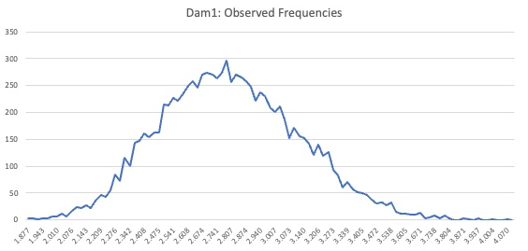

**Figure 1: Frequencies of Dam 1**

**Benefit-Cost Analysis for Dam #2**

**Introduction:**

In the pursuit of sustainable development and infrastructure enhancement, the evaluation of dam projects stands as a critical endeavour. This report embarks on a comprehensive benefit-cost analysis of Dam #2, shedding light on its anticipated benefits and associated costs across various domains.

**Dam #2: Benefits Assessment:**

Dam #2 presents a spectrum of potential benefits poised to impact diverse stakeholders positively:

**Improved Navigation (B1):** Foreseen to bolster navigational efficiency by 6 to 10 units, facilitating smoother transportation and trade routes along waterways.

**Hydroelectric Power (B2):** Expected to harness renewable energy, generating 5 to 8 units of hydroelectric power and contributing to sustainable electricity production.

**Fish and Wildlife (B3):** Promoting biodiversity conservation and ecosystem health, with benefits spanning from 2 to 8 units, supporting aquatic habitats and wildlife populations.

**Recreation (B4):** Offering recreational opportunities for residents and tourists, with benefits estimated between 3 and 7 units, enhancing quality of life and leisure activities.

**Flood Control (B5):** Providing crucial flood control measures, with benefits ranging from 1 to 5 units, mitigating the risk of inundation and protecting downstream areas.

**Commercial Development (B6):** Fostering economic growth and investment potential, with benefits projected between 4 and 8 units, catalysing business opportunities and job creation.

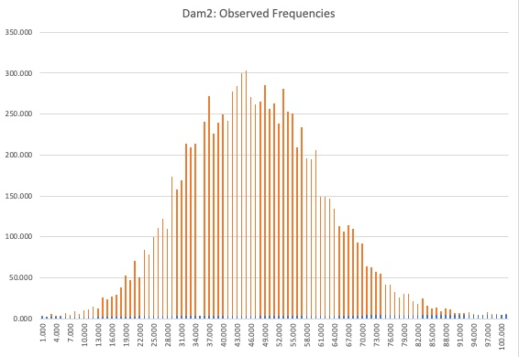

**Figure 2: Frequencies of Dam 2**

**The Benefit-Cost Ratio (BCR):**

The Benefit-Cost Ratio (BCR) serves as a pivotal metric in assessing the economic viability of Dam #2. By calculating this ratio, we aim to determine whether the benefits derived from the project outweigh the incurred costs. A BCR exceeding 1.0 indicates a favourable scenario where the benefits surpass the costs, suggesting that the project holds promising economic potential.

Utilising the total discounted benefits and costs, the BCR analysis provides a quantitative measure of the project's efficiency in generating positive returns relative to its investments. If the BCR exceeds the threshold of 1.0, it implies that the benefits accrued over the project's lifespan outweigh the initial and ongoing costs associated with its implementation and maintenance. This signifies a favourable economic outlook, indicating that the project is financially sound and likely to yield a surplus of benefits.

In summary, the BCR analysis offers a comprehensive evaluation of Dam #2's economic feasibility, enabling stakeholders to make informed decisions regarding resource allocation and project prioritisation. A BCR exceeding 1.0 serves as a clear indicator of the project's potential to contribute positively to economic development and societal welfare.

**Conclusion:**

In conclusion, the benefit-cost analysis of Dam #2 highlights its capacity to deliver significant socio-economic benefits, spanning infrastructure improvements, renewable energy production, ecological preservation, and recreational facilities. Despite recognizing the inherent intricacies and uncertainties inherent in such projects, a thorough examination of both benefits and costs remains essential for making well-informed decisions and effectively allocating resources. This comprehensive evaluation serves as a fundamental pillar guiding strategic decision-making processes, ensuring that investments are directed towards projects with the potential to generate the greatest societal value and long-term prosperity.

In summary, the benefit-cost analysis of Dam #2 underscores its potential to generate substantial socio-economic gains, ranging from infrastructure enhancements to ecological preservation and recreational amenities. Despite acknowledging the inherent complexities and uncertainties associated with such projects, a thorough assessment of benefits and costs remains crucial for informed decision-making and resource allocation. This rigorous evaluation serves as a vital tool in guiding strategic choices, directing investments towards initiatives that promise maximum societal value and sustainable development.

Reference:

1. Statisticslectures.com. 2021. Chi-Square Test for Independence. Retrieved April 24, 2021, from <http://www.statisticslectures.com/topics/testforindependence/>
2. Zach, V., 2021. Here is How to Interpret a P-Value of 0.000 - Statology. [online] Statology. Retrieved April 24, 2021, from <https://www.statology.org/here-is-how-to-interpret-a-p-value-of-0-000/>