ALY6050: Introduction to Enterprise ANALYTICS
Title: "Optimizing Profitability: A Strategic Analysis for a Northern Hardware Company's Distribution Center Expansion"
CATHERINE SMEREENA
Prof. He Zhi

Introduction:
The competitive nature of the business environment necessitates strategic decision-making to effectively allocate resources and optimize operational efficiency. Considering this, the report that follows conducts a thorough investigation with the goal of streamlining the operations of a hardware company located in the north as it seeks to open a new distribution center in the north-east. The principal objective of this study is to design tactics that will facilitate the organization in optimizing its net profit while managing diverse constraints, including financial limitations, spatial constraints, and focused product marketing campaigns.

A thorough optimization analysis must be carried out as the business prepares to expand into new markets to guarantee effective resource management and the achievement of long-term profitability. Through a careful examination of elements including spending plans, real estate use, and marketing tactics, the business can create a solid operating plan that not only satisfies its financial goals but also improves its competitive standing in the marketplace.
With a careful analysis of the available data and the use of mathematical modelling tools, this report seeks to offer practical insights and suggestions so that the business may decide on the layout of its distribution center with knowledge. The business can find chances for cost savings, revenue maximization, and operational efficiency improvement by utilizing optimization approaches. This will set the foundation for long-term success and growth in the Northeastern region's dynamic business landscape.

This optimization analysis will be a useful tool for directing the company's decision-making process and guiding it towards a path of sustainable profitability and operational excellence in its new distribution center venture, with a clear focus on maximizing net profit while considering various constraints and strategic considerations.

Part 1: Mathematical Formulation
The optimization problem is formulated as a linear programming model with the objective of maximizing the total profit while adhering to budget, space, and product promotion requirements. The decision variables represent the inventory levels of each product, and the objective function calculates the total profit based on the selling prices and costs of the products. Constraints are imposed to ensure that purchasing and space allocations do not exceed specified limits, and product promotion goals are integrated to maintain a balanced inventory mix.
Let:
x1=inventory level of Pressure Washers
x2=inventory level of Lawn Mowers
x3=inventory level of Snow Blowers
x4=inventory level of Water Pumps

The objective function to maximise total profit (Z) is given by:
Z=220x1​+300x2​+380x3​−240.01x4​
Budget constraint:
350x1+380x2+530x3+500x4≤130,000350x1​+380x2​+530x3​+500x4​≤130,000
Space constraint:
25x1​+40x2​+25x3​+6.25x4​≤12,300
Product promotion requirements:
0.7x1​+0.7x2​−0.3x3​−0.3x4​≥0 (Promotion goal for Pressure Washers and Lawn Mowers)
x3​−2x4​≥0(Promotion goal for Snow Blowers relative to Water Pumps)
- Non-negativity constraints:
x1​,x2​,x3​,x4​≥0
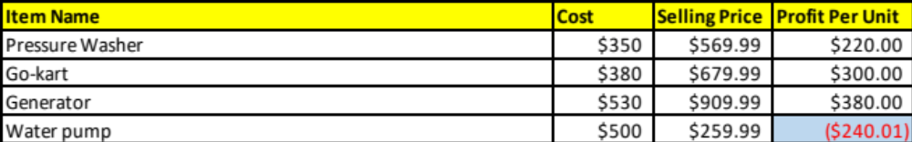

Part 1
Mathematical Formulation
Maximize Z = 219.99x1 + 299.99x2 + 379.99x3 + 142.99 x4
Subject to:
Budget: 349.99x1 + 379.99x2 + 530x3 + 500x4 <= 130000
Space: 25x1 + 40x2 + 25x3 + 6.25x4 <= 12300
Requirement1: x1 + x2 >= 0.3(x1 +x2 +x3 +x4)
OR 0.7x1 + 0.7x2 - 0.3x3 - 0.3x4 >= 0
Requirement2: x3 > 2x4 >= 0
OR x3 - 2x4 >= 0
Non-negativity x1, x2, x3, x4 >= 0
Table1: Mathematical solver table.

Part 2: Configuring a Linear Programming Model:

Excel Solver is used to set up the linear programming model and discover the best solution. For every product, decision variables are established, and an objective function is built with the goal of maximizing overall profit. In order to guarantee that the criteria for space, money, and product marketing are met, constraints are entered. The model is then solved using Excel Solver to determine the ideal inventory levels for every product and the associated maximum monthly profit.

Sensitivity analysis is used to look at how altering variables, such budgetary allotments and product selling prices, affect the best possible outcome. Sensitivity analysis insights offer useful data for strategic planning and decision-making.

The business can make wise decisions by evaluating sensitivity and solving the linear programming model.

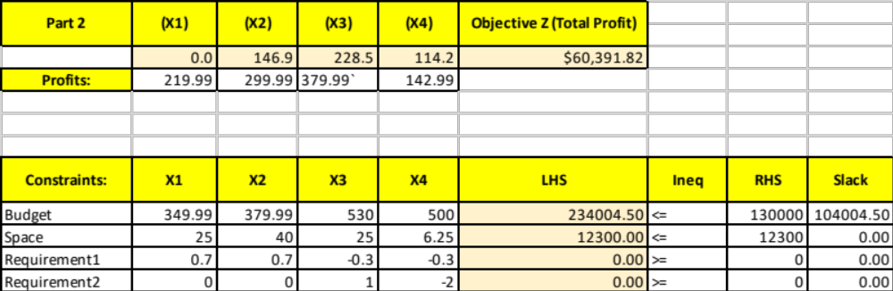
Table2 : Results of Mathematical solver.

Part 3: Optimal Solutions

The optimal solution derived from the linear programming model indicates a monthly profit of $60,391.82. This optimal profit is achieved through the stocking of Go-Karts, Generators, and Water Pumps. Notably, Pressure Washers are absent from the optimal product mix due to a zero optimal value, signifying that under current conditions, stocking Pressure Washers does not contribute to profit maximization. This finding underscores the need for potential adjustments, such as price modifications, to render Pressure Washers profitable and incorporate them into the optimal product mix.

Part 4: Sensitivity Analysis:

Sensitivity analysis provides insights into the robustness of the optimal solution concerning changes in constraints and decision variables. In the context of this analysis:

1. Purchasing Budget Sensitivity: The sensitivity analysis reveals that the current purchasing budget of $130,000 is adequate, as increasing it would not result in additional profit under existing conditions. The shadow price for the budget constraint is $0, indicating that within the permissible range, altering the purchasing budget does not influence the company's net monthly profit. Additionally, the large allowable increase in the budget constraint implies that the constraint is not active, further supporting the adequacy of the current budget allocation.

2. Warehouse Space Sensitivity: On the other hand, sensitivity analysis highlights the significance of warehouse space in determining monthly profits. With every additional square foot of warehouse space, there is a tangible increase in potential monthly profits. The shadow price associated with the space constraint indicates that expanding the warehouse can directly impact profitability, with each additional square foot contributing approximately $11.03 to monthly profits. Therefore, there is a clear incentive to consider expanding the warehouse to capitalize on this potential for increased profitability.

By conducting sensitivity analysis, the company gains valuable insights into the impact of changes in constraints on the optimal solution. While the current purchasing budget suffices, there is a compelling case for expanding warehouse space to enhance profitability. These findings enable the company to make informed decisions regarding resource allocation and operational strategies, ultimately maximizing profitability and competitiveness in the market.

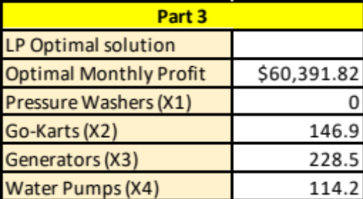

Pressure Washer Sensitivity Analysis

Pressure Washers' (X1) inventory level has a zero ideal value, according to the sensitivity analysis of the linear programming model, meaning that stocking this item does not currently contribute to profit maximization. To mitigate this issue and maybe incorporate Pressure Washers into a lucrative product mix, the model recommends raising the unit selling price. To be more precise, raising the price by $24.53 from the going rate of $169.99 might make the product profitable instead of unprofitable, with the new price point being around $194.52.
Sensitivity Analysis for Purchasing Budget:
It is found that the shadow price for the budget limitation is $0 by analyzing the sensitivity report for the purchasing budget within the linear programming model. This suggests that raising the budget will not result in an increase in the company's net monthly profit within the allowable range. The 'Allowable Increase' is notably substantial, indicating that the budget of $130,000 is sufficient and the constraint is not active under the current model setup. For the first month, it is advised to stick to the present budgetary allotment without making any additional investments. Given the current characteristics and limits, the data does not indicate a correlation between greater budget and increased earnings.

Analysis of Sensitivity in Warehouse Space:

The warehouse is now using all 12,300 square feet available, according to the analysis of the space limitation from the sensitivity report of the linear programming model. There is a clear financial incentive to expand the warehouse space, as each extra square foot has the potential to boost monthly earnings by $11.03, with a shadow price of roughly $11.03. A predicted profit increase of almost $6,248.20 would arise from an expansion up to the permitted increase of 566.502 square feet. It is therefore advised to think about enlarging the warehouse to 12,866.502 square feet in order to take advantage of this potential for higher profitability.

Additional Investment
Based on the sensitivity analysis conducted on the budget constraint, it is evident that for each additional dollar added to the budget, the total profit would increase by approximately $0.66. Moreover, the allowable increase in the budget is calculated to be $35,740.33.
To determine whether the company should allocate additional funds beyond the initial $130,000 purchasing budget during the first month, it is essential to evaluate the potential increase in net monthly profit.
The recommended additional investment equals the allowable increase in the budget, which amounts to $35,740.33. This additional investment is expected to yield a proportional increase in net monthly profit.
The increase in net monthly profit can be calculated as follows:
Increase in Net Monthly Profit= Allowable Increase in Budget×Marginal Increase in Profit Increase in Net Monthly Profit=Allowable Increase in Budget×Marginal Increase in Profit
Substituting the values:
\text{Increase in Net Monthly Profit} = $35,740.33 \times $0.66
\text{Increase in Net Monthly Profit} \approx $23,595.62
Rounding the result to the nearest dollar, the company can expect its net monthly profit to increase by approximately $23,596 due to allocating additional funds beyond the initial $130,000 purchasing budget during the first month.
Therefore, based on this analysis, it is advisable for the company to allocate additional funds beyond the initial $130,000 budget to maximize net monthly profit.
Conclusion:
In conclusion, the thorough investigation carried out on the new distribution center optimization for the northern hardware company has yielded important information for strategic decision-making. Utilizing sensitivity analysis and linear programming models, the business can make well-informed decisions to optimize profitability while skillfully handling resources and limitations. The suggestions include renting a larger warehouse to maximize space utilization and allocating additional monies above the original budget to capitalize on possible profit gains. The company's goals of attaining competitiveness in the market and sustained expansion are in line with these strategies. All things considered, the study acts as a guide for the business to successfully negotiate the challenges of setting up a distribution center, guaranteeing long-term prosperity and profitability.
References:
1.Hoosen University Library. (n.d.). Document repository. Retrieved from https://thuvienso.hoasen.edu.vn/handle/123456789/8952
2. CiteSeerX. (n.d.). Title of the document [PDF document]. Retrieved from https://citeseerx.ist.psu.edu/document?repid=rep1&type=pdf&doi=e3b6e2b3b50a42f5914840cd9985fb68e164e4f5

