**Team #35**

|  |  |  |
| --- | --- | --- |
| **Team Member Name** | **PID** | **UCSD Email ID** |
| Cailin Treseder | A12494269 | ctresede@ucsd.edu |
| Chelsea Challacombe | A12886877 | cchallac@ucsd.edu |
| Brigid Overton | A12011096 | bcoverto@ucsd.edu |
| Janice Kwon | A13040203 | jek043@ucsd.edu |
| Catherine Sun | A12113455 | clsun@ucsd.edu |
| James Rich | A15361532 | jcrich@ucsd.edu |
| Karla Avila | A11721951 | k2avila@ucsd.edu |

**Milestone 1 - Planning Phase**

**Risk Analysis**

*Following guidelines on Moodle (Link:* [*https://csemoodle3.ucsd.edu/mod/page/view.php?id=1321*](https://csemoodle3.ucsd.edu/mod/page/view.php?id=1321) *)  
Insert your work here*

Project Risks

Risk: Not enough time in our schedule for group meetings

Description: We only have 8 days from the first group meeting, with minimal time to actually work together on the project.

Severity: High

Resolution: Ring fence the allotted times we have on the calendar, and maybe consider extending our availability if possible. We can also work individually on our ideas, or in sub-groups, and try to use these as group sessions where we discuss and put all of our ideas together.

For meeting planning, we should plan together when the next meeting will be. All absences need a reasonable explanation, or they will be marked down as non-attendances.

Status: Resolved

Risk: Lack of skills

Description: Limited experience and skills on the team can affect the ability to complete a task on time.

Severity: Low

Resolution: Set early goals, based on ability and renegotiate with the client at the end, if something is impossible to do on time. Unlikely to be resolved overnight, individuals can research video tutorials and books for their individual study.

Status: In progress

Risk: Milestone incompletion

Description: We run out of time, because of problems we were not able to foresee despite full consideration of risks.

Severity: Medium

Resolution: Prioritise the First segments, Risk Analysis, User Story and Tasks as a single iteration = 68% of milestone, and perhaps leave out the poker hands. Or alternatively do the poker hands first, so we can estimate exactly how long each user story will take. Try to combine Zenhub, while trying to do some of these tasks.

Status: Resolved

Risk: Miscommunication with client

Description: We need to find a way to communicate with the client throughout the user stories and at the end of each iteration. Failing to do this, will only render one iteration, which could be far from useful to the customer.

Severity: Medium

Resolution: Post on piazza, or ask TA/professor.

Status: Resolved

Team Risks

Risk: Lack of motivation

Description: Team members start to drop out. People giving

Severity: Low

Resolution: Work together with others when possible. Make sure the sub-teams are self driven, with the light touch of a scrum master. Any problems within the group must be routed out early as these problems can affect the motivation of the group as a whole. I.e. if personal problems happen between members, direct them to the appropriate resources. Essentially make sure on top of this, make sure we get a ‘vision’ and this gets reiterated throughout the project.

Status:In progress

Risk: Poor communication

Description: Potential for misunderstandings and problems within the team, preventing effective completion of all the tasks. Lack of communication regarding meeting times and availabilities.

Severity: Medium

Resolution: Keep in touch using Facebook messenger, gmail and google docs to ensure everyone is on the same page. Allow a large enough time period planning meetings to allow everyone to be made aware of any last minute meetings.

Status: In progress

Risk: Time estimation of Milestone 1

Description: Severity: Low

Resolution: Will go through the User Stories as a high priority so we can play planner poker to get a good idea of which user stories will require the most time and have the highest priority.

We will re-evaluate who is assigned to which task and reorient with an additional focus on health

0.5 Initial velocity estimate, based on discussion in class. This obviously is not everyone’s only class, we are not being paid, and it’s flu season. This should account for all 7 of our team member’s productive time devoted to the project. We are aiming to undershoot our velocity estimate for the first iteration until we can more accurately measure our productivity.

**Planning Poker**

*Following guidelines on Moodle (Link:* [*https://csemoodle3.ucsd.edu/mod/page/view.php?id=1321*](https://csemoodle3.ucsd.edu/mod/page/view.php?id=1321) *)  
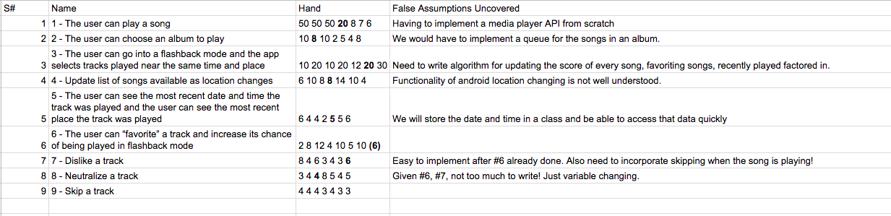*

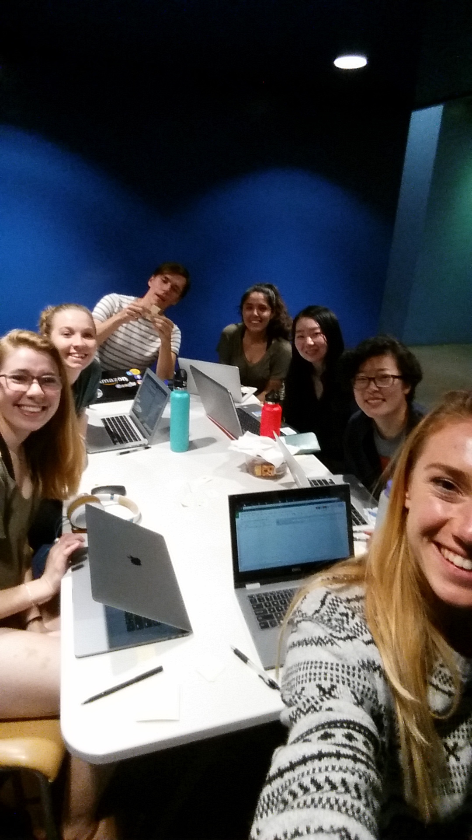

**URL of ZenHub Project:**

[*https://app.zenhub.com/workspace/o/cse-110-winter-2018/cse-110-team-project-team-35/boards?repos=119610710*](https://app.zenhub.com/workspace/o/cse-110-winter-2018/cse-110-team-project-team-35/boards?repos=119610710)

**User Interface Progressions/Screens (Wireframes)**

*Only if you don’t store User Stories in ZenHub, insert here, ordered and labelled by User Story*

All wireframes are in ZenHub with their associated User Story.