By the end of this ski season, we need to implement a data-driven strategy that takes into account Big Mountain’s market segment and its facilities to determine a ticket price that would increase revenue by at least $1.5 million by the end of the next ski season . We have determined a random forest model to select Big Mountain’s appropriate Adult Weekend ticket price based on its facilities and the prices of competitors in the market and their facilities. This ticket price will increase revenue.

We used all available competitor data on our model and it suggests that Big Mountain model price should be $95.87 for an adult weekend ticket. This is about $15 higher than the current price for an adult weekend ticket is $81.00. However, to make up for the cost of the additional $1M that the chair would cost, with 350k expected visitors on average buying 5 day tickets, this cost could be made up for by raising the price of a ticket by $0.88. So the ticket should be $96.75.

The mean absolute error of our model was $10.39 meaning predicting ticket price using the mean would have an average of being $10.39 off from the true price given its facilities. Even with this taken into account, Big Mountain is under-pricing its Adult Weekend tickets at $81.00.

For future improvements we should consider adding a run, and increasing the vertical drop by adding a run 150 ft lower down. This would support a $1.99 increase in ticket prices when including the additional chair. To determine how much profit ticket prices would bring in, relevant cost information that would be needed to know include the cost of adding height to vertical drops, maintaining/adding runs and maintaining/adding snow machine acre coverage.Big Mountain should also eliminate the consideration of closing 10 ski runs because that would cause a $1.75 drop in ticket price.

To select a model, we had first built a linear regression model on training and test sets and used cross-validation. We imputed median for missing values and we found that the ideal number of features would be 8.Our mean absolute error was about 12 meaning if we used this model to predict ticket price we would be about 11.79 dollars off. Our average mean absolute error of our cross-validation would be about 10.50 with a STD of 1.62.

Then we built a random forest model on training and test sets using pre-processing steps to determine using median would create a better model than mean when imputing msising values, and the ideal number of estimators in our model is 69. We used cross-validation with our random forest model. Our random forest model had a mean absolute error of 9.54. The mean absolute error was 9.54 meaning predicting ticket price using the mean would have an average of being 9.54 dollars off from the true price. The average mean absolute error of our cross-validation was 9.64 and the STD was 1.36. This means our random forest model has less variability and a better mean absolute error. In our pre-processing steps we had also found that using median to impute instead of mean was better. We also found not scaling the features was better for our model. We have selected random forest model to determine most important features in adult weekend ticket pricing. These features were fastQuads, Runs, Snow Making_ac, and vertical_drop.

Big Mountain's modeled price was so much higher than its current price because it is more competitive in all variables our model determined to be significant in impacting price yet it was not priced as high as many others. The mismatch probably would come as a surprise given that its been priced lower than what people are willing to pay based on its facilities.

Features that came up as important in the modeling as most important were fast quads, amount of runs, snow making area coverage and vertical drops.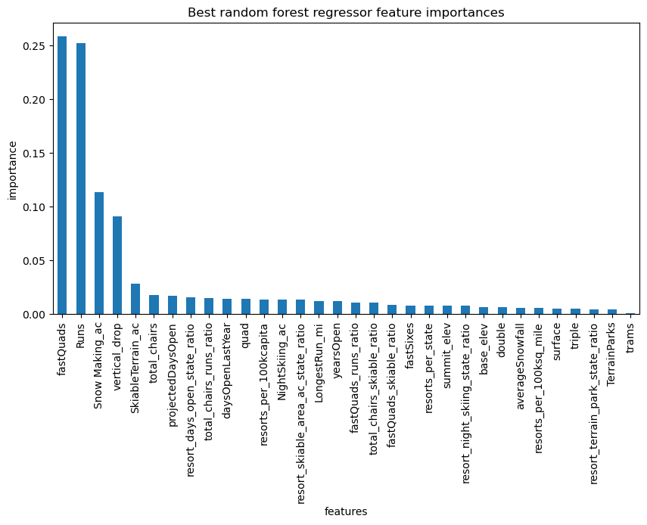

In these features Big Mountain is very competitive relative to other ski resorts in the market.

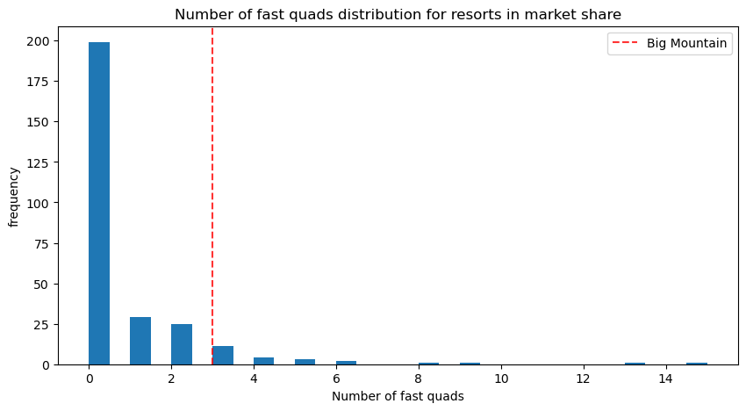

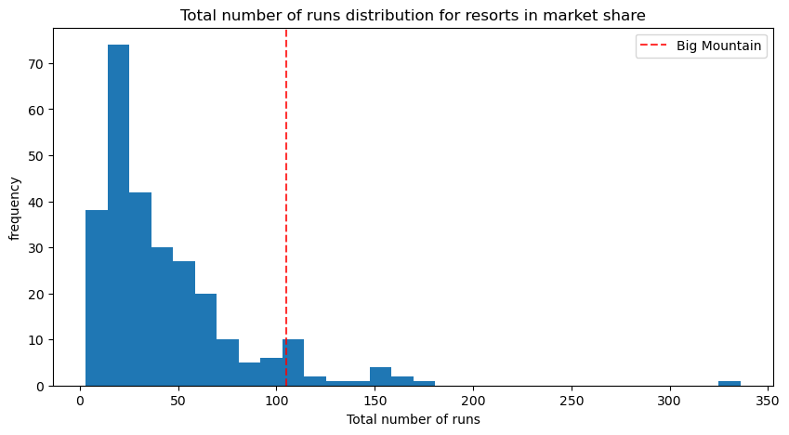

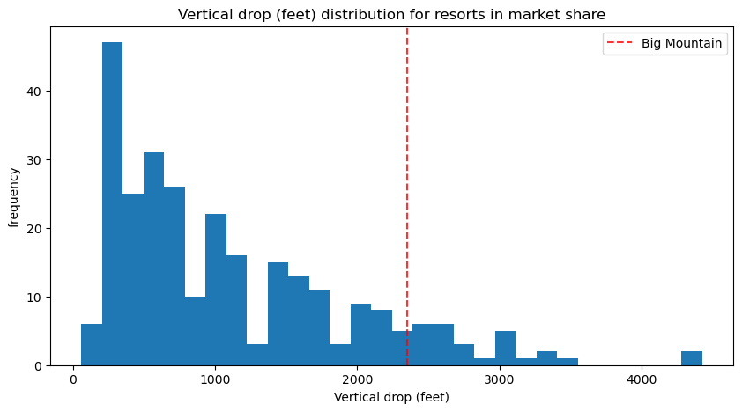

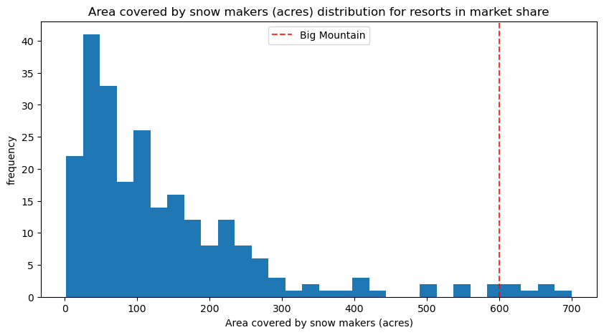

Our model should be used to see how other facility updates would impact ticket price. A business analyst can compare combinations of updating facilities/closing facilities in order to find the right cost reduction and/or price increase that can increase the profit margin.

Ex: The business can test run closures by seeing how ticket price is affected by number of closed runs and other facility additions. Closing 3 runs has the same effect on ticket price as closing 4 or 5. Closing 1 run has no effect.