Steps to creating a GitHub infographic – Help from Copilot

I want to build an interactive infographic in github based on Excel data input and a D3plus treemaps. Can you guide me through the creation of this?
Absolutely. A GitHub-hosted interactive infographic using Excel → JSON → D3plus Treemap is a very good architecture because it separates the data from the visualization and makes updates easy.

########################################################################################
This is great and exactly what I want to do. I really need my hand held for every step from conception to end product. I have the data.xlsx ready to go with the data in levels. I have github desktop open. I need the steps explicitly guided from creating the repo onwards please.

Ah! You're creating the repository on the GitHub website, not in GitHub Desktop. That's why you can't see a Local Path field.
You're actually in a good position. Let's use this repository you've already started.

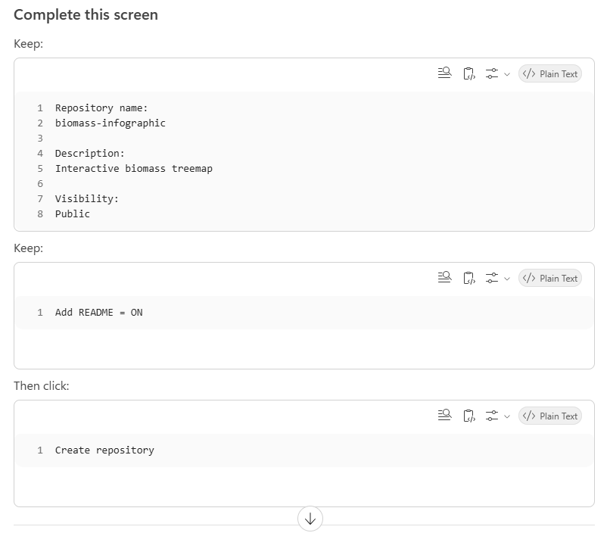
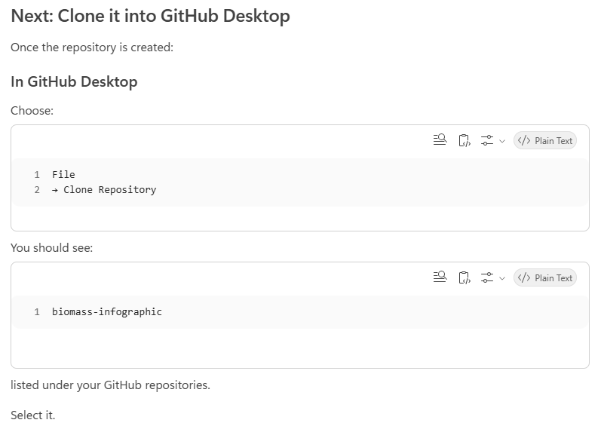
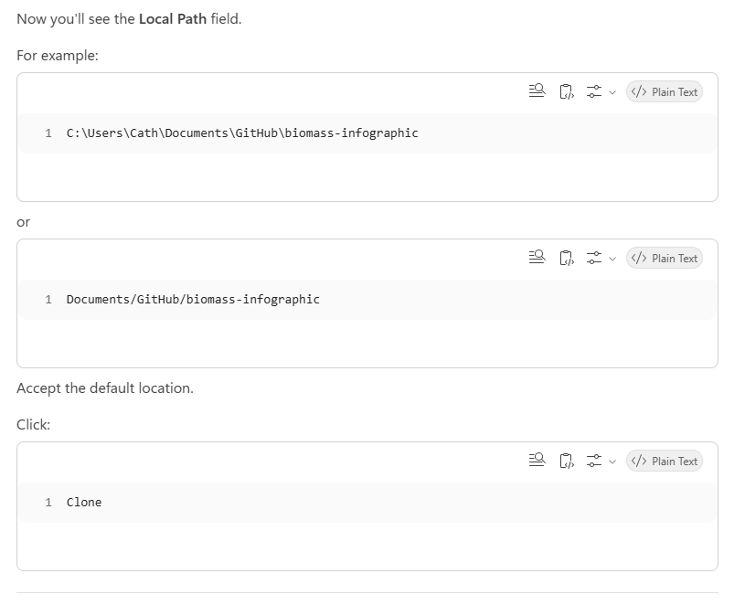

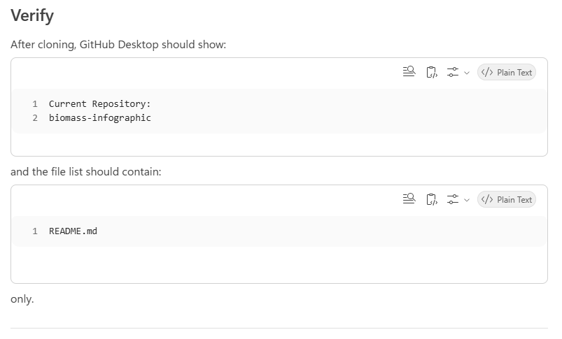
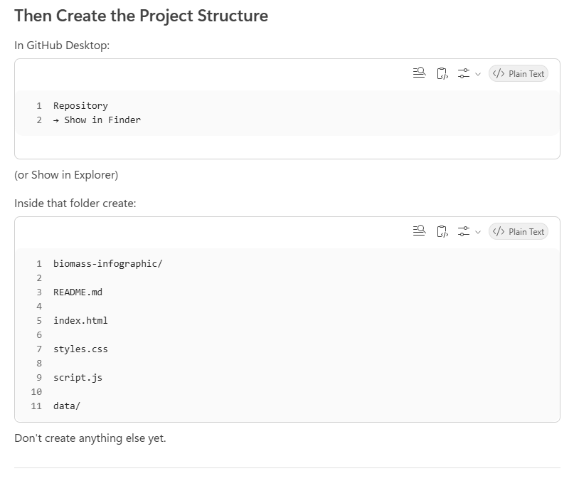

Before we go further
After you've:
- Created the repo on GitHub
- Cloned it into GitHub Desktop
- Created the folder structure above
tell me:
✅ "Phase 1 complete"
and upload a screenshot of:
- GitHub Desktop
- or the repository folder
Then we'll build the actual files together and I'll give you the exact code to paste into each one. We'll proceed one small step at a time so nothing gets overwhelming.
########################################################################################
Perfect — you're actually in exactly the right place.
From your screenshot I can see:
- Repository is cloned ✅
- Current repository = biomass-infographic ✅
- Branch = main ✅
The reason you don't see the README is simply that GitHub Desktop doesn't show files by default.
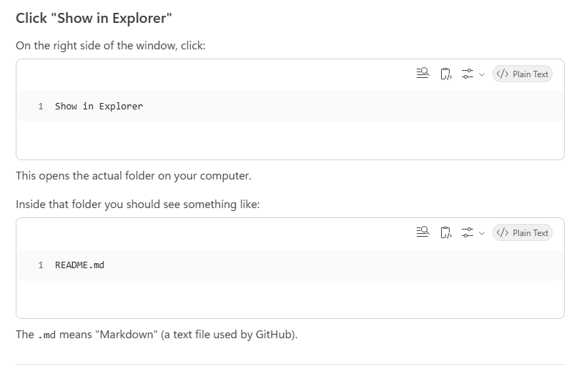

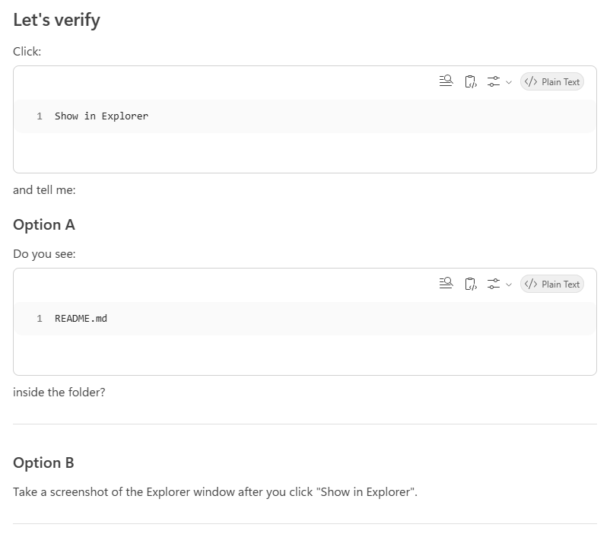
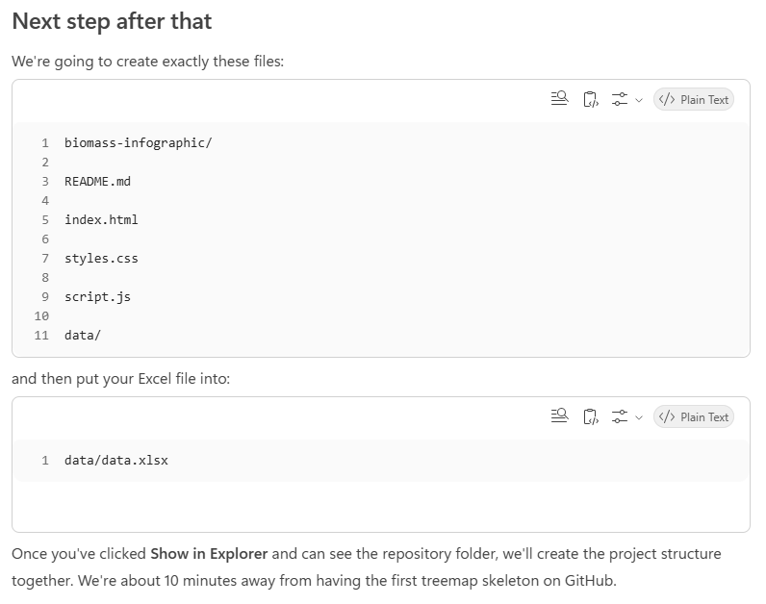
########################################################################################
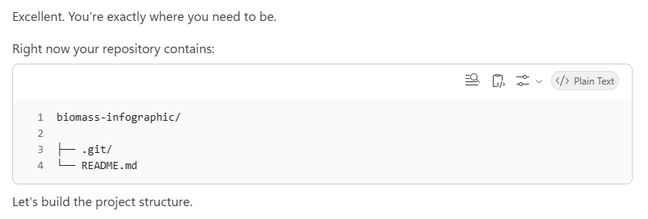
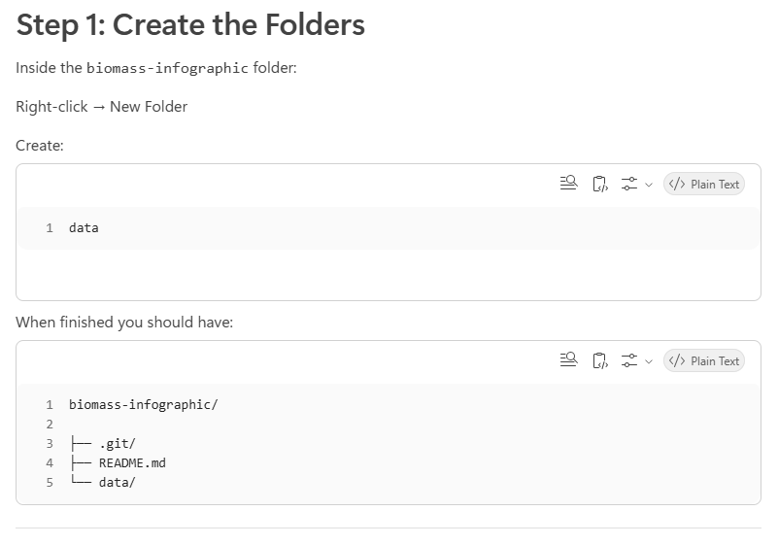
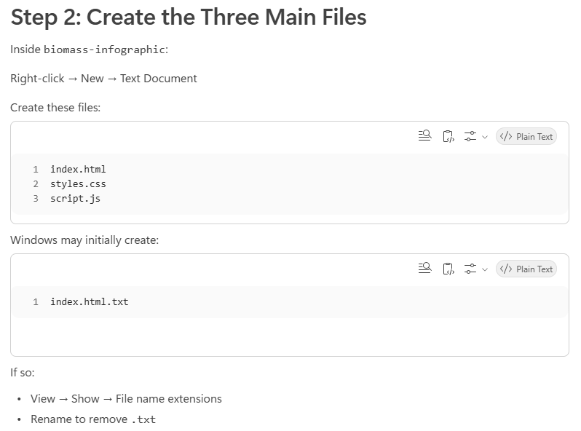

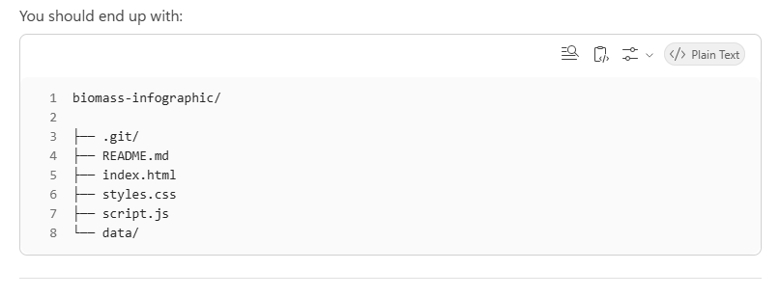
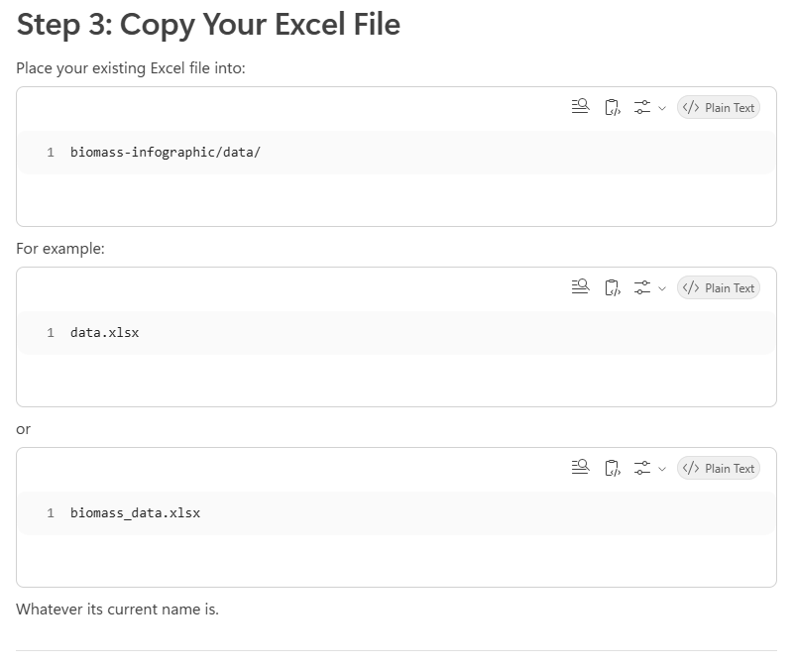
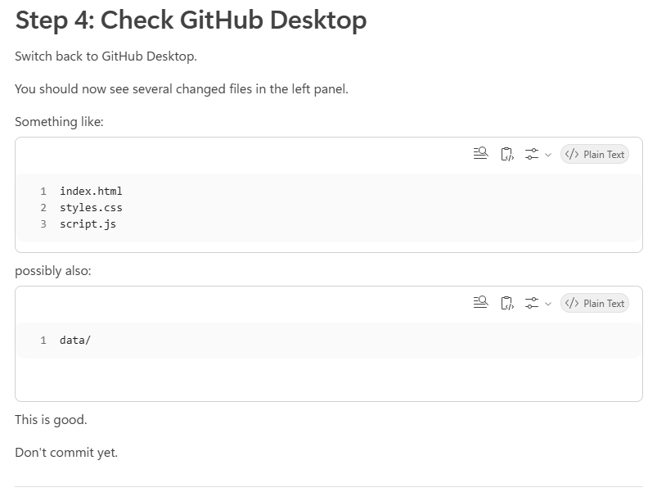
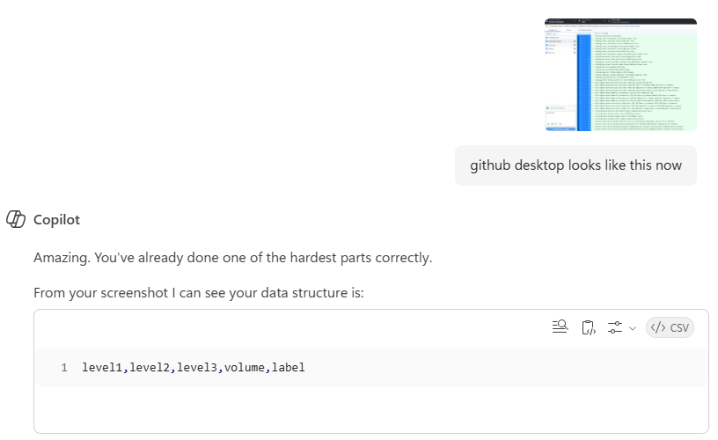

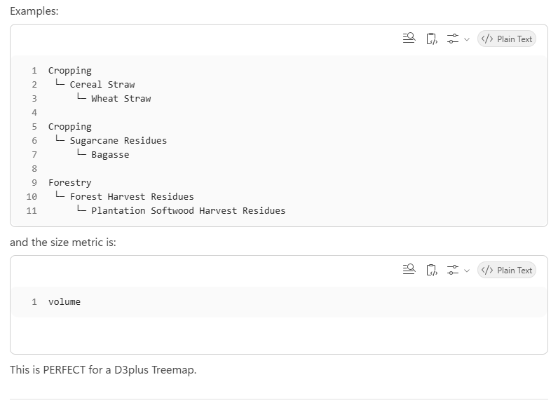
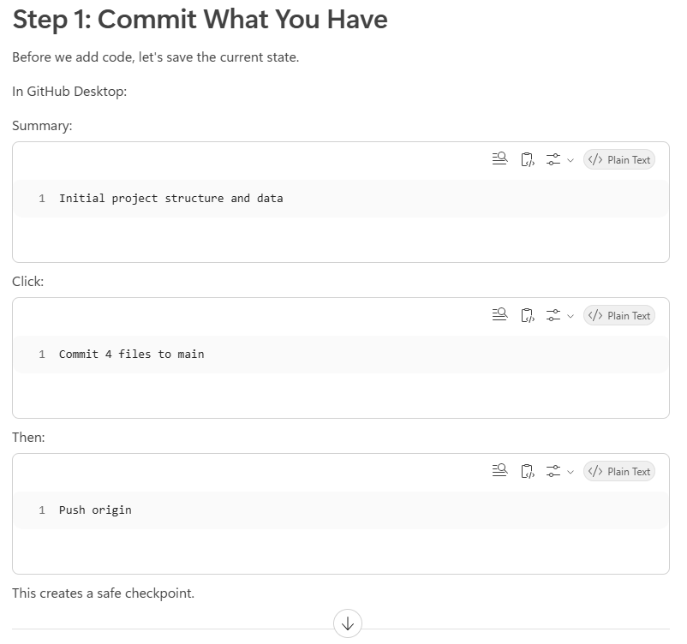
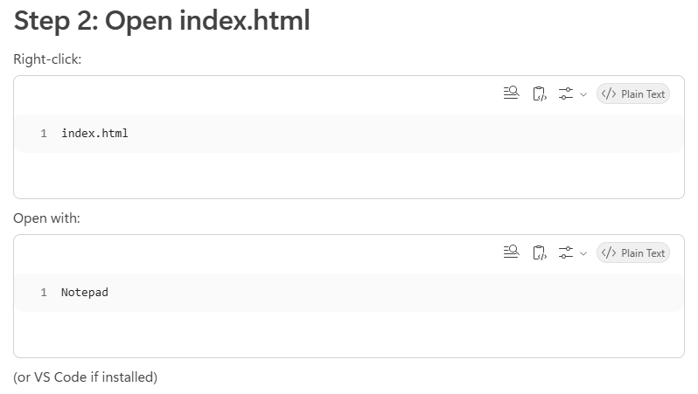
I used Visual Studio Code (VS Code) and manually typed the code in to get familiar with it.
########################################################################################
