115 年度「特考關務班第1期」
「專題研討」書面報告

旅客通關制度之探討

第五組

報告人：
小組成員：

報告日期：中華民國 OOO 年 O 月O日
摘要

Table of Contents
摘要 I
Abstract II
Acknowledgement III
List of Figure V
List of Table VI
Chapter 1 Thesis Format 1
1.1 Add number to table / figure 1
1.1.1 Index number 1
1.1.2 Format of content and title 1
1.2 Add List of Figure / Table 2
Chapter 2 Page index number 3
2.1 How to insert Roman numeral index page number 3
2.1.1 Step 1. Split the page between cover page and pages before content 3
2.1.2 Step 2. Add Roman numeral index page number 4
2.2 Insert Table of Contents 5
2.2.1 How to make class of titles 5
2.2.2 How to show Table of Contents in the thesis file 6

List of Figure
Figure 1 Path to add index number 3
Figure 2 Window when you click "Insert table of figures" 4
Figure 3 Path of "Breaks" 5
Figure 4 Category of "Breaks" 5
Figure 5 How to change the format of page number 6
Figure 6 The window of "Page Number Format" 6
Figure 7 Window of dialog box in "Paragraph" 7
Figure 8 Path to show Navigation Pane 8
Figure 9 Navigation Pane 8

List of Table
Table 1 Format description 3

Chapter 1 Thesis Format

1.1 Add number to table / figure
1.1.1 Index number

If you want to add index number, at the place that you want to add, click “References” -> “Insert Caption”.
If you have already set the number of contents, you can tick the “Include content number”, and choose the title 1 option.
When you insert the index number, click Tab for once, and then type the illustrate behind, the index number will be added successfully. E.g.: Figure1.1, Table2.1.

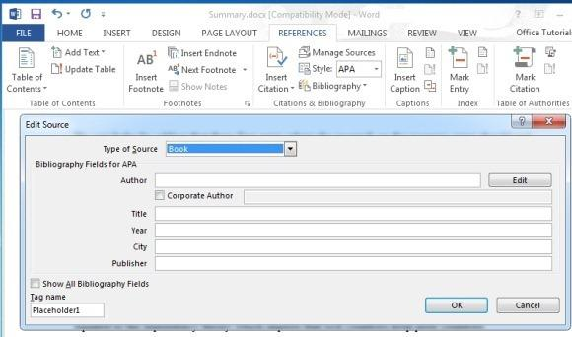
Figure 1 Path to add index number

1.1.2 Format of content and title

All the format of thesis can take Table 1 for reference.

Table 1 Format description
Category | Font size | Format
Content | 12 | -
Title 1 | 18 | Chapter 1
Title 2 | 16 | 1.1
Title 3 | 14 | 1.2.1
Figure / Table | 12 | As the caption format  (e.g., Figure 1)

1.2 Add List of Figure / Table

If you want to add list of figure or list of tables, click “References”, “Insert table of figures” at the place you want to add, and choose the caption label that you want to add.
You can take Figure 2 for reference.

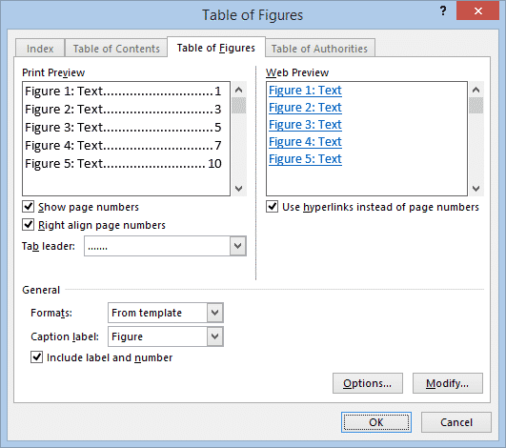
Figure 2 Window when you click "Insert table of figures"

Chapter 2 Page index number
2.1 How to insert Roman numeral index page number
2.1.1 Step 1. Split the page between cover page and pages before content

First, we need to click the page under the cover page and click “Layout”, and then click “Breaks”, choose “Next page”.
You can take Figure 3 and Figure 4 for reference.

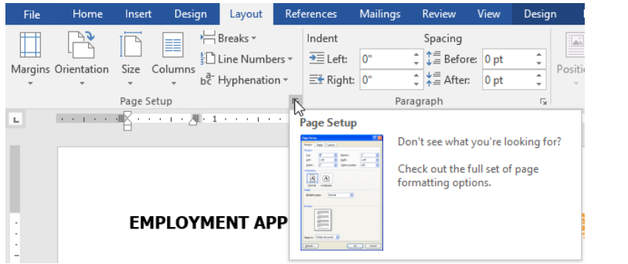
Figure 3 Path of "Breaks"

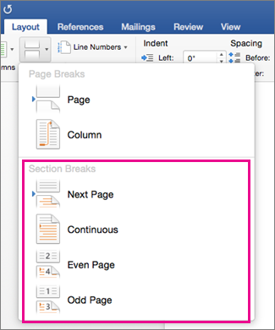
Figure 4 Category of "Breaks"

2.1.2 Step 2. Add Roman numeral index page number
Click “Page Number” below “Insert”, and choose the “Format Page Numbers”, select the Roman numeral numbers in “Number format”.
After you choose the number format, don’t forget to choose “Bottom of Page” when you insert the page numbers.

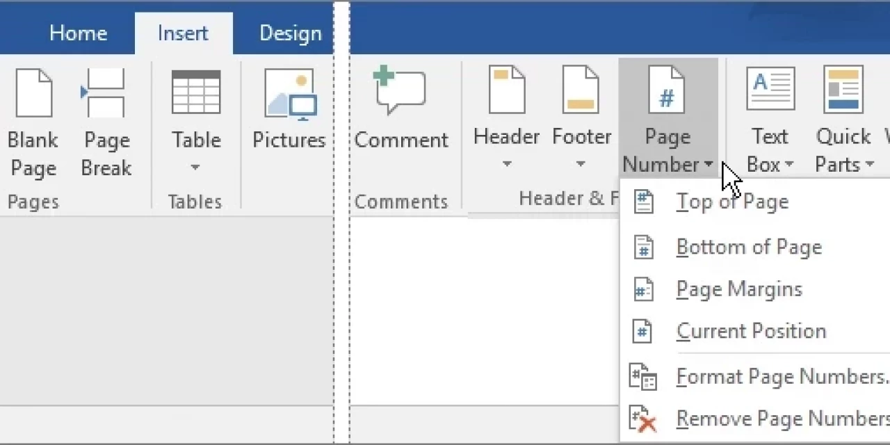
Figure 5 How to change the format of page number

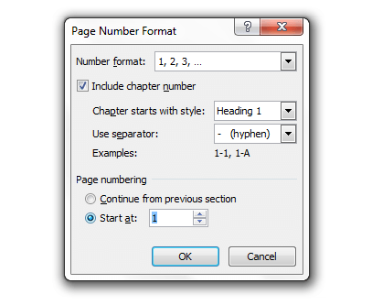
Figure 6 The window of "Page Number Format"

2.2 Insert Table of Contents
2.2.1 How to make class of titles
When you finish editing a title, tap “Home” and then click the dialog box right of “paragraph”, as Figure 7, choose the class of font in the “Outline level” of the window.

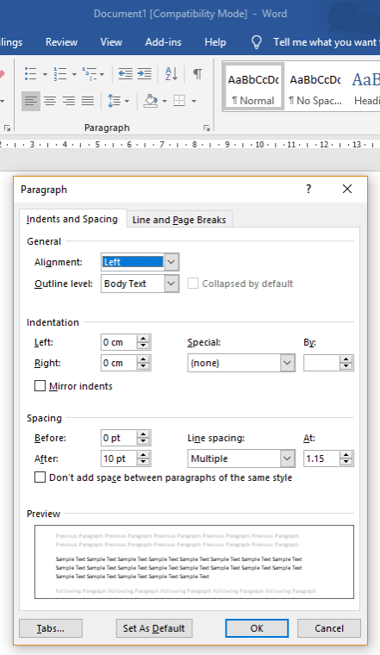
Figure 7 Window of dialog box in "Paragraph"

2.2.2 How to show Table of Contents in the thesis file
If you want to show Table of Contents beside the content, click “View” and then choose the “Navigation Pane”, then you can see Table of Contents in your file.
You can take Figure 8 for reference.

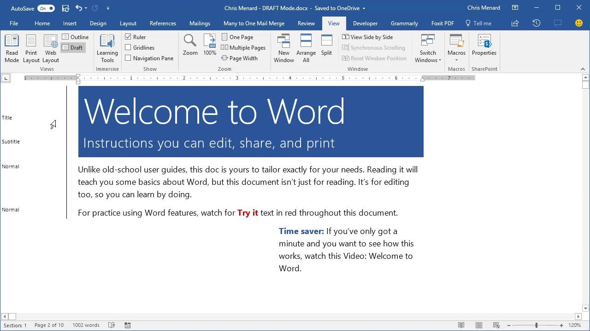
Figure 8 Path to show Navigation Pane

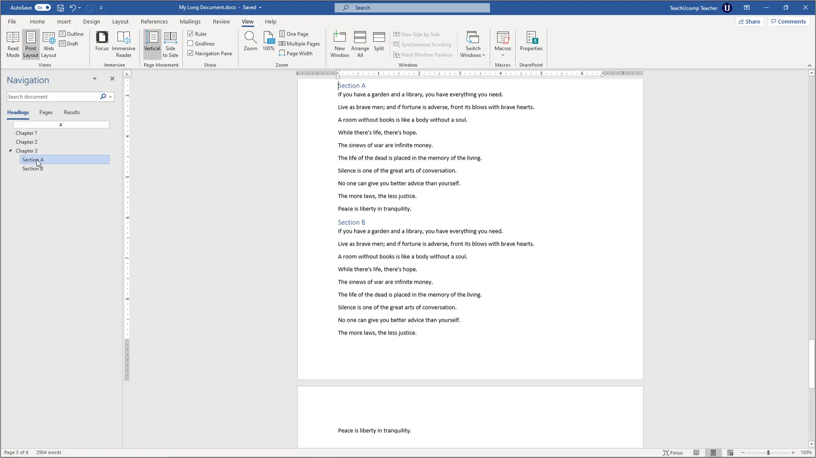
Figure 9 Navigation Pane

