A11: Learning to find MST using Prim’s and Kruskal’s algorithms

1. Priority Queue using Heaps
heap.h:
1 #include <iostream>
2 #include <vector>
3 using namespace std;
4
5 #ifndef HEAP_H
6 #define HEAP_H
7
8
9 class Heap{
10 public:
11 Heap();
12 bool insert(int wt, int node);
13 int retTop();
14 inline bool empty(){
15 return size==0;
16 }
17 inline bool inHeap(int node){
18 return position[node]!=-1;
19 }
20 bool deleteMin();
21 void decreaseKey(int key, int ne);
22 void buildHeap(vector<int>& vt, vector<int>& wt);
23 private:
24 void percolateUp(int i);
25 void percolateDown(int i);
26 vector<int> heap;
27 vector<int> vertices;
28 vector<int> position;
29 int size;
30 };
31 #endif

heap.cpp:
1 #include "heap.h"
2 #include <iostream>
3 using namespace std;
4
5 Heap::Heap(){
6 heap.push_back(-1);
7 vertices.push_back(-1);
8 position = vector<int> (1000,-1);
9 size = 0;
10 }
11
12 void display(vector<int>& a){
13 for(int i=0;i<a.size();i++){
14 cout<<i<<" : "<<a[i]<<endl;
15 }
16 cout<<endl;
17 }
18
19 int Heap::retTop(){
20 return vertices[1];
21
22 }
23
24 void Heap::percolateUp(int i){
25 while(i>1){
26 if(heap[i]<heap[i/2]){
27 int tmp = heap[i];
28 int tmp2 = vertices[i];
29 position[tmp2] = i/2;
30 position[vertices[i/2]] = i;
31 heap[i] = heap[i/2];
32 vertices[i] = vertices[i/2];
33 heap[i/2] = tmp;
34 vertices[i/2] = tmp2;
35 i/=2;
36
37 }
38 else{
39 break;
40 }
41 }
42 }
43
44 void Heap::percolateDown(int i){
45 while(2*i<heap.size()){
46 int minChild = 2*i;
47 if(2*i+1 < heap.size() && heap[2*i]>heap[2*i+1]){
48 minChild = 2*i+1;
49 }
50 if(heap[i]>heap[minChild]){
51 int tmp = heap[i];
52 int tmp2 = vertices[i];
53
54 position[tmp2] = minChild;
55 position[vertices[minChild]] = i;
56
57 heap[i] = heap[minChild];
58 vertices[i] = vertices[minChild];
59 heap[minChild] = tmp;
60 vertices[minChild] = tmp2;
61 }
62 i=minChild;
63 }
64 }
65 bool Heap::insert(int wt,int node){
66 heap.push_back(wt);
67 vertices.push_back(node);
68 size++;
69 int i = heap.size()-1;
70 position[node]=i;
71 percolateUp(i);
72 }
73
74 void Heap::decreaseKey(int node, int ne){
75 int i = position[node];
76 heap[i] = ne;
77 percolateUp(i);
78 }
79
80 bool Heap::deleteMin(){
81 int last = heap.size()-1;
82
83 int tmp = heap[1];
84 heap[1] = heap[last];
85 heap[last] = tmp;
86
87 position[vertices[last]]=1;
88 int tmp2 = vertices[1];
89 vertices[1] = vertices[last];
90 vertices[last] = tmp2;
91
92
93 heap.pop_back();
94 vertices.pop_back();
95
96 percolateDown(1);
97 position[tmp2] = -1;
98 size--;
99 }
100
101
102
103 void Heap::buildHeap(vector<int>& vt, vector<int>& wt){
104 heap.clear();
105 vertices.clear();
106 heap.push_back(-1);
107 vertices.push_back(-1);
108 for(int i=0;i<vt.size();i++){
109 heap.push_back(wt[i]);
110 vertices.push_back(vt[i]);
111 position[vt[i]] = i+1;
112 }
113 size = vt.size();
114
115
116 for(int i = heap.size()/2; i>0;i--){
117 percolateDown(i);
118 }
119 //display(heap);
120 }

heaptest.cpp
1 #include <iostream>
2 #include "heap.h"
3 using namespace std;
4
5 int main(){
6 vector<int> vt;
7 vector<int> wt;
8 vt.push_back(5);
9 vt.push_back(4);
10 vt.push_back(3);
11 vt.push_back(2);
12 vt.push_back(1);
13
14 wt.push_back(5);
15 wt.push_back(4);
16 wt.push_back(3);
17 wt.push_back(2);
18 wt.push_back(1);
19
20 Heap heap;
21 heap.buildHeap(vt,wt);
22
23 heap.insert(0,20);
24 cout<<heap.retTop()<<endl;
25 heap.deleteMin();
26 heap.decreaseKey(5,0);
27 cout<<heap.retTop()<<endl;
28 while(!heap.empty()){
29 cout<<heap.retTop()<<endl;
30 heap.deleteMin();
31 }
32
33
34 // cout<<heap.retTop()<<endl;
35 // heap.decreaseKey(5,0);
36 // cout<<heap.retTop()<<endl;
37 }

Sample Input/Output:
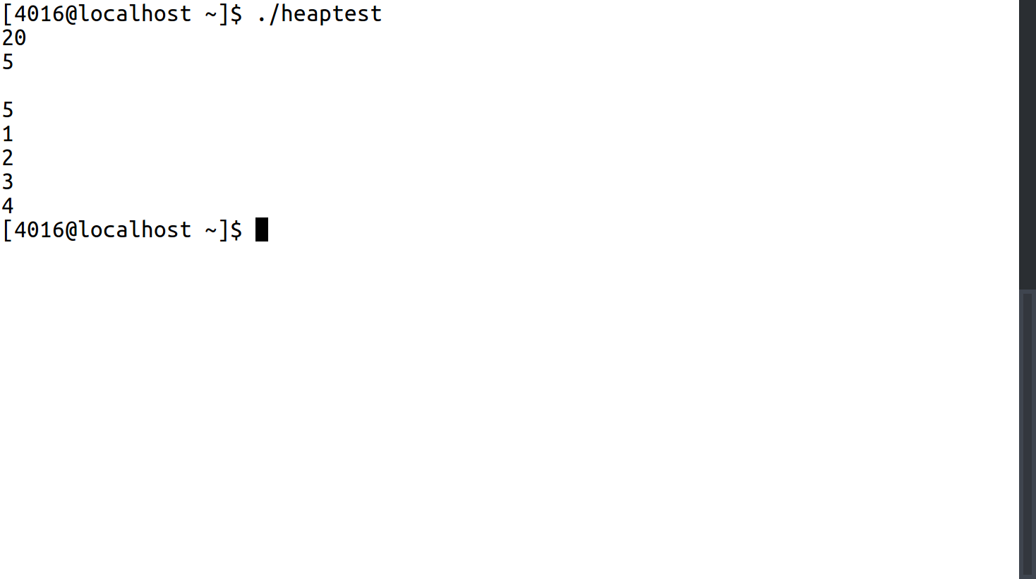

2. Union Find using Forest
disjset.h:
1 #include <vector>
2 using namespace std;
3 #ifndef DSU_H
4 #define DSU_H
5
6 //Array Implementation with Path Compression
7 class DSU{
8 public:
9 DSU();
10 DSU(int n);
11 int findSet(int node);
12 void unionSet(int node1, int node2);
13 private:
14 vector<int> parent;
15 int size;
16 };
17 #endif

disjset.cpp:
1 #include "disjset.h"
2 using namespace std;
3
4 DSU::DSU(){
5 size =0 ;
6 }
7 DSU::DSU(int n){
8 size = n;
9
10 for(int i=0;i<=n;i++){
11 parent.push_back(i);
12 }
13 }
14
15 int DSU::findSet(int node){
16 int i = node;
17 while(parent[i]!=i){
18 parent[node] = parent[i];
19 i = parent[i];
20 }
21 return parent[node];
22 }
23
24 void DSU::unionSet(int node1, int node2){
25 int root1 = findSet(node1);
26 int root2 = findSet(node2);
27 parent[root1] = root2;
28 }

disjsettest.cpp
1 #include <iostream>
2 #include "disjset.h"
3
4 using namespace std;
5
6 int main(){
7 DSU a(3);
8 a.unionSet(1,2);
9 if(a.findSet(2) == a.findSet(3)){
10 cout<<"CYC\n";
11 }
12 a.unionSet(2,3);
13 if(a.findSet(1) == a.findSet(3)){
14 cout<<"CYC\n";
15 }
16
17 }
Sample Input/Output:
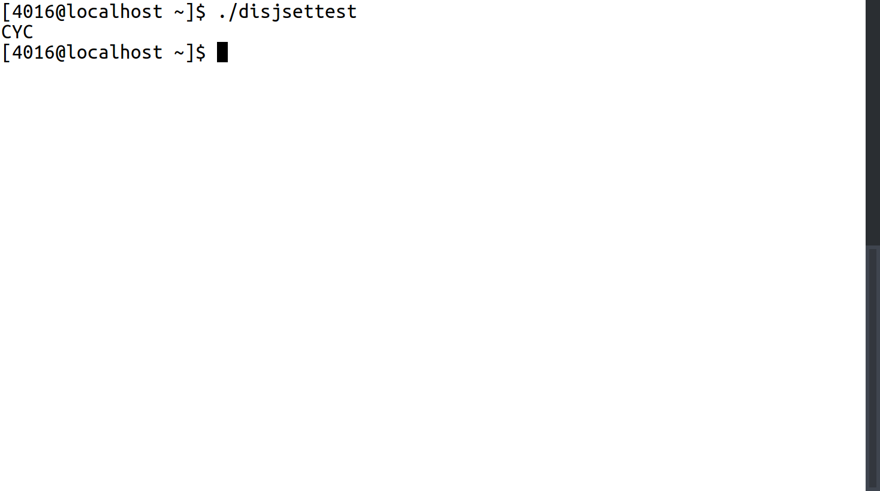

3. Prim’s Algorithm
prim.h:
1 #include "heap.h"
2 #include "wtgraph.h"
3 #include <vector>
4 using namespace std;
5
6 #ifndef PRIM_H
7 #define PRIM_H
8
9 class Prim{
10 public:
11 Prim(WtGraph& g);
12 void findMST();
13 WtGraph retMST();
14 int retWt();
15 private:
16 Heap heap;
17 WtGraph graph;
18 WtGraph MST;
19 int MSTWt;
20 vector<int> from;
21 vector<int> wt;
22 };
23 #endif

prim.cpp:
1 #include "prim.h"
2 #include <limits.h>
3 using namespace std;
4 Prim::Prim(WtGraph& g){
5 graph = g;
6 MSTWt = 0;
7 MST = WtGraph(g.getSize());
8 from = vector<int> (g.getSize()+1, -1);
9 wt = vector<int> (g.getSize()+1, INT_MAX);
10 }
11
12 void Prim::findMST(){
13
14 for(int i=2;i<=graph.getSize();i++){
15 heap.insert(wt[i],i);
16 }
17 heap.insert(0,1);
18 from[1]=-1;
19 wt[1] = 0;
20 while(!heap.empty()){
21 int u = heap.retTop();
22 heap.deleteMin();
23 for(int v=1;v<=graph.getSize();v++){
24 int weight = graph.getWt(u,v);
25 //cout<<u<<" "<<v<<" "<<weight<<endl;
26 if(weight>0 && wt[v]>weight && heap.inHeap(v)){
27 heap.decreaseKey(v,weight);
28 wt[v] = weight;
29 from[v]=u;
30 }
31 }
32 }
33 }
34
35 WtGraph Prim::retMST(){
36 for(int i=2;i<from.size();i++){
37 MSTWt+=wt[i];
38 cout<<i<<" "<<from[i]<<" "<<wt[i]<<endl;
39 MST.addEdge(i,from[i],wt[i]);
40 }
41 return MST;
42 }
43
44 int Prim::retWt(){
45 return MSTWt;
46 }

primtest.cpp
1 #include <iostream>
2 using namespace std;
3 #include "prim.h"
4 #include "wtgraph.h"
5
6 int main(){
7 WtGraph g(6);
8 g.addEdge(1,2,5);
9 g.addEdge(1,3,6);
10 g.addEdge(1,4,4);
11 g.addEdge(2,3,1);
12 g.addEdge(2,4,2);
13 g.addEdge(3,4,2);
14 g.addEdge(3,5,5);
15 g.addEdge(3,6,3);
16 g.addEdge(4,6,4);
17 g.addEdge(5,6,4);
18 //g.bfs();
19 Prim p(g);
20 p.findMST();
21 WtGraph mst = p.retMST();
22 cout<<"Wt of MST: "<<p.retWt()<<endl;
23
24 }
Sample Input/Output:
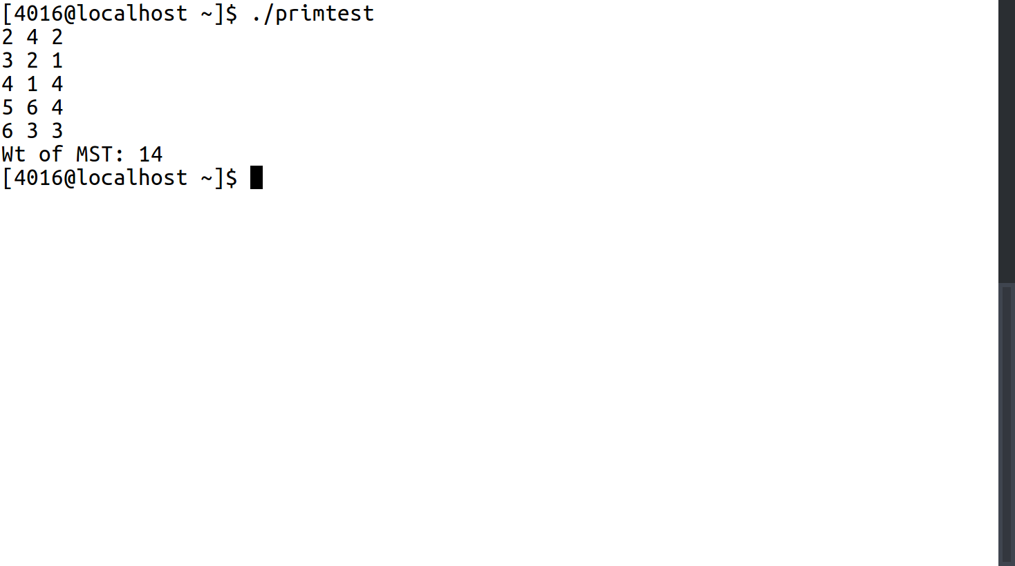

4. Kruskal’s Algorithm
kruskal.h:
1 #include "disjset.h"
2 #include "wtgraph.h"
3 #include <vector>
4 using namespace std;
5
6 #ifndef KRUSK_H
7 #define KRUSK_H
8
9 class Edge{
10 public:
11 Edge(int u,int v,int wt){
12 this->u = u;
13 this->v = v;
14 this->wt = wt;
15 }
16 inline int getU(){
17 return u;
18 }
19 inline int getV(){
20 return v;
21 }
22 inline int getWt(){
23 return wt;
24 }
25 bool operator < (const Edge & y) const{
26 return this->wt < y.wt;
27 }
28 bool operator > (const Edge & y) const{
29 return this->wt > y.wt;
30 }
31 private:
32 int u;
33 int v;
34 int wt;
35 };
36
37 class Kruskal{
38 public:
39 Kruskal(WtGraph& g);
40 void findMST();
41 WtGraph retMST();
42 int retWt();
43 private:
44 DSU dsu;
45 WtGraph graph;
46 int MSTWt;
47 WtGraph MST;
48 vector<Edge> edge;
49 };
50 #endif

kruskal.cpp:
1 #include "kruskal.h"
2 #include <algorithm>
3 #include <limits.h>
4 #include <iostream>
5 using namespace std;
6
7 Kruskal::Kruskal(WtGraph& g){
8 graph = g;
9 MSTWt = 0;
10 MST = WtGraph(g.getSize());
11 dsu = DSU(g.getSize());
12 }
13
14 void Kruskal::findMST(){
15 for(int i=1;i<=graph.getSize();i++){
16 for(int j=1;j<=graph.getSize();j++){
17 int wt = graph.getWt(i,j);
18 if(wt!=0){
19 edge.push_back(Edge(i,j,wt));
20 }
21 }
22 }
23 sort(edge.begin(),edge.end());
24 for(int i=0;i<edge.size();i++){
25 int u = edge[i].getU();
26 int v = edge[i].getV();
27 int wt = edge[i].getWt();
28 if(dsu.findSet(u)!=dsu.findSet(v)){
29 MST.addDirEdge(u,v,wt);
30 dsu.unionSet(u,v);
31 }
32 }
33 }
34
35 WtGraph Kruskal::retMST(){
36 for(int i=1;i<=MST.getSize();i++){
37 for(int j=1;j<=MST.getSize();j++){
38 int wt = MST.getWt(i,j);
39 if(wt!=0){
40 MSTWt += wt;
41 cout<<i<<" "<<j<<" "<<wt<<endl;
42 }
43 }
44 }
45 return MST;
46 }
47
48 int Kruskal::retWt(){
49 return MSTWt;
50 }

kruskaltest.cpp
1 #include <iostream>
2 #include "kruskal.h"
3 #include "wtgraph.h"
4 using namespace std;
5
6 int main(){
7 WtGraph g(6);
8 g.addEdge(1,2,5);
9 g.addEdge(1,3,6);
10 g.addEdge(1,4,4);
11 g.addEdge(2,3,1);
12 g.addEdge(2,4,2);
13 g.addEdge(3,4,2);
14 g.addEdge(3,5,5);
15 g.addEdge(3,6,3);
16 g.addEdge(4,6,4);
17 g.addEdge(5,6,4);
18 Kruskal k(g);
19 k.findMST();
20 k.retMST();
21 cout<<"Wt of MST: "<<k.retWt()<<endl;
22 }
Sample Input/Output:
