A12: Learning to find shortest path using Dijkstra's and Warshall's algorithms

1. Dijkstra’s Algorithm
dijk.h:
1 #include "heap.h"
2 #include "wtgraph.h"
3 #include <vector>
4 using namespace std;
5
6 #ifndef DIJK_H
7 #define DIJK_H
8
9 class Dijk{
10 public:
11 Dijk(WtGraph& g);
12 void findSPT(int source);
13 void tracePath(int dest);
14 WtGraph retSPT();
15 private:
16
17 Heap heap;
18 WtGraph graph;
19 WtGraph SPT;
20 vector<int> from;
21 vector<int> dist;
22 };
23 #endif

dijk.cpp:
1 #include "dijk.h"
2 #include <limits.h>
3 #include <vector>
4 #include <stack>
5 using namespace std;
6 Dijk::Dijk(WtGraph& g){
7 graph = g;
8 SPT = WtGraph(g.getSize());
9 from = vector<int> (g.getSize()+1, -1);
10 dist = vector<int> (g.getSize()+1, INT_MAX);
11 }
12
13 void Dijk::findSPT(int source){
14 vector<int> tmpV;
15 vector<int> tmpWt;
16 from[source]=-1;
17 dist[source] = 0;
18 for(int i=1;i<=graph.getSize();i++){
19 //heap.insert(dist[i],i);
20 tmpV.push_back(i);
21 tmpWt.push_back(dist[i]);
22 }
23 // for(int i=0;i<tmpV.size();i++){
24 // cout<<tmpWt[i]<<endl;
25 // }
26 heap.buildHeap(tmpV,tmpWt);
27 //heap.insert(0,source);
28
29 while(!heap.empty()){
30 int u = heap.retTop();
31 heap.deleteMin();
32 for(int v=1;v<=graph.getSize();v++){
33 int weight = graph.getWt(u,v);
34 //cout<<u<<" "<<v<<" "<<weight<<endl;
35 if(weight!=0 && dist[u]!=INT_MAX && dist[v]>dist[u]+weight && heap.inHeap(v)){
36 dist[v] = dist[u]+weight;
37 heap.decreaseKey(v,dist[v]);
38 from[v]=u;
39 }
40 }
41 }
42 }
43
44 WtGraph Dijk::retSPT(){
45 for(int i=1;i<from.size();i++){
46 if(dist[i]!=INT_MAX){
47 cout<<i<<" "<<dist[i]<<endl;
48 SPT.addDirEdge(i,from[i],dist[i]);
49 }
50 else{
51 cout<<i<<" "<<"INF"<<endl;
52 }
53
54 }
55 return SPT;
56 }
57
58 void Dijk::tracePath(int dest){
59 int i = dest;
60 int total = 0;
61 if(dist[i]==INT_MAX){
62 cout<<"No Path Exists\n";
63 return;
64 }
65 stack<int> tmp;
66 while(from[i]!=-1){
67 tmp.push(i);
68 total+=dist[i];
69 i = from[i];
70 }
71 tmp.push(i);
72
73 while(!tmp.empty()){
74 cout<<tmp.top()<<' ';
75 tmp.pop();
76 }
77 cout<<endl;
78 cout<<"Total Distance: "<<total<<endl;
79 }

dijktest.cpp
1 #include <iostream>
2 using namespace std;
3 #include "dijk.h"
4 #include "wtgraph.h"
5
6 int main(){
7 WtGraph g(5);
8 g.addDirEdge(1,2,10);
9 g.addDirEdge(1,3,3);
10 g.addDirEdge(3,2,4);
11 g.addDirEdge(2,3,1);
12 g.addDirEdge(2,4,2);
13 g.addDirEdge(3,4,8);
14 g.addDirEdge(4,5,7);
15 g.addDirEdge(5,4,9);
16 g.addDirEdge(3,5,2);
17
18 //g.bfs();
19 Dijk p(g);
20 p.findSPT(1);
21 p.retSPT();
22 cout<<"Path: \n";
23 p.tracePath(4);
24 }
Sample Input/Output:
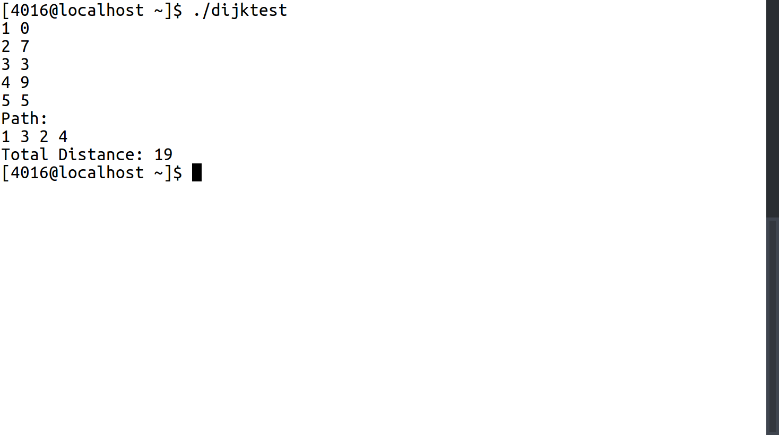

2. Floyd & Warshall’s Algorithm
floydwarshall.h:
1 #include <vector>
2 #include "wtgraph.h"
3 using namespace std;
4 #ifndef FW_H
5 #define FW_H
6
7 class FW{
8 public:
9 FW(WtGraph& g);
10 void findAPSP();
11 void printAPSP();
12 void findSP(int source, int dest);
13
14 private:
15 void findSP(int source, int dest, int& total);
16 WtGraph graph;
17 vector<vector<int> > dist;
18 vector<vector<int> > pred;
19 };
20 #endif

floydwarshall.cpp:
1 #include "floydwarshall.h"
2 #include <iostream>
3 #include <vector>
4 #include <limits.h>
5 using namespace std;
6
7
8 FW::FW(WtGraph& g){
9 graph = g;
10 dist = vector<vector<int> >(g.getSize()+1,vector<int>(g.getSize()+1,INT_MAX));
11 pred = vector<vector<int> >(g.getSize()+1,vector<int>(g.getSize()+1,0));
12 }
13
14 void FW::findAPSP(){
15 for(int i=1;i<=graph.getSize();i++){
16 for(int j=1;j<=graph.getSize();j++){
17 int wt = graph.getWt(i,j);
18 if(i==j){
19 dist[i][j]=0;
20 }
21 if(wt!=0){
22 dist[i][j] = wt;
23
24 }
25 }
26 }
27
28 for(int k = 0;k<graph.getSize();k++){
29
30 for(int u=1;u<=graph.getSize();u++){
31 for(int v=1;v<=graph.getSize();v++){
32 if(dist[u][k]!= INT_MAX && dist[k][v] != INT_MAX && dist[u][v] > dist[u][k] + dist[k][v] ){
33 dist[u][v] = dist[u][k] + dist[k][v];
34 pred[u][v] = k;
35 }
36 }
37 }
38
39 }
40
41 }
42
43 void FW::printAPSP(){
44 for(int i=1;i<dist.size();i++){
45 for(int j=1; j<dist.size();j++ ){
46 if(dist[i][j]==INT_MAX){
47 cout<<"INF"<<"\t";
48 }
49 else{
50 cout<<dist[i][j]<<"\t";
51 }
52 }
53 cout<<endl;
54 }
55 }
56
57 void FW::findSP(int source, int dest, int& total){
58 if(pred[source][dest]==0){
59 cout<<source<<"-"<<dest<<" Distance: "<<dist[source][dest]<<endl;;
60 total+=dist[source][dest];
61 }
62 else{
63 findSP(source,pred[source][dest], total);
64 findSP(pred[source][dest],dest, total);
65 }
66 }
67
68 void FW::findSP(int source, int dest){
69 int total = 0;
70 findSP(source,dest,total);
71 cout<<"Total Distance: "<<total<<endl;
72 }

pathtest.cpp
1 #include "floydwarshall.h"
2 #include "wtgraph.h"
3 using namespace std;
4
5 int main(){
6 WtGraph g(5);
7 g.addDirEdge(1,2,10);
8 g.addDirEdge(1,3,3);
9 g.addDirEdge(3,2,4);
10 g.addDirEdge(2,3,1);
11 g.addDirEdge(2,4,2);
12 g.addDirEdge(3,4,8);
13 g.addDirEdge(4,5,7);
14 g.addDirEdge(5,4,9);
15 g.addDirEdge(3,5,2);
16
17 FW fw(g);
18 fw.findAPSP();
19 fw.printAPSP();
20 fw.findSP(1,4);
21 }

Sample Input/Output:
