A1. Learning Classes, Objects, Constructor using Bank money transfer and planar geometry applications.

1.Bank Money Transfer Application
account.h:
1 class account{
2 public:
3 account(){
4 accNo=0;accBal=0;
5 }
6 account(unsigned id, double amount);
7 account(account &from);
8 void deposit(double amount);
9 bool withdraw(double amount);
10 unsigned int getId();
11 double getBalance();
12 bool transfer(account &from, double amt);
13 private:
14 unsigned accNo;
15 double accBal;
16 };
17
18 bool transfer(account &from, account &to, double amt);
account.cpp:
1 #include "account.h"
2
3 account::account(unsigned int id,double amt){
4 accNo = id;
5 accBal= amt;
6 if(accBal<0){
7 accBal=0.0;
8 }
9 }
10
11 void account::deposit(double amt){
12 if(amt>0){
13 accBal+=amt;
14 }
15 }
16
17 bool account::withdraw(double amt){
18 if(amt<accBal){
19 accBal-=amt;
20 return true;
21 }
22 return false;
23 }
24
25
26 double account::getBalance(){
27 return accBal;
28 }
29
30 unsigned int account::getId(){
31 return accNo;
32 }
33
34
35 bool account::transfer(account &from, double amt){
36 if(from.withdraw(amt)){
37 accBal+=amt;
38 return true;
39 }
40 return false;
41 }
42
43
44 account::account(account &from){
45 accNo = from.getId();
46 accBal = from.getBalance();
47 }
48
49 bool transfer(account &from, account &to, double amt){
50 if(from.withdraw(amt)){
51 to.deposit(amt);
52 return true;
53 }
54 return false;
55 }
banking.cpp
1 #include <iostream>
2 #include "account.h"
3
4
5 using namespace std;
6
7 void display(account &a){
8 cout<<"Account Id: "<<a.getId()<<endl;
9 cout<<"Account Balance: "<<a.getBalance()<<endl;
10 cout<<endl;
11 }
12
13 int main(){
14 account ravi;
15 cout<<"Ravi"<<endl;
16 display(ravi);
17
18 account mala(1234,50000.0);
19 cout<<"Mala"<<endl;
20 display(mala);
21 cout<<"Depositing\n";
22 mala.deposit(700.0);
23
24 cout<<"Mala"<<endl;
25 display(mala);
26 mala.withdraw(200.0);
27 cout<<"Withdrawing\n";
28 cout<<"Mala"<<endl;
29 display(mala);
30
31 account leela(mala);
32 cout<<"Leela"<<endl;
33 display(leela);
34
35 leela.transfer(mala,200.0);
36 cout<<"Transfering from Mala to Leela using Member Function\n";
37 cout<<"Mala"<<endl;
38 display(mala);
39 cout<<"Leela"<<endl;
40 display(leela);
41
42 transfer(mala,leela,200.0);
43 cout<<"Transfering from Mala to Leela using Non-Member Function\n";
44 cout<<"Mala"<<endl;
45 display(mala);
46 cout<<"Leela"<<endl;
47 display(leela);
48 return 0;
49 }
Sample Input/Output:
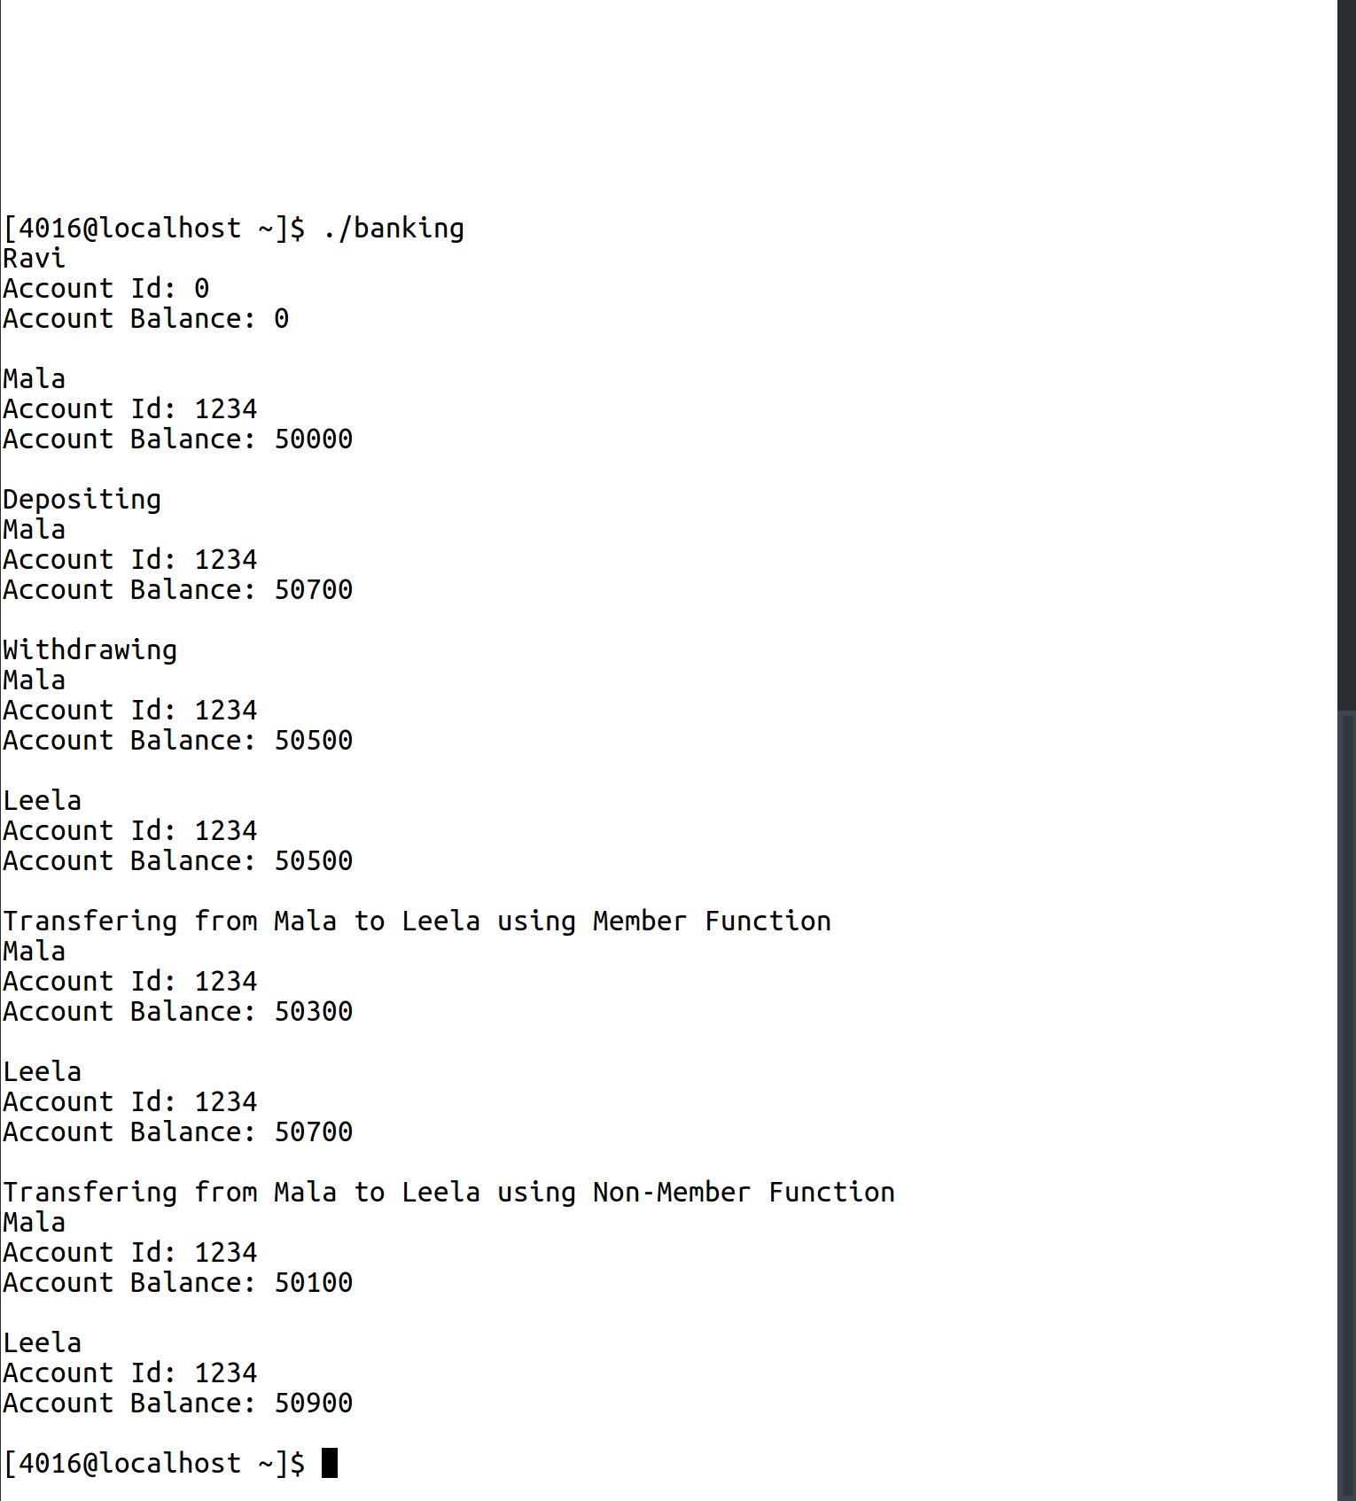

2. Geometry Application
vector.h:
1 class vector{
2 public:
3 vector(){
4 x=0;y=0;
5 }
6 vector(float a, float b){
7 x=a; y=b;
8 }
9 inline float getX(){
10 return x;
11 }
12 inline float getY(){
13 return y;
14 }
15 inline bool nonZero(){
16 return(!x==0 && !y==0);
17 }
18 vector difference(vector &a);
19 float inner(vector &a);
20 bool isPerpendicular(vector &a);
21 void display();
22 float mod();
23 float angle(vector &a);
24
25 private:
26 float x;
27 float y;
28 };
29
30 vector getVector();

vector.cpp:
1 #include <iostream>
2 #include "vector.h"
3 #include <math.h>
4
5 using namespace std;
6
7 vector vector::difference(vector &a){
8 vector tmp(x-a.getX(),y-a.getY());
9 return tmp;
10 }
11
12 float vector::inner(vector &a){
13 float ans =0;
14 ans+= x*a.getX();
15 ans+= y*a.getY();
16 return ans;
17 }
18
19 bool vector::isPerpendicular(vector &a){
20 float dot = inner(a);
21 return dot==0;
22 }
23
24 void vector::display(){
25 cout<<'('<<x<<','<<y<<')'<<endl;
26 }
27
28 float vector::mod(){
29 return sqrt(x*x + y*y);
30 }
31
32 float vector::angle(vector &a){
33 float ans = inner(a)/(mod()*a.mod());
34 return ans;
35 }
36
37
38 vector getVector(){
39 float a,b;
40 cout<<"Enter the X coordinate\n";
41 cin>>a;
42 cout<<"Enter the Y coordinate\n";
43 cin>>b;
44 vector tmp(a,b);
45 return tmp;
46 }
triangle.cpp
1 #include<iostream>
2 #include "vector.h"
3 using namespace std;
4
5 int main(){
6
7 vector points[3];
8 vector sides[3];
9 float angles[3];
10
11 points[0] = getVector();
12 points[1] = getVector();
13 points[2] = getVector();
14
15 sides[0] = points[0].difference(points[1]);
16 sides[1] = points[1].difference(points[2]);
17 sides[2] = points[2].difference(points[0]);
18
19 angles[0] = sides[0].angle(sides[1]);
20 angles[1] = sides[1].angle(sides[2]);
21 angles[2] = sides[2].angle(sides[0]);
22
23 if(angles[0] == angles[1] || angles[1] == angles[2] || angles[0]==angles[2]){
24 if(angles[0]==angles[1] && angles[1]==angles[2]){
25 cout<<"Equilateral\n";
26 }
27 else{
28 cout<<"Isoceles\n";
29 }
30 }
31 else{
32 cout<<"Scalene\n";
33 }
34 }
Sample Input/Output:
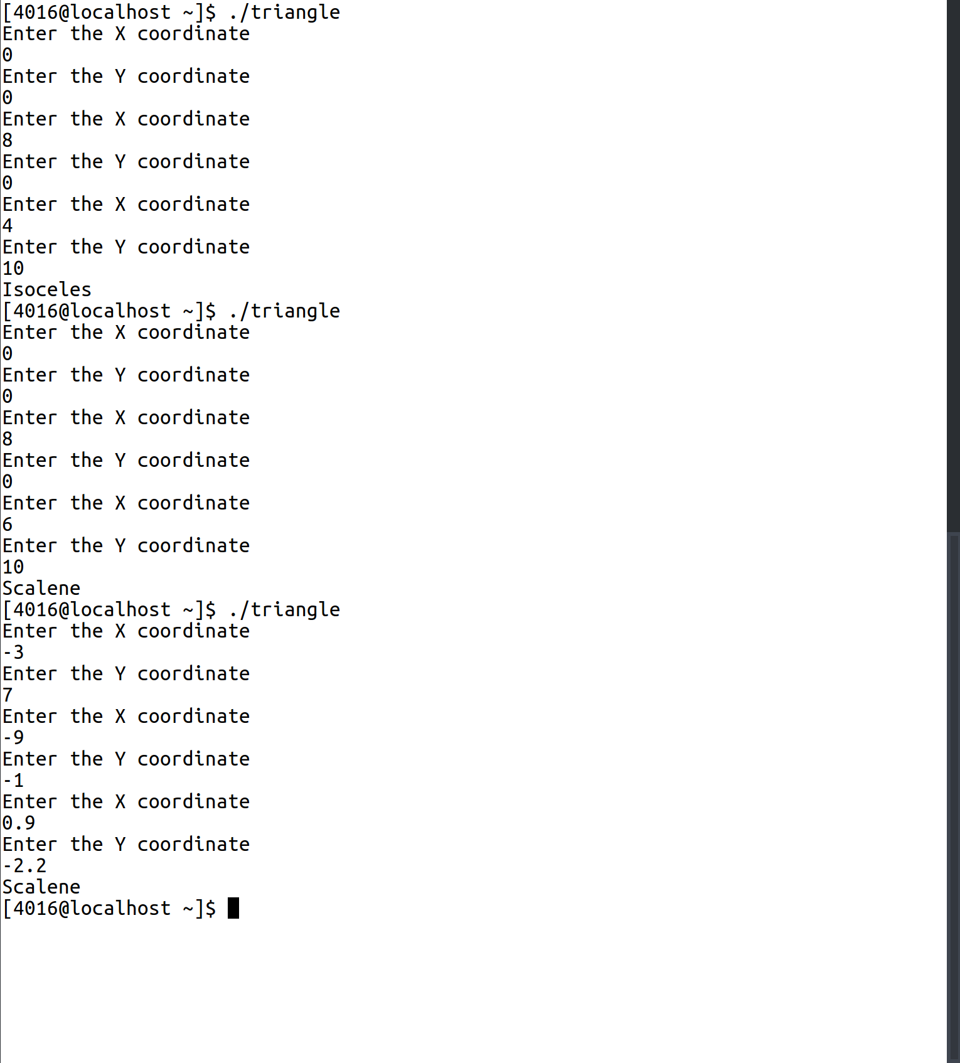
Equilateral

rectangle.cpp
1 #include <iostream>
2 #include "vector.h"
3 using namespace std;
4
5 int main(){
6 vector points[4],sides[4];
7 for(int i=0;i<4;i++){
8 points[i] = getVector();
9 }
10 for(int i=0;i<4;i++){
11 sides[i] = points[i].difference(points[(i+1)%4]);
12 }
13 int noPerpendicular=0;
14 for(int i=0;i<3;i++){
15 for(int j=i+1;j<4;j++){
16 if(sides[i].isPerpendicular(sides[j])){
17 noPerpendicular+=1;
18 }
19 }
20 }
21 if(noPerpendicular==4){
22 cout<<"Rectangle\n";
23 }
24 else{
25 cout<<"Not a Rectangle\n";
26 }
27 }

Sample Input/Output:
