T1: Checking min balance and Checking if two vectors are parallel

1. Withdrawal based on creditstatus.
account_credit.h:
1 class account{
2 public:
3 account(){
4 accNo=0;accBal=0;creditStatus='C';
5 limitA=100000;limitB=10000;
6 }
7 account(unsigned id, double amount,char status);
8 account(account &from);
9 void deposit(double amount);
10 bool withdraw(double amount);
11 char getCreditStatus();
12 void putCreditStatus(char status);
13 void modifyCreditLimit(int limA,int limB);
14 unsigned int getId();
15 double getBalance();
16 bool transfer(account &from, double amt);
17 private:
18 unsigned int accNo;
19 double accBal;
20 char creditStatus;
21 unsigned int limitA;
22 unsigned int limitB;
23 };
24
25 bool transfer(account &from, account &to, double amt);

account_credit.cpp:
1 #include "account_credit.h"
2
3 account::account(unsigned int id,double amt,char status){
4 accNo = id;
5 accBal= amt;
6 creditStatus = status;
7 limitA=100000;limitB=10000;
8 if(accBal<0){
9 accBal=0.0;
10 }
11 }
12
13 void account::deposit(double amt){
14 if(amt>0){
15 accBal+=amt;
16 }
17 }
18
19 void account::modifyCreditLimit(int limA,int limB){
20 limitA = limA;
21 limitB = limB;
22 }
23
24 bool account::withdraw(double amt){
25 bool possible = false;
26 if(amt<accBal){
27 if(amt>=limitA){
28 if(creditStatus == 'A'){
29 possible=true;
30 }
31 }
32 else if(amt>=limitB){
33 if(creditStatus == 'A' || creditStatus == 'B'){
34 possible=true;
35 }
36 }
37 else{
38 possible=true;
39 }
40 }
41
42 if(possible){
43 accBal-=amt;
44 return true;
45 }
46 else{
47 return false;
48 }
49 }
50
51
52 double account::getBalance(){
53 return accBal;
54 }
55
56 unsigned int account::getId(){
57 return accNo;
58 }
59
60 char account::getCreditStatus(){
61 return creditStatus;
62 }
63
64 void account::putCreditStatus(char status){
65 creditStatus = status;
66 }
67
68
69 bool account::transfer(account &from, double amt){
70 if(from.withdraw(amt)){
71 accBal+=amt;
72 return true;
73 }
74 return false;
75 }
76
77
78 account::account(account &from){
79 accNo = from.getId();
80 accBal = from.getBalance();
81 creditStatus = from.getCreditStatus();
82 limitA=100000;limitB=10000;
83 }
84
85 bool transfer(account &from, account &to, double amt){
86 if(from.withdraw(amt)){
87 to.deposit(amt);
88 return true;
89 }
90 return false;
91 }

banking_credit.cpp
1 #include<iostream>
2 #include "account_credit.h"
3 using namespace std;
4
5 void display(account &a){
6 cout<<"Account Id: "<<a.getId()<<endl;
7 cout<<"Account Balance: "<<a.getBalance()<<endl;
8 cout<<endl;
9 }
10
11
12 int main(){
13 account raju(1201,1000000,'A');
14
15 display(raju);
16 cout<<"Withdrawing 200000\n";
17 raju.withdraw(200000);
18 display(raju);
19
20 cout<<"Changing status to B\n";
21 raju.putCreditStatus('B');
22 cout<<"Withdrawing 200000\n";
23 display(raju);
24 cout<<"Withdrawing 20000\n";
25 raju.withdraw(20000);
26 display(raju);
27
28 cout<<"Changing status to C\n";
29 raju.putCreditStatus('C');
30 cout<<"Withdrawing 200000\n";
31 display(raju);
32 cout<<"Withdrawing 20000\n";
33 raju.withdraw(20000);
34 display(raju);
35 cout<<"Withdrawing 200\n";
36 raju.withdraw(200);
37 display(raju);
38 }
Sample Input/Output:
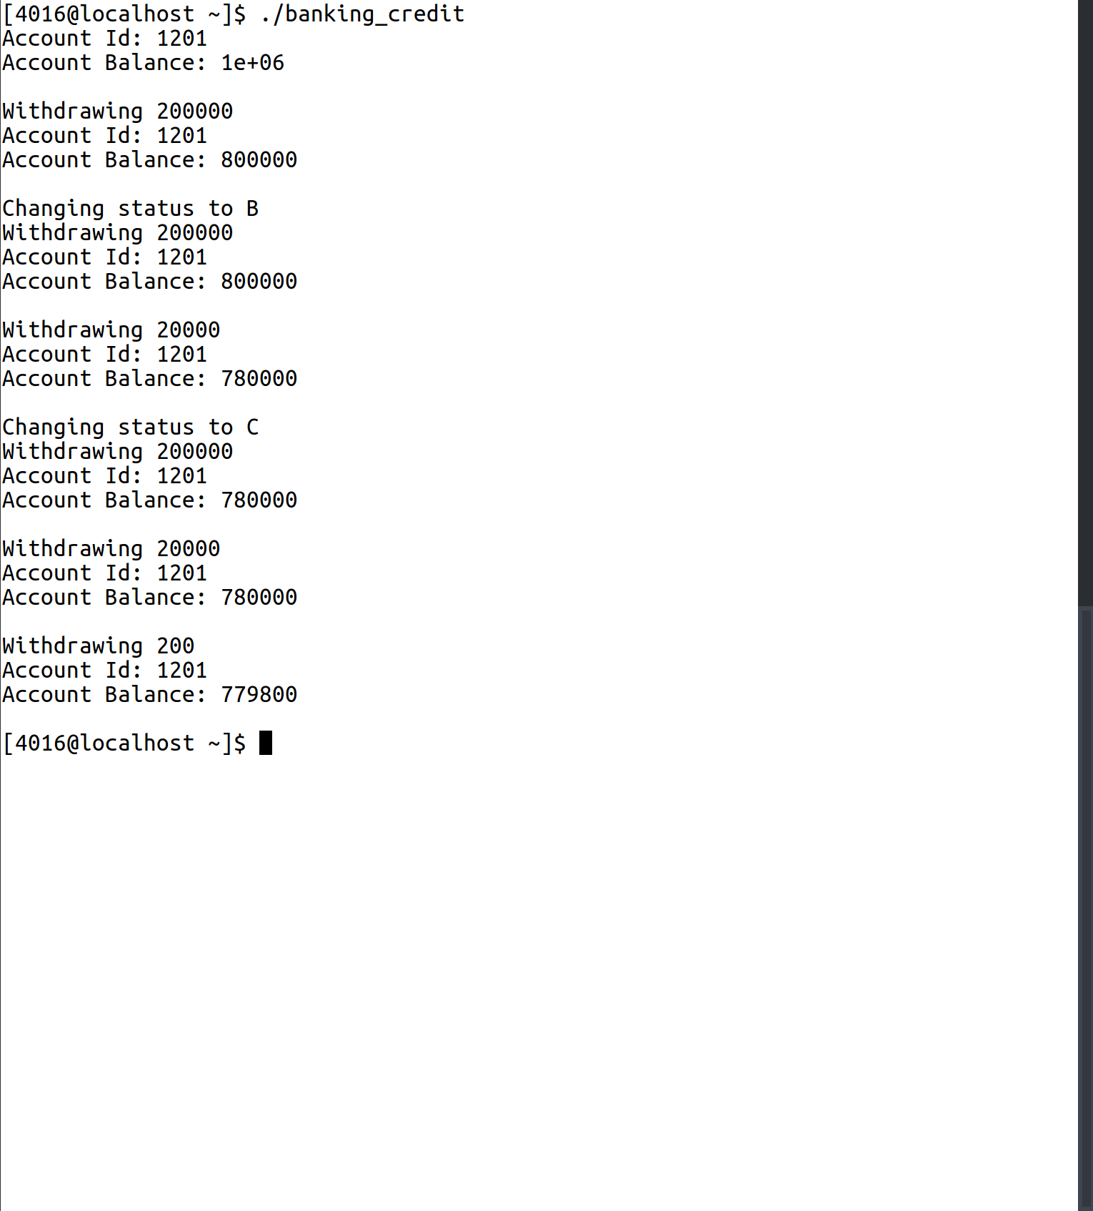

2. Checking if two vectors are parallel

vector_parallel.h:
1 class vector{
2 public:
3 vector(){
4 x=0;y=0;
5 }
6 vector(float a, float b){
7 x=a; y=b;
8 }
9 inline float getX(){
10 return x;
11 }
12 inline float getY(){
13 return y;
14 }
15 inline bool nonZero(){
16 return(!x==0 && !y==0);
17 }
18 vector difference(vector &a);
19 float inner(vector &a);
20 bool isPerpendicular(vector &a);
21 bool isParallel(vector &a);
22 void display();
23 float mod();
24 float angle(vector &a);
25
26 private:
27 float x;
28 float y;
29 };
30
31 vector getVector();
vector_parallel.cpp:
1 #include <iostream>
2 #include "vector_parallel.h"
3 #include <math.h>
4
5 using namespace std;
6
7 vector vector::difference(vector &a){
8 vector tmp(x-a.getX(),y-a.getY());
9 return tmp;
10 }
11
12 float vector::inner(vector &a){
13 float ans =0;
14 ans+= x*a.getX();
15 ans+= y*a.getY();
16 return ans;
17 }
18
19 bool vector::isPerpendicular(vector &a){
20 float dot = inner(a);
21 return dot==0;
22 }
23
24 void vector::display(){
25 cout<<'('<<x<<','<<y<<')'<<endl;
26 }
27
28 float vector::mod(){
29 return sqrt(x*x + y*y);
30 }
31
32 float vector::angle(vector &a){
33 float ans = inner(a)/(mod()*a.mod());
34 return ans;
35 }
36
37 bool vector::isParallel(vector &a){
38 if(angle(a)==1){
39 return true;
40 }
41 return false;
42 }
43
44 vector getVector(){
45 float a,b;
46 cout<<"Enter the X coordinate\n";
47 cin>>a;
48 cout<<"Enter the Y coordinate\n";
49 cin>>b;
50 vector tmp(a,b);
51 return tmp;
52 }
parallel.cpp:
1 #include <iostream>
2 #include "vector_2.h"
3 using namespace std;
4
5 int main(){
6 vector points[4];
7 for(int i=0;i<4;i++){
8 points[i] = getVector();
9 }
10 vector line1 = points[0].difference(points[1]);
11 vector line2 = points[2].difference(points[3]);
12
13 if(line1.isParallel(line2)){
14 cout<<"Parallel\n";
15 }
16 else{
17 cout<<"Not Parallel\n";
18 }
19 return 0;
20 }
Sample Input/Output:
