A5: Learning dynamic inclusion Polymorphism using banking and geometry applications

1. Banking Application
Account.h:
1 #include <iostream>
2 using namespace std;
3
4 #ifndef ACCOUNT_H
5 #define ACCOUNT_H
6 class Account{
7 public:
8 Account(unsigned id=0,double amount=0.0){
9 acct_no = id;
10 acct_bal = amount;
11 }
12 virtual void deposit(double amount);
13 virtual bool withdraw(double amount);
14 inline virtual unsigned get_id(){return acct_no;}
15 inline virtual double get_bal(){return acct_bal;}
16 virtual void display() const;
17 virtual void show(){
18 cout<<"Account Type: Account\n";
19 }
20 protected:
21 const static int SS_LEN = 12;
22 unsigned acct_no;
23 char ss[SS_LEN];
24 private:
25 double acct_bal;
26 };
27 #endif
Account.cpp:
1 #include <iostream>
2 #include "Account.h"
3 using namespace std;
4
5 void Account::deposit(double amount){
6 acct_bal+=amount;
7 }
8
9 bool Account::withdraw(double amount){
10 if(acct_bal>=amount){
11 acct_bal-=amount;
12 return 1;
13 }
14 return 0;
15 }
16 void Account::display() const{
17 cout<<"ID: "<<acct_no<<"\nBalance: Rs."<<acct_bal<<endl;
18 }
freeChecking.h:
1 #include<iostream>
2 #include "Account.h"
3 using namespace std;
4
5 class freeChecking:public Account{
6 static double minBal;
7 static double serviceFee;
8 bool free;
9 public:
10 freeChecking():Account(),free(1){};
11 freeChecking(int id,double bal):Account(id,bal),free(1){};
12 virtual void show(){cout<<"Account Type: Free Checking\n";}
13 virtual bool withdraw(double amt);
14 void fee();
15 };
freeChecking.cpp:
1 #include <iostream>
2 #include "freeChecking.h"
3 using namespace std;
4
5 double freeChecking::serviceFee = 200;
6 double freeChecking::minBal = 500;
7
8 bool freeChecking::withdraw(double amt){
9 if(Account::withdraw(amt)){
10 if(get_bal()<minBal)
11 free = 0;
12 return 1;
13 }
14 return 0;
15 }
16 void freeChecking::fee(){
17 if(free==0)
18 {
19 if(get_bal()>=serviceFee){
20 withdraw(serviceFee);
21 cout<<"Service Fee Deducted\n";
22 }
23 else
24 {
25 cout<<"Insufficient Funds in Account\nAccount Balance deducted to 0\n";
26 if(Account::withdraw(get_bal()));
27 }
28 }
29 }

banking.cpp:
1 #include <iostream>
2 #include "jointAccout.h"
3 #include "freeChecking.h"
4 using namespace std;

8 bool transfer(Account *a1,Account *a2,double amt){
9 if(a1->withdraw(amt)) {
10 a2->deposit(amt);
11 return 1;
12 }
13 return 0;
14 }
15
16 int main(){
17 Account *jA,*fcA;
18 jointAccount j(1000,500.00,"A","B");
19 freeChecking fc(1001,750.00);
20 jA = &j;
21 fcA = &fc;
22 jA->show();
23 jA->display();
24
25 cout<<'\n';
26 fcA->show();
27 fcA->display();
28
29 if(transfer(jA,fcA,250)){
30 cout<<"\nTransfer Successful\n\n";
31 }
32 else{
33 cout<<"Transfer Unsuccessful\n";
34 }
35 jA->show();
36 jA->display();
37
38 cout<<'\n';
39 fcA->show();
40 fcA->display();
41 }

Sample Input/Output:
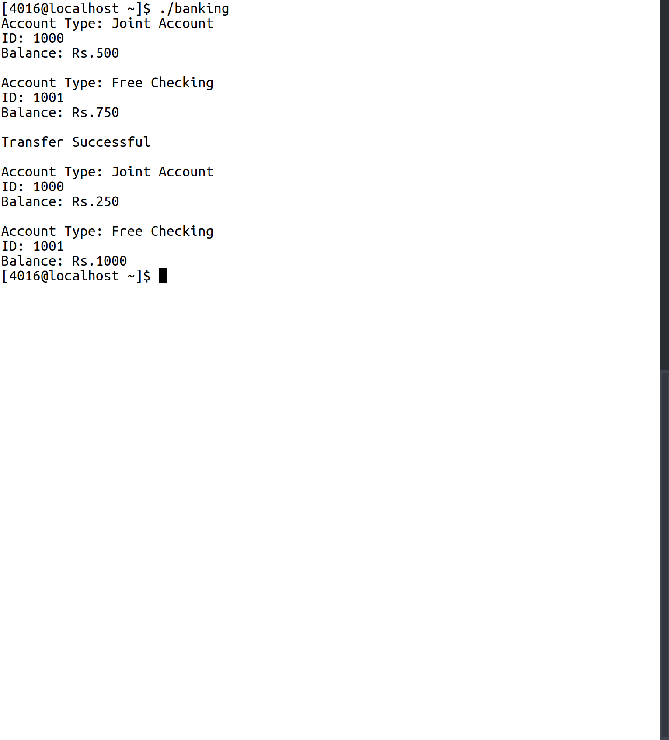

2. Geometry Application
shape.h:
1 #include <iostream>
2 using namespace std;
3 class shape{
4 public:
5 shape(){};
6 virtual void draw() const= 0;
7 virtual void displayShape() const= 0;
8 virtual double volume() const = 0;
9 virtual double area() const = 0;
10 static const double PI = 3.14159265;
11 };
point.h:
1 #include <iostream>
2 #include "shape.h"
3 using namespace std;
4 class point:public shape{
5 public:
6 point(){
7 this->X = 0;
8 this->Y = 0;
9 }
10 point(int x, int y){
11 this->X = x;
12 this->Y = y;
13 }
14 inline void setXY(int x, int y){
15 this->X = x;
16 this->Y = y;
17 }
18 inline int getX(){
19 return X;
20 }
21 inline int getY(){
22 return Y;
23 }
24 inline virtual void displayShape(){
25 cout<<"Point\n";
26 }
27 inline virtual void draw(){
28 cout<<"X: "<<X<<" Y: "<<Y<<endl;
29 }
30 inline virtual double area() const{
31 return 0;
32 }
33 inline virtual double volume() const{
34 return 0;
35 }
36
37 protected:
38 int X,Y;
39
40 };
circle.h:
1 #include <iostream>
2 //#include "shape.h"
3 #include "point.h"
4
5 using namespace std;
6
7 class circle:public point{
8 public:
9 circle():point(),radius(1){};
10 circle(int radius):point(){
11 this->radius = radius;
12 }
13
14 double virtual area() const{
15 return shape::PI * radius * radius;
16 }
17 inline virtual void draw() const{
18 cout<<"Radius: "<<radius<<endl;
19 }
20 inline virtual void displayShape() const{
21 cout<<"Circle \n";
22 }
23 inline virtual double volume() const{
24 return 0;
25 }
26
27 protected:
28 int radius;
29 };
shapeApp.cpp:
1 #include <iostream>
2 //#include "shape.h"
3 //#include "point.h"
4 //#include "circle.h"
5 #include "cylinder.h"
6 #include <math.h>
7 using namespace std;
8
9
10 double findVol(shape *ptr){
11 return ptr->volume();
12 }
13
14
15 int main(){
16 shape *circlePtr,*cylPtr;
17 circle circ(10);
18 cylinder cyl(10,10);
19 circlePtr = &circ;
20 cylPtr = &cyl;
21
22 circlePtr->displayShape();
23 cylPtr->displayShape();
24 cout<<findVol(circlePtr)<<endl;
25 cout<<findVol(cylPtr)<<endl;
26
27
28 }
Sample Input/Output:
