A6: Learning friend classes and pointer to objects using reference counting

1. Reference count for Cstring
refstr.h:
1 #include <iostream>
2 using namespace std;
3 #include <string.h>
4 #ifndef REFSTR_H
5 #define REFSTR_H
6
7 class cell{
8 public:
9 friend class refstr;
10 private:
11 cell(const char *s){
12 int len = strlen(s);
13 count++;
14 this->str = new char[len];
15 for(int i=0;i<len;i++){
16 this->str[i] = s[i];
17 }
18 }
19 unsigned int count;
20 char *str;
21 ~cell(){
22 delete[] str;
23 }
24 };
25
26 class refstr{
27 public:
28 refstr(const char *str=""){
29 ptr = new cell(str);
30 }
31 refstr(const refstr& s){
32 s.ptr->count+=1;
33 this->ptr = s.ptr;
34 }
35 refstr& operator=(const refstr& s){
36 if(s.ptr != NULL){
37 this->ptr->count--;
38 exterminate();
39 }
40 s.ptr->count+=1;
41 this->ptr = s.ptr;
42 }
43 void exterminate(){
44 if(ptr->count == 0){
45 delete ptr;
46 ptr = NULL;
47 }
48 }
49
50 int cmp(const refstr& s) const{
51 return strcmp(this->ptr->str, s.ptr->str);
52 }
53
54 unsigned int getCount(){
55 return this->ptr->count;
56 }
57 void display(){
58 cout<<ptr->str;
59 }
60 ~refstr(){
61 ptr->count-=1;
62 exterminate();
63 }
64
65
66 private:
67 cell *ptr;
68
69 };
70
71
72 #endif

application.cpp:
1 #include <iostream>
2 #include "refstr.h"
3 using namespace std;
4
5 int callcmp(refstr &a, refstr &b){
6 cout<<a.getCount()<<endl;
7 return a.cmp(b);
8 }
9
10 int main(){
11 refstr s1("Hello");
12 refstr s2("Welcome");
13 refstr s3("Here");
14 refstr s4 = s3;
15 refstr s5 = s2;
16 cout<<s3.getCount()<<endl;
17 s2 = s4;
18 cout<<s3.getCount()<<endl;
19 s1 = s3;
20 cout<<s3.getCount()<<endl;
21 callcmp(s1,s2);
22 s4 = s5;
23 cout<<s3.getCount()<<endl;
24 return 0;
25 }

Sample Input/Output:
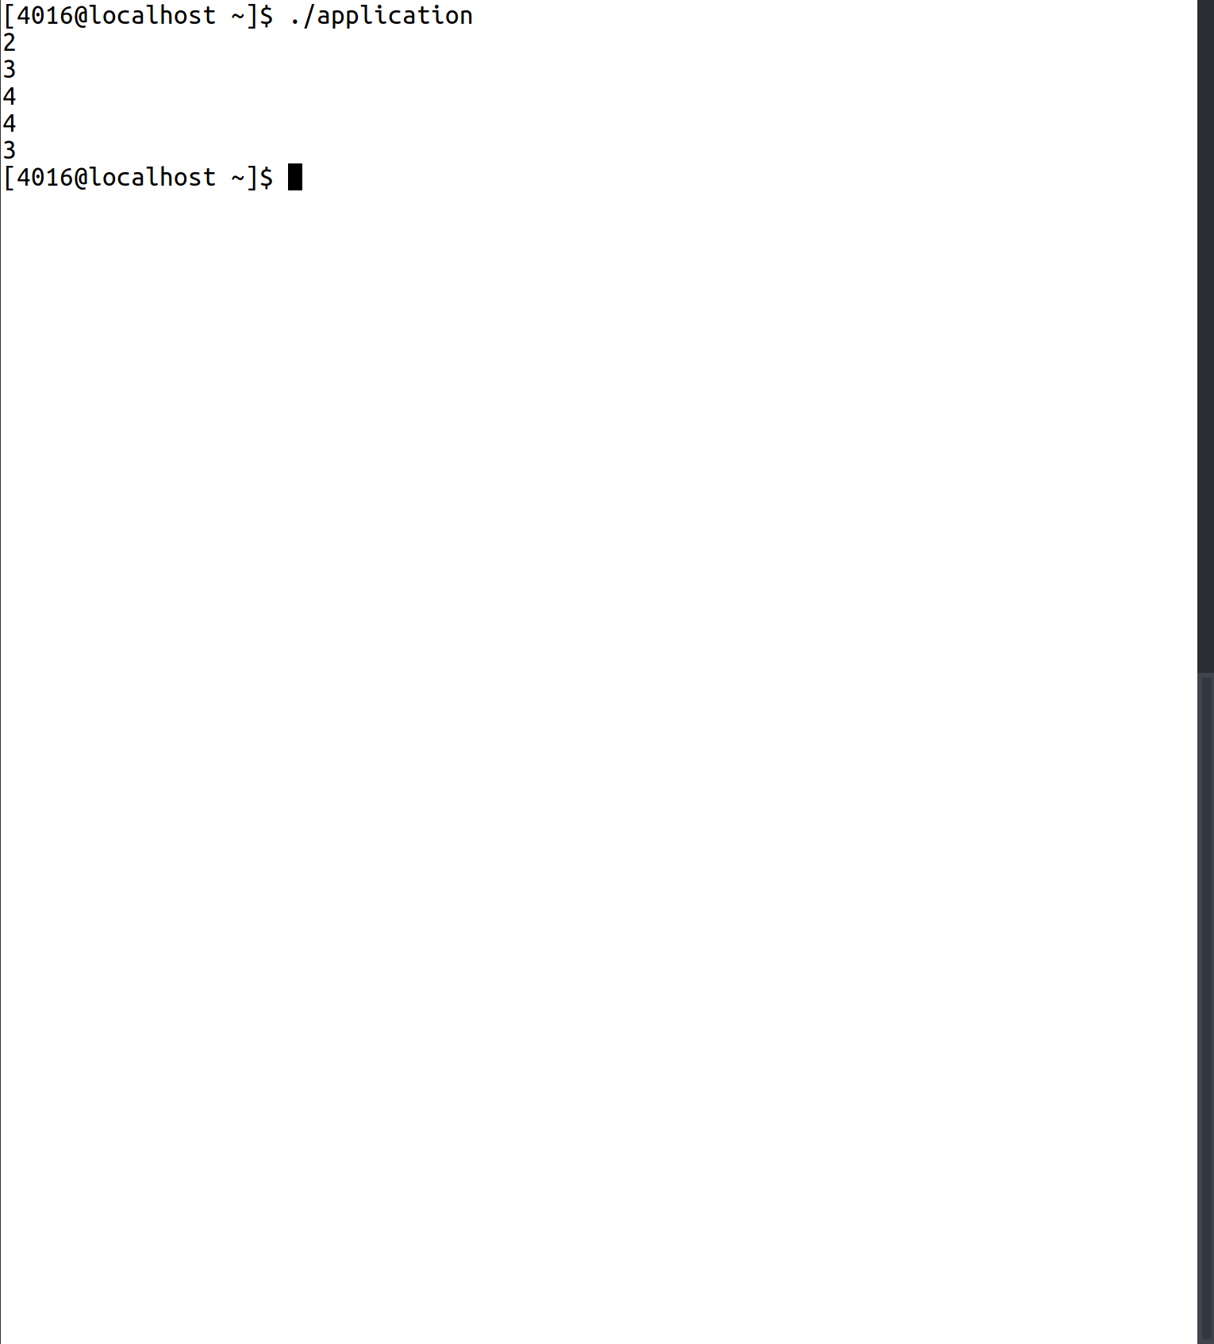

1. Reference count for Time Class
xyzcell.h:
1 #include <iostream>
2 //#include "shape.h"
3 #include "point.h"
4
5 using namespace std;
6
7 class circle:public point{
8 public:
9 circle():point(),radius(1){};
10 circle(int radius):point(){
11 this->radius = radius;
12 }
13
14 double virtual area() const{
15 return shape::PI * radius * radius;
16 }
17 inline virtual void draw() const{
18 cout<<"Radius: "<<radius<<endl;
19 }
20 inline virtual void displayShape() const{
21 cout<<"Circle \n";
22 }
23 inline virtual double volume() const{
24 return 0;
25 }
26
27 protected:
28 int radius;
29 };
cone.h:
1 #include <iostream>
2 //#include "shape.h"
3 //#include "point.h"
4 #include "circle.h"
5 #include <math.h>
6
7 class cone:public circle{
8 public:
9 cone():circle(){
10 this->height = 1;
11 slantHeight = (int)sqrt(2);
12 }
13 cone(int r, int h):circle(r){
14 this->height = h;
15 this->slantHeight = (int)sqrt(r*r + h*h);
16 }
17
18 inline virtual double volume() const{
19 return circle::area() * height /3;
20 }
21
22 inline virtual double curvedSurfaceArea() const{
23 return shape::PI * circle::radius * slantHeight;
24 }
25
26 inline virtual double totalSurfaceArea() const{
27 return curvedSurfaceArea() + circle::area();
28 }
29
30 inline virtual void draw() const{
31 cout<<"Radius: "<<circle::radius<<endl;
32 cout<<"Height: "<<height<<endl;
33 }
34 inline virtual void displayShape() const{
35 cout<<"Cone\n";
36 }
37
38
39 private:
40 int height, slantHeight;
41
42 };
cylinder.h:
1 #include <iostream>
2 //#include "shape.h"
3 //#include "point.h"
4 #include "circle.h"
5
6 class cylinder:public circle{
7 public:
8 cylinder():circle(),height(1){}
9 cylinder(int radius,int height):circle(radius){
10 this->height = height;
11 }
12
13 virtual double volume() const{
14 return circle::area() * height;
15 }
16
17 virtual double curvedSurfaceArea() const{
18 return shape::PI * circle::radius * 2 * height;
19 }
20
21 virtual double totalSurfaceArea() const{
22 return curvedSurfaceArea() + 2*circle::area();
23 }
24
25
26
27 inline virtual void draw() const{
28 cout<<"Radius: "<<circle::radius<<endl;
29 cout<<"Height: "<<radius<<endl;
30 }
31 inline virtual void displayShape() const{
32 cout<<"Cylinder\n";
33 }
34 private:
35 int height;
36 };
shapeApp.cpp:
1 #include <iostream>
2 //#include "shape.h"
3 //#include "point.h"
4 //#include "circle.h"
5 #include "cone.h"
6 #include <math.h>
7 using namespace std;
8
9
10 double findVol(shape *ptr){
11 return ptr->volume();
12 }
13
14
15 int main(){
16 shape *circlePtr,*conePtr;
17 circle circ(10);
18 cone cone1(10,10);
19 circlePtr = &circ;
20 conePtr = &cone1;
21
22 circlePtr->displayShape();
23 conePtr->displayShape();
24 cout<<findVol(circlePtr)<<endl;
25 cout<<findVol(conePtr)<<endl;
26
27
28 }

Sample Input/Output:
