A8: Learning class & function templates and STL

1.Binary Search Class
binSearch.h:
1 #include <string.h>
2 #include <vector>
3 using namespace std;
4
5 class binSearch{
6 public:
7 template <class T>
8 int binarySearch(const T obj, const vector<T> arr, int n){
9 int high= n-1;
10 int low = 0;
11 while(high>=low){
12 int mid = low + (high-low)/2;
13 if(obj == arr[mid]){
14 return mid;
15 }
16 else if(obj < arr[mid]){
17 high = mid-1;
18 }
19 else{
20 low = mid+1;
21 }
22 }
23 return -1;
24 }
25
26 int binarySearch(const char* obj, const vector<char*> arr, int n){
27 int high= n-1;
28 int low = 0;
29 while(high>=low){
30 int mid = low + (high-low)/2;
31 if(strcmp(obj,arr[mid])==0){
32 return mid;
33 }
34 else if(strcmp(obj,arr[mid])<0){
35 high = mid-1;
36 }
37 else{
38 low = mid+1;
39 }
40 }
41 return -1;
42 }
43 };

application.cpp:
1 #include <iostream>
2 using namespace std;
3 #include "binSearch.h"
4
5
6 int main(){
7 vector<int> a;
8 vector<string> b;
9 vector<char*> c;
10 binSearch search;
11 string tmp = "d";
12
13 a.push_back(1);
14 a.push_back(2);
15 a.push_back(3);
16 a.push_back(4);
17 cout<<search.binarySearch(2,a,4)<<endl;
18 cout<<search.binarySearch(12,a,4)<<endl;
19
20 b.push_back("a");
21 b.push_back("b");
22 b.push_back("c");
23 b.push_back("d");
24 cout<<search.binarySearch(tmp,b,4)<<endl;
25
26 c.push_back("a");
27 c.push_back("b");
28 c.push_back("c");
29 c.push_back("d");
30 cout<<search.binarySearch(tmp.c_str(),c,4)<<endl;
31
32 return 0;
33 }

Sample Input/Output:
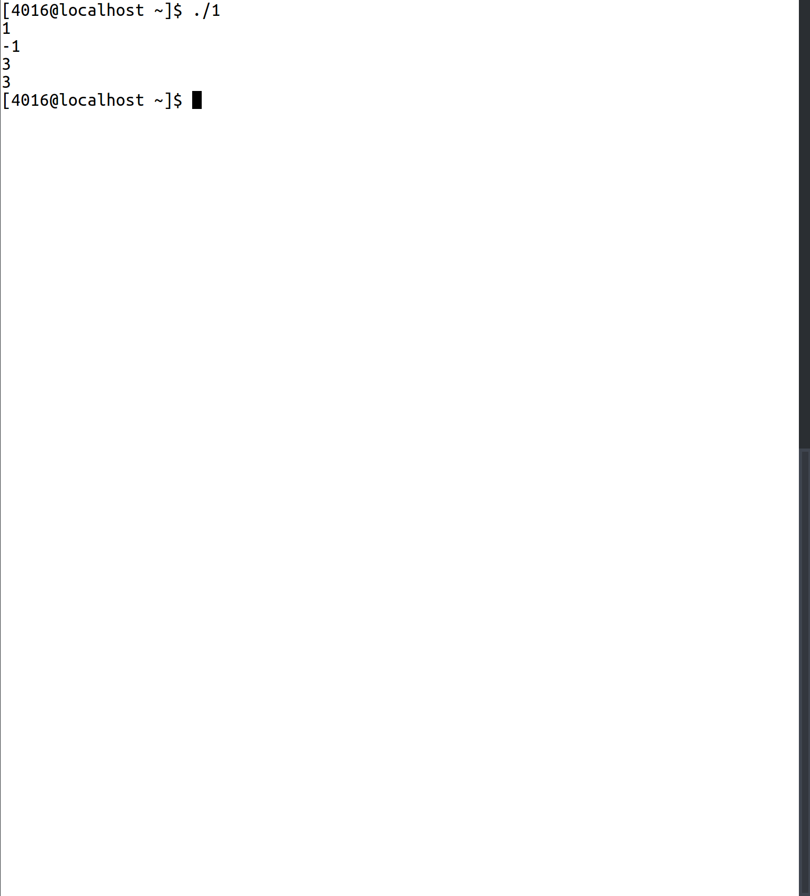

2.Linked List Class
List.h:
1 #ifndef LIST_H
2 #define LIST_H
3 template <class T>
4 class List{
5 private:
6 class Node{
7 friend class List;
8 private:
9 T data;
10 Node* next;
11 Node* prev;
12 }*front,*rear;
13 unsigned int size;
14
15 Node* find(T obj){
16 Node* tmp = front->next;
17 while(tmp != NULL){
18 if(tmp->data == obj){
19 return tmp;
20 }
21 tmp=tmp->next;
22 }
23 return NULL;
24 }
25
26 void del(Node* tmp){
27 tmp->next->prev = tmp->prev;
28 tmp->prev->next = tmp->next;
29 delete tmp;
30 size-=1;
31 }
32 public:
33 List(){
34 front = new Node;
35 rear = new Node;
36 front->next = rear;
37 front->prev = NULL;
38
39 rear->next = NULL;
40 rear->prev = front;
41 size = 0;
42 }
43 void push_back(T obj){
44 Node* tmp = new Node;
45 tmp->data = obj;
46 tmp->next = rear;
47 tmp->prev = rear->prev;
48 rear->prev->next = tmp;
49 rear->prev = tmp;
50
51 size+=1;
52 }
53 void push_front(T obj){
54 Node* tmp = new Node;
55 tmp->data = obj;
56 tmp->prev = front;
57
58 tmp->next = front->next;
59 front->next->prev = tmp;
60 front->next = tmp;
61
62 size+=1;
63 }
64 void push_after(T obj, T dat){
65 Node* location = find(obj);
66 if(location == NULL){
67 return;
68 }
69 Node* tmp = new Node;
70 tmp->data = dat;
71 tmp->prev = location;
72 tmp->next = location->next;
73 location->next->prev = tmp;
74 location->next=tmp;
75 size+=1;
76 }
77
78 void remove(T obj){
79 Node* tmp = find(obj);
80 if(tmp==NULL){
81 return;
82 }
83 del(tmp);
84 }
85
86 void remove_n(int n){
87 Node* tmp = front->next;
88 while(n-- && size>0){
89 del(tmp);
90 tmp = tmp->next;
91 }
92 }
93 void display(){
94 Node* tmp = front->next;
95 while(tmp != rear){
96 cout<<tmp->data<<" ";
97 tmp=tmp->next;
98 }
99 cout<<endl;
100 }
101
102 };
103 #endif
List.cpp:
1 #include <iostream>
2 #include "List.h"
3 using namespace std;
4
5 template <class T>
6 List<T>::List(){
7 front = rear = NULL;
8 size = 0;
9 }
10
11 template <class T>
12 void List<T>::push_back(T obj){
13 Node* tmp = new Node;
14 tmp->data = obj;
15 tmp->next = NULL;
16 if(rear == NULL){
17 tmp->prev = NULL;
18 front = rear = tmp;
19 }
20 else{
21 tmp->prev = rear;
22 rear->next = tmp;
23 rear = tmp;
24 }
25 size+=1;
26 }
27
28 template <class T>
29 void List<T>::display(){
30 Node* tmp = front;
31 while(tmp != NULL){
32 cout<<tmp->data<<" ";
33 tmp=tmp->next;
34 }
35 cout<<endl;
36 }

application.cpp:
1 #include <iostream>
2 using namespace std;
3 #include "List.h"
4
5 int main(){
6 List <int> l;
7 l.push_back(1);
8 l.display();
9 l.push_back(2);
10 l.display();
11 l.push_back(3);
12 l.display();
13 l.push_back(4);
14 l.display();
15 l.push_front(90);
16 l.display();
17 l.push_after(3,10);
18 l.display();
19 l.remove(90);
20 l.display();
21 l.remove_n(8);
22 l.display();
23 }

Sample Input/Output:
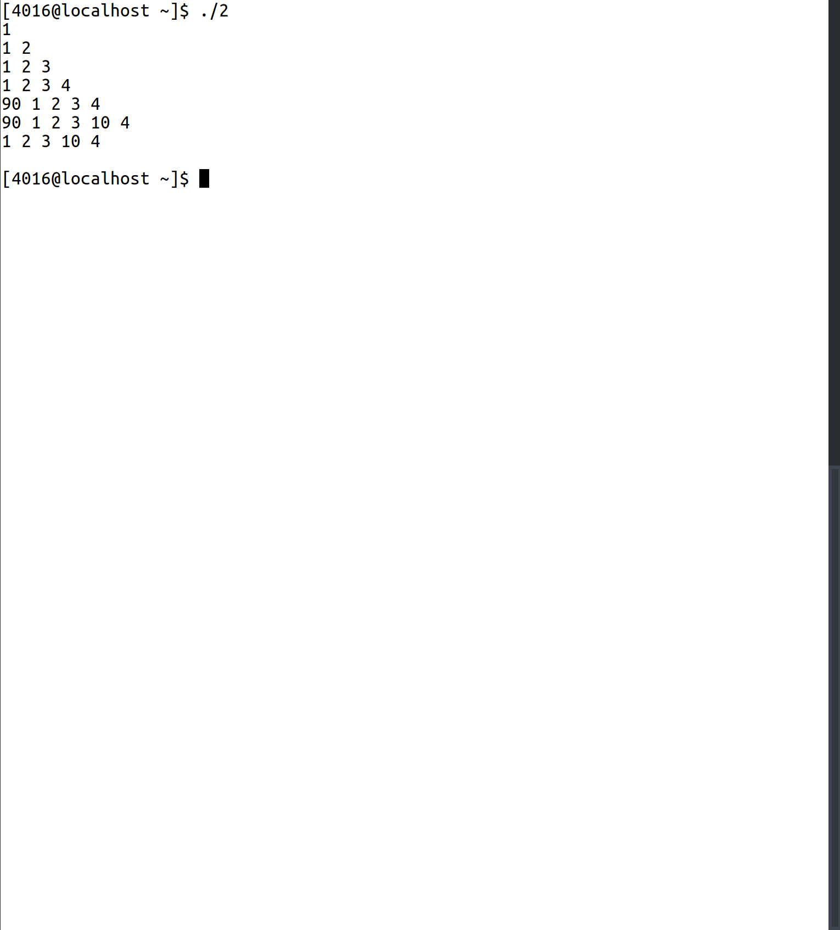

3.Stack Application
brackCheck.h:
1 #include <iostream>
2 #include <stack>
3 #include <fstream>
4 using namespace std;
5
6 class brackCheck{
7 public:
8 bool check(){
9 ifstream fs;
10 fs.open("bracket.txt");
11 if(!fs.is_open() || !fs.good()){
12 cout<<"Problem opening file \n";
13 return 0;
14 }
15 else{
16 char c;
17 stack<char> sc;
18 bool flag = true;
19 while(fs>>c){
20 if(c== '(' || c== '{' || c== '[' || c== '<'){
21 sc.push(c);
22 }
23 else if( c== ')' || c== '}' || c== ']' || c== '>'){
24 if(sc.empty()){
25 flag= false;
26 }
27 else{
28 if((c==')' && sc.top()!='(') || (c=='>' && sc.top()!='<') || (c==']' && sc.top()!='[') || (c=='}' && sc.top()!='{')){
29 flag = false;
30 }
31 else{
32 sc.pop();
33 }
34 }
35 }
36 }
37 if(flag){
38 cout<<"Balanced\n";
39 }
40 else{
41 cout<<"Unbalanced\n";
42 }
43 }
44 fs.close();
45 }
46
47
48 };

application.cpp:
1 #include <iostream>
2 using namespace std;
3 #include "brackCheck.h"
4
5 int main(){
6 brackCheck checkObj;
7 checkObj.check();
8 return 0;
9 }
Sample Input/Output:
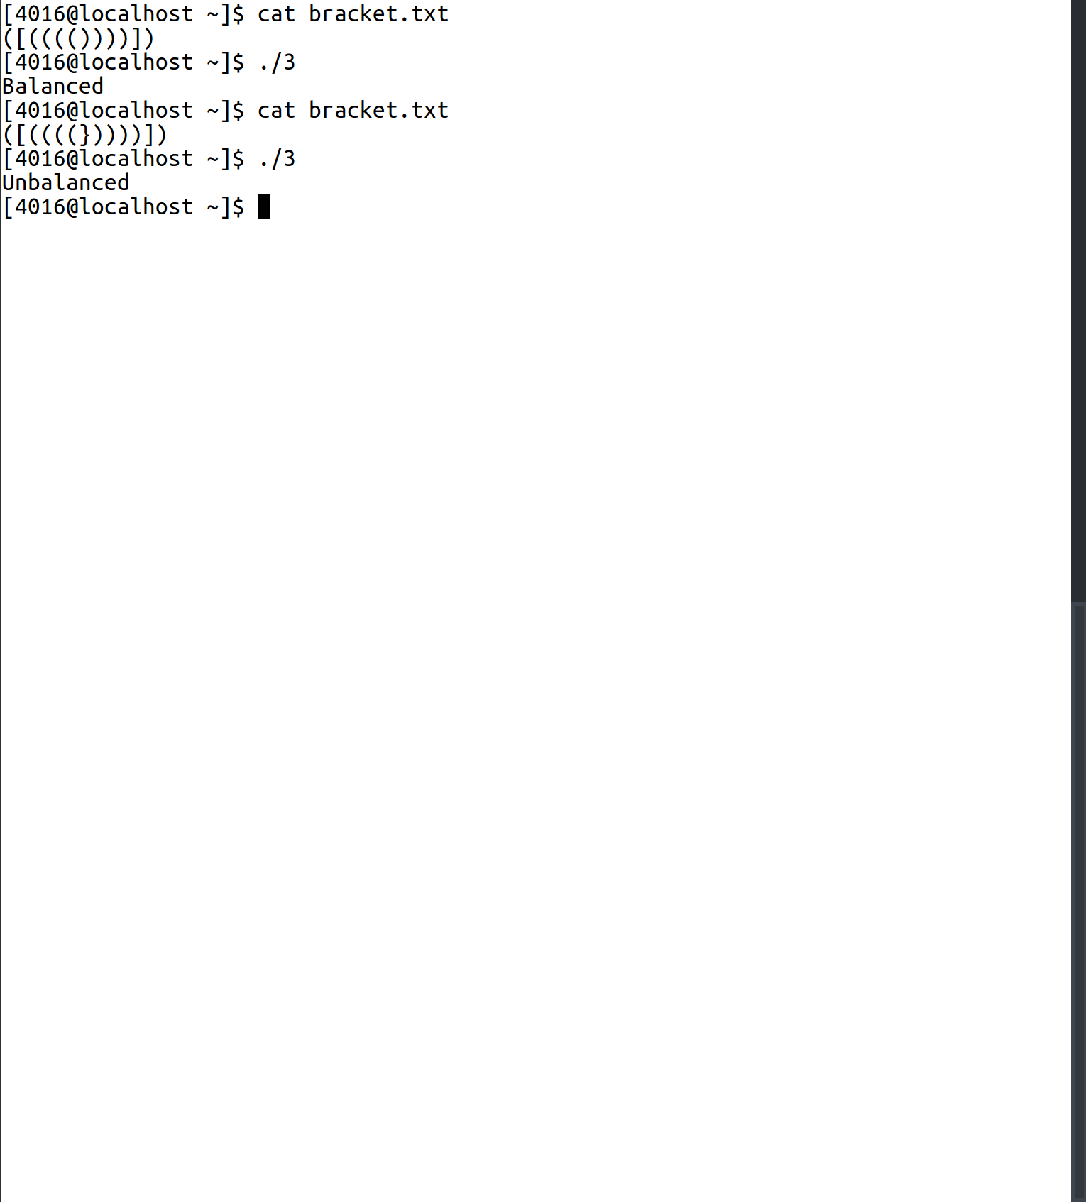

4.Set Application
pincode.h:
1 #include <iostream>
2 using namespace std;
3 #include <set>
4 #include <fstream>
5
6 class pincode{
7 public:
8 bool store(){
9 ifstream fs("pincode.txt");
10 if(!fs.is_open() || !fs.good()){
11 cout<<"Problem opening file \n";
12 return 0;
13 }
14 else{
15 string tmp;
16 while(fs>>tmp){
17 pincodeSet.insert(tmp);
18 }
19 }
20 fs.close();
21 }
22
23 void display(){
24 set<string>::iterator pin;
25 for(pin = pincodeSet.begin();pin!=pincodeSet.end();pin++){
26 cout<<*pin<<" ";
27 }
28 cout<<endl;
29 }
30 private:
31 set<string> pincodeSet;
32 };

application.cpp:
1 #include <iostream>
2 using namespace std;
3 #include <set>
4 #include <fstream>
5 #include "pincode.h"
6 int main(){
7 pincode pincodeList;
8 pincodeList.store();
9 pincodeList.display();
10 }
Sample Input/Output:
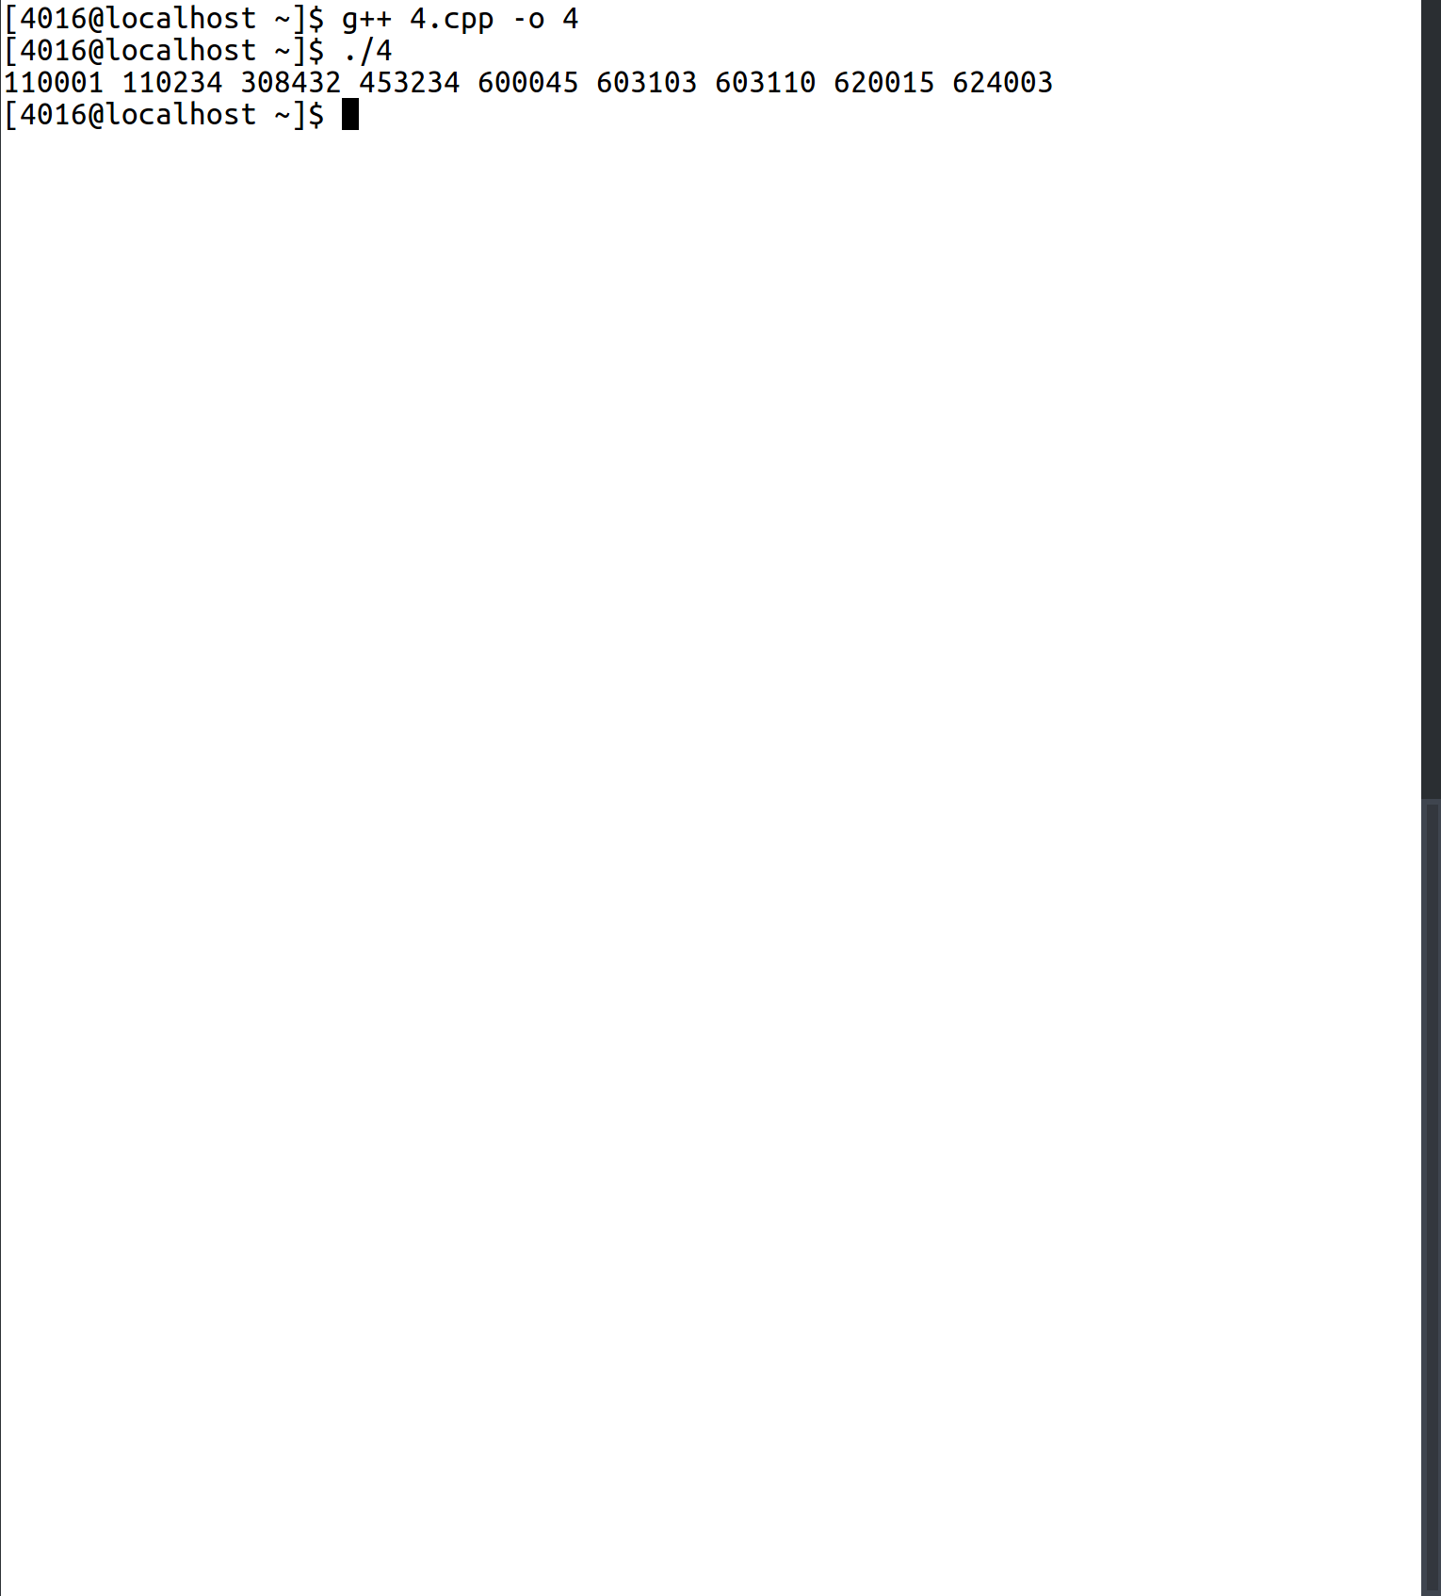

5.Vector Application
employee.h:
1 #ifndef EMP_H
2 #define EMP_H
3
4 class Employee{
5 public:
6 Employee(int eno=0, string name="",int sal=0){
7 this->empName = name;
8 this->empNo = eno;
9 this->salary = sal;
10
11 }
12 inline int getEno() const{
13 return empNo;
14 }
15 inline string getName() const{
16 return empName;
17 }
18 inline int getSal() const{
19 return salary;
20 }
21 private:
22 string empName;
23 int empNo;
24 int salary;
25
26 };
27
28 #endif

application.cpp:
1 #include <iostream>
2 #include <vector>
3 using namespace std;
4 #include "employee.h"
5
6 int main(){
7 int noOfEmps=0;
8 cout<<"Enter the number of employees\n";
9 cin>>noOfEmps;
10 vector<Employee> empVect;
11 for(int i=0;i<noOfEmps;i++){
12 int sal,eno;
13 string name;
14 cout<<"Enter Employee Number, Salary and Name\n";
15 cin>>eno>>sal>>name;
16 Employee tmp(eno,name,sal);
17 empVect.push_back(tmp);
18 }
19 int searchNo;
20 cout<<"Enter Employee Number to search for\n";
21 cin>>searchNo;
22 bool flag = false;
23 vector<Employee>::iterator curEmp;
24 for(curEmp = empVect.begin();curEmp<empVect.end();curEmp++){
25 if(curEmp->getEno() == searchNo){
26 cout<<"Employee Found\n";
27 cout<<"Name : "<<curEmp->getName()<<endl;
28 flag = true;
29 }
30 }
31 if(!flag){
32 cout<<"Not Found\n";
33 }
34 }

Sample Input/Output:
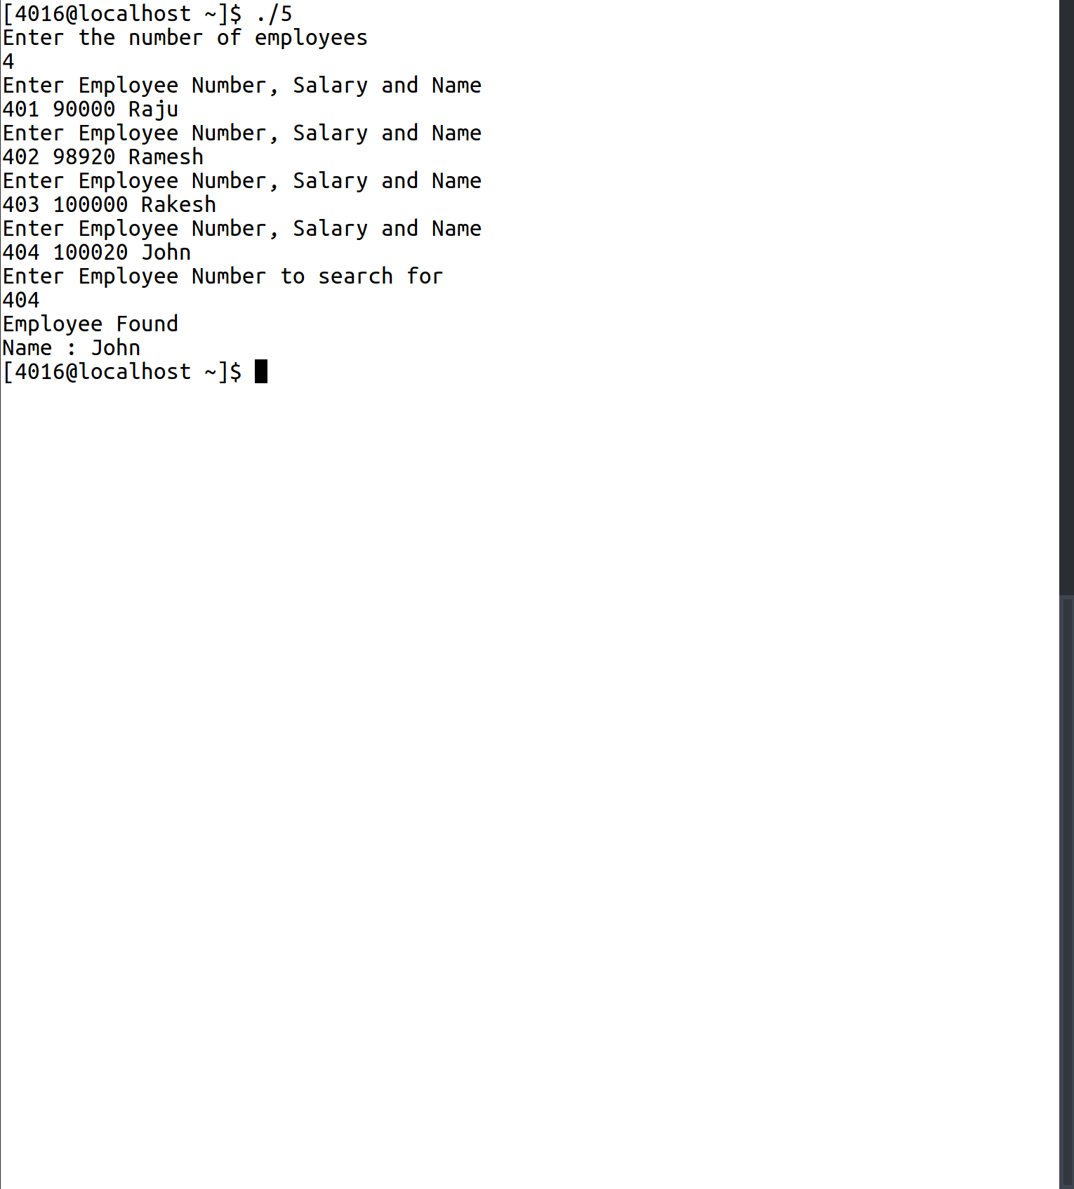

6.Map Application
phonebook.h:
1 #include <iostream>
2 #include <map>
3 using namespace std;
4 class phonebook{
5 public:
6 bool store(){
7 int quantity=0;
8 cout<<"Enter how many entries\n";
9 cin>>quantity;
10 for(int i=0;i<quantity;i++){
11 long long int phoneNo;
12 string name;
13 cout<<"Enter Phone Number and Name\n";
14 cin>>phoneNo>>name;
15 phonebook[phoneNo] = name;
16 }
17 }
18 void search(){
19 cout<<"Enter Phone Number to search\n";
20 long long int phoneNo;
21 cin>>phoneNo;
22 if(phonebook.find(phoneNo)!= phonebook.end()){
23 cout<<"Number belongs to : "<<phonebook[phoneNo]<<endl;
24 }
25 else{
26 cout<<"Not Found\n";
27 }
28 }
29 void display(){
30 map<long long int , string>::iterator curNumber;
31 for(curNumber = phonebook.begin();curNumber!=phonebook.end();curNumber++){
32 cout<<curNumber->first<<endl;
33 }
34 }
35 private:
36 map<long long int , string> phonebook;
37 };

application.cpp:
1 #include <iostream>
2 #include <map>
3 #include "phonebook.h"
4 using namespace std;
5
6 int main(){
7 phonebook ph;
8 ph.store();
9 ph.search();
10 ph.display();
11 return 0;
12 }
Sample Input/Output:
