Pitch

Summary

I found an interesting dataset with UFOs sightings over the years in [National UFO Reporting Center](http://www.nuforc.org/) and I thought that it will be nice to map the UFOs appearances and the most common shapes and colors of them. Also maybe there are some trends, like:

In California appear red fireballs and in Toronto Blue Disks.

The visualization could be a map with the number of the sightings and when you hover over the point the most common shape of this area could appear. Or if we want a not clickable viz I could try to make a timeline, but I don’t know how.

The viz could be like this:

(http://www.mufon.com/track-ufos.html)

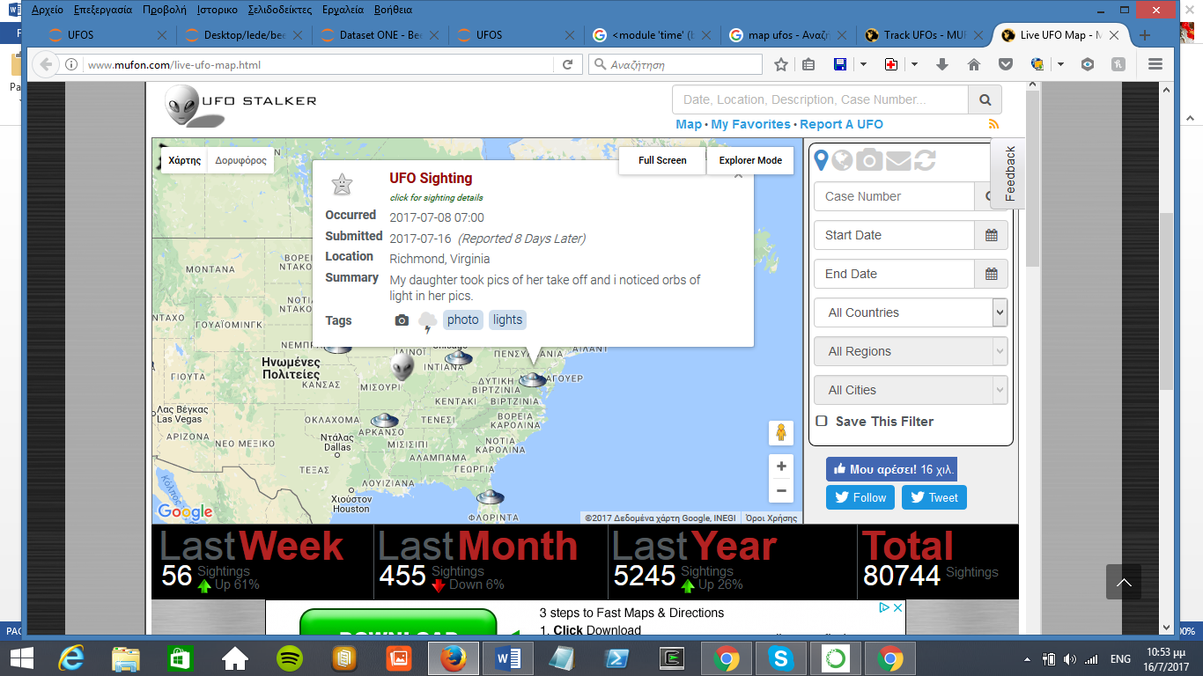

Possible Headlines:

UFOs fashion trends, what is the trend for 2017.

States attractive to UFOs.

Dateset: <http://www.nuforc.org/webreports/ndxevent.html>

Problems: The dataset is huge and selenium crashes after a while, I used a sample and I will try to find a way to get all the data.

Also I have to do some digging, because I stumbled upon some articles about Area 51 and the Roswell Incident in 1947 and I believe that around those areas - dates there should be traffic.

Work so far:

I scraped a dataset for the last month, cleaned it and plot this graph about shapes:

