Team Control Number:
14661
Problem Chosen:
A

2023 MidMCM / HiMCM
Dandelions: Friend? Foe? Both? Neither?
Summary
================================================================================

During the summer, your garden is often invaded by several dozen yellow flowers later turning into a white puffball, known as the Taraxacum officinal, the common dandelion. Originating in Eurasia, the dandelion can now be found in almost every country with its two main species being the Taraxacum officinal (common dandelion) and the Taraxacum erythrospermum (the red-seeded dandelion). Because it thrives in yards, gardens, sides of roads, and crops, it is considered a pest or invasive species by many.

Our team is given the two tasks; one of developing a model to predict the spread of dandelions throughout 1, 2, 3, 6, and 12 months, and the other is to determine an impact factor for different invasive or non-invasive species.

For the first task, we analyzed several factors that may affect to spread and growth of dandelions within this time to justify our model and process. We used coupled ordinary differential equations (ODEs) to assist us in solving the given challenge. In addition, we also used the programming language Python to help us solve and graph the equations so we can see the curves that the model predicts. Our model also includes various examples of valid data which assisted us in solving this first challenge.

Several factors that may affect the growth of the dandelion such as temperature, humidity, environmental capacity, and human or animal interference. To promote the best prediction for dandelion growth, considering the many factors listed above, we have multiple parameters to regulate the dandelion growth model and the results are displayed in a comprehensive way so it is easier to understand.

The second task is a broader model for creating a model which can tell the ‘impact factor’ of multiple different species. It tells us to test out the model for dandelions and two other species. However, we also created a practical (N=95) database for multiple different species and used a logistic regression model to predict plant invasiveness. We fit the model using a training dataset, estimate the coefficients using Python and test the model using testing data (N=25). In addition, we also used a confusion matrix to further evaluate our model and reported impact factor for testing data. Our model has achieved 82% balance accuracy on testing data. Based on the impact factor that generated from this model, we can conclude that dandelions are friends to Canada as non-invasive species. The other two species Water Hyacinth and Common Ivy are classified as invasive species.

Key Terms: Dandelion, Invasive Species, Mathematical Model, ODEs, Confusion matrix, Logistic Regression

Table Of Contents
1 Solution for Q1 2
1.1 Background 2
1.2 Restatement of Question 1 2
1.3 Assumptions and Justifications 3
2 Model Introduction for Q1 3
2.1 Description of Parameters 3
2.2 Parameters 4
2.3 Mathematical Equations 5
2.4 Description of Equations 5
2.4.1 Seed Dynamic Equation (Eq. 1) 6
2.4.2 Flower Dynamic Equation (Eq. 2) 6
2.4.3 Puffball Dynamic Equation (Eq. 3) 7
2.4.4 Temperature Equation (Eq. 4) 7
2.4.5 Relative Humidity Equation (Eq. 5) 8
2.4.6 Environmental Carrying Capacity Equation (Eq. 6) 8
2.5 Development Time and Percentage of Growth for Stages 9
2.6 Description of Solution Method 9
2.6.1 Ordinary Differential Equations (ODEs) 9
2.6.2 Python 10
2.7 Results 10
2.7.1 Temperature and Relative Humidity Data Fitting 11
2.7.2 Seeds, Flowers, and Puffballs at Time t 12
2.8 Conclusions for Q1 14
3 Notes for Q1 15
3.1 Strength 15
3.2 Limitations 15
4 Solution to Question 2 15
4.1 Background 15
4.2 Explanation of Question 2 15
4.3 Variable Definition and Justifications 16
4.4 Data Collection 17
5 Model for Q2 17
5.1 Method to Determine Impact Factor 17
5.3 Model Results and Evaluation 18
5.3.1 Data & Results 18
5.3.2 Evaluation 19
5.4 Part B 21
5.4.1 Restatement of Part B 21
5.4.2 Chosen species 21
5.4.2 Water Hyacinth 21
5.4.2 Common Ivy/English Ivy 21
5.5 Conclusion for Q2 21
6 Notes for Q2 22
6.1 Strengths 22
6.2 Limitations 22
7 Final Note 22
8 References 22
9 AI usage 24

1 Solution for Q1

1.1 Background
Dandelions, now found in every continent except Antarctica, are identified to be one of the most annoying and pesky weed species. Currently, there are more than 240 different species of dandelions [1] each being relatively similar to each other. Even though a weed, dandelions are edible and also nutritious containing several vitamins and minerals [2]. The Dandelion Extract market is valued at US 4 million in 2021 and is expected to reach 6 million by the end of 2028. Approximately 72% of the extract will go into medicine and health products while part of the remainder goes into cosmetic products [3].

With a maximum lifespan of 13-15 years, dandelion flowers bloom twice annually from May to October. After 9-12 days of blooming, seeds begin to ripen, fruiting from April to June. Once finished, one flower can harbor approximately 180 seeds, but may reach up to 400 seeds, with an entire plant containing 2000 - 12000 seeds. After dispersal, the dandelion seeds can persist in soil for up to 5 years, with their half-lives at approximately 3 months. Ripe seed has a germination rate of 90%, and most seeds emerge from the soil between March and October. [4]

Dandelions are able to have such a widespread presence mainly due to their effective seed dispersal, and ability to survive extensive damage, since even a small portion of the main taproot can regrow the plant.

We aim to create a model that is able to accurately predict the spread of dandelions while accounting for the varying temperatures, sudden climate changes, slower or faster wind speeds, humidity levels, usage of pesticides as well as life cycle time and survival rate.

Nevertheless, dandelions are still seen as a pest which results in hundreds of pesticides being used every year leading to damages to ecosystems and human health. For example 2,4-D (2,4-dichlorophenoxyacetic acid), a herbicide used to remove unwanted weeds including dandelions, also damages the roots of wanted plants like fruits and vegetables. Pesticides in general are the biggest killer of birds with their presence being in 70% of dead birds and have been increasingly used over 500% since 1960. [20]

1.2 Restatement of Question 1
In this problem, we are tasked with two things:
- Develop a mathematical model to anticipate the spread of dandelions over one hectare of land when one dandelion in its puffball stage is adjacent to it. We have to document the spread over 1, 2, 3, 6, and 12 months. The model needs to consider varying climatic conditions that may impact the spread of the dandelions.

- Create a mathematical model that calculates an “impact factor” for invasive species, taking into account various variables, such as the nature of the plant and the magnitude of its impact on the environment. This model should be applied to dandelions, and two other invasive plant species. The regions where these two other species are considered to be invasive must be acknowledged.

1.3 Assumptions and Justifications

- Assumption 1: The model timeline will begin on May 1.
Justification: May 1 is the approximate date when “puffballs” first start appearing in Edmonton, Alberta, Canada. Starting the model from this time point will align it with the life cycle of dandelions, and will provide a baseline for the number of dandelions as reproduction only occurs from this point on.

- Assumption 2: The hectare of land will contain no pre-existing dandelions and dandelion seeds
Justification: This establishes a clear starting point for the model, making it easier to track and analyze the growth and spread of dandelions.

- Assumption 3: The “Germination Time” variable is constant
Justification: Although discrepancies may exist, we use the mean of this quantity, which simplifies the model.

- Assumption 4: We assume that the dandelions do not spread by the underground roots system.
Justification: Even though dandelions may spread by an underground root system, we do not model it as we assume it does not spread that way for model generosity. In addition, the vast majority of spread dynamics comes from wind and the “parachute” dandelion seeds. When we compare this to the root spreading system, we see that the root system is significantly smaller.

- Assumption 5: As this problem does not specify where the experiment is taking place, we assume that it is going to be located in Edmonton, Alberta, Canada.
Justification: We are able to download the weather data of this location from the official website of Climate Weather Canada. The data includes temperature, precipitation, and gust levels.

- Assumption 6: We assume that the soil is going to be moist even though some days may be sunny days.
Justification: Even though some days are sunny days, the sun in Edmonton, Alberta is not strong or hot enough to dry out the soil. Edmonton does not have a history of any droughts which is why we believe it is safe to make this assumption.

- Assumption 7: The quality of soil will not affect dandelion growth.
Justification: According to the University of Wisconsin-Madison, a dandelion is a “short-lived perennial” which will “grow just about anywhere, regardless of soil conditions.” [21] However, the soil in Edmonton is still fairly high quality.

2 Model Introduction for Q1

2.1 Description of Parameters
The life cycle of the wild dandelion, Taraxacum officinale, consists of three stages: seed, flower, and the fully mature “puffball.” To capture the seasonal variation, three compartments representing the life stages of T. officinale were identified: seed ($S$), flower ($F$), and “puffball” stage ($P$). Seed refers to the T. officinale seeds that have already detached from the “puffball” of its parent plant and have already settled on the ground. Flower describes the iconic yellow flower of the dandelion. Finally, the puffball stage refers to the white ball composed of the seeds and their “parachute” like fluff. An aggregate stage was also estimated: a surface-occupying stage ($N_{SO}$). $N_{SO}$ compromises of any individual that is growing in an available space on the hectare, including $F$ and $P$.

A mature adult T. officinale generates seeds repeatedly throughout its lifespan ($L_{p}$ days for puffball). On average, $α$ seeds are released per puffball individual every $G_{SI}$ days. The spawning interval is very similar to the life of the puffball in this case, as When the seeds fly away from the puffball parent plant, they are then exposed to conditions to allow for they to germinate at the rate of $F_{g}(RH,T$$°)$. These germinated seeds grow into the iconic yellow flower at a development rate of $F_{d}(RH,T$$°)$ and time of $G_{F}(RH,T$$°$). After it becomes the flower, it takes $G_{P}(RH,T$$°$) days to turn into a puffball. In this case, the seed will then repeat the life cycle. In this case, the seed is unable to expire as multiple sources have stated that a seed can stay dormant for up to 13 years without further intrusion. Therefore, the expiration of the seed doesn’t need to be considered. Continuing on, the seed will once again land and be able to grow at a rate of around $F_{S}(RH,T$$°)$ which is capacity dependent and is thus adjusted by a capacity adjustment factor $γ(a,t)$.

Another factor that should be accounted for is the percentage of daily drop-off that may occur. Not all individuals will be able to survive all the natural factors that are imposed on them. This is why we have introduced three more variables to describe the drop-off in all three stages of life; the seed ($μ_{s}$), the flower ($μ_{F}$) and puffball ($μ_{P}$). Space occupancy also releases through the same process.

2.2 Parameters
Table 1. Parameter definitions, estimates, and parameter sources for dandelion population dynamics model. (Sources for temperature dependent parameters, which are marked with an asterisk, are shown in Table 1) Also please note that some of the values can be an estimation or average.
_____________________________________________________________________________________________
Parameter | Description | Value | Unit | Source
$G_{S}(RH, T°)$ | Development/ Germination time of seed* | 14-21 | Days | Cornell College
$G_{F}(RH,T$$°$) | Development time of flower* | 56-105 | Days | Cornell College
$G_{P}(RH,T$$°$) | Development time of puffball* | 9-12 | Days | Cornell College
$G_{SI}$ | Germination Interval | 3 | Days | Wisconsin Horticulture
$α$ | Number if seeds per germination | 54-172 | Seeds
$F_{g}(RH,T$$°)$ | %Germination* |  | % | *
$F_{d}(RH,T$$°)$ | %Development* |  | % | *
$F_{S}(RH,T$$°)$ | %Settlement* |  | % | *
$μ_{s}$ | % daily drop-off for seed |  | % | *
$μ_{F}$ | % daily drop-off for flower |  | % | *
$μ_{P}$ | % daily drop-off for puffball |  | % | *
$L_{p}$ | Lifespan of puffball | 10 | Days | Maine Government
$N_{SO}(t)$ | Total number of individuals in a visible stage |  | * | *
$K$ | Environmental carrying capacity |  | Individual $u^{2}$ | *
______________________________________________________________________________________________

2.3 Mathematical Equations
Table 2: List of mathematical equations for dandelion population dynamic model including differential equations, temperature model, and capacity adjustment factor.
______________________________________________________________________________________________
Mathematical Equations | Number
$\frac{dS(t)}{dt}=\frac{(x×α)×F_{g}(RH, T°)}{G_{SI}}×(P(t))-\frac{F_{d}(RH, T°)}{G_{S}(RH, T°)}×S(t)-μ_{s}×S(t) ;$  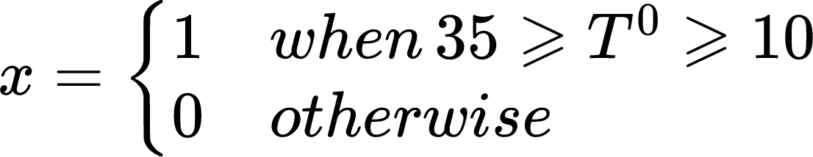 | Eq. 1
$\frac{dF(t)}{dt}=\frac{F_{d}(RH, T°)}{G_{S}(RH, T°)}×S(t)-\frac{F_{S}(RH, T°)}{G_{F}(RH, T°)}×γ(A,t)×F(t)-μ_{F}×F(t)$ | Eq. 2
$\frac{dP(t)}{dt}=\frac{F_{S}(RH, T°)}{G_{F}(RH, T°)}×$$γ(A,t)×F(t)×y-\frac{P(t)}{L_{p}}-μ_{p}×P(t) ;$  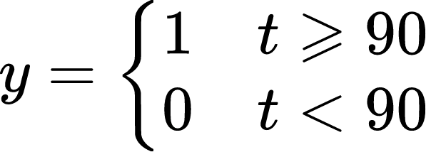 | Eq. 3
$T°=A×sin(Ωt+φ)+B$ | Eq. 4
$RH=A×sin(Ωt+φ)+B$ | Eq. 5
$γ(A,t)=1-\frac{N_{so}(t)}{α×K×A}$ | Eq. 6
______________________________________________________________________________________________

2.4 Description of Equations
The five equations create a base for our model. Overall, the first three (Eq. 1, 2, and 3) create descriptions as to the speed of growth of the individuals in each stage. The fourth and fifth equations (Eq. 4 and 5) describe the temperature and relative humidity fluctuations over the course of two years in Edmonton, Alberta, measured at the Edmonton International Airport. The final sixth equation (Eq. 6) describes the environmental capacity adjusting factor like described in Section 2.1.

2.4.1 Seed Dynamic Equation (Eq. 1)
$\frac{dS(t)}{dt}=\frac{(x×α)×F_{g}(RH, T°)}{G_{SI}}×(P(t))-\frac{F_{d}(RH, T°)}{G_{S}(RH, T°)}×S(t)-μ_{s}×S(t) ;$


Equation one has the overall intention to simulate how much seeds will kick start into the germination phase and proceed with growing. It includes a step function of $x$ depending on the temperatures. However, it acts as a lever as to whether or not germination will be affected by temperature. If it is too cold, the dandelion is unable to germinate or else it would die because there is no heat for the plant to reside in. If it is too hot, the dandelion cannot germinate either as the energy it will need to cool itself down overpowers the energy for germination. That is why when the temperature is less than 10 or greater than 35, the “lever variable” $x$ will equal to 0 as germination is unable to happen in those temperature ranges. Only in the prime temperature range, 10 to 35 degrees celsius will the dandelions be able to germinate assuming that the humidity and sunlight levels are average.

The left side of the equation describes the basic function of an ODE (ordinary differential equation) and it is written in the form of a first order differential equation.

The first section of the right side: $\frac{(x×α)×F_{g}(RH, T°)}{G_{SI}}×(P(t))$ has multiple variables involved. The first is the “lever variable” of $x$ that has been explained above multiplied by the variable $α$, the variable $F_{g}(RH, T°)$ and the variable $(P(t))$. This all signifies the number of seeds that will germinate based on the number of puffball adult plants they have come from. However, all of this needs to be divided by a spawning interval ($G_{SI}$) because it helps us find how many seeds germinate per day. The second section of the right side is $-\frac{F_{d}(RH, T°)}{G_{S}(RH, T°)}×S(t)-μ_{s}×S(t)$. This can be broken down to a simple equation of $a(b+c)$, where $a$ is $S(t)$ and $(b+c)$ is $-\frac{F_{d}(RH, T°)}{G_{S}(RH, T°)}+(-μ_{s})$. $a$ describes the total number of seeds. $b$ is $-\frac{F_{d}(RH, T°)}{G_{S}(RH, T°)}$, which describes the percentage that the germinated seed will develop over the time interval of development (which normally is dependent on the temperature and humidity). This helps describe deleting the seeds that have already developed from the developing/ germinating seeds. $c$ describes $-μ_{s}$ which shows the daily drop off for seeds. Seeds are very susceptible to attack from other species. For example, snails may eat the seeds before they get the chance to germinate or they may be eaten shortly after germination. This is the reason why the drop off rate of seeds are introduced.

2.4.2 Flower Dynamic Equation (Eq. 2)
$\frac{dF(t)}{dt}=\frac{F_{d}(RH, T°)}{G_{S}(RH, T°)}×S(t)-\frac{F_{S}(RH, T°)}{G_{F}(RH, T°)}×γ(a,t)×F(t)-μ_{F}×F(t)$

The presented ordinary differential equation tells a dynamic model designed to elucidate the complex processes governing the growth and development of a floral population over time. The equation, expressed as, $\frac{dF(t)}{dt}$ represents the rate of change of the total number of flowers $F$ with respect to time $(t)$. This model encapsulates a multifaceted interplay of various biological and environmental parameters.

The terms $F_{d}(RH, T°)$ and $F_{S}(RH, T°)$ denote the percentage development and settlement rates, respectively, in relation to the temperature and humidity $(RH, T°)$. These rates influence the total number of seeds $S(t)$ and flowers $F(t)$ by contributing to their growth and development. Furthermore, $G_{S}(RH, T°)$ and $G_{F}(RH, T°)$ symbolize the development times of seeds and flowers, representing the temporal aspect of their maturation.

The environmental capacity adjustment rate, $γ(a,t)$, introduces a dynamic factor accounting for the fluctuating environmental conditions that impact the population. This factor captures how the environment's capacity influences the growth and development of the floral population.

Moreover, the term $μ_{F}$ embodies the daily drop-off rate for flowers, illustrating the natural decline in flower numbers over time. This reflects the inherent life cycle characteristics of the floral population, acknowledging the reality of flowers naturally reaching the end of their life span.

Equation two provides a mathematical framework to understand and analyze the intricate interactions between developmental processes, environmental factors, and the inherent life cycle characteristics of a floral population, offering valuable insights into the dynamics of flower growth.

2.4.3 Puffball Dynamic Equation (Eq. 3)
$\frac{dP(t)}{dt}=\frac{F_{S}(RH, T°)}{G_{F}(RH, T°)}×$$γ(a,t)×F(t)×y-\frac{P(t)}{L_{p}}-μ_{p}×P(t) ;$

The provided ordinary differential equation describes the dynamics of a puffball population over time. The equation, $\frac{dP(t)}{dt}$, represents the rate of change of the total number of puffballs $P$ with respect to time $(t)$. Various factors influence the puffball population's growth and decline.

In this equation, $F_{S}(RH, T°)$, $G_{F}(RH, T°)$, $γ(a,t)$, $F(t)$, and $y$ are environmental and floral factors contributing to population growth. $F_{S}(RH, T°)$ represents the percentage settlement rate, $G_{F}(RH, T°)$ is the flower development time, $γ(a,t)$ is the environmental capacity adjustment rate, $F(t)$ is the total number of flowers, and $y$ is a time-dependent parameter. The term $\frac{P(t)}{L_{p}}$ introduces a density-dependent limitation, where $L_{p}$ is the lifespan of a puffball (which is normally 10 days). This factor constrains population growth when it approaches or surpasses the predefined limit. The last term, $μ_{p}×P(t)$, represents the percentage daily drop-off or mortality rate, indicating the natural decline in the puffball population over time.

The time-dependent parameter $y$ acts as a switch, taking the value of 0 when $t$ is less than 90 days and 1 when $t$ is greater than or equal to 90 days. This condition allows for the incorporation of potential shifts in environmental or ecological conditions, providing a versatile representation of the changing dynamics impacting the puffball population over time. In essence, this ODE offers a mathematical framework to explore and understand the complex interactions influencing the growth, limitations, and natural decline of puffball populations within varying environmental contexts.

2.4.4 Temperature Equation (Eq. 4)
$T° =_{}A_{T}×sin(Ω_{T}t+φ_{T})+B_{T}$
The sinusoidal function $T° =_{}A_{T}×sin(Ω_{T}t+φ_{T})+B_{T}$ signifies the temperature at a specific point in time. In this equation, $A$ represents the amplitude, which reflects the maximum deviation of temperature from the mean. It captures the extent of temperature fluctuations, such as the difference between the highest and lowest temperatures in a given cycle. The parameter $B$ serves as the vertical offset or baseline temperature, establishing the average temperature around which the sinusoidal wave oscillates.

The angular frequency $Ω$ in the equation determines the rate of oscillations, influencing how many cycles occur within a unit of time. $A$ higher $Ω$ results in a shorter period, affecting the frequency of temperature variations. The phase angle $φ$ is a crucial parameter, representing the horizontal shift or the starting point of the sinusoidal wave on the time axis.

2.4.5 Relative Humidity Equation (Eq. 5)
$RH =_{}A_{RH}×sin(Ω_{RH}t+φ_{RH})+B_{RH}$
This equation represents the calculation of relative humidity ($RH$) as the sinusoidal curve of time. It is also commonly used in meteorology and environmental science to obtain a representative value of humidity within a specific time range.
To get the daily average relative humidity, the following formula is used:
$RH=\frac{minRH + maxRH}{2}$
In this context:
- $RH$ stands for relative humidity, a measure of the moisture content of the air expressed as a percentage.
- $minRH$ represents the minimum relative humidity observed during a certain period.
- $maxRH$ represents the maximum relative humidity observed during the same period.

By averaging the minimum and maximum of daily relative humidity, the formula provides a simplified representation of the overall humidity level within the given time frame. The resulting value $RH$ serves as a single representative measure that conveys the central tendency of humidity conditions during the specified period. In addition, by using a similar sinusoidal mathematical model (as temperature), the relative humidity factors for all parameters can be simulated.

2.4.6 Environmental Carrying Capacity Equation (Eq. 6)
$γ(A,t)=1-\frac{N_{so}(t)}{α×K×A}$
This formula was used multiple times in the equations above. The direct use of it is for the capacity adjustment factor as stated before. This factor is a measure of how the environment's capacity to support a population is influenced by the number of individuals in a visible stage $N_{so}$, the environmental carrying capacity $K$, and the researched area A.

In the formula, $N_{so}(t)$ refers to the total number of dandelion plants in a visible stage at a specific time, which could represent the population of organisms at a certain life stage that is observable or measurable. During the analysis, the average diameter of a typical dandelion plant (15-centimeter diameter circle) is used for deriving the $N_{so}(t)$. The environmental carrying capacity $K$ is the maximum population size that the environment can sustain in the long term, indicating the optimal population size for a given ecosystem. For example, in a hillside scenario, K needs to be considered for the rocks/trees, which is not habitable for the dandelion. In the analysis, K is assumed to be 1 as an open area is under research. The number of seeds per germination (h) is a parameter representing the reproductive potential of the population, providing insight into the reproductive output in terms of seeds for the next generation. And the total area $A$ is the researched area, which is 1 hectare.

The carrying capacity adjustment factor, $γ(a,t)$, is calculated by a unit subtracting the ratio of the current dandelion population size $N_{so}(t)$ to the product of the environmental carrying capacity $K$ and the number of seeds per germination $α$ and the total area $A$. This adjustment factor reflects the proportion of the environmental capacity remaining available for the population to grow or occupy. As $N_{so}(t)$ approaches or exceeds $αK×A$, the adjustment factor decreases, indicating that the population is nearing or exceeding the environmental carrying capacity.

2.5 Development Time and Percentage of Growth for Stages
There are six variables present in the parameters chart that talk about the different life stages specifically. The first one is the development/growth time, i.e. $G_{S,F,P}(RH,T)$, and the second one is the percentage of growth, i.e.$F_{g,d,S}(RH,T)$. These two variables describe the amount of time it takes for an organism to develop and the development rate between each stage.

Figure 1: Gx Chart Figure 2: Fx Chart
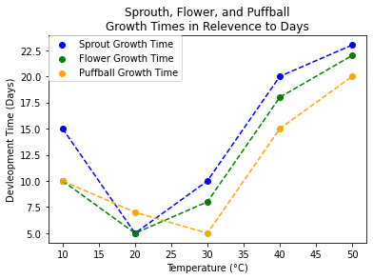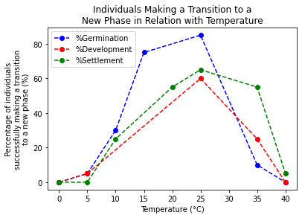
Figure 1 gives a dynamic understanding of how the sprout, in this case seed, flower, and puffball growth relative to temperature. It allows for more evidence when the model is solved as the time it takes for development and temperature are graphed as directly correlated. We see that there is an obvious temperature preference for all three stages of the dandelion life cycle as they take the shortest time to develop in those temperature ranges.

Figure 2 also does a very similar job. It plots the percentage of individuals who have successfully moved onto the next stage of the dandelion life cycle. It has three different lines to represent germination percentage (from dormant seed to sprout), development percentage (from sprout to iconic flower), and settlement percentage (from flower to adult puffball). There is also the very noticeable temperature favor as all three lines have an upward surge at temperatures from 15 degrees Celsius to 30 degrees Celsius.

In addition, the relative humidity will be multiplied to these times/factors to introduce the humidity effects of the environment.

2.6 Description of Solution Method
In the analysis, the programming language Python and the corresponding packages are used to solve the ordinary differential equations.

2.6.1 Ordinary Differential Equations (ODEs)
In approaching the given problem, the analysis strategy is centered on employing ODEs as a mathematical framework to model and understand the underlying dynamic processes at play. ODEs are particularly well-suited for scenarios where the evolution of a system is contingent on rates of change, making them a natural choice for describing dynamic phenomena in various scientific and engineering domains.

Ordinary Differential Equations (ODEs) are mathematical equations that involve one or more unknown functions and their derivatives with respect to one independent variable. These equations describe how a function changes as the independent variable changes. In simpler terms, ODEs model the rate at which a quantity changes concerning another variable.

For example, the general form of a first-order ordinary differential equation is:
$\frac{dy}{dx}=f(x,y)$
Here, $y$ is the unknown function of $x$, and $f(x, y)$ represents a given function of both $x$ and $y$. The equation states that the rate of change of $y$ with respect to $x$ is determined by the function $f$. Higher-order ODEs involve derivatives of higher order, however, we only used first order ODEs in our solution.

2.6.2 Python
Python is a high-level, interpreted programming language known for its many positive aspects. In our current context of mathematical modeling, Python has many uses.

- NumPy and SciPy: These libraries are fundamental to numerical and scientific computing in Python. NumPy provides support for large, multi-dimensional arrays and matrices, along with mathematical functions to operate on these arrays. SciPy builds on NumPy and adds additional functionality for optimization, signal processing, statistics, and more.

- Matplotlib: Matplotlib is a powerful plotting library that enables the creation of a wide variety of static, animated, and interactive visualizations in Python.

- SymPy: SymPy is a symbolic mathematics library for Python. It provides tools for symbolic computation, allowing users to manipulate algebraic expressions, solve equations symbolically, and perform various mathematical operations with exact precision.

- Pandas: Pandas is a data manipulation and analysis library that provides data structures for efficiently storing and manipulating large datasets. It is used to handle and analyze input and output data.

- Scikit-learn: For machine learning-based mathematical modeling, Scikit-learn is a popular library in Python. It includes a wide range of tools for machine learning tasks, such as regression, classification, clustering, and dimensionality reduction.

In solution for question one, all of the programming tools that were listed above are used to analyze a more comprehensive and knowledgeable model.

2.7 Results
We have data already defined for the parameters in the parameters chart, and we used different sources for databases to plug into temperature and humidity values. However, there are also pitfalls to this. Sometimes, we are unable to find the exact databases we need to create a graph and plot out the different model equations. To solve this equation, we use estimating techniques to piece together different information sources to create a fabricated database.

We have plotted out the different results for our model mathematical equations. They are mainly line charts with linear extrapolation and interpolation between the different data points.

2.7.1 Temperature and Relative Humidity Data Fitting
In this section, temperature and relative humidity data are fitted through trying to find the curve that minimizes the vertical (y-axis) displacement of a point from the curve (e.g., ordinary least squares). The curve_fit in SciPy is used in this section.
The temperature data is collected for the city of Edmonton, Alberta in Canada from Weather Canada for the past 1000 days (Feb-2021 to Nov-2023). It has a fitting with the sinusoidal curve model. The formula for temperature is $T° =_{}A_{T}×sin(Ω_{T}t+φ_{T})+B_{T}$. Using the database provided, values for $A_{T}$, $Ω_{T}$, $φ_{T}$, and $B_{T}$ are estimated to plot the diagram. Here are the fitted values: $A_{T}$ = 14.52 ± 0.03, $Ω_{T}$ = 0.02 ± 0.00, $φ_{T}$= -1.02 ± 0.00, and $B_{T}$ = 4.31 ± 0.02.

Figure 3: Diagram of the daily average temperature fitting for two years (Feb-2021 to Nov-2023) and the fitting Residuals/R-square for temperature fitting.
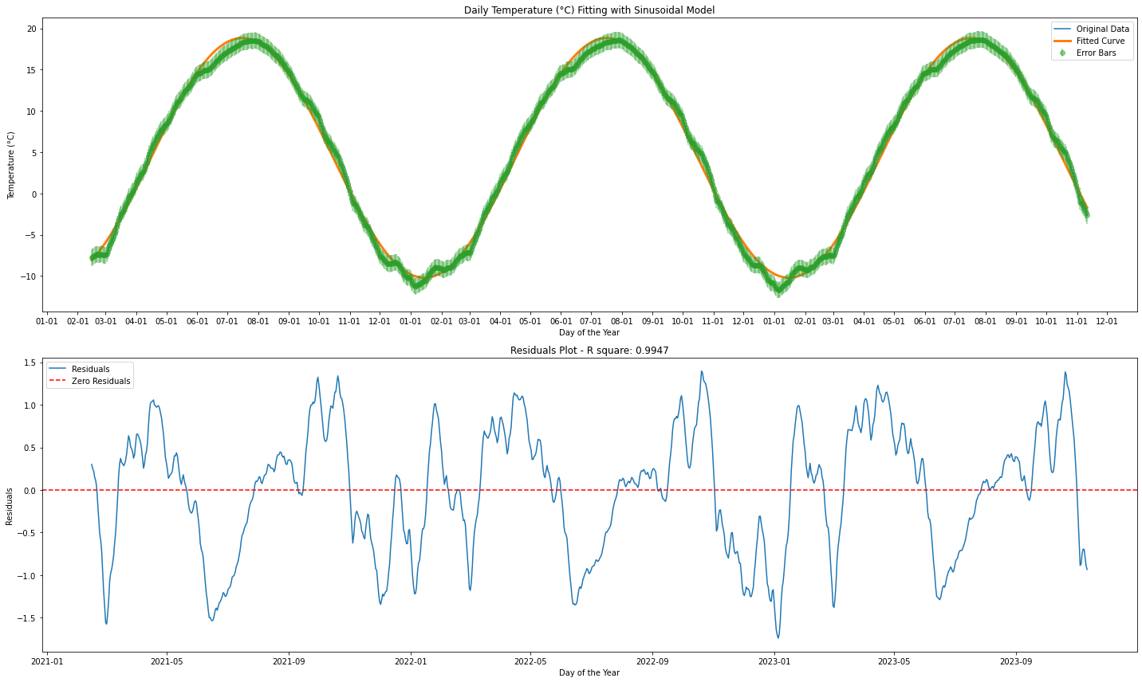
There are two plots presented in Figure 1. The one on top represents the temperature curvature over the course of two years. It helps us better understand the sinusoidal model of what the climate in our proposed ecosystem (Edmonton, Alberta) looks like. Therefore, we can accurately represent the time in which the dandelion puffballs first begin blooming to include it in that area.
“R-Squared (R² or the coefficient of determination) is a statistical measure in a regression model that determines the proportion of variance in the dependent variable that can be explained by the independent variable. In other words, r-squared shows how well the data fit the regression model (the goodness of fit).” [22] The second diagram is one depicting the residual and R-squared of our first graph. It helps develop a sense of how good our curvature function fits onto the original one. Overall, the R-squared for this function is 99.47%, proving that the fitting rate is excellent.

Similarly, the daily average relative humidity data is for Edmonton, Alberta, Canada from Weather Canada over the past two years. The sinusoidal curve model ($RH =_{}A_{RH}×sin(Ω_{RH}t+φ_{RH})+B_{RH}$) is used to fit the data.

Figure 4: Relative humidity(RH) data fitting for two years and corresponding residuals/R-square for RH fitting.
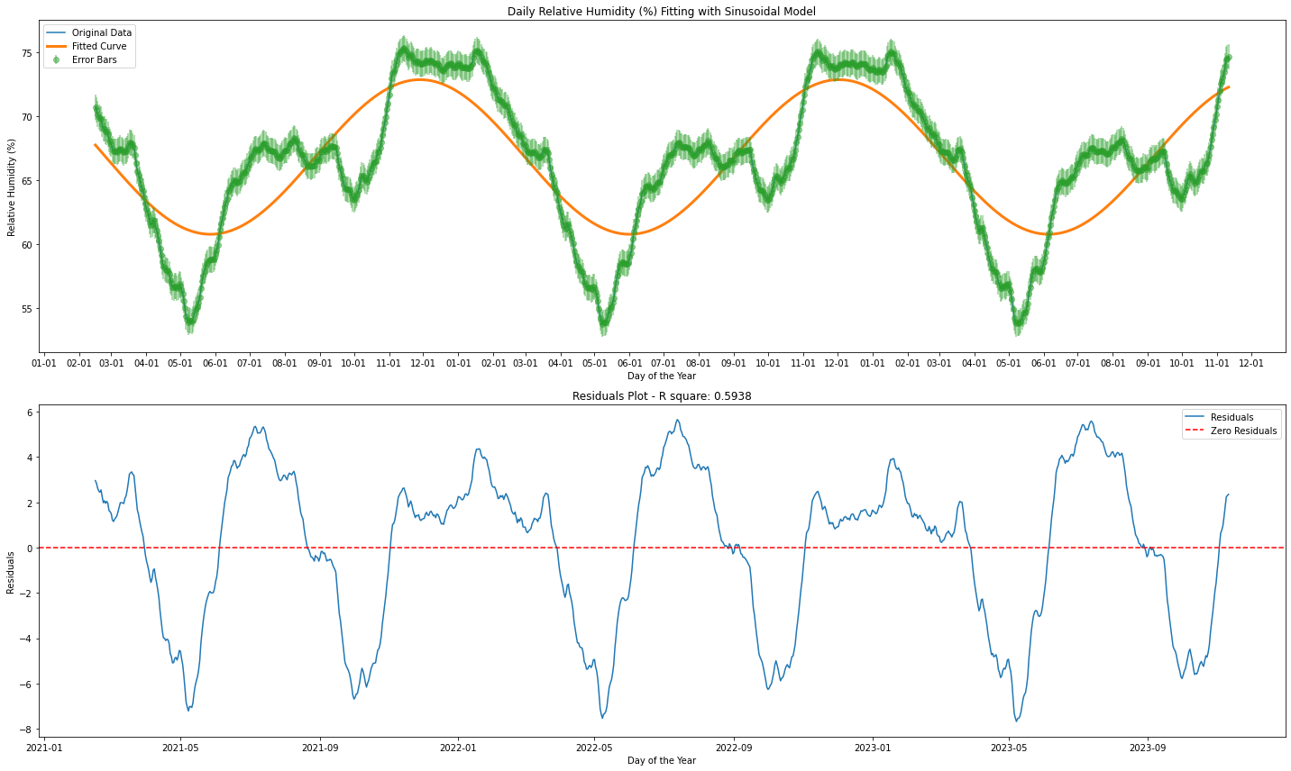
There are also two diagrams presented in Figure 2. The one on top represents the humidity curvature over the course of two years. It helps us better understand the sinusoidal model of what the climate in our proposed ecosystem (Edmonton, Alberta) looks like. Here are the fitted values: $A_{RH}$ = -6.03 ± 0.16, $Ω_{RH}$ = 0.02 ± 0.00, $φ_{RH}$= -0.15 ± 0.05, and $B_{RH}$ = 66.81 ± 0.11.
The second graph is one depicting the R-squared of the first graph. It helps develop a sense of how good our curvature function fits onto the original one. This graph still has a relatively mediocre R-square of 59.38%. Though it may be less than the one for temperature, it is still quite good.

2.7.2 Seeds, Flowers, and Puffballs at Time $t$
In this section, the results from the first model are presented. This will help to determine how much plants will be relevant at the time periods of 1 month, 2 months, 3 months, 6 months, and 12 months.

We will determine the number how many of each stage are present at each of the time stamps. For example, if we have 400 developed seeds at some point and then the puffballs stop producing seeds, we would still have 400 plants that had developed as multiple literature sources have stated that dandelion roots are very hard to die off on their own after they have formed.

There are three graphs in Figure 3. The first one describes how many seeds there are at time t. The second for flowers, and the third for puffballs. We will be using all three of these graphs to help us determine how many of each stage will be present at each of the time stamps.

Figure 5: The seeds, flowers, and puffballs apparent at time t.
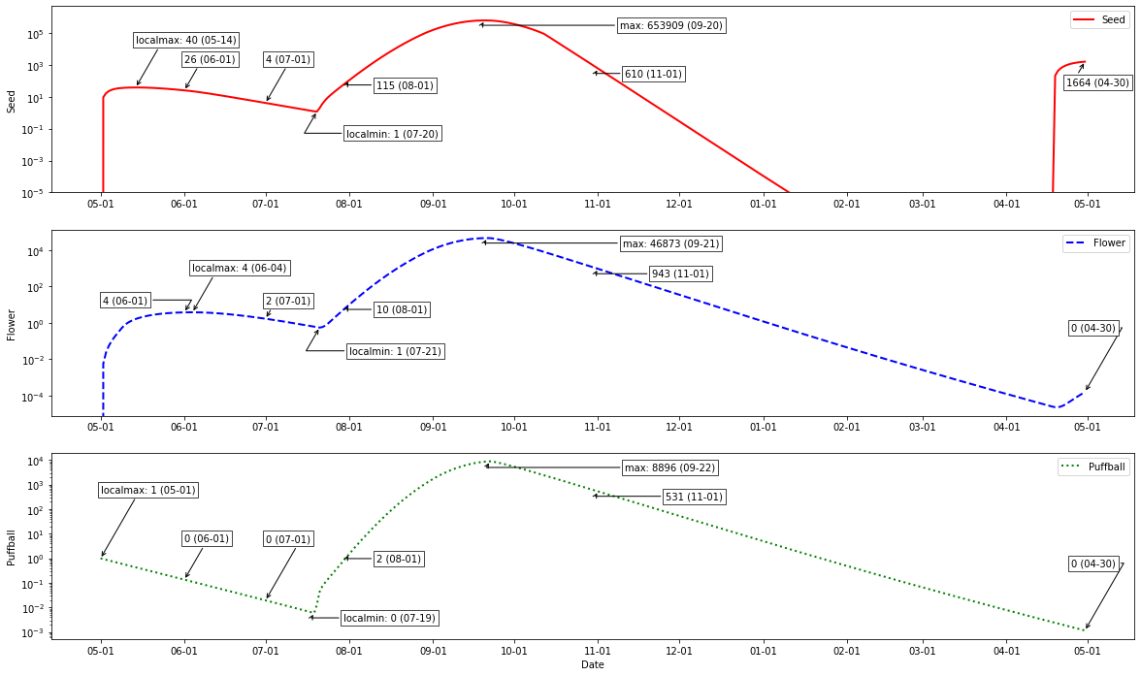

Table 3: The noticeable statistics from the Figure 5:
_______________________________________________________________________________________________
Month | Day | Date | Seed | Flower | Puffball | Notes
0 | 0 | 05-01 | 0 | 0 | 1 | Initial condition
1 | 14 | 05-14 | 40 | - | - | Local maximum value for seeds in day [0, 60]
1 | 31 | 06-01 | 26 | 4 | 0 | Status at Month 1
2 | 35 | 06-04 | - | 4 | - | Local maximum value for flowers in day [0, 60]
2 | 61 | 07-01 | 4 | 2 | 0 | Status at Month 2
3 | 79 | 07-19 | - | - | 0 | Local minimum value for puffballs in day [60, 90]
3 | 80 | 07-20 | 1 | - | - | Local minimum value for seeds in day [60, 90]
3 | 81 | 07-21 | - | 1 | - | Local minimum value for flowers in day [60, 90]
3 | 92 | 08-01 | 115 | 10 | 2 | Status at Month 3
5 | 142 | 09-20 | 653,909 | - | - | Maximum value for seeds
5 | 143 | 09-21 | - | 46,873 | - | Maximum value for flowers
5 | 144 | 09-22 | - | - | 8,896 | Maximum value for puffballs
6 | 184 | 11-01 | 610 | 943 | 531 | Status at Month 6
12 | 364 | 04-30 | 1,664 | 0 | 0 | Status at Month 12
_______________________________________________________________________________________________

2.8 Conclusion for Q1
If a single dandelion in its “puffball” stage is adjacent to an open one-hectare plot of land, with the proposed mathematical model, the spread of dandelions over the course of 1, 2, 3, 6, and 12 months can be predicted.

- Month 1:
  - There will be 26 seeds ready to develop, 4 flowers in their growing stage, and 0 puffballs will be observed to be at Month 1, assuming we started on May 1st.

- Month 2:
  - There will be 4 seeds ready to develop, 2 flowers in their growing stage, and 0 puffballs will be observed to be at Month 2, assuming we started on May 1st.

- Month 3:
  - There will be 115 seeds ready to develop, 10 flowers in their growing stage, and 2 puffballs will be observed to be at Month 2, assuming we started on May 1st.

- Month 6:
  - There will be 610 seeds ready to develop, 943 flowers in their growing stage, and 531 puffballs will be observed to be at Month 2, assuming we started on May 1st.

- Month 12:
  - There will be 1664 seeds ready to develop, 0 flowers in their growing stage, and 0 puffballs will be observed to be at Month 2, assuming we started on May 1st.

Our final solution counts many factors. For example, we count the life cycle of the dandelion into this pull as well as humidity and temperature. The formatted our solution such that it has the appearance of how many individuals in each stage at each time. We have this type of solution because if this was a real experiment, the scientists involved will be plotting out these concrete numbers of how many individuals were at each stage when each observation was made.

3 Note for Q1

3.1 Strength
We have numerous strengths in our model. For example, several factors that may affect dandelions are included. The temperature and humidity is included to investigate how germination may affect growth of dandelions and time for dandelion life cycle to help determine how many dandelions there will eventually be in the one hectare of field. In addition, the model data is also taken from various sources of real world analysis and studies to create a more accurate analysis.

3.2 Limitations
However, we also admit that every success has its flaws. We do not account for the probability that the dandelion may be inclined to disease or that the dandelion field may be threatened with sudden disaster. We did not account for these circumstances due to the probability of such instances happening which is relatively low. Secondly, we do not account for all potential effects created by humans such as the removal of dandelions with pesticides or by hand and increased spread of seeds from human activities such as blowing on the puffballs. Thirdly, the effect of different substrates on the spread of dandelions was not considered as dandelions can grow in pretty much all soil conditions, but changes in the nutrient content of the soil can have effects on the growth of dandelions and how they compete with other plants. Next, predation on dandelions from animals was not considered as the impact is miniscule, but still could’ve been considered for increased accuracy. Last but not least, one of the bigger limitations is that we only analyzed how much of each individual was at each time of observation. We believe our solution could have been further improved if we added the number of plants at each recorded observation.

4 Solution to Question 2

4.1 Background
The relationship of species with human beings and environment can be complex and it is related with multiple variables including species characteristics, its habitation, nature and extent with the environment. There are many invasive species that are taking over many ecosystems worldwide. They are mainly introduced through accidents and can have detrimental impacts.

Key terms: Impact factor, Invasive species, Logistic regression

4.2 Explanation of Question 2
In question 2 we are tasked to create a model to create the impact factor and predict the binary outcome, in this case being invasive or non-invasive for several plant species. The model we use should incorporate several factors that may impact their invasive ability and be able to solve the two statements listed below:

- Creating a model that is able to incorporate several factors and that may change the impact factor for dandelions.

- Being able to apply our model to determine the impact factor for two other species of our choice. We will also be identifying the region of the plants that we choose which are invasive

Invasive species: The invasive plants are harmful non-native to Canada trees, shrubs and herbaceous plants. They invade Canadian land and prevent native plants from growing, which have harmful impacts on economics, environment, human, ecosystem function including native vegetation and wildlife.

Impact factor: In this case, the factor can help to determine the invasiveness of a plant species. If the impact factor probability is greater than 0.5, the species is considered as invasive. If the impact factor is less than 0.5, the species is considered as non-invasive.

4.3 Variable Definition and Justifications
As stated above, the impact factor determines if a species is invasive or not. To determine this we have included several factors such as environmental harms, economic harms, if the species is edible, if it spreads fast, whether it has long life cycle or not, if it is native to Canada or not, and if it is able to grow in harsher conditions like roads, highways, curbs, etc. In this model we set our home region as Canada as it is filled with hundreds of plant species but is also invaded with several invasive species from other countries. Below we define the factors that affect our impact factor and the justification for why we chose them.

Factor 1: Whether the species causes environmental harms or not
Justification: By definition, an invasive species becomes invasive once it harms the new environment it resides in. For example, most invasive species such as the water hyacinth block out sunlight from reaching other plants destroying the original ecosystem. If the species is considered to cause environmental harm, it will be noted as 1 otherwise 0.

Factor 2: Economic harms also contribute to whether a species is invasive or not. Economic harm means that removing the species will take a lot of money and time from the government.
Justification: We believe economic harm ties into whether a species is invasive or not as species needing to be removed by the government are species that are completely overgrown, disrupting native life, or being a hassle towards humans, all which are characteristics for invasive species.If the species is considered to cause economic harm, it will be noted as 1 otherwise 0.

Factor 3: Whether a species is edible or not also affects how invasive that species is.
Justification: If a species is edible and is able to provide nutritional benefits, that means less of that species will exist due to animal or human consumption. Species that are not edible will have a higher population as opposed to ones that are (that is, if the two species begin with the same population). This contributes to our impact factor as invasive species usually have higher populations. If the species is considered to be not edible, it will be noted as 1 otherwise 0.

Factor 4: Whether a species is able to spread and/or reproduce quickly
Justification: An important characteristic of an invasive species is if it is able to spread across the region it has invaded. If the species spreads its seeds through wind or water while having a constant lifespan, it is usually able to spread rapidly. Conversely, species that have to be replanted or such will not be able to spread as fast; these species will not be invasive.If the species is considered to bedspread quickly, it will be noted as 1 otherwise 0.

Factor 5: Whether the species has a long life cycle
Justification: A long life cycle is defined if one species is able to survive more than 1 year. Perennial plant is considered to have a short life cycle. If a plant has a long life cycle, the variable will be noted as 1, otherwise 0.

Factor 6: Whether the species is native to Canada or not
Justification: As stated above, the region we chose for this model is Canada meaning species not from Canada will not be invasive species. Species that are not from Canada which are in Canada are more likely to be an invasive species.If a plant is not native to Canada, the variable will be noted as 1, otherwise 0.

Factor 7: Whether the species is able to grow in several different conditions (roads, highways, varying temperatures, nearly everywhere in the region, etc) and still be able to thrive (Habitat Widely)
Justification: Invasive species have a strong ability to adapt to several different conditions. By determining if the species is able to survive in different conditions we are able to determine whether a species is more likely to be invasive. If a plant is habitat widely in Canada, the variable will be noted as 1, otherwise 0.

Factor 8: Whether the species is invasive or non invasive.
Justification: Invasive species can be found through the Canada government website and research. If a plant is considered to be invasive to Canada, the variable will be noted as 1, otherwise 0.

4.4 Data Collection
In order to build a generalizable model, a total of 95 plant species were considered in our dataset and their characteristics and information fact were collected through literature review, google search and ChatGPT as well as the official Invasive Plant Field Guide by the Canadian Government [5]. Please see the attachment for the dataset that was generated for this study. Given time limitation, only 95 plants were considered with 70 species used to build a machine learning model and 25 species were used for testing including dandelion and other selected additional species. [10] [11] [12] [13] [14] (as well as ChatGPT (AI usage 1))

The 25 considered species in testing data are those that grow in Canada including: Dandelion, Water Hyacinth, Common Ivy, Purple Loosestrife, Garlic Mustard, Kudzu, Japanese knotweed, Giant Hogweed, Common Buckthorn, Himalayan Balsam, Dog-strangling Vine, Wild Parsnip, Tamarack, Labrador Tea, Lodgepole Pine, Cardinal Flower, Balsam fir, Pink lady’s slipper, Pacific Dogwood, Marsh Marigold, Red Osier Dogwood, Black eyed Susan, Blue vervain, Butterfly Weed, Nodding Onion. [10] [11] [13] (AI usage 2)
Same prompt was used to generate testing data in ChatGPT. (AI usage 3)
*Data was then checked through google and previous websites provided [10] [11] [13] [14] [15].

The data can be seen in Table 4 (7.3.1) as well as the results.

5 Model for Q2

5.1 Method to Determine Impact Factor
The method we have decided to build a Logistic Regression (LR) model based on the given variables. We chose to use this method because we are predicting binary outcomes (1=Invasive, 0=Non-invasive) in this case. Logistic regression is the process of modeling the probability of a discrete outcome given an input variable [7]
It takes the following form:

$LR(x;b) = \frac{1}{1+e^{-b_{0}-\sum_{i=1}^{n}{}b_{i}x_{i}}}$

Where $b=[b_{0},b_{1}, . . ., b_{n}]∈ ℝ^{n+1}$ is the vector for the constant term and coefficients of $n$ input variables, $x_{1}, x_{2}, . . ., x_{n}$. Here we have n=7 input variables in this study listed as factor 1 to factor 7 in section 6.3. The learning process involves computing the appropriate values of b, which maximize the log likelihood. [7] Python program was used to estimate the coefficients of this model.

Variable | Variable(x) | Coefficient(b)
$X_{1}$ | Environmental Harmful | 0.2582
$x_{2}$ | Economic Harmful | 0.9519
$x_{3}$ | Edible | 0.1009
$x_{4}$ | Spreads Fast | 2.4582
$x_{5}$ | Long Life Cycle | 0.0243
$x_{6}$ | Non-Native to Canada | -0.3502
$x_{7}$ | Habitat Widely | -0.1455

5.3 Model Results and Evaluation

5.3.1 Data & Results
We used 56 samples for logistic regression to fit the model with accuracy 0.85. There were 14 samples used as validation dataset and gave us sensitivity=1.0 and specificity=0.64. This means that our model did better to pick up invasive plant species then identify non-invasive plants.

Table 4: Testing data results and impact factors
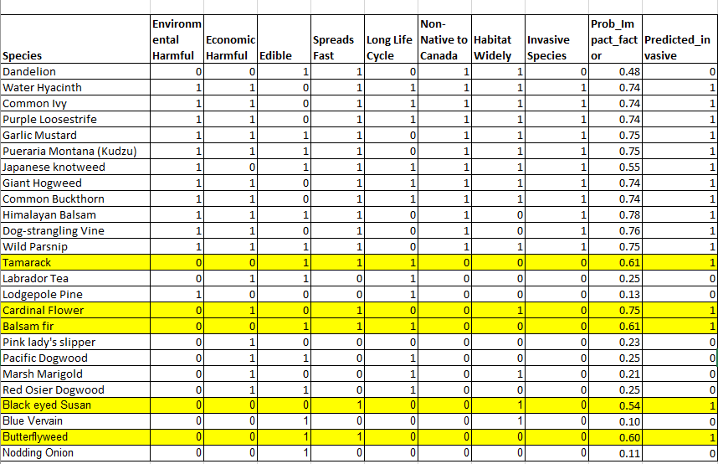
*The yellow highlight indicates that our result for the species may potentially be incorrect. Our model did not predict non-invasive species 100% accurately and mistakenly predicted non-invasive species to be invasive.

Table 5 Predicted results for dandelion and two other species.

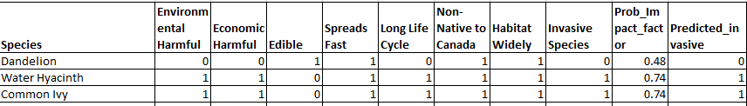

In the table, we can see that the impact factor is the fitted probability from the model. For dandelions, based on the 7 variables about dandelions, the modeled probability (impact factor) is 0.48 which indicates that it is a non-invasive species. The impact factor is a value between 0 and 1. The closer to 1 of this value, it is more likely to be an invasive species. In our study, in general situations, we believe dandelions are our friends, not foes. In Canadian national parks, it could pose some harm to the environment if it is not under control.

5.3.2 Evaluation
To determine the accuracy of our model we use the following equation [7]:

$Accuracy=\frac{TP+TN}{TP+FP+FN+TN}$
Where TP, FP, FN, TN, come form the following confusion matrix

 |  | Prediction
 |  | Success | Failure
Truth | Success | TP | FN
 | Failure | FP | TN

We also define the model evaluation metrics as following:
- sensitivity = $\frac{TP}{(TP+F{N)}_{}}$
- specificity = $\frac{TN}{(TN+FP)}$
- balanced_accuracy = $\frac{\frac{TP}{TP+FN}+\frac{TN}{TN+FP}}{2}$

Sensitivity refers to our model’s ability to identify a species as invasive species. A highly sensitive test means that there are few false negative results, and thus fewer cases of invasive species are missed. The specificity of our model is its ability to identify a species who is non invasive as negative. A low specificity means that there are more non-invasive species that are identified incorrectly.
Figure 6: ROC Curve and AUC
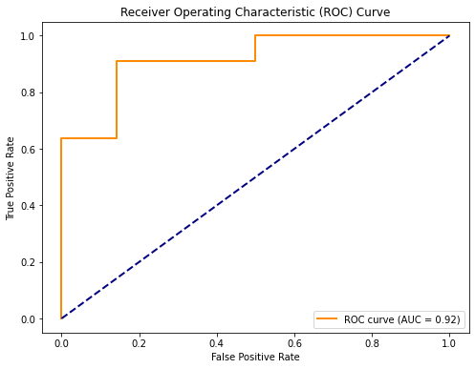
A Receiver Operator Characteristic (ROC) curve is a graphical plot used to show the model fit ability. One common approach is to calculate the area under the ROC curve, which is abbreviated to AUC. It is used to measure how well the model predicts and performs. AUC is close to 1 indicating a better model. We had AUC=0.92 based on our data with sample n=25 indicated an excellent model fit.

5.4 Part B

5.4.1 Restatement of Part B
In part B we are tasked to apply our model to determine the impact factor for two other plant species of our choice which are often considered invasive. We also are requested to identify the region for both species.

5.4.2 Chosen species
For the two chosen species, we choose the Water Hyacinth as well as the Common Ivy (English Ivy). Both being invasive in Canada with the Water Hyacinth mainly being found in Ontario [8] and the Common Ivy being found in Southwestern British Columbia [9]. We chose these two species as they are two very common species that can be seen throughout Canada (where we reside) even though they may spread more in specific provinces.

5.4.2 Water Hyacinth
From our table we see that the Water Hyacinth causes environmental and economical damage, is not edible, spreads fast, has a long life cycle, is not native to Canada, is able to grow in harsher conditions. Its environmental problem due to its nature of forming “dense vegetative mats” that block sunlight and reduce sunlight for native algae and plankton. Due to the abundance of the plant, its death causes bacteria to consume the oxygen within the water, killing much of the aquatic animals. The abundance of the plant also makes it hard and costly to remove. Typically each Hyacinth has a lifespan of five years while blooming perennially. The water hyacinth originated in South America but currently can be found in the Great Lakes as well as Ontario. As the name states, they grow in water. Moreover, they are able to both sexually and asexually reproduce through seeds and budding. This allows the plant to double itself in 5-16 days [8] [16] [17] [18]

5.4.2 Common Ivy/English Ivy
Similarly to the Water Hyacinth, the Common Ivy causes environmental and economical damage, cannot be eaten, spreads fast, lives for long times, and can grow in harsh conditions. Also known as English Ivy, it is an evergreen vine that forms a dense ground cover which kills other vegetation and makes it difficult for most animals. The Ivy forms mats on the forest floor, not allowing other plants to grow, weakens other trees, and damages property. It cannot be eaten and may even be poisonous. Additionally, the Ivy is able to live for more than 100 years making it harder to die out on its own. It spreads through birds when they eat the fruit and can root from cutting. The Ivy originated from Europe but is now invasive in several parts of British Columbia. [9] [23] [24] [25]

5.5 Conclusion for Q2
Based on our model, dandelion is a non-invasive species with an impact factor (0.48). Both Water Hyacinth and Common Ivy had an impact factor 0.74 which is greater than 0.5 making them both invasive species. When actual research is completed, it shows that our model’s results are correct, therefore making the validity airtight.

6 Notes for Q2

6.1 Strengths
This model has numerous strengths. To begin, we have the flexibility to determine the impact factor of multiple different plant species. The impactor factor has real meaning and it is easy to understand. It shows the likelihood of a plant to be classified as an invasive species. This model is able to determine the impact factor for a plant species based on its different factors. For example, some factors are if it is edible or not, if it is native to Canada, or if it has a harmful environmental impact. We can include more features if the model needs to be used on animals or insects. In addition, the data used has gone through a series of tests, therefore, we are certain it is accurate. Using accurate information is key because it allows us to produce high quality model results.

6.2 Limitations
Our model does not account for invasive species that are animals in this study. We did not include this factor because animals and plants vary in characteristics and as the Dandelion is a plant, we decided to only use plant species for our data. There may also be several other factors that may affect the prediction model such other characteristics: species. This is because the more species we have, the larger the dataset can be used for model predictions and plant size, plant seed dispersal type, other plant characteristics and more factors that describe the relation with environment and human society. Even though we already have a very large database with different plant species, we could use more to increase the model accuracy.

In addition, ChatGPT may still have some errors. We have manually checked the data quality before modeling and rectified the errors that ChatGPT generated. More research should be applied for selected species to guarantee the data quality for modeling.

7 Final Note
To answer the problem given, we have developed two models: one to estimate the spread of dandelions within a period of time and another capable of determining an impact factor for several invasive species.

In our first model, we created three differential equations to individually model important three life stages of dandelion: Seeding, Flower and Puffball. We also use sin models to best fit the temperature and relative humidity data in Edmonton Canada. The climate model results were incorporated in three coupled differential equations. We also considered other factors in the model including environmental capacity, and human or animal interference. We modeled the population of seed, flower and puffball numbers that can be produced by one single dandelion puffball spread in one hectare area in a year. In peak summer time, a puffball plant can produce about 650K seeds, 46K flowers and 9K puffballs.However, our model does have a few limitations as it does assume that several factors—such as the soil, insect attack, pesticide damage—remain constant throughout the active and inactive seasons.

In our second model, we consider a variety of factors that may affect a species invasiveness along with justification of why we chose the factor. The factors are: environmental harms, economic harms, if the species is edible, if it spreads fast, whether it has a long life cycle or not, if it is native to Canada or not, and if it is able to grow in harsher conditions like roads, highways, curbs, etc. We then collected our data for different Canadian species from ChatGPT, the Canadian Government Field guide as well as several other online sources. This gave us a list of 95 different plant species including, Giant Hogweed, Purple Loosestrife, Nodding Onion, and more. We used Logistic Regression to help calculate our impact factor and classify plants to be invasive and non-invasive species. To validate our model, we calculated the confusion matrix and achieved a balance accuracy of 0.82 for testing data. The area under the curve (AUC) was 0.92 indicating an excellent fit and prediction. However, our model does include some inaccuracies as we do not include all factors that may impact invasiveness. For the second part of the question, we chose two invasive plant species, the Water Hyacinth and Common Ivy. We provided insight to both of these species on why they were invasive, how they were hurting the environment, and their region of living. Our model determined that both these species were invasive, but the dandelion, which we often think is invasive, is not.

Overall, we think the dandelion is a friend more than a foe. Even though it seems like it appears everywhere from your garden, to the roadside, it is not as hurtful as it seems. If you really dislike them, try not to use a pesticide. Instead, brew up some dandelion petals, stir fry some stems, and make a delicious and nutritional afternoon snack for the summer.

8 References
[1] Lancs, Bury. “Dandelion.” Dandelion - Wild Flower Finder, Oct. 2011,
https://wildflowerfinder.org.uk/Flowers/D/Dandelion/Dandelion.htm.
[2] Krebs, Jessie. “Are Dandelions Edible Raw? How to Forage Wild Dandelions - 2023.” MasterClass, 23 Mar. 2022, https://www.masterclass.com/articles/are-dandelions-edible-raw
[3] “Global Dandelion Extract Market Outlook 2022.” Dandelion Extract Market Size, Share, Trends, Outlook 2022, 2022, https://reports.valuates.com/market-reports/QYRE-Auto-22O8956/global-dandelion-extract
[4] “Dandelion.” Garden Organic, 2023, https://www.gardenorganic.org.uk/expert-advice/garden-management/weeds/weed-datasheets/dandelion
[5] Canadian Food Inspection Agency. “Invasive Plant Field Guide - Publications.Gc.Ca.” Invasive Plant Field Guide, 2012, https://publications.gc.ca/collections/collection_2014/acia-cfia/A104-97-2012-eng.pdf
[6] David O. Manz, Thomas W. Edgar. “Logistic Regression.” Logistic Regression - an Overview | ScienceDirect Topics, 2017, https://www.sciencedirect.com/topics/computer-science/logistic-regression
[7] Mark A. Lewis, Yanyu Xiao, Russell Greiner. “Evaluation of Machine Learning Methods for Predicting ... - Ualberta.Ca.” Evaluation of Machine Learning Methods for Predicting Eradication of Aquatic Invasive Species, 2018, https://www.math.ualberta.ca/~mlewis/Publications%202018/Xiao2018_Article_EvaluationOfMachineLearningMet(1).pdf
[8] OFAH/OMNR Invading Species Awareness Program. “Water Hyacinth.” Ontario’s Invading Species Awareness Program, 2021, https://www.invadingspecies.com/invaders/aquatic-plants/water-hyacinth-2/
[9] ISCMV. “English Ivy.” ISCMV, 2023, https://iscmv.ca/invasives/detail/1077
[10] 29, Sharon Miki Chan Updated June, et al. “17 Native Plants in Canada, by Province.” HGTV Canada, 29 June 2023, https://www.hgtv.ca/native-plants-in-canada-by-province/
[11] Ontario Invasive Plant Council. “Invasive Plants.” Invasive Species Centre, 5 Sept. 2023, https://www.invasivespeciescentre.ca/invasive-species/meet-the-species/invasive-plants/
[12] Care, Diabetes. “10 Fruits and Vegetables You Can Find Year-Round in Canada.” Diabetes Care Community, 21 Apr. 2022, https://www.diabetescarecommunity.ca/diet-and-fitness-articles/10-fruits-and-vegetables-you-can-find-year-round-in-canada/
[13] Hicks-Hamblin, Kristina. “15 of the Best Native Wildflowers for the US and Canada.” Gardener’s Path, 24 Aug. 2023, https://gardenerspath.com/plants/flowers/best-native-wildflowers/
[14] The Nature Conservancy of Canada. “Invasive Species Gallery.” NCC, 2023, https://www.natureconservancy.ca/en/what-we-do/resource-centre/invasive-species/
[15] “Invasive Species.” Wikipedia, Wikimedia Foundation, 6 Nov. 2023, https://en.wikipedia.org/wiki/Invasive_species
[16] Mary Bohling, Michigan State University Extension. “National Invasive Species Awareness Week: Water Hyacinth.” MSU Extension, 21 Jan. 2022, https://www.canr.msu.edu/news/national_invasive_species_awareness_week_water_hyacinth_bohling16
[17] “How to Plant & Care for Hyacinths.” BRECK’S - Direct to You from Holland since 1818, 2023, https://www.brecks.com/how_to_tips_growing_instructions_hyacinths#:~:text=Hyacinths%20bloom%20in%20late%20spring,years%2C%20coming%20back%20each%20season
[18] Jim Graham, Thomas J. Stohlgren. “Water Hyacinth.” Water Hyacinth - an Overview | ScienceDirect Topics, 2019, https://www.sciencedirect.com/topics/earth-and-planetary-sciences/water-hyacinth.
[19] Mathematical Model Describing the Population Dynamics of Ciona ... - REABIC, www.reabic.net/journals/mbi/2014/1/MBI_2014_Patanasatienkul_etal.pdf. Accessed 14 Nov. 2023.
[20] Sedbrook, Danielle. “2,4-D: The Most Dangerous Pesticide You’ve Never Heard Of.” 2,4-D Weed Killer Toxicity, Use in Herbicides and Potential Dangers, 15 Mar. 2016, www.nrdc.org/stories/24-d-most-dangerous-pesticide-youve-never-heard.
[21] “Dandelion, Taraxacum Officinale.” Wisconsin Horticulture, hort.extension.wisc.edu/articles/dandelion-taraxacum-officinale/. Accessed 14 Nov. 2023.
[22]“R-Squared.” Corporate Finance Institute, 11 Aug. 2023, corporatefinanceinstitute.com/resources/data-science/r-squared/.
[23] Lewthwaite, Kate. “Is Ivy Poisonous? .” Woodland Trust, 2021, https://www.woodlandtrust.org.uk/blog/2021/08/is-ivy-poisonous/
[24] Leininger, Sam. “BMP: English Ivy (Hedera Helix).” WeedWise Program, WeedWise Program, 10 May 2022, https://weedwise.conservationdistrict.org/english-ivy
[25] Tim Abbey, Tim. “English Ivy in the Landscape.” Penn State Extension, extension.psu.edu/english-ivy-in-the-landscape. Accessed 14 Nov. 2023. https://extension.psu.edu/english-ivy-in-the-landscape

9 AI Usage
- OpenAI ChatGPT (January 2022 version, ChatGPT-3.5)
Query1: Please create a chart for the following: Dandelion, Water Hyacinth, Common Ivy, Purple Loosestrife, Garlic Mustard, Kudzu, Japanese knotweed, Giant Hogweed, Common Buckthorn, Himalayan Balsam, Dog-strangling Vine, Wild Parsnip, Tamarack, Labrador Tea, Lodgepole Pine, Cardinal Flower, Balsam fir, Pink lady’s slipper, Pacific Dogwood, Marsh Marigold, Red Osier Dogwood, Back eyed Susan, Blue vervain, Butterfly Weed, and Nodding Onion with column names called: Species, Environmental Harmful (1/0), economic Harmful (1/0), Edible (1/0), Spreads Fast (1/0), Long Life Cycle (1/0), Non-Native to Canada (1/0), habitat widely(1/0), invasive specie(1/0).

Output:

Species | Environmental Harmful | Economic Harmful | Edible | Spreads Fast | Long Life Cycle | Non-Native to Canada | Habitat Widely | Invasive Species
Dandelion | 0 | 0 | 1 | 1 | 0 | 1 | 0 | 0
Water Hyacinth | 1 | 1 | 0 | 1 | 1 | 1 | 1 | 1
Common Ivy | 1 | 1 | 0 | 1 | 1 | 1 | 1 | 1
Purple Loosestrife | 1 | 1 | 0 | 1 | 1 | 1 | 1 | 1
Garlic Mustard | 1 | 1 | 1 | 1 | 0 | 1 | 1 | 1
Kudzu | 1 | 1 | 1 | 1 | 0 | 1 | 0 | 1
Japanese Knotweed | 1 | 0 | 1 | 1 | 1 | 1 | 1 | 1
Giant Hogweed | 1 | 1 | 0 | 1 | 1 | 1 | 1 | 1
Common Buckthorn | 1 | 1 | 0 | 1 | 1 | 1 | 1 | 1
Himalayan Balsam | 1 | 1 | 1 | 1 | 0 | 1 | 0 | 1
Dog-strangling Vine | 1 | 1 | 0 | 1 | 0 | 1 | 0 | 1
Wild Parsnip | 1 | 1 | 1 | 1 | 0 | 1 | 1 | 1
Tamarack | 0 | 0 | 1 | 1 | 1 | 0 | 0 | 0
Labrador Tea | 0 | 1 | 1 | 0 | 1 | 0 | 0 | 0
Lodgepole Pine | 1 | 0 | 0 | 0 | 1 | 0 | 0 | 0
Cardinal Flower | 0 | 1 | 0 | 1 | 0 | 0 | 1 | 0
Balsam Fir | 0 | 0 | 1 | 1 | 1 | 0 | 0 | 0
Pink Lady’s Slipper | 0 | 1 | 0 | 0 | 0 | 0 | 0 | 0
Pacific Dogwood | 0 | 1 | 1 | 0 | 1 | 0 | 0 | 0
Marsh Marigold | 0 | 1 | 0 | 0 | 1 | 0 | 1 | 0
Red Osier Dogwood | 0 | 1 | 1 | 0 | 1 | 0 | 0 | 0
Black-eyed Susan | 0 | 0 | 0 | 1 | 0 | 0 | 1 | 0
Blue Vervain | 0 | 0 | 1 | 0 | 0 | 0 | 1 | 0
Butterfly Weed | 0 | 0 | 1 | 1 | 0 | 0 | 0 | 0
Nodding Onion | 0 | 0 | 1 | 0 | 0 | 0 | 0 | 0

- OpenAI ChatGPT (January 2022 version, ChatGPT-3.5)
Query1: Give me 50 plant species with no detail at all just species common name in paragraph form which reside in Canada not including these: Dandelion, Water Hyancinth, Common Ivy, Purple Loosestrife, Garlic Mustard, Kudzu, Japanese knotweed, Giant Hogweed, Common Buckthorn, Himalayan Balsam, Dog-strangling Vine, Wild Parsnip, Tamarack, Labrador Tea, Lodgepole Pine, Cardinal Flower, Balsam fir, Pink lady’s slipper, Pacific Dogwood, Marsh Marigold, Red Osier Dogwood, Back eyed Susan, Blue vervain, Butterfly Weed, and Nodding Onion
Output: Canada boasts a diverse array of plant species, each contributing to the country's rich ecological landscape. Among these are White Spruce, Black Spruce, Canada Goldenrod, Blue Flag Iris, Bunchberry, Jack Pine, Canada Anemone, Milkweed, Wild Rose, Fireweed, Labrador Violet, Canadian Columbine, Common Yarrow, Wild Strawberry, Canadian Serviceberry, Tamarack, Lodgepole Pine, Pacific Dogwood, Marsh Marigold, Red Osier Dogwood, Corkscrew Hazel, Spinach, Japanese Maple, Sugar Maple, Amur Maple, Ohio Buckeye, Horse Chestnut, Paper Birch, European Birch, Canada Redbud, Pagoda Dogwood, Chinese Kousa Dogwood, Smoke Bush, Toba Hawthorn, Russian Olive, European Beech, Manchurian Ash, Green Ash, Ginkgo, Kwanzan Cherry, Honey Locust, Black Walnut, Star Magnolia, Saucer Magnolia, Crabapple, Weeping Mulberry, London Plane Tree, Eastern Cottonwood, Columnar Swedish Aspen, Trembling Aspen, Amur Cherry, Pincherry, Kwanzan Cherry, Schubert Chokecherry, Pear, White Oak, and Red Oak.

- OpenAI ChatGPT (January 2022 version, ChatGPT-3.5)
Query1: Please create a table with 9 columns and provide accurate fact information. The column names are: Species, Environmental Harmful (1/0), economic Harmful (1/0), Edible (1/0), Spreads Fast (1/0), Long Life Cycle (1/0), Non-Native to Canada (1/0), habitat widely(1/0), invasive specie(1/0) in a concise format. Include the following: Lettuce, Common Crupina, Dallis Grass, Devil's-Tail Tearthumb, Giant Reed, Iberian Starthistle, Japanese Stiltgrass, Jointed Goatgrass, Kudzu ,Paterson's Curse, Serrated Tussock, Silverleaf Nightshade, Slender Foxtail, South African Ragwort, Madagascar Ragwort, Syrian Bean-Caper, Woolly Cup Grass, Yellow Starthistle, Giant Hogweed, Common Buckthorn, Japanese Knotweed, Garlic Mustard, Himalayan Balsam, Purple Loosestrife, Dog-Strangling Vine, Wild Parsnip, Broccoli, Red Twig Dogwood, Potatoes, Thyme, Corkscrew Hazel, Spinach, Japanese Maple, Red Maple, Silver Maple, Sugar Maple, Amur Maple, Ohio Buckeye, Horse Chestnut, Paper Birch, European Birch, Canada Redbud, Pagoda Dogwood, Chinese Kousa Dogwood, Smoke Bush, Toba Hawthorn, Russian Olive, European Beech, Manchurian Ash, Green Ash, Ginkgo, Kwanzan Cherry, Honey Locust, Black Walnut, Star Magnolia, Saucer Magnolia, Crabapple, Weeping Mulberry, London Plane Tree, Eastern Cottonwood, Columnar Swedish Aspen, Trembling Aspen, Amur Cherry, Pincherry, Kwanzan Cherry, Schubert Chokecherry, Pear, White Oak, and Red Oak
Output:
Species | Environmental Harmful | Economic Harmful | Edible | Spreads Fast | Long Life Cycle | Non-Native to Canada | Habitat Widely | Invasive Species
Lettuce | 0 | 0 | 1 | 0 | 0 | 1 | 1 | 0
Common Crupina | 1 | 1 | 0 | 1 | 1 | 1 | 0 | 1
Dallis Grass | 1 | 1 | 0 | 1 | 1 | 1 | 0 | 1
Devil's-Tail Tearthumb | 1 | 1 | 0 | 1 | 1 | 1 | 0 | 1
Giant Reed | 1 | 1 | 0 | 1 | 1 | 1 | 1 | 1
Iberian Starthistle | 1 | 1 | 0 | 1 | 1 | 1 | 1 | 1
Japanese Stiltgrass | 1 | 1 | 0 | 1 | 1 | 1 | 1 | 1
Jointed Goagrass | 1 | 1 | 0 | 1 | 1 | 1 | 1 | 1
Kudzu | 1 | 1 | 1 | 1 | 0 | 1 | 0 | 1
Paterson's Curse | 1 | 1 | 0 | 1 | 1 | 1 | 1 | 1
Serrated Tussock | 1 | 1 | 0 | 1 | 1 | 1 | 1 | 1
Silverleaf Nightshade | 1 | 1 | 0 | 1 | 1 | 1 | 1 | 1
Slender Foxtail | 1 | 1 | 0 | 1 | 1 | 1 | 1 | 1
South African Ragwort | 1 | 1 | 0 | 1 | 1 | 1 | 1 | 1
Madagascar Ragwort | 1 | 1 | 0 | 1 | 1 | 1 | 1 | 1
S Syrian Bean-Caper | 1 | 1 | 1 | 1 | 0 | 1 | 0 | 1
Woolly CupGrass | 1 | 1 | 0 | 1 | 1 | 1 | 1 | 1
Yellow Starthistle | 1 | 1 | 0 | 1 | 1 | 1 | 1 | 1
Giant Hogweed | 1 | 1 | 0 | 1 | 1 | 1 | 1 | 1
Common Buckthorn | 1 | 1 | 0 | 1 | 1 | 1 | 1 | 1
Japanese Knotweed | 1 | 1 | 0 | 1 | 1 | 1 | 1 | 1
Garlic Mustard | 1 | 1 | 1 | 1 | 0 | 1 | 1 | 1
Himalayan Balsam | 1 | 1 | 0 | 1 | 1 | 1 | 1 | 1
Purple Loosestrife | 1 | 1 | 0 | 1 | 1 | 1 | 1 | 1
Dog-Strangling Vine | 1 | 1 | 0 | 1 | 1 | 1 | 1 | 1
Wild Parsnip | 1 | 1 | 1 | 1 | 0 | 1 | 1 | 1
Broccoli | 0 | 1 | 1 | 1 | 0 | 1 | 1 | 0
Red Twig Dogwood | 1 | 1 | 0 | 1 | 1 | 1 | 1 | 1
Potatoes | 0 | 1 | 1 | 0 | 0 | 1 | 1 | 0
Thyme | 0 | 1 | 1 | 1 | 0 | 1 | 1 | 0
Corkscrew Hazel | 1 | 1 | 0 | 1 | 1 | 1 | 1 | 1
Spinach | 0 | 1 | 1 | 1 | 0 | 1 | 1 | 0
Japanese Maple | 1 | 1 | 0 | 1 | 1 | 1 | 1 | 1
Red Maple | 1 | 1 | 0 | 1 | 1 | 1 | 1 | 1
Silver Maple | 1 | 1 | 0 | 1 | 1 | 1 | 1 | 1
Sugar Maple | 0 | 0 | 1 | 0 | 0 | 1 | 1 | 0
Amur Maple | 1 | 1 | 0 | 1 | 1 | 1 | 1 | 1
Ohio Buckeye | 1 | 1 | 0 | 1 | 1 | 1 | 1 | 1
Horse Chestnut | 1 | 1 | 0 | 1 | 1 | 1 | 1 | 1
Paper Birch | 1 | 1 | 0 | 1 | 1 | 1 | 1 | 1
European Birch | 1 | 1 | 0 | 1 | 1 | 1 | 1 | 1
Canada Redbud | 1 | 1 | 0 | 1 | 1 | 1 | 1 | 1
Pagoda Dogwood | 1 | 1 | 0 | 1 | 1 | 1 | 1 | 1
Chinese Kousa Dogwood | 1 | 1 | 0 | 1 | 1 | 1 | 1 | 1
Smoke Bush | 1 | 1 | 0 | 1 | 1 | 1 | 1 | 1
Toba Hawthorn | 1 | 1 | 0 | 1 | 1 | 1 | 1 | 1
Russian Olive | 1 | 1 | 0 | 1 | 1 | 1 | 1 | 1
European Beech | 1 | 1 | 0 | 1 | 1 | 1 | 1 | 1
Manchurian Ash | 1 | 1 | 0 | 1 | 1 | 1 | 1 | 1
Green Ash | 1 | 1 | 0 | 1 | 1 | 1 | 1 | 1
Ginkgo | 1 | 1 | 0 | 1 | 1 | 1 | 1 | 1
Kwanzan Cherry | 1 | 1 | 0 | 1 | 1 | 1 | 1 | 1

- OpenAI ChatGPT (January 2022 version, ChatGPT-3.5)
Query1: Do the same for the following species: Honey Locust, Black Walnut, Star Magnolia, Saucer Magnolia, Crabapple, Weeping Mulberry, London Plane Tree, Eastern Cottonwood, Columnar Swedish Aspen, Trembling Aspen, Amur Cherry, Pincherry, Kwanzan Cherry, Schubert Chokecherry, Pear, White Oak, and Red Oak
Output:
Species | Environmental Harmful | Economic Harmful | Edible | Spreads Fast | Long Life Cycle | Non-Native to Canada | Habitat Widely | Invasive Species
Honey Locust | 1 | 1 | 0 | 1 | 1 | 1 | 1 | 1
Black Walnut | 1 | 1 | 0 | 1 | 1 | 1 | 1 | 1
Star Magnolia | 1 | 1 | 0 | 1 | 1 | 1 | 1 | 1
Saucer Magnolia | 1 | 1 | 0 | 1 | 1 | 1 | 1 | 1
Crabapple | 1 | 1 | 0 | 1 | 1 | 1 | 1 | 1
Weeping Mulberry | 1 | 1 | 0 | 1 | 1 | 1 | 1 | 1
London Plane Tree | 1 | 1 | 0 | 1 | 1 | 1 | 1 | 1
Eastern Cottonwood | 1 | 1 | 0 | 1 | 1 | 1 | 1 | 1
Columnar Swedish Aspen | 1 | 1 | 0 | 1 | 1 | 1 | 1 | 1
Trembling Aspen | 1 | 1 | 0 | 1 | 1 | 1 | 1 | 1
Amur Cherry | 1 | 1 | 0 | 1 | 1 | 1 | 1 | 1
Pincherry | 1 | 1 | 0 | 1 | 1 | 1 | 1 | 1
Kwanzan Cherry | 1 | 1 | 0 | 1 | 1 | 1 | 1 | 1
Schubert Chokecherry | 1 | 1 | 0 | 1 | 1 | 1 | 1 | 1
Pear | 1 | 1 | 1 | 1 | 0 | 1 | 1 | 1
White Oak | 1 | 1 | 0 | 1 | 1 | 1 | 1 | 1
Red Oak | 1 | 1 | 0 | 1 | 1 | 1 | 1 | 1

- OpenAI ChatGPT (January 2022 version, ChatGPT-3.5)
Query1: what are ODEs
Output: Ordinary Differential Equations (ODEs) are mathematical equations that involve one or more unknown functions and their derivatives with respect to one independent variable. These equations describe how a function changes as the independent variable changes. In simpler terms, ODEs model the rate at which a quantity changes concerning another variable.

ODEs are prevalent in various scientific and engineering disciplines as they provide a mathematical framework for modeling dynamic processes and systems. They are commonly used to describe phenomena such as population dynamics, chemical reactions, fluid flow, heat transfer, and electrical circuits. Solving ODEs helps in predicting and understanding the behavior of systems over time, making them a crucial tool in mathematical modeling and simulation.

- OpenAI ChatGPT (January 2022 version, ChatGPT-3.5)
Query1: what is python
Output:
Python is a high-level, interpreted programming language known for its readability, versatility, and ease of use. It was created by Guido van Rossum and was first released in 1991. Python has gained widespread popularity for its simplicity, which makes it an excellent choice for beginners, as well as its extensive libraries and frameworks that cater to a wide range of applications.

Key features of Python include:

Readability: Python's syntax is designed to be clear and readable, using English keywords rather than punctuation. This characteristic makes it easy for developers to express concepts in fewer lines of code compared to languages with more complex syntax.

Versatility: Python supports multiple programming paradigms, including procedural, object-oriented, and functional programming. This flexibility allows developers to choose the best approach for a particular task.

Extensive Libraries: Python boasts a rich ecosystem of libraries and frameworks that cover areas such as web development (Django, Flask), scientific computing (NumPy, SciPy), machine learning (TensorFlow, PyTorch), data analysis (Pandas), and more. These libraries contribute to Python's versatility and expedite development by providing pre-written code for common tasks.

Community Support: Python has a large and active community of developers, which means that there is a wealth of resources, tutorials, and forums available. The community-driven nature of Python fosters collaboration and the sharing of knowledge.

Interpretation: Python is an interpreted language, meaning that the code is executed line by line by an interpreter rather than being compiled into machine code. This makes development and debugging more straightforward.

Cross-Platform: Python is compatible with various operating systems, including Windows, macOS, and Linux, making it a cross-platform language.

Open Source: Python is open-source, meaning that its source code is freely available and can be modified and distributed. This openness encourages collaboration and the continuous improvement of the language.

Python is used in a wide range of applications, from web development and scientific research to artificial intelligence and data analysis. Its simplicity and readability make it an excellent language for both beginners and experienced developers alike.

- OpenAI ChatGPT (January 2022 version, ChatGPT-3.5)
Query1:
write a python code to create a graph where i can plot points and there is linear extrapolation between those points.
here is the data
y=[0,10,30,75,85,10,0]
x=[3,5,10,15,25,35,40]
Output:
Certainly! You can use the matplotlib library to create a graph and plot points with linear extrapolation. If you don't have it installed, you can install it using pip install matplotlib. Here's a simple Python code using matplotlib:
import matplotlib.pyplot as plt
import numpy as np

# Given data
y = [0, 10, 30, 75, 85, 10, 0]
x = [3, 5, 10, 15, 25, 35, 40]

# Plotting the original points
plt.scatter(x, y, color='blue', label='Original Points')

# Linear extrapolation function
def linear_extrapolation(x_val, x_data, y_data):
# Fit a linear regression
slope, intercept = np.polyfit(x_data, y_data, 1)
# Use the equation of a line to extrapolate
return slope * x_val + intercept

# Extrapolating points beyond the given data range
extrapolated_x = np.arange(0, 45, 5)
extrapolated_y = [linear_extrapolation(val, x, y) for val in extrapolated_x]

# Plotting the extrapolated points
plt.plot(extrapolated_x, extrapolated_y, color='red', linestyle='dashed', label='Linear Extrapolation')

# Adding labels and legend
plt.xlabel('X-axis')
plt.ylabel('Y-axis')
plt.legend()

# Display the plot
plt.show()

This code uses the np.polyfit function from NumPy to perform linear regression and then extrapolates points beyond the given data range. The extrapolated points are plotted with a dashed red line, while the original points are plotted with blue dots. Adjust the code as needed for your specific requirements.

- OpenAI ChatGPT (January 2022 version, ChatGPT-3.5)
Query1: i want to connect the dots using a dashed line
Output:
Certainly! You can modify the code to connect the original points with a dashed line. Here's the updated code:
import matplotlib.pyplot as plt
import numpy as np

# Given data
y = [0, 10, 30, 75, 85, 10, 0]
x = [3, 5, 10, 15, 25, 35, 40]

# Plotting the original points with a dashed line
plt.plot(x, y, 'bo-', linestyle='dashed', label='Original Points')

# Linear extrapolation function
def linear_extrapolation(x_val, x_data, y_data):
# Fit a linear regression
slope, intercept = np.polyfit(x_data, y_data, 1)
# Use the equation of a line to extrapolate
return slope * x_val + intercept

# Extrapolating points beyond the given data range
extrapolated_x = np.arange(0, 45, 5)
extrapolated_y = [linear_extrapolation(val, x, y) for val in extrapolated_x]

# Plotting the extrapolated points with a dashed line
plt.plot(extrapolated_x, extrapolated_y, 'ro-', linestyle='dashed', label='Linear Extrapolation')

# Adding labels and legend
plt.xlabel('X-axis')
plt.ylabel('Y-axis')
plt.legend()

# Display the plot
plt.show()

In this code, the plot function is used with the 'bo-' and 'ro-' format strings to connect the original and extrapolated points with a dashed line ('dashed' linestyle). The rest of the code remains unchanged.

- OpenAI ChatGPT (January 2022 version, ChatGPT-3.5)
Query1: i want to get rid of the "Linear Extrapolation" line
Output:
Certainly! If you want to remove the "Linear Extrapolation" line from the plot, you can simply remove the corresponding plot function call. Here's the modified code:
import matplotlib.pyplot as plt
import numpy as np

# Given data
y = [0, 10, 30, 75, 85, 10, 0]
x = [3, 5, 10, 15, 25, 35, 40]

# Plotting the original points with a dashed line
plt.plot(x, y, 'bo-', linestyle='dashed', label='Original Points')

# Adding labels and legend
plt.xlabel('X-axis')
plt.ylabel('Y-axis')
plt.legend()

# Display the plot
plt.show()

Now, only the original points will be plotted with a dashed line, and the "Linear Extrapolation" line will be removed.

- OpenAI ChatGPT (January 2022 version, ChatGPT-3.5)
Query1: are wetter places hotter
Output:
Not necessarily. The relationship between wetness (humidity or precipitation) and temperature can be complex and is influenced by various factors. In general terms, places with high humidity might feel hotter due to the impact of humidity on the body's ability to cool itself through evaporation. High humidity can make it feel stickier and more uncomfortable.

However, the actual air temperature is determined by factors such as sunlight, latitude, altitude, and local geography. For example, tropical rainforests are often both wet and hot, but there are also wet and relatively cooler places, such as some temperate rainforests.

In some cases, precipitation can have a cooling effect. When rain falls, it can cool the air temperature temporarily, especially if there is a lot of cloud cover. Additionally, bodies of water, like oceans and large lakes, can moderate temperatures in nearby areas, making them cooler in the summer and warmer in the winter.

So, while there can be a correlation between wetter places and higher temperatures due to factors like humidity, it's not a strict rule, and other variables play a crucial role in determining the overall climate of a region.

- OpenAI ChatGPT (January 2022 version, ChatGPT-3.5)
Query1: dandelion seed germination relation to temperature and humidity
Output:
Dandelion (Taraxacum officinale) is a common weed with a high reproductive capacity, primarily through its seeds. The germination of dandelion seeds is influenced by various environmental factors, including temperature and humidity. Here's a brief overview of the relationship between dandelion seed germination and these environmental factors:
Temperature:

Optimal Temperature Range: Dandelion seeds generally germinate well within a certain temperature range. The optimal temperature for dandelion seed germination is typically around 20 to 25 degrees Celsius (68 to 77 degrees Fahrenheit).
Temperature Extremes: Extreme temperatures, either too high or too low, can inhibit germination. If it's too cold, the metabolic processes within the seed may slow down, and if it's too hot, it can lead to seed damage or desiccation.
Humidity:

Moisture Requirement: Dandelion seeds require a certain level of moisture for germination. Adequate soil moisture is crucial to initiate the germination process. Insufficient moisture can delay or prevent germination.
Humidity Fluctuations: Dandelion seeds are adapted to a variety of environmental conditions, and they can often tolerate fluctuations in humidity. However, maintaining consistent moisture in the germination environment is generally beneficial.
Light Requirements:

Light Sensitivity: Dandelion seeds are somewhat indifferent to light conditions during germination. They can germinate in both light and dark conditions. However, exposure to light can influence the subsequent growth and development of the seedlings.
Soil Type:

Adaptability to Soil: Dandelion seeds are adaptable to various soil types but generally prefer well-draining soils. Compacted or waterlogged soils can hinder germination.
Stratification:

Cold Stratification: Some dandelion seeds may benefit from cold stratification, a period of exposure to cold temperatures, which can break seed dormancy and enhance germination. This mimics the natural conditions of winter.
It's important to note that dandelion is a resilient and opportunistic plant, and its seeds can germinate under a range of conditions. The adaptability of dandelion seeds contributes to the widespread distribution of this plant in different environments.

For specific information on dandelion seed germination under local conditions, it may be helpful to consult regional agricultural extension services or scientific literature focused on local ecosystems.

- OpenAI ChatGPT (January 2022 version, ChatGPT-3.5)
Query1: what percent of dandelions germinate at 5 degrees C
Output:
Specific data on the percentage of dandelion (Taraxacum officinale) seed germination at 5 degrees Celsius may not be readily available in the general information. Germination rates can vary based on factors such as seed source, local climate, and genetic variability within dandelion populations. It's important to note that dandelion seeds are known to exhibit a certain level of adaptability to different temperatures. To obtain accurate and specific information about dandelion seed germination at 5 degrees Celsius, you may need to refer to scientific studies, research articles, or agricultural extension resources that focus on dandelion germination under controlled conditions. These sources can provide detailed data on germination rates at specific temperatures, including 5 degrees Celsius. Additionally, you might consider conducting your own experiments or literature review to find studies that have investigated dandelion germination under various temperature conditions, including colder temperatures. This could provide you with more precise information based on the context you are interested in, such as a specific geographic location or ecological setting.

