ASSIGNMENT 4

Kimberly Cable

2022-04-23

# Part 1

## Set the working directory to the root of your DSC 520 directory

## Load the data/r4ds/heights.csv to

## earn height sex ed age race  
## 1 50000 74.42444 male 16 45 white  
## 2 60000 65.53754 female 16 58 white  
## 3 30000 63.62920 female 16 29 white  
## 4 50000 63.10856 female 16 91 other  
## 5 51000 63.40248 female 17 39 white  
## 6 9000 64.39951 female 15 26 white

# <https://ggplot2.tidyverse.org/reference/geom_boxplot.html>

## Create boxplots of sex vs. earn and race vs. earn using geom_point() and geom_boxplot()

## sex vs. earn

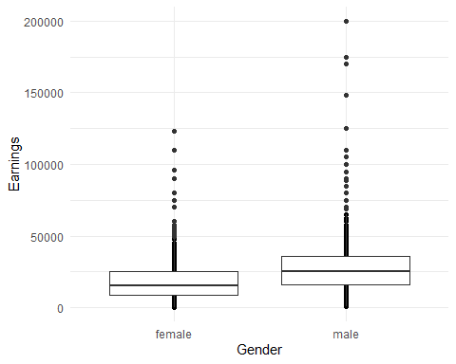

## race vs. earn

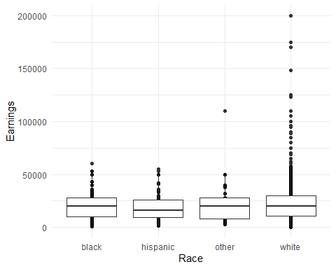

# <https://ggplot2.tidyverse.org/reference/geom_bar.html>

## Using geom_bar() plot a bar chart of the number of records for each sex

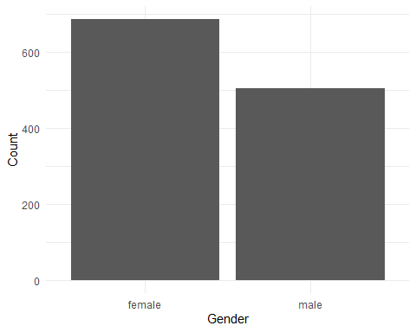

## Using geom_bar() plot a bar chart of the number of records for each race

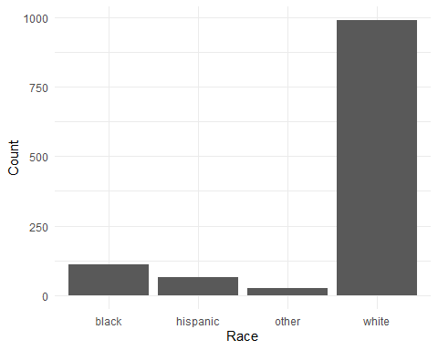

## Create a horizontal bar chart by adding coord_flip() to the previous plot

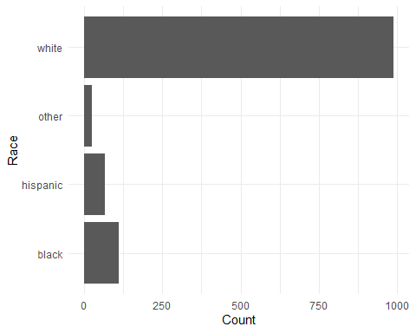

# <https://www.rdocumentation.org/packages/ggplot2/versions/3.3.0/topics/geom_path>

## Load the file "data/nytimes/covid-19-data/us-states.csv" and

## assign it to the covid_df dataframe

## date state fips cases deaths  
## 1 2020-01-21 Washington 53 1 0  
## 2 2020-01-22 Washington 53 1 0  
## 3 2020-01-23 Washington 53 1 0  
## 4 2020-01-24 Illinois 17 1 0  
## 5 2020-01-24 Washington 53 1 0  
## 6 2020-01-25 California 6 1 0

## Parse the date column using as.Date()

## date state fips cases deaths  
## 1 2020-01-21 Washington 53 1 0  
## 2 2020-01-22 Washington 53 1 0  
## 3 2020-01-23 Washington 53 1 0  
## 4 2020-01-24 Illinois 17 1 0  
## 5 2020-01-24 Washington 53 1 0  
## 6 2020-01-25 California 6 1 0

## Create three dataframes named california_df, ny_df, and florida_df

## containing the data from California, New York, and Florida

# California

## date state fips cases deaths  
## 6 2020-01-25 California 6 1 0  
## 10 2020-01-26 California 6 2 0  
## 14 2020-01-27 California 6 2 0  
## 18 2020-01-28 California 6 2 0  
## 22 2020-01-29 California 6 2 0  
## 26 2020-01-30 California 6 2 0

# New York

## date state fips cases deaths  
## 247 2020-03-01 New York 36 1 0  
## 262 2020-03-02 New York 36 1 0  
## 277 2020-03-03 New York 36 2 0  
## 294 2020-03-04 New York 36 11 0  
## 314 2020-03-05 New York 36 22 0  
## 339 2020-03-06 New York 36 44 0

# Florida

## date state fips cases deaths  
## 243 2020-03-01 Florida 12 2 0  
## 256 2020-03-02 Florida 12 2 0  
## 271 2020-03-03 Florida 12 3 0  
## 287 2020-03-04 Florida 12 3 0  
## 305 2020-03-05 Florida 12 4 0  
## 326 2020-03-06 Florida 12 7 2

## Plot the number of cases in Florida using geom_line()

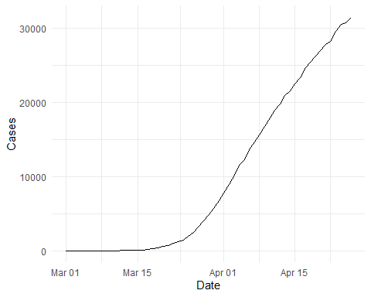

## Add lines for New York and California to the plot

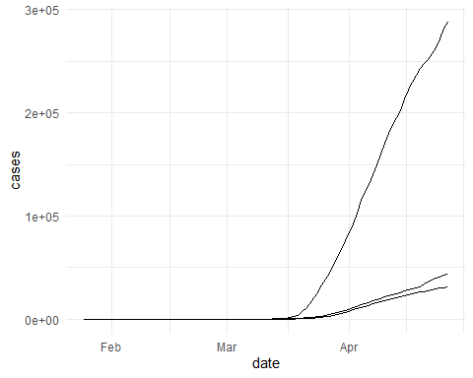

## Use the colors “darkred”, “darkgreen”, and “steelblue” for Florida, New York, and California

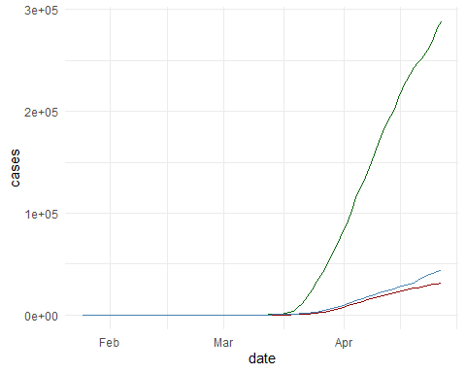

## Add a legend to the plot using scale_colour_manual

## Add a blank (” “) label to the x-axis and the label”Cases” to the y axis

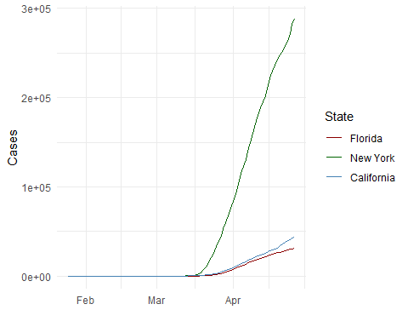

## Scale the y axis using scale_y_log10()

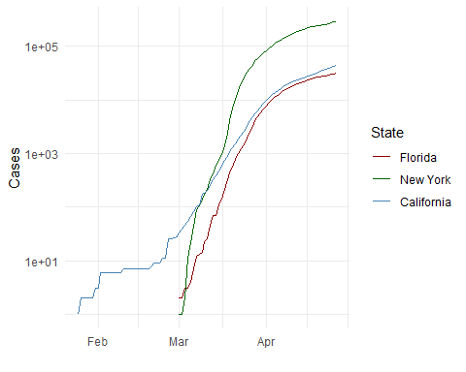

# Part 2

# Markdown Basics

## Favorite Foods

1. Chocolate
2. King Crab
3. Maria’s Cookies

## Images

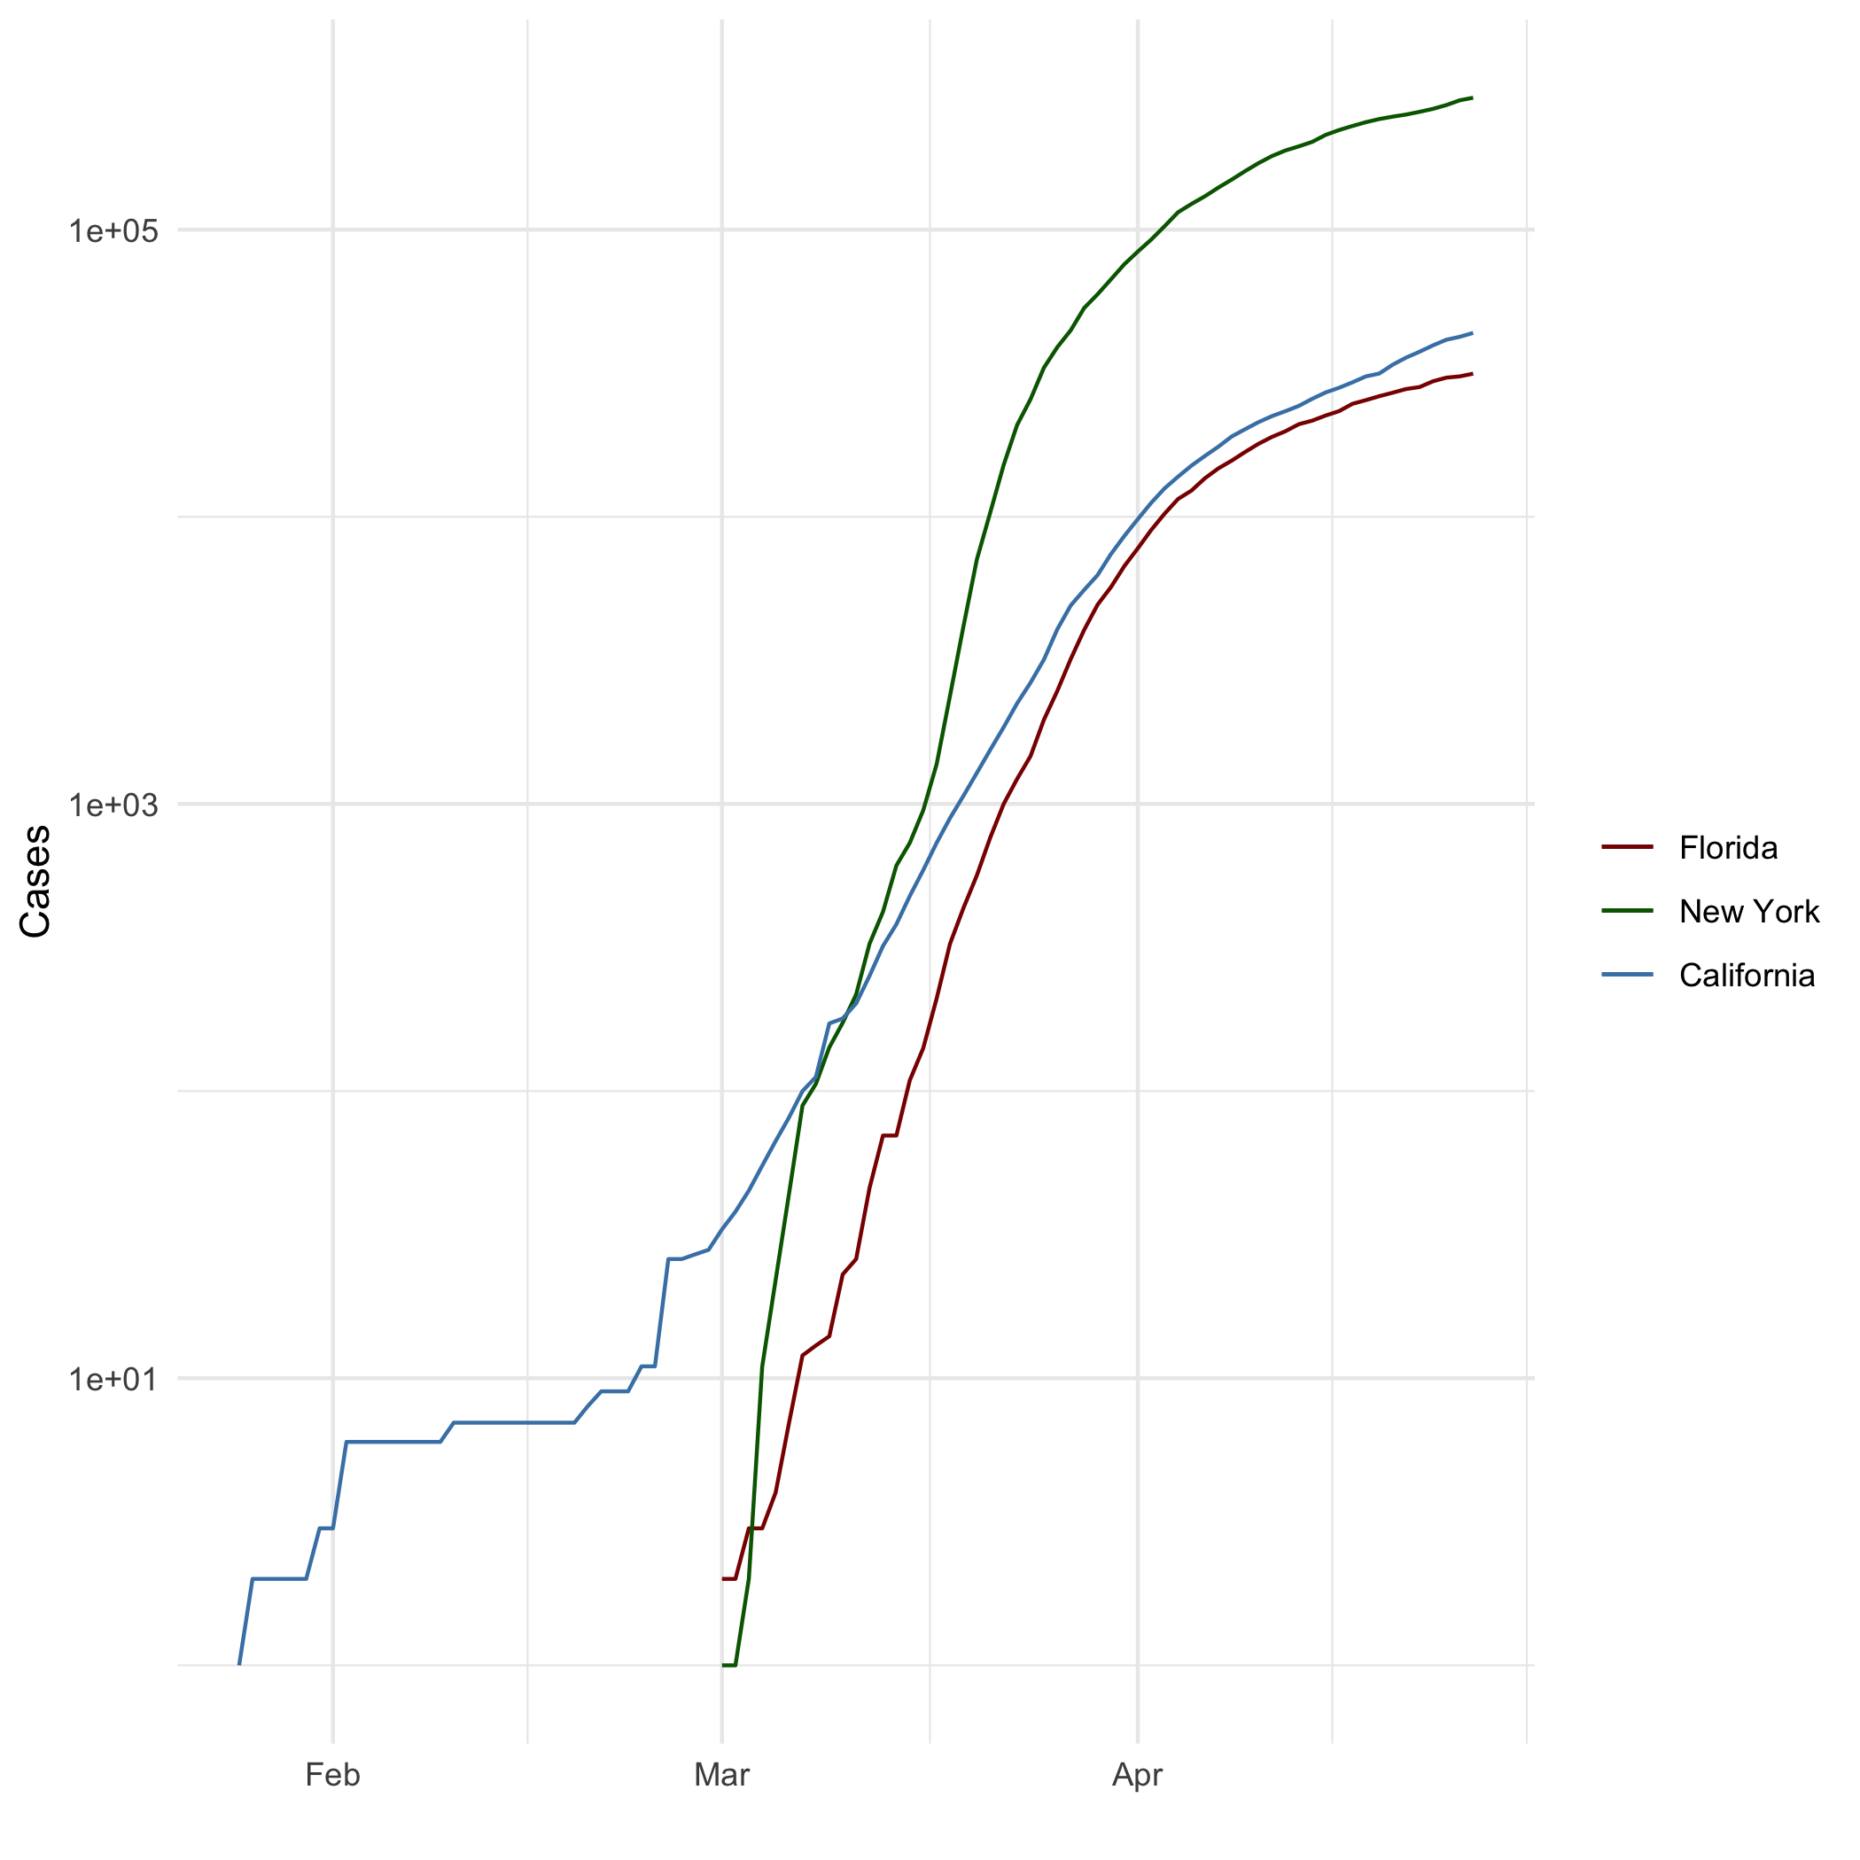

All Cases (Log Plot)

## Add a Quote

*“Practically perfect in every way”*

## Add an Equation

$$CDF\left(x\right)=1−{\left(\frac{x}{x_{m}}\right)}^{−}α$$

## Add a Footnote

This is a footnote[1]

## Add Citations

* R for Everyone (Lander 2014)
* Discovering Statistics Using R (Field, Miles, and Field 2012)

# Inline Code

## NY Times COVID-19 Data

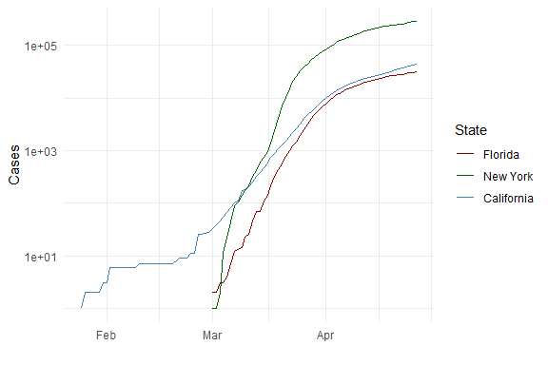

## R4DS Height vs Earnings

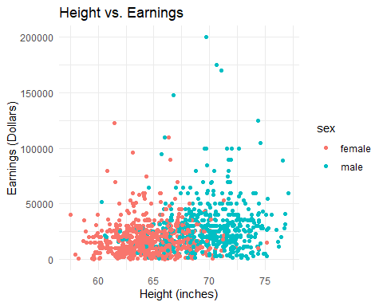

# Tables

## Knitr Table with Kable

One Ring to Rule Them All

| name | race | in_fellowship | ring_bearer | age |
| --- | --- | --- | --- | --- |
| Aragon | Men | TRUE | FALSE | 88 |
| Bilbo | Hobbit | FALSE | TRUE | 129 |
| Frodo | Hobbit | TRUE | TRUE | 51 |
| Galadriel | Elf | FALSE | FALSE | 7000 |
| Sam | Hobbit | TRUE | TRUE | 36 |
| Gandalf | Maia | TRUE | TRUE | 2019 |
| Legolas | Elf | TRUE | FALSE | 2931 |
| Sauron | Maia | FALSE | TRUE | 7052 |
| Gollum | Hobbit | FALSE | TRUE | 589 |

## Pandoc Table

| name | race | in_fellowship | ring_bearer | age |
| --- | --- | --- | --- | --- |
| Aragon | Men | TRUE | FALSE | 88 |
| Bilbo | Hobbit | FALSE | TRUE | 129 |
| Frodo | Hobbit | TRUE | TRUE | 51 |
| Galadriel | Elf | FALSE | FALSE | 7000 |
| Sam | Hobbit | TRUE | TRUE | 36 |
| Gandalf | Maia | TRUE | TRUE | 2019 |
| Legolas | Elf | TRUE | FALSE | 2931 |
| Sauron | Maia | FALSE | TRUE | 7052 |
| Gollum | Hobbit | FALSE | TRUE | 589 |

# References

Field, A., J. Miles, and Z. Field. 2012. *Discovering Statistics Using r*. SAGE Publications. <https://books.google.com/books?id=wd2K2zC3swIC>.

Lander, J. P. 2014. *R for Everyone: Advanced Analytics and Graphics*. Addison-Wesley Data and Analytics Series. Addison-Wesley. <https://books.google.com/books?id=3eBVAgAAQBAJ>.

1. This is the explanation to the footnote