|  |  |  |  |
| --- | --- | --- | --- |
| LAB 20b Beginning React  |  | | --- | | What You Will Learn   * How to use JSX to create components * How to work with React collections such as props, state, and refs * How to add behaviors to your React components |  |  | | --- | | Approximate Time  The exercises in this lab should take approximately 75 minutes to complete. | |  | |
| Fundamentals of Web Development, 2nd Ed  Randy Connolly and Ricardo Hoar |
| Textbook by Pearson  http://www.funwebdev.com  Date Last Revised: Jan 30, 2018 |

## Learning React

|  |
| --- |
| Preparing Directories |
| 1 | If you haven’t done so already, create a folder in your personal drive for all the labs for this book. |
| 2 | From the main labs folder (either downloaded from the textbook’s web site using the code provided with the textbook or in a common location provided by your instructor), copy the folder titled lab20b to your course folder created in step one. |

This lab walks you through the creation of a few simple React applications. We have multiple ways of creating React. We will begin with the simplest approach: using <script> tags with JSX conversion happening at run-time. While this approach is certainly slower and not what you would do in a real-world application, it simplifies the process when first learning.

|  |
| --- |
| Exercise 20b. — Using JSX (createClass version) |
| 1 | Examine lab20b-exercise00.html in the browser. We will be adding React functionality to this base page. It uses the Bulma CSS framework, which is a lightweight and clean framework. Why are we using it? No real reason, other than to try something new! |
| 2 | Copy the first <article> element to the clipboard (this will save you typing in step 4). |
| 3 | Open lab20b-exercise01.html in a code editor.  Notice that it already has the React JS files included via <script> tags. Notice also that it is using the Babel script library to convert our React JSX scripts at run-time. |
| 4 | Add the following JavaScript code to the head. Notice the type="text/babel" in the script tag. This is necessary because you will be entering JSX and not JavaScript. To save typing you can paste the <article> element you copied in step 2. Notice that you have to change the class= attributes to className= attributes. You are writing JSX and not JS.  <script type="text/babel">  /*  There are several ways of creating a React component.  The traditional approach is shown here: the createClass function  */  const Company = React.createClass({  render: function() {  return (  <article className="box media ">  <div className="media-left">  <figure className="image is-128x128">  <img src="images/AMZN.svg" />  </figure>  </div>  <div className="media-content">  <h2>Amazon</h2>  <p><strong>Symbol:</strong> AMZN</p>  <p><strong>Sector:</strong> Consumer Discretionary</p>  <p><strong>HQ:</strong> Seattle, Washington</p>  </div>  <div className="media-right">  <button className="button is-primary">Edit</button>  </div>  </article>  );  }  });  /*  We now need to add the just-defined component to the browser DOM  */  ReactDOM.render(<Company />, document.querySelector('#react-container'));    </script>  Note that JSX is class sensitive. |
| 5 | Test in browser.  This code won’t work. |
| 6 | Go to the JavaScript console and examine the error message. You will see that it wanted the <img> tag to have a closing end tag. Why? JSX is an XML-based syntax (just like the old XHTML was), and thus your JSX must follow XML syntax rules: case sensitive, all tags must be closed, and all attributes in quotes. |
| 7 | Fix the code by adding a close tag to the <img> element:  <img src="images/AMZN.svg" /> |
| 8 | Save and test in the browser. It should display a single <Company> element. |

|  |
| --- |
| Exercise 20b. — Using JSX (class version) |
| 1 | Open lab20b-exercise02.html.  In this exercise, you will create the same functionality as the previous exercise, but we will use the new ES6 class approach. |
| 2 | Add the following code:  /* There are several ways of creating a React component.  The newer approach is shown here: using a class  */  class Company extends React.Component {  render() {  return (  <article className="box media ">  <div className="media-left">  <figure className="image is-128x128">  <img src="images/AMZN.svg" />  </figure>  </div>  <div className="media-content">  <h2>Amazon</h2>  <p><strong>Symbol:</strong> AMZN</p>  <p><strong>Sector:</strong> Consumer Discretionary</p>  <p><strong>HQ:</strong> Seattle, Washington</p>  </div>  <div className="media-right">  <button className="button is-primary">Edit</button>  </div>  </article>  );  }  } |
| 3 | Test in browser.  This should work the same as the previous version (see Figure 20b.1) |

You are welcome to use either of these two approaches. We recommend you make yourself comfortable with either approach.

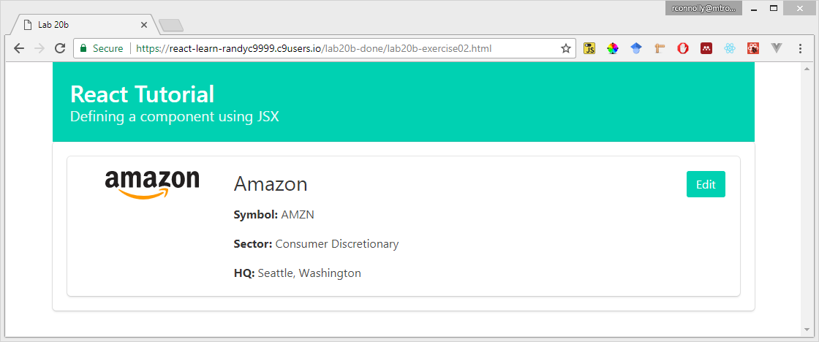

Figure 20b. – Finished Exercise 20b.02

|  |
| --- |
| Exercise 20b. — Adding additional components instances |
| 1 | Open lab20b-exercise03.html.  In this exercise, you will add multiple instances of this component. |
| 2 | Add/modify the following code:  /* Notice here that we are defining another component which will  contain other other components    For this to work there must be a single root element that is being  rendered ... try removing the <div> and it will no longer work  */  var app = (  <div>  <Company />  <Company />  <Company />  </div>  );    ReactDOM.render(app, document.querySelector('#react-container')); |
| 3 | Test in browser. |

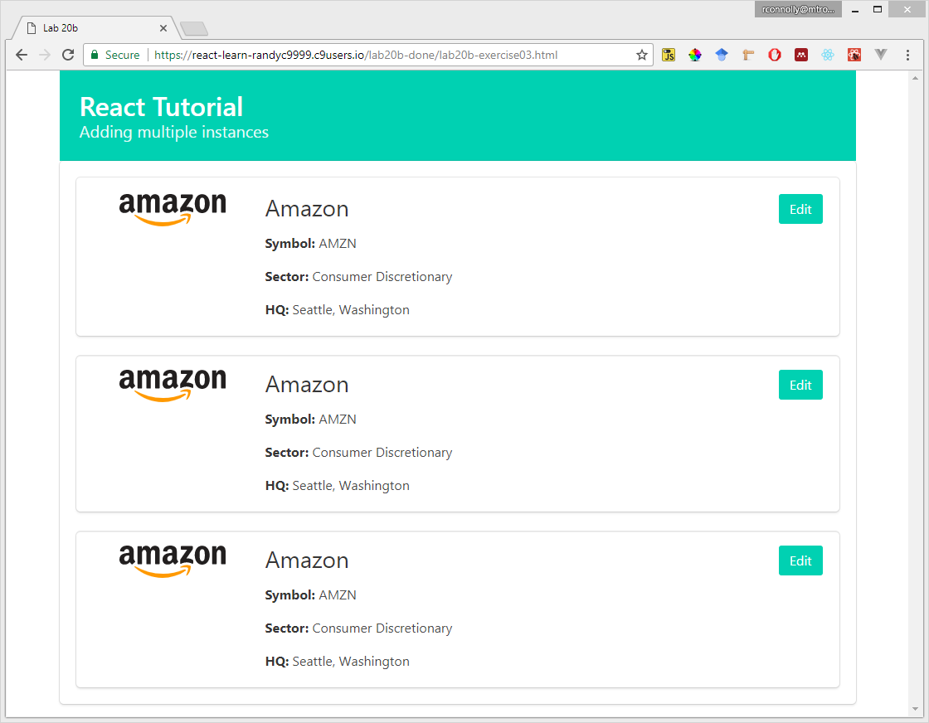

Figure 20b. – Finished Exercise 20b.03

Of course, the previous exercise was limited by the fact that it displays the same content. In the next exercise, you will use props, a read-only collection of data that is populated via your JSX markup, to rectify this limitation.

|  |
| --- |
| Exercise 20b. — Using props |
| 1 | Open lab20b-exercise04a.html. |
| 2 | Modify the <app> element as shown in the following code:  /* Notice here that we are adding attributes (and a child element) to our  <Company> elements. These will be accessing within the component via  the props collection.  */  var app = (  <div>  <Company symbol="AMZN" sector="Consumer Discretionary" hq="Seattle, Washington">Amazon</Company>  <Company symbol="GOOG" sector="Information Technology" hq="Mountain View, California">Alphabet Inc Class A</Company>  <Company symbol="AAPL" sector="Information Technology" hq="Cupertino, California">Apple</Company>  <Company symbol="T" sector="Telecommunications Services" hq="Dallas, Texas">AT&T</Company>  </div>  );  The use of the child element for the name is not necessary; it is here just to show how to use it instead of attributes. |
| 3 | Modify the component as follows and test.  /* Here we are using the props collection to access the element attributes  */  const Company = React.createClass({  render: function() {  return (  <article className="box media ">  <div className="media-left">  <figure className="image is-128x128">  <img src={"images/" + this.props.symbol + ".svg"} />  </figure>  </div>  <div className="media-content">  <h2>{this.props.children}</h2>  <p><strong>Symbol:</strong> {this.props.symbol}</p>  <p><strong>Sector:</strong> {this.props.sector}</p>  <p><strong>HQ:</strong> {this.props.hq}</p>  </div>  <div className="media-right">  <button className="button is-primary">Edit</button>  </div>  </article>  );  }  }); |
| 4 | If you are interested, examine lab20b-exercise04b.html. It contains the equivalent but using a class instead of createClass. |

In the next two exercises, you will add behaviors to the components and make use of the state collection to edit data within a component.

|  |
| --- |
| Exercise 20b. — Adding Behaviors |
| 1 | Open lab20b-exercise05.html and add the following code:  /* We can add event handlers (or any helper functions) to our component  class. In this example, you will be also wiring a click event handler  in the JSX ...notice the camel case  */  const Company = React.createClass({    edit: function() {  alert("now editing");  },    render: function() {  return (  <article className="box media ">  <div className="media-left">  <figure className="image is-128x128">  <img src={"images/" + this.props.symbol + ".svg"} />  </figure>  </div>  <div className="media-content">  <h2>{this.props.children}</h2>  <p><strong>Symbol:</strong> {this.props.symbol}</p>  <p><strong>Sector:</strong> {this.props.sector}</p>  <p><strong>HQ:</strong> {this.props.hq}</p>  </div>  <div className="media-right">  <button className="button is-primary"  onClick={this.edit}>Edit</button>  </div>  </article>  );  }  }); |
| 2 | Test in browser by clicking on any of the edit buttons.  This isn’t all the impressive perhaps. In the next exercise, we will change the rendering of the component based on whether it is in edit mode. |

|  |
| --- |
| Exercise 20b. — Adding Behaviors |
| 1 | Open lab20b-exercise06.html and add the following code:  /* While helpful, props are read-only meaning that a component can't change  them. Most components still need data it can manipulate and change. This  is achieved via State ...  In this example, our first State variable will be a flag indicating  whether or not we are in edit mode .  */  const Company = React.createClass({    /* if using createClass this function is kind of like a class constructor  for setting up initial state */  getInitialState: function() {  return {editing: false}  },    /* Here we are defining some helper functions that change state ...  notice the use of setState() ... it's a bit like PHP, which uses  the setcookie() function to change a cookie, but $_COOKIE to retrieve  a cookie */  edit: function() {  this.setState({editing: true});  },  save: function() {  this.setState({editing: false});  }, |
| 2 | You can examine lab20b-exercise06b.html to see the class version of this step. You will notice that it doesn’t use getInitialState but instead uses a class constructor. As well, using “this” is more complicated within classes. |
| 3 | Rename the render function to renderNormal (don’t test it yet though). Also add a comma after the function definition (since we will be adding additional functions after this one to our class). |
| 4 | Add the following functions:  renderEdit: function() {  return (  <article className="box media ">  <div className="media-left">  <figure className="image is-128x128">  <img src={"images/" + this.props.symbol + ".svg"} />  </figure>  </div>  <div className="media-content">  <h2><input type="text" className="input"  defaultValue={this.props.children} /></h2>  <p><strong>Symbol:</strong> <input type="text"  className="input" defaultValue={this.props.symbol} /></p>  <p><strong>Sector:</strong> <input type="text"  className="input" defaultValue={this.props.sector} /></p>  <p><strong>HQ:</strong> <input type="text" className="input"  defaultValue={this.props.hq} /></p>  </div>  <div className="media-right">  <button className="button is-info" onClick={this.save}>  Save</button>  </div>  </article>  );  } ,    /* we will render the component differently depending on our state (whether use has clicked edit button) */  render: function() {  if (this.state.editing)  return this.renderEdit();  else  return this.renderNormal();  }  When setting state, the setState() function merges the provided state items with other items (so long as they have different names).  State updates actually happen asynchronously, so it is possible that a state update might not have occurred immediately after setting it. |
| 5 | Test in browser.  The Edit button should change the rendering of the component (see Figure 20b.3). Pressing the Save button will return the component to its normal view. You will notice that any state changes haven’t been preserved. |

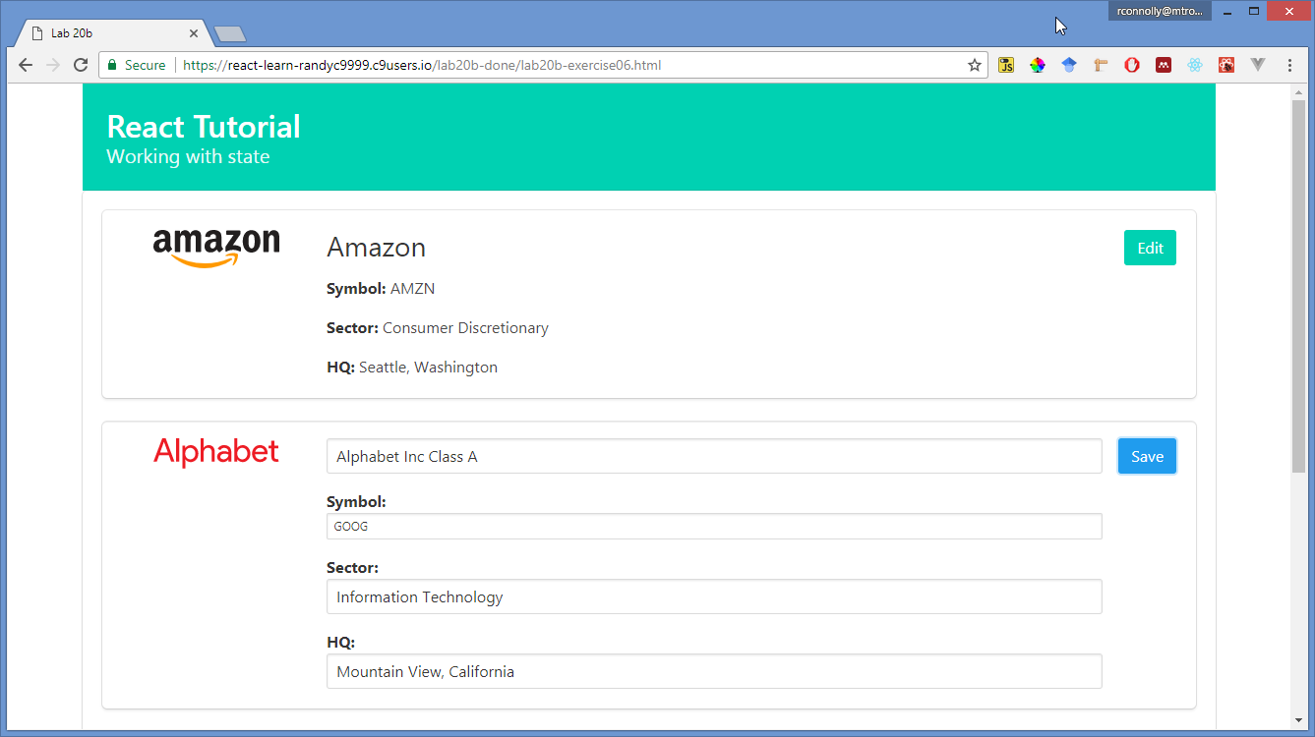

Figure 20b. – Finished Exercise 20b.06

Right now, the data for our components is provided by attributes when they are defined. It is more common, however, for a component’s data to be provided dynamically at run-time, perhaps from some type of AJAX call to a web service. To build towards that, the next exercise will add a new parent component that will be responsible for dynamically populating the individual <Company> elements (for now, just from an array).

|  |
| --- |
| Exercise 20b. — Creating a Parent Component |
| 1 | Open lab20b-exercise07.html and add the following code:  /* In this example we are adding in a more sophisticated parent that  contains Company data. Notice how we have moved the content out of the  markup and into a data array in the component's state. Notice also then  that the parent is responsible for populating the state of its children.  */  const Portfolio = React.createClass({    /* the parent will contain the data needed for the children */  getInitialState: function() {  return {  companies: [  { name: "Amazon", symbol: "AMZN",  sector: "Consumer Discretionary",  hq: "Seattle, Washington" },  { name: "Alphabet Inc Class A", symbol: "GOOG",  sector: "Information Technology",  hq: "Mountain View, California" },  { name: "Apple", symbol: "AAPL",  sector: "Information Technology",  hq: "Cupertino, California"},  { name: "AT&T", symbol: "T",  sector: "Telecommunications Services",  hq: "Dallas, Texas"}  ]  }  },    /* This function will be responsible for generating a single populated  Company element from the passed company data literal */  createCompany: function (obj, ind) {  return (<Company symbol={obj.symbol}  sector={obj.sector}  hq={obj.hq}  key={ind}  index={ind}>{obj.name}</Company>)  },    /* The render for this component will loop through our data and generate  the appropriate Company elements */  render: function() {  return (  <div> { this.state.companies.map(this.createCompany) } </div>  );  }    }); |
| 2 | Delete the old app variable definition. |
| 3 | Change the ReactDOM.render call to use the new parent:  ReactDOM.render(<Portfolio />, document.querySelector('#react-container')); |
| 4 | Test in browser.  The result in the browser should be the same as the previous exercise. |

Notice once again that the parent component was responsible for managing the data of the child (the Company elements). In the next exercise, you will add behaviors to this parent so that it manages the changes to the individual Company elements state. We will also add a Delete button to the edit state to demonstrate more functionality.

|  |
| --- |
| Exercise 20b. — Preserving State Changes |
| 1 | Open lab20b-exercise08.html and modify the RenderEdit method of the Company class (some code omitted):  renderEdit: function() {  return (  <article className="box media ">  <div className="media-left">  ...  </div>  <div className="media-content">  <h2><input type="text" className="input"  defaultValue={this.props.children} ref="newName"/></h2>  <p><strong>Symbol:</strong> <input type="text"  className="input" defaultValue={this.props.symbol}  ref="newSymbol" /></p>  <p><strong>Sector:</strong> <input type="text"  className="input" defaultValue={this.props.sector}  ref="newSector" /></p>  <p><strong>HQ:</strong> <input type="text" className="input"  defaultValue={this.props.hq} ref="newHq" /></p>  </div>  <div className="media-right">  <button className="button is-info"  onClick={this.save}>Save</button>  <button className="button is-danger"  onClick={this.delete} >Delete</button>  </div>  </article>  );  } ,  In order to retrieve data from the DOM (i.e., the <input> element values), we need to first add the React ref attribute to those elements. |

|  |  |
| --- | --- |
| 2 | Add the following methods to the Portfolio class:  /* notice that the parent is responsible for making changes to the  state */  saveCompany: function (newName, newSymbol, newSector, newHq, index) {  let tempArray = this.state.companies;  /*  remember that components change their state via setState()  */  tempArray[index] = { name: newName, symbol: newSymbol,  sector: newSector, hq: newHq };  this.setState({companies: tempArray});  },    deleteCompany: function (index) {  let tempArray = this.state.companies;  tempArray.splice(index,1);  this.setState({companies: tempArray});  }, |
| 3 | Since the Company components are the ones with the Save and Delete buttons, you will need to pass the handlers in the Portfolio to the Company components. To do so, modify the createCompany method in Portfolio as follows:  createCompany: function (obj, ind) {  return (<Company symbol={obj.symbol}  sector={obj.sector}  hq={obj.hq}  key={ind}  index={ind}  saveData={this.saveCompany}  removeData={this.deleteCompany}>{obj.name}</Company>)  },  What’s happening here? We are passing the save and delete methods defined in the parent to each child. |
| 4 | Now you will change the edit and delete event handlers for the buttons so they use the appropriate handlers in the parent. Add or modify the following event handlers in the Company class.  /*  when we save, we're going to use refs to retrieve the user input and  then ask the parent to save the data  */  save: function() {  /* using the ref attributes, retrieve the user input */  let newName = this.refs.newName.value;  let newSymbol = this.refs.newSymbol.value;  let newSector = this.refs.newSector.value;  let newHq = this.refs.newHq.value;    /* via props we can call the functions in parent that have been  passed to the child */  this.props.saveData(newName, newSymbol, newSector, newHq,  this.props.index);  this.setState({editing: false});  },    delete: function() {  this.props.removeData(this.props.index);  this.setState({editing: false});  }, |
| 5 | Test in browser. You should be able to change and delete the data. If you specify a symbol that exists in the image folder, the logo will change as well. |

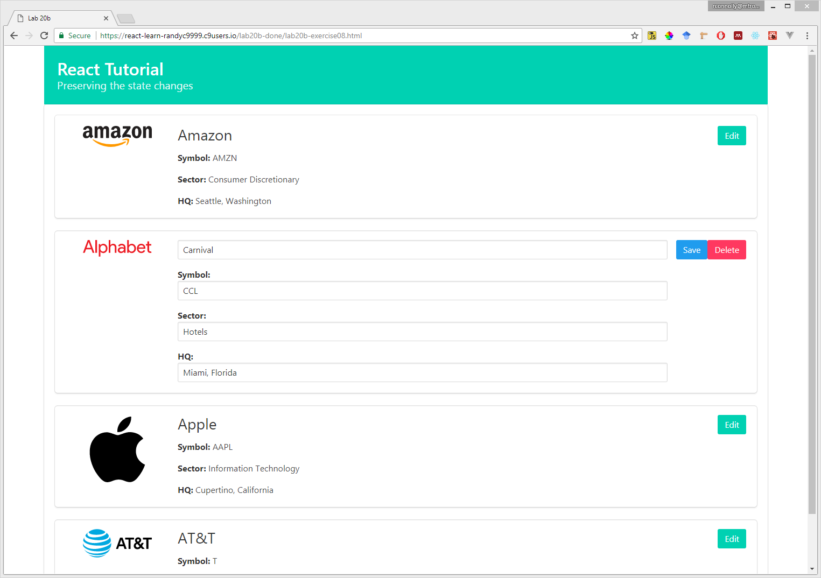

Figure 20b. – Finished Exercise 20b.08

Our last task will be to add a panel that allows to dynamically add <Company> elements based on user input.

|  |
| --- |
| Exercise 20b. — Adding Components to Parent |
| 1 | Open lab20b-exercise09.html and add/modify the following code in Portfolio class:  addCompany: function () {  let tempArray = this.state.companies;  tempArray.push({ name: "New Company", symbol: "", sector: "",  hq: ""});  this.setState({companies: tempArray});  },      /* the render for this component will loop through our data and generate  the appropriate Company elements */  render: function() {  return (  <div>  <div className="box">  <button className="button is-primary"  onClick={this.addCompany}>Add Company</button>  </div>  { this.state.companies.map(this.createCompany) }  </div>  );  } |
| 2 | Test in browser. |

Now it is your turn. The next exercise shows you what to create, but leaves it to you to implement it in React using the knowledge gained in the previous exercises.

|  |
| --- |
| Exercise 20b. — Your Turn |
| 1 | Open lab20b-exercise10-markup-only.html in the browser.  This provides the markup needed for the exercise. You will be implementing a reddit-style vote up/down component to each company. The number of votes will be shown in normal mode (see Figure 20b.5), but when in edit mode, you will display the up and down buttons with the current vote count displayed between the buttons (see Figure 20b.6). This markup file shows both so you know which markup to use. |
| 2 | You will be starting with lab20b-exercise10.html (it’s the same as the finished previous exercise). |
| 3 | Modify the companies array by adding a vote property to each company object. |
| 4 | Modify saveCompany, createCompany, and addCompany functions in Portfolio component to include vote information. |
| 5 | Modify the renderNormal function in Company component to display the number of votes (see Figure 20b.5). |
| 6 | Create a new React component that will implement the functionality for voting up/down (see Figure 20b.6). This component will store a single vote number in its state, and will be passed the initial value via props. The markup for element can be found in the markup file mentioned in step 1. The up and down buttons will need event handlers in the class that will increment the vote value stored in the state. |
| 7 | Modify the renderEdit function in Company component to display your vote component (see Figure 20b.5). This is simply a matter of adding a tag with the component name and passing, via an attribute, the correct vote data from the companies array. You will need to be able to access this element later, so be sure to give it a ref attribute. |
| 8 | You will need to modify the save function in the Company component to pass the current vote value to the saveData function. You can retrieve the vote value from the component by using its ref name, the state property, and whatever its state variable name is in your vote component. |
| 9 | Finally, modify the saveCompany function in the Portfolio component to sort the companies array by the vote count (i.e., the company with highest number of votes is shown first). This is actually quite easy, though you will have to discover on your own how to sort an array of objects on a property’s values. |

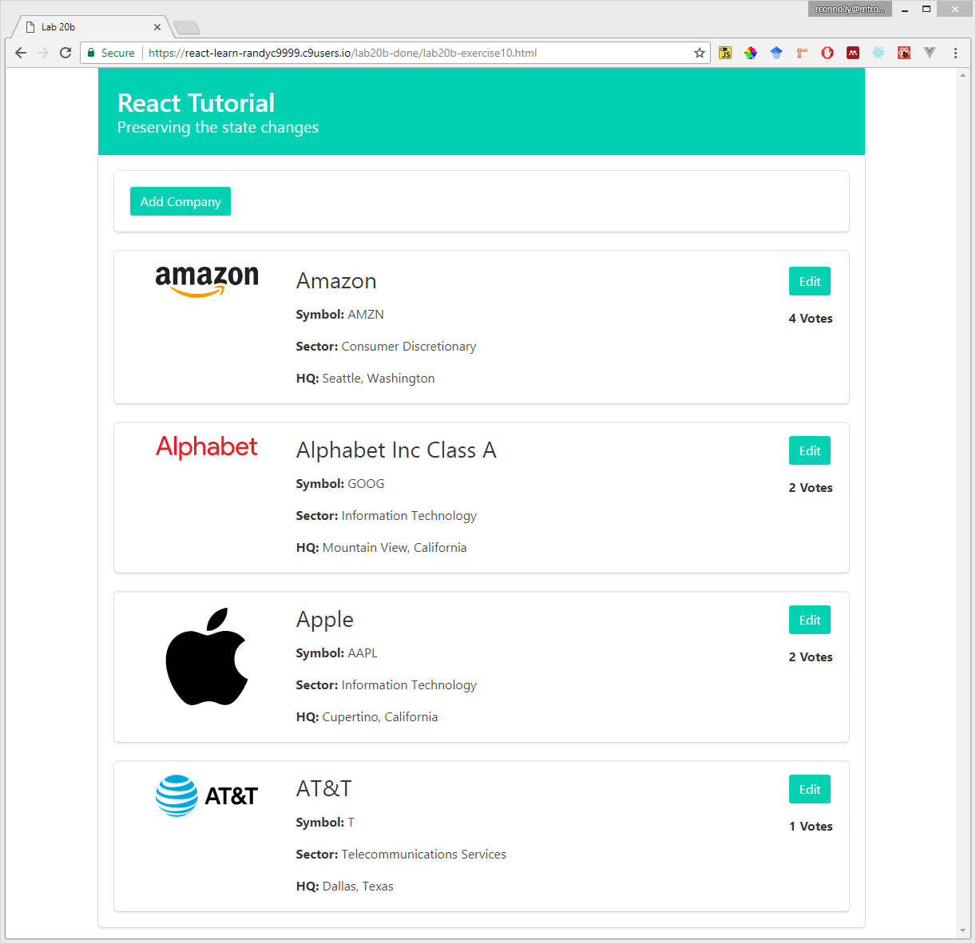

Figure 20b. –Exercise 20b.10 in normal mode

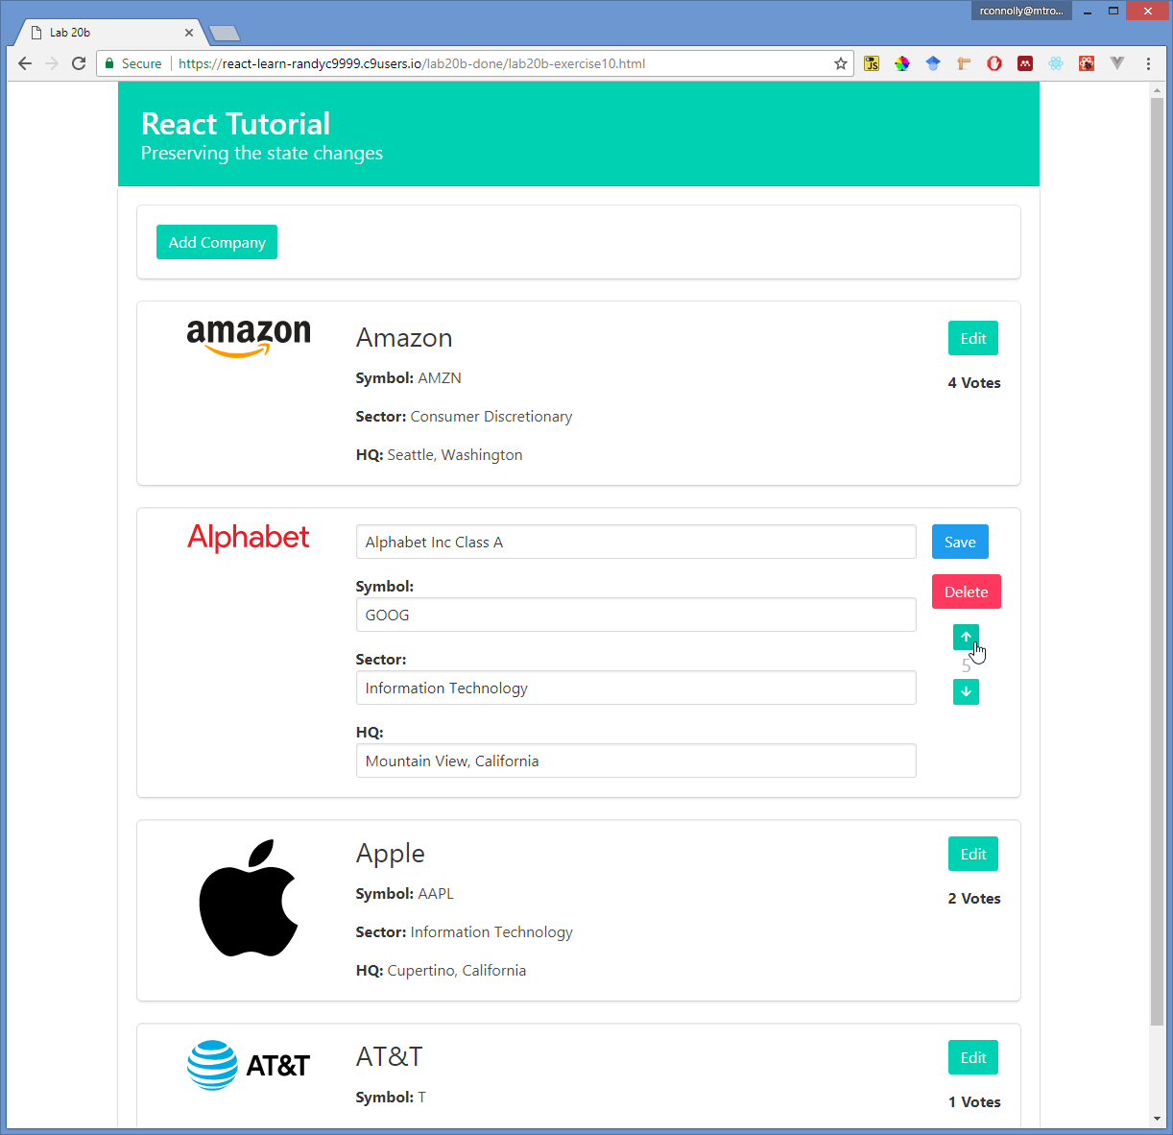

Figure 20b. –Exercise 20b.10 in edit mode