NANYANG TECHNOLOGICAL UNIVERSITY
NTU Centre in Computational Technologies for Finance (CCTF)
SC6113 Group Project
MicroLend
Tokenized Micro-lending for the Unbanked
Technical Report
Field | Detail
Course | SC6113 Group Project
Document | Technical report
Version | 1.4
Date | 14 October 2026
Team | Six members (see the accompanying contribution report)
Repository | https://github.com/catjlx/microlend
Live frontend | https://microlend-web.onrender.com
Live API | https://microlend-api.onrender.com
Network | Ethereum Sepolia, chainId 11155111
Demonstration video | https://www.youtube.com/watch?v=yrgKagY_duw
Presentation slides | https://youtu.be/S3S13By7L0E
Status | Unaudited coursework prototype. Testnet only, mock stablecoin, model trained on synthetic data.

Sections 0 to 12 form the graded body of the report; the cover page, the contents, the abbreviations, the references and the appendices are front and back matter and are not counted in the 10 to 15 page limit.

Contents
Abstract 4
Problem statement and evidence 4
Stakeholders and requirements 5
System architecture 6
Credit scoring and risk model 8
Smart-contract design 9
Security 11
Backend and data 13
Frontend and user experience 13
Testing and evaluation 15
Deployment and DevOps 17
Limitations, ethics and future work 17
Conclusion 18
References 18
Appendix A. Reproducing the results 18
Appendix B. Detailed reference tables 19
Appendix C. Author contributions 22
List of Figures
Figure 1. System architecture: browser, cloud tier and Sepolia 6
Figure 2. The off-chain data model 7
Figure 3. End-to-end process flow 8
Figure 4. Calibration of the score on the held-out test set 9
Figure 5. Contract interaction 10
Figure 6. Loan lifecycle state machine 10
Figure 7. Default handling: the loss waterfall 11
Figure 8. Administrator screens: pool parameters and contract-level validation 14
Figure 9. The deployed application at a 390-pixel phone viewport 14
Figure 10. Lender return against the portfolio default rate 20
Figure 11. Continuous integration: six runs, all successful 21
Figure 12. Continuous integration: the four jobs of run 6 22
List of Tables
Table 1. Evidence base for the problem statement 4
Table 2. Competitive landscape 5
Table 3. Stakeholder analysis 5
Table 4. Functional requirements traceability 5
Table 5. Non-functional requirements 6
Table 6. Component technologies 7
Table 7. Database schema 7
Table 8. Model card 8
Table 9. The eight questionnaire inputs 8
Table 10. Calibration deciles 9
Table 11. Risk tiers and observed default rates 9
Table 12. Fairness checks 9
Table 13. The five contracts 10
Table 14. Loan rules enforced by LoanManager 10
Table 15. Nineteen transaction types 11
Table 16. Gas report 11
Table 17. Threat model and implemented controls 11
Table 18. Slither results before and after remediation 12
Table 19. REST API surface 13
Table 20. Role-based pages 13
Table 21. Test results at a glance 15
Table 22. Coverage by contract 15
Table 23. Manual end-to-end scenarios 15
Table 24. Measured effect of the checks-effects-interactions fix 16
Table 25. Defects raised by the independent test pass 16
Table 26. Success indicators, targets and measured values 16
Table 27. Deployed contracts on Ethereum Sepolia 19
Table 28. Deployment topology and continuous-integration evidence 19
Table 29. Consolidated limitations 19
Table 30. Problem-validation survey results 20
Table 31. Contribution matrix 22

Abbreviations
Term | Meaning | Term | Meaning
API | application programming interface | JSON-RPC | the remote procedure call protocol used to read the chain
APR | annual percentage rate | JWT | JSON Web Token; the signed-in session credential
AUC | area under the receiver-operating-characteristic curve | KS | Kolmogorov-Smirnov statistic, a discrimination measure
bps | basis points; 10,000 bps = 100% | KYC / AML | know-your-customer and anti-money-laundering requirements
CI | continuous integration | mUSDC | mock USD Coin; the 6-decimal test stablecoin used by this project
EIP-191 | Ethereum signed-message standard, used for wallet sign-in | PD | probability of default
EIP-712 | Ethereum standard for signing typed structured data | REST | representational state transfer
EVM | Ethereum virtual machine | USDC | a real dollar-pegged stablecoin, not used here

0. Abstract
About 1.3 billion adults still have no bank account, and because they have no verifiable repayment history they are excluded from formal credit and fall back on informal lenders. MicroLend is a full-stack decentralised application that attacks the record half of that problem rather than the funding half. Lenders fund a transparent on-chain liquidity pool; would-be borrowers answer a short questionnaire, an off-chain logistic-regression model estimates their probability of default, and an authorised scoring service signs that score as an EIP-712 attestation which the borrower records on-chain. A credit officer approves each loan, collateral is escrowed per loan, and an auditor can export the complete event ledger. Repaying on time raises a borrower's effective score, which lowers their interest rate and collateral requirement on the next loan: credit that grows and that any other platform can read.
The system is implemented as four interoperating Solidity 0.8.24 contracts plus a mock stablecoin, an Express and PostgreSQL backend with a chain event indexer, a React dashboard with MetaMask, and a Python modelling pipeline. It is deployed to the Ethereum Sepolia testnet, with the API and frontend hosted on Render. Automated testing passes 49 of 49 contract tests and 16 of 16 backend tests with 97.1% statement coverage; an independent test pass executed 83 test cases with no failures and raised four low or medium presentation-layer defects. Static analysis with Slither reduced findings from 10 to 7, all remaining findings being accepted zero-value guards. The honest limitations are that the model trains on synthetic data (AUC 0.68), the stablecoin is a mock, scoring inputs are self-reported, no formal audit or KYC has been performed, and primary validation rests on a seven-respondent survey of a thin-file but non-representative sample.

1. Problem statement and evidence

1.1 The problem
Access to credit is gated by evidence of past repayment. Someone who has never held a bank account has no such evidence, so a lender cannot price their risk and either refuses them or charges a rate that reflects pure uncertainty. The result is a circular exclusion: no record, therefore no loan; no loan, therefore no record. Two structural features of the current landscape keep the circle closed:
- Credit records are siloed. A repayment history built with one mobile-money lender, microfinance institution or savings group is not portable. A borrower who defaults with one provider can borrow again from another, and a borrower who repays faithfully gains nothing with anyone else.
- Pool accounting and loss handling are opaque. Lenders and auditors in informal or semi-formal lending cannot independently verify how much was lent, what the loss experience was, or whether the rules were applied consistently.

1.2 Evidence
Every figure below is attributed. All seven rows are now sourced, because the brief requires that no number appears in the report without a citation; rows E4 and E5 carry the market caveat noted beneath the table.
Table 1. Evidence base for the problem statement. Rows E1 to E3 and E6 are secondary sources; row E7 is primary evidence collected by the team. Rows E4 and E5 are scoped to India, where informal-lending and microfinance data are best documented, and must be re-sourced if the team fixes a different market.
# | Claim | Figure | Source | Status
E1 | Adults worldwide still without a bank account | about 1.3 billion | World Bank and CGAP, What's Next for Financial Inclusion: Unpacking Findex 2025 (Global Findex 2025) | Verified
E2 | Account ownership among adults in low- and middle-income countries | 75% | Same source (Global Findex 2025) | Verified
E3 | Persistent gender gap in account ownership and in access to credit, insurance and emergency funds | Qualitative | Same source (Global Findex 2025) | Verified
E4 | Typical interest rate charged by informal lenders | 5% to 10% flat interest charged by local moneylenders, India | MFIN and NCAER, Assessing the Effectiveness of Regulated Small Borrowing in India | Verified
E5 | Microfinance repayment and default rates | Portfolio at risk, 30+ days, rose from 0.8% to about 2.1% through FY2024-25; the 31-180 day bucket was reported at 6.4% | MFIN, Micro Matters Macro View 2024-25; CareEdge Ratings via Moneycontrol | Verified
E6 | Mobile-money adoption | 2 billion registered accounts and over 500 million monthly active users; 108 billion transactions worth $1.68 trillion in 2024 | GSMA, State of the Industry Report on Mobile Money 2025 | Verified
E7 | Whether real, thin-file respondents recognise the problem and the proposed direction | 7 responses | Primary: the MicroLend problem-validation questionnaire, summarised in Section 9.7 and tabulated in Appendix B | Verified

Target market. The prototype is designed for the urban informal-sector micro-entrepreneur (market traders, gig and transport workers, and smallholders) in a mobile-money-mature economy in South or Southeast Asia, together with the individual, donor and institutional lenders who would fund them. The reference borrower used in the scoring demonstration has a monthly income of USD 280, 35 mobile-money transactions per month and 14 months of mobile-money history, which is representative of that segment. The final submission must still fix one market: rows E4 and E5 are currently sourced to India, where informal-lending and microfinance data are best documented, and must be re-sourced if the team selects a different market. Primary validation (Section 9.7) used a proxy sample of seven respondents aged 22 to 24, so it supports the direction of the problem rather than demand among micro-entrepreneurs.

1.3 What exists today, and why it is not enough
Table 2. Competitive landscape.
Existing solution | Why it excludes or disappoints the target user
Banks | Require identity documents, a formal income record and collateral. The unbanked have none of the three, so the application never reaches credit assessment.
Microfinance institutions | Reach further, but have a high operating cost per small loan, often require group guarantees, and keep the resulting record in their own system.
Informal lenders | Fast and administratively light, but charge rates that can consume the margin of the business being financed, and their terms are neither documented nor auditable.
Mobile-money lending and BNPL | Data-driven and convenient, but the data are platform-owned, so the customer is locked into one provider and cannot carry a record elsewhere.
Existing crypto lending | Almost always over-collateralised, which by construction excludes borrowers who lack assets. It solves leverage for the already banked, not access for the unbanked.

1.4 Why a blockchain, and when it is not needed
Where the blockchain earns its place. Three properties of this problem map onto on-chain execution. First, shared, tamper-evident history: a repayment record that must be trusted by lenders who do not trust each other is exactly what a public ledger provides, and because the record is keyed by wallet address it is portable by construction. Second, public, rules-based pool accounting: deposits, disbursements, interest, reserve and losses are all visible, and the loss waterfall executes identically for every loan. Third, permissionless enforcement: once a loan is past due plus the grace period, any wallet can trigger the default and the waterfall, so the outcome does not depend on an operator choosing to act.
Where it does not. A single lender with its own borrowers needs no blockchain: an ordinary database would be faster, cheaper and easier to change. The advantage appears only when several parties must trust the same record without sharing an owner. The costs are real too: gas on every state change, key management for users who may be new to it, and the privacy consequences of linking an address to a person. MicroLend is therefore deliberately hybrid, with only the score, its expiry and a model-version hash on-chain.

2. Stakeholders and requirements

2.1 Stakeholders
Table 3. Stakeholder analysis.
Stakeholder | Need | Pain point today | What MicroLend gives them | Residual risk
Borrower | Credit without collateral or a bank record | No formal record, so no loan | A portable on-chain score; lower collateral and a higher limit at higher tiers | Self-reported inputs; over-indebtedness
Lender or donor | A return commensurate with risk; verifiable fair treatment | Opaque accounting in informal lending | Public pool accounting, share-based claims and a documented loss waterfall | Loss beyond the reserve is shared pro rata
Credit officer | Enough information for a defensible decision | Intuition and paper | Score, probability of default, inputs and past-loan history in one queue | The officer can still be wrong or corrupt
Auditor or regulator | Complete, unalterable evidence | Records can be edited after the fact | Full event log with transaction hashes, CSV export and hashed audit notes | Does not by itself satisfy KYC and AML
Platform operator | A maintainable system that can be stopped safely | Not applicable | Pause controls that never block repayment or withdrawal; role and tier administration | Single admin key with no multisig
Local community | That credit does not become a debt trap | Predatory rates | Interest visible up front, one open loan per wallet, an enforced grace period | No financial-literacy support

2.2 Functional requirements and traceability
The course brief requires at least three interacting contracts, at least ten transaction types, at least three roles, a REST API, a persistent database, a visualisation dashboard, gas analysis, testing and cloud deployment. Each requirement carries an identifier and is linked to where it is implemented and where it is tested.
Table 4. Functional requirements traceability.
ID | Requirement | Implementation | Test or evidence
FR-01 | Role-based access control with at least three roles | AccessControl on all contracts: admin, officer, auditor, scorer and pauser; wallet-signature login returns roles read from the chain | Contract access-control tests; API role gating; scenario S9
FR-02 | MetaMask integration and wallet transaction signing | AppContext: connect, network switch, personal_sign, every write through the signer | Functional cases F1 to F11 executed in the browser
FR-03 | At least three contracts that call each other | LoanManager calls CreditRegistry, LendingPool and CollateralVault, and is the only holder of LOAN_MANAGER_ROLE on the other three | All 49 contract tests
FR-04 | At least ten distinct transaction types | 19 types enumerated in Table 15, and the main lifecycle executed end to end on Sepolia and recorded in the demonstration video | Contract tests, plus the Sepolia run of 13 October 2026
FR-05 | Backend REST API | Express routers: public, session, ledger, score and staff (Table 19) | API tests 1 to 10
FR-06 | Persistent data storage | knex with SQLite in development and PostgreSQL in the cloud; seven tables | Backend tests; the Docker and PostgreSQL pre-deployment run
FR-07 | Comprehensive exception handling | Custom Solidity errors; the error module maps validation and chain failures to HTTP codes | Backend error-path tests; defect BUG-03
FR-08 | Responsive dashboard with history, logs and charts | Six role-based pages; pool and status charts; filterable, paginated event log with CSV export; verified at a 390-pixel viewport (Figure 9) | F11 and S3; Figures 8 and 9
FR-09 | Gas estimation and optimisation analysis | hardhat-gas-reporter; Section 9.4 | docs/gas-report.txt
FR-10 | Smart-contract testing | 49 Hardhat tests; 97.1% statement coverage | Section 9.1
FR-11 | Public cloud deployment | Docker and a Render blueprint (API, static site, PostgreSQL); GitHub Actions CI | Section 10; live URLs

2.3 Non-functional requirements
Table 5. Non-functional requirements.
ID | Requirement | Target | Measured or status
NFR-01 | Availability of the public demo | Reachable with no local install | Live; the free tier sleeps after about 15 minutes and the first request takes 60 to 90 seconds
NFR-02 | Event visibility latency | New on-chain events appear within seconds | Indexer polls every 4 s; observed lag of 2 blocks in production health output
NFR-03 | Confidentiality of questionnaire data | Raw answers never on-chain | Only score, expiry and model hash are stored on-chain
NFR-04 | Auditability | Every state change traceable to a transaction | Every state change emits an event carrying a transaction hash
NFR-05 | Cost per operation | Affordable at micro-loan scale | Table 16; roughly 0.10 to 0.24 million gas per operation
NFR-06 | Safety of lender funds | Losses bounded and ordered | Collateral, then reserve, then lenders; enforced in markDefault
NFR-07 | Deployability | Reproducible cloud deployment | Render blueprint, Docker image and CI workflow

3. System architecture
MicroLend is a three-tier hybrid: a browser client that holds the user's keys, a cloud tier that runs the off-chain services, and the Sepolia chain that holds money, permissions and the record of truth. The three design rules below are what keep the boundary honest.
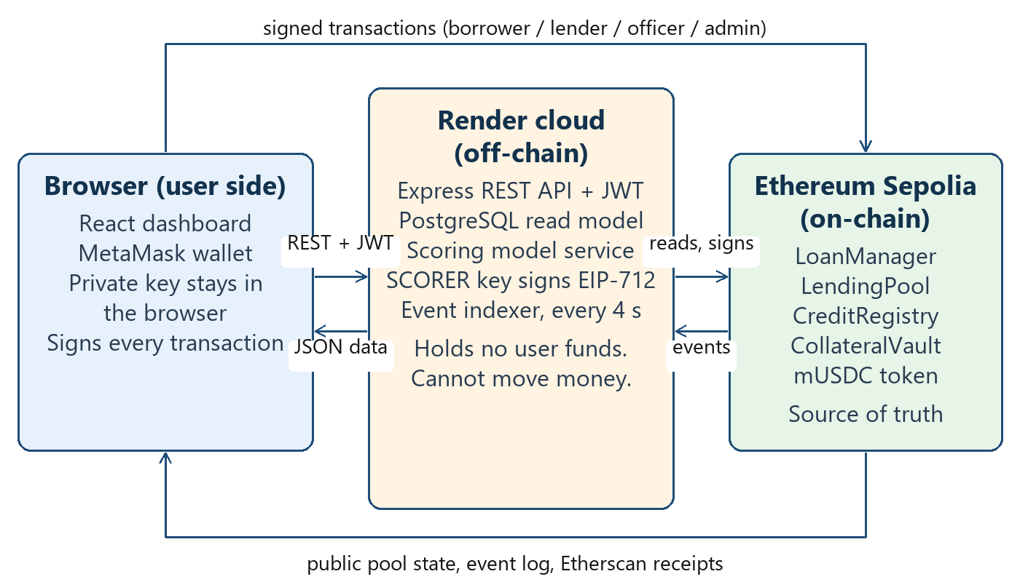
Figure 1. System architecture. The cloud tier never holds user funds and cannot move them; its only on-chain authority is signing score attestations with a revocable SCORER key.
- Money and permissions live on-chain. The API never custodies funds. Its single privileged capability is signing credit-score attestations with a key that holds SCORER_ROLE, and the admin can revoke that role at any time.
- The database is a read model. Rows in the events, loans and pool snapshots tables are rebuilt from the chain by the indexer. Only genuinely off-chain data (profiles, score requests and sign-in nonces) is authoritative in the database.
- Roles come from the chain. Admin, officer and auditor are read from LoanManager at sign-in and re-checked every 30 seconds, so revoking a role takes effect almost immediately even while a valid token is still in the browser.

3.1 Component technologies
Table 6. Component technologies.
Layer | Technology | Responsibility
Smart contracts | Solidity 0.8.24, OpenZeppelin 5, Hardhat, optimiser 200 runs with viaIR | Money, permissions, credit record and the loan state machine
Backend | Node 20, Express 4, knex 3, PostgreSQL 16 or SQLite, ethers v6, zod, JWT, helmet | REST API, wallet login, scoring, EIP-712 attestations and the event indexer
Frontend | React 18, Vite, ethers v6, Recharts, MetaMask | Six role-based pages, transaction signing and visualisation
Data science | Python, numpy, pandas, scikit-learn | Synthetic data generation, model training, fairness checks and portfolio simulation
Infrastructure | Docker, Render (web service, static site, managed PostgreSQL), GitHub Actions | Build, deploy and continuous integration

3.2 Off-chain data model
Seven tables are created on first start. Only three of them are authoritative: profiles, score requests and sign-in nonces cannot be rebuilt from the chain. The rest are a projection, regenerated by the indexer, which is what allows the database to be dropped and rebuilt without losing the record of truth. Token amounts are stored as decimal strings because a 6-decimal amount can exceed the safe integer range of JavaScript.
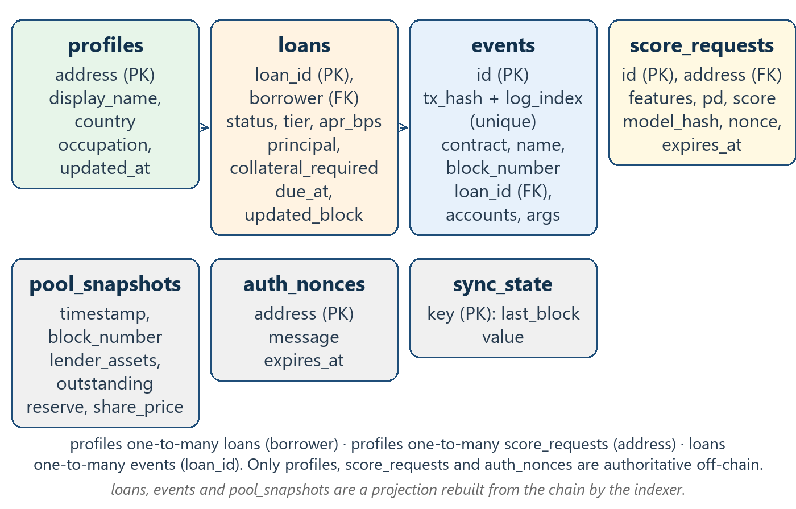
Figure 2. The off-chain data model. Boxes on the lower row are supporting tables or, in the case of sync_state, the indexer checkpoint. The three relationships are enforced in application code rather than by database foreign keys, because rows arrive from the chain in block order.
Table 7. Database schema, with the full column list for each table.
Table | Purpose | Key columns
loans | Denormalised current loan struct, re-read from the chain | loan_id (PK), borrower, status, status_name, tier, apr_bps, term_days, principal, collateral_required, interest_total, due_at, updated_block
events | Decoded protocol events; the audit-log substrate | id (PK), contract, name, block_number, tx_hash, log_index, timestamp, loan_id, accounts, args; unique on (tx_hash, log_index)
pool_snapshots | Pool time series for the overview charts | timestamp, block_number, lender_assets, outstanding, reserve, total_shares, cash, utilization_bps, share_price
profiles | Off-chain KYC-lite metadata that never goes on-chain | address (PK), display_name, country, occupation
score_requests | Every scoring call, for audit and rate limiting | address, features, pd, score, tier, model_version, model_hash, nonce
auth_nonces | Single-use sign-in challenges | address (PK), message, expires_at
sync_state | Indexer checkpoint | key (PK; only last_block is used), value

3.3 End-to-end flow
Figure 3 traces one complete loan through all three tiers. The split is worth noting: only sign-in, scoring and the signature are off-chain. Everything that moves value or changes the credit record is a transaction the borrower or an officer signs.
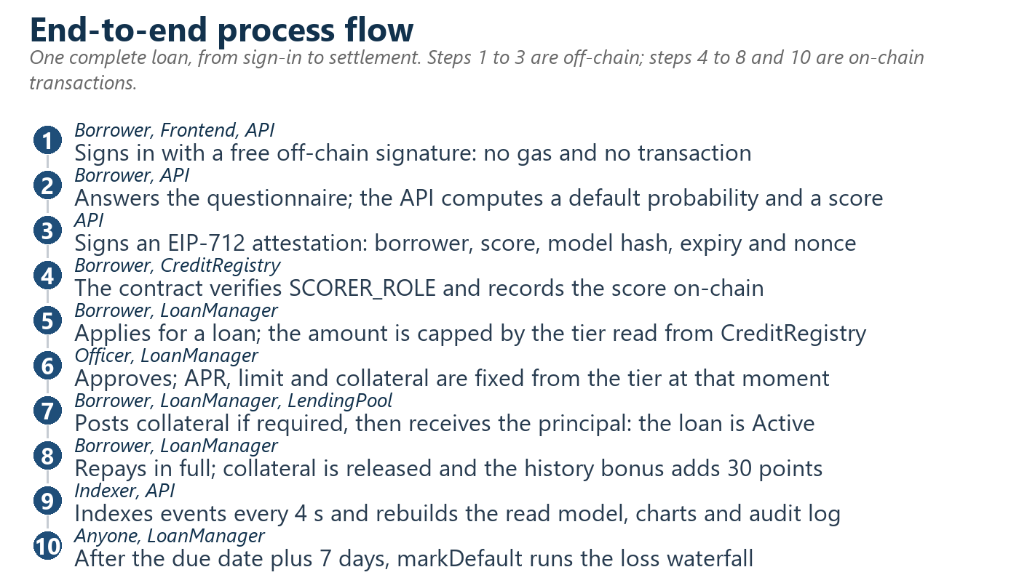
Figure 3. One complete loan, from sign-in to settlement. Steps 1 to 3 are off-chain operations; steps 4 to 8 and step 10 are on-chain transactions that each require a wallet signature and gas.

4. Credit scoring and risk model
The score is the hinge of the whole product: it decides the borrower's limit, interest rate and collateral requirement, yet it must not be trusted blindly and must not expose the borrower's personal data. The design answers both constraints by keeping the model off-chain and putting only a signed, expiring, versioned result on-chain.
Table 8. Model card.
Property | Value
Model | Logistic regression (credit-model-v1), trained in scikit-learn and exported as coefficients
Target | Probability of default within the loan term
Training data | Synthetic: 20,000 borrowers generated from a documented latent risk process (seed 42), target default rate 8.5%
Split | 14,000 training and 6,000 test rows, stratified on the default label
Features | Eight (Table 9)
Discrimination | AUC 0.6807; KS 0.2653
Calibration | Brier score 0.073; deciles in Table 10 and Figure 4
Score scale | 300 to 900, with base score 620 at base odds 15 and 80 points per doubling of odds
Tier cut-offs | T0 at 0 or above, T1 at 450, T2 at 600, T3 at 750, mirroring CreditRegistry
On-chain footprint | Score, expiry, model hash and a nonce; never the inputs

Interpretation, stated honestly. An AUC of 0.68 on synthetic data demonstrates that the pipeline works end to end: data generation, training, calibration, export, and byte-identical reproduction by the JavaScript scorer. It is not evidence of predictive power on real borrowers. The synthetic generator embeds a known risk process, so a model that recovers it is a correctness check on the code, not a credit result.

4.1 Model inputs
Table 9. The eight questionnaire inputs, with the ranges enforced server-side.
# | Input | Meaning | Range | Transform
1 | monthly_income_usd | Typical monthly income in USD | 30 to 2000 | log1p
2 | income_volatility | 0 is very stable, 1 is very unstable | 0 to 1 | none
3 | years_in_occupation | Years in the current occupation | 0 to 40 | none
4 | mobile_money_txn_per_month | Digital-footprint proxy | 0 to 200 | log1p
5 | mobile_money_months_active | Age of the mobile-money account in months | 0 to 60 | none
6 | existing_debt_ratio | Existing debt payments divided by income | 0 to 1.5 | none
7 | household_size | People supported | 1 to 12 | none
8 | savings_group_member | Member of a savings or community group | 0 or 1 | none

Every input is self-reported, which is the model's single biggest weakness. The design mitigates rather than hides it: the score only sets the tier and never approves a loan; a human credit officer makes the lending decision; limits and collateral are deliberately small; and every scoring request is stored, so a pattern of misreporting is visible in the audit trail.

4.2 Calibration, tier separation and fairness
Table 10. Calibration deciles on the test set, grouped in pairs. Predicted and observed track each other across the whole range; the ungrouped deciles are plotted in Figure 4.
Deciles grouped | Mean predicted | Observed default rate | n
1 and 2 (lowest risk) | 0.0286 | 0.0309 | 1,200
3 and 4 | 0.0487 | 0.0558 | 1,200
5 and 6 | 0.0687 | 0.0650 | 1,200
7 and 8 | 0.0978 | 0.0992 | 1,200
9 and 10 (highest risk) | 0.1690 | 0.1650 | 1,200

Table 11. Risk tiers and the observed default rate of each tier on the held-out test set. The monotonic ordering is the evidence that tiering carries information.
Tier | Minimum score | Limit (mUSDC) | APR | Collateral | Share of test set | Observed default rate
T0 Starter | 0 | 100 | 24% | 20% | 2.47% | 31.76%
T1 Builder | 450 | 300 | 20% | 10% | 43.25% | 11.56%
T2 Established | 600 | 800 | 16% | 5% | 50.45% | 4.96%
T3 Trusted | 750 | 2000 | 12% | none | 3.83% | 0.87%

Table 12. Fairness checks. Protected attributes are never model inputs; they are held back purely to measure the outcome. The rural and urban gap is small but real, and is discussed as a limitation in Section 11.
Protected attribute | Approval-rate ratio | AUC group 1 / group 0 | Observed default group 1 / group 0
Female against male | 0.9989 | 0.6901 / 0.6720 | 0.0833 / 0.0831
Rural against urban | 0.9720 | 0.6815 / 0.6763 | 0.0912 / 0.0768

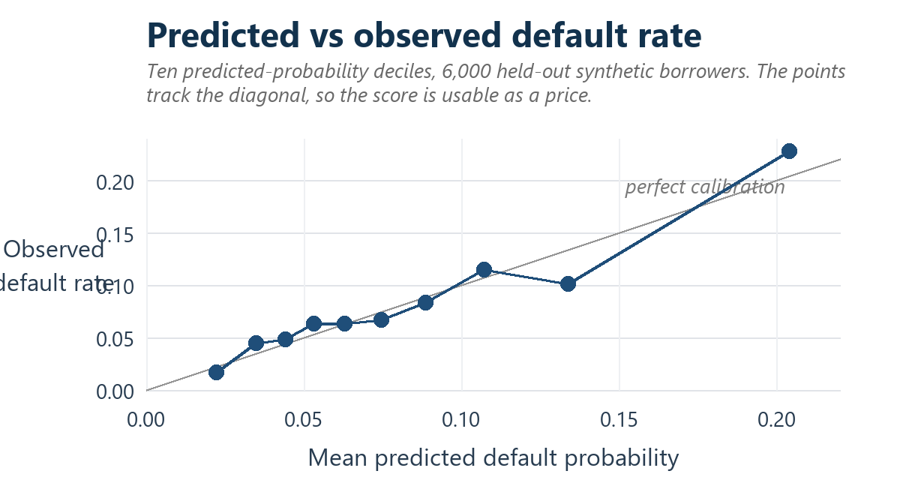
Figure 4. Calibration of the score on the held-out test set. Each point is one decile of predicted default probability; the grey diagonal is perfect calibration. The points track the diagonal across the whole range, which is what allows the score to be used as a price rather than merely as a ranking.

4.3 Making an off-chain score trustworthy on-chain
The course brief flags "the credibility of putting an off-chain AI score on-chain" as the main risk of this topic. MicroLend answers it with a signed, versioned, expiring attestation rather than a plain number:
- The API signs an EIP-712 message containing the borrower, the score, the model hash, an expiry and a nonce. The EIP-712 domain binds the chain id and the CreditRegistry address, so a signature cannot be replayed on another chain or another contract.
- The borrower, or any relayer, submits the signature to the registry. The contract recovers the signer and requires it to hold SCORER_ROLE at that moment, so a compromised key can be revoked by the admin without redeploying anything.
- Each signature carries a single-use per-borrower nonce, so a signed score cannot be submitted twice, and an expiry of at most 180 days, so a stale score cannot be resurrected.
- The model hash is a SHA-256 over the canonical coefficients, so an observer can tell which model produced a given on-chain score and can detect a silent model swap.
- Crucially, the attestation does not approve a loan. It sets the tier; a human credit officer still approves or rejects every application.
The residual trust assumption should be stated plainly: the scorer key, and whoever controls the model, remain trusted. Removing that assumption would require a zero-knowledge proof of inference or a decentralised scorer committee. Both are plausible future work; neither is implemented here.

5. Smart-contract design
Four contracts carry the business logic and a fifth provides the test currency. The split is not cosmetic: keeping the collateral escrow separate from the pool means a fault in the lending logic cannot reach collateralised balances, and making LoanManager the only contract that may drive the other three means there is a single, auditable entry point for every state change.
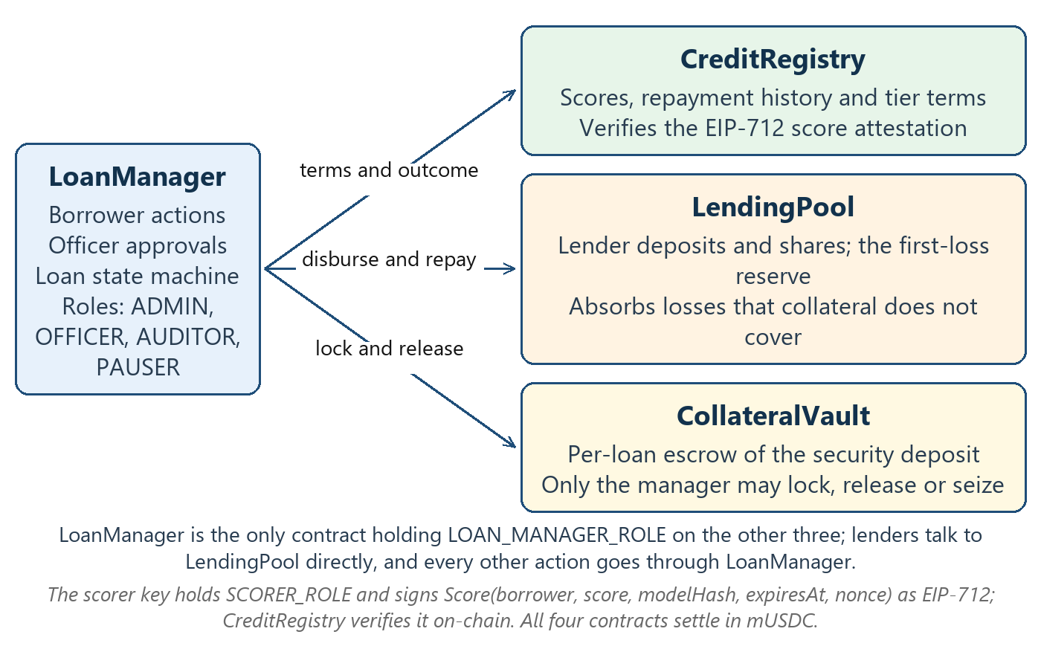
Figure 5. Contract interaction. LoanManager is the only holder of LOAN_MANAGER_ROLE on the other three contracts, and lenders interact with the pool directly. The scorer key never holds funds or permissions beyond signing score attestations.
Table 13. The five contracts.
Contract | Responsibility | Key state | Authorised callers
CreditRegistry | Scores, repayment history and tier terms; EIP-712 verification | per-borrower profile, four tier configs, nonces | SCORER_ROLE for scores, LOAN_MANAGER_ROLE for outcomes, admin for tiers and blocking
LendingPool | Lender deposits, share accounting, reserve and loss absorption | totalShares, sharesOf, outstandingPrincipal, reserve, reserveBps, maxUtilizationBps | lenders directly through deposit and withdraw; LOAN_MANAGER_ROLE for disbursement, repayment and loss
CollateralVault | Per-loan escrow of the security deposit | positions by loan id, totalLocked | LOAN_MANAGER_ROLE only, for lock, release and seize
LoanManager | Loan state machine; orchestrates the other three; access control | loans, loanCount, openLoanOf, auditNoteCount | officer for approve and reject, auditor for notes, pauser, borrower, and any wallet for markDefault
MockStablecoin | 6-decimal test currency with a rate-limited faucet | lastFaucetAt per address | any wallet may call faucet; the owner may mint

5.1 Loan lifecycle
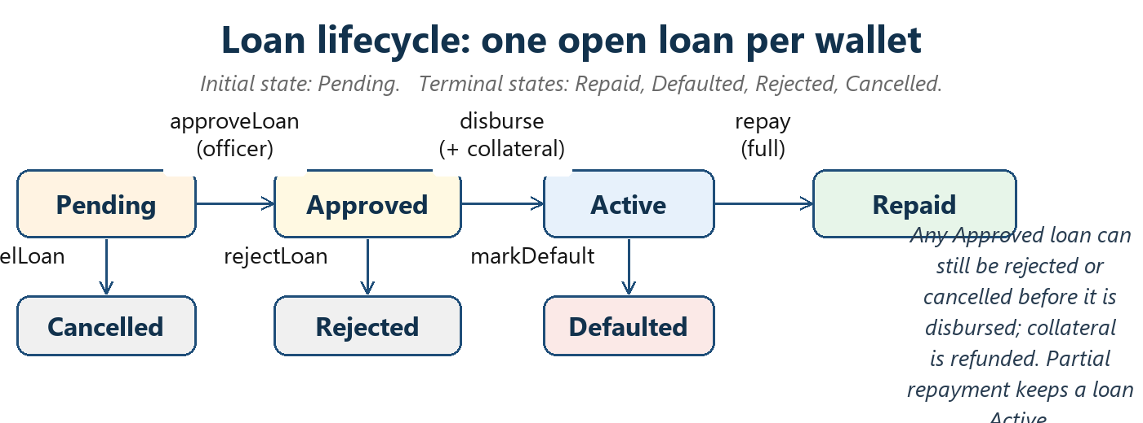
Figure 6. Loan state machine. Terms are fixed at approval time, so a later tier change cannot reprice an already-approved loan.
Table 14. Loan rules enforced by LoanManager.
Rule | Value | Rationale
Loan term | 7 to 180 days | Matches the working-capital cycle of a micro-business
Interest | Simple: principal times APR times days divided by 365, fixed for the whole term | Transparent; no compounding and no hidden fees
Repayment order | Interest first, then principal | The pool's yield is recognised before the principal is reduced
Open loans | One per wallet | Prevents a borrower from stacking obligations
Approval validity | 7 days, then ApprovalExpired | Limits exposure to a stale decision
Grace period | 7 days after the due date, after which any wallet may call markDefault | Gives genuine hardship a window while keeping enforcement permissionless
Self-approval | Rejected with the SelfApproval error | Removes the most obvious insider route

5.2 Default handling: the loss waterfall
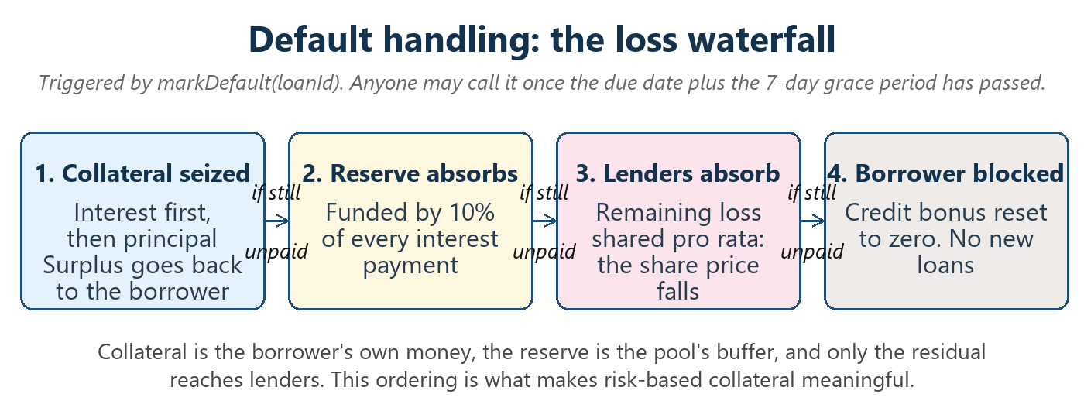
Figure 7. The loss waterfall. Losses are absorbed in a fixed order, so lender exposure is bounded and predictable.
The ordering matters. Collateral is the borrower's own money and absorbs the first loss; the reserve, funded by 10% of every interest payment, absorbs the next tranche; only the residual reaches lenders, where it is shared pro rata through a fall in the share price. The borrower is then blocked and their history bonus is reset to zero. Section 9.7 shows that the reserve funded from interest alone is weak protection, and that a sponsor-funded first-loss tranche is what actually changes lender outcomes. That is an unflattering finding, and the team kept it.

5.3 Transaction types and gas
Table 15. Nineteen transaction types, comfortably more than the ten required by FR-04. Each entry names the function, the contract and the sender.
# | Transaction and contract | # | Transaction and contract
1 | deposit(amount), LendingPool, lender | 2 | withdraw(shares), LendingPool, lender
3 | applyLoan(amount, termDays, purposeHash), LoanManager, borrower | 4 | approveLoan(loanId, amount), LoanManager, officer
5 | rejectLoan(loanId, reasonHash), LoanManager, officer | 6 | cancelLoan(loanId), LoanManager, borrower
7 | depositCollateral(loanId), LoanManager to vault, borrower | 8 | disburse(loanId), LoanManager to pool, borrower or officer
9 | repay(loanId, amount), LoanManager to pool, borrower | 10 | markDefault(loanId), vault, pool and registry, any wallet
11 | updateScoreWithSignature, CreditRegistry, borrower | 12 | updateScore, CreditRegistry, scorer key
13 | addAuditNote(loanId, noteHash), LoanManager, auditor | 14 | fundReserve(amount), LendingPool, admin
15 | grantRole and revokeRole, any contract, admin | 16 | pause and unpause, LoanManager and LendingPool, pauser
17 | setBlocked and setTier, CreditRegistry, admin | 18 | setReserveBps and setMaxUtilizationBps, LendingPool, admin
19 | faucet and approve, MockStablecoin, any wallet | — | —

Table 16. Gas report, measured with the gas reporter at optimiser 200 runs and viaIR. The USD column in the repository is intentionally blank because no price feed is configured; converting to a currency requires a stated gas price, ETH price and date.
Function | Min gas | Max gas | Average gas
LendingPool.deposit | 62,233 | 113,546 | 105,557
LoanManager.applyLoan | 190,035 | 224,447 | 218,648
LoanManager.depositCollateral | 136,616 | 170,816 | 167,016
LoanManager.repay | 157,251 | 283,705 | 228,740
LoanManager.markDefault | 177,519 | 297,041 | 241,268
CreditRegistry.updateScoreWithSignature | 100,409 | 100,409 | 100,409
Other operations: withdraw, approveLoan, disburse | 53,970 | 128,573 | 57,174 to 126,930
Deployment, per contract, average | not applicable | not applicable | 717,821 to 2,249,123

6. Security
Status: unaudited coursework code. It has not been reviewed by a third party and has no formal verification and no fuzzing. The material below is a threat model, the controls actually implemented, and the results of static analysis; it is not a security guarantee.

6.1 Threat model and controls
Table 17. Threat model and implemented controls.
Risk | Control | Where
Reentrancy and unsafe token interaction | ReentrancyGuard on every state-changing entry point that moves tokens; checks-effects-interactions ordering, with state updated before any transfer; OpenZeppelin SafeERC20 throughout | all contracts
Privilege escalation | OpenZeppelin AccessControl; only LoanManager holds LOAN_MANAGER_ROLE on pool, vault and registry; no owner backdoors; roles granted explicitly by the deploy script | all contracts
Officer fraud | An officer cannot approve their own application; every approval and rejection is an event; auditors attach immutable notes | LoanManager
Pool and vault accounting manipulation | MINIMUM_SHARES of 1,000 minted to nobody on the first deposit, which blunts first-depositor inflation; recordRepayment reverts unless the pool balance really covers the reserve; lock reverts unless the vault holds totalLocked plus the new amount | LendingPool, CollateralVault
Liquidity run and over-lending | Utilisation cap, default 90%; withdrawals limited to idle cash | LendingPool
Rounding drift | All divisions round down, so shares and interest never favour the caller by more than one 6-decimal unit | LendingPool, LoanManager
Signature replay or forgery | The EIP-712 domain binds the chain id and verifying contract; a single-use per-borrower nonce; expiry of at most 180 days; the signer must hold SCORER_ROLE at verification time; OpenZeppelin ECDSA rejects malleable signatures | CreditRegistry
Stale approval | Approval expires after 7 days, and terms are fixed at approval so a later tier change cannot reprice the loan | LoanManager
Admin error and griefing | Tier updates are validated so thresholds stay strictly ascending and tier 0 starts at zero; the reserve share is capped at 50%; pausing never blocks repayment, cancellation, withdrawal or default handling; one open loan per wallet; markDefault only after the due date plus grace | CreditRegistry, LendingPool, LoanManager
Session forgery and scorer-key abuse | Wallet signature over a server-issued, single-use, 5-minute nonce that is burned even when verification fails; the JWT carries only the address, and roles are re-read from the chain every 30 seconds; scoring is limited to 10 requests per hour per wallet with range validation, every request is logged, the key is revocable on-chain and scores expire | auth module, scoring route
Injection and secret leakage | Parameterised queries through knex; zod request validation; a 50 kB body limit; helmet headers; a CORS allow-list; CSV export prefixes formula-leading characters; all secrets come from environment variables, and production refuses a JWT secret shorter than 32 characters | app, serializers, config

6.2 Static analysis
Slither 0.11.6, with its 99 detectors, was run against Solidity 0.8.24 before and after remediation. Findings fell from 10 to 7, with no High-severity finding in either run. Every finding was triaged as fixed or accepted with a written reason.
Table 18. Slither results before and after remediation.
Run | Total | High | Medium | Low | Disposition
Before fixes | 10 | 0 | 7 incorrect-equality | 3 reentrancy | baseline run, before remediation
After fixes | 7 | 0 | 7 incorrect-equality | 0 | 3 reentrancy findings fixed; 7 equality findings accepted

- Fixed: one reentrancy finding of low severity in LoanManager.repay. A fully repaid loan was closed in storage after the external calls. The function now marks the loan repaid before transferring, and performs collateral release and credit-record updates afterwards. It was already non-reentrant and all callees are trusted contracts, so this was not exploitable, but the ordering now matches checks-effects-interactions.
- Fixed: two event-ordering findings in CollateralVault. The release and seize functions emitted events after the token transfers. Events now precede the transfers, so the log order matches the state.
- Accepted: seven incorrect-equality findings in LendingPool. These are zero-value guards, such as totalShares equal to zero or shares equal to zero, protecting division by zero and the first-deposit branch. Because the lender-assets figure depends on the token balance, any wallet can donate tokens to the pool; but a donation only raises the value and therefore cannot turn a zero guard into a harmful path. The classic first-depositor inflation attack is bounded by MINIMUM_SHARES, and any deposit that would round to zero shares reverts instead of silently losing funds. This reasoning has not yet been backed by a dedicated donation-attack test, which is a good candidate for extra coverage.
What Slither cannot tell you. Static analysis cannot validate business logic such as the loss waterfall or the share accounting; those rest on the 49 contract tests and the accounting invariant test. The configuration also excludes the mock token from the reported counts, so MockStablecoin is not covered by the 10 and 7 figures.

6.3 A production finding worth reporting
While the application was running on Render, an RPC failure caused the private RPC URL, which embeds an Alchemy API key, to be returned inside the public error field of the health endpoint. The condition has since cleared, and the public configuration endpoint now exposes a credential-free RPC, so no live leak was observed at the time of writing. The code path that can echo a credential into a public error field is nevertheless still present. The correct response is to redact credentials from all public error output and to rotate the API key, on the assumption that the key has been exposed. This is a concrete lesson: the boundary between internal error detail and a public response has to be enforced, not assumed.

7. Backend and data
The backend is a stateless Express application plus one background loop. It holds no user funds; its only privileged capability is signing score attestations.
Table 19. REST API surface: 17 endpoints, grouped. All routers are mounted under /api, and a global limit of 600 requests per 15 minutes per client applies.
Method and path | Auth and role | Purpose
GET /health, /config, /abis, /stats, /pool/history | public | Liveness and indexer status; deployment addresses and the model card; contract ABIs; pool, loan and scoring aggregates; the pool snapshot time series for the charts
POST /auth/nonce and /auth/verify | public, 60 per 15 min | Issue a single-use sign-in challenge, then verify the wallet signature and return a JWT with the caller's on-chain roles
GET /me and PUT /profile | JWT | Wallet, roles, credit profile, lender position and balances; upsert of the off-chain KYC-lite metadata that never goes on-chain
GET /loans and /loans/:id | JWT; own rows, or all rows for staff | Filterable paginated loan list; loan detail with its full event trail
GET /events and /events/export.csv | JWT for own rows; auditor or admin for the CSV | Audit-log query by event, loan, account and time window; full CSV export for offline audit
POST /score and GET /score/latest | JWT, 10 per hour per wallet | Off-chain score with its EIP-712 attestation; the most recent stored score for the caller
GET /officer/queue and /audit/summary | officer; auditor or admin | Pending applications with model inputs and past-loan history; approval and default rates, processing speed and reserve cover

7.1 Sign-in and authorisation
There are no passwords. The nonce endpoint stores a 32-hex-character nonce against the lower-cased address and returns a human-readable message containing the address, chain id, nonce, timestamp and the sentence "This signature costs no gas and does not authorise any transaction." The wallet signs it with personal_sign. The verify endpoint deletes the nonce row before recovering the signer, so it is single use whatever the outcome, then compares the recovered address with the claimed one, reads the caller's on-chain roles, and issues an HS256 token valid for 8 hours. Roles are never baked into the token; they are re-read from LoanManager on every request and cached for 30 seconds, so revoking a role takes effect within about half a minute even for an already-issued token.

7.2 Event indexer
The indexer is the only component that writes chain data to the database, and it is deliberately idempotent so that a crash is always recoverable.
- Every 4 seconds it reads the chain head, computes a safe head by subtracting the confirmation depth (2 in production), and scans only up to that point. A reorganisation shallower than the confirmation depth therefore cannot be indexed; no rollback logic is needed because writes are idempotent and the checkpoint only moves forward.
- It resumes from the stored checkpoint or from the deployment start block on a fresh database, and fetches logs in chunks whose size is configurable.
- Logs are decoded against the committed ABIs, and the mock token is skipped to avoid ERC-20 transfer noise. Address-typed arguments are collected into an accounts column formatted with leading and trailing commas, so ownership filtering is a single indexed LIKE predicate.
- Each chunk writes events with conflict-ignoring on transaction hash and log index, refreshes the denormalised loan rows, and advances the checkpoint inside one transaction, so state only advances if the writes committed. Pool snapshots are written afterwards, plus one idle heartbeat point per hour so the chart does not go flat.
- Errors are swallowed after being recorded in the status object, so one failed poll does not kill the loop, and a running flag prevents overlapping polls.
Operationally, the chunk size had to be lowered to 10 in the hosting console, because the configured RPC endpoint rejected the default range of 2,000 blocks. That override lives in the console rather than in the blueprint file, which means recreating the service from the blueprint alone would silently reintroduce the failure. Recording such out-of-band configuration is part of deployment hygiene.

8. Frontend and user experience
The frontend is a single-page React application that renders a different set of tabs depending on the roles read from the chain. A wallet with no staff role sees three tabs; the admin wallet sees six.
Table 20. Role-based pages.
Page | Visible to | Purpose
Overview | everyone, no wallet needed | Pool KPIs, pool history and loan-status charts, and the model card
Borrow | any connected wallet | Wallet card and test-token faucet, credit questionnaire, application, collateral, disbursement and repayment
Lend | any connected wallet | Deposit, position value and share price, withdrawal
Credit officer | officer and admin | Review queue with score, probability of default, questionnaire inputs and past loans
Audit | auditor and admin | Summary indicators, filterable event log with transaction hashes, CSV export and audit notes
Admin | admin | Pause controls, pool parameters, roles, reserve funding, borrower blocking and tier configuration

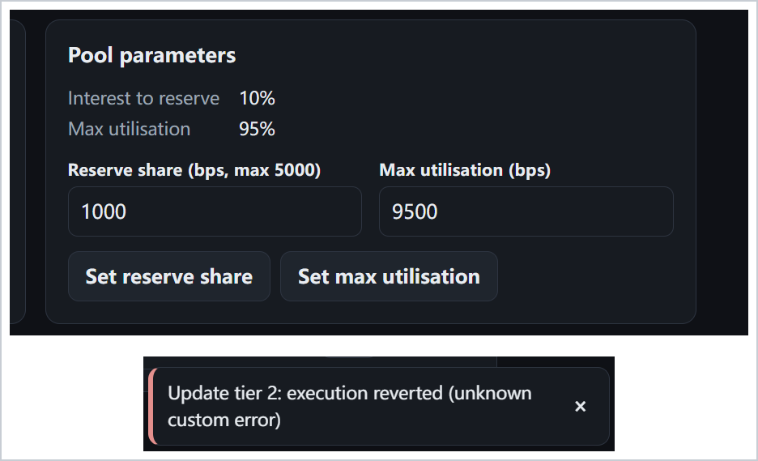
Figure 8. Administrator screens from the running application, captured on the local Hardhat chain. Upper panel: the pool parameters card, with the reserve share set to 1,000 basis points (10% of interest) and the utilisation cap at 9,500 basis points (95%). Lower panel: the contract rejecting an invalid tier reconfiguration, because the proposed minimum scores were not strictly ascending. The wording of that rejection is itself defect BUG-03: the contract raises a specific custom error, but the front end falls back to a generic "unknown custom error" message instead of showing the explanation it already contains for this case.
Responsive behaviour was verified at a 390-pixel viewport, the CSS width of a current phone. Figure 9 is that capture of the deployed application. The header keeps the brand, the chain badge and the truncated wallet address on one line and pushes the "Sign in" control to its own column; the two-column statistic grid collapses from four columns to two, with the labels reflowing inside each card rather than being truncated. No horizontal scrolling is required at this width.
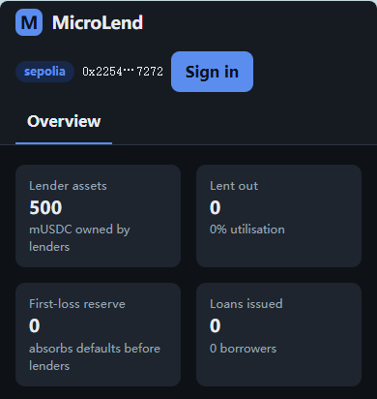
Figure 9. The deployed application at a 390-pixel viewport, captured from the browser device toolbar at 390 x 844. The statistic grid reflows to two columns and the header stacks, with no horizontal overflow.

8.1 Usability observations
The independent test pass surfaced four defects, all in the presentation layer, listed in full in Section 9.5. The most consequential is BUG-03: contract reverts reach the user as "execution reverted (unknown custom error)", because the decoder does not walk the nested revert data through the contract interface, so the friendly message the application already holds is never shown. A second is that staff wallets see other borrowers' loans beneath a heading that says "My loans" (BUG-01); the exposure is intentional for staff but the labelling is misleading.
A structured expert review of the interface, applying Nielsen's ten heuristics to the frontend source and the captured screens, produced fifteen findings: one high, eight medium and six low severity. The theme is not layout but feedback — six of the fifteen concern the system failing to say what is happening or why an action failed, which is consistent with the defect log above: two independent methods converged on the same short list. The full review and a remedy for each finding are in the companion document MicroLend: Usability Evaluation and User-Test Kit, with the protocol for the participant test, which has not been run; Section 9.7 records the status.

9. Testing and evaluation

9.1 Automated test results
Table 21. Test results at a glance. The automated suites were re-run on an independent machine (macOS, Node 20.20.2) and reproduced the recorded coverage to one decimal place.
Level | Command | Executed | Passed | Failed | Pass rate
Smart-contract unit and integration tests | npm test | 49 | 49 | 0 | 100%
Backend: scoring logic and REST API | npm --prefix backend test | 16 | 16 | 0 | 100%
Frontend production build | npm --prefix frontend run build | 1 | 1 | 0 | 100%
Functional main flow, F1 to F11 | manual, browser and wallet | 11 | 11 | 0 | 100%
Functional edge cases and access control | manual, browser and wallet | 6 | 6 | 0 | 100%
Total | — | 83 | 83 | 0 | 100%

Table 22. Coverage by contract. Branch coverage is the weakest metric: the untested failure paths are concentrated in CollateralVault and LendingPool.
Contract | Statements | Branches | Functions | Lines | Uncovered lines
CollateralVault | 100% | 58.33% | 100% | 100% | none
CreditRegistry | 100% | 79.55% | 100% | 100% | none
LendingPool | 92.31% | 69.51% | 95% | 94.44% | 169, 170, 208, 209
LoanManager | 97.89% | 82.14% | 95% | 99.22% | 356
MockStablecoin | 100% | 100% | 100% | 100% | none
All files | 97.13% | 75.94% | 96.72% | 98.31% | n/a for the aggregate

9.2 End-to-end scenarios
The scenarios below were executed against the deployed application on Sepolia on 13 October 2026, and the ten-minute demonstration video records the run. The main flow is loan #2: 50 mUSDC for 30 days at a rate of 0.82, collateral 5.00, due 12 November 2026, repaid in full at 50.82. The same run moved the borrower from a score of 594 (Builder, tier 1) to 624 (Trusted, tier 2), the 30-point history bonus included, and exercised the lender side with a deposit of 500 mUSDC and a withdrawal of 100.
Table 23. Manual end-to-end scenarios. "Sepolia 13 Oct" means executed against the deployed application on 13 October 2026 and recorded in the demonstration video; scenario definitions follow the repository testing guide.
ID | Scenario | Expected result | Status
S1 | Unscored borrower requests 101 mUSDC against a limit of 100 | Refused | Pass, Sepolia 13 Oct
S2 | Borrower scores, records on-chain and applies for 400 | Tier applied; the officer queried | Pass, Sepolia 13 Oct
S3 | Officer approves, borrower posts collateral, funds received | Events emitted in order | Pass, Sepolia 13 Oct
S4 | Borrower repays on time, in instalments | Repaid; collateral returned; +30 bonus | Pass, Sepolia 13 Oct
S5 | Same borrower applies again | Higher limit, lower collateral | Pass, Sepolia 13 Oct
S6 | Loan passes due date plus 7 days, then markDefault is called | Seizure, reserve use, share price falls | Automated tests only, see 9.3
S7 | Lender withdraws more than the idle cash | Clear error; maximum works | Pass, Sepolia 13 Oct
S8 | Admin pauses the loan manager | Applications blocked, repayment works | Pause on Sepolia; repayment while paused by tests, see 9.3
S9 | Non-staff wallet opens staff pages or calls a staff route | Tab hidden; API returns 403 | Pass, Sepolia 13 Oct
S10 | Replay a used score signature | Reverts as an invalid signer | Automated tests only, see 9.3

9.3 Scenario coverage gaps, stated explicitly
The following elements were validated only by automated tests and were not exercised through the interface on Sepolia. They are reported as automated coverage, not as live transactions:
- S6, default and the loss waterfall: requires the due date plus the 7-day grace period to elapse. Covered by three contract default scenarios, including surplus collateral returned after a partly repaid default.
- S10, replay of a used score signature, and officer self-approval: covered by the EIP-712 replay, forgery and self-approval contract tests.
- S9 at the API layer, S7 at the contract layer and S8, repayment while paused: covered by the backend role-gating tests and the insufficient-liquidity and pause-behaviour contract tests.

9.4 Optimisation and gas analysis
Even where the security fix was judged not exploitable, it was implemented, and the gas cost of doing so was measured rather than assumed. The results support the change:
Table 24. Measured effect of the checks-effects-interactions fix.
Metric | Before | After | Change
LoanManager.repay average gas | 228,899 | 228,740 | down 159
LoanManager.repay maximum gas | 283,963 | 283,705 | down 258
LoanManager.markDefault maximum gas | 297,053 | 297,041 | down 12
LoanManager deployment gas | 2,240,934 | 2,249,123 | up 8,189, or 0.4%

The safer ordering cost nothing on the hot path and only slightly enlarged the deployed bytecode, by one extra internal function. The optimisations already present in the code are: custom errors instead of revert strings; a packed loan struct, where borrower, status, tier, APR, term and a flag share slots and the timestamps are 64-bit; immutable contract references read from bytecode rather than storage; only purpose and reason hashes stored on-chain; and event-carried data so that no on-chain enumeration is needed. Remaining ideas the team has not yet measured include tuning the optimiser run count and removing the redundant closed-at write.

9.5 Defect log
Table 25. Defects raised by the independent test pass. In every case the contract or the backend behaved correctly; the defect is what the user sees. No defect affecting fund safety, on-chain access control or backend data isolation was found.
ID | Title | Component | Severity | Priority | Status
BUG-01 | Staff accounts see all borrowers' loans under "My loans" | Frontend, Borrow | Low | Medium | Open
BUG-02 | A repaid loan still shows collateral as deposited | Frontend, Borrow | Low | Low | Open
BUG-03 | Contract errors shown as "unknown custom error" | Frontend, error handling | Medium | High | Open
BUG-04 | Pause status uses the loan labels "Rejected" and "Active" | Frontend, Admin | Low | Low | Open

BUG-02 is worth noting as an example of verification working. The card wrongly showed collateral as still deposited after repayment, but the exported event log contained a collateral-released event for the full amount, which proved that funds were returned correctly and isolated the fault to the display layer.

9.6 Success indicators
The brief asks for success indicators with a target and a measurement method. The table below gives the target, what was actually measured, and where the measurement comes from. The one row without a measured value is marked accordingly rather than estimated.
Table 26. Success indicators, targets and measured values. Processing-time figures drawn from the seeded local dataset are labelled as such and are not field results.
Indicator | Target | Measured | Source
Public demo reachable | No local install required | Live; 60 to 90 s to wake | Live URLs, Section 10
Indexer lag | Under 30 seconds | 2 blocks, about 24 s | Health endpoint
Raw questionnaire data on-chain | None | Only score, expiry and model hash | Design and contract tests
State changes traceable to a transaction | 100% | 100% | Every write emits an event
Cost per operation | Under 0.5 million gas | 0.10 to 0.24 million gas | Table 16
Automated tests passing | 100% | 83 of 83 | Table 21
Statement coverage | Above 90% | 97.13% | Table 22
Probability that lenders lose money at a 5% default rate | Report, not a target | About 9% with tiered terms against 38% flat | Portfolio simulation, Section 9.7
Problem-validation survey responses | Five to ten | 7 collected | Section 9.7, Appendix B
Respondents who recognise the problem | Majority agree | 7 of 7 rated both problem statements 4 or 5 | Section 9.7
Task completion in a participant usability test | At least 80% | Not yet measured | Pending, see Section 9.7

9.7 Portfolio economics and problem validation
The portfolio simulation is plotted in Figure 10 and its full result set is tabulated in Appendix B, so that the body can carry the interpretation and the appendix the raw numbers.
The simulation produces a counter-intuitive and useful finding. Under the stated assumptions of 60-day loans, 80% utilisation and loans at 60% of the limit, diverting 0 to 30% of interest into the reserve barely changes lender outcomes, whereas an externally funded first-loss reserve changes them dramatically: at a 5% default rate, no initial reserve gives a mean annual lender return of about minus 4% with an 87% probability of loss, a 2% reserve gives about plus 6% and 8%, and a 5% reserve gives about plus 12% and near-zero loss probability. Risk-based pricing also helps on its own: the probability of loss at a 5% default rate is about 9% with tiered terms against 38% flat, and the break-even default rate is about 7.0% tiered against 5.4% flat. Results near break-even are sensitive, so ranges are quoted with Monte-Carlo noise of one to two percentage points. The conclusion is that a pool funded only from its own borrowers' interest cannot credibly protect lenders, and that a sponsor- or insurance-funded first-loss tranche is the mechanism that would.
Primary validation. A short problem-validation questionnaire (Appendix B, Table 30) was distributed to the team's own network and returned seven anonymous responses, all from people aged 22 to 24 who are not members of the team. All seven reported having no formal credit record; six had either been refused a loan or had decided not to apply because they expected to be refused; five had needed a small short-term loan of under SGD 1,000 at least once in the previous twelve months; and of those who had borrowed, four turned to family rather than a bank while three used a bank. That supports the claim in Section 1.3 that formal channels do not reliably reach thin-file borrowers.
Agreement with the two problem statements was strong and uniform: a mean of 4.57 of 5 (sd 0.54) that lenders make it difficult for people without a bank record to obtain credit, and 4.71 (sd 0.49) that a repayment record which followed them between lenders would improve their terms, with all seven respondents at 4 or 5 on both. Intention to use the proposed service averaged 4.43 (sd 0.54, again all seven at 4 or 5). Forced to choose a single priority, three chose a lower interest rate and two each chose data privacy and the absence of collateral.
One design assumption failed validation, and it is reported rather than smoothed over. Willingness to pay a higher interest rate in exchange for not needing collateral scored exactly 3.00 of 5, with only two of seven agreeing, so the zero-collateral top tier is not supported by this sample: either the trade-off must be presented differently or that tier needs a different incentive. The free-text answers surfaced what closed questions cannot: three of the seven named a blockchain-specific obstacle unprompted, namely distrust of cryptocurrency, an inability to manage private keys, and a fear of being pursued for debt. The first two are onboarding rather than credit problems, and they point at the same conclusion as the expert review in Section 8.1: onboarding matters more for adoption than further work on the credit model.
What this establishes, and what it does not. Seven respondents is at the lower end of the five-to-ten the brief accepts, and all of them are university-aged, so this is a thin-file proxy rather than the intended market of urban informal-sector micro-entrepreneurs. The results support the direction of the problem and the appeal of a portable record, not demand among target users, and the high intention score carries the usual social-desirability caution.
How the validation requirement is met. The brief accepts any one of three forms of validation: five to ten stakeholder interviews or a short survey; a usability test with five to ten people; or expert feedback from a lecturer or someone in finance. This project satisfies two of the three: the problem-validation survey reported above, and the structured expert review in Section 8.1, which produced fifteen usability findings against Nielsen's heuristics. The moderated usability test, the second form, has not been run; the report does not claim otherwise, and the protocol for it is held in the companion usability document should the team run it before submission.

10. Deployment and DevOps
Five contracts are deployed on Sepolia, chain id 11155111, on 11 October 2026, and all five are verified on Etherscan: mUSDC 0x882b02C3…B2d1, CreditRegistry 0xa80e874c…248F, LendingPool 0x576358F6…f410, CollateralVault 0x9c7b6130…0B31 and LoanManager 0x9279A53E…0b69. The full addresses and the Etherscan source link pattern are in Appendix B, Table 27, and are also served at runtime from the configuration endpoint.
The full deployment topology, including the continuous-integration detail, is tabulated as Table 28 in Appendix B. In summary: the frontend is a Vite static site, the API is a Docker service built from the repository root and health-checked on /api/health, the database is managed PostgreSQL, and the chain is reached over JSON-RPC. Continuous integration runs four parallel jobs on every push to main and every pull request, and all six runs to date succeeded (as of 14 October 2026), the latest covering commit e7a8ae7d.

10.1 Operational realities worth recording
- The live services track a fork, not the team repository. Both Render services are connected to a member's fork on its main branch. Merging into the team repository does not update the live site; the fork must be synchronised first. At the time of writing the fork was lagging behind the team repository.
- Free-tier cold start. The free web service sleeps after about 15 minutes without traffic and the first request can take 60 to 90 seconds; an observed request returned a 503 loading page for roughly 75 seconds before becoming healthy, so any demonstration must wake the service first. The free PostgreSQL instance expires 30 days after creation, and off-chain data such as questionnaire answers cannot be rebuilt from the chain, so a backup is required.
- Out-of-band configuration and credential risk. The indexer chunk size exists only in the hosting console (Section 7.2) and the JWT secret is generated by the platform, so recreating the service from the blueprint alone would not reproduce the running configuration. Separately, an RPC key was briefly reachable through a public error field (Section 6.3); rotation and redaction are outstanding.
- No secret has ever been committed. The repository tracks only .env.example, which contains placeholder text rather than values. No .env, key file or keystore appears in the current tree, and no commit removed one, so none was ever added. .env is listed in .gitignore, the deployment record holds only public addresses, and the local test mnemonic in scripts/local-mnemonic.js is deliberately public.

11. Limitations, ethics and future work

11.1 Limitations
The consolidated list is Table 29 in Appendix B. In short: scoring inputs are self-reported; the model trains on synthetic data (AUC about 0.68); the scorer key and the admin are trust anchors; the stablecoin is a mock; a reserve funded only from interest barely protects lenders; branch coverage is 75.9% with untested failure paths in CollateralVault and LendingPool; there is no formal audit, fuzz or invariant testing; no KYC or AML; and primary validation rests on seven university-aged respondents, with no moderated usability test run.

11.2 Ethics and regulation
- Over-indebtedness. Automated scoring can push credit onto those least able to absorb a shock. Exposure is capped through one open loan, small limits and the total cost shown up front, but affordability assessment is not implemented.
- Fairness. Protected attributes are excluded, yet proxies such as region still produce group differences; the rural to urban approval-rate ratio is 0.972. Fairness must be monitored continuously, not certified once.
- Privacy. A wallet address linked to a profile and a country is personal data under most regimes. Keeping only the score, its expiry and a model hash on-chain limits exposure, but the off-chain database still needs a retention policy and consent.
- Regulation and exclusion. Deposit-taking, lending and handling digital tokens are regulated, and none of the required licensing or KYC/AML is implemented. A smartphone and the ability to manage a key are also prerequisites, so removing the bank does not remove the digital divide.

11.3 Future work
- Replace the synthetic generator with a real or public dataset and re-evaluate discrimination, calibration and fairness against a fixed holdout, verifying score inputs with signed mobile-money statements or group-guarantee attestations instead of self-reporting.
- Remove the scorer trust assumption with a zero-knowledge proof of model inference, or a threshold committee of scorers with on-chain quorum verification.
- Put the admin behind a multisig plus a timelock, and separate the pause guardian from the role administrator.
- Raise branch coverage with failure-path tests for CollateralVault and LendingPool, a donation-attack test, and invariants for the identity that cash plus outstanding equals lender assets plus reserve; fund the reserve externally; and redact credentials from public error output while rotating the exposed RPC key.

12. Conclusion
MicroLend delivers what the brief asks for and is honest about what it does not. It implements four interoperating contracts plus a mock stablecoin, 19 transaction types and five roles, a REST API with a persistent database and a 4-second event indexer, a six-page role-based dashboard, a documented scoring model with fairness checks and Monte-Carlo economics, gas analysis, an 83-case test pass, static analysis with triaged findings, and a public cloud deployment with continuous integration.
The most defensible parts of the design are the separation of concerns, with money and permissions on-chain and computation off-chain while the database is a rebuildable projection rather than a source of truth, and the treatment of the AI score as a signed, versioned, expiring attestation that sets a tier but never approves a loan. The most useful analytical result is negative: a reserve funded only from borrower interest does not meaningfully protect lenders, whereas external first-loss capital does.
The work that remains is the moderated usability test with five to ten participants, which would turn the interface findings from expert opinion into measured participant data.

References
[1] World Bank and CGAP. What's Next for Financial Inclusion: Unpacking Findex 2025. Global Findex 2025. https://connect4impact.worldbank.org/topic/whats-next-financial-inclusion-unpacking-findex-2025-2026. Used for the figure of about 1.3 billion unbanked adults and 75% account ownership in low- and middle-income countries.
[2] World Bank. The Global Findex Database 2025. https://www.worldbank.org/en/publication/globalfindex
[3] MFIN and NCAER. Assessing the Effectiveness of Regulated Small Borrowing in India. Microfinance Industry Network. https://mfinindia.org/assets/upload_image/publications/Studies/MFIN-NCAER-study-on-Assessing-the-Effectiveness-of-Regulated-Small-Borrowing-in-India.pdf. Source for the 5% to 10% flat interest charged by local moneylenders (row E4).
[4] MFIN. Micro Matters: Macro View 2024-25. https://mfinindia.org/assets/upload_image/publications/Studies/MFIN%20Micro%20Matter%20-%20Macro%20View%202024-25.pdf. Portfolio at risk, 30+ days (row E5). The 31-180 day figure is reported by CareEdge Ratings, https://www.careratings.com/uploads/newsfiles/1760347854_NBFC-%20Microfinance%20Industry%20-%20CareEdge%20Report.pdf, and summarised by Moneycontrol, https://www.moneycontrol.com/news/business/microfinance-sector-s-portfolio-at-risk-31-180-days-rises-sharply-to-6-4-12949917.html.
[5] GSMA. The State of the Industry Report on Mobile Money 2025. https://www.gsma.com/sotir. Mobile money passed two billion registered accounts and over 500 million monthly active users in 2024 (row E6).
[6] SC6113 course brief, Group project candidate topics: mandatory project requirements and the 100-mark rubric, including the 15-mark problem-analysis-and-validation criterion.
[7] MicroLend source repository. https://github.com/catjlx/microlend. Contains the contracts, backend, frontend, model pipeline, documentation and the Sepolia deployment record.
[8] MicroLend team documentation: architecture, security, testing, Slither triage, Sepolia deployment, requirement traceability and the report guide, in the docs directory of the repository.
[9] DONG RUNZHOU. MicroLend Test Report, version 1.0, 12 October 2026. Independent test pass: 83 cases and four defects.
[10] OpenZeppelin Contracts 5.0.2: AccessControl, ReentrancyGuard, SafeERC20, ECDSA, EIP712 and Pausable.
[11] EIP-712: Typed structured data hashing and signing. https://eips.ethereum.org/EIPS/eip-712
[12] Slither 0.11.6 output, recorded as evidence logs 09 (before) and 10 (after) in the repository.
[13] Render. Free instance types. https://render.com/docs/free. Sleep after 15 minutes idle and free PostgreSQL expiry after 30 days.

Appendix A. Reproducing the results
npm run setup # install root, backend and frontend dependencies
npm run build:contracts # compile and export ABIs to shared/abis
npm test # 49 contract tests
npm run test:gas # gas table -> docs/gas-report.txt
npm run coverage # coverage report
npm --prefix backend test # 16 scoring and API tests
npm --prefix frontend run build
python3 ml/train_model.py && python3 ml/simulate_portfolio.py
The local end-to-end system needs four terminals: the Hardhat node on port 8546 with chain id 31338, then the deploy, seed and environment scripts, then the backend on port 4000 and the Vite development server on port 5173. MetaMask must be pointed at the local RPC with chain id 31338, and the printed test private keys imported. Those keys come from a public mnemonic and are valid only on the local chain.
Submitted deliverables. The repository is at https://github.com/catjlx/microlend; the running application is at https://microlend-web.onrender.com with its API at https://microlend-api.onrender.com. The ten-minute demonstration video is at https://www.youtube.com/watch?v=yrgKagY_duw and the presentation slides are at https://youtu.be/S3S13By7L0E. The user manual, this report and the contribution report are submitted alongside them.

Appendix B. Detailed reference tables
These are supporting tables and one figure, moved out of the body so that the graded body stays within its page limit. They are referenced from Sections 9.6, 9.7, 10 and 11.1.
Table 27. Deployed contracts on Ethereum Sepolia, chain id 11155111, deployed on 11 October 2026. All five were verified on Etherscan; the verified source for each is at https://sepolia.etherscan.io/address/<address>#code.
Contract | Sepolia address
MockStablecoin (mUSDC, 6 decimals) | 0x882b02C3eeaC59BC42C283c6C8d32BaA3723B2d1
CreditRegistry | 0xa80e874cA4C8C33b7c1887370005823f4cBe248F
LendingPool | 0x576358F66d8d521bcd02A472Ef87F903f1c4f410
CollateralVault | 0x9c7b61301E2573f0Ab52aA51669e496E1Cf10B31
LoanManager | 0x9279A53E8E93cA960f682c3bAEd6cCC940aE0b69

Table 28. Deployment topology, with the continuous-integration evidence.
Component | Where | Notes
Frontend | https://microlend-web.onrender.com | Static site built by Vite; the API base URL is baked in at build time
API | https://microlend-api.onrender.com | Docker service built from the backend Dockerfile with the repository root as context, health-checked on /api/health
Database | Render managed PostgreSQL | The free tier is deleted 30 days after creation
Chain | Ethereum Sepolia via a JSON-RPC provider | The API holds no funds; it reads and signs only
Continuous integration | GitHub Actions, .github/workflows/ci.yml | Four parallel jobs on every push to main and every pull request: contracts (compile, 49 tests, gas report, Slither), backend (16 tests), frontend production build, and model (retrain plus the assertion that the JavaScript scorer reproduces the Python reference vectors). Six runs as of 14 October 2026, every one successful; the latest covers commit e7a8ae7d and completed in 1 minute 4 seconds, with contracts at 1m 1s and backend, frontend and model at 15s, 11s and 32s, uploading two artefacts. It also carries four Node.js 20 deprecation warnings. See Figures 11 and 12.

Table 29. Consolidated limitations.
# | Limitation | Consequence
L1 | Self-reported questionnaire inputs | A dishonest borrower can inflate their score. This is mitigated by keeping the officer in the loop and by small limits and collateral, but it is not eliminated.
L2 | Synthetic training data, AUC about 0.68 | Demonstrates the pipeline, not real-world predictive power.
L3 | The scorer key and the admin are trust anchors | A compromised scorer key can mint inflated scores, bounded by officer approval, tier limits and expiry; the admin can pause, block, reprice tiers and manage roles, and in production belongs behind a multisig and a timelock.
L4 | Simplified product on a mock stablecoin | Flat interest, single bullet maturity, no late fees, no restructuring and one loan at a time; a real stablecoin adds issuer, depeg, blacklist and fee-on-transfer risks that this accounting does not handle.
L5 | Reserve economics | A reserve funded only from interest barely improves lender safety; real protection needs external first-loss capital.
L6 | Coverage and assurance gaps | Branch coverage is 75.9%, with untested failure paths in CollateralVault at 58.3% and LendingPool at 69.5%; Slither and 49 tests are not a formal audit, fuzz or invariant test.
L7 | No KYC or AML | The prototype relies on a manual officer review and cannot satisfy regulatory obligations.
L8 | Validation sample and default handling | Primary validation rests on seven university-aged respondents rather than the target market, and no moderated usability test has been run. The default path (S6) is covered by automated tests and a local demonstration only; it was not exercised on Sepolia, because the 7-day grace period after the due date had not elapsed at the time of the recorded run.

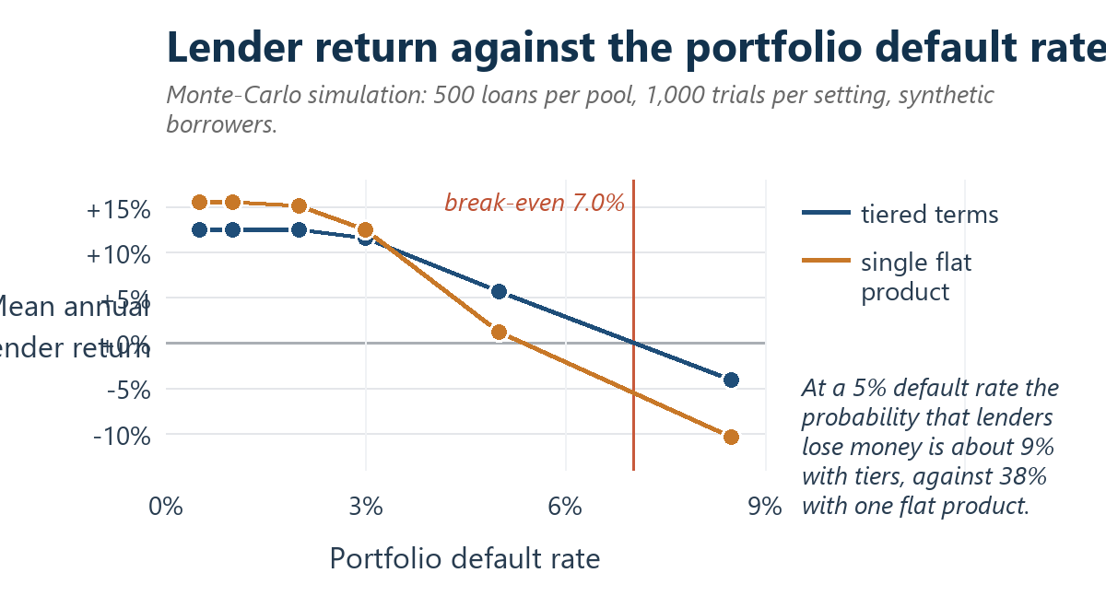
Figure 10. Lender return as the portfolio default rate rises, under tiered terms and under a single flat product, from the Monte-Carlo simulation of 500 loans per pool and 1,000 trials per setting on synthetic borrowers. The gap between the two curves, and the break-even markers, are the quantitative argument for risk-based pricing.
Table 30. Problem-validation survey results. Seven anonymous respondents aged 22 to 24, not members of the team. Likert items are 1 = strongly disagree or very unlikely and 5 = strongly agree or very likely. Collected 12 October 2026; the raw responses are held in the team's response workbook.
Question | Result | n
Respondents (not team members) | 7 | 7
No formal credit record | 7 (100%) | 7
Refused, or did not apply for fear of refusal | 6 (86%) | 7
Needed a small loan at least once in 12 months | 5 (71%) | 7
Borrowed from family rather than a bank | 4 (57%) | 7
"Lenders make it hard without a bank record" (mean of 5) | 4.57, sd 0.54, 7 of 7 at 4 or 5 | 7
"A portable repayment record would help" (mean of 5) | 4.71, sd 0.49, 7 of 7 at 4 or 5 | 7
"Willing to pay more for no collateral" (mean of 5) | 3.00, sd 0.82, only 2 of 7 agreed | 7
Likely or very likely to use the service | 4.43 mean, 7 of 7 at 4 or 5 | 7
Most chosen single priority | Lower interest rate (3), privacy (2), no collateral (2) | 7
Barriers named unprompted in free text | Distrust of cryptocurrency; cannot manage private keys; fear of debt pursuit | 3 of 7

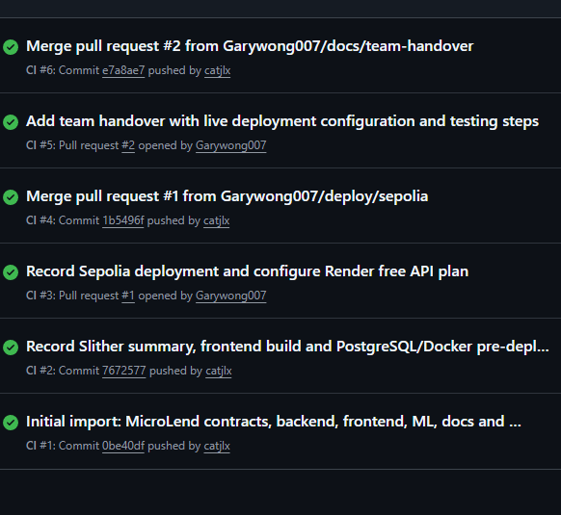
Figure 11. The GitHub Actions run list for the repository, captured 12 October 2026. Six runs, every one successful, from the initial import on 10 October to the merge of pull request #2 on 11 October. The second line of each entry names the commit the run built, which is how the pipeline ties to the history in the contribution report.
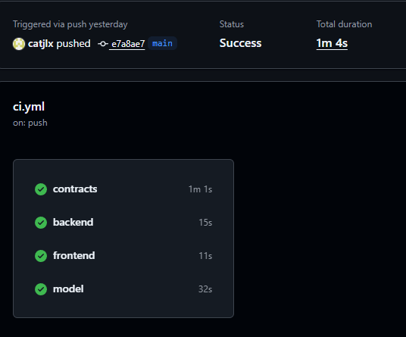
Figure 12. The four parallel jobs of run 6, the current head of main. The contracts job takes about a minute because it compiles, runs the 49-test suite, produces the gas report and runs Slither; backend, frontend and model together take under a minute: 15, 11 and 32 seconds. Two artefacts are uploaded. The run also carries four Node.js 20 deprecation notices, which are warnings rather than failures and are recorded here rather than omitted.

Appendix C. Author contributions
The matrix below is the team's own record of who did what. It is compiled from that record rather than from the commit history alone, because the repository records only two contributing accounts while the work was shared across six members: catjlx (JIANG LEXUAN), whose initial import placed the whole codebase in one commit, and Garywong007 (HUANG JUNXUAN). The accompanying contribution report holds the full master table, the commit and pull-request log, and the actions still outstanding.
Table 31. Contribution matrix, from the team's own record. Section numbers refer to this report. All six members reviewed the final draft.
Member | Matric. | Primary responsibility | Sections | Verifiable artefacts
LIU ZHEN | G260146E | Contract interfaces; LoanManager and LendingPool; Sepolia deployment | 5, 6 | The LoanManager and LendingPool sources, the shared interface definitions, and the Sepolia deployment record
DONG RUNZHOU | G2603792L | CreditRegistry and CollateralVault; automated test suites; gas analysis | 5, 6, 9 | The CreditRegistry and CollateralVault sources, the 49 contract and 16 backend tests, and the gas report
JIANG LEXUAN | G2601709B | The role-based interfaces for every role, six pages in total; MetaMask connection; transaction history and charts | 8 | The frontend sources, the role-based pages, the event log and charts, and the interface screenshots
HUANG JUNXUAN | G2602046C | The Express API and database; wallet sign-in and role enforcement; Render deployment | 3, 7, 10 | The backend sources, the database schema, the session and role-check modules, and the live URLs
GU YAOYUAN | G2602099F | Evidence gathering; stakeholder analysis; ethics and regulation; report editing, slides and video | 0 to 2, 11, 12 | The evidence table, the stakeholder analysis, the ethics discussion and the final edit
ZHANG SHUJIA | G2601577A | The credit-scoring model and its evaluation metrics; the validation questionnaire | 4, 9.7 | The model pipeline, the metrics report, the calibration and fairness figures, and the questionnaire

