Rubrics for Serving at a Hierarchical Liturgy
For deacons, subdeacons and altar servers
Watch the whole video · Download PDF · Download Word

How to use this document
This document has a section covering each step in the hierarchical liturgy. There are some of the major rubrics to consider for each step, and there is a video clip accompanying the step. The video clip may be accessed by scanning the QR code with your phone or tablet.
Alternatively you may go to the online document and follow along there, and use this document for taking notes, and for future reference.
There are also useful appendices at the end of the document (see the table of contents) some which can be cut out and pasted into your liturgy book for reference in the liturgy.
generated 16 Sep 2026, 11:25 · dd866c2
A step-by-step guide to serving at a hierarchical Divine Liturgy, from the greeting of the bishop at the doors through the Great Entrance, built on video footage recorded 20 June 2026 at Saints Peter and Paul Church, Endicott NY. OCA, Russian recension · Diocese of New York and New Jersey.

Contents
- Greeting of the Hierarch at the Doors · 0:00
- The Bishop Enters the Nave · 1:10
- Entrance Prayers · 2:35
- Preparing to Vest the Bishop · 3:13
- Vesting the Bishop · 4:27
- The Blessing of the Dikiri and Trikiri · 6:15
- Final Prayers before the Liturgy · 8:31
- Washing of the Hands · 10:10
- Completion of the Washing of Hands and the Second Litany · 11:36
- The Second Antiphon · 12:16
- The Beginning of the Little Entrance · 12:48
- The Conclusion of the Little Entrance · 14:08
- Hierarchical Censing After the Great Entrance · 15:54
- Troparion, Kontakion, Save the Pious and the Thrice Holy · 18:01
- Conclusion of Thrice Holy · 22:10
- Lesser Censing, and Epistle Reading · 23:08
- Alleluias and the Gospel Book Goes Out · 26:32
- Reading of the Gospel · 27:30
- Gospel is Returned to the Altar · 28:41
- Augmented Litany Begins · 29:15
- Augmented Litany through censing before great entrance · 29:36
- Clergy Kissing the Bishops Shoulder · 36:24
- The Bishop makes His Commemorations · 36:40
- Covering the Gifts and The Great Entrance · 36:55
- Conclusion of the Great Entrance · 41:13
- Litany of Supplication and the Creed · 41:59
- The anaphora part 1 · 42:30
- The anaphora part 2 · 44:51
- The anaphora part 3 · 46:33
- The anaphora part 4 · 47:42
- After Communion · 51:51
- Litany of Thanksgiving · 53:30
- Final blessing and Many Years · 54:53
- Conclusion · 59:06 A. Glossary B. Assigning Subdeacons and Altar Servers C. A Note on the Spiritual role of Altar Servers D. Serving with More or Less than Two Deacons E. Pages to Cut Out and Add to the Liturgy Book

Hierarchical Divine Liturgy Recorded at NY&NJ Deacon Training 20 June 2026
Page references are from St. Tikhon’s Hieratikon Vol 2, 2017

Greeting of the Hierarch at the Doors
clip 1 · 1:27 · 0:00 in the video
Greeting of the Hierarch at the Doors
Ready at the door should be Children with flowers. Parish Council President — bread and salt.
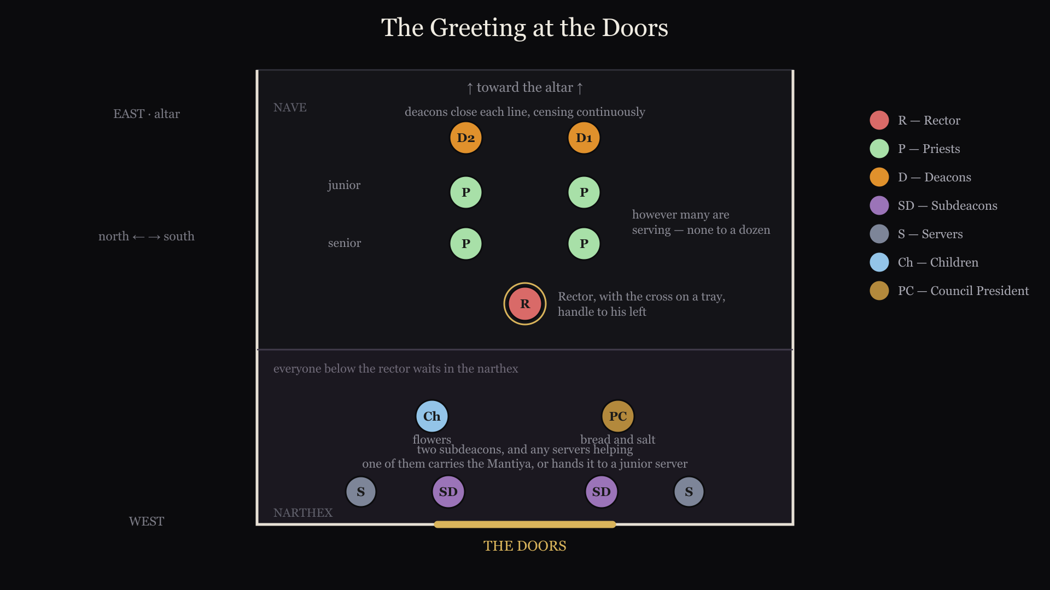
Greeting of the Hierarch at the Doors — plan
Parish Council President should be prepared with Bread and salt
Children should come with flowers
Priest should be ready with a blessing cross on a tray with handle to the priest’s left
Rector at center, other priests to south and north sides of the church
Other priests present should be lined up in order of rank inside the Nave
Deacons should be ready with censers behind the priests
Two vested servers should be ready at the doors with the Mantiya
One subdeacon or altar server holds the train of the Mantiya
Two additional servers should be in the narthex ready to follow and assist
0:06 · SUBDEACONS
place the Mantiya
0:10 · DEACONS
Continuously cense the Bishop
0:14
Notice arrangement of priests in order of seniority with deacons behind them.
1:22 · PRIEST
At the conclusion, the priest presents the cross

The Bishop Enters the Nave
clip 2 · 1:20 · 1:10 in the video
The Bishop Greets the Clergy, and Enters the Nave
0:01
The priests in order kiss the cross, and the Bishop’s hand and receive the blessing,
0:09
Then the presiding priest does the same, and is given back the cross on his tray
0:16 · FIRST DEACON
“Bless, master, the holy incense” - Both Deacons hold up their censers
0:27 · SECOND DEACON
Wisdom!
0:30 · DEACONS
turn around and walk forward toward cathedra
0:34 · CHOIR
While the first deacon, chants and the choir sings - “it is truly meet…”
0:42 · DEACONS
walk past cathedra, turn around and continue to cense the Bishop
0:56 · DEACONS, SERVERS
turn towards the altar, as Bishop walks past, giving their censers away
1:00 · SERVERS
The server holding the train takes the staff, and the Bishop will greet the icons
1:04 · SERVERS
The two servers holding the censers return them to the altar

Entrance Prayers
clip 3 · 2:44 · 2:35 in the video
Entrance Prayers
0:15 · FIRST DEACON
reads the entrance prayers quietly, As normal, BUT stops before “I will enter thy house”

Preparing to Vest the Bishop
clip 4 · 2:10 · 3:13 in the video
Preparing to Vest the Bishop
1:05 · FIRST DEACON
Ton Despótēn kaì Archiaréa hēmōn, Kýrie phýlatte: eis pollà étē, Déspota!
1:09
Pronunciation: ton thes-PO-teen keh ar-hee-eh-REH-ah ee-MON, KEE-ree-eh FEE-lah-teh: ees poh-LAH EH-tee, THES-poh-tah!
1:50 · SERVERS
have censers ready at both deacon’s doors
1:54 · DEACONS
retrieve loaded censers from north and south doors

Vesting the Bishop
clip 5 · 1:28 · 4:27 in the video
Vesting the Bishop
All vestments, and other articles must have been prepared and neatly stacked. A tray should be ready to receive the Mantiya and Klobuk. These are ready in the sanctuary or on a table in the nave. Altar servers need to be assigned to carry these items. An altar server should be ready to receive the staff, as the senior servers will now help with the vesting.
0:00 · SERVERS
A junior server takes the staff, and the Mantiya is removed
0:04 · SUBDEACONS
The Bishop takes off his Klobuk and hands to the subdeacons, who place it on the tray.
0:15 · SUBDEACONS
The Bishop removes his cross, and Encolpion, and other items
0:19 · SERVERS
MEANWHILE: The vestments are brought from their location to the Bishop
0:25 · SUBDEACONS
The Bishop removes his riassa, and its placed with the rest of the items
0:33 · SERVERS
The items are taken back to the sanctuary
0:36 · DEACONS
The deacons raise their censers for the blessing
0:50 · DEACONS
Before each item is readied, the second deacon says: Let us pray to the Lord! Then the first deacon chants the appropriate prayer for that item.
1:05 · DEACONS
During the vesting the deacons continuously cense the Bishop.

The Blessing of the Dikiri and Trikiri
clip 6 · 2:10 · 6:15 in the video
The Blessing of the Dikiri and Trikiri
As the cross and Encolpion are placed, the Dikiri and Trikiri are brought from the altar, followed by the clergy.
0:00 · SUBDEACONS
Dikiri on bishops left (left is less), Trikiri on the right (more candles, more letters in right)
0:46 · DEACONS
At the last Amen, rapidly cense the Bishop
1:24 · SUBDEACONS
take the Dikiri and Trikiri (kissing the hand) and go to the iconostasis
1:29 · DEACONS
as the Bishop blesses the deacons they cense him nine times
1:40 · SUBDEACONS, DEACONS
The two subdeacons, and deacons turn and reverence the altar, then turn and reverence the Bishop.
1:49
the subdeacons and servers take the Dikiri, Trikiri and censers to the altar
1:53 · DEACONS
while the deacons stand in front and to the side of the Bishop, bowing first to the altar, then to the Bishop

Final Prayers before the Liturgy
clip 7 · 1:31 · 8:31 in the video
Final Prayers before the Liturgy
These are the same prayers said by the priest at the altar, but here they are said in front of the Ambo (see pg 87)
0:26 · FIRST DEACON
It is time for the Lord to act etc, just the same as at the beginning of the Liturgy
0:32 · FIRST DEACON
pray for me reverend master and receive the blessing
0:35 · SECOND DEACON
also receives a blessing and stands behind the Bishop on his left.
0:38 · FIRST DEACON
stands before the icon of Christ at the iconostasis
0:52 · FIRST DEACON
along with those at the altar, bow to the high place, then to the Bishop and the liturgy begins
1:05 · SERVERS
The Bishop’s Hieratikon is brought out the north door, and the server stands with the first deacon for the blessing.
1:16 · FIRST DEACON
after unto ages of ages… turn around and again reverence the Bishop. note: this is done before each litany by both deacons, remember get a blessing to proceed

Washing of the Hands
clip 8 · 1:17 · 10:10 in the video
Washing of the Hands
These are said by the first deacon during the singing of the first antiphon (see page 71) The second deacon moves into place for the second (little) litany
0:00 · SUBDEACON, SERVERS
As the final litany is chanted commemorating our most holy… Three servers come down in front of the Ambo Traditionally a young server carries the bowl, pitcher and towel.
0:08 · SECOND DEACON
moves forward to stand before the Theotokos

Completion of the Washing of Hands and the Second Litany
clip 9 · 0:30 · 11:36 in the video
Completion of the Washing of Hands and the Second Litany
The second deacon is now in place to chant the second litany. The first deacon moves behind and to the right of the Bishop. The servers return to the sanctuary
0:00 · SERVERS
At the conclusion of the washing of the hands, the servers return to sanctuary
0:04 · FIRST DEACON
moves behind and to the right of the Bishop
0:15 · SECOND DEACON
As the first antiphon concludes, bow to the icon, and then to the Bishop

The Second Antiphon
clip 10 · 0:21 · 12:16 in the video
The Second Antiphon
At the conclusion of each litany the deacon also bows to the Bishop.
As the second antiphon begins, the Hieratikon is brought to the Bishop.
The third Litany is chanted as usual.

The Beginning of the Little Entrance
clip 11 · 1:05 · 12:48 in the video
The Beginning of the Little Entrance
The key is to organize the players before leaving the altar - 1) junior servers with candles: they will end at the back - 2) then the Dikiri: it will end up at the bishops left - 3) then a fan: it will be between the Dikiri and the altar - 4) the second and (5) the first deacon: who will travel behind the Bishop the second deacon crosses over with the censer, between the fan and the altar the first deacon moves level with the second deacon carrying the Gospel - 6) then the second fan, which will be level with the other fan - 7) and finally the Trikiri
0:00 · SERVERS
Extra servers carrying candles come first
0:02 · SUBDEACON
the Dikiri
0:04 · SERVERS
the fan on the left
0:06 · SECOND DEACON
carrying the censer
0:08 · FIRST DEACON
carrying the Gospel
0:11 · SERVERS
the fan on the right
0:13 · SUBDEACON
the Trikiri
0:16
the Dikiri and fan on the left are dropped off
0:18
every one else moves behind the Bishop and to his right
0:24
notice the censer is carried around to the Bishop’s left
0:28
everyone reverences the icons, and then the Bishop
0:39
everyone is now facing each other with the Bishop at the center

The Conclusion of the Little Entrance
clip 12 · 1:40 · 14:08 in the video
The Conclusion of the Little Entrance
Generally follows the rubrics on pages 97-99
The Dikiri and Trikiri will be taken from the Bishop as he enters the royal doors.
0:10 · FIRST DEACON
Bless Master the Holy Entrance (p 98)
0:16 · FIRST DEACON
Presents the Gospel to Bishop to kiss. Be sure to hold it high enough for the Bishop.
0:21 · SUBDEACONS
Hand the Dikiri and Trikiri to the Bishop. And move just behind the first deacon. The second deacon continuously censes. While the fans cover the Gospel.
1:10 · DEACONS
with the censer leading, return to the sanctuary
1:22 · SUBDEACONS
The senior servers return to escort the Bishop to the Ambo, and return to the sanctuary, where they wait to take the Dikiri and Trikiri

Hierarchical Censing After the Great Entrance
clip 14 · 1:54 · 15:54 in the video
Hierarchical Censing After the Great Entrance
The Bishop is given the Dikiri (left hand) and censer (right hand.) The first deacon will lead the Bishop in the censing carrying the Trikiri.
The rubrics for the lesser censing are on page 38.
1:43
The first deacon carries the Trikiri to the altar, and is ready to receive the censer. A server takes the Dikiri, while the first deacon takes the censer.

Troparion, Kontakion, Save the Pious and the Thrice Holy
clip 15 · 3:58 · 18:01 in the video
Troparion, Kontakion, Save the Pious and the Thrice Holy
This follows the exact rubrics from page 101, including the first deacon’s proclamation of O Lord, save the pious which is often not said in parish practice.
0:00
Ignore the many observing deacons
0:04 · SUBDEACONS
Dikiri on the right, Trikiri on the left. So that they are the bishops left and right hand as he faces the people.
0:31 · FIRST DEACON
As the choir sings to ages of ages… goes to the high place bows to the high place and the Bishop. This is the normal practice and should always be done before any action by the deacon
0:44 · SUBDEACONS
Note the position of Trikiri and Dikiri
0:50 · FIRST DEACON
Get the blessing from the Bishop and stand in front of Christ.
1:13 · FIRST DEACON
Let us pray to the Lord etc, following the full rubric on page 101
1:27 · FIRST DEACON
O Lord, save the pious is often translated in modern use as O Lord, save those who fear thee
2:00 · FIRST DEACON
After smoothly walking through the royal doors, go to the high place as usual, and take the DIKIRI to the Bishop

Conclusion of Thrice Holy
clip 16 · 1:17 · 22:10 in the video
Conclusion of the Thrice Holy
Rubrics are the same as page 102-103 Second deacon will read the epistle
1:05 · SECOND DEACON
gets the blessing from the Bishop, and walks out the royal doors holding the epistle book high with the cross facing the people.

Lesser Censing, and Epistle Reading
clip 17 · 3:17 · 23:08 in the video
Lesser Censing, and Epistle Reading
0:00 · SERVERS
bring the censer opened fully, and spoon of incense. Hand the censer to the first deacon and spoon to the Bishop. The first deacon will hold the censer and the Bishop will add the incense.
0:32 · FIRST DEACON
Let us attend!, etc… per the normal liturgy, followed by the lesser censing.
1:00 · SUBDEACONS
remove the Omophoron, and hand it to a server who will stand to the side holding with the cross at the center
1:42 · FIRST DEACON
in best practice will finish censing the sanctuary and the doors and will wait at the royal doors till he announces the epistle before censing the iconostasis.
2:18 · FIRST DEACON
after censing the iconostasis, returns to cense the clergy as is normal, remembering to first cense the Bishop 9 times, then clergy from senior to junior, and south to north.
2:38 · FIRST DEACON
then censes the reader, the choir and the people as is normal.
3:00 · FIRST DEACON
finally censes Christ, Mary, and the altar as normal, and the Bishop (but only three times), bows to the high place, and the Bishop, and gives away the censer.

Alleluias and the Gospel Book Goes Out
clip 18 · 0:52 · 26:32 in the video
Alleluias and the Gospel Book Goes Out
0:00 · SERVERS
Altar servers use both doors, candle bearers first, then fans, then Dikiri and Trikiri.
0:36 · SERVERS
go out both doors, and wait at the Ambo for the Gospel
0:48 · FIRST DEACON
walk out the doors, as the Alleluias finish. Two deacons should cross beside each other.

Reading of the Gospel
clip 19 · 1:04 · 27:30 in the video
Reading of the Gospel
0:00 · SECOND DEACON
enters through the royal doors after reading the epistle, and stands on the south side of the altar holding the epistle book up, as the Gospel is announced.
0:12 · SECOND DEACON
Wisdom let us attend, let us listen to the Holy Gospel!
0:48 · SECOND DEACON
Let us attend!
0:52 · SECOND DEACON
Kiss the altar, and then get a blessing from the Bishop, returning to his place at the altar.
1:00 · SERVER
presents Omophoron to the Bishop to kiss.

Gospel is Returned to the Altar
clip 20 · 0:28 · 28:41 in the video
Gospel is Returned to the altar
0:04 · SUBDEACONS
upon returning to the Ambo hands the Trikiri and Dikiri to the Bishop, and waits for him to complete the blessing, then return them to the altar
0:14 · FIRST DEACON
unfolds the Eliton
0:20 · FIRST DEACON
unfolds the left and right sides of the Antimension, and kisses the altar

Augmented Litany Begins
clip 21 · 0:22 · 29:15 in the video
The Second deacon Begins The Augmented Litany after the Sermon as usual

Augmented Litany through censing before great entrance
clip 22 · 7:10 · 29:36 in the video
Augmented Litany through Censing before Great Entrance
There are several important differences, so watch carefully.
0:06 · SUBDEACON
during the augmented litany, uncovers the gifts in preparation for the Bishop’s commemorations. Note the placement of the various cloths, and utensils.
2:09 · DEACONS
perform the full rubrics for dismissing the catechumens. (pg 113)
2:30 · FIRST DEACON
censes the sanctuary - altar, table of oblation, high place, the icons, Bishop (9x), the clergy and servers, then stops.
4:12 · SERVERS
bring out the pitcher of water, with a server having a towel on his shoulders, carrying the bowl.
4:22 · SUBDEACONS
prepare to hold the Omophoron above the Bishop during the washing of the hands.
Be sure the buttons are facing the Royal Doors
4:38 · SUBDEACONS
raise the Omophoron after the Bishop has passed through the Royal Doors
4:46
note: in some traditions the Bishop will sprinkle the water towards the congregation. Wait a few seconds before presenting the towel.
5:08 · SUBDEACONS
reattach the Omophoron.
5:24 · DEACONS
follow the rubrics on pg 118 as normal: That we may receive the King of all… X 3
6:02 · SERVER
takes the Bishop’s Miter.
6:15 · DEACONS
proceed to the table of oblation, the second deacon carrying a censer.
6:20 · SECOND DEACON
hands the censer to the Bishop, kissing His hand.
6:31 · SECOND DEACON
receives the censer back from the Bishop, kneels, and receives the Aer on his shoulder, and the censes the doors, the iconostasis, and the people.

Clergy Kissing the Bishops Shoulder
clip 23 · 0:09 · 36:24 in the video
Clergy Kissing the Bishops Shoulder
In order of rank the clergy and the servers state their rank and name, and kiss the Bishop’s shoulder.

The Bishop makes His Commemorations
clip 25 · 0:09 · 36:40 in the video
The Bishop now makes His Commemorations
0:00 · SECOND DEACON
remains at the Table of Oblation ready to complete the Proskomedia with the Bishop.

Covering the Gifts and The Great Entrance
clip 26 · 4:31 · 36:55 in the video
Covering the Gifts and The Great Entrance
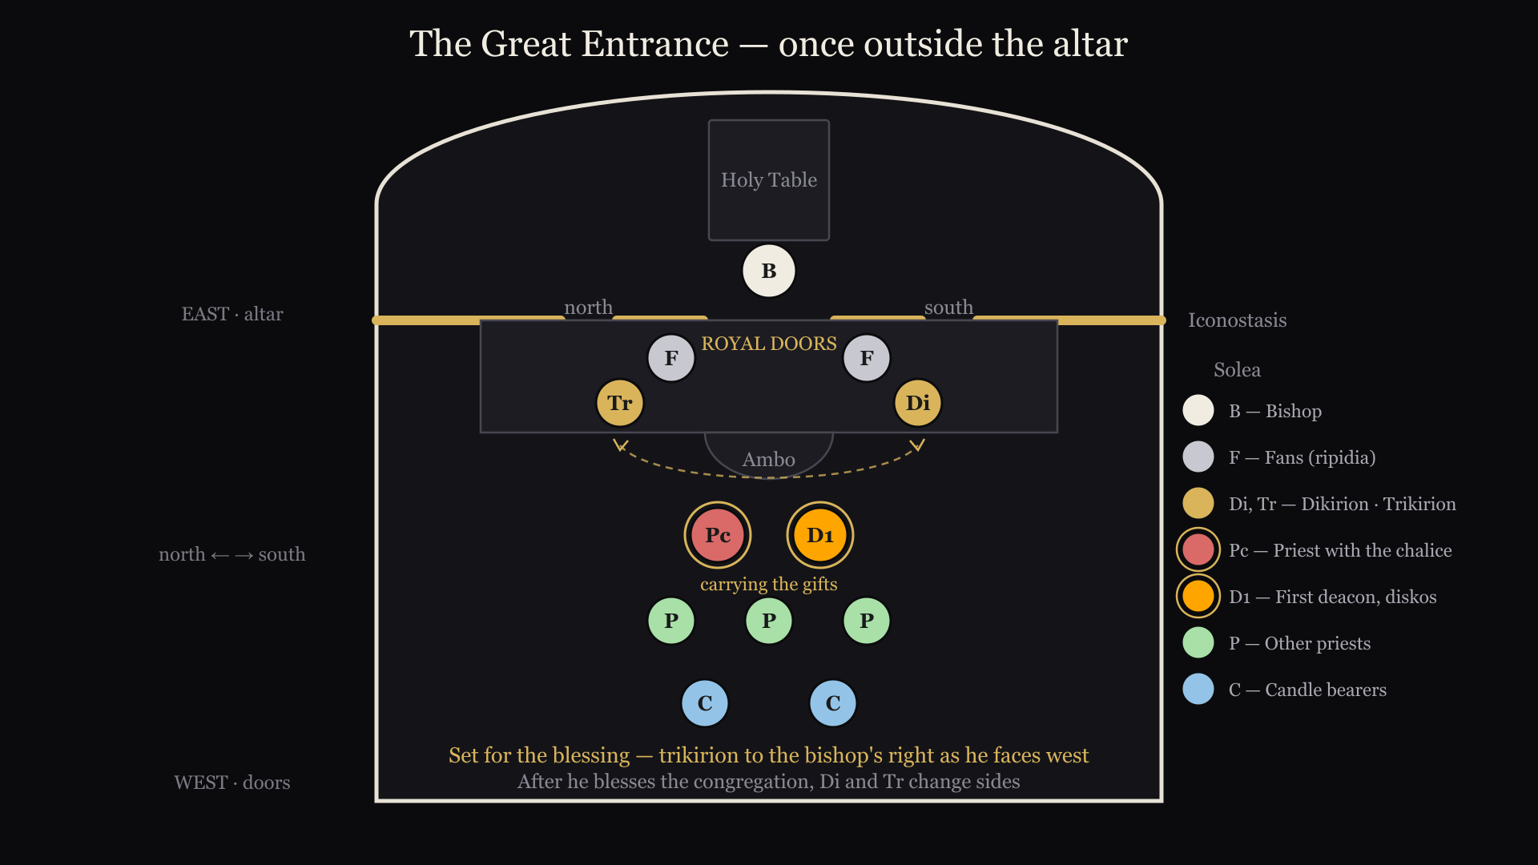
The Great Entrance — positions
0:00
At the Table of Oblation
0:10 · SECOND DEACON
holds the censer. Notice how the censer is held: by the bottom, with the lid pulled away.
0:18 · SECOND DEACON
concludes the Proskomedia with the Bishop. (See pgs 82-85, the deacon’s part should be memorized)
1:16 · SERVERS
carry (in order) the Miter and the Omophoron…
1:22
the candles…
1:24
the Dikiri…
1:26
the censer (carried by the second deacon)…
1:28
a fan…
1:33
the Diskos (carried by the first deacon)…
1:36
the Chalice…
1:38
the second fan, and Trikiri…
1:43
and other priests carrying crosses.
1:47 · SERVERS
have continued moving through the south deacon’s doors, carrying the Omophoron and Miter
1:53 · SECOND DEACON
also has returned to the sanctuary through the Royal Doors and is at his side of the altar, with his censer.
2:00
meanwhile on the Ambo the procession proceeds so that: fans are on either side of the Royal doors, Dikiri and Trikiri behind them (or if Ambo is narrow beside them) the first deacon and priest carrying the gifts at the foot of the Ambo, other priests behind them, and candle bearers behind them. This will set things up for the following actions
2:31 · SECOND DEACON
gives the censer to the Bishop.
2:36 · FIRST DEACON
moves the center of the royal doors, and kneels presenting the Diskos to the Bishop, who censes him.
2:46 · DEACONS
The second deacon takes the censer and the first deacon hands the Diskos to the Bishop. The first deacon returns to the altar, either through the royal doors (if there is room) or through the south deacon’s door.
3:23
The priest carrying the chalice has presented it to the Bishop and again the second deacon will hand the censer to the Bishop and take it back.
3:41 · SECOND DEACON
now moves to the other side of the altar still holding the censer, and wearing the aer.
3:51 · SUBDEACONS
after the Bishop finishes blessing with the Dikiri and Trikiri and returns to the altar, the subdeacons cross the Ambo swapping places.
This allows the Dikiri and Trikiri to return to the correct side of the altar.
4:05
The following is a diagram of the where everyone should stand outside the sanctuary during the Great Entrance.

Conclusion of the Great Entrance
clip 27 · 0:30 · 41:13 in the video
Conclusion of the Great Entrance
Not shown: The second deacon kneels to the Bishop and the Aer is removed. He rises and holds the censer as the Aer is censed, then the censer is given to the Bishop.
0:00 · SECOND DEACON
takes the censer back from the Bishop, goes the high place, censes the Bishop 9 times, then bows to the high place.
0:15 · SUBDEACONS
have remained on the Ambo and will hand the Dikiri and Trikiri to the Bishop, and then after the blessing return them to the Altar.

Litany of Supplication and the Creed
clip 28 · 2:41 · 41:59 in the video
Litany of Supplication and the Creed
For the Deacons and servers this follows the normal rubrics.

The anaphora part 1
clip 29 · 2:55 · 42:30 in the video
The anaphora part 1
0:00 · SUBDEACONS
have brought the Trikiri and Dikiri to the corner of the altar during the creed…
0:06
and hand them to the Bishop as the creed concludes.
0:34
the first deacon returns to the sanctuary, and the subdeacons and deacons now stand together, at the high place
1:18 · SUBDEACONS
move back to be ready to receive the Trikiri and Dikiri as the choir sings It is meet and right… (pg 129)
1:30
All will bow to the high place together, turn, and then the Dikiri and Trikiri are returned to their places
1:42 · SUBDEACONS
return to their places. The second deacon will kiss the altar and hold the star as usual.

The anaphora part 2
clip 30 · 1:36 · 44:51 in the video
The anaphora part 2: Words of Institution
This follows the exact rubrics on pg 132, the first deacon raising the chalice.

The anaphora part 3
clip 31 · 1:04 · 46:33 in the video
The anaphora part 3: Epiclesis
Again this follows the exact rubrics on pg 134-135.
0:04 · FIRST DEACON
Create in me a clean heart oh God, and renew a right Spirit within me!
0:14 · SECOND DEACON
Cast me not away from thy presence, and take not thy Holy Spirit from me!
0:42 · FIRST DEACON
Bless Master the Holy Bread…Bless Master the Holy Cup…etc (all said by the first deacon pg 134)

The anaphora part 4
clip 32 · 2:44 · 47:42 in the video
The anaphora part 4
With the Bishop present additional prayers are said by the first deacon before the Lord’s prayer.
These are not in the rubrics book!
0:16 · SECOND DEACON
takes the censer from the Bishop and continues to bless the south, east, north, and west sides of the altar, and returning to the south-east corner, censes the Bishop 3 times.
0:48 · FIRST DEACON
while the hymn is being sung, goes to the high place, makes the usual reverences, and kissing the altar as he passes, goes out through the Royal doors.
0:56 · CHOIR
singing… without corruption thou gavest birth to God the Word: true Theotokos, we magnify thee.
1:07 · FIRST DEACON
now says: For All Mankind!
1:38
The following prayer and action begins as the priest concludes with the words Among the first … and rightly divides the word of thy truth!
1:58 · FIRST DEACON
For His Eminence, The Most Reverend Michael, Archbishop of New York, of the Diocese of New York, and New Jersey…
2:06 · FIRST DEACON
who here offers – and turning enters the sanctuary – These Holy Gifts – pointing to the Diskos and Chalice
2:09 · FIRST DEACON
Unto the Lord our God – after going to the high place and reverencing the high place and the Bishop
2:12 · FIRST DEACON
For the most blessed Tikhon, Archbishop of Washington Metropolitan of all America and Canada
2:18 · FIRST DEACON
For the holy synod of Bishops, the Most Reverend Metropolitans, Archbishops and Bishops
2:25 · FIRST DEACON
For the honorable priesthood the diaconate in Christ
2:29 · FIRST DEACON
Goes and stands again under the arch of he Royal doors, while saying: For every priestly and monastic order.
2:35 · FIRST DEACON
For this land, its civil authorities and armed forces.
2:42 · FIRST DEACON
For peace of the whole world For the good estate of God’s Holy Churches
0:00 · FIRST DEACON
For the salvation and assistance of all those who diligently labor and serve
0:08 · FIRST DEACON
For the healing of the sick, for the repose, pardon, blessed memory, and forgiveness of sins of all Orthodox who have fallen asleep.
0:20 · FIRST DEACON
For the salvation of all the people here present, and for those they have in mind.
0:28 · FIRST DEACON
And for all mankind!
0:35 · FIRST DEACON
Returns to the high place, makes the usual reverences, and receives a blessing from the Bishop, kissing His hand and shoulder.
1:00 · SECOND DEACON
Goes out the south door, to give the litany before the Lords Prayer in the usual fashion (pgs 140-143)

After Communion
clip 34 · 1:22 · 51:51 in the video
Holy Communion now proceeds in the usual fashion.
The clergy in order of rank receive the body, from the Bishop, stating their rank and name, and kissing the Bishops hand and shoulder.
And again receiving the precious blood in the usual manner.
The video continues after the clergy and faithful have received communion.

Litany of Thanksgiving
clip 35 · 1:17 · 53:30 in the video
Litany of Thanksgiving

Final blessing and Many Years
clip 36 · 4:07 · 54:53 in the video
Final blessing and Many Years

Conclusion
clip 37 · 0:21 · 59:06 in the video
Conclusion

Glossary
Appendix A
Dikirion — the two-branched candlestick, signifying the two natures of Christ. Trikirion — the three-branched candlestick, signifying the Trinity.
Zhezl — the bishop’s staff. Written jezel in some of the notes; the same object is called simply “the staff” elsewhere, and one spelling should win before this is published.
Orlets — the eagle rug the bishop stands on.

Assigning Subdeacons and Altar Servers
Appendix B
The rubrics above call on subdeacons throughout. You may have to appoint one or even two subdeacons choosing adult, experienced altar servers for the role. They should be vested and know the whole sequence beforehand — this is not a role to hand to someone on the day. Another option is to have deacons act as subdeacons.
Where there are no subdeacons, the two senior altar servers, unless blessed to do so do not vest as subdeacons and do not handle the dikirion and trikirion at the blessing.
Another important role, is the altar server who will bring out the bowl, pitcher and towel for the washing of the Bishops hands. Usually this is a junior server who will be greatly encouraged by playing this important role.
Optimally you will have at least two more adult servers who will carry the fans, and who will keep an eye on things on the north and south sides of the altar is a good idea. They should watch the subdeacons for direction, and can be a great help in keeping things running smoothly by paying attention.
Additional altar servers can carry lamps in the entrances, and should behind the other clergy and servers. See the little and great entrances for details. Also try to line the servers up symmetrically if possible: for example if you have two smaller boys carrying lamps and one larger boy, the larger boy should be in the middle.

A Note on the Spiritual role of Altar Servers
Appendix C
The following analogy may be useful in helping younger boys to stay focused and on task:
Christians, and especially Orthodox Christians are like God’s special forces. We are in the world taking back territory that has been stolen by the evil one.
The temple in which we meet is like a protected forward fort in enemy territory. When we are in the temple, we are in a safe place, with more protection from evil than in the outside world. We come to the temple to be healed from our wounds, to rest, and to be trained for the next battle.
But at any fort you will always have guards, and that is precisely what the altar servers are. And the more alert and focused the servers on their duty no matter how small it may seem, the harder time the enemy will have in attacking our fort.

Serving with More or Less than Two Deacons
Appendix D
The rubrics and video above have assumed two deacons, which is the normal case at a hierarchical liturgy. Where fewer are available the duties do not disappear; they are reassigned.
With one deacon, he takes the first and second deacon’s part throughout, and the litanies that would alternate fall to him.
Consult the Bishop or your Dean to determine how to handle the “washing of the hands”, and censing during the Cherubic Hymn, which are normally done simultaneously with the second Deacon
Where there are more than two deacons, the third and fourth deacons are given some of the roles of the second deacon, and subdeacons as well.
The following chart shows the typical roles for 2-8 Deacons serving at a liturgy. Read across for each liturgical action, and stop at the column for the number of deacons serving. That will determine which deacon(s) perform that role.
Note: If there are less than 4 deacons, the Trikiri and Dikiri are carried by Subdeacons, and the Fans by either subdeacons or altar servers.
A version sized to be cut out and kept in a service book is at the end of this document, under Pages to Cut Out.
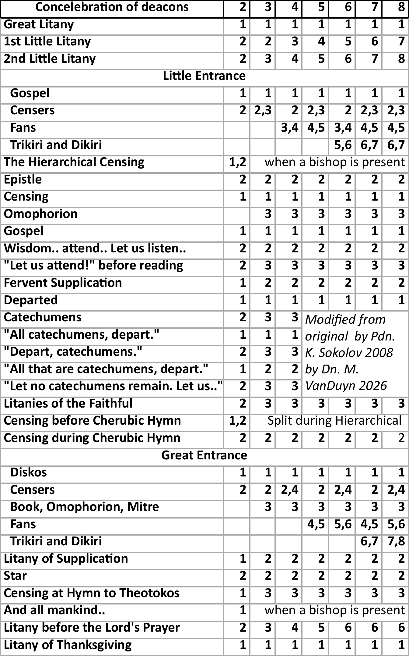
Roles for concelebrating deacons

Pages to Cut Out and Add to the Liturgy Book
Appendix E
Where a hierarchical liturgy departs from the ordinary one, the difference is easier to keep in the book than in the head. The pages below are set to the size and type of the service book itself, so a printed one can take the place of the handwritten note most of us end up making.
Each is printed on one side only: paste the blank side over the page it replaces, and where a piece spans two facing pages, fold it down the middle into the gutter first.
The sheets themselves are gathered at the end of this document, under Pages to Cut Out, each at the size it should be cut to.
Page 56 — the completion of the vesting. This page adds rubrics for the completion of the vesting of the Bishop; it is pasted over page 56.
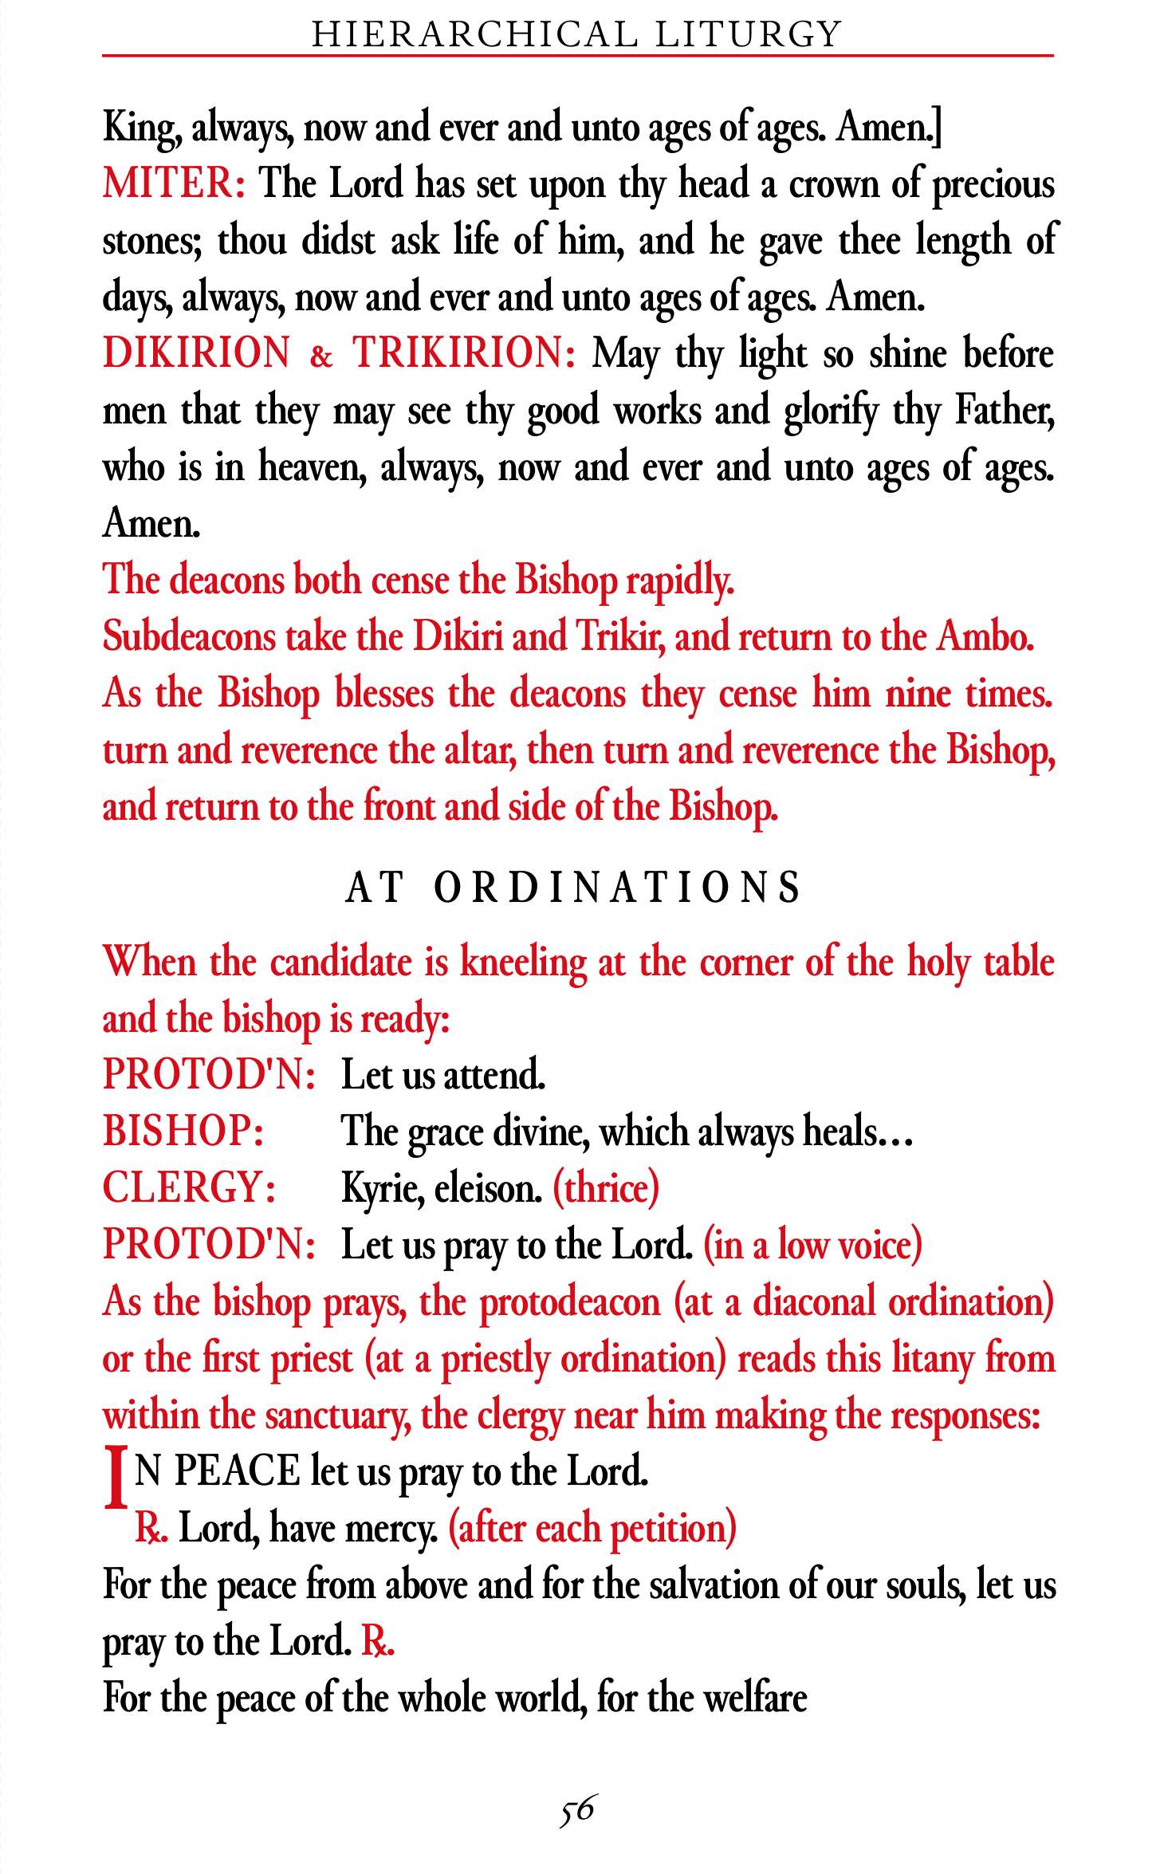
Page 56, the completion of the vesting
Pages 64–65 — the entrance prayers. The ordinary entrance prayers, with the hierarchical addition set where it belongs: after the priest’s prayer the deacon and choir intone Ton Despótēn, which is answered often and mispronounced easily, so it is given here with its pronunciation. The ordinary rite then resumes on page 65, undisturbed.
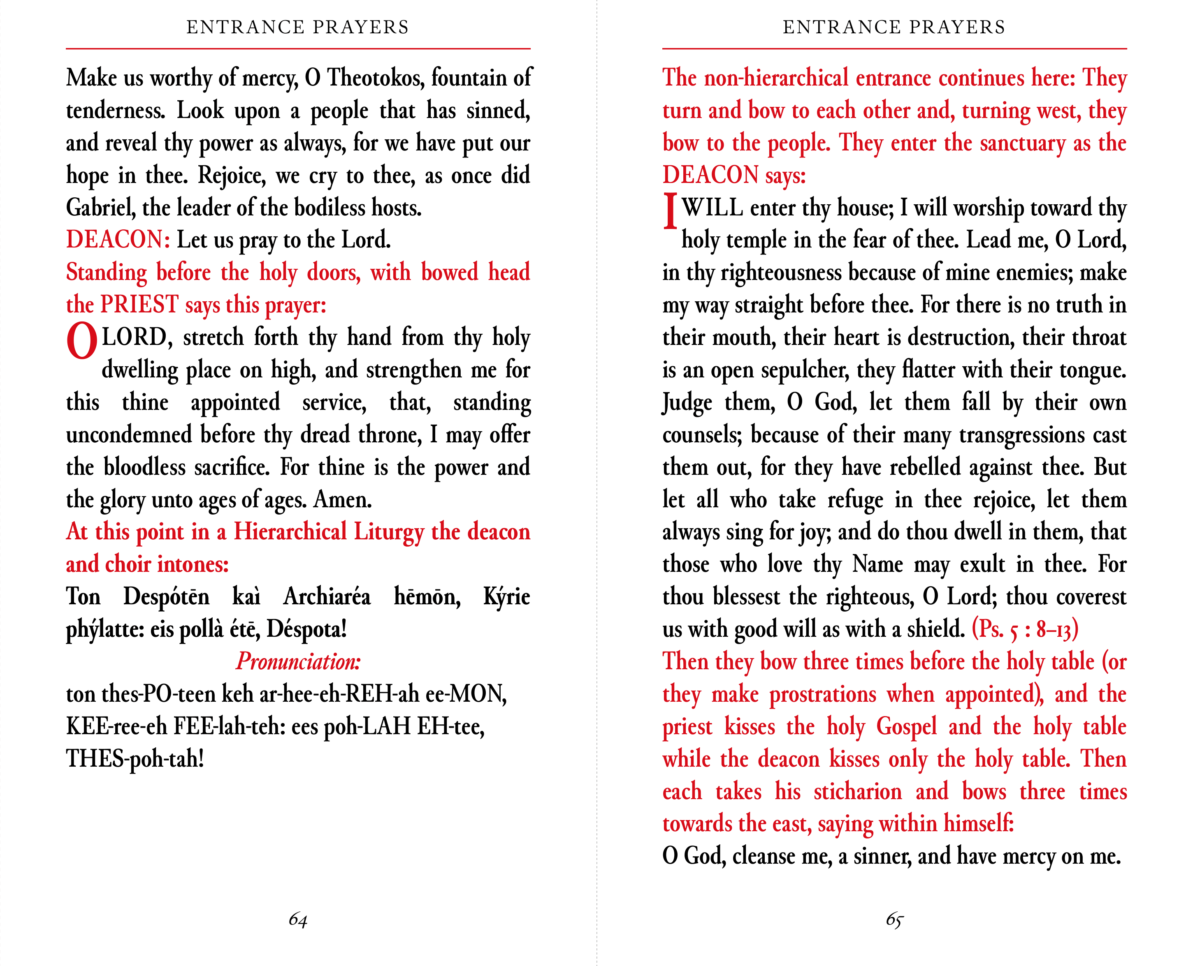
Pages 64-65, the entrance prayers
Pages 136–137 — the great commemoration. From the offering through Is Polla Eti Despota. This one spans the open book, so it folds into the gutter and is pasted over both facing pages.
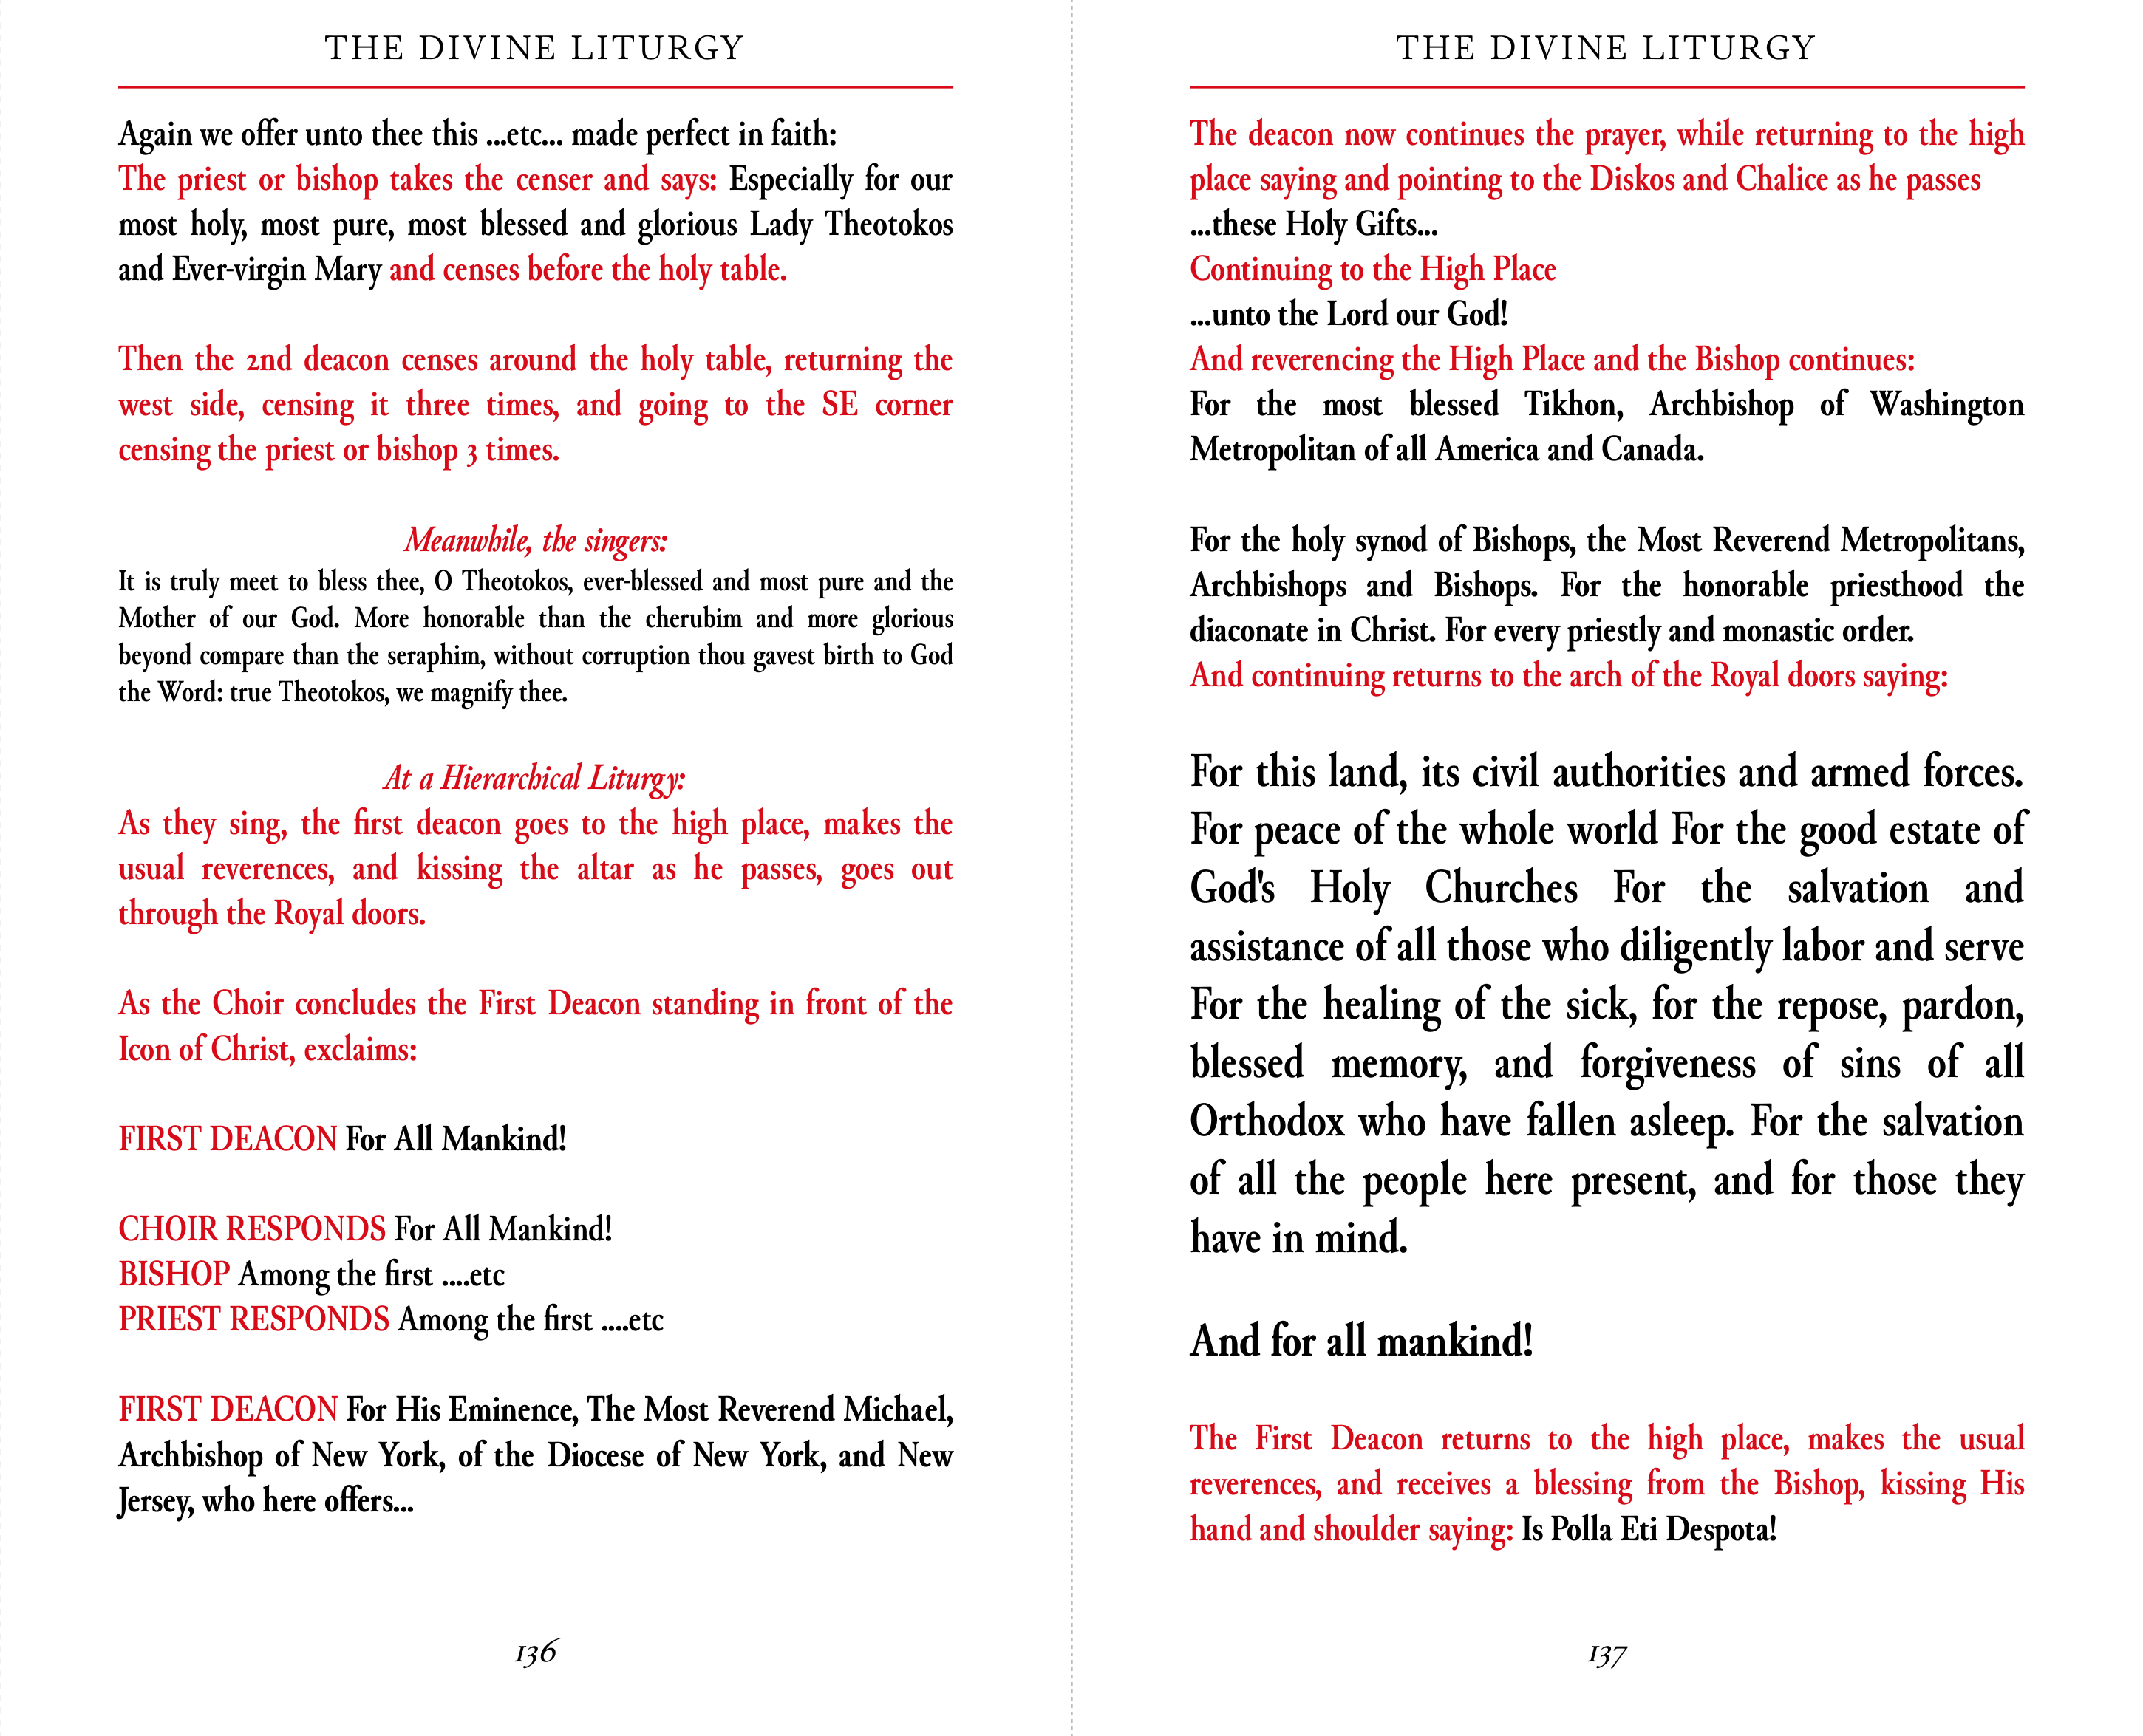
Pages 136-137 for a hierarchical liturgy

