Hashing Algorithms Assignment
- Hashing Fundamentals
Define the following terms and concepts:
  - Hash Function
The most common use of hash functions in data structures and algorithms is in hash tables. A hash function takes a key, of any length, as input and maps it to fixed sized value that is used to determine an index in the table. A hash function must always produce the same output for the same input and should distribute keys uniformly to reduce collisions (Khinchi 2025).
  - Hash Table
Data in a hash table is stored in key value pairs. The hash table is used to insert, find and remove these key value pairs and has an average time complexity of O(1) but in the worst case requires O(n) if there is a high number of collisions or an overly high load factor. Hash tables are often used for search large amounts of data (Garg 2025).
  - Collision in a hash table
Collisions occur when more than one key maps to the same index. Avoiding collisions completely is not possible but can be reduced by using a well designed hash function. Open addressing or chaining can be used to deal with the collisions that do occur (Cormen et al. 2022).
1.4. Load Factor
The load factor is determined by how many elements are in the table compared to how large the table is. A high load factor can result in a longer search time if collisions are not well distributed. To ensure efficient performance hash tables are typically resized and rehashed when the load factor exceeds a specified amount (Garg 2025).
1.5. Open addressing
Open addressing is a type of collision resolution used in hash tables where all elements are stored in the table itself. It works by checking if the first insert position is possible, if it is not possible to insert there as it holds another value it will then try another position and will continue to do this until an empty position is found (Cormen et al. 2022).

2. Compare Hashing with Tree-based Structures:
2.1. Discuss how hash-based data structures (like hash tables) differ from tree-based data structures (like red-black trees or AVL trees).
Hash based structures store elements using a hash function to map keys to indexes. This allows for fast access but does not order the keys. The quality of the structure depends heavily on the quality of the hash function, the load factor and how collisions are handled.
Tree based data structures like AVL Trees and red black trees organise and store their data in a self balancing binary search tree structure. Keys are kept in a sorted order and the tree automatically balances after insertions to maintain their height.

2.2. What are the advantages and disadvantages of each in terms of time complexity for operations such as insert, delete, and search?
Hash based data structures have an average complexity time of O(1) which means that all operations should be constant per operation and results in very fast operations. Worst case performance can occur due to high amounts of collisions and results in a time complexity of O(n).
Tree based data structures such as AVL or red black trees have a guaranteed O(log n) time for all operations as self balancing ensures that the height always remains logarithmic and operations will traverse at most the height of the tree (Cormen et al. 2022).
It must also be considered how tree based data structures offer a wider range of operations such as select, sort and range search which is not possible with hashing so in cases where these operations were necessary tree based structures would be the obvious choice (Sedgewick and Wayne 2017).
3. Hashing Algorithms with Divide and Conquer Approach:
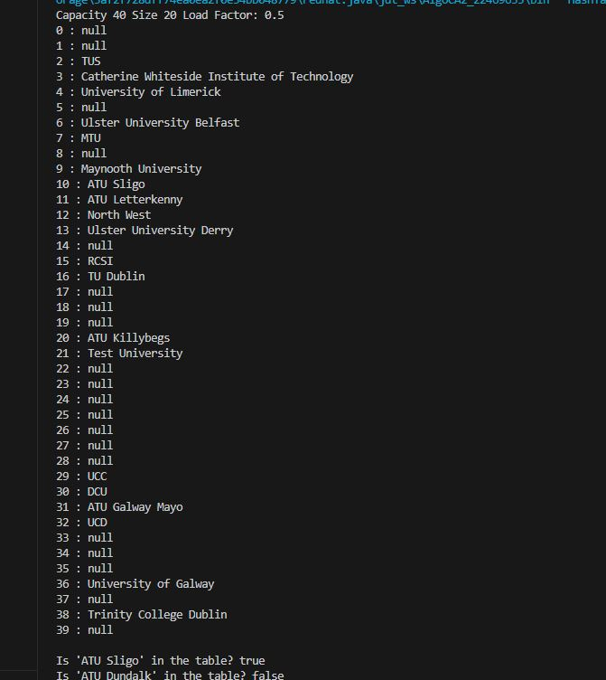
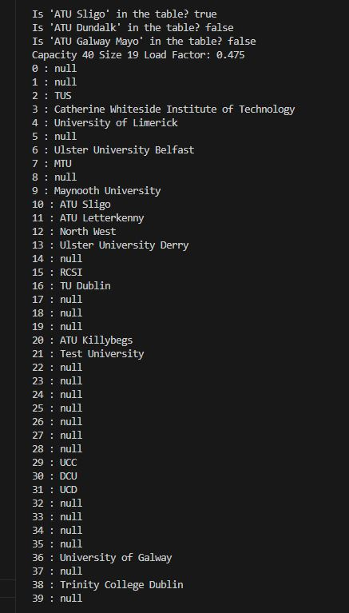

Q4.
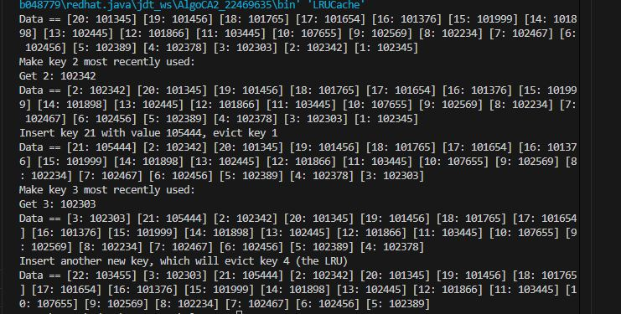
5. Briefly describe how Question 4 (LRU cache) can be updated to support concurrency.
Question 4 could be updated to use ConcurrentHashMap rather than HashMap and use a ReentrantLock for synchronisation (Kumar 2023).
ConcurrentHashMap is thread safe and allows for multiple threads to read and write at the same time without slowing operations down. It does not lock the entire map and instead locks small parts when needed so threads working on different keys can run in parallel. Read operations typically do not need locking and are fast. Write operations use short locks to keep data consistent. The map is also able to resize itself while other threads are using it (Oracle 2025) . This differs from HashMap as HashMap is not thread safe so if multiple threads are accessing it at the same time it can result in race conditions causing unpredictable outputs or data corruption.
ReentrantLock also works to prevent race conditions as it ensures that only one thread can access synchronised methods at one time. ReentrantLock needs to be called explicitly in order to lock and unlock threads which makes it more flexible than many other options but also can cause issues if it is not implemented properly.

References
Cormen, T.H., Leiserson, C.E., Rivest, R.L., and Stein, C. (2022) Introduction to Algorithms, 4th edn, The MIT Press.
Garg, N. (2025) Hash Table Data Structure [online], GeeksforGeeks, available: https://www.geeksforgeeks.org/dsa/hash-table-data-structure/ [accessed 23 Dec 2025].
Khinchi, R. (2025) Hash Functions and Types of Hash Functions [online], GeeksforGeeks, available: https://www.geeksforgeeks.org/dsa/hash-functions-and-list-types-of-hash-functions/ [accessed 22 Dec 2025].
Kumar, P. (2023) ‘Mastering LRU Caching: From Implementation to Thread-Safety’, Medium, available: https://medium.com/@pk261/mastering-lru-caching-from-implementation-to-thread-safety-8892a6295465 [accessed 26 Dec 2025].
Oracle (2025) ConcurrentHashMap (Java Platform SE 8 ) [online], Java Platform Standard Ed. 8, available: https://docs.oracle.com/javase/8/docs/api/java/util/concurrent/ConcurrentHashMap.html [accessed 26 Dec 2025].
Sedgewick, R. and Wayne, K. (2017) Algorithms, 4th Edition., Addison-Wesley Professional.

