景德镇陶瓷大学PYTHON语言程序设计基础实验报告

**学号：**117060400118 **姓名：**梁倩乐 **班级：**17应用统计学1班 **指导老师：**林卫中

**实验名称：实验七**

**实验要求：使用datetime库，学习递归算法。**

**实验题目：1.使用datetime库，对自己的生日输出不少于10种日期格式。**

1. **汉诺塔。请用python编写一个汉诺塔的移动函数，采用递归方法解决这个难题，要求输入汉诺塔的层数，输出整个移动流程。**
2. **七段数码管的改造。**

**实验过程：程序》1.**

**from datetime import datetime**

**birthday = datetime(1973,2,4)**

**birthday.strftime("%Y-%m-%d")**

**birthday.strftime('%b %d, %Y')**

**birthday.strftime('%d %B %Y')**

**birthday.strftime('%Y/%m/%d')**

**birthday.strftime('%m/%d/%Y')**

**birthday.strftime('%A/%Y/%m/%d')**

**birthday.strftime('%b %d, %Y')**

**birthday.strftime('%d %B %Y')**

**birthday.strftime('%Y/%m/%d')**

**birthday.strftime('%m/%d/%Y')**

**birthday.strftime('%A/%Y/%m/%d')**

**程序》2.**

**def hanoi(a,b,c,p):**

**if len(p) == 1:**

**print("圆盘{}:{}-->{}".format( str(p[0]), a, c))**

**else:**

**hanoi(a,c,b,p[0:-1])**

**hanoi(a,b,c,[p[-1]])**

**hanoi(b,a,c,p[0:-1])**

**p = range(1,5)**

**hanoi('a','b','c',p)**

**结果：**

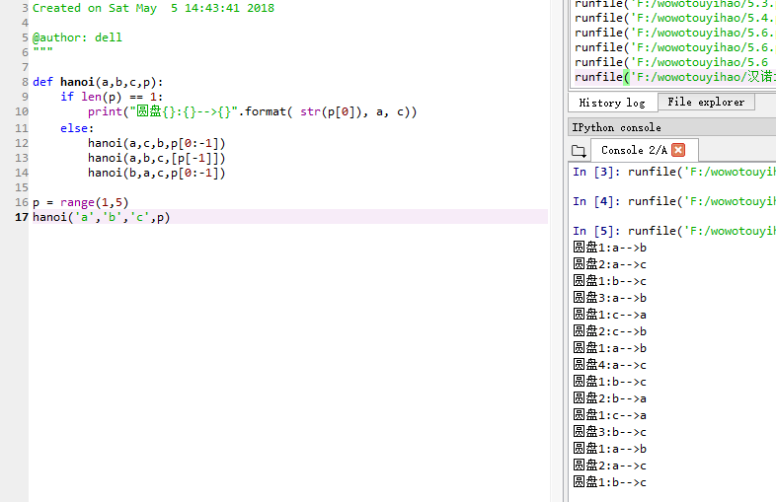**程序》3：**

**import turtle, datetime**

**strcol = ['red','blue','yellow','gold','violet','purple','green','darkgreen','grey','orange']**

**def drawGap():**

**turtle.penup()**

**turtle.fd(5)**

**def drawLine(draw):**

**drawGap()**

**turtle.pendown() if draw else turtle.penup()**

**turtle.fd(40)**

**drawGap()**

**turtle.right(90)**

**def drawDigit(digit):**

**turtle.pencolor(strcol[digit])**

**drawLine(True) if digit in [2,3,4,5,6,8,9] else drawLine(False)**

**drawLine(True) if digit in [0,1,3,4,5,6,7,8,9] else drawLine(False)**

**drawLine(True) if digit in [0,2,3,5,6,8,9] else drawLine(False)**

**drawLine(True) if digit in [0,2,6,8] else drawLine(False)**

**turtle.left(90)**

**drawLine(True) if digit in [0,4,5,6,8,9] else drawLine(False)**

**drawLine(True) if digit in [0,2,3,5,6,7,8,9] else drawLine(False)**

**drawLine(True) if digit in [0,1,2,3,4,7,8,9] else drawLine(False)**

**turtle.left(180)**

**turtle.penup()**

**turtle.fd(20)**

**def drawDate(date):**

**for i in date:**

**if i == '-':**

**turtle.pencolor("black")**

**turtle.write('年',font=("Arial", 18, "normal"))**

**turtle.fd(40)**

**elif i == '=':**

**turtle.pencolor("black")**

**turtle.write('月',font=("Arial", 18, "normal"))**

**turtle.fd(40)**

**elif i == '+':**

**turtle.pencolor("black")**

**turtle.write('日',font=("Arial", 18, "normal"))**

**else:**

**drawDigit(eval(i))**

**def main():**

**turtle.setup(800, 350, 200, 200)**

**turtle.penup()**

**turtle.fd(-300)**

**turtle.pensize(5)**

**drawDate(datetime.datetime.now().strftime('%Y-%m=%d+'))**

**turtle.hideturtle()**

**turtle.done()**

**main()**

**程序》3.2：**

**import turtle, datetime**

**strcol = ['red','blue','gold','violet','purple','green','yellow']**

**def drawGap():**

**turtle.penup()**

**turtle.fd(5)**

**def drawLine(draw):**

**drawGap()**

**turtle.pendown() if draw else turtle.penup()**

**turtle.fd(40)**

**drawGap()**

**turtle.right(90)**

**def drawDigit(digit):**

**turtle.pencolor(strcol[0])**

**drawLine(True) if digit in [2,3,4,5,6,8,9] else drawLine(False)**

**turtle.pencolor(strcol[1])**

**drawLine(True) if digit in [0,1,3,4,5,6,7,8,9] else drawLine(False)**

**turtle.pencolor(strcol[2])**

**drawLine(True) if digit in [0,2,3,5,6,8,9] else drawLine(False)**

**turtle.pencolor(strcol[3])**

**drawLine(True) if digit in [0,2,6,8] else drawLine(False)**

**turtle.left(90)**

**turtle.pencolor(strcol[4])**

**drawLine(True) if digit in [0,4,5,6,8,9] else drawLine(False)**

**turtle.pencolor(strcol[5])**

**drawLine(True) if digit in [0,2,3,5,6,7,8,9] else drawLine(False)**

**turtle.pencolor(strcol[6])**

**drawLine(True) if digit in [0,1,2,3,4,7,8,9] else drawLine(False)**

**turtle.left(180)**

**turtle.penup()**

**turtle.fd(20)**

**def drawDate(date):**

**for i in date:**

**if i == '-':**

**turtle.pencolor("black")**

**turtle.write('年',font=("Arial", 18, "normal"))**

**turtle.fd(40)**

**elif i == '=':**

**turtle.pencolor("black")**

**turtle.write('月',font=("Arial", 18, "normal"))**

**turtle.fd(40)**

**elif i == '+':**

**turtle.pencolor("black")**

**turtle.write('日',font=("Arial", 18, "normal"))**

**else:**

**drawDigit(eval(i))**

**def main():**

**turtle.setup(800, 350, 200, 200)**

**turtle.penup()**

**turtle.fd(-300)**

**turtle.pensize(5)**

**drawDate(datetime.datetime.now().strftime('%Y-%m=%d+'))**

**turtle.hideturtle()**

**turtle.done()**

**main()**

**结果：**

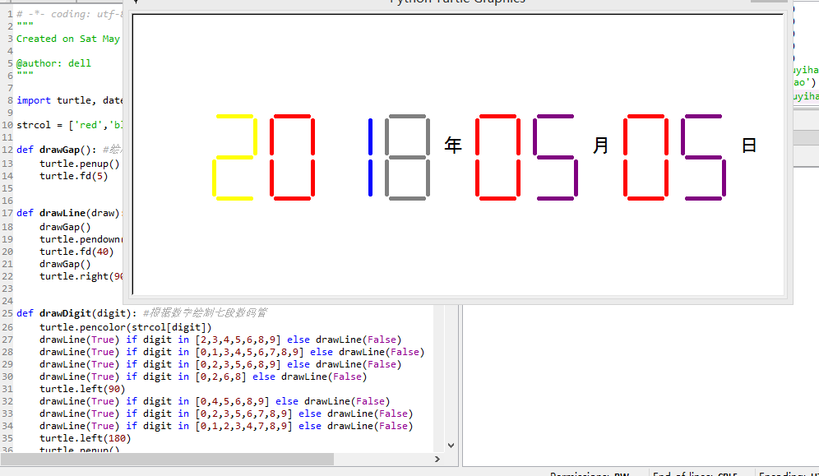

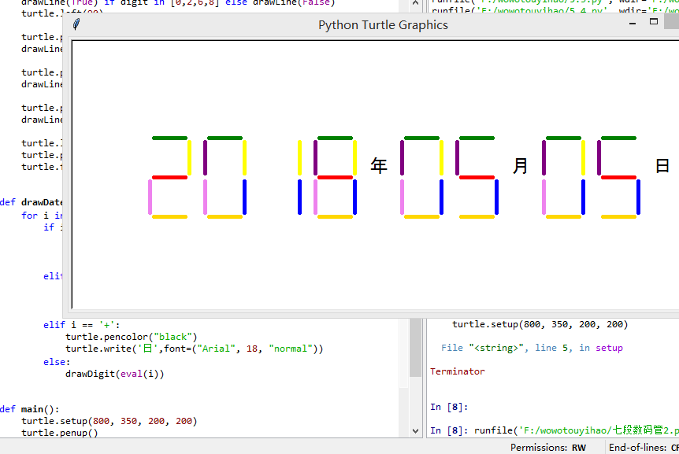

**实验小结**：复习了一下课本以后，感觉比以前多懂了一点。多看课本很有用。