A few comments on workload estimation

Workload is difficult to define precisely but easy to understand generally. The factors that influence your experiences in the experiment may come from the experiment itself, your feelings about your own performance, how much effort you put in, or the stress and frustration you felt. The workload contributed by these different factors may change as you get more familiar with the experiment. The physical parts of workload are easy to measure but the mental ones are harder.

Since workload is something that is experienced individually by each person, there are no effective measures that can be used to estimate the workload of different activities. One way to find out about workload is to ask people to describe the feelings they experienced. Because workload may be caused by many different factors, we would like you to evaluate several of them individually. This set of 7 scales was developed for you to use in evaluating your experiences in different tasks. Please read the definitions of the scales carefully. If you have a question about any of the scales in the table please ask me about it. It is extremely important that they be clear to you. You may keep the descriptions with you during the experiment.

After each section of the experiment you will be asked you to fill in the 7 scales. You will evaluate the condition by marking each scale at the point which matches your experience. Each line has a description at each end. Please consider your responses carefully. Consider each scale individually. Your ratings will play an important role in the evaluation being conducted, thus your active participation is essential to the success of this experiment, and is greatly appreciated.

WORKLOAD Rating Scale Definitions

Title | Endpoints | Description
Mental Demand | Low/High | How much mental, visual and auditory activity was required? (e.g. thinking, deciding, calculating, listening, scanning, searching)
Physical Demand | Low/High | How much physical activity was required?  (e.g. pressing, controlling)
Time Pressure | Low/High | How much time pressure did you feel because of the rate at which things occurred or the time limit imposed on the task? (e.g. slow, leisurely, rapid, frantic)
Effort Expended | Low/High | How hard did you work (mentally and physically) to accomplish your level of performance?
Performance Level Achieved | Poor/Good | How successful do you think you were in doing the task set by the experimenter? How satisfied were you with your performance?
Frustration Experienced | Low/High | How much frustration did you experience?  (e.g. were you relaxed, content, stressed, irritated, discouraged)
Annoyance Experienced | Low/High | How annoying did you find the system used in the experiment?

WORKLOAD RATING SCALES (CON1)
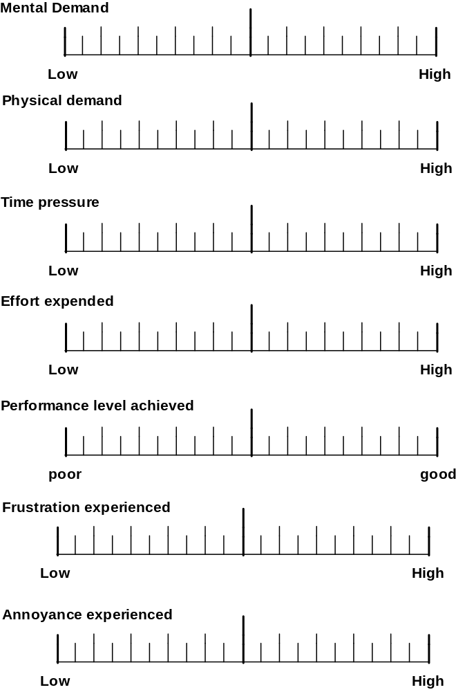
WORKLOAD RATING SCALES (CON2)

WORKLOAD RATING SCALES (CON3)

WORKLOAD RATING SCALES (CON4)

