Gardeners and Herbicides
Gardeners who imagined a pest-free space where their vegetables, fruits and decorative plants could flourish without competition from weeds and insects have long been able to turn to chemicals and branded chemical products. Gardeners were able to use chemicals at their disposal in the household that when either sprinkled onto or applied by spiking with a skewer were capable of killing weeds, which included common salt, carbolic acid, sulphuric acid. As we have already seen, acids including carbolic and sulphuric became more difficult to get when they were included on the Poisons List. The number of chemicals and preparations, which were not on the Poisons List and that were marketed to amateur gardeners to help them look after their garden expanded rapidly between the 1930s and the 1980s. Tool-sheds of chemical-minded gardeners were described as looking like laboratories with their rows of bottles, tins, powders and liquids. By the late 1970s there were over 200 branded chemical preparations available for amateur use in the domestic garden, along with their own consumer-focussed regulatory system, implemented by MAFF.

Although annual expenditure by British gardeners perhaps suggests that weeds are of less concern to garden chemical users than insect or fungal pests, I have chosen to look at herbicides in this chapter. While there are certainly fascinating stories to be told about the control of insects and fungi using chemicals, concentrating on the practices of weeding, characterised as back-breaking and tedious, allows me to consider the concept of labour and therefore tie in more closely with the thesis' other chapters on household chemicals and photographic home processing. Other users of the garden such as children, pets and wildlife may be considered in any decision to use any kind of pesticide. Gardeners must also consider the future, how the want to use the space occupied by the weed, and the residue left on treated fruits or vegetables. Advertisements or warnings associated with these other pesticides may be included for reference, context or comparison, but the focus of this chapter remains on herbicides. My choices of chemicals for case studies, sulphate of ammonia, sodium chlorate and paraquat, have properties that make them the most suitable choice for one of three different weeding scenarios commonly encountered by amateur gardeners: lawns, paths and cultivated beds.

Not only are they used for different purposes, this selection of chemicals represents different stages in the lifecycle of a product on the market, as sulphate of ammonia was already in widespread domestic use by the 1930s, and can be considered a well established garden chemical that was routinely used by amateurs, allowing it to be compared to sodium chlorate and paraquat which newly arrived on the market in the 1930s and the 1960s respectively. In this chapter, the arrival of ammonium sulphate in domestic gardens will be taken as 1868, when it was "hidden" as the active ingredient in proprietary branded mixtures known as lawn sand. Both sulphate of ammonia and lawn sand continued to be available throughout the time period that this thesis covers (even to the present day). Garden use of sodium chlorate began in the 1930s, embraced for its long term suppression of weeds and was always referred to by its chemical name whether or not it was also associated with a brand. Paraquat was introduced in the 1960s, and it "starred" as the active ingredient in branded products from a very limited number of manufacturers, and again the chemical name paraquat dominated, rather than its brand names. Complexity was added to the story of paraquat by the provision of a specially formulated version for domestic users. Misuse of sodium chlorate and paraquat led to both these chemicals facing restrictions on sale, then total bans. This detailed examination of the uses of herbicides in British homes encompasses stories about the social history of gardening.

Sulphate of ammonia 1868 - - - - - - - - - - - - - - - - - - - - - - - - - - - - - - - - - - - - - - – - - - - - - - - - - present
sodium chlorate 1934 - - - - – - - - - - - - - - - - - - - - - - - - - - - - - - - - - - - - - - - - -2009
paraquat 1965 - - - - - - - - - - - - - - - - - - - - - - - - - - - 2007
Figure (needs work) to try to show that the weedkillers were introduced to amateur gardeners at different times, but in later part of the time frame of this thesis users were able to choose between all three, depending on their needs.

The increased availability of chemical aids to gardening must be considered in the context of who worked in the home, and of how leisure was pursued at home, as well as the capability of the chemistry industry to provide new chemicals and convince people of their utilities. When these factors are taken into account, as this chapter aims to do, we can start to understand the position of the chemical user as an active, decision-making agent operating amongst social factors including changes in availability, affordability or acceptance of chemicals, of buying-in garden care services, life cycle or recreational approaches to garden care duties. The use of gardens between the 1930s and the 1980s changed, increasingly becoming designed and used as outdoor rooms, with patios for alfresco dining, safe places for children and pets to play and for families to relax in an easy to maintain, aesthetically pleasing space. Yet gardens have remained functional, as a place to grow food for the family, a place to dry the washing. Gardens might incorporate paths that served to avoid tracking mud into the house when visiting washing lines or sheds, and so needed to be kept free of weeds and slimy, slippery algae. Even as more homes acquired automatic laundry dryers, clothes lines were not abandoned and in appropriate weather laundry was hung out in gardens, though perhaps on more technologically advanced carousels or using synthetic lines and pegs. Plants could be seen as a nuisance not only in the form of weeds, aesthetically displeasing plants out of place or competing with desired plants, but also a threat to neatly laid paving of parking areas or patios, to building foundations or structural walls by upheaval of roots or prying tendrils. Weeding is bound up in ideas of control and power over one's domain, with weeds and other pests portrayed as enemies to be constantly battled into submission through sustained labour and chemical applications. In this way, the supposed peace and security of a domestic garden is transformed into the site of outright violence against weeds.

Although the literature review demonstrated that the historiography concerning the use of garden chemicals in Britain is distinctly lacking, there are plenty of practical gardening books, magazines and newspaper columns that can help shed light on the use of garden chemicals between the 1930s and the 1980s. The choice of sources, as ever, can change the conclusions drawn. For instance, Jane Fearnley-Whittingstall asserted that chemical weed killers did not exist before 1939 based on her analysis of a gardener's note book and the newspaper clippings contained within. This statement hinges on how a chemical weedkiller is defined or understood. Even if we understand chemical weedkillers to be specialised for use in the garden, such as "daisy destroyer", these too have been available before the 1930s. Fearnley-Whittingstall was led to this generalised statement by her view of the power of weedkillers readily available to domestic gardeners at the end of the 20th century, which eclipsed the chemicals employed in the garden in the 1930s, as well as the compilation of the gardening notebook she studied.

Some weedkiller adverts in the 1930s framed hand weeding as expensive, which introduces tangled ideas of who might be doing this work, and how weeding was approached. At first glance it indicates that in some gardens people were being paid to do the time consuming, repetitive and therefore costly task. (need photo of that advert, didn't have camera with me that day) While the practices of employing hired help inside the house has been examined by scholars, gardening (in homes other than stately) has not received the same attention, possibly because it was often carried out by the householders themselves. Historian Steven Constantine's view of middle-class gardening was that magazines for amateurs promoted gardening as a predominantly do-it-yourself activity from the 1850s, and that gardening was taken up as a gently active, restorative past-time. Even operating garden equipment used to spray insecticides was pleasurable "What can be more tonal than the satisfaction which the grown up amateur or master of the house, enjoys when he returns from the city to his garden in the summer evenings, and applies the syringe to his wall trees, with refreshing enjoyment to himself and the plants and to the delight of his children who may be watching his operations." Although the author of this scene did not mention what was contained within the sprayer, it could have simply been water to refresh the leaves in an industrially polluted area, the possibility of fascinating picture of domestic chemical use in 1838 as entertainment, not just care of plants, has been conjured up.

This reference to the master of the household also points to gendered division of labour. He was expected to manage the fruit trees, vegetables and lawn, while the light work of tending flowers and weeding were allocated to women and children of the household. However, an important part of the lawn care in addition to the manipulation of heavy machinery, was the identification and eradication of weeds. That this was undertaken by men is hinted at by the description of how "brain workers" would find the sense of achievement that could be gained from seeing the immediate visual impact of a session of weeding particularly beneficial, and the process of identifying weeds was even characterised as a stimulating, interesting activity. These "brain workers" who were presumably involved in office based, long term projects and denied the satisfaction of a tangible result as part of their regular employment.

The ways that weeding could be approached was also described in gendered terms, which could be linked to the experience of work in the home and paid employment elsewhere. The concept that weeding was a task to be done in "odd moments" was one that garden writer Marion Cran espoused, and this meant that it could be regarded as costing nothing. I argue that this reflects women's experience of fragmented nature of domestic work which involves waiting for processes and people. Lawn weeding on the other hand was something that had to be approached stoically and done for extended periods of time, and this relates to the single minded focus that men are expected to exhibit in their paid work. The concept of hand weeding as expensive in the context of a weedkiller advertisement, depends on how the person doing the weeding values their time. An unpaid housewife may appreciate the opportunity to spend a productive "odd moment" in the garden, choosing if she prefers, or if circumstances allow, to do a longer stint, whereas for a man used to approaching tasks for prolonged periods of time, weeding was a tedious chore, and he knew the monetary value of his time. The magazine that the aforementioned advert was taken from, Amateur Gardener, was on the whole aimed at this middle class set of gardeners who generally did for themselves, so perhaps the word "expensive", was used ambiguously and could be read as cash paid out or simply time spent, which would worked to make the sentiment, and the product, relevant to both DIYers and employers of gardening staff.

A gendered activity?
Suggesting that the garden and the physicality of the work required there with dedicated tools, heavy machines and chemicals makes it a masculine space, is false as by that argument the physicality, machines and chemicals required for housework would attract men to the task. Nonetheless, in garden manuals the sense of a male gardener is carried beyond the casual use of pronouns, and the desire for standardisation of measurements and aids for accuracy could hint at a masculine gardening taskforce, especially when compared to the more vague domestic measurements employed in handling chemicals used by women in laundering and general housework. We saw in the earlier chapter that women were dealing with "little lumps" that may or may not have a comparable size to a roughly standard item such as a walnut.

In garden chemical adverts, both men and women are featured but they do different tasks. Women are not depicted as weeders, despite a history of low paid work as weeders. Adverts depict men doing the lawn care and weeding, but this is not to say that women's use of chemicals is feminised (although sometimes it is – see the advert about being house-proud) or that they are not involved in the same battle against the ravages of garden pests. When adverts for other garden products, are considered female users signal the items' lightness, or simplicity of use. This can be seen most strongly in lawn mower adverts, but also in those for sprayers and chemical sprays. The appearance of women spraying the garden with chemicals means that they are chemical users, and they are killers of mites, aphids and fungi, but not of weeds. This division of labour is interesting and coincides not just with the increasingly visible movement for equality, but it occurs from the 1960s and the heightened awareness of the health effects of chemicals. In this respect, the female users also stand in for chemical safety, but when lawn care chemicals are as benign as ammonium sulphate, women are not needed to denote safety. Adverts for lawncare and weedkillers however depict and perhaps perpetuate the role of men in charge of caring for the lawn, whether through application of lawn sand or another formulation of weedkiller for lawns, as seen in the Murphy's advert for their range of chemicals (Illustration ) and in PBI's Velvas lawn sand. Freedom from the danger of poison, or nuisance of smell, associated with weedkilling and fertilising respectively, tend not to be used, suggesting that lawn sand appears to stand alone, occupying a well established niche that does not require reference to anything else.

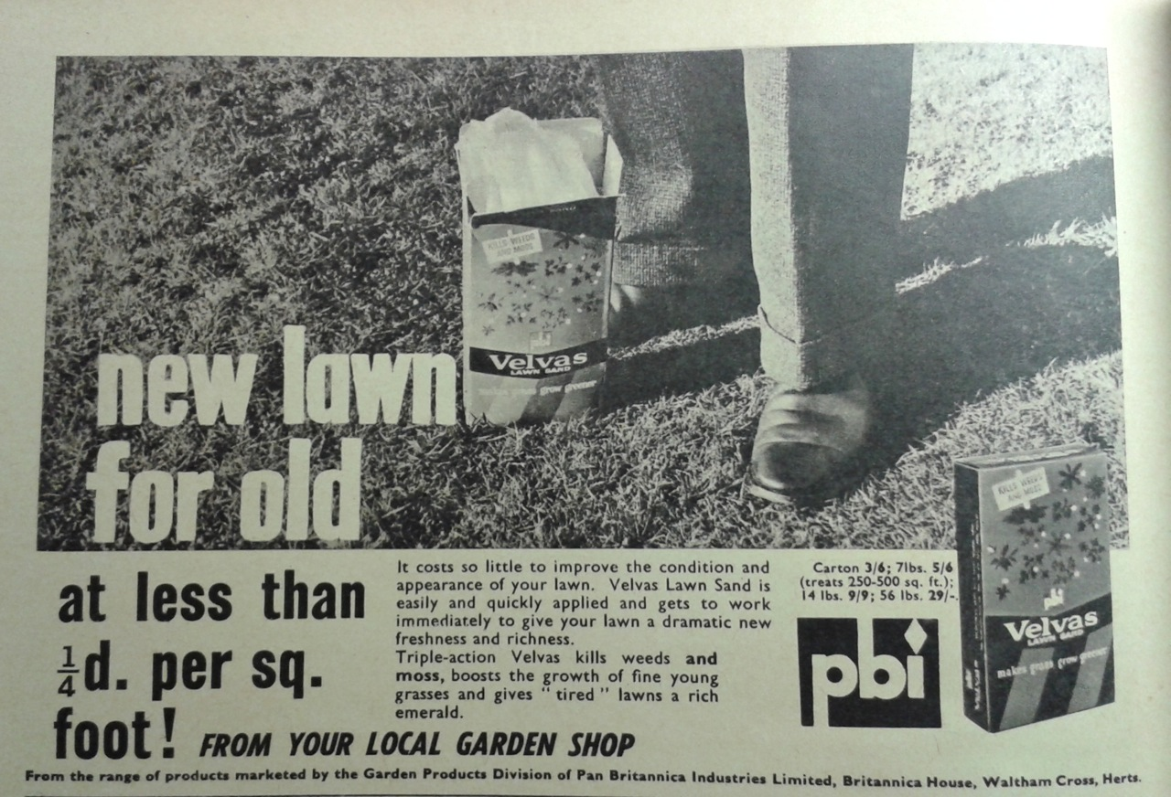Illustration 1: 1964 advert for Pan Britannica Industries Velvas lawn sand, showing a man standing on a lawn with a bag of the product at his feet.

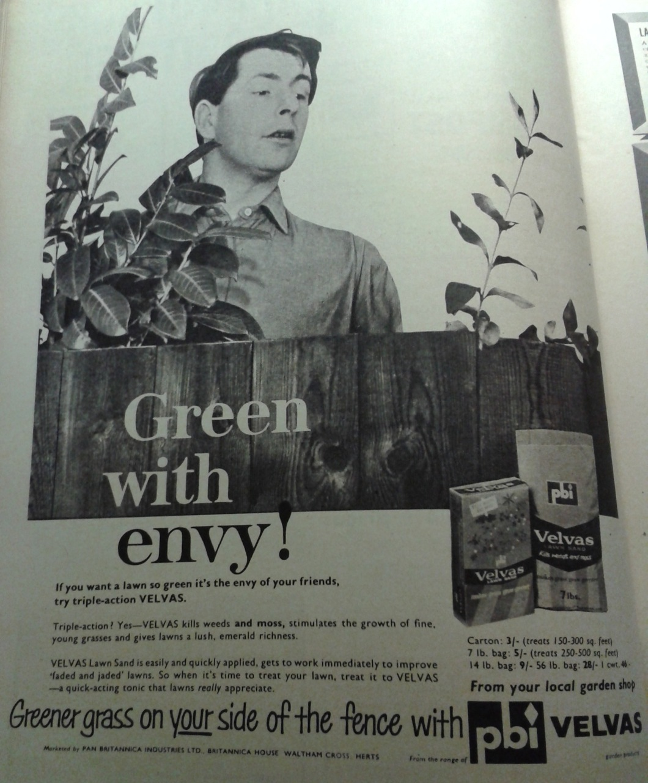Illustration 2: Illustration 5: 1963 advert for Velvas lawn sand, showing a non-user jealous of the healthy lawn of the Velvas user
The non-user could also be used as an advertising device, in PBI's Velvas lawn sand advert, a male neighbour looks over the fence with astonishment at the sight of such a healthy green lawn. PBI employed the same device (and photographic model) but in a slightly different way for their range of insecticides, where the text made out that his insect-ridden garden was a threat to the neighbour who used the insecticides and that the non-user was "soppy", for not performing the masculine duty of attacking insects in his garden. Although a weed filled garden could be made out to be similarly threatening, weedkillers do not seem to have been advertised in this way, instead promoting an idealised result of dead weeds.

Magazines modelled a more equal division of labour, at least from the mid 1960s, which showed women involved in lawn care and weeding, measuring out chemicals into a watering can and operating a flame gun. In the six images showing a person waging war on weeds, rather than just the tools involved, four showed men, whether a whole body or the appearance of obviously masculine feet or hands. This montage features a gardener wearing a floaty, feminine dress and coiffured hair making up a solution of lawn treatment which is then applied by a man.
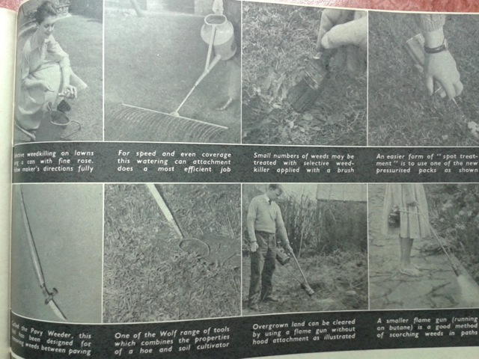Illustration 3: Photo montage from "War on Weeds" Practical Gardening, June 1963, p65
A photo sequence that appeared in 1981 showed an almost androgynous woman dressed for heavy gardening work, in warm, loose fitting clothes. She's not pictured on a lawn, but she is also the one who applies the solution she made up. Both sequences model the advised best practice of making up the solution outside, rather than in the kitchen or utility room. Protective gloves are not indicated as necessary here, and the cap is used as the measure in the 1981 photographs, removing the need to use spoons as appears to be shown in the 1963 image. The clothing is probably more to do with the time of year that the articles were produced for, March and June, although the comparatively smart dress of the 1963 lady gardener also implies the absence of heavy gardening work and that the use of chemicals negates any need to dress down for dirty gardening because using chemicals is clean and easy. An artist for Good Housekeeping played on the hand in pocket trope when they illustrated an article on choosing and using weedkillers. The glasses the woman in the drawing wears also function to protect her eyes from any wayward droplets.

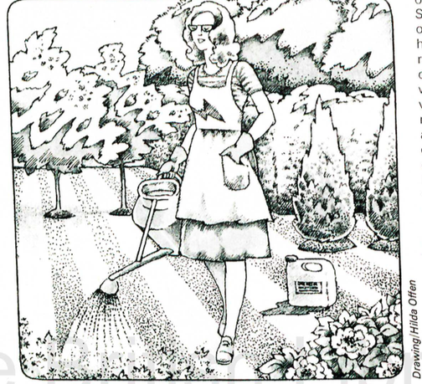Illustration 4: Waging War on Weeds: a profoundly peaceful image of the war in this garden.

Advertising is only one way of getting a glimpse of the situation, but there is certainly a difference in how chemical products that reduced the amount of work in the house, compared to those for the garden, were portrayed. Household cleaning products in the 1930s were regularly portrayed as anthropomorphised servants under the influence of the housewife, while weedkiller advertising did not follow this trope. Although it is hard to say from the illustrated hands and feet that appeared in weedkiller adverts that they were not those of a hired gardener, where a more complete image of the product user appeared they appeared leisurely rather than busy. That chemicals were not generally taking the place of hired help supports Constantine's notion that generally gardening was done by the home dweller.
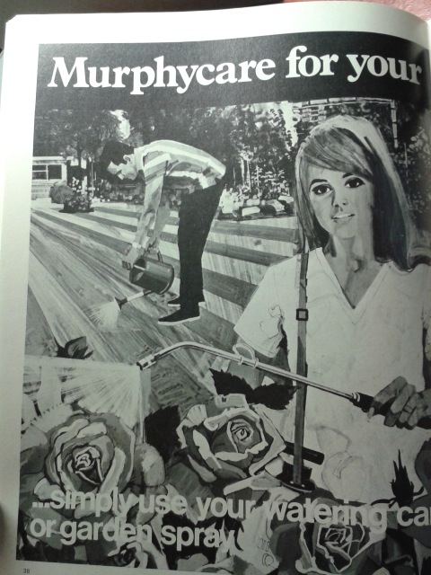Illustration 5: Garden chemical advert showing typically gendered gardening: the man tends the lawn while the woman treats the roses.
Working in the garden is a past time that can be pursued alone, or as a joint project. An example of this can be seen in a 1970s advertisement for Murphy's range of garden chemicals, which shows who we assume to be a husband and wife working together. More often though, advertisements for garden chemicals often show only the chemical user, suggesting it as a solitary endeavour while other garden users kept out of the way. This may be one of the reasons behind why garden chemicals, or at least their packaging, do not appear to have been collected with the same relish or desire for completeness as food and other household products, even when more specialised collections such as those of the Garden Museum and the Museum of Brands are taken into account. Unlike goods experienced by the whole household, such as foods or washing detergents, garden chemicals tend to be used relatively scarcely, through well spaced applications rather than daily or weekly, and are only used by particular household members. As such, they would not be expected to elicit the same type of nostalgia as do food and laundry products. Perhaps their status as killers has meant that they are even more likely to be thrown away when no longer needed, or as attitudes to work in the garden change. Maybe their low profile in museums matches their profile in the home, items that were not prominently displayed but kept, as the instructions advised, out of reach in the shed.

As chemists synthesised new chemicals and uses were found for them, increasingly specialised weedkillers became available to domestic users. Most often these domestic products originated as agricultural chemicals, but this was not always the case as demonstrated by Boot's weedkiller based on 2,4-D, Lawnox, which was firstly a domestic product, then later adapted for large scale agricultural use as Cornox. Advice on creating a less labour intensive garden design included features that made herbicide application even easier, and as more sophisticated chemicals became available even the definition of a long lasting weedkiller would be altered from months to years. However, there is not a straightforward relationship between the arrival of new products and disappearance or removal of simple chemicals or old products, which we shall see with the chemicals examined in this chapter.

Regulation and Legislation
The Pharmacy and Poisons Act 1933, and the Poisons Rules, which we encountered earlier in the chapter on household chemicals, also affected gardeners seeking to kill pests and weeds in their gardens. It exerted its influence on retailers, who had to be registered to sell products, then discern who could properly buy the poison and record their details if necessary, but as with household chemicals, the legislation also shaped the products that were sold, as manufacturers searched for products that could be sold as widely as possible.

Acids were mentioned earlier as a form of herbicide that became restricted through the Poisons List, but another type of chemical on this list were the arsenical compounds, which were still available to domestic gardeners into the 1980s. Their use was not recommended and other less poisonous products were on the market, for instance DDT replaced arsenical insecticides when it became publicly available in the 1940s. However, arsenic based domestic products had not been embraced by users with particular gusto despite their effectiveness. Their association with accidental or deliberate poisoning, as well as the early implementation of maximum arsenic residue levels on food crops would have raised the profile of risks associated with domestic spraying. Indeed, poisoning with arsenical weedkiller was a staple of Agatha Christie novels, cementing this domestic use of chemicals into the popular imagination.

While not a frequent choice of domestic gardeners, arsenic was held up as the standard by which other weedkillers were judged, as an advertisement from 1934 for Sofnol declared the product a "non-poisonous weedkiller as effective as arsenic yet absolutely safe". This shows that the absence of arsenic was a feature that some consumers sought out, and was therefore a selling point to be highlighted. However, the advertisement did not divulge what the active herbicidal chemical was. Another couple of adverts from the 1930s, from chemical manufacturers Tomlinson and Hayward, provides a demonstration of how gardeners had to read between the lines. The company offered two different weedkillers, adverts for which emphasised different qualities and no doubt appealed to users with different needs, but neither advert stated what in the weedkiller made it effective. Adverts for Luda pictured 2 smiling dogs and declared that it "contains no poison so is absolutely harmless to animal life", indicating that pets had been known to be harmed by weedkillers and that for some would-be weedkiller users, the safety of their pets prevented them from using weedkiller at all. In contrast, adverts for Eureka focussed on ease of use and the avoidance of backache, without mentioning poisonousness. Eureka in fact did contain arsenic, and shows that garden chemical users had to use their own knowledge of their market and interpret what was not said as well as what was laid out in the advertising or on the packaging. In this context, effective weedkillers that were safe to humans and animals, as well as could be sold without restriction to certain types of suppliers or with off-putting processes such as scrutiny from shop staff, would have been attractive prospects for both chemical manufacturers and amateur gardeners.

Pesticides Safety Precautionary Scheme
Until 1957, garden chemicals were not subject to any further regulatory requirements than the Poisons Rules. In the wake of an investigation by a newly formed Committee on Toxic Substances in Consumer Goods which specifically looked at new chemical products, a cluster of deaths among farm workers associated with pesticide application between 1946 and 1950 alerted officials to the existence of detrimental occupational health effects of using new agrochemicals. This sparked a separate investigation which recommended the formation of a regulatory scheme to ensure the safe use of agrochemicals. As many of the garden chemicals used at home were the same, or closely related products used in large scale agriculture, this meant that the findings were applicable to domestic users. The voluntary, industry-regulated Pesticides Safety Precautionary Scheme (PSPS) was set up in 1957 and operated in close contact with the Ministry of Agriculture, Food and Fisheries (MAFF), particularly the Pesticides Branch, as a way of avoiding the potential inflexibility of full legislative measures. Flexibility allowed a pragmatic case by case approach, where assessments of the safety of chemicals were made based on quite limited toxicological observations of test animals. The trade association which represented pesticide manufacturers and importers agreed not to market new chemicals unless appropriate safety precautions, including presentation, labelling and instructions, had been agreed. As the name implies, the scheme dealt purely with safety factors, rather than the effectiveness of any product, but a programme that covered efficacy had already been in operation for around 15 years, and became formally recognised as the complementary system to PSPS when it was renamed the Agricultural Chemicals Approval Scheme (ACAS). This shows that although effectiveness had been considered important enough to be tested, safety came second, or rather not at all. The situation was turned upside down by the committee's formal recommendation to take safety more seriously and new chemicals had to pass scrutiny by PSPS before their efficacy could be considered by ACAS.

The impact of this scheme on domestic users was that they were told that they could feel reassured that the new chemicals arriving on the market could be relied on to be safe (when the carefully worded precautions were followed) and effective. Garden chemical users were encouraged, through the government booklet Chemicals for the Gardener and via gardening magazines which picked up public relations material from the Association of British Manufacturers of Agricultural Chemicals (ABMAC), later renamed British Agrochemicals Association (BAA), to look out for the 'A' symbol granted to products that had successfully been approved (Illustration). Manufacturers duly included this in product advertisements and packaging. Some of the processes behind approval and what could be expected of products with the Approved logo were also explained in publications from the Consumers Association.
Illustration 6: The clearly recognisable logo of a crown-topped letter A, denoting that a product had been approved.
The Chemicals for the Gardener booklet also took care to emphasise the importance of following the safety instructions given by the manufacturer on the label, because these too had been approved. The warnings and instructions for use were scrutinised as part of the PSPS process because appropriate information reduces the likelihood of accidents, although words on a label or box cannot compel the user to follow them. This was an issue that those in the chemical industry grappled with for every new product. ICI's Frank Rose referred to pharmaceuticals when he said "sooner or later someone will try to commit suicide with it" although the sentiment is applicable to other chemicals. As the research director of chemical company Fisons explained on television in 1964, misuse was an "inevitable risk" for any new chemical product. He made it clear that chemists were exceedingly careful to produce useful, effective products that could be used safely, and followed this by directing attention to the user as the cause of any problems when he said "I bet my bottom dollar that someone is going to misuse it so much that even the safest chemical is going to cause trouble somewhere, sometime."

Despite the agrochemical industry aiming to avoid legislation by voluntarily initiating the PSPS, the British government deemed greater protection of consumers desirable, which they sought to foster through the Farm and Garden Chemicals Act 1967. Care was taken to specifically define gardening as including the destruction of weeds in drives, paths and courtyards, meaning it was applicable to householders who perhaps did not see themselves as gardeners in the traditionally creative or nurturing sense. However, results were slow to come about due to expectations that the Act would be superseded soon after, as well as taking into account relevant legislative changes in Europe.

The focus of the Act was on labelling, which according to the Act should include the name of the substance, a "mark, symbol or colour" to indicate any hazard to "human beings or other forms of life". Where products should be labelled, anyone found to "sell, or offer or expose for sale" an unlabelled quantity of product would be committing an offence and subject to a fine. This suggests that not only did the manufacturer have to label their product appropriately, but that some retailers were selling inadequately labelled, presumably re-packed or decanted garden chemicals and this was considered to be a problem that the Act aimed to rectify.

This Act was championed by Joyce Butler, who consistently voiced concerns on behalf of consumers. Butler stressed the need for consumers to know what chemicals the product contained, whereas others believed that this information would be meaningless to the average user and what should be prioritised on the limited space available on the product's label and packaging was the instructions, advice and warnings. Butler got her way eventually, and from May 1973, all proprietary garden chemicals had to be labelled with the common chemical names of their active ingredients.

When the Act was being debated in parliament, of particular interest was the safety of children, essentially non-users who could not be expected to read and understand, and who might benefit from a colour coded or pictorial system. At the same time that this Act was being debated, the European Council was working towards a standardised hazard labelling system. Only in 1984 were hazard symbols compulsorily included on garden chemical products, and it is worth noting that they did not always correspond to the hazards that were understood by the consumers.

Gardeners wanted clear, informative labelling on garden chemical's packaging, but this desire for was not considered met, generally due to the small print necessitated by the size of the product. This can be seen by solutions improvised by frustrated gardeners, shared in magazines such as Practical Gardening, who had felt that their personal efficiency in the garden was hampered by user-unfriendly labelling. Examples included the attachment of large labels to overcome illegibly small ones or creating ready reference dosage charts for their selection of garden chemicals. What is striking about these examples is that the gardeners focused on personal efficiency, while government targeted safety, something generally not mentioned by the user as a problem with the labels. This is not to say that personal safety was not considered as part of these solutions, for instance the provision of dedicated spoons shows how that domestic user avoided the temptation to use and contaminate kitchen equipment. For the users, size was the issue and not one that could be rectified by any parliamentary acts.
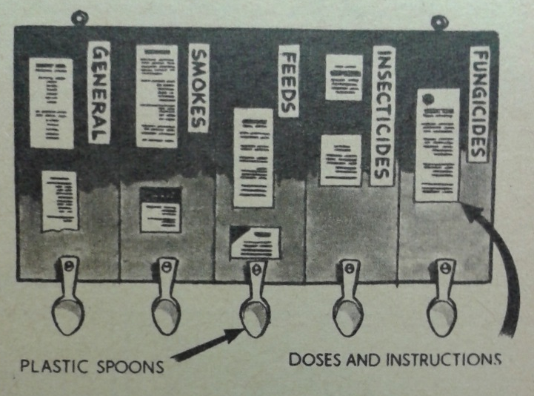Illustration 7: Reader's suggestion to help gardeners keep appropriate equipment and instructions available for garden chemical use

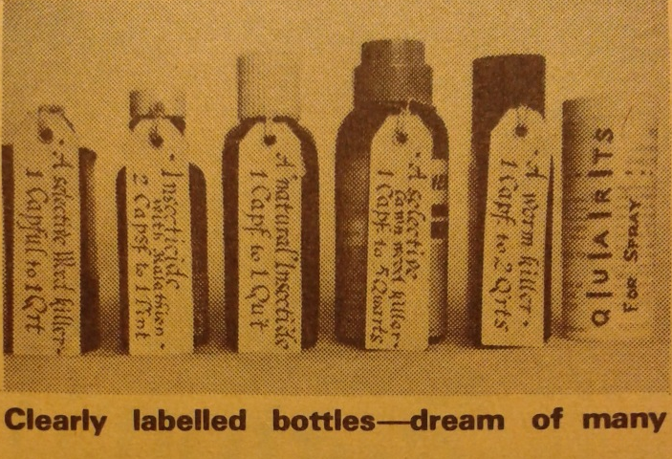Illustration 8: Reader's solution to illegibly small instructions on chemical packaging. Measures here all use container caps.

Despite the Act covering the use of insecticides and pesticides which were used in the garden or on the farm, the Act does not call attention to the home or workplace, which is interesting. This omission is not raised in the debates recorded in Hansard. It is as if the concept of home being a threat is inconceivable, or simply cannot be looked at, possibly for fear of what might be found.

Sulphate of ammonia and Lawn Sand
Before the introduction of biologically sophisticated hormonal selective weedkillers, such as 2,4-D and MCPA onto the amateur market in the 1940s, a grand claim was made about sulphate of ammonia, when it was declared "probably the most important chemical agent for weed destruction". Sulphate of ammonia was especially highly regarded in a certain niche of gardening, that of lawn care, but judging from the regularity that it was recommended, and arguments about correct proportions for what kind of desired outcome were publicly aired by professionals and amateurs alike, I feel confident in saying that it was an important chemical for a gardener intent on killing weeds to have at one's disposal.

Ammonium sulphate has been linked to the industrial age as a by-product of the coal-gas industry, which perhaps explains the timing of its appearance in agricultural and garden products in the 1870s as uses were found for this newly abundant chemical. However, it was also produced through conventional chemical manufacturers, including Imperial Chemical Industries.

Agricultural fertilisation was the main use of ammonium sulphate, because it releases ammonia into the soil where it becomes available as nitrogen, which is vital for plant growth. However, when the chemical was recommended as an alternative to natural nitrates, no weed killing properties were mentioned. Ammonium sulphate as a weedkiller first entered domestic gardens in the form of lawn sands in 1870. The purpose of lawn sand was two-fold, primarily it was to fertilise the lawn, but it would also kill broadleaved weeds in the lawn. Lawn sand could therefore be used in two different ways: the entire lawn could be treated, fertilising the grass and killing the weeds at the same time, or the lawn sand could be dropped onto individual weeds to kill them.

Branded, ready mixed, convenient lawn sand made by Mr Watson, of Leeds was recommended by name as a new product in Samuel Beeton's garden book, together with information on price and where to obtain the product. Lawn sand was embraced by users, indicated by other companies producing competing lawn sands, which caused Watson's to advertise their garden aid as "the only original lawn sand". Lawn sands were advertised in small classified adverts in The Times from 1913, the readers of which had evidently been targeted as garden owners likely to have well tended lawns. Proprietary lawn sands won awards at the Royal Horticultural Society's Chelsea flower show in 1913 and 1914. These awards show that over the forty years since introduction, lawn sands had gained a solid reputation among users and could be relied on to be effective.

However, it was lawn sand, rather than ammonium sulphate or any of the other constituents, that was presented as the solution to gardeners' weed problems. What is especially interesting is that for over fifty years, the active ingredient in lawn sands was considered "shrouded in mystery" to the detriment of most amateur gardeners. Gardeners with enough curiosity and knowledge of experimental chemistry to work out the components of these branded mixtures could remove that mystery, and the proliferation of similar products suggests that some did, even if they used the knowledge to make competing lawn sands rather than to simply make the ingredients in it more widely known.

What did users understand about how it worked?
Lawn sand users could not casually discern the ingredients or mode of action by simply looking at the product, nor by perusing the sales advertisements or packaging information. Amateur users were not enlightened by vague descriptions of how lawn sand killed weeds, such as "impregnated with chemicals of a caustic nature". Nevertheless expert users, the authors of garden care manuals, set out to demystify the amateur lawn sand user in the hope that they would at least use the right amount for their situation, even if they were unable to give a recipe for making up the mixture at home. The "invisibility" of the chemical constituents in branded lawn sands, caused proprietors of lawn sand to be viewed with suspicion, due to their lack of explanation to consumers about how the product would work and which possibly caused users to buy much more than necessary.

Approximately fifty years after lawn sand had emerged on to the domestic market, in 1922, gardeners were only just being informed by the gardening press about the active component's identity, sulphate of ammonia, and that it was mixed with sand in order to facilitate its even distribution across the lawn. This revelation, which does not appear to coincide with any ended patents, led to recipes for lawn sand being made available in books, magazines and newspapers. The recipes did not spell out where to obtain the chemical constituents, which suggests that gardeners were familiar with obtaining chemicals and advice on their use from hardware stores, seedsmen and chemists.

Farmers who had also been using sulphate of ammonia for fertilisation and weedkilling were perhaps more likely to access accurate information about how it worked. The chemical was clearly explained in a farming text book as killing weeds not through being poisonous, but by drawing water from the leaf by osmosis and scorching the plant, causing it to die. The differential effect on broadleaved weeds and grassy crops such as wheat was thus resolved; the upright leaves of grasses prevent the chemical from resting on them and killing them, and instead direct the chemical to fall to the soil where it acts as a fertiliser. It is not surprising that the information did not rapidly transfer to amateur gardeners, who would have had little cause to read specialised technical book about animal and plant nutrition. Wanting a smart lawn does not necessarily translate into desiring to learn about the biochemistry of the soil and the plants it supports, nor the intricacies of chemicals that can be applied. Carers of domestic lawns relied heavily on experts further up the chain, to explain when to use lawnsand for best effect, why using it did not work as expected, and to assure them that it was suitable for a set of predictable domestic situations.

By the 1930s, lawn sand recipes were ubiquitous in advice about lawns and gardens, and the basic proportions provided a template that gardeners could adjust and personalise to their particular needs. For instance, those with mossy lawns could include iron sulphate, a slightly green tinged crystalline chemical. Proprietary lawn sands continued to be marketed for the duration that this thesis is concerned with, indeed to the present day, as a convenient option.

How was it used and by whom?
Sulphate of ammonia could be applied "neat" to individual weeds, as could lawn sand, but for use on larger areas, it was easier to evenly broadcast lawn sand than sulphate of ammonia alone. The smallest volume advertised in Fisons' adverts, 14lb, would treat 56 square yards at their recommended dosage. The volume of space occupied by a bag containing 14 pounds of lawn sand should be considered, as it provides an insight into whether a gardener would have wanted to or been able to store something this large. The option to buy prepared lawn sand as this kind of quantity would have suited a gardener who wanted to treat their whole lawn, using up the whole amount and not having to store it for any length of time. For someone who wanted to use it just to spot-kill weeds, keeping this amount could be considered foolish, taking up much space, potentially spilling or otherwise spoiling. Advertisements do not suggest or model this spot-weeding, after all their function was to promote the use of large, lawn sized amounts. Nor did they depict the measures that gardeners ultimately carried out in order to get even coverage of the product, which implied that the use of lawn sand was much easier than it truly was. For even application for large lawns, gardeners could trust their judgement and distribute the chemical by eye and hand alone, or they could section out the lawn into measured areas using string and pegs according to the suggested application rate. This more detailed information, or truths about using lawn sand were never presented as a chore in gardening magazines of manual, as hand weeding itself generally was, but as necessary maintenance for a healthy lawn, and with an attitude of pride in doing a job well. As lawn sand is not a poisonous substance, nor an irritant, hand application is perfectly safe, however to assist with the perhaps surprisingly complex and skilful practice of actually applying the mixture, machinery to transport and distribute the mixture was invented and employed.

Even for spot weeding, lawn sand did not need to be applied with any special equipment as it could be sprinkled straight from the container on to the offending weed by hand, the approximate measurement being a saltspoonful. This domestic measure, but a more uniform or standard size than a pinch which could vary with the size of the gardeners' hands, has not remained in common use, probably due to changed preferences and availability of the tableware that salt was served in. Fractions of a teaspoon are not referred to as numbers of saltspoonfuls and by the 1930s the salt spoon reference may serve as an indication of the class of user. However the bulky and sack-like packages that lawn sand was sold in were not suited carrying around, so gardeners would decant the product into more conveniently sized, reused household containers. Gardeners could construct a shaker by perforating the tightly fitting lid of a tin can, or purchase a dedicated conical distributor which dropped a little of the sand onto the weed was in use. These machines and gadgets, homemade and bought, perhaps speak more of the appeal to men of dedicated tools that can accompany and enhance the experience of gardening, rather than any necessity attributable to the chemical's properties.

Notable by their absence are adverts for sulphate of ammonia alone. When purchased as an amount weighed out by a chemist or seedsman, it would have been unbranded, but as retail became increasingly self-service oriented, the chemical would have appeared on the shelves of garden centres as a prepackaged and branded product. The lack of adverts could indicate that the volume sold was steady but low, not such that warranted an advertising campaign, perhaps because greater profit could be had from promoting a more complex formulation, such as lawn sand. Both lawn sand and sulphate of ammonia continued to be recommended and used in domestic gardens for the entire period that this thesis examines. In 1954, gardeners were reassured that although lawn sand was "old fashioned" now that so many other weedkillers were available, it was still useful and this message was reasserted in 1986 with the extra detail that there were weeds on which selective weedkillers were ineffective.

This incredible longevity and continuity of domestic use shows that this ammonium sulphate, once it was better understood, was considered by gardeners to be reliable, effective and safe. The coexistence of lawn sand and sulphate of ammonia shows that different types of domestic user, those who preferred the convenience of buying a ready mixed product when they need it, and those who preferred to make it up as required, which could generally be done more economically, created enough demand and used it appropriately for both to be regularly retailed.

Sodium chlorate
From the mid 1930s, another method of killing weeds had become available to home gardeners in the form of sodium chlorate. In some cases it was offered by gardening manuals, magazines and newspaper gardening advice columns as an alternative to lawn sand for killing isolated weeds in lawns but its long lasting effects could prevent anything from growing in the treated spot, causing a bald patch. This longevity meant that sodium chlorate was singled out as particularly effective for clearing weeds from paths and other areas that the user intentionally wanted to keep barren. During the early 1930s, sodium chlorate was employed on an industrial scale by agriculturalists, particularly for clearing land of ragwort which is poisonous to cattle, sheep, horses and pigs, as part of renovating pasture. Amateur gardeners may have first encountered the practice of using sodium chlorate for killing weeds through a description in The Times farming column, which relayed the results of trials conducted by the New Zealand agriculture conducted trials with sodium and calcium chlorate. Sodium chlorate, but not calcium chlorate, was quickly seized on in that paper's gardening column as an alternative to arsenical weed-killers "of evil repute". It is unclear why sodium chlorate emerged as the winner in these trials when both chemicals had approximately similar herbicidal results. Cost of production, and therefore to the user, could have been the deciding factor here.

Sodium chlorate was introduced to the readers of the National Allotment Society's journal in a 1934 article about tidily kept allotments (unkempt allotments were a major bugbear of the society). Shortly afterwards, the journal claimed to have received requests for more information about this wonderful weedkiller and letters from disappointed enthusiasts unable to obtain it. This was not surprising, as the "foreign product" was only imported to Britain.

A likely importer was Albright & Wilson's Oldbury Electro-Chemical Company,. They had dominated global sodium chlorate production from their plant at Niagara Falls since 1902, making use of the hydro power available there to run electric furnaces. Albright & Wilson used the same equipment they had employed to make potassium chlorate, an ingredient for use in manufacturing matches, but had stopped making when competition from other manufacturers increased. While it is unclear for exactly which industry the chemical was destined, possibly leather making or to make bleach for paper pulp, in 1926 they were the only producer of sodium chlorate in the USA, with another plant in Canada producing the chemical when it was economic to do so. Albright and Wilson's position as the main sodium chlorate manufacturer in the early 1930s suggest that when those first allotment holders struggled to find it, and the NAS dealt direct with importers, it was possibly A&W's chemical that they were handling. Despite this, A&W do not seem to have entered the domestic consumer market, as no advertisements for sodium chlorate weedkiller can be traced to this company.

However, since sodium chlorate had been produced on a large scale since 1902, it is perhaps surprising that it did not emerge as a herbicide until the 1930s. Business historian Hugh Podger pinpoints 1932 as when global demand for sodium chlorate as a herbicide increased, but does not comment on why or how this came about. It is likely that this growth is associated with the positive results shown in agricultural trials that had been taking place in the early 1930s, as farmers would have required large quantities of the chemical and therefore make a significant impression on the volume demanded, much more than the volume amateur gardeners would have needed. This increased demand can be verified by the announcement in 1935 by Staveley's Coal and Iron Company announced that they were to build Britain's first sodium chlorate manufacturing plant, allowing it to compete with Colonial and Continental manufacturers. This suggests that the company perceived that the amount of sodium chlorate required by British users was significant enough for them to manufacture the chemical in this country, which without the additional costs to imposed by import, they could offer at a competitive price. This decision indicates that the market for sodium chlorate as a herbicide had grown quickly and shown itself to be lucrative, bearing in mind that only three years earlier the idea of using sodium chlorate agriculturally was novel, and limited to trials in New Zealand. However, Staveley's did not appear to market any products direct to consumers.

The same year that Britain's first sodium chlorate plant was announced, 1935, the National Allotment Society (NAS) responded to the difficulties expressed by would-be sodium chlorate users regarding obtaining the chemical and arranged for sodium chlorate to be packaged in quantities appropriate for domestic use, which they made available through their existing service, the National Horticultural Supplies seed and equipment business. Buying the chemical directly from importers in hundredweights (8 stone, or 50kg) too expensive and too bulky a retail option for individuals, or even for allotment associations who could club together to cover costs and then divide the quantity up among the members. This new chemical was therefore quite inaccessible to gardeners, who were not used to dealing directly with importers, or with industrial quantities, until it was mediated and repackaged for domestic consumers by organisation turned retailer NAS. The NAS continued to buy imported sodium chlorate, probably from Albright & Wilson, as Staveley's encountered problems setting up the plant which eventually became operational in 1938.

By 1940, sodium chlorate was more widely available and marketed as a dedicated herbicide packaged in domestically appropriate quantities, including through Boot's who called themselves "The Gardeners Chemist".

Throughout the 1940s agricultural users expressed anxiety that they faced a shortage of sodium chlorate, despite British production and continued imports of the chemical from France, Italy, Poland and Norway. This concern about shortages does not appear to have been voiced in the magazines that were the mouthpieces of the amateur users, nor did these sources carry any obvious sign of domestic users being compelled to sacrifice their use of this product so that farmers, and therefore the nation, could benefit. If domestic users had grown accustomed to a chemical then had it withdrawn or rationed, there would have been traces of this in the form of notices and complaints in the sources investigated. Therefore, perhaps the agricultural users actually faced a shortage of subsidised, governmentally purchased chemical, or that there were problems associated with distribution rather than there being a true shortage. Check this properly - I don't think I've really explored the 1940s mags properly to find evidence of this. It certainly doesn't come up in the newspapers anyway.

Sodium chlorate was purchased by gardeners in a variety of forms, as soluble crystals like salt or an even more easily soluble powder form which could be applied to weeds either dry or dissolved in water, in addition to a preprepared solution of sodium chlorate being offered by some manufacturers: Nantcol was a liquid, and the 1981 advert for Cooke's sodium chlorate highlights a liquid form. Gardeners were free to make up a solution to their desired strength using the solid forms, and could dilute the liquid forms to weaker concentrations. Different concentrations of sodium chlorate solution were used to kill different types of weeds; stubborn deep rooted weeds were given the strongest treatment while smaller annual or biennial weeds could be done away with a weaker solution. This gave an apparently crude, total and unselective herbicide a degree of subtlety and allowed the gardener to exercise their judgement in determining what would best suit their particular situation.

Boots' sodium chlorate was sold ready packaged in tins, under the plain chemical name, but it was also available from other manufacturers under brand names, such as "Eureka" sodium chlorate from Tomlinson & Haward Ltd (apparently still keen to capitalise on their well known Eureka brand, although clearly identifying sodium chlorate) and "Nantcol" from Synchemicals. However, even when branded like this it did not lose its true chemical identity, as sodium chlorate remained prominently on the label, making it quite a different strategy to the inscrutable presentation of lawn sand that we saw earlier in this chapter. Like sulphate of ammonia, users could handle it without irritation to their skin. The following two adverts are typical of those for sodium chlorate, which appeared among the smaller adverts rather than a whole page.
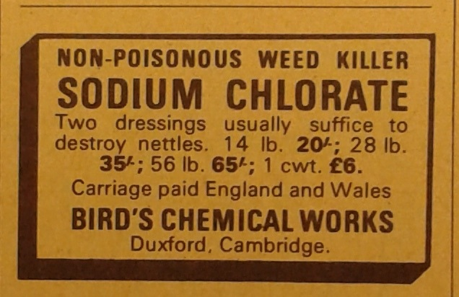Illustration 10: Advert from 1966, Practical Gardening magazine
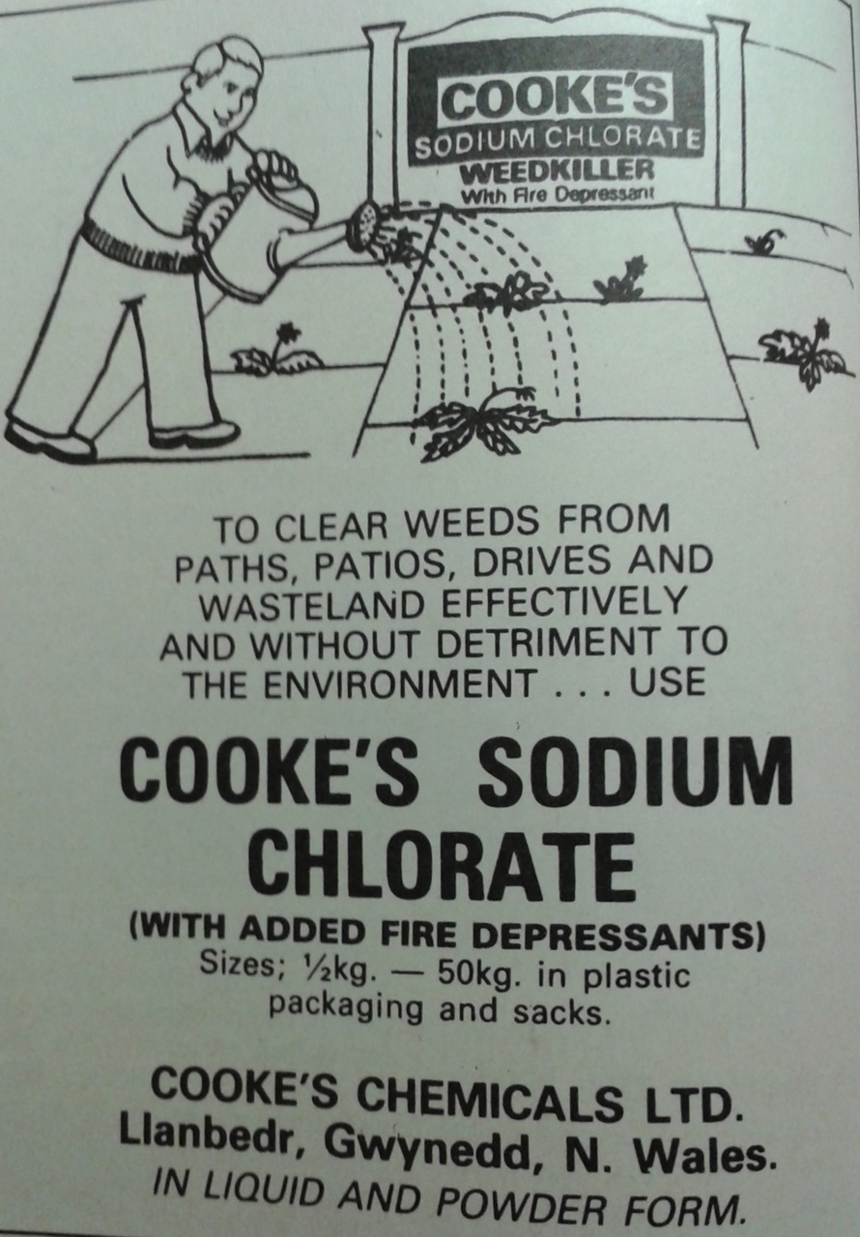Illustration 9: Advert from 1981, Practical Gardening magazine
Sodium chlorate is clearly the chemical that is being sold to gardeners, nothing obscures this, although each chemical company imprints their own name on the product. Bird's highlights the non-poisonous nature of the chemical, where as the Cooke's advert does not. No users are shown in the Bird's advert, while the Cooke's advert shows a man using a watering can, which we presume to contain a solution of sodium chlorate. Potential users are invited to imagine clearing weeds from drives, paths and wasteland in addition to the pictured patio. No information about how long the user can expect the sodium chlorate to last is given, but the listed scenarios do not include any that suggest to the user that they would be growing anything there for a while. The addition to Cooke's product of fire depressants is stressed, as is the chemical's effectiveness and inability to harm the environment. This concern for the environment is particularly typical of advertisements from the 1980s, when this angle was seen as one that could attract users concerned about this issue. We are also told to expect plastic packaging and sacks.

What we do not see is the "A" symbol which would communicate that it has been approved as safe and effective. Although some large producers, such as ICI and Syngenta, would be able to put their sodium chlorate preparations through the approval system, the adverts shown here are from small companies for whom financing this operation would have been prohibitive, but they were also selling a relatively simple product: solid crystals or powder, rather than with additives other than fire suppressant. Consumers were navigating a fairly complex landscape of chemicals and assurances, but here the identity of the chemical is all they really required.

Precautions
As alluded to in the Cooke's advert, there was a fire risk involved in using sodium chlorate. This had been long known, if perhaps too-little-appreciated or repeatedly forgotten, as when the solution soaked into gloves or other textiles, then dried, the friction from wearing the sodium chlorate impregnated garment caused the chemical to ignite or explode. Accidental fires with sodium chlorate had claimed lives since its introduction as an agricultural herbicide, and when the NAS first introduced sodium chlorate it highlighted flammability as a concern for potential users. NAS initially described this danger as an inflammable gas given off as the garment dried, but after doing some more research, gave their readers a comprehensive description of the action of friction and advised users to rinse in clean water any items that had become impregnated with chlorate solution. Occasionally an incident where someone had been burned by a fire with sodium chlorate would appear in the letters section of a British medical journal, or newspaper, apparently not warranting the attention given by a full article. The only exception to this was when a baby was hurt which made the national news, although the article was so brief that it is hard to tell what happened. No reference to previous or foreign accidents was given in these accounts of fire, but none carried the full outrage of some danger newly discovered, reading as if the information about fire risk was quite readily available.

This danger of fire was deemed preferable to the danger of poisoning by arsenical weedkillers, and the unpleasant handling qualities of tar-based compounds, which explained the popularity of sodium chlorate among amateur gardeners for weed clearance. Not all recommendations for sodium chlorate came with detailed information about safety, and not all users received the same warnings. For instance, when the chemical was discussed in The Times agricultural news column, the fire risks were outlined, but this information was not included in the praise for sodium chlorate presented in the paper's gardening column, read by gardeners the following year.

This fire risk meant that sodium chlorate brands were developed for agricultural and domestic garden users with fire retardant chemicals from early on in the story of sodium chlorate's domestic use; by 1949 Atlacide was recommended to British amateur gardeners as being a brand formulated to avoid fires. American farmers had experimented with Atlacide since 1930 comparing it's effects favourably to unaltered sodium chlorate. This lag between agricultural and domestic use raises questions about the level of engagement from domestic users if they unquestioningly accepted the risk of fire from sodium chlorate without fire retardants and were surprised about ensuing accidents.

However, if domestic gardeners did not read journals associated with their hobby, nor a variety of instructional manuals, it is entirely possible that they would have been unaware of the chemical's flammability, unless informed at the point of sale by their shop keeper. Advice supplied in instructional gardening books varied considerably, from giving no information on the chemical's flammability, to extensive instructions to avoid spilling the crystals or the solution on wooden surfaces as well as to throughly rinse in clean water anything that contacted the solution, while one went even further and recommended wearing rubber boots as protection. These examples highlight how users of the same chemical for the essentially the same tasks could receive quite different information about how to safely use it.

When EC regulations became effective in the 1980s meant chemical products carried standardised warning symbols, sodium chlorate would bear the icon for oxidising. While it was the chemically correct description of sodium chlorate's fire starting properties, the chemical had always been described to domestic users as inflammable, and it would continue to be so in magazines and books. This discrepancy seems to have passed without public comment, perhaps indicating that garden users did not mind about this pedantry, so long as they could still purchase and use the chemical when they wanted it. Both symbols both represent fire, so even if a user did not fully understand the difference, they should get the gist of the warning.

The risk which was highlighted to gardeners far more frequently than accidental fires was sodium chlorate's propensity to seep or creep into non-target areas and kill or damage non-weeds. To reduce this possibility, users were urged consider the likely future weather conditions as well as weighing up the which plants might come into range if rain caused the weedkiller to spread further. Labour saving garden designs took into account how easily weedkiller could be applied to paths without harming nearby plants, trees or lawns. The exhortations to consider sodium chlorate creep incorporated the reminder that neighbours' plants were at risk and show that accidental damage was a distinct possibility, but the unsolicited use of the herbicide to deliberately damage a person's property does not appear to have been a large problem, with very few cases making the newspapers. A vandal targeted multiple gardens of a village where the gardeners were understandably shocked at the severity of the action, but sports facilities rather than domestic gardens, were the most high profile instances of unsolicited weedkiller use.

While vandalism using weedkillers was not something that manufacturers could address, creep and fire risks were features that could be highlighted by manufacturers and marketers to set their new products apart from sodium chlorate. By 1964, simazine based products were available and were recommended as preferable to sodium chlorate because they did not creep, they were not associated with fires, and their effects were even longer lasting than sodium chlorate. As simazine could last years in the soil, this changed sodium chlorate's status as the chemical that could give the longest period of effectiveness, and redefined sodium chlorate as a medium-term weed suppressant. Nevertheless, the fire risk and potential for creep of sodium chlorate must not have been an overwhelming concern for many domestic users, as it continued to be used when a relatively cheap and reliable long term weedkiller was needed.

Although the flammability of sodium chlorate was not a principle concern of gardeners, it was, at different times, a preoccupation of various governments. During World War Two, it was included in the "Prohibited Chemicals" list, a selection of chemicals compiled by MI5 in 1939 thought to be desirable to people wishing to damage national security. Homemade bombs were the subject of concerned correspondence in 1941 when a German agent was found to be carrying instructions to go to chemists shops and purchase bomb making chemicals, including sodium chlorate. It was hypothesised that while chemists may consider selling 28lb of these bulk drugs specified in the instructions, a would-be bomb maker would not purchase supplies from a single store, to avoid arousing suspicion. Another route of access to these restricted chemicals that officials hypothesised was that would-be bombers would join horticultural or co-operative societies, both of which had been identified potentially distributing chemicals to unrecorded people. This circularity, as we saw the role of allotment societies in informing and enabling access to the chemical, is striking.

Its availability to legitimate gardeners should have been uncomplicated, although subject to the whims of the retailer. Sodium chlorate's place on the prohibited items list did not meant that it could not be sold at all, but it meant that the sale was recorded, for monitoring purposes. One pound of sodium chlorate was all that a person could buy at any one time, unless they had a police certificate. One pound would be enough to make a gallon of strong, 10% solution for treating deep rooted weeds, or four gallons of 2.5% solution for smaller annual weeds, so this restriction should not have affected most domestic gardeners. The retailer had to fill out a lengthy form declaring that the buyer was known to them, the quantity sold and return it to be centrally processed. Being asked for an ID card, an address and the reason for the purchase may have been a deterrent to a customer, but the process proved mainly to be discouraging to the vendor. Suttons Seeds worried that they could not properly describe their customers as "known" to them and complained that the number of purchasers of chlorates and nitrates during spring would require an extra clerk to process all the paperwork. While most retailers did endeavour to go through this time consuming process and lots of forms were received in the first year of implementing the scheme, the urgency and enthusiasm for this national duty waned, shown by the tailing off of reporting. Some chemists continued to sell the chemical without reporting, while others preferred not to sell prohibited chemicals at all, as they did not like the bother of dealing with the paperwork.

These measures were not widely communicated among the general public, at least not through mainstream media, and only appropriate retailers were issued with the list of prohibited substances. There had been concern about whether the concept of sabotage should even be included in how the list was titled, fearing that it could even inspire this type of misuse. The list was not discussed in gardening magazines or in newspapers, suggesting that gardeners on the whole did not encounter any changes in the supply of their new favourite herbicide that were serious enough to complain or comment about. By 1943, the threat level was declared lowered, and the reporting procedure was lifted on sodium chlorate and most of the other chemicals on the list.

With the threat of war over, entertainment motivated school boys to employ sodium chlorates' oxidising nature to make fireworks and bangers. The accidents most often occurred during transport of the bangers, often in a pocket, where the friction caused by walking or running resulted in premature ignition and detonation. Between 1956 and 1966, 242 young people had been injured by homemade explosives containing sodium chlorate. Gardening journalists called for "serious investigation" into why such a potentially dangerous chemical could be bought in brown paper bags from any hardware shop or chemist, without any warnings as to its nature, but they themselves had rarely noted that the chemical should be handled with care by gardeners. This shows an inherent, and unaddressed, distinction about in whose hands a chemical became dangerous. In an adult gardener's hands, sodium chlorate was only a danger to plants, but in a child's hands the chemical became a danger to their intact body.

These accidents involving young banger makers caused a flurry of parliamentary activity, in which retailers, manufacturers and teachers were all identified as both the source of the problem and the solution. The Home Office announced that it was talking to retailers to prevent sales to children, while parliamentarians questioned whether manufacturers could alter the formulation or delivery of the chemical to prevent it from being used as an explosive, but not affect its ability to kill weeds. Some parliamentarians queried whether sodium chlorate could be sold as a liquid, although other more scientifically-minded members reminded them that anyone dedicated to making an explosive could circumvent a liquid formulation by evaporating out the solvent.

As we saw earlier in this chapter, fire depressants had been added to some, but not all, sodium chlorate herbicides since the 1930s without altering their efficacy, and that liquid preparations did come on to the amateur market, though this measure was not necessarily marketed as fire prevention. The continued visibility of sodium chlorate's potential for misuse did stimulate some manufacturers to change their formulation, such as ICI, who by 1970 advertised that their sodium chlorate weedkiller contained fire depressant. This showed that the company were keen to avoid their amateur gardening products being connected with accidental fires, not to mention deliberate explosions.

The focus of concern tended to be the protection of children who might use the chemical to make bangers, rather than other more serious, politically motivated, adult explosive-makers, although the politicians did keep the legitimate user of sodium chlorate in mind with their desire to not alter the herbicidal properties of the chemical. The implications for gardeners of any changes to the soil of adding fire suppressant chemicals such as sodium chloride, sodium carbonate or borax, do not appear to have been discussed in gardening publications, possibly because sodium chlorate was used for total, rather than selective weedkilling and was expected to be long term so any changes to the soil wrought by the new additives went unnoticed or were dissipated by the time the area was replanted, so long as the product applied was seen to still effectively kill weeds. This indifference by one set of users to the measures implemented by manufacturers to accommodate the alternative use by another set of users should be remarked upon.

Dr Hugh Black of Her Majesty's Inspectorate of Explosives recommended that science teachers left out details of sodium chlorate's explosive ability from their classes. It is interesting that teachers, not parents, were called upon by police to put down bomb making among schoolboys. Even though police acknowledged that children did not make bombs at school, or even on school premises, which implies that they were doing it on domestic property where presumably adults were in charge, head teachers were prioritised over parents or guardians for instilling sensible behaviour. Parental discipline appears to have been futile, at least in the reporting of the incident that led to these pleas to teachers. In that particular case, a boy lost a hand in a sodium chlorate explosion despite his parents' attempts to stop him making explosives. The child began making small bombs with a chemistry set, then graduated to making larger bombs with weedkiller and sugar. The parents confiscated their child's bomb making equipment but the child was easily able to replace his supplies, causing the parents to call for traders to stop selling sodium chlorate to children. These particular parents had attempted to protect their child from explosions, but they'd probably also encouraged his interest in them by giving him a chemistry set and presumably the means to buy more supplies through pocket money, unless he had a part-time job. A commercial chemistry set was named as the gateway to bomb making, rather than any motivation originating within the child, and shop keepers were identified as responsible for controlling access to chemicals, which to a certain extent they were. In contrast to this, parents were held in highest responsibility by R.E. Parker, writing on behalf of the Royal Institution of Chemistry. The Institute identified "adventurous boys" as the experimental users of sodium chlorate in the search for bigger, better bangs, and called for better education of parents and these youths through improved labelling and information at the point of sale.

Progress on the subject of preventing sales to minors was slow and in May of 1970, Boots sent out a special announcement to all of its shops, which requested that tins of sodium chlorate be displayed out of the reach of children, and instructed staff to affix labels that declared the product should "not be sold to children under 18" to each tin in stock. These actions show that Boots was serious about attempting to stop the sale of that chemical to young people, who were specifically deemed likely to use it for pyrotechnic purposes. The long delay between the discussions and one of the major retailers of sodium chlorate taking steps to restrict the chemical may indicate quite a number of possibilities, including resentment at the assumption that sales staff would not question or refuse a youth, opposition to tighter controls in general, or the difficulty in implementing them. Despite Boots' efforts to prevent sales to minors, their continued production of sodium chlorate weedkiller without a fire depressant made their product appealing for pyrotechnic use.

The blame for firework injuries can be lifted a little from sodium chlorate, at least during firework season. Between 1965 and 1970, at least for the times between 11th October and 7th November, homemade explosives were responsible for fewer accidents than commercially bought fireworks. Fireworks were under particular scrutiny with regards to the development and imposition of manufacturing safety standards and prevention of sales to children. Homemade fireworks were responsible for a small fraction of accidents, 4%, compared to the 31% caused by shop bought bangers, and while this does not really give an idea of how many people were using sodium chlorate for this purpose, it does not seem to be a major use of the chemical. The total number of accidents decreased each year from 1965 to 1970, with accidents relating to homemade explosives following that same trend, despite no formal changes in sodium chlorate sales. A large educational campaign about firework safety in general, including a graphic and forceful BBC documentary Remember Remember, was credited with having achieved this reduction.

Although the sale of sodium chlorate to children might have been a problem, there was another route that labels and restricted sales could not address. Obtaining an amount from a relative's herbicidal stock was even further beyond governmental influence than sales, but this perhaps more frequently used supply route does not appear to have been discussed, nor any specific education directed towards adult gardeners about the possibility of pilfering for this use. Certainly it was not suggested in the newspaper or magazine gardening columns that securing personal supplies against this use might be considered.

Entertainment was not the only reason for mixing homemade explosives. As well as bangers, bombs were also made. Newspapers dubbed them "two bob bombs", referring to their inexpensive nature. The same principle as bangers, but generally larger, the bomb makers sought revenge, fear and damage, with examples reported in newspapers of a bomb set by a disgruntled customer, and one left under a woman's car by her jilted husband. Invariably, these sodium chlorate bomb makers were men or boys. Globally, 1970 saw increased employment of chemicals used in agriculture and the garden to construct bombs in the name of political terrorism, as a result of tightened controls on commercial explosives. The oxidising nature of sodium chlorate was put to work in variety of ways beyond simply starting fires. In 1970s Northern Ireland the IRA, Provisional IRA, Ulster Volunteer Force and Ulster Defence Association used sodium chlorate in a variety of ways, not simply as a crude explosive. Sodium chlorate mixed with nitrobenzene as the filler in pipe bombs, but it was also used as propellant, (along with another household item the J-cloth) for ammonium nitrate mortar bombs, and as a component in delayed chemical ignition systems for bombs, though access to one other necessary part for the delay switch a condom, marked out the users as not-Catholic.

Although these explosives were called homemade, this moniker was used to convey that the materials were assembled by individuals rather than purchased as ready made military provisions, than to draw attention to actual homes, when in fact lock up garages, not domestic garages, and other non-domestic buildings were used. This removal from the home was to reduce danger to other family members as well as to minimise forensically incriminating materials from the home from becoming associated with the bomb. However, other less well informed and professionally organised bomb makers no doubt did construct devices at home, and arrests made of members of anarchist group the Angry Brigade (unrelated to the ideologies of the Troubles) found bomb making equipment and chemicals, including sodium chlorate, at their home address which demonstrate this.

Frequent high profile bombings carried out by paramilitary organisations using sodium chlorate in homemade explosive devices in Northern Ireland led to the imposition of restrictions in that region on sales of the chemical in 1972. Although the Explosives Act UK (1875) stated that "any substance used or manufactured with a view to produce a practical effect by explosion", the separate Northern Ireland explosives act 1970 was amended to spell out the law maker's awareness that otherwise benign chemicals were being used by terrorists: "any substance (including any liquid article or thing) which is capable of being used whether by itself or in combination with anything else, as an explosive and which appears to the Minister of Home Affairs likely to be so used for unlawful purposes". I would question, as some parliamentarians did, the need for Northern Ireland to have a separate explosives act and for this amendment, because any substance that could be used as an explosive, no matter what it was originally manufactured for, was already covered by the 1875 Act. The identification by MI5 of sodium chlorate as a chemical that should be monitored during WW2 could have been used to flag up the possibility of this use sooner. Others may point to the involvement of MI5 as the reason that it was not flagged up, and that very organisation was how the chemical was used in relatively sophisticated ways.

Although the idea of restricted sales of sodium chlorate was supported in principle, Whitehall politicians also wanted to stress their reservations about the effectiveness and reach of this gesture. Perhaps the experience of the Prohibited Chemical sales which showed the limitations and resistance to sales monitoring was not completely forgotten, but it was not mentioned by name. Enoch Powell called the order "pathetic" and "unlikely to correspond with any of the hopes expressed in connection with it". The restrictions were only applied to Northern Ireland and the ease of getting the banned substances from either Ireland or mainland Great Britain was a concern. One parliamentarian recalled his own experience with the unreliability of sodium chlorate, or rather the reliability of it to backfire when making homemade fireworks in his attempt to refocus attention to the systematic theft of commercial explosives and detonators. In the declaration of this order, through the desire not to disrupt benign domestic use, nor cause trouble to manufacturers and retailers, but to be seen to take action against the bombers, the order was ineffectual. Despite regular and publicised arrests relating to unlicensed bulk transport of sodium chlorate, the chemical continued to be used in explosives throughout the conflict.

It should be noted that the calls for the addition of fire suppressants to sodium chlorate which had been prevalent during the 1960s when children had been blowing themselves up accidentally, dried up during the time that sodium chlorate was used in intensive political terrorism. It might have been expected that manufacturers would have been publicly called upon to help prevent this use. However, the British Agrochemicals Directory, published from 1970, listed manufacturers of sodium chlorate herbicide and described the form (powder, coarse powder, crystals or liquid) as well as whether it included fire suppressant. These booklets show how numerous suppliers continued to offer pure sodium chlorate, and that they could easily be selected with the help of the directory. It could be argued that fire suppressants added by manufacturers could have had a larger role in preventing the chemical from being misused in this way and that the government, and the agrochemicals associations, could have acted more strongly in the interest of security had they insisted that all suppliers added this safety measure as it did not appear to change the herbicidal performance of the chemical. No particular brands of sodium chlorate used in these attacks were publicly identified, so in media reports only the chemical name, sodium chlorate, was implicated rather than any specific manufacturers. This meant that chemical companies were not held to account for producing chemicals that could be used in this way, the paramilitary users of the herbicide were simply unstoppable in their determination to make explosives.

Although sodium chlorate was heralded as not poisonous, this did not stop people from using it as a poison. In the case of sodium chlorate, the poisoners were both men and women. Sodium chlorate was reported by a pathologist as tasting noticeably bitter, making it unsuitable for surreptitious poisoning, but this did not stop people from trying, allegedly adding it to sandwiches, tea, and cereal and cordial. These instances were unsuccessful poisoning attempts, most likely carried in newspapers for their human stories of love affairs, angry husbands and suspicious wives, while disseminating the message that sodium chlorate was not an effective poison for humans. This built on the reputation initially built by seed merchants of sodium chlorate as the non-poisonous weedkiller. Interestingly, despite this reputation, recovery from chlorate poisoning involving doses of 20g or more was rare, and sodium chlorate was used for deliberate, fatal self-poisoning. However, it was even rarer to find mention of this use outside specialist medical journals, and as such sodium chlorate, despite being readily available to gardeners, does not seem to have become popularised as a means of suicide by appearing in the public eye through media stories. Where it did appear, it was in a failed, farcical attempt. Similarly to the use of sodium chlorate in explosives, no brands were ever identified in these cases, but that is not to say that the chemicals used were unbranded.

Other than occasional autumnal calls for controls on sales to children, sodium chlorate remained on sale until 2009. When its withdrawal from the market as a weedkiller was announced, devotees stockpiled the chemical and lamented the loss of such an effective weedkiller. The use of electronic message boards also enabled the recording of gardeners' awareness and blaming of groups who may misuse the chemical, coming in the wake of homemade peroxide-based bombs being used in London by Islamists, as well as blaming the EU. With the growth of online sales of any type of product, sodium chlorate can be easily found. Instead of being promoted by the manufacturers as a herbicide, it instead carries a warning that the chemical, ostensibly for leather tanning use, will kill all plant life if applied. These evasive tactics are negated by the fact that even if the seller had not categorised it as a weedkiller for driving sales, the aggregation of website user information such as which other products they considered or bought, the chemical is firmly placed alongside sprayers and other herbicides, while other users, rather than the manufacturer, supply information about how to use it on weeds. The birth and growth of online sales, as well as communication among users and misusers, as all the users in this example do not use the product for leather working or bleaching, will provide rich topics for further historical investigators.

Paraquat
Of the three herbicides in this chapter, paraquat is the most complex, both chemically and in it's uses, making this section lengthier than the other studies. Unlike the other chemicals in this chapter it was not recommended for use on lawns, instead it was for weeds in cultivated beds. Paraquat was brought onto the market in 1962 by Imperial Chemical Industries (ICI) as an agricultural and horticultural product called Gramoxone, then Weedol for amateur gardeners was marketed from 1965. As a newly synthesised chemical to be marketed in Britain, it had to pass the scrutiny of the Pesticides Safety Precautionary Scheme in terms of its danger to the health of users and others, then the Agricultural Chemicals Assurance Scheme regarding its efficacy, a system that chemical manufacturers in Britain had voluntarily subjected their new products to from 1957. Paraquat quickly acquired a reputation as a "killer chemical" and not just for its action on plants. Since it came onto the market, acute paraquat poisoning has been responsible for more deaths in Britain than all other pesticides combined. This section of the chapter looks at the development of paraquat as a herbicide, its uses in Britain, and how some users ignored the categories set by the product makers.

'Paraquat is the B.S.I. (British Standards Institution) common name of the cation 1,1'-dimethyl-4,4'-bipyridylium, which is available as the dichloride of the di(methyl sulphate).' This formal, chemical description of paraquat instantly shows us that we are dealing with quite a different substance to sodium chlorate, or sulphate of ammonia. Those garden chemicals have compound names that are clearly linked to the elements from which they are made, paraquat is much more complicated for the average domestic user. First synthesised in the nineteenth century and used as a redox indicator dye, the herbicidal potential of the paraquat was first observed by ICI in 1947. Work started in earnest to characterise, test and formulate weedkillers based on paraquat from 1955. This endeavour took place at a subsidiary company of ICI, Plant Protection Limited (PPL) at their test farm Jealott's Hill (see table 1).

Paraquat was widely promoted as a revolutionary new herbicide before the production processes had been streamlined and all its uses properly worked out. Even Weedol was on the market in 1965 before an efficient manufacturing method was fully in their grasp. ICI must have gained confidence from their track record with MCPA, and their network of farming contacts though PPL that there would be enough demand for paraquat to continue investing in improving the manufacturing process.

Finding uses for paraquat
One researcher at ICI has been identified by his colleagues as particularly important in driving the commercialisation of paraquat forward, for weaving together the use scenarios and the particular qualities of paraquat. When paraquat's strong herbicidal qualities were shown to be deactivated by contact with the soil, chemist William Boon seized this as the unique property that they could focus on, and persuaded his reluctant colleagues that paraquat was worth developing. Bradbury et al identified Boon as paraquat's "product champion", according to Schon's dissection of successful innovation. Schon described the champion as "willing to put himself on the line for an idea of doubtful success... he is capable of using any and every means of informal sales and pressure in order to succeed". Without a champion, an idea would fail as the person in this role works to overcome resistance within the organisation and allow the concept to be developed into a viable product. Boon certainly filled this role during the chemical's development, once the product was on the market he moved onto other projects and new responsibilities. Comments from him once paraquat gained its reputation as a "killer chemical" were rare, dedicated public relations representatives for the company handled this.

The bipyridyl herbicides, paraquat and diquat, are known as contact herbicides, meaning that they kill plants by being absorbed through leaves. They are rapidly inactivated by the soil, which initially dampened the enthusiasm raised by their unusual herbicidal strength. They are also unselective, killing all plants. These three qualities marked the bipyridyls as different from herbicides available in the 1950s. As seen earlier in this chapter, gardeners liked to use sodium chlorate for its generally unselective but long lasting effects. Other more recently developed weedkillers such as Fison's simazine, and PPL's MCPA were embraced by agriculturalists and home gardeners for their selectivity and long lasting action. A 1958 market survey presumably of agricultural users, indicated that there was a strong demand for similar, even more selective, hormone weedkiller.

If ICI had prioritised the demand from users for similar, long lasting, more narrowly selective weedkillers, they would not have developed paraquat, which was none of these things. Carrying out market surveys to guide product development can be helpful, but ICI's test farm and a network of farmers meant that the company were in tune with the problems growers faced in agriculture, but distanced from the culture of farming enough that they could approach problems quite differently and therefore create and promote effective solutions that their customers had not considered.

In paraquat's properties Boon saw the potential for, and with the teams of researchers at Plant Protection, developed not just a herbicide but completely new systems of arable farming and pasture regeneration. Domestic users and the scenarios that they might use paraquat for were not at the forefront of his mind, this market was very much a secondary development. In fact, the features of agricultural paraquat use, a mulch of dead vegetation on the surface which was not ploughed or dug in, thus retaining moisture and preventing soil erosion, were not ones that would please aesthetically oriented gardeners, especially as they were unlikely to be very concerned by erosion. Ruth Stout, a promoter of no-dig gardening and composting in place similar to the agricultural method proposed by Boon, recorded a common occurrence among visitors to her garden: they marvelled at the productivity and health of the plants, but commented that the untidiness was not something they wanted for their own gardens. Once provisional approval had been gained through the PSPS scheme, to confirm how acceptable paraquat 's effects were to domestic users, PPL and other ICI staff were given Weedol to try at home along with a detailed questionnaire. This demonstrated that when paraquat was used on young weeds, the dead vegetation quickly dissolved away and was not aesthetically unpleasant.

Date | Regulation/context | ICI Activity | Paraquat Event
1883 |  |  | Paraquat first synthesised, used as redox indicator (not ICI)
1927 |  | ICI bought Jealott's Hill farm, set up propaganda unit
1933 | Pharmacy and Poisons Act, est of Poisons Board
1937 |  | Formed Plant Protection Limited with Cooper McDougal and Robinson
1947 | Fuel crisis holds up manufacture of raw materials needed by chem ind. |  | Herbicidal activity discovered at ICI
1952 | Agriculture (poisonous substances) Act
1954 |  |  | Boon and others moved from Dyestuffs at Blackley to Jealott's Hill
1957 | Pesticides Safety Precautionary Scheme; Consumers Association (Assocn for Consumer Research Ltd) | Alderley Park opens and Pharmaceutical Division moves there, independent
1959 |  | PPL losing money, became wholly owned by ICI, restructure of PPL | First large batch paraquat made
1961 |  | Paraquat pioneer production plant
1962 | Silent Spring published | Second production plant for paraquat, Gramoxone enters agricultural market
1965 | Chemicals for the Gardener v2 | Weedol enters domestic market
1966 |  |  | First paraquat related deaths recorded
1967 | Farm and Garden Chemicals Act passed (not in force until 1973) | PPL gains Queens Award for export activities, mainly due to paraquat
1968 |  | Improved paraquat production plant | 1st paraquat deaths reported in mainstream media, added to Poisons List
1972 | Poisons Act, Poisons Board cont.
1973 | oil crisis; Economic recession until 1975 |  | Patent expires, but ICI remain only producer in UK
1974 | Health and Safety at Work Act; Health and Safety Commission established | Stenching agent added to Gramoxone | Stricter rules for poisons sales.
1975 |  | Weedol changed to include diquat, reducing the paraquat content.
1977 |  | Emetic added to all formulations
1981 | Wildlife and Countryside Act
1986 | HSE enforces pesticide safety
1987 |  |  | Germany refuses to use paraquat
Table 1: Timeline of relevant company activities and key events in paraquat's development

Decisions about the formulation
PPL had a lot of experience manufacturing and handling dry agrochemicals in the form of dusts, powders and granules, and farmers already had equipment to apply these forms of product. The agricultural paraquat products, including Gramoxone were a departure from this. Gramoxone arrived with farmers as a brown liquid containing paraquat at a concentration of 20%, which users diluted in their new, specially dedicated and designed application equipment. To domesticate the product, PPL planned to offer a less concentrated liquid amount in a smaller volume to home gardeners. This type of scaling down was a common practice in diversifying the market for agrochemicals, and although the product was sold as a weaker concentrate, when they were diluted they were equally effective. Giving domestic users a less concentrated product avoided the risks associated with in storing a high strength chemical at home.

A risk of storing concentrated paraquat was that is was very corrosive. For this reason, Gramoxone was sold in glass bottles, later polythene bottles that could withstand containing such a chemical, rather than metal which corroded. The Advisory Committee on Poisonous Substances Used in Agriculture and Food Storage were content that corrosiveness would not be a serious problem for agricultural users. They were expected to be used to handling similarly noxious chemicals, and to obediently follow ICI's instructions to immediately wash off splashes of concentrate, as well as to avoid prolonged contact with the dilute solution. Disruption of finger nail growth and nosebleeds in ICI staff formulating and packing the chemical had also been observed. These were interpreted as emphasis on the need to use protective clothing and to avoid contact with paraquat but the conditions of exposure that these staff experienced were not considered relevant to the intended use of the herbicide by agricultural and domestic users. A variety of possible biological mechanisms were discussed by the scientists on the committee and company representatives, but exactly why ICI workers experienced those symptoms was not known.

While the regulatory board considered the agricultural users competent to handle corrosive chemicals, members of the committee were apprehensive about allowing domestic users to handle such a corrosive liquid. ICI had considered the everyday domestic encounters with potentially harmful liquid chemicals, such as bleach, caustic soda, and ammonia suitable experience for handling liquid paraquat. The regulatory board did not take this approach, considering the training and experience agricultural workers had with agrochemicals to be the only suitable qualification for safely handling concentrated liquid paraquat preparation. The committee refused to give Weedol clearance and directed the company to look at alternative preparations that would avoid potentially splashing or spilling corrosive liquids. This shows that the committees could influence the chemical company, as PPL developed a solid, granular paraquat preparation. This was presented to the domestic user as pre-weighed sachets of pellets containing 5% paraquat, to be dissolved directly in a watering can or sprayer. In this way, amateur gardeners did not have to handle the product to measure it out, it was less likely to splash about providing they mixed it carefully, and there should not be any left over granules or liquid to store.

As well as addressing the handling qualities associated with domestic use of corrosive chemicals, PPL had to provide toxicological data to satisfy the PSPS. It had to be established whether paraquat was poisonous, so observations on test animals were made to find out what happened when paraquat was applied to the skin and ingested. The mode of action in plants, being the disruption of photosynthesis, was not considered an applicable danger to animals (although the finer details of this disruption had implications for the treatment for ingested paraquat). The results of lethal dose tests on rats showed paraquat had no effect when eaten in small doses, but it did kill when it was eaten in large amounts. The corrosive nature of paraquat meant that it irritated the skin, although paraquat did not cause the cataracts that closely related chemical diquat appeared to. As far as anybody could tell, paraquat was a skin irritant, it disrupted nail formation and it could be poisonous in large doses. Tissue examinations did not show any particularly unique toxicity, though the collection of fluid in the lungs was noted and not thought to be the cause of death, although the toxicologists were concerned that humans would not eliminate the chemical faster than rats, which could render more harmful effects. There was no requirement to further investigate the poisoning or its treatment, so the only advice ICI could give in case of "gross contamination" was to provide generic first aid. Until the chemical had been used in real scenarios, with real users, they could not know for sure what all the effects on people could be.

Following the granulation of Weedol and provision of limited toxicological information, in 1964 the domestic paraquat preparation was given provisional commercial clearance by MAFF. The first users of Weedol were ICI's own staff. These were real users in real garden situations, rather than carefully controlled laboratory conditions, and these users were able to feed back information about their experiences as users directly to the company. Key concerns were how well and how easily the granules dissolved, and what weed kill rate was achieved. Some experimental users found the granules made a foamy solution, or that the solution was so cloudy they could not tell if the granules dissolved. Some found a sediment at the bottom of their watering can, which could not be dissolved further. Although the solution did not block watering can roses or sprinkle bars, the presence of sediment could indicate waste to some users, especially the cost-conscious ones, and probably drove the inclusion of a helpful tip in the instructions to use warm but not boiling water to ensure the granules dissolved more completely. Comments about using the packaging also helped to avoid accidental spillage and wastage or unwanted handling when the containers were opened. These experimental users also raised questions about the size of commonly owned watering cans, and thus what could reasonably be expected to give reliable results if a single use sachet was used.

ICI's experimental users also confirmed which weeds gardeners commonly wanted to remove and indicated what would or would not be killed successfully with Weedol. Docks, nettles and couch grass were reported as particularly resilient, especially when the weeds were above a certain size. Controlled tests in the laboratory had showed that paraquat could kill both broadleaved and grassy plants depending on the dose, although domestic users were discouraged from altering the strength of the weedkiller through the provision of sachets to be dissolved in a standard quantities of water. Therefore, the instructions for best use of Weedol were tailored to draw attention to applying the herbicide to young, small weeds, rather than to complicate matters by restricting the types of weed it could be used on.

The provisional status of the PSPS approval for Gramoxone and Weedol meant that nce the chemicals were on sale ICI and PPL were in regular contact with MAFF and the expert committees on safety and efficacy. ICI and members of the committee collected information, often initially from coroners reports which appeared in newspapers, about all accidents relating to paraquat products, so that sales restrictions and printed warnings on labels affixed to packaging could be reevaluated and amended if necessary. Although all this regulatory activity was behind the scenes, it was communicated in part to users. In early adverts for Weedol, the "Approved by the Agricultural Chemicals Approval Scheme" logo was clearly displayed, either visible on any packaging or integrated into the advert body.

In 1964, when Gramoxone had been on the market for two years, accidents began to happen which confirmed that paraquat was indeed poisonous to man when it was ingested, and that humans were indeed worse than rats at eliminating it. Rats had turned out to be an unfortunate choice of test species, with dogs and monkeys having a more similar reaction to the chemical. These accidents related to two specific instructions: that Gramoxone must never be repacked and that it was "not to be taken". These instructions indicate that the chemical company were aware that some users decanted agricultural chemicals into other containers, and were concerned that this could lead to an accident, either relating to the chemical incompatibility with the container material, or of mistaken identity. Mistaken identity could result in the chemical being ingested. However, in carefully wording the instructions, the consequences of disobedience were not explained, so the significance of the instructions was diminished.

Following these earliest accidental poisonings, Roy Goulding founder of the National Poisons Information Bureau and a member of MAFF's Poisons Board, wondered how to prevent further accidents: "How we can deter them I don't know, but labelling the concentrate as poison might help.” Pressure also came from representatives of agricultural users, when the Essex branch of the National Farmers Union (NFU) wanted the severity of dangers of misusing Gramoxone to be emphasised on the label. ICI had been resistant to suggestions that the word "Poison" should be included on the label, as they did not want potential users to be scared by the word and put off using their product, nor did they want people to use it as a poison. They called attention to other agricultural chemicals that under the Agriculture (Poisonous Substances) Act of 1952 only needed to have the word "caution" on their labels despite their acute toxicity in rats being greater than that of paraquat. The company complained that being labelled as a poison would put paraquat into the same category as the arsenites, cyanide or strychnine despite no such similar problems occurring in the field. They maintained that when users followed the instructions, the product was safe.

While the PSPS advisory committee accepted that no deaths had followed appropriate use, they were concerned about deaths of those who were not using it for the specified purpose and did not follow the instructions. They decided that liquid formulations of paraquat should be included in the lowest grade, Schedule II, of the Poisons List. This demonstrates how a very small number of disobedient users of paraquat outweighed the majority of obedient, safe, careful users and caused the chemical to be classified as a poison. Although the reclassification really only affected the labelling, because Gramoxone was already sold as if it were a poison, the frustration that accompanied the reasons for changed status, i.e. deliberate misuse and accidents relating directly to not following clear instructions, was clearly visible in the letters exchanged on the topic.

Retail
From 1962, Gramoxone had only been sold by PPL's farm advisors or through registered merchants of agricultural chemicals to bona fide agricultural users, not to people who wanted to use it at home. This was an agreement, rather than a legislative restriction, demanded by the company and the PSPS. The minimum packaged volume of Gramoxone, 1 gallon, was much larger than a domestic user would ever need for their own garden, and the cost of this quantity was considered high enough that small-scale domestic users ought to have been deterred. Should these prohibited users try to negotiate with the retailer for a smaller amount, retailers were expected to adhere to the same instruction given to users, to never repack or decant Gramoxone into other containers. In this way, retailers were counted on to control access to Gramoxone.

Not all retailers followed these instructions, and there was quite a demand among small scale agricultural users, crofters and people with small holdings to break down the bulk amount into smaller portions. These types of users, especially in Ireland, were likely to buy small amounts of agricultural chemicals in reused containers such as drinks bottles and store them in their homes and so were disproportionately accidentally poisoned. Other than pointing out this regional difference, the company did not offer any further comment on retailers or purchasers who broke the condition of sale not to repack. In 1967 PPL saw fit to send what they called a "strongly worded letter" to its main agents and distributors reminding them about the dangers of selling Gramoxone that was not in its original container. The letter was perhaps not strong enough and demonstrating that this problem was not confined to Ireland, a court case in Cambridge saw a chemist found guilty of gross carelessness and fined after they sold Gramoxone in a reused lemonade bottle to a schoolmaster and delivered it to his doorstep. Luckily in this instance no-one was poisoned.

Additionally, the message needed to reach beyond the main retailers, and organisations such as allotment societies that were not already subject to formal regulation should have been approached with the message that Gramoxone must not be sold by unregistered sellers, and should not be repacked. Allotment associations were sadly the source of some illicit paraquat that ended up in homes, even though they had been identified as a potential route of permeability in the separation between bulk and domestic use. Despite this, there was no centralised, systematic or sustained effort to reach these organisations. Home Office representatives stated that getting the message to them was not their job, and that general campaigns about household safety which included information on preventing poisonings from pharmaceuticals and other chemicals should be sufficient.

George Staples was a member of a horticultural club who had bought a share of agricultural strength paraquat, and kept it at home in a bottle marked "poison". His troubled teenage son deliberately took the herbicide in 1971 and subsequently died. Staples wrote to his MP to complain about the suffering caused by the processes involved in a coroner's inquest and the lack of anonymity in its reporting. Staples declared that he was "astonished... and disappointed" that there was no recommendation to withdraw the weedkiller, and compared the situation to the investigation of an aircraft crash which should be to prevent a similar occurrence ever happening again. The father was aggrieved that publicity following the inquest focused on his illicit behaviour of decanting concentrated paraquat, an attitude which conflicted with the coroner's view that publicity on the dangers of doing so was an important part of preventing this type of domestic misuse of paraquat. It must have been a very difficult letter for Gordon Staples to pen. He was unusual among relatives of paraquat poisoning victims, as this letter is the only one that appears in the Home Office archives. The only other traces of reaction from relatives are found in newspaper reports of the inquests of accidental poisoning, which tended to be "I should never have brought it home".

Coroner's inquests are much more limited in scope than air crash investigations, they focused on individuals' unnatural deaths rather than the complex networks and actors involved in catastrophic aircraft accidents. A coroner operating at this date would have adhered to the Coroner's Rules 1953. The question of anonymity should perhaps been better directed at the press, regarding sensitivity towards the family, as all inquests were public, unless a matter of national security meant otherwise. The 1953 Rules restricted inquests to establishing who the victim was, how, when and where they died, if the cause of death was murder, manslaughter or infanticide, who ought to be charged as principle or accessory and the particulars for registration. Recommendations could be made to prevent further similar cases, and indeed, as coroners act on behalf of the Crown, they have an obligation to protect. The 1953 rules had been specifically written to avoid paving the way for action for damages against someone held civilly liable. It is not clear from Mr Staples' letter whether he wanted action to be taken against the company, but when he wrote in 1971, this scenario had already played out many times before and the parents' horror that it would continue to devastate families was evident. It is impossible to know why Mr Staples chose to use the agricultural concentrate over the far safer Weedol, as there is no reflection on the variety of products available in his letter, although it was a point made by both the coroner, and by Home Office representatives responding to Mr Staples' MP, that horticultural societies are associations of amateurs and therefore not considered the correct users of agricultural products.

Amateur gardeners and other small scale users such as allotment holders, should not have had to ask retailers to break their agreement, or to deceive them or find loopholes, as Weedol was widely available from 1965, found at garden nurseries and home improvement centres, chemists including Boots and Timothy Whites, as well as general stores like Woolworths. Weedol adverts suggested simply going to "your shop", rather than list the diverse outlets that users might prefer to buy this type of chemical. Weedol was packaged for shelf display, with plenty of information incorporated on the exterior of the packet. This design did not require a gardener to interact with a shop keeper or assistant, beyond processing the sale. Even some of the language in the instructions had been simplified, with "weedkiller" in place of herbicide and "breathe" instead of inhale. It may have been unusual for Gramoxone and Weedol to have been sold in the same shop but where they were, as may have been the case with the Cambridgeshire chemist, the retailer should have directed the user to the correct paraquat product.

The classification of Gramoxone as Schedule II poison in August 1968 formalised the existing agreement about who could sell, and who could legitimately buy the concentrated liquid paraquat. This legal status should have meant even stricter enforcement through the local authority with whom each retailer had to register, but no sign that paraquat was taken especially seriously has been forthcoming. Care was taken to explain that the granular Weedol for amateur gardeners was exempt, even if the differences between the two products were not clarified more widely. ICI blamed those "silly and irresponsible" retailers who had broken the conditions of Gramoxone's sale for this restrictive change. However, even this supposed tightening of retail to domestic users was ineffective, or at least did not last very long, demonstrated when in 1972 reporters from the Daily Mail experimentally bought Gramoxone from different vendors around the country. The journalists were surprised at how easily the agricultural chemical was sold to them, they found generally very low levels of interest in their background or what their plans for the chemical were. The volume of negative publicity that paraquat received worried agricultural users and the NFU were anxious that clamping down on retailers due to misuses of the chemical would make Gramoxone more difficult for farmers to obtain for legitimate and necessary purposes.

Continued press publicity of deaths from paraquat poisoning "which have usually resulted from the carelessness of individuals" was pinpointed as the cause for public concern which prompted yet stricter controls on the sale of paraquat. Here carelessness applied to an inadequately-interested retailer as it had with the Cambridgeshire chemist, as well as the domestic user themselves. In 1974, further restrictions, at least in name, were placed on the sale of Gramoxone when it was reclassified as a Schedule I poison, and the restrictions were well publicised when newspapers picked up the press release issued by MAFF. The difference as a Schedule I poisons was that the buyer had to sign a poisons book. As well as recording who was buying the product, signing the book was intended to emphasise to the user that they should take special care with the product. All of these supposed safeguards could be, and were, easily ignored by retailers, or circumvented by buyers, such as entering a false name into the Poisons Book. No matter how hard anyone wished, making buyers accountable for "every single drop" would be impossible. There was nothing beyond a person's conscience that would stop them from doing what they liked with the herbicide once they had bought it.

Nevertheless, some agricultural users who should have been familiar with the warnings on packaging as well as those implicitly conveyed through the sales procedure, claimed to have been unaware of the risks associated with the chemical before they read about poisonings in their daily newspaper. This indicates how instructions and warnings on labels are not always read carefully and the consequences of failing to adhere to the precautions given were not fully comprehended by their users.

As we have seen, retailers were expected to prevent domestic users looking for paraquat from buying Gramoxone and to direct them to Weedol. It may have been relatively easy to identify those who genuinely needed Gramoxone for large scale herbicidal needs perhaps by the amount they required or how (and by whom) it was paid for, but it was impossible to tell who would cross the boundary between work and home and abstract some for domestic use. To clarify who was an appropriate prospective buyer, it was announced in 1974 that in addition to the Schedule I poisons procedures there was a new requirement that prospective buyers of agricultural strength paraquat concentrates would need to obtain a certificate stating that they were entitled to buy poisons. Although, as "all householders are authorised to give certificates certifying a person to be one to whom a poison may properly be sold" according to Rule 36 of the Poisons Rules 1972, in reality this measure was only superficially stricter. How widely known this was is unclear, but it was definitely not included in the publicity heralding the change. Needless to say, this measure still did not resolve the problem of paraquat poisonings.

Media reports of fatal incidents, which for brevity and impact blurred the distinction between Weedol and Gramoxone, contributed to the use of both forms of paraquat as a poison being perpetuated. Readers wanted to know why garden columnist Roy Hay kept casually recommending a potentially lethal chemical to them, without ever mentioning risk. The columnist explained the existence of a domestic product which was much safer. Looking over the columns where the herbicide was named, Hay was often imprecise: he usually simply said "paraquat" rather than specifying the brand name Weedol, he described the domestic version as "smaller packs" rather than less concentrated, and directed them to follow the manufacturers’ instructions. It is not surprising that some home gardeners were unclear about the relationship between the two products, based on the same chemical.

Additionally, ICI facilitated domestic users making a hazy distinction between the agricultural and domestic versions. When domestic users simply referred to using "paraquat" in the garden, they mirrored the lack of information about concentration that was apparent in the most publicly visible arenas: the Weedol adverts and packaging. Paraquat was never hidden as an ingredient; it was clearly visible in the adverts and on the packaging as the reason for choosing that product, even before naming the active chemicals became a requirement of the Farm and Garden Chemical Act 1967, but the distinction between the types meant for different user groups was not emphasised outside of warnings or admonishments following accidents. The general confusion about paraquat products continued into the 1980s, as illustrated by an exchange in the House of Lords, where Baroness Masham of Ilton asked why when she bought Weedol from her local shop, the retailer did not volunteer the information, nor know, that the product contained a poison. The concentration of paraquat in Weedol was low enough that the amount contained in a retail unit would not, under normal use, constitute a poison threat.

Adverts for Gramoxone and Weedol differ in both style and content. They show ICI's idealised professional and domestic users, and when compared side by side (something users were unlikely to have done) the differences between the two clearly clearly meant that the two audiences did not overlap. The professional user, the farmer was pictured juxtaposed with a pastoral landscape, where "ICI research pays off on your land". By contrast, the unskilled domestic user was shown wearing nice shoes, with a clean shirt and jumper in a much tamer setting, where an isolated shrub required their attention. It is easy to see how a small-holder would find this domestic setting and therefore Weedol irrelevant to their situation, identifying more strongly with the farm setting and Gramoxone for their needs.

The agricultural and domestic user were imagined by PPL and their advertising agency to have different motivations for using the product. They both wanted to kill weeds, but on different scales. The hardy farmers they pictured were willing to try new things and take advantage of the latest agricultural grants to maximise his yields and profits. Domestic users did not have to be concerned with profit, what they were thought to be interested in was how paraquat could change their physical experience of weeding.

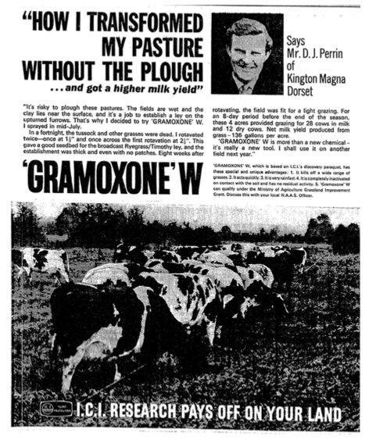

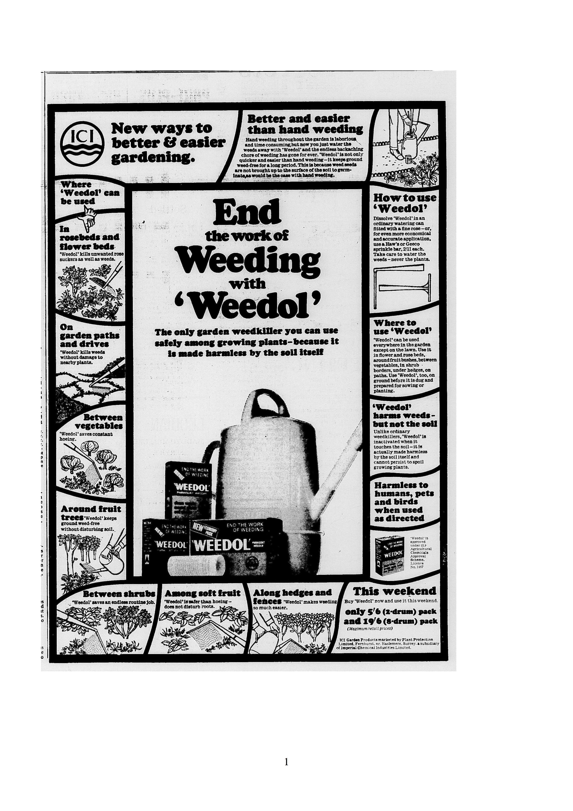
The adverts for Weedol are summarised in Table 2 in order to highlight the key words that were used in the adverts and to see changes over time. General trends were that early Weedol adverts were more informative than later ones, as they were crafted to explain to potential users how Weedol worked, the scenarios that it could be deployed and what users could expect from it. Great pains were taken to put across the ease and simplicity of use, emphasising the use of the plants' own "natural" processes to kill the plant. Later adverts relied on Weedol's established place in the market and were less explanatory. Market research had suggested that potential users were needed reassurance about the immediate and long term effects on soil, animals and other garden users, and these aspects have certainly been addressed, especially in the earlier adverts.

Although the rhetoric of weeding could be war-like, which invoked battles, domination and death, the language of Weedol adverts was restrained when it came to violence against weeds and instead focused on saving time and effort. While pictorial images of the user were masculine, advert readers of any gender were consistently addressed directly through the use of "you". The most common image that the user can relate to in these adverts, is of the packaging which they can find in their shop.

Weedol's adverts imagined users to be looking for particular assurances from the product, and the adverts consistently addressed these by emphasising the time saved, reduction of effort by switching “hard” or “back-breaking” work for faster and easier watering as well as “harmlessness” to anything other than weeds. An awareness that Weedol was perceived by users to be expensive, or at least that the cost had to be justified, also shows in the adverts. They detailed the precise area that can be treated, and consistently highlight the low costs involved, either of the product itself or of the specialised applicators (a substantial 22 shillings and sixpence, though later reduced to 15 shillings and sixpence) that would allow the herbicide's most economical application. Throughout this chapter, we've seen that this information has been important to users of any garden chemical, not just paraquat as it also helps them to work out how much they would need to buy, not only to rationalise spending money on a task that could be done without any purchased products. Indeed, not all gardeners wanted to invest in dedicated application equipment, so made do with items at hand, such as putting a large funnel over the watering can rose to refine the spray accuracy.

From time to time the price of garden chemicals was discussed in the pages of gardening magazines. The staff were well versed in the reasons behind the "appearance" of the high cost, sometimes they even quoted the British Agrochemicals Association, or explained the development process. Home gardener Alf Prosser from Biggleswade had a letter printed in Practical Gardening, in which he noted he was shocked by the high prices of garden chemicals that he was looking at on a shelf. He related it to the record number of people out of work in 1980, so were living on unemployment benefit and asked "How are these people supposed to afford such prices?". He declared that he would go back to hoeing his weeds. The editor responded that there had been a slow-down in price increases but interestingly referred to the cost of "all gardening necessities" as becoming prohibitive. As Alf demonstrated, herbicides are not strictly essential, but it was interesting that he did not mention any of the older chemicals that we have looked at in this chapter. Perhaps now that he was considering what had been a necessary expenditure in a different light, any amount was too great when he could do it for the cost of his time. The table shows how different users, or at least potential purchasers, were reached through different papers. The Times rarely carried for Weedol, while Weedol adverts were carried much more frequently, were of greater variety and tended to be richly detailed in the lower class daily papers. The focus on time saving and costs of material suggests that ICI knew that these were important to the majority of their users.

Year | Advert | Paper | User image | Key phrases | Advertised Price
1965 | Ends the work of weeding | Express, Mirror | No user | Hard work, neutralised, harmless | 5/6
1966 | End the work of weeding | Express, Mirror, Mail | Hands, feet | Safely, harmless, easier, endless, economical, accurate | 5/6 (2 drum pack) 19/6 (8 drum)
1967 | Don't waste time with weeds | Times, Express, Mirror, Mail | No user | Time, revolutionary, safely, save hours | 5/6 (2), 9/6 (4), 17/6 (8), 32/6 (16)
1967 | My Dad's a Weedol weeder | Express, Mirror | Father (plus daughter) | Saves hours, kills, harmless | 5/6 (2), 9/6 (4), 17/6 (8), 32/6 (16)
1968 | Stand up to weeds | Mirror, Mail | Male | Gardeners, revolutionary, kills harmless | 5/6 = 40 sq yds
1969 | Block the living daylight out of weeds | Express, Mirror, Mail | No user | Low priced, harmless, unique, rain, time saved | Sprinkle bar 3/- applicator 15/6
1970 | [month]...in the garden with ICI | Mail, Express, Mirror | No user, but male tech advisor | Save hours of back breaking | ----
1970 | … without killing the soil or your back | Mail, Express, Mirror | Gloved hand | Backache, harmless, economical, ordinary, cost | Avg sized garden/yr 30 bob, 2 drum 5/6, money saving bulk
1970 | Your garden pin up | Amateur Gardening Annual | Non-user woman | Easy
1971 | Two ways | Mail, Express, Mirror | Male | Back-breaking, minutes, kill, harmless, cost | 40 sq yd = 30p
1975 | … without killing the soil or your back | Mail, Express, Mirror | Male | Kill, safely, inactivated, economical, hours, back-breaking | -----
1977 | Fast and easy. | Mail, Express | Percy Thrower | Safely, backache | ----
1977 | ...plenty of help | Mail, Express | Percy Thrower | Compete, safely | ----
1978 | Stop weeds going to bed with your flowers | Mail | No user | Easy, kill, rain, effective | ----
1979 | Our weeders choice/ Weedol about it | Express, Mail, Guardian | No user | Kill, revolutionised, hours | ----
1980 | Don't let weeds be the first sign of spring | Times, Guardian | No user | Effective, speedy, inactivate | ---
1981 | The British gardener's No.1 weedkiller | Mail | No user | Kill, harm, inactivated, risk, rain, gardeners | ---
1984 | Weeds stop here | Mail | No user | Inexpensive, Care | ---
Table 2: Table showing the Weedol advertising campaign key words. Decimalisation facilitated a price rise, with 30 pence being equivalent to 6 shillings, when previously the same pack to treat 40 square yards was slightly less expensive at 5/6.

Users were not always the main feature of Weedol adverts, and in 1965 did not include an image of user at all, instead only picturing weeds around a rose bush. This demonstration of Weedol's "sensitive use" had been shown to be particularly appealing in market research, and would continue to be employed in advertisements that depicted Weedol use. The following season’s advert showed small illustrations of isolated parts of a user: hands, legs and feet, which although did not show a face, look decidedly masculine. In 1967 photographs of users, rather than application equipment, were used for the first time. They showed an excited young girl pointing to a man, declaring "My dad’s a Weedol weeder". The use of the weedkiller in close proximity to the child represents safety, although instructions on the packaging always exhorted the user to keep the chemical out of reach of children. In 1967 another advert ran simultaneously which did not show any user figures at all. 'Don’t waste time with weeds – water them away with Weedol' gave potential users a clear and alliterative message about what the product was for, the benefit of saved time and how to use the weedkiller.

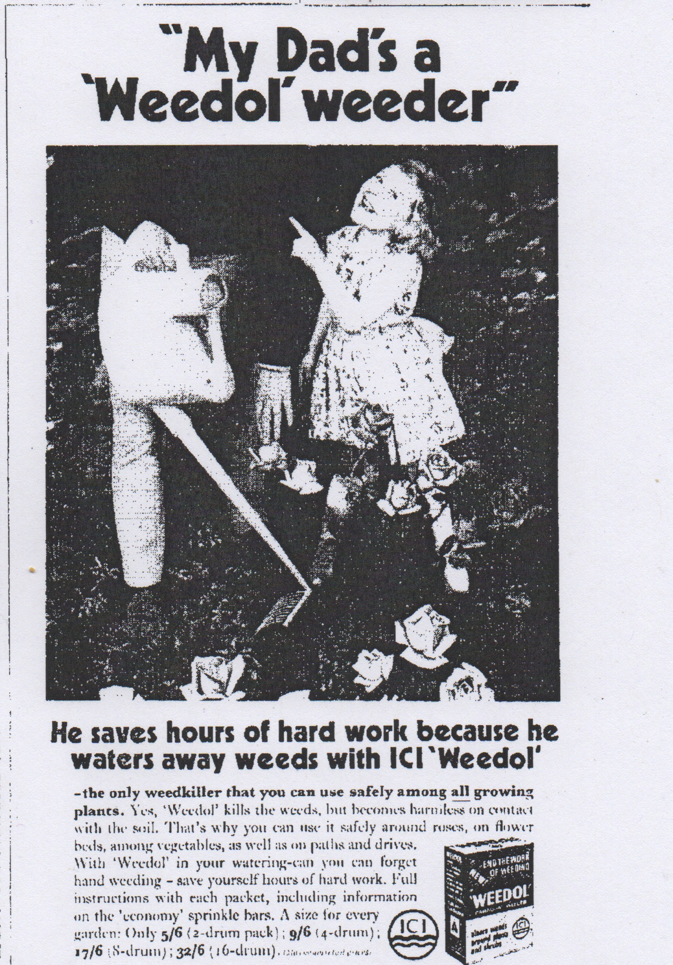Illustration 11: My dad's a Weedol weeder! The tone is conversational and friendly, focussed on how the user can save time using safe Weedol.
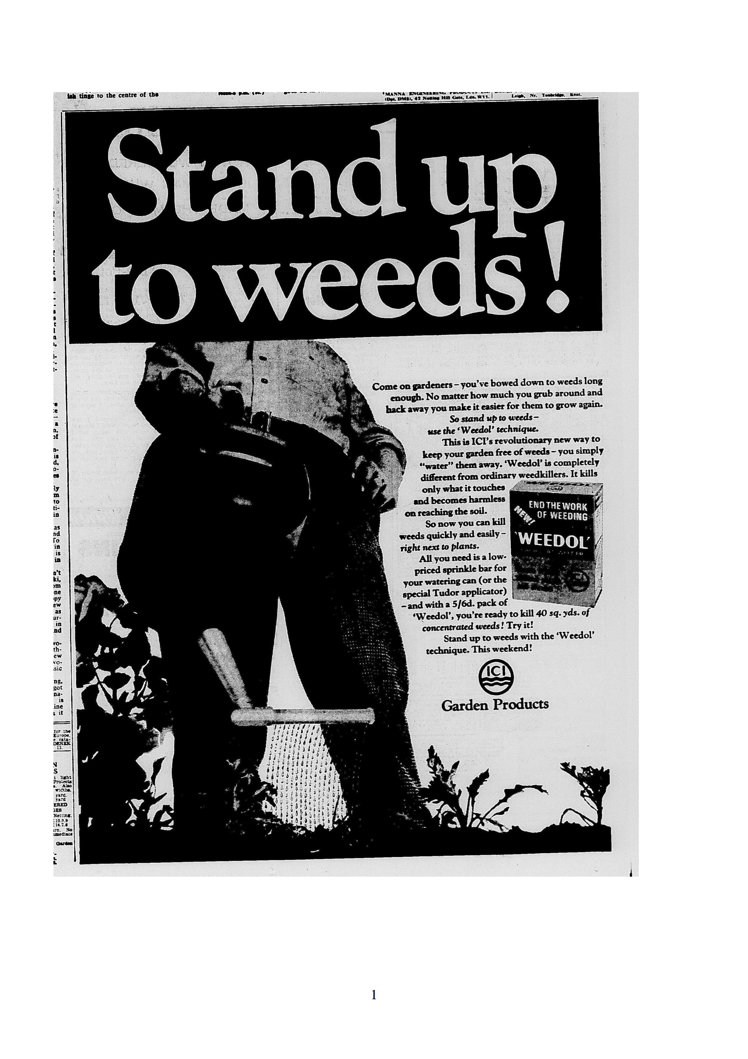Illustration 12: Stand up to weeds. The user has a relaxed posture as he applies Weedol, although the work of weeding has not completely been eliminated, it no longer involves grubbing about.
The "Stand up to weeds!" advert was first placed in mid-April 1968, again only showing the lower half of a male user in neat trousers and a shirt, standing with a hand on his hip and holding a watering can with which to apply weedkiller. The wording implies both the physical action of weeding, which with Weedol no longer involves bending or kneeling, as well as overcoming the relentless invasion of weeds in ones' garden.
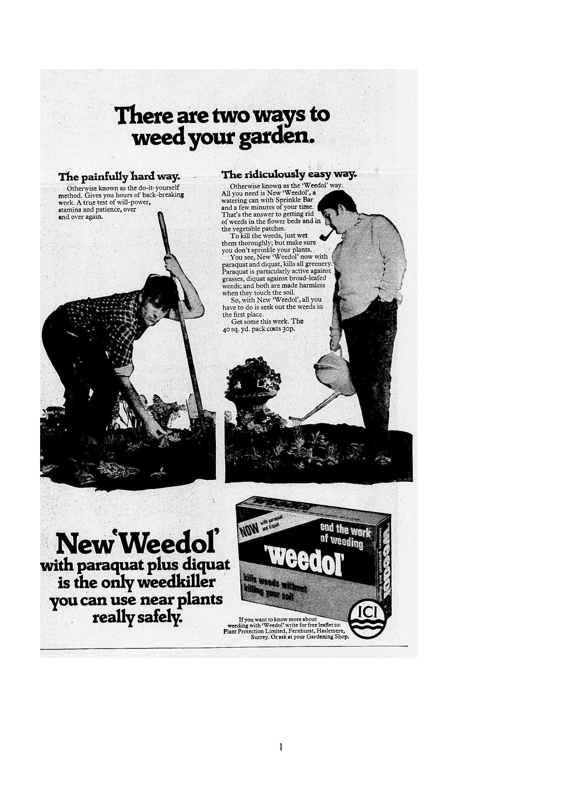Illustration 13: Two Ways to Weed. The dishevelled figure contrasts with a man at leisure, the hand in pocket stance is repeated from Stand up to Weeds.
In 1970, a whole user was depicted for the first time, and compared to a non-user (illustration 12).The user was a middle aged man, probably in his own garden, where he used it among flowers and shrubs, not to clear expanses of weeds or in paving. Through his casual clothes, his relaxed, upright stance and smoking a pipe, his appearance suggested leisure. The dress and actions of the gardener using Weedol in these adverts communicate how easy and clean using the product was. If Weedol was not available, meaning they had to manually weed instead, they would have to wear clothes that could get grass stains and mud on them, so the pale cable knit jumper, the white shirt cuffs show how mess is avoided. The presence of the pipe indicates masculinity, that the man is at leisure, but also that Weedol is safe to use. If the user had to weigh out the chemical, they risked getting it on their hands then transferring it to the pipe and from there into their mouths. Dissolving Weedol directly in a watering can or spray cannister avoids this contamination problem. Perhaps these men would have been less used to handling potentially dangerous chemicals in the home, leaving that task to their wives. Perhaps the comfort of home, and a mindset unique to leisurely activities, meant that vigilance and care that men might have applied to handling dangerous substances in their working lives was abandoned once in the domestic environment.

1970 was an unusual year, as ICI featured a woman in their garden chemical adverts. "Your garden pin-up" featured a simpering woman holding a parasol next to a lush, flowering border, with a variety of ICI garden chemicals at her feet, including "great easy to use" Weedol. The advert described its function as "To remind you, in the nicest possible way, that ICI make a complete range of products to make your garden look lovely". Pin-ups are generally for the benefit of men, which indicates that the imagined gardeners and chemical users were men. However, compared to other adverts for consumer products in the late 1960s and 70s, this incarnation of a fully clothed pin-up was quite tame. By not featuring a woman applying the product, the overall balance of is tipped towards addressing men as the principle likely users of their product.

Competition for resources (soil nutrients, water, light) is a major reason for weeding, not just that weeds can look untidy. Competition for water in times of drought was especially important and in 1976 the UK experienced the hottest and driest summer in 350 years. However, ICI did not create a new campaign capitalising on this, possibly to avoid criticism about using water on weeds during a time of scarcity, though not concerned enough about that charge to not advertise at all and continued to run "Don't waste time with weeds". A couple of years later, space was the competed for resource in the innuendo-laden tagline "Stop weeds going to bed with your flowers" which placed the gardener in a protective role against the invasion of weeds into the flower bed. "Block the living daylight" plays on the action of the chemical, to disrupt photosynthesis, as well as the phrase to knock the daylight out of something
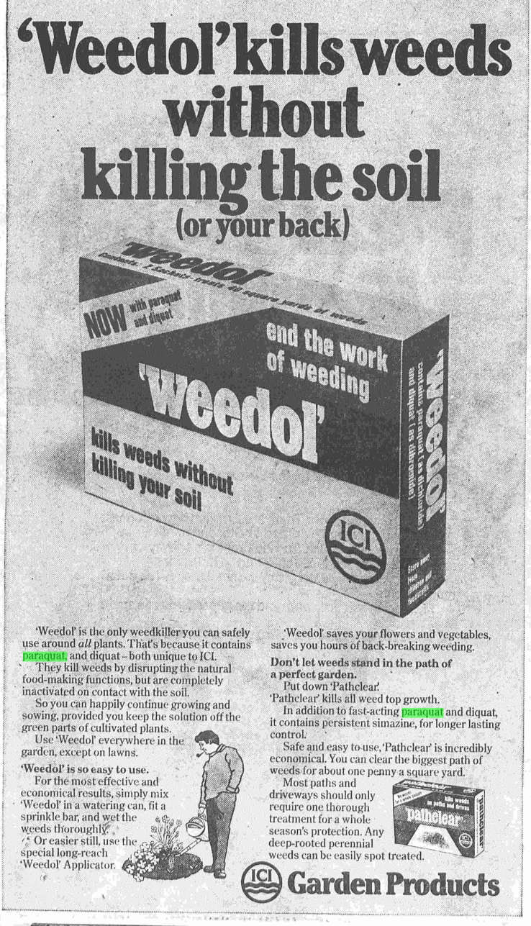Illustration 14: Weedol kills weeds without killing your back. The leisurely gardener from the Two Ways advert has been illustrated here.
ICI even featured a celebrity paraquat user, Percy Thrower, in some of their adverts. Thrower had been a household name since 1947, when he started giving gardening advice on BBC radio. He also had columns in the Daily Mail, the Mirror and the magazine Amateur Gardening, he published books, as well as being lead presenter on the television show Gardeners World and appeared on children's programme Blue Peter. Thrower embraced the range of ready-made chemical aids, although this enthusiasm for chemical fixes was one of the factors in his parting company with Gardeners World in 1976. This decision may have reflected not just the view of the programme makers, but also that of their audience.
-------
The model user could also counter accusations that Weedol was expensive, by reiterating that by investing in the appropriate application spray bar, the herbicide could be applied without waste. The model users were by no means perfect, or even ideal, as inconsistent product placement shows, or the occasional modelling of unideal opinions such as that "amateur packs were expensive". Columnists offered paraquat as an option for home gardeners, even when closer reading of descriptions of their own gardens and practices showed that they chose not to use paraquat in as many situations as they suggested. Many actually preferred to use cover planting to avoid weeding in their own gardens, limiting the amount of bare soil that could be colonised by weeds. Paraquat could play a part in preparing the soil for the desired plants, but it was not the kind of frequent application that ICI had envisaged. However, for many of their readers, this aesthetic was alien and messy. Gardeners were used to hoeing and digging to remove weeds, although disturbing the soil like this brought weed seeds to the surface to germinate. Using Weedol while the weed seedlings were tiny would ensure that the resulting dead material would quickly dissolve away. Weedol required a significant change in gardening practice, targeting seedlings rather than visible, graspable weeds. Using the chemical on larger weeds did not give such satisfactory results, leaving a desiccated, dead plant which would then have to be pulled out, inevitably disturbing the soil and encouraging new weed growth.

Disobedient or Careless Users
So far, this case study has examined the intended uses of paraquat with the knowledge that paraquat could cause fatalities when improperly used, specifically when it was drunk. The darker side of paraquat's story will be examined through the disobedient users who did not follow the instructions which had been crafted to direct safe use. What should be remembered is that the majority of users were obedient, they carefully followed the instructions for normal, expected uses and neither they, nor anyone else, came to any harm. Typically, a disobedient user of Gramoxone contained it in an unlabelled drinks bottle and allowed it into a domestic environment. A disobedient domestic user of Weedol would allow children access to the granules, dissolve granules to make up a solution concentration different to those recommended by ICI, or use the herbicide for purposes other than killing weeds in their garden.

There were plenty of instances of experienced agricultural workers who handled Gramoxone irresponsibly, with an industrial hygienist going so far as to declare farmworkers as “notoriously careless”. This jars with the concept of agricultural workers as skilled, trusted and responsible handlers of agrochemicals that we saw put forward by the regulatory boards associated with the PSPS procedure. Injuries to the skin and eyes were caused by careless handling, and restricted to the applicator but if the result of disobedient use was to repack the chemical into a bottle, the consequences could extend beyond the farmworker themselves if they took that container into a domestic location, where it could have a fatal outcome.

Despite being corrosive, when swallowed paraquat did not burn immediately instead irritating and ulcerating the mouth and throat after a period of time. When first marketed paraquat products did not necessarily cause vomiting, although it had been judged to be unpalatable, although how this conclusion was reached is unclear. After being absorbed into the bloodstream, paraquat caused damage in the kidneys and the liver. What surprised doctors who treated the first poisonings, not to mention all those who had been involved in examining the chemical's risks and hazards, was that paraquat had a peculiar effect on lung tissue. It irritated and thickened the membranes that gas exchange occurs across, which reduced the efficiency of the organ, but also caused cell proliferation (a repair response) in the lungs, so much so that the lungs solidify. Research at ICI's Central Toxicology Laboratory eventually showed that paraquat reacted with a cellular transport process in the lungs, causing this characteristic damage.

The novel features of paraquat weedkiller poisoning caused consternation, and medics were urged to extract further information regarding the type of weedkiller their patients had ingested, as no longer could they assume a weedkiller admission to equate to relatively familiar, arsenic-based herbicides. Despite doctors’ best efforts to deactivate paraquat with Fullers earth, or kaolin, which mimicked the chemical's deactivation seen in soils, or to dilute the chemical in the bloodstream through forced diuresis as was employed in treating barbiturate overdoses, their treatments were experimental and often unsuccessful. In some cases treatments even worsened the situation, although this eventually provided evidence supporting increased understanding of paraquat's mechanism of action. Gramoxone poisonings led to a horrifyingly certain and slow death, potentially over two weeks or more. Even in the 1980s after more experience of treating paraquat poisoning including some successful recoveries, the advice was to focus on palliative care, supporting the patient and their family towards the end of life.

This aspect of suffering was central to the mainstream media coverage of accidental Gramoxone poisonings, which only started appearing as news items in their own right in 1968 although as we have seen already, accidents had happened earlier. The stories invariably conveyed the lack of effective treatment available, often with the stock phrase "no known antidote". As father of paraquat Bill Boon wearily noted, this antidote statement was technically accurate, but it was not unusual as in the true sense of antidote where one chemical neutralises another, very few poisons have an antidote, not even aspirin. Boon attributed the origins of this phrase to an answer given to a coroner in court to the question whether an antidote was available. However, it grabbed attention and was useful shorthand in newspapers for expressing the horror and despair that was experienced by victims, their families, and the medics who cared for them.

Earlier we considered the instruction for safe use and storage of Gramoxone, that it must be kept in its original container and not repacked into unlabelled bottles. Some retailers broke their agreement with ICI, then the Poisons Rules, if they sold Gramoxone in other bottles but often having a bottle of Gramoxone was associated with workplace theft. In 1968, 6 year old Beverley Pollitt died after she drank Gramoxone from a lemonade bottle at home. Her father worked for ICI and had asked another ICI laboratory worker with access to Gramoxone, to get some for him. The liberation of paraquat formulations from the ICI plant was not uncommon: it "leaked out of the plant like water off a roof" according to someone who did not have any connections with the plant, other than living in the area.

None of the other reported cases of accidental poisoning were linked so closely to the chemical company and or hinted at any repercussions for the supplier of the chemical. Yet there were numerous poisonings that occurred because people stored small quantities of the weedkiller in bottles at home. MAFF described people who brought home Gramoxone as trying to avoid the expense of buying Weedol. Market research revealed that from the start, potential users expected the price for such a product to be between 3/7 – 4/- rather than the maximum recommended retail price of 5/6. In table 2, we saw that this advertised price of Weedol remained remarkably stable over time, which reflected the need to recoup the costs of development and manufacturing, but may have frustrated some would-be users. A journalist calculated that Weedol was eight times more expensive than Gramoxone, and suggested that reducing the cost of Weedol would prevent people from decanting the herbicide and bringing it home. Stealing from work is not necessarily about cost, as demonstrated by pens and other stationery abstracted from office jobs, it may be the only kind of perk a person at the bottom of the hierarchy can extract, so reducing the perceived price differential between Gramoxone and Weedol may not have had such a large impact as some people may still have considered work a source of free herbicide, which they could generously redistribute. From the circumstances reported in newspapers, liquid paraquat preparations tended to be brought home by quite young men, who worked in agricultural or horticultural jobs or were in social circles with people who could access the high concentration product. Although they might have been impressed by its efficacy, they do not seem to have respected the strength of the chemical and its potential to do harm. This attitude may have been influenced through the choices of words used on Gramoxone's labelling, prompting the NFU to call for greater emphasis on its dangers.

No matter which words, such as "poison", were employed on the label, the reception of them depended on the user. If they did notice and read the label, as a user who was trained to use the chemical at work, they may well have believed themselves competent to use the same product at home. Where the problem lay was in the presence of other people in their domestic environment who could not be expected to know what the liquid was or the warnings that accompanied the herbicide in its original packaging. Once inside an unlabelled, reused bottle, the herbicide could be given another identity by an unsuspecting, unintended user. The familiar shapes of drinks bottles, an important part of their brand identity, sent out the wrong signals about safe contents when they were reused to store agrochemicals. The bottles of concentrated herbicide found their way into bags, glove compartments, sheds, and kitchens where they were mistaken for dark coloured drinks: cordial, dandelion and burdock, cola, beer, wine, or sherrythen swigged by curious or thirsty children, teens and adults, with very serious and sad consequences. A mouthful could be lethal, even if it was spat out.

The story of 15 year old Alex Smith's accidental paraquat poisoning is one of a teenager exploring his father's shed, who then found a bottle and drank the contents. The incident was fairly widely reported on, but the weedkiller was not the focus. Alex became Europe's first lung transplant patient, and although this was the first paraquat poisoning to gain this level of coverage the chemical was never named as such, only described in a ways that would become typical for paraquat poisonings, including the description that it "looked like cola" and the devastating effects on the lungs. Alex's character was commented on positively, fitting his status as brave patient involved in a risky and pioneering operation. He was pictured cheerily sitting in his hospital bed and described as having "no previous significant history ... a well-balanced, intelligent, and stoic individual" This highlighted how the accident could happen to anyone, which was a departure from the list of poisoning occurring in 1966 and 1967 compiled by PPL and ICI representatives. The Irish and Scottish incidents were described in a way that emphasised poor or defective character of the unfortunate misuser, "patient was drunk when he consumed the chemical" and "a mentally retarded man drank Gramoxone in mistake for wine" as well as the explicitly prohibited behaviour, repacking into beer bottles, and storing them among other drinks.

Disobeying the instruction to never repack Gramoxone, and keeping the herbicide in reused bottles at home was publicly condemned by authority figures. Where Gramoxone was sold to an amateur gardener which resulted in a fatal poisoning, an ICI representative criticised the vendor as "silly and irresponsible". ICI's Bill Boon, champion of paraquat, was reported as attributing accidental deaths to "human stupidity". Keeping Gramoxone in unmarked, reused bottles was "asking for it" coroner Donal Summerfield said. Coroner Roger Stokes was gave good copy when he described the "monumental folly" and "disgraceful act of carelessness" that putting weedkiller in "tempting bottles" was, and compared it to "putting fireworks in a box labelled baby powder." As poisonings of this type accumulated, another coroner frustratedly asked "when will the public learn?", but the reporters did not expand or moralise on the subject of those who chose to use Gramoxone at home.

Despite accidental deaths among people of all ages, it was perceived that children were most at risk. A discussion on paraquat in Handyman Which?, itself an interesting mixture of DIY and professionalism, pointed out that Gramoxone was "one of the main poisons which kill children under 5 in this country" behind pharmaceuticals. Worded like this, it sounds shocking, but the actual incidence of paraquat poisoning, in fact with any household or garden chemical, was very low, especially compared to the greater number of instances of poisoning with prescribed and over the counter drugs. The problem lay in the fact that pharmaceutical poisonings were more likely to be treated successfully.

This section has focused exclusively on accidents involving Gramoxone, which was never intended to be used domestically. Dissolving Weedol granules directly in a watering can to make a small amount was specifically designed to result in fewer opportunities for storing in bottles or mistaken identity and ingestion. The consequences of clumsily handling the low concentration granules were less severe than if the strong Gramoxone liquid was mishandled. From Weedol's launch in 1965 to May 1967, 7 million units were sold, in which there were five medical incidents reported associated with normal use. Only one was a poisoning, where a child “who should not have access to the preparation” ate the granules, and the others were skin irritation due to "carelessness". Considering the volume sold is a tribute to how safe the granulated product could be.

For use only as a herbicide
Another form of disobedience was to go against the instruction that it was only to be used as a herbicide. An example of this was using the product as an insecticide, not only was it ineffective as an insecticide and harmed the plants, when used in a confined space as a fumigant paraquat was fatal for the user. Thankfully, this was not a regular misuse but it was one that ICI representatives took upon themselves to address through firmly worded letters published in the national press. These attempted to educate people about the correct users and uses for Gramoxone, as separate from the users and uses of Weedol. Somewhat unsympathetically, the misusers were held up as misguided, clearly using the product for something that it was not intended, and their own harm followed logically.

Deliberate harm to oneself or another person using both Gramoxone and Weedol also occurred, through disobeying the advice that the herbicide was "not to be taken". Paraquat was not a special case among weedkillers, as we have already seen that suicide using this type of product was already an established practice. As arsenic rat poisons were replaced on the shelves by non-arsenical formulations in the twentieth century, widely available arsenical weedkillers became the product of choice of those determined to obtain arsenic for the purposes of self destruction. The displacement of arsenical weedkillers by "safe" sodium chlorate, did not mean that suicides stopped, as this chemical too could also prove fatal. The arrival of a new herbicide also provided a new chemical to poison oneself with, despite the lack of arsenic and many declarations that it was harmless (when used as directed). Therefore, the arrival of paraquat weedkillers, both agricultural and domestic variants, was another choice among many products for suicidal users.

This use emerged quickly after paraquat was first marketed. Gramoxone was implicated in suicide from 1966 and three suicides were attempted using Weedol, heavily advertised as "harmless" between 1965 and 1967, meaning that these occurred before any publicity about the fatal outcome of Gramoxone misuse, sadly validating the predictions we saw made earlier by chemical industry representatives that someone would try to harm themselves. Although it was possible to deliberately ingest enough Weedol and behave in ways to result in a fatal outcome, the domestic paraquat product mainly featured in para-suicides (“failed suicide attempt” being considered an unsatisfactory term as patients did not want to die but used self-poisoning as an expression of distress).

Although the medical press carried case studies of paraquat suicides from the earliest occasions, this use for paraquat was not explicitly mentioned in the mainstream press until 1972. This followed an investigation earlier in the year into how easily anyone could obtain Gramoxone. As an agrochemical, it might be expected that most of these incidents involved farmers or other workers with easy access to the herbicide but in around half the number of deliberate self-poisonings involving Gramoxone, the people had obtained it by either asking a friend or relative, or bought it openly. Many more men than women poisoned themselves, reflecting the gender balance of occupations that legitimately used paraquat concentrates but perhaps also who would use weedkiller at home. Paraquat poisonings had a seasonal peak (May to July), which is when the herbicide could be expected to be used domestically and therefore readily available.

In 1973 Dr Matthew of the Poisons Board blamed what he called "disproportionate" media coverage given to paraquat deaths for the fact that in Scotland, the number of accidental deaths from paraquat was overshadowed by the number of suicides with the chemical. The agonising decline of patients was described in any news article about the lethality of paraquat, communicating to would-be users that this was not an “easy way out”, even if it was certain. Perhaps in reporting how easy it was to obtain Gramoxone and what size dose resulted in death, media reports effectively put the idea into public circulation, validated it and perpetuated this misuse of paraquat.

Murder
Murder through poisoning with paraquat was another misuse of the Gramoxone (but not Weedol), as until 1974 the herbicide did not have an especially offensive taste or smell, (although the manufacturers declared it unpalatable) so could it could surreptitiously administered in strongly flavoured food and drink without suspicion from taint or residue (arsenic left white powder in drinks and soups). The delayed, generic symptoms of paraquat poisoning did not necessarily initiate detailed chemical analysis of blood or urine to bring the poison to light, and a poisoner could feign ignorance in order to delay or withhold appropriate treatment, ensuring their success in terms of dispatch and remaining undetected.

In 1973 it became apparent that paraquat was being misused as a deliberate poison, when Shelia Sheldon accused her husband of poisoning her, then Jennifer Kenyon and David Roberts were charged with the murder of Keith Kenyon. The character of the paraquat misusers were described as adulterous, jealous men and women, in turbulent, unconventional relationships that made for grippingly sordid, salacious news. I say misuser, because not only was the poisoner themselves described in these terms, but their victim, the unwitting misuser of paraquat, had these negative descriptions applied to them. Poisoning is often thought of as a method used predominantly by women as a method of despatch not reliant on physical strength, but in the cases reported on in the newspapers it was used about equally by men. This alignment of adultery and herbicide use highlighted the potential (if mild) sauciness of Weedol's 1978 slogan "Stop weeds going to bed with your flowers".

Despite journalists fascination with the complex personal relationships of paraquat poisoners, there was a subject on which the newspapers remained quiet. In two separate murder cases, the accused (and convicted) poisoners even stated that they had got the idea from a story in the newspaper. This raises an interesting question of responsibility for copy-cat behaviour triggering, which we saw blamed for the high number of paraquat suicides. Paraquat had moved from the confines of niche columns to the main body of newspapers, and most importantly, the information carried in all these articles centred on the harm that paraquat, specifically Gramoxone, could cause when misused, rather than the correct, safe use of the appropriate chemical. The graph in Figure 2 shows the frequency of reports in the Daily Mail on paraquat involved in accidents, murders and suicides. Visualising the frequency in this way suggests the level of public exposure to the concept of paraquat causing human death, it does not show separate incidents, as accidents might be reported as the outcome of a coroners report, or several articles might be associated with the same story, if for example the progress of a poisoning victim was followed, and murder trials provided regular opportunities for coverage. Suicides were comparatively rarely reported, and as we have seen in this chapter, they had taken place since a couple of years after Gramoxone's introduction but did not make national news. What the graph demonstrates is that as knowledge of paraquat ingestion being fatal became more widespread through the reporting of accidental poisoning, stories of intentional paraquat fatalities followed.
Figure 2: Graph showing the focus on accidents, murder and suicide using paraquat weedkillers.

Fear and Disruption
Another manifestation of paraquat misuse was product tampering, carried out by extortionists and saboteurs who threatened unknown, random people with paraquat poisoning. Arguably, as this required access to products already in stores, or in distribution chains and therefore the adding the paraquat to the product did not take place at home, this might not be considered a true "domestic use". However, these examples provides an opportunity to consider the unwitting, or unintended domestic use, through consumption, of paraquat. In 1974 a man was jailed for attempting to blackmail the CocaCola company by threatening to put paraquat into 200 bottles of the beverage. In the approach to Christmas in 1982, the Animal Liberation Front warned that they had poisoned turkeys on sale in Harrods and Woolworths, as well as in several Bristol supermarkets and butchers.
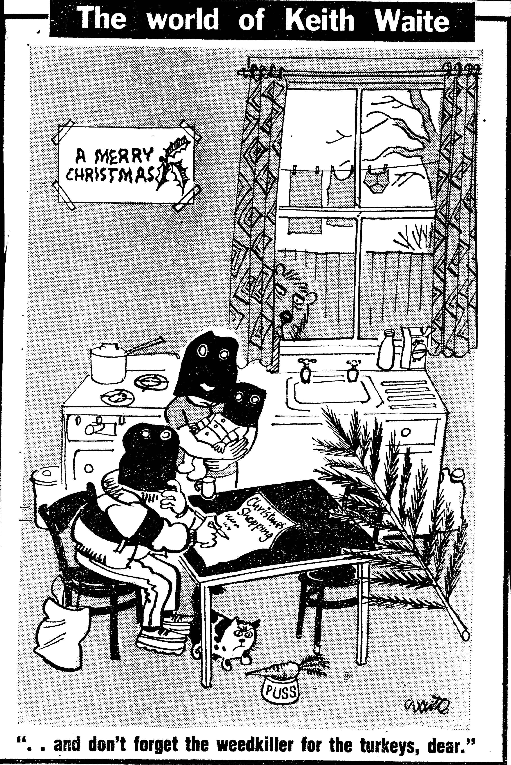Illustration 15: (c) Keith Waite, British Cartoon Archive, University of Kent, Keith Waite, Daily Mirror, 17 December 1984

Political cartoonist Keith Waite made the story into the subject of one of his sketches, caricaturing the absurdist situation in his depiction of balaclava-clad terrorists from the ALF writing a shopping list at home (see illustration). Ultimately no paraquat was found in any meat, but the withdrawal of turkeys from sale, and the anxiety it caused customers show that the threats were taken seriously. Shoppers at Safeway supermarkets were the target of product tampering in 1981 and 1987. In an attempt to deny the blackmailers the satisfaction of attention, a media blackout was imposed while the police and the supermarkets worked on the issue. The supermarket users were surprisingly tolerant of the risk, citing their prior experiences with bomb threats and explosions. Some declared that by continuing to shop there, they were defeating the extortionist’s aim of disruption. Shoppers also trusted the vigilance of supermarket employees and their own ability to spot tampered packaging. The blackmailer operating in 1974 was certainly at an advantage for novelty but that year a stenching agent was added to Gramoxone which could have tipped off recipients of their poisoned food. These events showed that like sodium chlorate, paraquat could be misused to terrorise people.

Public Warnings about Paraquat
Paraquat's sinister reputation was elevated and perpetuated by public warnings in relation to loss or suspected theft of Gramoxone, as well as the normal application of paraquat. Police broadcast warnings with loudspeakers or went door to door to announce the presence of rogue paraquat, and therefore the possibility of a rogue (mis)user, in the residents' locality. Examples included containers going missing from the back of a truck, being stolen from a locked garage, and containers of paraquat getting swept overboard from a container ship with the possibility of them being found washed up on a beach. Local warnings were issued in cases of paraquat use demonstrating the fever pitch surrounding the dangers associated with paraquat, for instance a plant nursery sprayed their property and the spray drifted onto residents gardens, and yet another when a bramble patch was treated and children were discovered to have eaten the blackberries.

The possibility of large containers of concentrate being unaccounted for and in the hands of potential misusers, is understandably troubling, but warnings issued following the use of diluted paraquat seem to be an over-reaction. When diluted according to the instructions, the concentration would not be expected to be harmful to humans. Therefore, these warnings could have stirred up unnecessary alarm. Neither did warnings improve the distinction between agricultural and domestic products, of the low concentration that paraquat was applied at, best practices of application, or the circumstances when it really was harmful. In the desire to protect the wider public through these dramatic methods, the warnings were potentially scaremongering for those who received them.

The Daily Mail took a particularly active role in educating readers about the dangers of paraquat, and routinely contacted the Home Office for the latest comment on regulation. Civil servants’ reactions to this show a mixture of relief that the paper was getting across information about storing chemicals safely and following instructions for safe use, in fact so effectively that civil servant RA Kendall wondered "whether there is much scope for useful Government publicity on top of all the educative publicity already given by the newspapers to paraquat accidents".

This issue of not creating a distinction between Gramoxone and Weedol by referring simply to the active chemical paraquat is hard to explain. Avoiding the brand name would not achieve the same level of anonymity as a product that was made by lots of different companies, for example "bleach" as opposed to "Domestos". If the papers had been trying to avoid singling out an ICI product as related to horrific poisoning cases to protect themselves from being accused of tarnishing the company's reputation or campaigning against them, they were inconsistent, because sometimes it was necessary to use the brand names Weedol or Gramoxone. Worse still was misnaming Weedol instead of Gramoxone when reporting on a poisoning.

Reassuring Users and Non Users
Profile boosting adverts were a staple feature of ICI's communication with the general public about their work and public relations for the chemical industry in general. ICI used these adverts to reassure users and non users that ICI products were of great benefit to their quality of everyday life. When Gramoxone was first launched, ICI's promised that paraquat would boost the nation's total area of agriculturally productive land, improving Britain's self sufficiency regarding its food supply, and when paraquat was exported, it was set to guarantee riches to the UK's chemical industry. In post-war Britain which was rebuilding its economy and anxious about reliance on imports, this was an encouraging message.

Later, as paraquat poisonings accumulated and the United Kingdom suffered in a recession in the 1970s, ICI ran a series of half page adverts to demonstrate the company's contributions to everyday life and the British economy. "Ideas in Action from ICI" (1974) showcased three of their revolutionary products, with Gramoxone listed with, and therefore as beneficial as"Halodane, the world's most widely used anaesthetic" and BCF liquified gas to put out fires "saving precious seconds, precious lives." In these adverts, their message was summed up "Changes for the better, world wide". In addition, ICI spelled out how much money the company was making, investing and recirculating through using "35 000 suppliers" in the UK, very much effort to show the importance of the company when the country was in recession.

This profile raising activity ran for the duration of nearly two weeks of daily court reports of the first murder case involving Gramoxone poisoning. I wonder if this was deliberate, an exercise in damage limitation, in which they aimed to reinforce the positive benefits brought by paraquat when properly used as agricultural chemical. This tactic is only successful where people pay attention to advertisements, which in this case was not measured. This public relations exercise did not extend to encouraging newspapers to expand on the social usefulness of paraquat, although articles concerning the murder trial did contain information about the proper segregation of Gramoxone as only for professional use.

The agricultural background that MPs and Peers came from personally, or represented constitutionally, were important in their arguments, as was the ability of Britain to produce enough affordable, safe food for a growing population. Also included in those who needed reassurance about paraquat were those who made the chemical, and those who lived in those vicinity of chemical plants. Personal safety of manufacturing plant workers was dealt with on a relatively private level, when protective clothing and ventilation were discussed at Poisonous Substances subcommittee meetings. Chemical industry workers used their MP to voice concerns about their economic safety, when calls for further sales restrictions or revoking of its approval by the PSPS and withdrawal of paraquat were debated in parliament.

Those who lived near chemical plants and saw (and smelt) ominous-looking, unknown vapours wafting into the sky, were treated to another interesting act of public reassurance following a fire at a warehouse which stored the chemical. This was the deliberate, public ingestion of homegrown vegetables believed by local gardeners and allotment holders to be contaminated by paraquat, but there is not evidence of the "paraquat pie" being particularly well known. Locals of Woodkirk, West Yorkshire baked the pie containing rhubarb from allotments affected by a fire at a warehouse, which contained a number of different herbicides including paraquat. Vegetation in the area had died and fish in streams were poisoned. Here the concerned local people used contaminated rhubarb as a signal of their distress at living in an environment where they felt unsafe, specifically, where they perceived that chemical and allied industries, such as warehouses to store the products, were allowed to operate without consulting or informing the residents. The pie-eating politicians used paraquat's reputation as deadly, as the ultimate demonstration of "putting their health where their mouth is", even if they did not have to live full-time in the worrying, polluted environment.

Preventing Misuse
As poisonings started to mount up, the problem of misuse was exacerbated by newspaper stories which derailed the correct uses of paraquat that had been carefully modelled through images in advertising, on pack instructions, and through gardening media. When misuse was reported on, the possibilities beyond killing weeds laid out and would-be misusers were provided with very detailed information. ICI had considered the consequences of By demanding that something should be done, a question was posed regarding how far the company should go in protecting people who did not follow instructions for safe use. In this section, we will look at a variety of solutions that were proposed to avoid poisonings.

Restricting availability of drinks bottles
An alternative approach suggested by Scottish Medical Officer of Health (MOH) involved criminalising individuals who used soft drink bottles for the storage of anything other than soft drinks, through the amendment of the Soft Drinks Regulations. In the 1960s cash deposits on glass bottles caused the MOH concern that bottles which had been used to store noxious household or garden chemicals would then be returned tainted with residue. However, this was considered unnecessary by at those in London, as the Poisons Law already covered this the sale of poisons, but that it would be impossible to control how people use bottles. Even though the aim of eliminating accidental poisonings is honourable, administering and enforcing any such scheme would be cumbersome as well as ineffectual. If mystery poisonings traceable to bottles which had been through the returns system had not been a noticeable problem before paraquat, then fears of residue contamination would not have been something to worry about.

Although general advice to gardeners using chemicals in their garden was to buy chemicals only when needed and use them up to avoid storing chemicals and remove the possibility of accidental poisoning, this recommendation was perhaps undermined by special price offers on garden chemicals, including Weedol. Price reductions run by both ICI and individual retailers as part of wider seasonal promotions, as well as to promote the new formulation which contained diquat, but the discounts also be seen as a response to claims made by gardeners that they found the high prices of garden chemicals a deterrent to using them. Although people could buy what they required at this lower price, it could provide temptation to stock up and therefore store the product, making it available in the household for unintended users, and uses.

Changes to formulation
When domestic users were assumed by experts on the PSPS committees to be incompetent to handle a concentrated liquid, the problem they considered was splashes and spills of a caustic substance, not accidental consumption. When it appeared that amateur gardeners did want to use highly effective, revolutionary Gramoxone, rather than tame, expensive Weedol, and so they illicitly decanted the concentrate into an inappropriately labeled bottle, the suggestion that ICI should offer small bottles of Gramoxone in order to reduce accidental poisoning seemed to make sense. While this might have eliminated mistaken identity, smaller bottles as were sold in Japan where most farmers operated on a scale that demanded this change, turned out to be almost an invitation to suicide. Despite the reported problems of home Gramoxone use all relating to consumption, the original decision about paraquat's causticity was not revisited. This reluctance to approach user safety from the liquid to solid angle, may have been related to ICI's revolutionary new system of agriculture being reliant on new equipment to apply liquid rather than powders or prills. This meant that farmers worldwide were locked in to a mode of delivery that demanded liquid, where the consequences of an incompletely dissolved particle blocking a sprayer were far more infuriating and expensive than an amateur gardener's blocked a sprinkler bar on a watering can. Farmers' investment in kit meant that Gramoxone could not be reformulated to a far bulkier and more awkward, but safer solid. ICI's research into making the liquid formulation thicker, so it would be harder to swallow, or into a jelly-like formula were also options can be seen as attempting to work out a compromise that could accommodate their professional and amateur paraquat users. I strongly suspect that if a Gramoxone jelly had been marketed, it would have shifted the problem from bottles to those other readily available domestic containers, jars.

Although it had been suggested that certain poisons be highly coloured, this most often related to how white powders were sold by pharmacists and mistakes made with their storage and labelling, rather than for consumer-ready products. ICI had been extremely resistant to requests that the labelling move beyond "Caution", so to include precautionary measures from the very beginning would have have signalled that they expected there to be trouble. Ultimately, although the very small minority of misusers were predictable, their actions were hard to control. The relatively low incidence of serious misuse, despite its high profile, and the utility of the agrochemical meant that the majority of obedient users outweighed the misusers.

Although company and MAFF representatives put full responsibility for accidents on the chemical users, and insisted that when the instructions were followed paraquat was safe, it would have been a public relations disaster for ICI if they could not be shown to have responded with some positive actions. Company spokespeople were readily contactable by journalists, who were able to portray the chemical company positively, as working hard to make the formulation of the very effective and valuable herbicide safer, and investing in research to find better treatments for poisoning.

Despite an assumption that “those who drank paraquat in mistake for something else tended in any case to swig their drink back, without stopping to savour the bouquet" the addition of a stenching agent was one of the first changes to Gramoxone's formulation, despite initial concerns that it would affect the herbicidal efficacy. The off-putting smell was expected to be alert the user to the noxious nature of liquid if it was decanted into a different container. If the stenching agent had not deterred the drinker, another line of protection was added by addition of another of ICI's discoveries, a triazolopyridine referred to as PP-797 made by FL Rose and ICI colleagues. From 1977 PP-796 was added to both Weedol and Gramoxone to make people vomit and reduce the amount of paraquat that could be absorbed. From 1980 Bitrex, as an increasingly prevalent and high profile proprietary additive in a variety of household chemicals, so had been publicly raised as an option for making paraquat preparations safer. However, ICI had investigated this and decided against including it as paraquat was already unpalatable, so Bitrex, which they would have to licence or buy at additional cost, would not make their products any safer to use.

The issue of Gramoxone being mistaken for dark coloured drinks presented a target for change, but a difficult one to achieve. In a parliamentary debate on the Farm and Garden Chemicals Act, it was proposed that manufacturers of any garden chemical should strongly consider the appearance of their products, using the example of Gramoxone's visual similarity to cola. This echoed old arguments about colouring poisonous chemicals, for instance giving normally white arsenic and strychnine formulations unmistakably vivid colours in order to avoid accidental poisoning. However, in the case of Gramoxone which was a dark liquid, it was much harder to add a colour that would stand out.

After paraquat
Following the drama of paraquat poisonings in the preceding years, some new garden weedkillers were put onto the market with the specific claim that they did not contain paraquat. This can be interpreted as a reaction against the perceived danger of paraquat and fulfilling a desire among gardeners for an alternative product, and we can see a parallel with the adverts for products in the 1930s that stated that they were as effective as arsenic but not poisonous. In 1981, new amateur or domestic weedkillers named DeeWeed and Leroco were advertised with the claim that they did not contain paraquat or sodium chlorate. The fact that the effect would last at least 3 years confirms that it would not be a direct competitor to paraquat really, but the assertion that it is neither of these well known chemicals is striking. Leroco took some cues from Weedol by offering ready-weighed sachets to be dissolved in 2 gallon watering can, indicating that this delivery method must have been deemed worthwhile by users and manufacturers.

These products were more likely to have been designed to cater for the user keen to keep a low maintenance patio or drive barren, "property owners" were addressed, not the gardeners that Weedol targeted. By the nature of the type of gardening featured in Weedol adverts, rose gardens, flower beds and vegetable plots, a degree of long-term investment in the activity is supposed, which means that those at least some of the those same gardeners are likely to be property owners too. Addressing "owners" excludes tenants, who may also be keen to keep the outside areas of the property they inhabit tidy, but maybe this presumed economically lowly group of renters are not seen as reliable enough either weed regularly or handle chemical weedkillers.

Thanks to paraquat's inactivation by soil and gardeners weed killing situations continued to call for a contact herbicide, where gardeners could rely on the soil being suitable to plant in immediately Weedol was not immediately displaced from its position in the market and continued to be available. It also shows that a significant majority of users who bought and used the herbicide were not shaken by the negative publicity that paraquat as an active ingredient received. ICI had been able to reassure users that their welfare was a concern by changing the formula, and by being involved in the development of treatment for poisoning victims. The amount of paraquat in Weedol was reduced by replacing half with diquat, but because of the niche it occupied when considered how it would be used in the garden, paraquat was not pushed off the shelves by other products. Eventually, both diquat and paraquat were replaced in Weedol by glyphosate, another example of retaining the strength of brand recognition that we saw earlier in Hayward and Tomlinson's Eureka weedkiller. The demand from users for a herbicide that would break down rapidly in the soil paved the way for glyphosate. Glyphosate products such as Murphy's Tumbleweed which came onto the amateur gardening market in the 1980s did not define themselves in relation to paraquat, as Leroco or DeeWeed did. Neither did they allude to backache, as one of the forms that the product came in was a gel to be painted on to individual weeds, a laborious if precise application method that certainly involved getting up close with the weed.

Conclusions
Paraquat was certainly extremely effective at killing plants and this primary function won favour with agricultural and domestic users alike. All bodies involved in safety regulations made a judgement that all users would follow the instructions provided. This required domestic users to take responsibility for their safety and to treat the products as potent killers, to remain safe by following carefully crafted instructions.

I have shown that users shunned the demarcations set by Plant Protection Limited for two preparations of paraquat weedkiller, for two different user groups. The agricultural Gramoxone was invited into some private homes and garden, although it was never intended by the manufacturers for domestic use. Unfortunately this sometimes resulted in fatal poisoning, largely due to user error relating to reusing a beverage bottle, an explicitly prohibited action.

Users were not always as obedient, careful or competent as PPL hoped they would be. Retail was certainly a weak link in the chain, and provided an opportunity for domestic users to obtain possession of a substance that ICI and the expert committees had declared unsuitable for them. Enforcing the appropriate retail of poisonous substances was, and continues to be, difficult as both the purchaser and vendor can be motivated to get around restrictions.

Although the first accidental ingestions with Gramoxone were related to people using the herbicide as part of their work (though generally the poisoning did not take place at work), after Weedol was widely marketed to home gardeners, both in display adverts and in garden advice columns, accidental poisonings with Gramoxone spread to people who did not work with the chemical. I argue that referring to the active chemical “paraquat” in advice columns created a desire for paraquat rather than the branded product Weedol, and that their inconsistent use of the brand name contributed to a lack of awareness about the distinction between the agricultural and domestic variants. Some domestic users were not willing to pay more for a safer product designed especially for them. Some professional users of Gramoxone also had domestic needs for a similar product and judged that their workplace experiences enabled them to safely disregard the agricultural-domestic division preferred by ICI and MAFF. Some domestic users of Gramoxone must have used it successfully for its herbicidal purpose because the number of accidental poisonings was quite low, so it was not inevitable that it would wreak destruction outside of the boundaries that had been set for it. Bringing agricultural chemicals into the domestic environment potentially exposed Gramoxone to a group who had been designated by ICI and the expert committees specifically as non-users, to be kept separate from all paraquat products. Children were believed to be particularly at risk of accidental poisonings, even though the actual numbers of accidental poisoning of adults and children were not very different.

Users of paraquat based herbicides who did not follow the strict instruction to keep the chemical in its original packaging, put themselves and others (who would not have known of the instructions associated with the concentrate) at risk of mistakenly using the weedkiller as a drink, brought the chemical to wider attention. Focusing on these relatively rare incidents, inevitably made the problem appear more prevalent than it was. The seriousness of the outcome overshadowed the low likelihood of it actually happening, despite the “it could happen to anyone” angle that was taken by campaigners for stricter safety.

Those calling for the complete withdrawal of paraquat were not the legitimate, agricultural users of the strong products. Farmers wanted more comprehensive labelling, but they did not want their access to the very effective herbicide impeded. Domestic users of Gramoxone, who knowingly transgressed the boundaries set by ICI and clearly violated the multiple instructions for safe use, tended not to be among the voices calling for bans. When accidental poisoning with the concentrate occurred, generally the way that the misuser had come to have a prohibited bottle of herbicide meant that they were aware that what they were doing was proscribed. They did not call for, or seem to expect absolute safety. Those who used Weedol, and conformed to the user categories as agreed by PPL and ICI in negotiation with PSPS committees, appear untroubled by the presence of a poison in their preparation because this poison was what made the chemical effective, and trusting of the manufacturer to provide a product that would not ordinarily harm their customers. However, the appearance of products that were specifically marketed as not containing paraquat perhaps indicate that the manufacturers of those preparations had found that some gardeners considered paraquat to be a fearsome thing to be avoided. Where inactivation by soil was applicable to the users' gardening situation, Weedol continued to be relevant, so relevant that the product did not change its name when paraquat was completely ousted from the formula.

The focus on user behaviour, rather than than the withdrawal of the product or changes that could be made to the product, the Publicising the danger of breaking down bulk agricultural chemicals

Overall, the number of UK deaths in relation to the total volume of paraquat sold and used was very small, the safety precautions were easily followed by the majority of users and the herbicide was extremely effective. This meant that ICI and regulatory government committees could not seriously contemplate a ban, although ICI were directed to, and did, investigate and implement a variety of changes to the formulation. It also shows that while some letters received by papers and MAFF from members of the public called for the chemical to be banned or withdrawn from sale, their very most of the users were confident that they could use the chemical appropriately and safely, so continued to buy and apply it.

Linking sentence goes here. The imagined incompetence of domestic users to handle a liquid preparation of Weedol, even though it was a lower concentration than the agricultural variant, led to its granulation. The actual misuses of agricultural and domestic paraquat preparations led to substantial changes in the formulation and presentation of both products, but not their revocation of safety approval or withdrawal. Paraquat was considered far too valuable an agricultural chemical to entertain thoughts of a full ban on its use at this time. Those determined to misuse the products still circumvented the conditions of sale, went against the continually reviewed and revised instructions.

Through their attention to users, as well as their reformulation efforts, ICI were seen to be acting to prevent accidents and their ready availability to comment on poisonings and the proper use of their chemicals, along with their public relations address made the company feel approachable and accountable. It could be asked why the company did not make their paraquat products stinky and unpalatable from the start, if they suspected that some people would try to misuse them. I would answer that other poisonous garden chemicals did not have these safety features either, and there was nothing to mark out paraquat as needing special treatment. When decisions were being made about the formulation, the chemical was believed to be, on the basis of rodent tests, “moderately toxic orally” and “mildly irritant to the skin and mucous membranes”. It was through the media furore around deaths of children that paraquat acquired such a sinister reputation. Death by any other agrochemical was equally tragic, but it was the emotive stories, the incredible repetition of very similar accidents and the science fiction effects on the lungs which propelled paraquat as a poison into the public eye.

In this chapter, we have looked at who used weedkillers. While women were shown using them in a very limited medium and no doubt used them in the garden, men and even more specifically, white men, are shown as the main herbicide users in advertising and in news about accidents or incidents. Men were more likely to die through accidental or deliberate poisoning with herbicides, which also reflected their greater likelihood of working with them, either at home or in their employment. Sodium chlorate and paraquat were the top two pesticides involved in deaths from acute poisoning between 1945 and 1989.

Gardeners' letters published in Practical Gardening did not generally show evidence of unbranded chemicals becoming harder to get, but they demonstrated frustration at not being able to find, as well as their high cost, natural products such as dried blood, for use as a fertilising agent, which disappeared from the market in 1975, or the chrysanthemum-based insecticide pyrethrum. This suggests that synthetic garden chemicals were dominant, that at least branded, ready compounded products were readily available. The explanation such as when products were not "big-sellers" they got pushed to the back of the shelf, but there were still available. This seems to paint a picture where the users who wanted to buy ingredients to mix their own preparations were in a minority, the products they wanted were outnumbered and made easy to miss by the much greater number of complex, branded preparations.
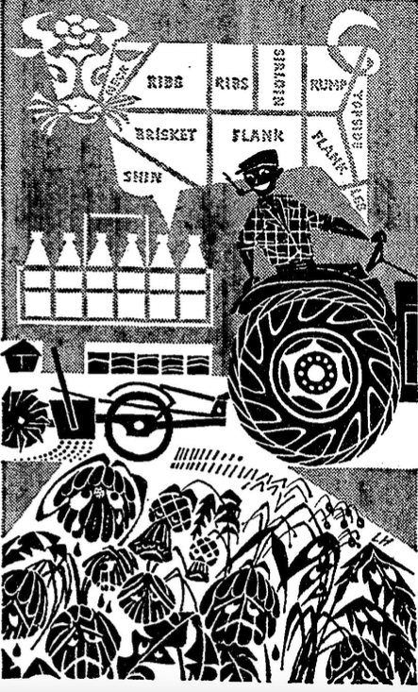Illustration 16: One of ICI's profile raising advert, promoting the benefits of their work "Research: the Springboard of Progress" (1964) depicted these sad weeds being sprayed with Gramoxone by a grinning farmer.
The war against weeds, despite using herbicides, was never referred to as chemical warfare. Herbicides were described as part of the arsenal, or as ammunition, involved in skirmishes and sieges against weeds and other pests set up as as the enemy, but invoking the horror and mass destruction wrought by chemicals used in actual war was avoided in editorials and advertising. While ICI's sprayed weeds looked sad, the control and the power was all in the hands of the user. The chemicals studied in this chapter were mainly untarnished through their extra-garden uses. It appeared impossible to come to harm through misusing sulphate of ammonia, sodium chlorate did not become demonised through its use by terrorists in the 1970s, but through its misusers paraquat was. What was different? Although homes and their inhabitants were affected, such as those who lived above and near pubs that were bombed with sodium chlorate devices and mortars, being attacked is different to inviting a chemical into your home and expecting to be able to control it. Gardeners who used sodium chlorate for gardening were not waiting for sodium chlorate to attack them, Weedol using and probably the careful Gramoxone users were not at risk from paraquat attack. The only thing that could lead to harm using paraquat was not following the instructions. Paraquat cannot be thought of as attacking, except at the bidding of a murderer Perhaps the home makes paraquat misuse stand out, this was where mistaken identities occurred, where paraquat was swigged or taken deliberately. In combination with it's status as a newly synthesised chemical, marketed only by one large company, compared to sodium chlorate as a well established, relatively simple chemical made by many smaller chemical companies.

Gardeners must think about the future, imagining and looking forward to when their planting schemes reach maturity. The need to balance immediate with future needs is played out in weeding.

Weeding and success in using weedkiller hinges on correctly identifying the weed and then selecting the correct herbicide for both the situation and the plant, followed by applying it correctly. An example of how the first hurdle must be cleared can be seen in the case of a gardener who sent in a sample of problem "moss" from their lawn, and asked for advice to treat it. They were told that it was in fact chickweed, which explained why moss killer had been ineffective, and directed to the appropriate weedkiller. Using herbicides requires intellectual work, even if the following physical work is less arduous than weeding purely by hand. Like choosing chemicals for cleaning the home, the gardener must be able to select the right one for the job. By adding this layer of skill, understanding which chemical to select, on top of identifying the weeds, a menial task becomes one for an expert. This use of chemical products can be thought of thought of as a way of engaging with the wider world of scientific research and development, of modernising one's practices and keeping up with the times, if not the neighbours. Betty Frieden used this argument in her discussion of women and consumption, particularly regarding the proliferation of household cleaning products in the 1950s, but it can be applied equally well to garden chemical users, and users of photographic chemicals, of any gender, throughout the entire period that this thesis examines.

Using weedkiller for human harm was not unique to paraquat herbicides, as we saw in the earlier part of this chapter. The deliberate ingestion of weedkillers that were specifically marketed as harmless, such as sodium chlorate and Weedol, shows how any chemical is a candidate for this particular misuse. Sensationalised news reports about the severity of paraquats effects on the human body gave the chemical a notoriety which facilitated its use to end lives, which made it threatening enough to be used as an agent of saboteurs and blackmailers. Correct uses of garden chemicals were modelled in advertisements as well as garden advice columns, magazines and books. Misuses which were reported following accidents educated others about the dangers of garden chemicals and in some cases motivated users to improve their own methods of storage to ensure safety. However, they also acted as inspiration to misuse, by providing a primer on how much would be fatal, by showing how easy supposedly restricted substances could be obtained or through guaranteed media attention when a notorious poison was (threatened to be) involved.

Russell, Stan. "Laboratory Gardening." Practical Gardening, April 1964, 3.
Russell, Stan. "Over the Fence." Practical Gardening, 1976. p5
Fearnley-Whittingstall, Jane. The Garden: An English Love Affair. London: Weidenfeld & Nicolson, 2002. p287
Sutton & Son, Lawns. London: Simpkin, Marshall, Hamilton, Kent & Co. Ltd, 1899. p25
Constantine, S. (1981). Amateur Gardening and Popular Recreation in the 19th and 20th Centuries. Journal of Social History, 14(3), 387–406.
JC Loudon "Suburban Gardener and Willa Companion" quoted in Holmes, Caroline. New Shoots Old Tips. London: Frances Lincoln, 2004. p25
Holmes, Caroline. New Shoots Old Tips. London: Frances Lincoln, 2004. p21-22
Beale, Reginald. The Book of the Lawn: A Complete Guide to the Making and Maintenance of Lawns and Greens for All Purposes. London: Cassell, 1931. p78
"War on Weeds." Practical Gardening, June 1963, p65.
Lawrence, Bill. "Shock Tactics: a Special Report on Weed Control." Practical Gardening, March 1981, 54-54.
"Waging War on Weeds." Good Housekeeping, July 1975, p110.
Bhatti, Mark, and Andrew Church. "‘I Never Promised You a Rose Garden’: Gender, Leisure and Home-Making." Leisure Studies 19, no. 3 (2000): 183-97.
Kirby, Celia. The Hormone Weedkillers: A Short History of Their Discovery and Development. Croydon: British Crop Protection Council, 1980 p45-46
Glasspoole, Claire. "25 Labour Saving Ideas." Practical Gardening, November 1966. p31
Church, Roy, and Christine Clark. "Purposive Strategy or Serendipity? Development and Diversification in Three Consumer Product Companies, 1918 - 1939: J & J Colman, Reckitt & Sons and Lever Bros./Unilever." Chap. 3 In The Emergence of Modern Marketing, edited by Roy Church and Andrew Godley. London: Frank Cass and Company Ltd, 2003.
Whitehead 1949? or Chemicals for the
Lanman, Susan W. "Colour in the Garden: 'Malignant Magenta'." Garden History 28, no. 2 (2000): 209-21.
Agatha Christie novels containing weedkiller related deaths: The Cornish Mystery 1923, How does your garden grow 1935, Dumb Witness 1937
Russell, Stan. "Douse That Bonfire!". Practical Gardening 7, no. 2 (May 1966). Stan had come back from an ABMAC conference with the statistic that agrochemical operatives had the lowest incidence of lung cancer, and that burning green material on bonfires released huge quantities of carcinogens, worse than using garden chemicals.
Handyman Which?, February 1973, p10
Chemicals for the gardener: for the control of plant pests, diseases and weeds, MAFF, HMSO 1963
Kennedy, p120
“Pesticides and Posterity”, Horizon, BBC Television, first aired 30.05.64 (accessed BFI)
Hassall, Kenneth A., and A. V. Percival. Weed Control in the Home Garden: A Simple Guide. West Byfleet: Percival, Best, Publications, 1973.
Ridler, P. "Clearer Labels." Practical Gardening, December 1966, 5.
Rudd, E. "Dosage Chart." Practical Gardening, April 1964, 43.
Reed, F. J. Lawns and Playing Fields. London: Faber and Faber, 1950. p119
Hall, A.D. The Feeding of Crops and Stock: An Introduction to the Science of the Nutrition of Plants and Animals. London: J. Murray, 1912. p250-251
The Book of Garden Management 1870, p414
Irish Gardening Vol. 4. 1909. Reprint. London: Forgotten Books, 2013. 339-40.
"Garden Requisites and Produce." The Times, 04/01/1913 1913, 1.
"Close of the Chelsea Flower Show." The Times, 23/05/1913 1913, 6.
"Success of the Flower Show." The Times, 22/05/1914 1914, 5.
"Lawns and Lawn Sands." The Times (1922/04/22/ 1922): 15.
Macself, A. J. Grass: A New and Thoroughly Practical Book on Grass for Ornamental Lawns and All Purposes of Sports and Games. London: Cecil Palmer, 1924. p101
Macself, A. J. Grass: A New and Thoroughly Practical Book on Grass for Ornamental Lawns and All Purposes of Sports and Games. London: Cecil Palmer, 1924. p101
"Lawns and Lawn Sands." The Times (1922/04/22/ 1922): 15.
Hall, A.D. The Feeding of Crops and Stock: An Introduction to the Science of the Nutrition of Plants and Animals. London: J. Murray, 1912. p250-251
GB190804276 (A) 1908-09-10, A distributing device for seeds, fertilisers, lawn sand, weed killer and other solid materials of a similar character; GB191312911 (A) 1914-06-04 A Machine for distributing lawn sand, artificial manures and the like; GB614142 (A) 1948-12-09 Improvements in hand distributors for lawn sands and like substances.
Beale, Reginald. The Book of the Lawn: A Complete Guide to the Making and Maintenance of Lawns and Greens for All Purposes. London: Cassell, 1931.
Macself, 1924. PAGE NO
Beale, Reginald. The Book of the Lawn: A Complete Guide to the Making and Maintenance of Lawns and Greens for All Purposes. London: Cassell, 1931. p81
Dawson, R.B. Lawns. Amateur Gardening Handbook. London: W.H. & L. Collingridge Ltd, 1954. p63
Hellyer, Arthur George. Your Lawn. Twickenham: Hamlyn, 1970. p31
"Farming Notes and Comments." The Times (19/01/1931): 18.
"Garden Notes." The Times (09/07/1932/ 1932): 13.
"Attractive Allotments and the National Scheme." National Allotments Journal, no. 21 (1934): 10-12.
"A Wonderful Weed-Killer (Continued)." National Allotments Journal, no. 23 (1935): 19-21.
"Attractive Allotments and the National Scheme." National Allotments Journal, no. 21 (1934): 10-12.
Podger, Hugh. Albright & Wilson: The Last 50 Years. Sudley: Brewin Books Ltd, 2002. p15
Podger (2002) p8
Podger (2002) p15
Podger (2002) p15
"Staveley's New Venture." The Daily Mail, 28 September 1935. p2
"A Wonderful Weed-Killer (Continued)." National Allotments Journal, no. 23 (1935): 19-21.
"A Wonderful Weed-Killer." National Allotments Journal, no. 22 (1934): p19
"Staveley Coal & Iron Company." The Times, 27.09.1938, 20.
Display advertising, The Daily Mail, 27.04.40. p9
"Sodium chlorate" HC Deb 19 November 1945 vol 416 cc25-6; "Sodium chlorate" HC Deb 11 November 1948 vol 457 c1717; "Sodium chlorate supplies" HC Deb 15 March 1949 vol 462 cc171-2W
"Sodium chlorate" HC Deb 21 February 1949 vol 461 cc231-2W
Whitehead, Stanley B. Garden Weeds and Their Control. London: J.M. Dent, 1949. p58
Display advertising, The Daily Mail, 17.04.54 p6
"Weeding out the Weed-Killers." The Daily Mail, 18.09.1971, 19.
Watson, James. "The Significance of Mr Richard Buckley's Exploding Trousers: Reflections on an Aspect of Technological Change in New Zealand Dairy Farming between the World Wars." Agricultural History 78, no. 3 (2004): 346-60.
"A Wonderful Weed-Killer." National Allotments Journal, no. 22 (1934): p17
"Garden Poisoner Injures Baby." The Daily Mail, 01 July 1958, 5.
"A Wonderful Weed-Killer." National Allotments Journal, no. 22 (1934): p19
Whitehead, Stanley B. Garden Weeds and Their Control. London: J.M. Dent, 1949. p59
Overholser, Earle Long. "Study of the Shipment of Fresh Fruits and Vegetables to the Far East, Part 1." University of California, 1930. p33
Reed, F. J. Lawns and Playing Fields. London: Faber and Faber, 1950.
Sprague, Howard B. Better Lawns for Homes and Parks. Whittlesey House Garden Series. edited by F.F. Rockwell London: Whittlesey House, 1940. p169 and p172
Whitehead, 1949 p59
A Correspondent. "Weary Battle against the Weeds." The Times, 21 March 1959, 9.
Glasspoole, Claire. "25 Labour Saving Ideas." Practical Gardening, November 1966. p31
"Garden Poisoner Injures Baby." The Daily Mail, 01 July 1958, 5.
"Police Rule out Cricket Tour Vigilantes." The Times, 07 May 1970, 2; "Wrecker Poisons Golf Links." The Daily Mail, 25 July 1960 1960, 7.
HO 144/23246 19 March 1941 letter to Dr Watts from Gonne St Clair Pilcher
IMG_3090 Letter from chief constable Reading police to the Explosives Department, Home Office
"Extract from Minutes of Special Branch Conference (Regional) Held at Reading on 29/4/43.".MAFF: HO45/11240 National Archives, Kew, 1943.
"Home made explosives (accidents)" HC Deb 28 June 1966 vol 730 cc250-1W
"The Best Way to Keep Paths Free of Weeds." The Daily Mail, 13 June 1959.
"Sodium chlorate" HC Deb 21 December 1961 vol 651 c178W
Hansard "Sodium Chlorate "HC Deb 07 February 1963 vol 671 cc644-5
"May in the Garden with ICI." The Daily Mail, 02 May 1970, p9.
"Sodium Chlorate" HC Deb 07 February 1963 vol 671 cc644-5; "Sodium Chlorate" HC Deb 18 May 1966 vol 728 cc266-7W,
Health and Executive Safety. 1998 "Storage and Use of Sodium Chlorate and Other Similar Strong Oxidants." p7.
"Two Bob Bombs Menace Children." The Daily Mail, 20.08.64, 1.
"Bomb-Making Outbreak." The Times 19.03.1962, 5
R. E, Parker. "Warning Needed." The Times (19/08/1964) 11
Boots, Home and Garden. "Special Announcement: Sodium Chlorate." news release, 18 May 1970, 1970.
British Agrochemicals Association. Directory of Garden Chemicals. Third ed. London: British Agrochemicals Association 1978.
"Report of Her Majesty's Inspectors of Explosives for the Year Ended 31st December 1970." London: Home Office, 1971. p36
"Bath "Booby-Trap" Case." The Times, 12/12/1953, 3.
"Son-in-Law 'Blew up Car with Sodium Bomb'." The Daily Mail, 03.10.1961 1961, 9.
Geraghty, Tony. The Irish War: The Hidden Conflict between the Ira and British Intelligence. JHU Press, 1998. p189
Rodwell, Rodwell. "Army Uncovers a Mrs Beeton for Bombers." New Scientist, 03.05.1973 1973, 276-77.
"Revolutionaries and Anarchists Used Bombs against Political Enemies, Prosecution Says." The Times 11/11/1971
NORTHERN IRELAND (CONTROL OF EXPLOSIVES) HC Deb 05 June 1972 vol 838 cc156-72
"House of Lords Debate "Explosives Security"." Hansard 365 (06 November 1975): cc1377-9.
"Weed-Killer Wife Jailed for Life." The Daily Mail, 21 July 1973, 11.
"Spinster Killed Nosey Old Man - Police." The Daily Mail, 03 April 1962, 6.
"Angry Husband 'Poisoned His Wife's Cereal'." The Daily Mail, 16 October 1985, 8.
Knight, Author R. K., J. R. Trounce, and J. S. Cameron. "Suicidal Chlorate Poisoning Treated with Peritoneal Dialysis." The British Medical Journal 3, no. 5565 (1967): 601-02.
"How I Wooed the Head by Lovelorn Caretaker." The Daily Mail, 15 May 1974, 15.
Haworth, Carl, Alan, and Cleaning and environmental solutions (seller). "Questions & Answers: How Can You Sell Weedkiller Containing Sodium Chlorate When Wholesale of This Was Banned in 2009 & Use of It Since 2010?"
Casey, P., and J.A. Vale. "Deaths from Pesticides Poisoning in England and Wales: 1945 - 1989." Human & Experimental Toxicology 13, no. 2 (1994): 95-101.
MAF284/307, 2, PS427 SC 1175, Scientific Subcommittee on Poisonous Substances used in Agriculture and Food Storage, “First Report on Paraquat”, 23.03.62
Howard, 1982, Paraquat: Uses and Misuses, MD thesis, University of Edinburgh, p2.
“Improved Type of Weed Killer” The Times, 23.08.62, p10.; “Farewell to the plough” Daily Mail, 29.08.62
Bradbury, McCarthy and Suckling, “Patterns of Innovation Part III – The bipyridyl herbicides, Chemistry and Industry, 4 March 1972,
DA Schon, 1963, "Champions for Radical New Inventions", Harvard Business Review pp77-86, p84
Bradbury, McCarthy and Suckling, “Patterns of Innovation Part III – The bipyridyl herbicides, Chemistry and Industry, 4 March 1972, p195;
Wain, p.139
Kennedy, p146
Stout, Ruth, and Richard V. Clemence. The Ruth Stout No-Work Garden Book. Emmaus, Pa.,: Rodale Press, 1971.
SC 2376 Weedol Co-operator Trials
Gramoxone Data Sheet, SC 1174, 3 pages.
"Extracts from Minutes: Advisory Committee on Poisonous Substances Used in Agriculture and Food Storage 20/03/62." National Archives, Kew, 1962.
Gramoxone W label HO 305/32, National Archives, Kew.
Pl/w, SW 1169, Paraquat SC1174 draft SC1175 Advisory Committee on Poisonous Substances Used in Agriculture and Food Storage 2 pages. 20.03.62 (IMG_3002 and 3003 in my files)
Howard, (1982)
MAF 284/307 "Extracts from Minutes: Advisory Committee on Poisonous Substances Used in Agriculture and Food Storage stamped 20/03/62." National Archives, Kew, 1962.
MAF 284/289 "[Extracts] Minutes of 89 Meeting 28 April '64 (SC1850): Scientific SubCommittee Advisory Committee on Poisonous Substances Used in Agriculture and Food Storage" National Archives, Kew, 1964.
MAF 284/307 "SC1174: Gramoxone Data Sheet." MAF 284/307 National Archives, Kew, 1962.
SC 2376 Weedol Co-operator Trials
SC 2376 Weedol Co-operator Trials Summary of Information obtained from questionnaires p3
"Coroners and the Public Interest." The British Medical Journal 3, no. 5927 (1974): 374
"Ends the work of weeding" Daily Express, 03.04.65 p14; "My Dad's a Weedol weeder" Daily Mirror, 06.05.67, p21
Howard, p13.
“Information On Poisons” The British Medical Journal , Vol. 1, No. 5339 (May 4, 1963), p. 1220
“Weedkiller Warning”, Peter Bullen, Daily Mail, 25.05.68, p4
Swan, A. A. B. "Letter to F. Stewart 13 May 1968." National Archives, Kew.
Holloway, G. R. "Letter to F. Stewart: Paraquat 12 March 1968." National Archives, Kew.
Plant Protection Limited. "Sc1174: Gramoxone Data Sheet." MAF 284/307 National Archives, Kew, 1962.
MAF 284/307, 149, p4 Letter from AAB Swan (Plant Protection Ltd) to F Stuart (Poisons Board) 16.02.68, National Archives, Kew
MAF 284/307, 149, p3 Letter from AAB Swan (Plant Protection Ltd) to F Stuart (Poisons Board) 16.02.68, National Archives, Kew
MAF 284/307, 199-201 Letter from CE Rabington (MAFF Regional Safety Inspector) to J Rowe (MAFF Deputy Chief Inspector) giving details of article in Cambridge Daily News, 09.11.68 “Label on bottle of weed killer said 'Lemonade'”
MAF 305/32 Letter from Stewart, P. to Holloway 30 April 1969 "Paraquat" National Archives, Kew
MAF 305/32 Holloway, G. R. "Letter to Bates, 25th October 1968." National Archives, Kew..
MAF 305/32 Letter from Stewart, F. to Holloway G.R. 30 April 1969, Letter from Holloway, G. R. to Stewart, F. 06 June 1969", "Extract from Minutes of the 86th Meeting of Adivisory Committee on Pesticides and Other Toxic Chemicals Held 15/01/70." National Archives, Kew, 1970.
Buton, John. "Report by the Coroner on the Inquest Upon Robert Staples." In Control of Paraquat: National Archives, Kew, 1971.
Staples, Gordon. "Letter from Mr Staples to Mr Onslow." 6. In Control of Paraquat: National Archives, Kew, 1971.
Buton, John. "Report by the Coroner on the Inquest Upon Robert Staples." In Control of Paraquat: National Archives, Kew, 1971.
"New Coroners Rules." The British Medical Journal 1, no. 4809 (1953): 554-55.
Pilling, H. H. "Coroners' Jurisdiction." The British Medical Journal 3, no. 5558 (1967): 179.
"New Coroners Rules." The British Medical Journal 1, no. 4809 (1953): 554-55.
Carlisle, Mark. "Letter to Cranley Onslow, MP, from Mark Carlisle." National Archives, Kew, 1971; Stewart, F. "Letter to DH Morpeth from F Stewart: Paraquat 01 December 1971." National Archives, Kew, 1971.
B&Q advert, Daily Mail, 25.05.88, p11
Boots advert, 25% off all garden chemicals, Daily Mail, 19.05.79, p30
“Super Summer” Timothy Whites advert, Daily Express, 17.05.68
Woolworths advert, Daily Mail, 27.05.87, p17
"Don't waste time with weeds"
MAF 284/307, 61, Letter from Labrum to Wiseman (PPL) 02 August 1965, National Archives, Kew.
"Killer chemical goes on Poisons List", Daily Mail, 09.09.68 p6
'Poison death: Firm rapped', Daily Mirror, 31.10.72, p9
“Killer chemical goes on Poisons List” Daily Mail 09.09.68, p6
“Should this killer be allowed?” DM, 30.08.72, p6
Easton, P. H. "Regulations on the Sale of Paraquat."HO305/32: National Archives, Kew, 1973.
"Now paraquat must carry poison label", Daily Mail, 02.02.74, p11
Memo from DA Wrigley, 18.10.72
"Paraquat's toll of 97 victims" Daily Express, 13.07.74 (mentions murderer Jennifer Kenyon using a false name)
“Should this killer be allowed?” DM, 30.08.72, p6
“My stupid little wife” Daily Mail, 07.01.75, p11
HO 305/32, Letter from R Kendall to GR Waters, 22.01.74
“Strict controls imposed on paraquat weedkiller” The Times, 02.02.74, p2; “Now paraquat must carry poison label” Daily Mail, 02.02.74 p11.
“Worth the extra pound or two” The Times, 07.09.68, p22.
Weedol: Public Warning, HL Deb 02.06.80, vol 409 cc1104-6;
'Gramoxone'w. The Times (London, England), Monday, Dec 07, 1964; pg. ii; Issue 56188.
Herbert, DWM. "Paraquat." In HO305/32, MAFF: National Archives, Kew, 1973.
"First in the Field" Plant Protection. The Times (London, England), Monday, Dec 02, 1963; pg. v; Issue 55873.
MAF 284/307 Bureau of Commercial Research Ltd (Research Division of Erwin Wasey, Ruthrauff and Ryan Ltd). "Report of a Placement Test for Weedol Weedkiller October 1964." National Archives, Kew, 1964.
“Don't waste time with weeds”, Spring 1967 Campaign. The Times 10 June 1967, p8.
“Amazing new weeder discovery ENDS THE WORK OF WEEDING” Spring 1965, Daily Express, 03 April 1965, p14;“End the work of weeding with Weedol” Weedol advertisement, Spring 1966 Campaign, Daily Mail, 16 April 1966.
"Weedol kills weeds without killing the soil (or your back)" The Daily Mail 24 March 1970, p3
"Stand up to weeds!" Daily Mirror, 13 April 1968, p20
"Tudor 'Weedol' Applicator Made to Make 'Weedol' Weeding Easier Still." The Daily Mail, 18 May 1968, 6.
Turner, W. "Safer Weed-Killer Spraying." Practical Gardening, October 1966, p65.
du Boton, Roger. "Doomwatch Checks Chemical Safety." Practical Gardening, 1971, 69; Lawrence, Bill. "Shock Tactics a Special Report on Weed Control." Practical Gardening, March 1981, 54-54.
Prosser, Alf. "Growing Prices." Practical Gardening, 1980, p7.
“Amazing new weeder discovery ENDS THE WORK OF WEEDING” Spring 1965, Daily Express, 03.04.65, p14 as first instance. Alternated each week between Express and the Mirror until mid May. Did not appear in the Mail or the Times.
MAF 284/307 Bureau of Commercial Research Ltd (Research Division of Erwin Wasey, Ruthrauff and Ryan Ltd). "Report of a Placement Test for Weedol Weedkiller October 1964." National Archives, Kew, 1964.
“End the work of weeding with Weedol” Weedol advertisement, Spring 1966 Campaign, Daily Mail, 16.04.66. This advert appeared in the Mirror and Express, but not the Times.
“My dad's a Weedol weeder!” Weedol advertisement, Spring 1967 Campaign, Daily Mirror 24.04.67, p21 was the first instance of this advert. There were two image variants, using the same text, which were run each weekend for a month (until 25.05.67).
“Don't waste time with weeds”, Spring 1967 Campaign. The Times 10.06.67, p8. On this date the same advert also appeared in the Express and Mirror
“Super Summer” Timothy Whites advert, Daily Express, 17.05.68
Hilton, Matthew. Smoking in British Popular Culture, 1800-2000 : Perfect Pleasures. Studies in Popular Culture. Manchester, UK ; p119
"Your garden pin-up" Amateur Gardening Annual, 1970, p78. This immediately preceded an article "Chemicals: where do we stand?"
"Stop weeds going to bed with your flowers", Spring 1978 campaign, Daily Mail, 08.04.78, p32
“To get plenty of vegetables, I give them plenty of help” ICI Garden Products Even the greenest fingers need a little help, Daily Express, 04.09.77, p22. This advert featured soil conditioner (mulch), granulated fertiliser, and Weedol. ; "Fast and easy. That's how I get rid of weeds" Daily Mail, 16.04.77 p31. Advert for Weedol and Pathclear. In both adverts, Percy is shown holding his pipe
Timothy O'Sullivan, ‘Thrower, Percy John (1913–1988)’, rev. Oxford Dictionary of National Biography, Oxford
"Gardening" The Times, 16.05.70, p26; "Gardening" The Times, 04.07.70 p23
Take the backbreak out of weeding' Roy Hay, The Times, 17.06.67, p6
'Take the backbreak out of weeding' Roy Hay, The Times, 17.06.67, p6 (this article predominantly about ground cover was adjacent to a Weedol advert); 'A case for ground cover.' Times [London, England] 1 June 1974: 13, Roy Hay. 'Covering a lot of ground.' Times [London, England] 15 June 1974: 12.
"Gardening" The Times, 10.05.67, p5
Howard, p92, 113
Howard, 216
Smith, L.L. "Mechanisms of Paraquat Toxicity in Lung and Its Relevance to Treatment." Human & Experimental Toxicology 6, no. 1 (1987): 31-36.
Howard, p162
“Paraquat poisoning Treated by forced diuresis” F. Kerr et al (1968), BMJ, vol 3, No. 5613, pp. 290-291
Howard, p30 (oxygen), p169 (forced diruresis)
Vale et al, 1987
Kennedy, p.148
HO305/32, Extract from minutes of 66th Meeting of the Poisons Board, 23.2.73
“Child died from weed killer” The Times, 14.08.68, p2
P. Meara, Personal communication, email 28.01.14
SW 1169, 182, PNM Moore documenting a telephone conversation with Holloway 26.6.68, National Archives, Kew
MAF 284/307 Bureau of Commercial Research Ltd (Research Division of Erwin Wasey, Ruthrauff and Ryan Ltd). "Report of a Placement Test for Weedol Weedkiller October 1964." National Archives, Kew, 1964.
Look for the bit in Practical Gardening
Hawkes, Nigel, and Jane Edgington. "Ban This Poison." The Observer, 25 March 1973, 44-45.
“The boy who thought he'd had a drink of pop”, Jane Gaskell, The Daily Mail, 24.06.71, p6.
SC3078 Paraquat and diquat liquid formulations summary of experience of human exposure December 1965 – May 1967, National Archives; “Girl drinks first and dies” Daily Mail, 30.09.72
“Children steal deadly weedkiller” Daily Mail, 30.08.72, p3
“The killer inside the bottle” Daily Mail, 08.07.72, p20; “Doctors save paraquat toddler” Daily Mail, 18.11.72, p3; “Alive! The boy who drank paraquat” Daily Mail, 06.08.82, p1
“Bottle said lemonade but it killed Beverley” Daily Mail 14.08.68 (clipping from paper, no page, 'Poison tragedy of a gardener' Daily Express, 30.09.72, p15
'Poison tragedy of a gardener' Daily Express, 30.09.72, p15
Swan, A. A. B. "Letter to F. Stewart, Poisons Board." National Archives, Kew, 1968.
“Boy and Girl in lung-swop operation” Daily Mail, 13.05.68, p1
SC3078 Paraquat and diquat liquid formulations summary of experience of human exposure December 1965 – May 1967; “Man drank weedkiller by mistake” The Times, 11.12.69, p 5;
SC3078, Paraquat and Diquat liquid formulations summary of experience of human exposure December 1965 - May 1967
“Poison husband's grief”, Daily Mail, 23.11.77, p11
'Weedkiller was nice, dying child whispered' The Times, 19.07.72, p2
“Lung Transplant in Edinburgh”, Glasgow Herald, 17.05.68, p1
“Boy and Girl in lung-swop operation” Daily Mail, 13.05.68 , p1; “Lung boy sits up for icecream”, Daily Mail, 18.05.68, p1; “Lung transplant boy dies” Daily Mail, 29.05.68, p1
“Boy with new lung winks at father” The Times, 18.05.68, p10
Matthew et al, BMJ Vol 3, no 5621, pp 759-763 759
Scientific Subcommittee on Poisonous Substances Used in Agriculture and Food Storage
'Poison death: Firm rapped', Daily Mirror, 31.10.72, p9
“Should this killer be allowed?” Daily Mail, 30.08.72, p6;
“Man drank weedkiller by mistake”, The Times, 11.12.69, p.5
“Peril of poison in a pop bottle”, Daily Mirror, 16.11.72, p22
“Girl drinks first and dies”, Daily Mail, 30.09.72, p9
Handyman Which?, Feburary 1973, p57
Fifth report on paraquat - Home Garden Use, MAF 284 307, doc 108 {IMG_2917}
“Read the label”, Letter from TRL Waring ICI Plant Protection, Daily Express, 06.08.74, p3
“Read the label”, Letter from TRL Waring ICI Plant Protection, Daily Express, 06.08.74, p3; 'Why they died' Letter from AI Allen Press Officer ICI, Daily Express, 02.12.72, p16
Clarke (1993), p271
Scientific Subcommittee on Poisonous Substances used in Agriculture and Food Storage, "Fifth Report on Paraquat - Home Garden Use." National Archives, Kew
Howard 1982 p184
Millard (2012)
“Paraquat: Firm urged to act”, Daily Mail, 31.10.72, p11
“Should this killer be allowed?” DM, 30.08.72, p6;
Howard (1982), p177 -183
Extract from minutes of 66th Meeting of the Poisons Board, held on 23.2.73, Paraquat PB 998 IMG_2643 - check Kew sequence to find file name
Weedkiller was nice, dying child whispered' The Times, 19.07.72, p2
Arsenic, King of Poisons?
Colling, Keith. "The Couple Who Nearly Got Away with Murder." The Daily Mail, 03 July 1974, 23.
Smith, Ian. "Husband Aids Police in Poison Case." The Daily Mail, 31 October 1973, 13
"Wife Accused of Poison Killing." The Daily Mail, 12 December 1973, 11.
Watson, Katherine. Poisoned Lives : English Poisoners and Their Victims. London ; New York: Hambledon and London, 2004.
"Stop weeds going to bed with your flowers", Spring 1978 campaign, Daily Mail, 08.04.78, p32
''I'll pole-axe you' a mother's shout at murder case', Daily Mail, 05.07.74, p13; “Poison stew wife is jailed for life” Daily Mail, 10.01.75, p3
“Jail for Coke blackmailer”, The Times, 23.11.74 p3
“Anger over 'poisoned turkeys'” Daily Mail, 20.12.82, p10
“Another turkey alarm”, Daily Mail, 21.12.82 p22
“More poisoned food may be lying in shops” The Times, 08.05.81 (front page leader, article p7); “Safeway food poison dose 'not lethal'”, The Times, 09.05.81, p2.
“Poisoner hits supermarket shelves”, Daily Mail, 22.06.87, p2
“Poison food threat”, Daily Mail, 15.08.87, p2
“Safeway counts cost of scare” Daily Mail, 09.05.81, p2.
“Paraquat drums lost from lorry”, The Times, 28.03.74, p2
“Children steal deadly weedkiller” DM, 30.08.72, p3
“Poison overboard!” DM, 06 April 1973, p17; "Coast Alert on Lost Weedkiller." The Guardian, 06 April 1973, 1.
“Deadly shower” DM, 25.08.80, p11
“Children eat poison spray blackberries” DM, 25.08.73 p13
Howard, p65.
Kendall, R. "Letter to J Harrison from R Kendall." 27 March 1973 HO305/32, National Archives, Kew.
“Research the Springboard of Progress” The Times, 18.12.63, p.9
“'Paraquat pie' eaters surprise village” The Times, 22.05.82, p4 Woodkirk can be considered on the edge of Yorkshire's Rhubarb Triangle, so the choice of rhubarb pie is particularly significant for locals.
HO305/32, Letter from Mr Mathewson, 30.01.73
HO305/32, Letter from JL Gilloran, 02.03.73
HO305/32, Letters from R. Kendall to Mathewson, 14.02.73, and 13.03.73
Handyman Which? February 1973, p9
Hawkes, Nigel, and Jane Edgington. "Ban This Poison." The Observer, 25 March 1973, 44-45.
Howard p147
Morpeth, D. H. "Paraquat." HO305/32: National Archives, Kew, 11 October 1972; Kendall, R. "Poisons Board: Paraquat." HO305/32: National Archives, 07 February 1973.
“Should this killer be allowed?” DM, 30.08.72, p6; “Paraquat: Treatment for a lethal dose” The Times, 11.12.74, p18
HO305/32, Extract from minutes of 66th Meeting of the Poisons Board, 23.2.73
Meredith, T.J., and J.A. Vale. "Treatment of Paraquat Poisoning in Man: Methods to Prevent Absorption." Human & Experimental Toxicology 6, no. 1 (1987): 49-55.
Tesco took out full page advertisements to announce that their household products contained the additive. Tesco. "We're Hoping Our Latest Innovation Will Be Hard to Swallow." The Daily Mail, 1988, 21.
Farm and Garden Chemicals, HC Deb 20.07.71, vol 821 cc1395-407
Price, TH. "Colouring of Liquid Arsenical Weedkillers." National Archives, Kew, 1922.
Deeweed advert, Daily Mail, 04.07.81, p27
Leroco advert, Daily Mail, 12.05.84, p20
Handyman Which?, February 1973, p57
First Report on Paraquat, Scientific Subcommittee on Poisonous Substances Used in Agriculture and Food Storage, PS 427 SC 1175, 23.03.62
Wears, J. "Lawn Feed." Practical Gardening, April 1975, p7.
Wilds, B.F. "Hasn't Disappeared." Practical Gardening, July 1971, p7.
Goatley, Martin. "Nitro-Chalk." Practical Gardening, August 1980, p7.
"Can We Help You? Mossy Lawn." Practical Gardening 7, no. 2 (May 1966): 25.
Frieden, B. The Feminine Mystique p.174, p.182

