Paraquat
Of the three herbicides in this chapter, paraquat is the most complex, both chemically and in it's uses, making this section lengthier than the other studies. Unlike the other chemicals in this chapter it was not recommended for use on lawns, instead it was for weeds in cultivated beds. Paraquat was brought onto the market in 1962 by Imperial Chemical Industries (ICI) as an agricultural and horticultural product called Gramoxone, then Weedol for amateur gardeners was marketed from 1965. As a newly synthesised chemical to be marketed in Britain, it had to pass the scrutiny of the Pesticides Safety Precautionary Scheme in terms of its danger to the health of users and others, then the Agricultural Chemicals Assurance Scheme regarding its efficacy, a system that chemical manufacturers in Britain had voluntarily subjected their new products to from 1957. Paraquat quickly acquired a reputation as a "killer chemical" and not just for its action on plants. Since it came onto the market, acute paraquat poisoning has been responsible for more deaths in Britain than all other pesticides combined. This section of the chapter looks at the development of paraquat as a herbicide, its uses in Britain, and how some users ignored the categories set by the product makers.

'Paraquat is the B.S.I. (British Standards Institution) common name of the cation 1,1'-dimethyl-4,4'-bipyridylium, which is available as the dichloride of the di(methyl sulphate).' This formal, chemical description of paraquat instantly shows us that we are dealing with quite a different substance to sodium chlorate, or sulphate of ammonia. Those garden chemicals have compound names that are clearly linked to the elements from which they are made, paraquat is much more complicated for the average domestic user. First synthesised in the nineteenth century and used as a redox indicator dye, the herbicidal potential of the paraquat was first observed by ICI in 1947. Work started in earnest to characterise, test and formulate weedkillers based on paraquat from 1955. This endeavour took place at a subsidiary company of ICI, Plant Protection Limited (PPL) at their test farm Jealott's Hill (see table 1).

Paraquat was widely promoted as a revolutionary new herbicide before the production processes had been streamlined and all its uses properly worked out. Even Weedol was on the market in 1965 before an efficient manufacturing method was fully in their grasp. ICI must have gained confidence from their track record with MCPA, and their network of farming contacts though PPL that there would be enough demand for paraquat to continue investing in improving the manufacturing process.

Finding uses for paraquat
One researcher at ICI has been identified by his colleagues as particularly important in driving the commercialisation of paraquat forward, for weaving together the use scenarios and the particular qualities of paraquat. When paraquat's strong herbicidal qualities were shown to be deactivated by contact with the soil, chemist William Boon seized this as the unique property that they could focus on, and persuaded his reluctant colleagues that paraquat was worth developing. Bradbury et al identified Boon as paraquat's "product champion", according to Schon's dissection of successful innovation. Schon described the champion as "willing to put himself on the line for an idea of doubtful success... he is capable of using any and every means of informal sales and pressure in order to succeed". Without a champion, an idea would fail as the person in this role works to overcome resistance within the organisation and allow the concept to be developed into a viable product. Boon certainly filled this role during the chemical's development, once the product was on the market he moved onto other projects and new responsibilities. Comments from him once paraquat gained its reputation as a "killer chemical" were rare, dedicated public relations representatives for the company handled this.

The bipyridyl herbicides, paraquat and diquat, are known as contact herbicides, meaning that they kill plants by being absorbed through leaves. They are rapidly inactivated by the soil, which initially dampened the enthusiasm raised by their unusual herbicidal strength. They are also unselective, killing all plants. These three qualities marked the bipyridyls as different from herbicides available in the 1950s. As seen earlier in this chapter, gardeners liked to use sodium chlorate for its generally unselective but long lasting effects. Other more recently developed weedkillers such as Fison's simazine, and PPL's MCPA were embraced by agriculturalists and home gardeners for their selectivity and long lasting action. A 1958 market survey presumably of agricultural users, indicated that there was a strong demand for similar, even more selective, hormone weedkiller.

If ICI had prioritised the demand from users for similar, long lasting, more narrowly selective weedkillers, they would not have developed paraquat, which was none of these things. Carrying out market surveys to guide product development can be helpful, but ICI's test farm and a network of farmers meant that the company were in tune with the problems growers faced in agriculture, but distanced from the culture of farming enough that they could approach problems quite differently and therefore create and promote effective solutions that their customers had not considered.

In paraquat's properties Boon saw the potential for, and with the teams of researchers at Plant Protection, developed not just a herbicide but completely new systems of arable farming and pasture regeneration. Domestic users and the scenarios that they might use paraquat for were not at the forefront of his mind, this market was very much a secondary development. In fact, the features of agricultural paraquat use, a mulch of dead vegetation on the surface which was not ploughed or dug in, thus retaining moisture and preventing soil erosion, were not ones that would please aesthetically oriented gardeners, especially as they were unlikely to be very concerned by erosion. Ruth Stout, a promoter of no-dig gardening and composting in place similar to the agricultural method proposed by Boon, recorded a common occurrence among visitors to her garden: they marvelled at the productivity and health of the plants, but commented that the untidiness was not something they wanted for their own gardens. Once provisional approval had been gained through the PSPS scheme, to confirm how acceptable paraquat 's effects were to domestic users, PPL and other ICI staff were given Weedol to try at home along with a detailed questionnaire. This demonstrated that when paraquat was used on young weeds, the dead vegetation quickly dissolved away and was not aesthetically unpleasant.

Date | Regulation/context | ICI Activity | Paraquat Event
1883 |  |  | Paraquat first synthesised, used as redox indicator (not ICI)
1927 |  | ICI bought Jealott's Hill farm, set up propaganda unit
1933 | Pharmacy and Poisons Act, est of Poisons Board
1937 |  | Formed Plant Protection Limited with Cooper McDougal and Robinson
1947 | Fuel crisis holds up manufacture of raw materials needed by chem ind. |  | Herbicidal activity discovered at ICI
1952 | Agriculture (poisonous substances) Act
1954 |  |  | Boon and others moved from Dyestuffs at Blackley to Jealott's Hill
1957 | Pesticides Safety Precautionary Scheme; Consumers Association (Assocn for Consumer Research Ltd) | Alderley Park opens and Pharmaceutical Division moves there, independent
1959 |  | PPL losing money, became wholly owned by ICI, restructure of PPL | First large batch paraquat made
1961 |  | Paraquat pioneer production plant
1962 | Silent Spring published | Second production plant for paraquat, Gramoxone enters agricultural market
1965 | Chemicals for the Gardener v2 | Weedol enters domestic market
1966 |  |  | First paraquat related deaths recorded
1967 | Farm and Garden Chemicals Act passed (not in force until 1973) | PPL gains Queens Award for export activities, mainly due to paraquat
1968 |  | Improved paraquat production plant | 1st paraquat deaths reported in mainstream media, added to Poisons List
1972 | Poisons Act, Poisons Board cont.
1973 | oil crisis; Economic recession until 1975 |  | Patent expires, but ICI remain only producer in UK
1974 | Health and Safety at Work Act; Health and Safety Commission established | Stenching agent added to Gramoxone | Stricter rules for poisons sales.
1975 |  | Weedol changed to include diquat, reducing the paraquat content.
1977 |  | Emetic added to all formulations
1981 | Wildlife and Countryside Act
1986 | HSE enforces pesticide safety
1987 |  |  | Germany refuses to use paraquat
Table 1: Timeline of relevant company activities and key events in paraquat's development

Decisions about the formulation
PPL had a lot of experience manufacturing and handling dry agrochemicals in the form of dusts, powders and granules, and farmers already had equipment to apply these forms of product. The agricultural paraquat products, including Gramoxone were a departure from this. Gramoxone arrived with farmers as a brown liquid containing paraquat at a concentration of 20%, which users diluted in their new, specially dedicated and designed application equipment. To domesticate the product, PPL planned to offer a less concentrated liquid amount in a smaller volume to home gardeners. This type of scaling down was a common practice in diversifying the market for agrochemicals, and although the product was sold as a weaker concentrate, when they were diluted they were equally effective. Giving domestic users a less concentrated product avoided the risks associated with in storing a high strength chemical at home.

A risk of storing concentrated paraquat was that is was very corrosive. For this reason, Gramoxone was sold in glass bottles, later polythene bottles that could withstand containing such a chemical, rather than metal which corroded. The Advisory Committee on Poisonous Substances Used in Agriculture and Food Storage were content that corrosiveness would not be a serious problem for agricultural users. They were expected to be used to handling similarly noxious chemicals, and to obediently follow ICI's instructions to immediately wash off splashes of concentrate, as well as to avoid prolonged contact with the dilute solution. Disruption of finger nail growth and nosebleeds in ICI staff formulating and packing the chemical had also been observed. These were interpreted as emphasis on the need to use protective clothing and to avoid contact with paraquat but the conditions of exposure that these staff experienced were not considered relevant to the intended use of the herbicide by agricultural and domestic users. A variety of possible biological mechanisms were discussed by the scientists on the committee and company representatives, but exactly why ICI workers experienced those symptoms was not known.

While the regulatory board considered the agricultural users competent to handle corrosive chemicals, members of the committee were apprehensive about allowing domestic users to handle such a corrosive liquid. ICI had considered the everyday domestic encounters with potentially harmful liquid chemicals, such as bleach, caustic soda, and ammonia suitable experience for handling liquid paraquat. The regulatory board did not take this approach, considering the training and experience agricultural workers had with agrochemicals to be the only suitable qualification for safely handling concentrated liquid paraquat preparation. The committee refused to give Weedol clearance and directed the company to look at alternative preparations that would avoid potentially splashing or spilling corrosive liquids. This shows that the committees could influence the chemical company, as PPL developed a solid, granular paraquat preparation. This was presented to the domestic user as pre-weighed sachets of pellets containing 5% paraquat, to be dissolved directly in a watering can or sprayer. In this way, amateur gardeners did not have to handle the product to measure it out, it was less likely to splash about providing they mixed it carefully, and there should not be any left over granules or liquid to store.

As well as addressing the handling qualities associated with domestic use of corrosive chemicals, PPL had to provide toxicological data to satisfy the PSPS. It had to be established whether paraquat was poisonous, so observations on test animals were made to find out what happened when paraquat was applied to the skin and ingested. The mode of action in plants, being the disruption of photosynthesis, was not considered an applicable danger to animals (although the finer details of this disruption had implications for the treatment for ingested paraquat). The results of lethal dose tests on rats showed paraquat had no effect when eaten in small doses, but it did kill when it was eaten in large amounts. The corrosive nature of paraquat meant that it irritated the skin, although paraquat did not cause the cataracts that closely related chemical diquat appeared to. As far as anybody could tell, paraquat was a skin irritant, it disrupted nail formation and it could be poisonous in large doses. Tissue examinations did not show any particularly unique toxicity, though the collection of fluid in the lungs was noted and not thought to be the cause of death, although the toxicologists were concerned that humans would not eliminate the chemical faster than rats, which could render more harmful effects. There was no requirement to further investigate the poisoning or its treatment, so the only advice ICI could give in case of "gross contamination" was to provide generic first aid. Until the chemical had been used in real scenarios, with real users, they could not know for sure what all the effects on people could be.

Following the granulation of Weedol and provision of limited toxicological information, in 1964 the domestic paraquat preparation was given provisional commercial clearance by MAFF. The first users of Weedol were ICI's own staff. These were real users in real garden situations, rather than carefully controlled laboratory conditions, and these users were able to feed back information about their experiences as users directly to the company. Key concerns were how well and how easily the granules dissolved, and what weed kill rate was achieved. Some experimental users found the granules made a foamy solution, or that the solution was so cloudy they could not tell if the granules dissolved. Some found a sediment at the bottom of their watering can, which could not be dissolved further. Although the solution did not block watering can roses or sprinkle bars, the presence of sediment could indicate waste to some users, especially the cost-conscious ones, and probably drove the inclusion of a helpful tip in the instructions to use warm but not boiling water to ensure the granules dissolved more completely. Comments about using the packaging also helped to avoid accidental spillage and wastage or unwanted handling when the containers were opened. These experimental users also raised questions about the size of commonly owned watering cans, and thus what could reasonably be expected to give reliable results if a single use sachet was used.

ICI's experimental users also confirmed which weeds gardeners commonly wanted to remove and indicated what would or would not be killed successfully with Weedol. Docks, nettles and couch grass were reported as particularly resilient, especially when the weeds were above a certain size. Controlled tests in the laboratory had showed that paraquat could kill both broadleaved and grassy plants depending on the dose, although domestic users were discouraged from altering the strength of the weedkiller through the provision of sachets to be dissolved in a standard quantities of water. Therefore, the instructions for best use of Weedol were tailored to draw attention to applying the herbicide to young, small weeds, rather than to complicate matters by restricting the types of weed it could be used on.

The provisional status of the PSPS approval for Gramoxone and Weedol meant that nce the chemicals were on sale ICI and PPL were in regular contact with MAFF and the expert committees on safety and efficacy. ICI and members of the committee collected information, often initially from coroners reports which appeared in newspapers, about all accidents relating to paraquat products, so that sales restrictions and printed warnings on labels affixed to packaging could be reevaluated and amended if necessary. Although all this regulatory activity was behind the scenes, it was communicated in part to users. In early adverts for Weedol, the "Approved by the Agricultural Chemicals Approval Scheme" logo was clearly displayed, either visible on any packaging or integrated into the advert body.

In 1964, when Gramoxone had been on the market for two years, accidents began to happen which confirmed that paraquat was indeed poisonous to man when it was ingested, and that humans were indeed worse than rats at eliminating it. Rats had turned out to be an unfortunate choice of test species, with dogs and monkeys having a more similar reaction to the chemical. These accidents related to two specific instructions: that Gramoxone must never be repacked and that it was "not to be taken". These instructions indicate that the chemical company were aware that some users decanted agricultural chemicals into other containers, and were concerned that this could lead to an accident, either relating to the chemical incompatibility with the container material, or of mistaken identity. Mistaken identity could result in the chemical being ingested. However, in carefully wording the instructions, the consequences of disobedience were not explained, so the significance of the instructions was diminished.

Following these earliest accidental poisonings, Roy Goulding founder of the National Poisons Information Bureau and a member of MAFF's Poisons Board, wondered how to prevent further accidents: "How we can deter them I don't know, but labelling the concentrate as poison might help.” Pressure also came from representatives of agricultural users, when the Essex branch of the National Farmers Union (NFU) wanted the severity of dangers of misusing Gramoxone to be emphasised on the label. ICI had been resistant to suggestions that the word "Poison" should be included on the label, as they did not want potential users to be scared by the word and put off using their product, nor did they want people to use it as a poison. They called attention to other agricultural chemicals that under the Agriculture (Poisonous Substances) Act of 1952 only needed to have the word "caution" on their labels despite their acute toxicity in rats being greater than that of paraquat. The company complained that being labelled as a poison would put paraquat into the same category as the arsenites, cyanide or strychnine despite no such similar problems occurring in the field. They maintained that when users followed the instructions, the product was safe.

While the PSPS advisory committee accepted that no deaths had followed appropriate use, they were concerned about deaths of those who were not using it for the specified purpose and did not follow the instructions. They decided that liquid formulations of paraquat should be included in the lowest grade, Schedule II, of the Poisons List. This demonstrates how a very small number of disobedient users of paraquat outweighed the majority of obedient, safe, careful users and caused the chemical to be classified as a poison. Although the reclassification really only affected the labelling, because Gramoxone was already sold as if it were a poison, the frustration that accompanied the reasons for changed status, i.e. deliberate misuse and accidents relating directly to not following clear instructions, was clearly visible in the letters exchanged on the topic.

Retail
From 1962, Gramoxone had only been sold by PPL's farm advisors or through registered merchants of agricultural chemicals to bona fide agricultural users, not to people who wanted to use it at home. This was an agreement, rather than a legislative restriction, demanded by the company and the PSPS. The minimum packaged volume of Gramoxone, 1 gallon, was much larger than a domestic user would ever need for their own garden, and the cost of this quantity was considered high enough that small-scale domestic users ought to have been deterred. Should these prohibited users try to negotiate with the retailer for a smaller amount, retailers were expected to adhere to the same instruction given to users, to never repack or decant Gramoxone into other containers. In this way, retailers were counted on to control access to Gramoxone.

Not all retailers followed these instructions, and there was quite a demand among small scale agricultural users, crofters and people with small holdings to break down the bulk amount into smaller portions. These types of users, especially in Ireland, were likely to buy small amounts of agricultural chemicals in reused containers such as drinks bottles and store them in their homes and so were disproportionately accidentally poisoned. Other than pointing out this regional difference, the company did not offer any further comment on retailers or purchasers who broke the condition of sale not to repack. In 1967 PPL saw fit to send what they called a "strongly worded letter" to its main agents and distributors reminding them about the dangers of selling Gramoxone that was not in its original container. The letter was perhaps not strong enough and demonstrating that this problem was not confined to Ireland, a court case in Cambridge saw a chemist found guilty of gross carelessness and fined after they sold Gramoxone in a reused lemonade bottle to a schoolmaster and delivered it to his doorstep. Luckily in this instance no-one was poisoned.

Additionally, the message needed to reach beyond the main retailers, and organisations such as allotment societies that were not already subject to formal regulation should have been approached with the message that Gramoxone must not be sold by unregistered sellers, and should not be repacked. Allotment associations were sadly the source of some illicit paraquat that ended up in homes, even though they had been identified as a potential route of permeability in the separation between bulk and domestic use. Despite this, there was no centralised, systematic or sustained effort to reach these organisations. Home Office representatives stated that getting the message to them was not their job, and that general campaigns about household safety which included information on preventing poisonings from pharmaceuticals and other chemicals should be sufficient.

George Staples was a member of a horticultural club who had bought a share of agricultural strength paraquat, and kept it at home in a bottle marked "poison". His troubled teenage son deliberately took the herbicide in 1971 and subsequently died. Staples wrote to his MP to complain about the suffering caused by the processes involved in a coroner's inquest and the lack of anonymity in its reporting. Staples declared that he was "astonished... and disappointed" that there was no recommendation to withdraw the weedkiller, and compared the situation to the investigation of an aircraft crash which should be to prevent a similar occurrence ever happening again. The father was aggrieved that publicity following the inquest focused on his illicit behaviour of decanting concentrated paraquat, an attitude which conflicted with the coroner's view that publicity on the dangers of doing so was an important part of preventing this type of domestic misuse of paraquat. It must have been a very difficult letter for Gordon Staples to pen. He was unusual among relatives of paraquat poisoning victims, as this letter is the only one that appears in the Home Office archives. The only other traces of reaction from relatives are found in newspaper reports of the inquests of accidental poisoning, which tended to be "I should never have brought it home".

Coroner's inquests are much more limited in scope than air crash investigations, they focused on individuals' unnatural deaths rather than the complex networks and actors involved in catastrophic aircraft accidents. A coroner operating at this date would have adhered to the Coroner's Rules 1953. The question of anonymity should perhaps been better directed at the press, regarding sensitivity towards the family, as all inquests were public, unless a matter of national security meant otherwise. The 1953 Rules restricted inquests to establishing who the victim was, how, when and where they died, if the cause of death was murder, manslaughter or infanticide, who ought to be charged as principle or accessory and the particulars for registration. Recommendations could be made to prevent further similar cases, and indeed, as coroners act on behalf of the Crown, they have an obligation to protect. The 1953 rules had been specifically written to avoid paving the way for action for damages against someone held civilly liable. It is not clear from Mr Staples' letter whether he wanted action to be taken against the company, but when he wrote in 1971, this scenario had already played out many times before and the parents' horror that it would continue to devastate families was evident. It is impossible to know why Mr Staples chose to use the agricultural concentrate over the far safer Weedol, as there is no reflection on the variety of products available in his letter, although it was a point made by both the coroner, and by Home Office representatives responding to Mr Staples' MP, that horticultural societies are associations of amateurs and therefore not considered the correct users of agricultural products.

Amateur gardeners and other small scale users such as allotment holders, should not have had to ask retailers to break their agreement, or to deceive them or find loopholes, as Weedol was widely available from 1965, found at garden nurseries and home improvement centres, chemists including Boots and Timothy Whites, as well as general stores like Woolworths. Weedol adverts suggested simply going to "your shop", rather than list the diverse outlets that users might prefer to buy this type of chemical. Weedol was packaged for shelf display, with plenty of information incorporated on the exterior of the packet. This design did not require a gardener to interact with a shop keeper or assistant, beyond processing the sale. Even some of the language in the instructions had been simplified, with "weedkiller" in place of herbicide and "breathe" instead of inhale. It may have been unusual for Gramoxone and Weedol to have been sold in the same shop but where they were, as may have been the case with the Cambridgeshire chemist, the retailer should have directed the user to the correct paraquat product.

The classification of Gramoxone as Schedule II poison in August 1968 formalised the existing agreement about who could sell, and who could legitimately buy the concentrated liquid paraquat. This legal status should have meant even stricter enforcement through the local authority with whom each retailer had to register, but no sign that paraquat was taken especially seriously has been forthcoming. Care was taken to explain that the granular Weedol for amateur gardeners was exempt, even if the differences between the two products were not clarified more widely. ICI blamed those "silly and irresponsible" retailers who had broken the conditions of Gramoxone's sale for this restrictive change. However, even this supposed tightening of retail to domestic users was ineffective, or at least did not last very long, demonstrated when in 1972 reporters from the Daily Mail experimentally bought Gramoxone from different vendors around the country. The journalists were surprised at how easily the agricultural chemical was sold to them, they found generally very low levels of interest in their background or what their plans for the chemical were. The volume of negative publicity that paraquat received worried agricultural users and the NFU were anxious that clamping down on retailers due to misuses of the chemical would make Gramoxone more difficult for farmers to obtain for legitimate and necessary purposes.

Continued press publicity of deaths from paraquat poisoning "which have usually resulted from the carelessness of individuals" was pinpointed as the cause for public concern which prompted yet stricter controls on the sale of paraquat. Here carelessness applied to an inadequately-interested retailer as it had with the Cambridgeshire chemist, as well as the domestic user themselves. In 1974, further restrictions, at least in name, were placed on the sale of Gramoxone when it was reclassified as a Schedule I poison, and the restrictions were well publicised when newspapers picked up the press release issued by MAFF. The difference as a Schedule I poisons was that the buyer had to sign a poisons book. As well as recording who was buying the product, signing the book was intended to emphasise to the user that they should take special care with the product. All of these supposed safeguards could be, and were, easily ignored by retailers, or circumvented by buyers, such as entering a false name into the Poisons Book. No matter how hard anyone wished, making buyers accountable for "every single drop" would be impossible. There was nothing beyond a person's conscience that would stop them from doing what they liked with the herbicide once they had bought it.

Nevertheless, some agricultural users who should have been familiar with the warnings on packaging as well as those implicitly conveyed through the sales procedure, claimed to have been unaware of the risks associated with the chemical before they read about poisonings in their daily newspaper. This indicates how instructions and warnings on labels are not always read carefully and the consequences of failing to adhere to the precautions given were not fully comprehended by their users.

As we have seen, retailers were expected to prevent domestic users looking for paraquat from buying Gramoxone and to direct them to Weedol. It may have been relatively easy to identify those who genuinely needed Gramoxone for large scale herbicidal needs perhaps by the amount they required or how (and by whom) it was paid for, but it was impossible to tell who would cross the boundary between work and home and abstract some for domestic use. To clarify who was an appropriate prospective buyer, it was announced in 1974 that in addition to the Schedule I poisons procedures there was a new requirement that prospective buyers of agricultural strength paraquat concentrates would need to obtain a certificate stating that they were entitled to buy poisons. Although, as "all householders are authorised to give certificates certifying a person to be one to whom a poison may properly be sold" according to Rule 36 of the Poisons Rules 1972, in reality this measure was only superficially stricter. How widely known this was is unclear, but it was definitely not included in the publicity heralding the change. Needless to say, this measure still did not resolve the problem of paraquat poisonings.

Media reports of fatal incidents, which for brevity and impact blurred the distinction between Weedol and Gramoxone, contributed to the use of both forms of paraquat as a poison being perpetuated. Readers wanted to know why garden columnist Roy Hay kept casually recommending a potentially lethal chemical to them, without ever mentioning risk. The columnist explained the existence of a domestic product which was much safer. Looking over the columns where the herbicide was named, Hay was often imprecise: he usually simply said "paraquat" rather than specifying the brand name Weedol, he described the domestic version as "smaller packs" rather than less concentrated, and directed them to follow the manufacturers’ instructions. It is not surprising that some home gardeners were unclear about the relationship between the two products, based on the same chemical.

Additionally, ICI facilitated domestic users making a hazy distinction between the agricultural and domestic versions. When domestic users simply referred to using "paraquat" in the garden, they mirrored the lack of information about concentration that was apparent in the most publicly visible arenas: the Weedol adverts and packaging. Paraquat was never hidden as an ingredient; it was clearly visible in the adverts and on the packaging as the reason for choosing that product, even before naming the active chemicals became a requirement of the Farm and Garden Chemical Act 1967, but the distinction between the types meant for different user groups was not emphasised outside of warnings or admonishments following accidents. The general confusion about paraquat products continued into the 1980s, as illustrated by an exchange in the House of Lords, where Baroness Masham of Ilton asked why when she bought Weedol from her local shop, the retailer did not volunteer the information, nor know, that the product contained a poison. The concentration of paraquat in Weedol was low enough that the amount contained in a retail unit would not, under normal use, constitute a poison threat.

Adverts for Gramoxone and Weedol differ in both style and content. They show ICI's idealised professional and domestic users, and when compared side by side (something users were unlikely to have done) the differences between the two clearly clearly meant that the two audiences did not overlap. The professional user, the farmer was pictured juxtaposed with a pastoral landscape, where "ICI research pays off on your land". By contrast, the unskilled domestic user was shown wearing nice shoes, with a clean shirt and jumper in a much tamer setting, where an isolated shrub required their attention. It is easy to see how a small-holder would find this domestic setting and therefore Weedol irrelevant to their situation, identifying more strongly with the farm setting and Gramoxone for their needs.

The agricultural and domestic user were imagined by PPL and their advertising agency to have different motivations for using the product. They both wanted to kill weeds, but on different scales. The hardy farmers they pictured were willing to try new things and take advantage of the latest agricultural grants to maximise his yields and profits. Domestic users did not have to be concerned with profit, what they were thought to be interested in was how paraquat could change their physical experience of weeding.

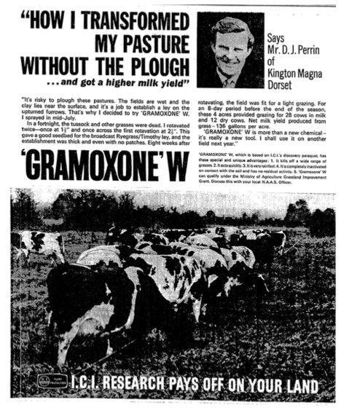

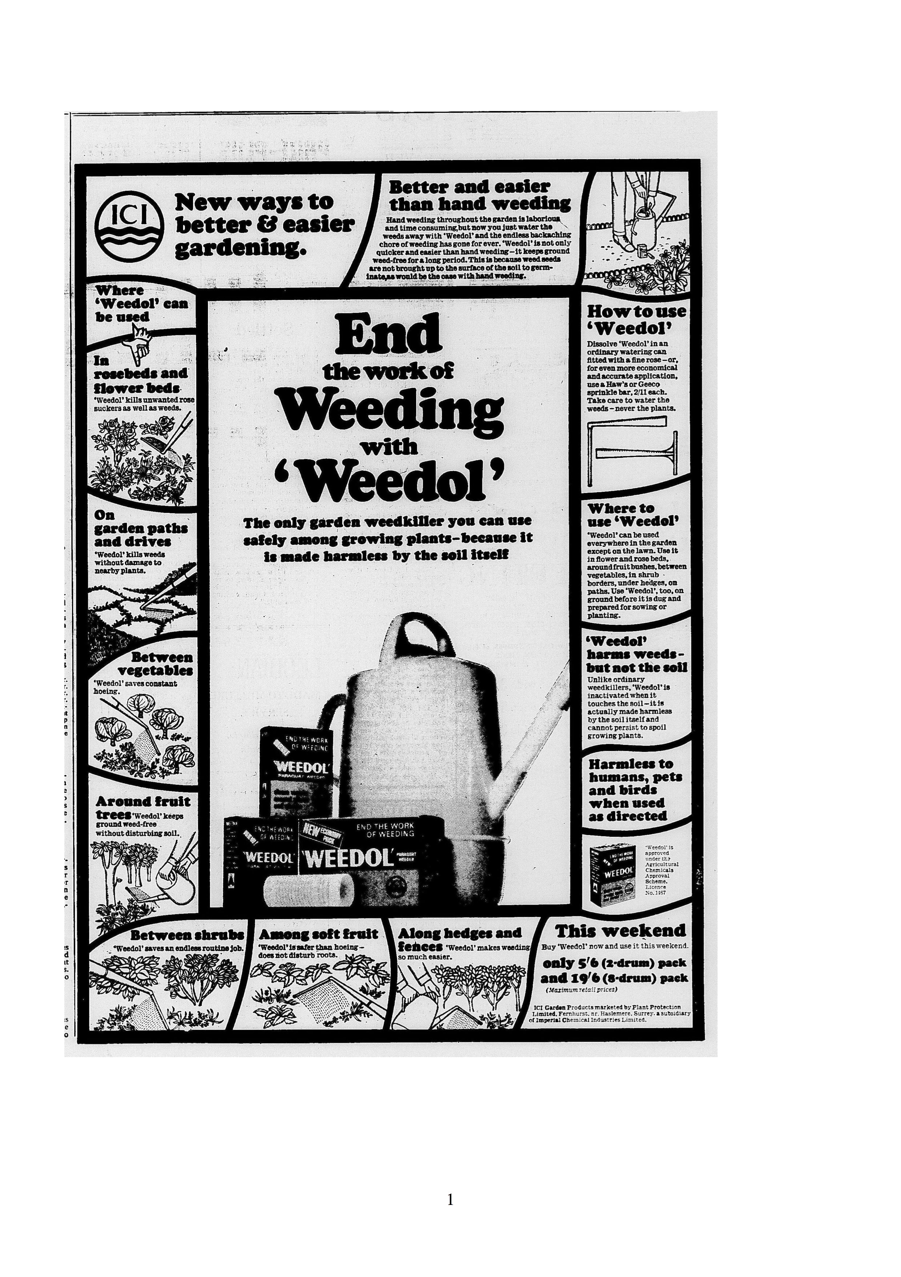
The adverts for Weedol are summarised in Table 2 in order to highlight the key words that were used in the adverts and to see changes over time. General trends were that early Weedol adverts were more informative than later ones, as they were crafted to explain to potential users how Weedol worked, the scenarios that it could be deployed and what users could expect from it. Great pains were taken to put across the ease and simplicity of use, emphasising the use of the plants' own "natural" processes to kill the plant. Later adverts relied on Weedol's established place in the market and were less explanatory. Market research had suggested that potential users were needed reassurance about the immediate and long term effects on soil, animals and other garden users, and these aspects have certainly been addressed, especially in the earlier adverts.

Although the rhetoric of weeding could be war-like, which invoked battles, domination and death, the language of Weedol adverts was restrained when it came to violence against weeds and instead focused on saving time and effort. While pictorial images of the user were masculine, advert readers of any gender were consistently addressed directly through the use of "you". The most common image that the user can relate to in these adverts, is of the packaging which they can find in their shop.

Weedol's adverts imagined users to be looking for particular assurances from the product, and the adverts consistently addressed these by emphasising the time saved, reduction of effort by switching “hard” or “back-breaking” work for faster and easier watering as well as “harmlessness” to anything other than weeds. An awareness that Weedol was perceived by users to be expensive, or at least that the cost had to be justified, also shows in the adverts. They detailed the precise area that can be treated, and consistently highlight the low costs involved, either of the product itself or of the specialised applicators (a substantial 22 shillings and sixpence, though later reduced to 15 shillings and sixpence) that would allow the herbicide's most economical application. Throughout this chapter, we've seen that this information has been important to users of any garden chemical, not just paraquat as it also helps them to work out how much they would need to buy, not only to rationalise spending money on a task that could be done without any purchased products. Indeed, not all gardeners wanted to invest in dedicated application equipment, so made do with items at hand, such as putting a large funnel over the watering can rose to refine the spray accuracy.

From time to time the price of garden chemicals was discussed in the pages of gardening magazines. The staff were well versed in the reasons behind the "appearance" of the high cost, sometimes they even quoted the British Agrochemicals Association, or explained the development process. Home gardener Alf Prosser from Biggleswade had a letter printed in Practical Gardening, in which he noted he was shocked by the high prices of garden chemicals that he was looking at on a shelf. He related it to the record number of people out of work in 1980, so were living on unemployment benefit and asked "How are these people supposed to afford such prices?". He declared that he would go back to hoeing his weeds. The editor responded that there had been a slow-down in price increases but interestingly referred to the cost of "all gardening necessities" as becoming prohibitive. As Alf demonstrated, herbicides are not strictly essential, but it was interesting that he did not mention any of the older chemicals that we have looked at in this chapter. Perhaps now that he was considering what had been a necessary expenditure in a different light, any amount was too great when he could do it for the cost of his time. The table shows how different users, or at least potential purchasers, were reached through different papers. The Times rarely carried for Weedol, while Weedol adverts were carried much more frequently, were of greater variety and tended to be richly detailed in the lower class daily papers. The focus on time saving and costs of material suggests that ICI knew that these were important to the majority of their users.

Year | Advert | Paper | User image | Key phrases | Advertised Price
1965 | Ends the work of weeding | Express, Mirror | No user | Hard work, neutralised, harmless | 5/6
1966 | End the work of weeding | Express, Mirror, Mail | Hands, feet | Safely, harmless, easier, endless, economical, accurate | 5/6 (2 drum pack) 19/6 (8 drum)
1967 | Don't waste time with weeds | Times, Express, Mirror, Mail | No user | Time, revolutionary, safely, save hours | 5/6 (2), 9/6 (4), 17/6 (8), 32/6 (16)
1967 | My Dad's a Weedol weeder | Express, Mirror | Father (plus daughter) | Saves hours, kills, harmless | 5/6 (2), 9/6 (4), 17/6 (8), 32/6 (16)
1968 | Stand up to weeds | Mirror, Mail | Male | Gardeners, revolutionary, kills harmless | 5/6 = 40 sq yds
1969 | Block the living daylight out of weeds | Express, Mirror, Mail | No user | Low priced, harmless, unique, rain, time saved | Sprinkle bar 3/- applicator 15/6
1970 | [month]...in the garden with ICI | Mail, Express, Mirror | No user, but male tech advisor | Save hours of back breaking | ----
1970 | … without killing the soil or your back | Mail, Express, Mirror | Gloved hand | Backache, harmless, economical, ordinary, cost | Avg sized garden/yr 30 bob, 2 drum 5/6, money saving bulk
1970 | Your garden pin up | Amateur Gardening Annual | Non-user woman | Easy
1971 | Two ways | Mail, Express, Mirror | Male | Back-breaking, minutes, kill, harmless, cost | 40 sq yd = 30p
1975 | … without killing the soil or your back | Mail, Express, Mirror | Male | Kill, safely, inactivated, economical, hours, back-breaking | -----
1977 | Fast and easy. | Mail, Express | Percy Thrower | Safely, backache | ----
1977 | ...plenty of help | Mail, Express | Percy Thrower | Compete, safely | ----
1978 | Stop weeds going to bed with your flowers | Mail | No user | Easy, kill, rain, effective | ----
1979 | Our weeders choice/ Weedol about it | Express, Mail, Guardian | No user | Kill, revolutionised, hours | ----
1980 | Don't let weeds be the first sign of spring | Times, Guardian | No user | Effective, speedy, inactivate | ---
1981 | The British gardener's No.1 weedkiller | Mail | No user | Kill, harm, inactivated, risk, rain, gardeners | ---
1984 | Weeds stop here | Mail | No user | Inexpensive, Care | ---
Table 2: Table showing the Weedol advertising campaign key words. Decimalisation facilitated a price rise, with 30 pence being equivalent to 6 shillings, when previously the same pack to treat 40 square yards was slightly less expensive at 5/6.

Users were not always the main feature of Weedol adverts, and in 1965 did not include an image of user at all, instead only picturing weeds around a rose bush. This demonstration of Weedol's "sensitive use" had been shown to be particularly appealing in market research, and would continue to be employed in advertisements that depicted Weedol use. The following season’s advert showed small illustrations of isolated parts of a user: hands, legs and feet, which although did not show a face, look decidedly masculine. In 1967 photographs of users, rather than application equipment, were used for the first time. They showed an excited young girl pointing to a man, declaring "My dad’s a Weedol weeder". The use of the weedkiller in close proximity to the child represents safety, although instructions on the packaging always exhorted the user to keep the chemical out of reach of children. In 1967 another advert ran simultaneously which did not show any user figures at all. 'Don’t waste time with weeds – water them away with Weedol' gave potential users a clear and alliterative message about what the product was for, the benefit of saved time and how to use the weedkiller.

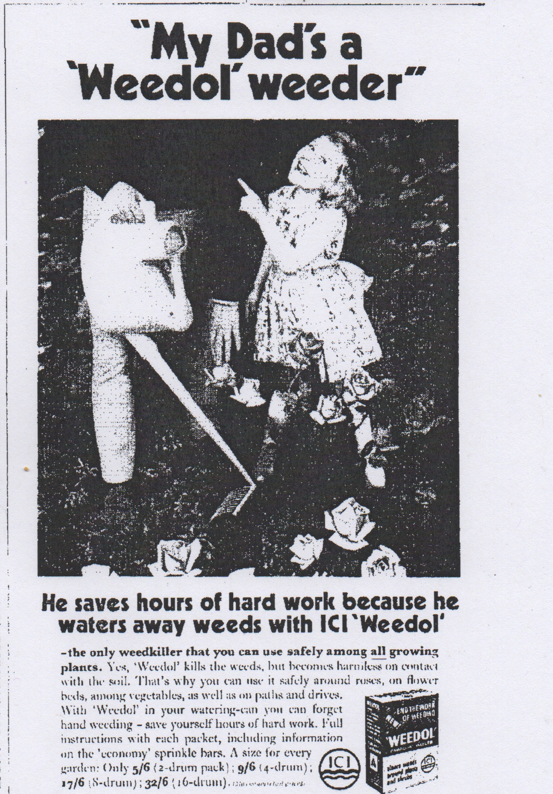Illustration 1: My dad's a Weedol weeder! The tone is conversational and friendly, focussed on how the user can save time using safe Weedol.
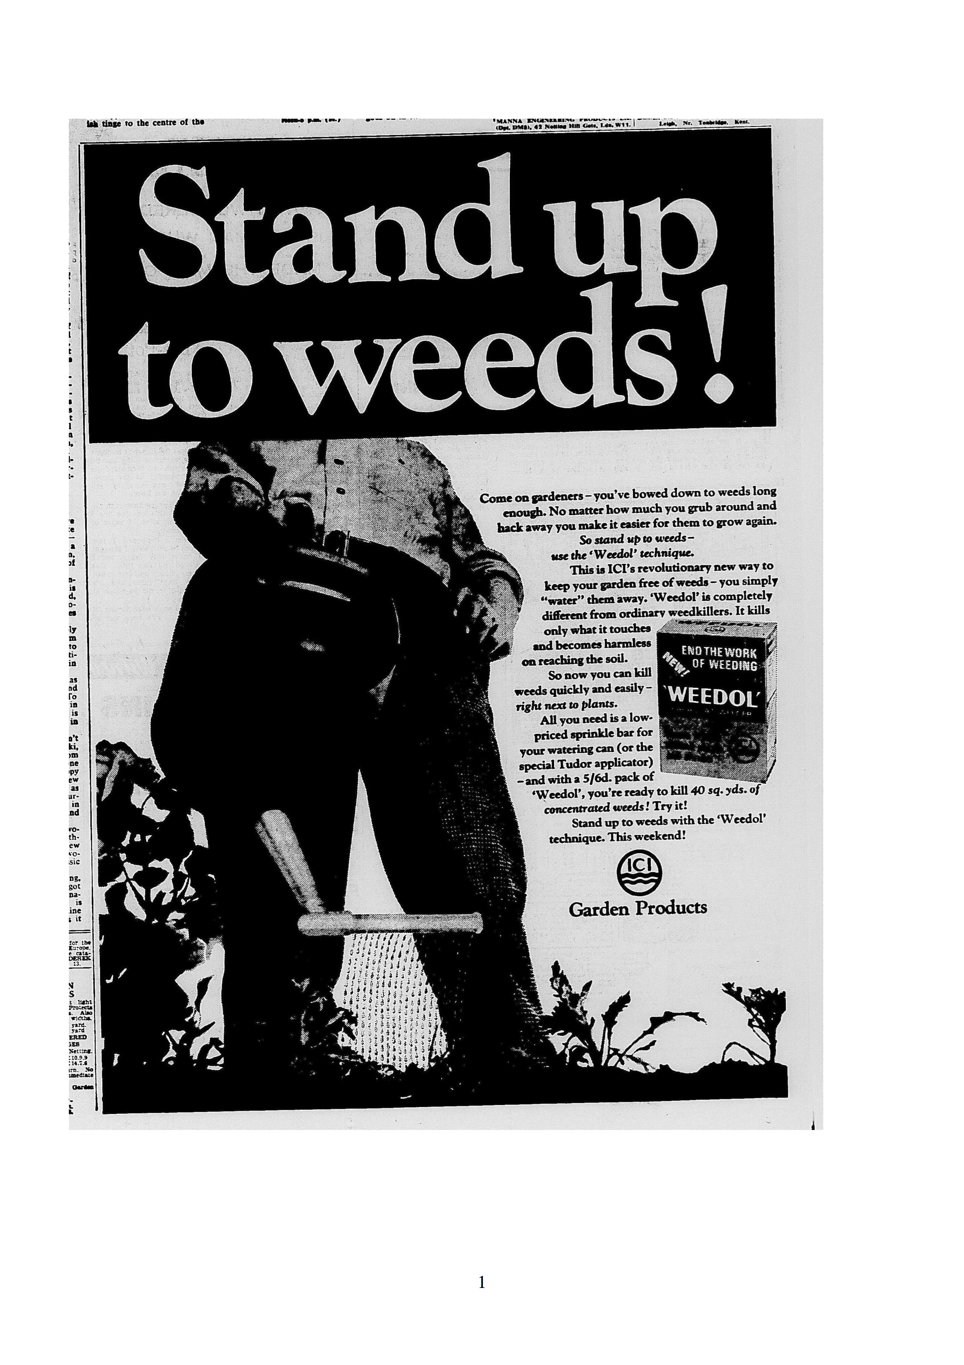Illustration 2: Stand up to weeds. The user has a relaxed posture as he applies Weedol, although the work of weeding has not completely been eliminated, it no longer involves grubbing about.
The "Stand up to weeds!" advert was first placed in mid-April 1968, again only showing the lower half of a male user in neat trousers and a shirt, standing with a hand on his hip and holding a watering can with which to apply weedkiller. The wording implies both the physical action of weeding, which with Weedol no longer involves bending or kneeling, as well as overcoming the relentless invasion of weeds in ones' garden.
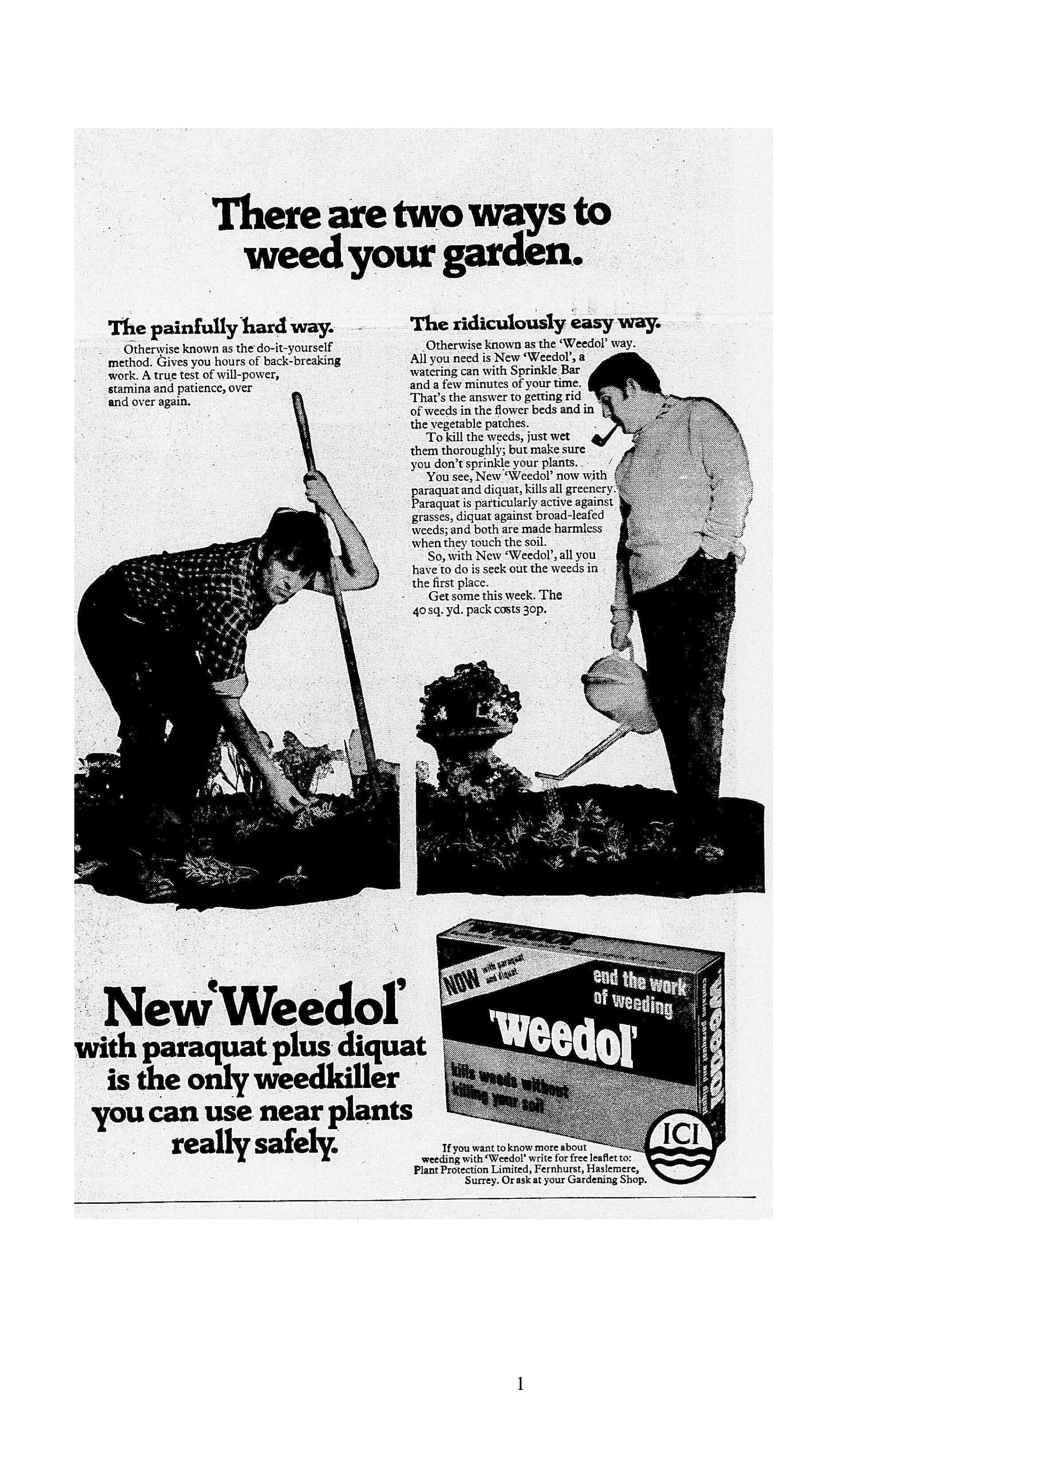Illustration 3: Two Ways to Weed. The dishevelled figure contrasts with a man at leisure, the hand in pocket stance is repeated from Stand up to Weeds.
In 1970, a whole user was depicted for the first time, and compared to a non-user (illustration 12).The user was a middle aged man, probably in his own garden, where he used it among flowers and shrubs, not to clear expanses of weeds or in paving. Through his casual clothes, his relaxed, upright stance and smoking a pipe, his appearance suggested leisure. The dress and actions of the gardener using Weedol in these adverts communicate how easy and clean using the product was. If Weedol was not available, meaning they had to manually weed instead, they would have to wear clothes that could get grass stains and mud on them, so the pale cable knit jumper, the white shirt cuffs show how mess is avoided. The presence of the pipe indicates masculinity, that the man is at leisure, but also that Weedol is safe to use. If the user had to weigh out the chemical, they risked getting it on their hands then transferring it to the pipe and from there into their mouths. Dissolving Weedol directly in a watering can or spray cannister avoids this contamination problem. Perhaps these men would have been less used to handling potentially dangerous chemicals in the home, leaving that task to their wives. Perhaps the comfort of home, and a mindset unique to leisurely activities, meant that vigilance and care that men might have applied to handling dangerous substances in their working lives was abandoned once in the domestic environment.

1970 was an unusual year, as ICI featured a woman in their garden chemical adverts. "Your garden pin-up" featured a simpering woman holding a parasol next to a lush, flowering border, with a variety of ICI garden chemicals at her feet, including "great easy to use" Weedol. The advert described its function as "To remind you, in the nicest possible way, that ICI make a complete range of products to make your garden look lovely". Pin-ups are generally for the benefit of men, which indicates that the imagined gardeners and chemical users were men. However, compared to other adverts for consumer products in the late 1960s and 70s, this incarnation of a fully clothed pin-up was quite tame. By not featuring a woman applying the product, the overall balance of is tipped towards addressing men as the principle likely users of their product.

Competition for resources (soil nutrients, water, light) is a major reason for weeding, not just that weeds can look untidy. Competition for water in times of drought was especially important and in 1976 the UK experienced the hottest and driest summer in 350 years. However, ICI did not create a new campaign capitalising on this, possibly to avoid criticism about using water on weeds during a time of scarcity, though not concerned enough about that charge to not advertise at all and continued to run "Don't waste time with weeds". A couple of years later, space was the competed for resource in the innuendo-laden tagline "Stop weeds going to bed with your flowers" which placed the gardener in a protective role against the invasion of weeds into the flower bed. "Block the living daylight" plays on the action of the chemical, to disrupt photosynthesis, as well as the phrase to knock the daylight out of something
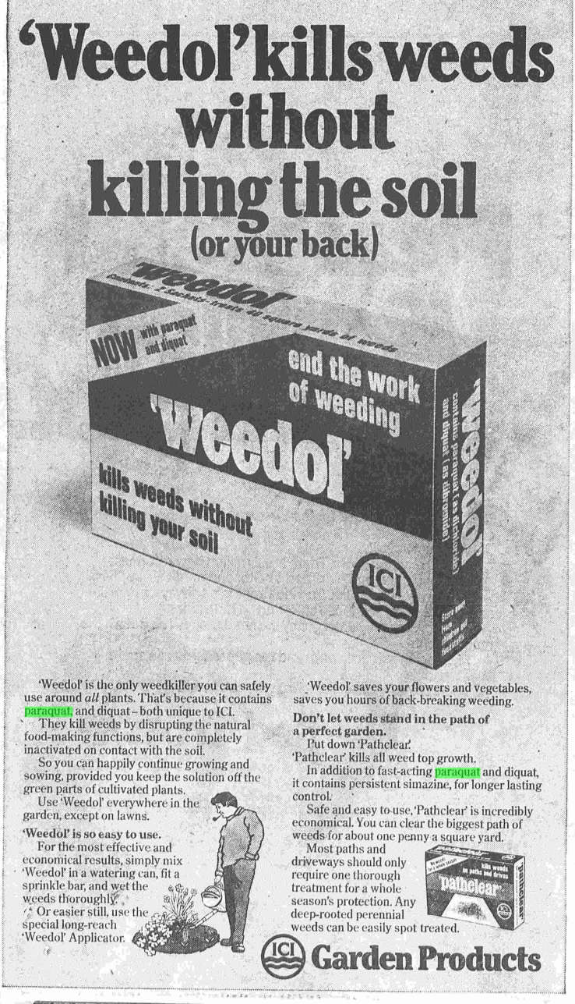Illustration 4: Weedol kills weeds without killing your back. The leisurely gardener from the Two Ways advert has been illustrated here.
ICI even featured a celebrity paraquat user, Percy Thrower, in some of their adverts. Thrower had been a household name since 1947, when he started giving gardening advice on BBC radio. He also had columns in the Daily Mail, the Mirror and the magazine Amateur Gardening, he published books, as well as being lead presenter on the television show Gardeners World and appeared on children's programme Blue Peter. Thrower embraced the range of ready-made chemical aids, although this enthusiasm for chemical fixes was one of the factors in his parting company with Gardeners World in 1976. This decision may have reflected not just the view of the programme makers, but also that of their audience.
-------
The model user could also counter accusations that Weedol was expensive, by reiterating that by investing in the appropriate application spray bar, the herbicide could be applied without waste. The model users were by no means perfect, or even ideal, as inconsistent product placement shows, or the occasional modelling of unideal opinions such as that "amateur packs were expensive". Columnists offered paraquat as an option for home gardeners, even when closer reading of descriptions of their own gardens and practices showed that they chose not to use paraquat in as many situations as they suggested. Many actually preferred to use cover planting to avoid weeding in their own gardens, limiting the amount of bare soil that could be colonised by weeds. Paraquat could play a part in preparing the soil for the desired plants, but it was not the kind of frequent application that ICI had envisaged. However, for many of their readers, this aesthetic was alien and messy. Gardeners were used to hoeing and digging to remove weeds, although disturbing the soil like this brought weed seeds to the surface to germinate. Using Weedol while the weed seedlings were tiny would ensure that the resulting dead material would quickly dissolve away. Weedol required a significant change in gardening practice, targeting seedlings rather than visible, graspable weeds. Using the chemical on larger weeds did not give such satisfactory results, leaving a desiccated, dead plant which would then have to be pulled out, inevitably disturbing the soil and encouraging new weed growth.

Disobedient or Careless Users
So far, this case study has examined the intended uses of paraquat with the knowledge that paraquat could cause fatalities when improperly used, specifically when it was drunk. The darker side of paraquat's story will be examined through the disobedient users who did not follow the instructions which had been crafted to direct safe use. What should be remembered is that the majority of users were obedient, they carefully followed the instructions for normal, expected uses and neither they, nor anyone else, came to any harm. Typically, a disobedient user of Gramoxone contained it in an unlabelled drinks bottle and allowed it into a domestic environment. A disobedient domestic user of Weedol would allow children access to the granules, dissolve granules to make up a solution concentration different to those recommended by ICI, or use the herbicide for purposes other than killing weeds in their garden.

There were plenty of instances of experienced agricultural workers who handled Gramoxone irresponsibly, with an industrial hygienist going so far as to declare farmworkers as “notoriously careless”. This jars with the concept of agricultural workers as skilled, trusted and responsible handlers of agrochemicals that we saw put forward by the regulatory boards associated with the PSPS procedure. Injuries to the skin and eyes were caused by careless handling, and restricted to the applicator but if the result of disobedient use was to repack the chemical into a bottle, the consequences could extend beyond the farmworker themselves if they took that container into a domestic location, where it could have a fatal outcome.

Despite being corrosive, when swallowed paraquat did not burn immediately instead irritating and ulcerating the mouth and throat after a period of time. When first marketed paraquat products did not necessarily cause vomiting, although it had been judged to be unpalatable, although how this conclusion was reached is unclear. After being absorbed into the bloodstream, paraquat caused damage in the kidneys and the liver. What surprised doctors who treated the first poisonings, not to mention all those who had been involved in examining the chemical's risks and hazards, was that paraquat had a peculiar effect on lung tissue. It irritated and thickened the membranes that gas exchange occurs across, which reduced the efficiency of the organ, but also caused cell proliferation (a repair response) in the lungs, so much so that the lungs solidify. Research at ICI's Central Toxicology Laboratory eventually showed that paraquat reacted with a cellular transport process in the lungs, causing this characteristic damage.

The novel features of paraquat weedkiller poisoning caused consternation, and medics were urged to extract further information regarding the type of weedkiller their patients had ingested, as no longer could they assume a weedkiller admission to equate to relatively familiar, arsenic-based herbicides. Despite doctors’ best efforts to deactivate paraquat with Fullers earth, or kaolin, which mimicked the chemical's deactivation seen in soils, or to dilute the chemical in the bloodstream through forced diuresis as was employed in treating barbiturate overdoses, their treatments were experimental and often unsuccessful. In some cases treatments even worsened the situation, although this eventually provided evidence supporting increased understanding of paraquat's mechanism of action. Gramoxone poisonings led to a horrifyingly certain and slow death, potentially over two weeks or more. Even in the 1980s after more experience of treating paraquat poisoning including some successful recoveries, the advice was to focus on palliative care, supporting the patient and their family towards the end of life.

This aspect of suffering was central to the mainstream media coverage of accidental Gramoxone poisonings, which only started appearing as news items in their own right in 1968 although as we have seen already, accidents had happened earlier. The stories invariably conveyed the lack of effective treatment available, often with the stock phrase "no known antidote". As father of paraquat Bill Boon wearily noted, this antidote statement was technically accurate, but it was not unusual as in the true sense of antidote where one chemical neutralises another, very few poisons have an antidote, not even aspirin. Boon attributed the origins of this phrase to an answer given to a coroner in court to the question whether an antidote was available. However, it grabbed attention and was useful shorthand in newspapers for expressing the horror and despair that was experienced by victims, their families, and the medics who cared for them.

Earlier we considered the instruction for safe use and storage of Gramoxone, that it must be kept in its original container and not repacked into unlabelled bottles. Some retailers broke their agreement with ICI, then the Poisons Rules, if they sold Gramoxone in other bottles but often having a bottle of Gramoxone was associated with workplace theft. In 1968, 6 year old Beverley Pollitt died after she drank Gramoxone from a lemonade bottle at home. Her father worked for ICI and had asked another ICI laboratory worker with access to Gramoxone, to get some for him. The liberation of paraquat formulations from the ICI plant was not uncommon: it "leaked out of the plant like water off a roof" according to someone who did not have any connections with the plant, other than living in the area.

None of the other reported cases of accidental poisoning were linked so closely to the chemical company and or hinted at any repercussions for the supplier of the chemical. Yet there were numerous poisonings that occurred because people stored small quantities of the weedkiller in bottles at home. MAFF described people who brought home Gramoxone as trying to avoid the expense of buying Weedol. Market research revealed that from the start, potential users expected the price for such a product to be between 3/7 – 4/- rather than the maximum recommended retail price of 5/6. In table 2, we saw that this advertised price of Weedol remained remarkably stable over time, which reflected the need to recoup the costs of development and manufacturing, but may have frustrated some would-be users. A journalist calculated that Weedol was eight times more expensive than Gramoxone, and suggested that reducing the cost of Weedol would prevent people from decanting the herbicide and bringing it home. Stealing from work is not necessarily about cost, as demonstrated by pens and other stationery abstracted from office jobs, it may be the only kind of perk a person at the bottom of the hierarchy can extract, so reducing the perceived price differential between Gramoxone and Weedol may not have had such a large impact as some people may still have considered work a source of free herbicide, which they could generously redistribute. From the circumstances reported in newspapers, liquid paraquat preparations tended to be brought home by quite young men, who worked in agricultural or horticultural jobs or were in social circles with people who could access the high concentration product. Although they might have been impressed by its efficacy, they do not seem to have respected the strength of the chemical and its potential to do harm. This attitude may have been influenced through the choices of words used on Gramoxone's labelling, prompting the NFU to call for greater emphasis on its dangers.

No matter which words, such as "poison", were employed on the label, the reception of them depended on the user. If they did notice and read the label, as a user who was trained to use the chemical at work, they may well have believed themselves competent to use the same product at home. Where the problem lay was in the presence of other people in their domestic environment who could not be expected to know what the liquid was or the warnings that accompanied the herbicide in its original packaging. Once inside an unlabelled, reused bottle, the herbicide could be given another identity by an unsuspecting, unintended user. The familiar shapes of drinks bottles, an important part of their brand identity, sent out the wrong signals about safe contents when they were reused to store agrochemicals. The bottles of concentrated herbicide found their way into bags, glove compartments, sheds, and kitchens where they were mistaken for dark coloured drinks: cordial, dandelion and burdock, cola, beer, wine, or sherrythen swigged by curious or thirsty children, teens and adults, with very serious and sad consequences. A mouthful could be lethal, even if it was spat out.

The story of 15 year old Alex Smith's accidental paraquat poisoning is one of a teenager exploring his father's shed, who then found a bottle and drank the contents. The incident was fairly widely reported on, but the weedkiller was not the focus. Alex became Europe's first lung transplant patient, and although this was the first paraquat poisoning to gain this level of coverage the chemical was never named as such, only described in a ways that would become typical for paraquat poisonings, including the description that it "looked like cola" and the devastating effects on the lungs. Alex's character was commented on positively, fitting his status as brave patient involved in a risky and pioneering operation. He was pictured cheerily sitting in his hospital bed and described as having "no previous significant history ... a well-balanced, intelligent, and stoic individual" This highlighted how the accident could happen to anyone, which was a departure from the list of poisoning occurring in 1966 and 1967 compiled by PPL and ICI representatives. The Irish and Scottish incidents were described in a way that emphasised poor or defective character of the unfortunate misuser, "patient was drunk when he consumed the chemical" and "a mentally retarded man drank Gramoxone in mistake for wine" as well as the explicitly prohibited behaviour, repacking into beer bottles, and storing them among other drinks.

Disobeying the instruction to never repack Gramoxone, and keeping the herbicide in reused bottles at home was publicly condemned by authority figures. Where Gramoxone was sold to an amateur gardener which resulted in a fatal poisoning, an ICI representative criticised the vendor as "silly and irresponsible". ICI's Bill Boon, champion of paraquat, was reported as attributing accidental deaths to "human stupidity". Keeping Gramoxone in unmarked, reused bottles was "asking for it" coroner Donal Summerfield said. Coroner Roger Stokes was gave good copy when he described the "monumental folly" and "disgraceful act of carelessness" that putting weedkiller in "tempting bottles" was, and compared it to "putting fireworks in a box labelled baby powder." As poisonings of this type accumulated, another coroner frustratedly asked "when will the public learn?", but the reporters did not expand or moralise on the subject of those who chose to use Gramoxone at home.

Despite accidental deaths among people of all ages, it was perceived that children were most at risk. A discussion on paraquat in Handyman Which?, itself an interesting mixture of DIY and professionalism, pointed out that Gramoxone was "one of the main poisons which kill children under 5 in this country" behind pharmaceuticals. Worded like this, it sounds shocking, but the actual incidence of paraquat poisoning, in fact with any household or garden chemical, was very low, especially compared to the greater number of instances of poisoning with prescribed and over the counter drugs. The problem lay in the fact that pharmaceutical poisonings were more likely to be treated successfully.

This section has focused exclusively on accidents involving Gramoxone, which was never intended to be used domestically. Dissolving Weedol granules directly in a watering can to make a small amount was specifically designed to result in fewer opportunities for storing in bottles or mistaken identity and ingestion. The consequences of clumsily handling the low concentration granules were less severe than if the strong Gramoxone liquid was mishandled. From Weedol's launch in 1965 to May 1967, 7 million units were sold, in which there were five medical incidents reported associated with normal use. Only one was a poisoning, where a child “who should not have access to the preparation” ate the granules, and the others were skin irritation due to "carelessness". Considering the volume sold is a tribute to how safe the granulated product could be.

For use only as a herbicide
Another form of disobedience was to go against the instruction that it was only to be used as a herbicide. An example of this was using the product as an insecticide, not only was it ineffective as an insecticide and harmed the plants, when used in a confined space as a fumigant paraquat was fatal for the user. Thankfully, this was not a regular misuse but it was one that ICI representatives took upon themselves to address through firmly worded letters published in the national press. These attempted to educate people about the correct users and uses for Gramoxone, as separate from the users and uses of Weedol. Somewhat unsympathetically, the misusers were held up as misguided, clearly using the product for something that it was not intended, and their own harm followed logically.

Deliberate harm to oneself or another person using both Gramoxone and Weedol also occurred, through disobeying the advice that the herbicide was "not to be taken". Paraquat was not a special case among weedkillers, as we have already seen that suicide using this type of product was already an established practice. As arsenic rat poisons were replaced on the shelves by non-arsenical formulations in the twentieth century, widely available arsenical weedkillers became the product of choice of those determined to obtain arsenic for the purposes of self destruction. The displacement of arsenical weedkillers by "safe" sodium chlorate, did not mean that suicides stopped, as this chemical too could also prove fatal. The arrival of a new herbicide also provided a new chemical to poison oneself with, despite the lack of arsenic and many declarations that it was harmless (when used as directed). Therefore, the arrival of paraquat weedkillers, both agricultural and domestic variants, was another choice among many products for suicidal users.

This use emerged quickly after paraquat was first marketed. Gramoxone was implicated in suicide from 1966 and three suicides were attempted using Weedol, heavily advertised as "harmless" between 1965 and 1967, meaning that these occurred before any publicity about the fatal outcome of Gramoxone misuse, sadly validating the predictions we saw made earlier by chemical industry representatives that someone would try to harm themselves. Although it was possible to deliberately ingest enough Weedol and behave in ways to result in a fatal outcome, the domestic paraquat product mainly featured in para-suicides (“failed suicide attempt” being considered an unsatisfactory term as patients did not want to die but used self-poisoning as an expression of distress).

Although the medical press carried case studies of paraquat suicides from the earliest occasions, this use for paraquat was not explicitly mentioned in the mainstream press until 1972. This followed an investigation earlier in the year into how easily anyone could obtain Gramoxone. As an agrochemical, it might be expected that most of these incidents involved farmers or other workers with easy access to the herbicide but in around half the number of deliberate self-poisonings involving Gramoxone, the people had obtained it by either asking a friend or relative, or bought it openly. Many more men than women poisoned themselves, reflecting the gender balance of occupations that legitimately used paraquat concentrates but perhaps also who would use weedkiller at home. Paraquat poisonings had a seasonal peak (May to July), which is when the herbicide could be expected to be used domestically and therefore readily available.

In 1973 Dr Matthew of the Poisons Board blamed what he called "disproportionate" media coverage given to paraquat deaths for the fact that in Scotland, the number of accidental deaths from paraquat was overshadowed by the number of suicides with the chemical. The agonising decline of patients was described in any news article about the lethality of paraquat, communicating to would-be users that this was not an “easy way out”, even if it was certain. Perhaps in reporting how easy it was to obtain Gramoxone and what size dose resulted in death, media reports effectively put the idea into public circulation, validated it and perpetuated this misuse of paraquat.

Murder
Murder through poisoning with paraquat was another misuse of the Gramoxone (but not Weedol), as until 1974 the herbicide did not have an especially offensive taste or smell, (although the manufacturers declared it unpalatable) so could it could surreptitiously administered in strongly flavoured food and drink without suspicion from taint or residue (arsenic left white powder in drinks and soups). The delayed, generic symptoms of paraquat poisoning did not necessarily initiate detailed chemical analysis of blood or urine to bring the poison to light, and a poisoner could feign ignorance in order to delay or withhold appropriate treatment, ensuring their success in terms of dispatch and remaining undetected.

In 1973 it became apparent that paraquat was being misused as a deliberate poison, when Shelia Sheldon accused her husband of poisoning her, then Jennifer Kenyon and David Roberts were charged with the murder of Keith Kenyon. The character of the paraquat misusers were described as adulterous, jealous men and women, in turbulent, unconventional relationships that made for grippingly sordid, salacious news. I say misuser, because not only was the poisoner themselves described in these terms, but their victim, the unwitting misuser of paraquat, had these negative descriptions applied to them. Poisoning is often thought of as a method used predominantly by women as a method of despatch not reliant on physical strength, but in the cases reported on in the newspapers it was used about equally by men. This alignment of adultery and herbicide use highlighted the potential (if mild) sauciness of Weedol's 1978 slogan "Stop weeds going to bed with your flowers".

Despite journalists fascination with the complex personal relationships of paraquat poisoners, there was a subject on which the newspapers remained quiet. In two separate murder cases, the accused (and convicted) poisoners even stated that they had got the idea from a story in the newspaper. This raises an interesting question of responsibility for copy-cat behaviour triggering, which we saw blamed for the high number of paraquat suicides. Paraquat had moved from the confines of niche columns to the main body of newspapers, and most importantly, the information carried in all these articles centred on the harm that paraquat, specifically Gramoxone, could cause when misused, rather than the correct, safe use of the appropriate chemical. The graph in Figure 2 shows the frequency of reports in the Daily Mail on paraquat involved in accidents, murders and suicides. Visualising the frequency in this way suggests the level of public exposure to the concept of paraquat causing human death, it does not show separate incidents, as accidents might be reported as the outcome of a coroners report, or several articles might be associated with the same story, if for example the progress of a poisoning victim was followed, and murder trials provided regular opportunities for coverage. Suicides were comparatively rarely reported, and as we have seen in this chapter, they had taken place since a couple of years after Gramoxone's introduction but did not make national news. What the graph demonstrates is that as knowledge of paraquat ingestion being fatal became more widespread through the reporting of accidental poisoning, stories of intentional paraquat fatalities followed.
Figure 2: Graph showing the focus on accidents, murder and suicide using paraquat weedkillers.

Fear and Disruption
Another manifestation of paraquat misuse was product tampering, carried out by extortionists and saboteurs who threatened unknown, random people with paraquat poisoning. Arguably, as this required access to products already in stores, or in distribution chains and therefore the adding the paraquat to the product did not take place at home, this might not be considered a true "domestic use". However, these examples provides an opportunity to consider the unwitting, or unintended domestic use, through consumption, of paraquat. In 1974 a man was jailed for attempting to blackmail the CocaCola company by threatening to put paraquat into 200 bottles of the beverage. In the approach to Christmas in 1982, the Animal Liberation Front warned that they had poisoned turkeys on sale in Harrods and Woolworths, as well as in several Bristol supermarkets and butchers.
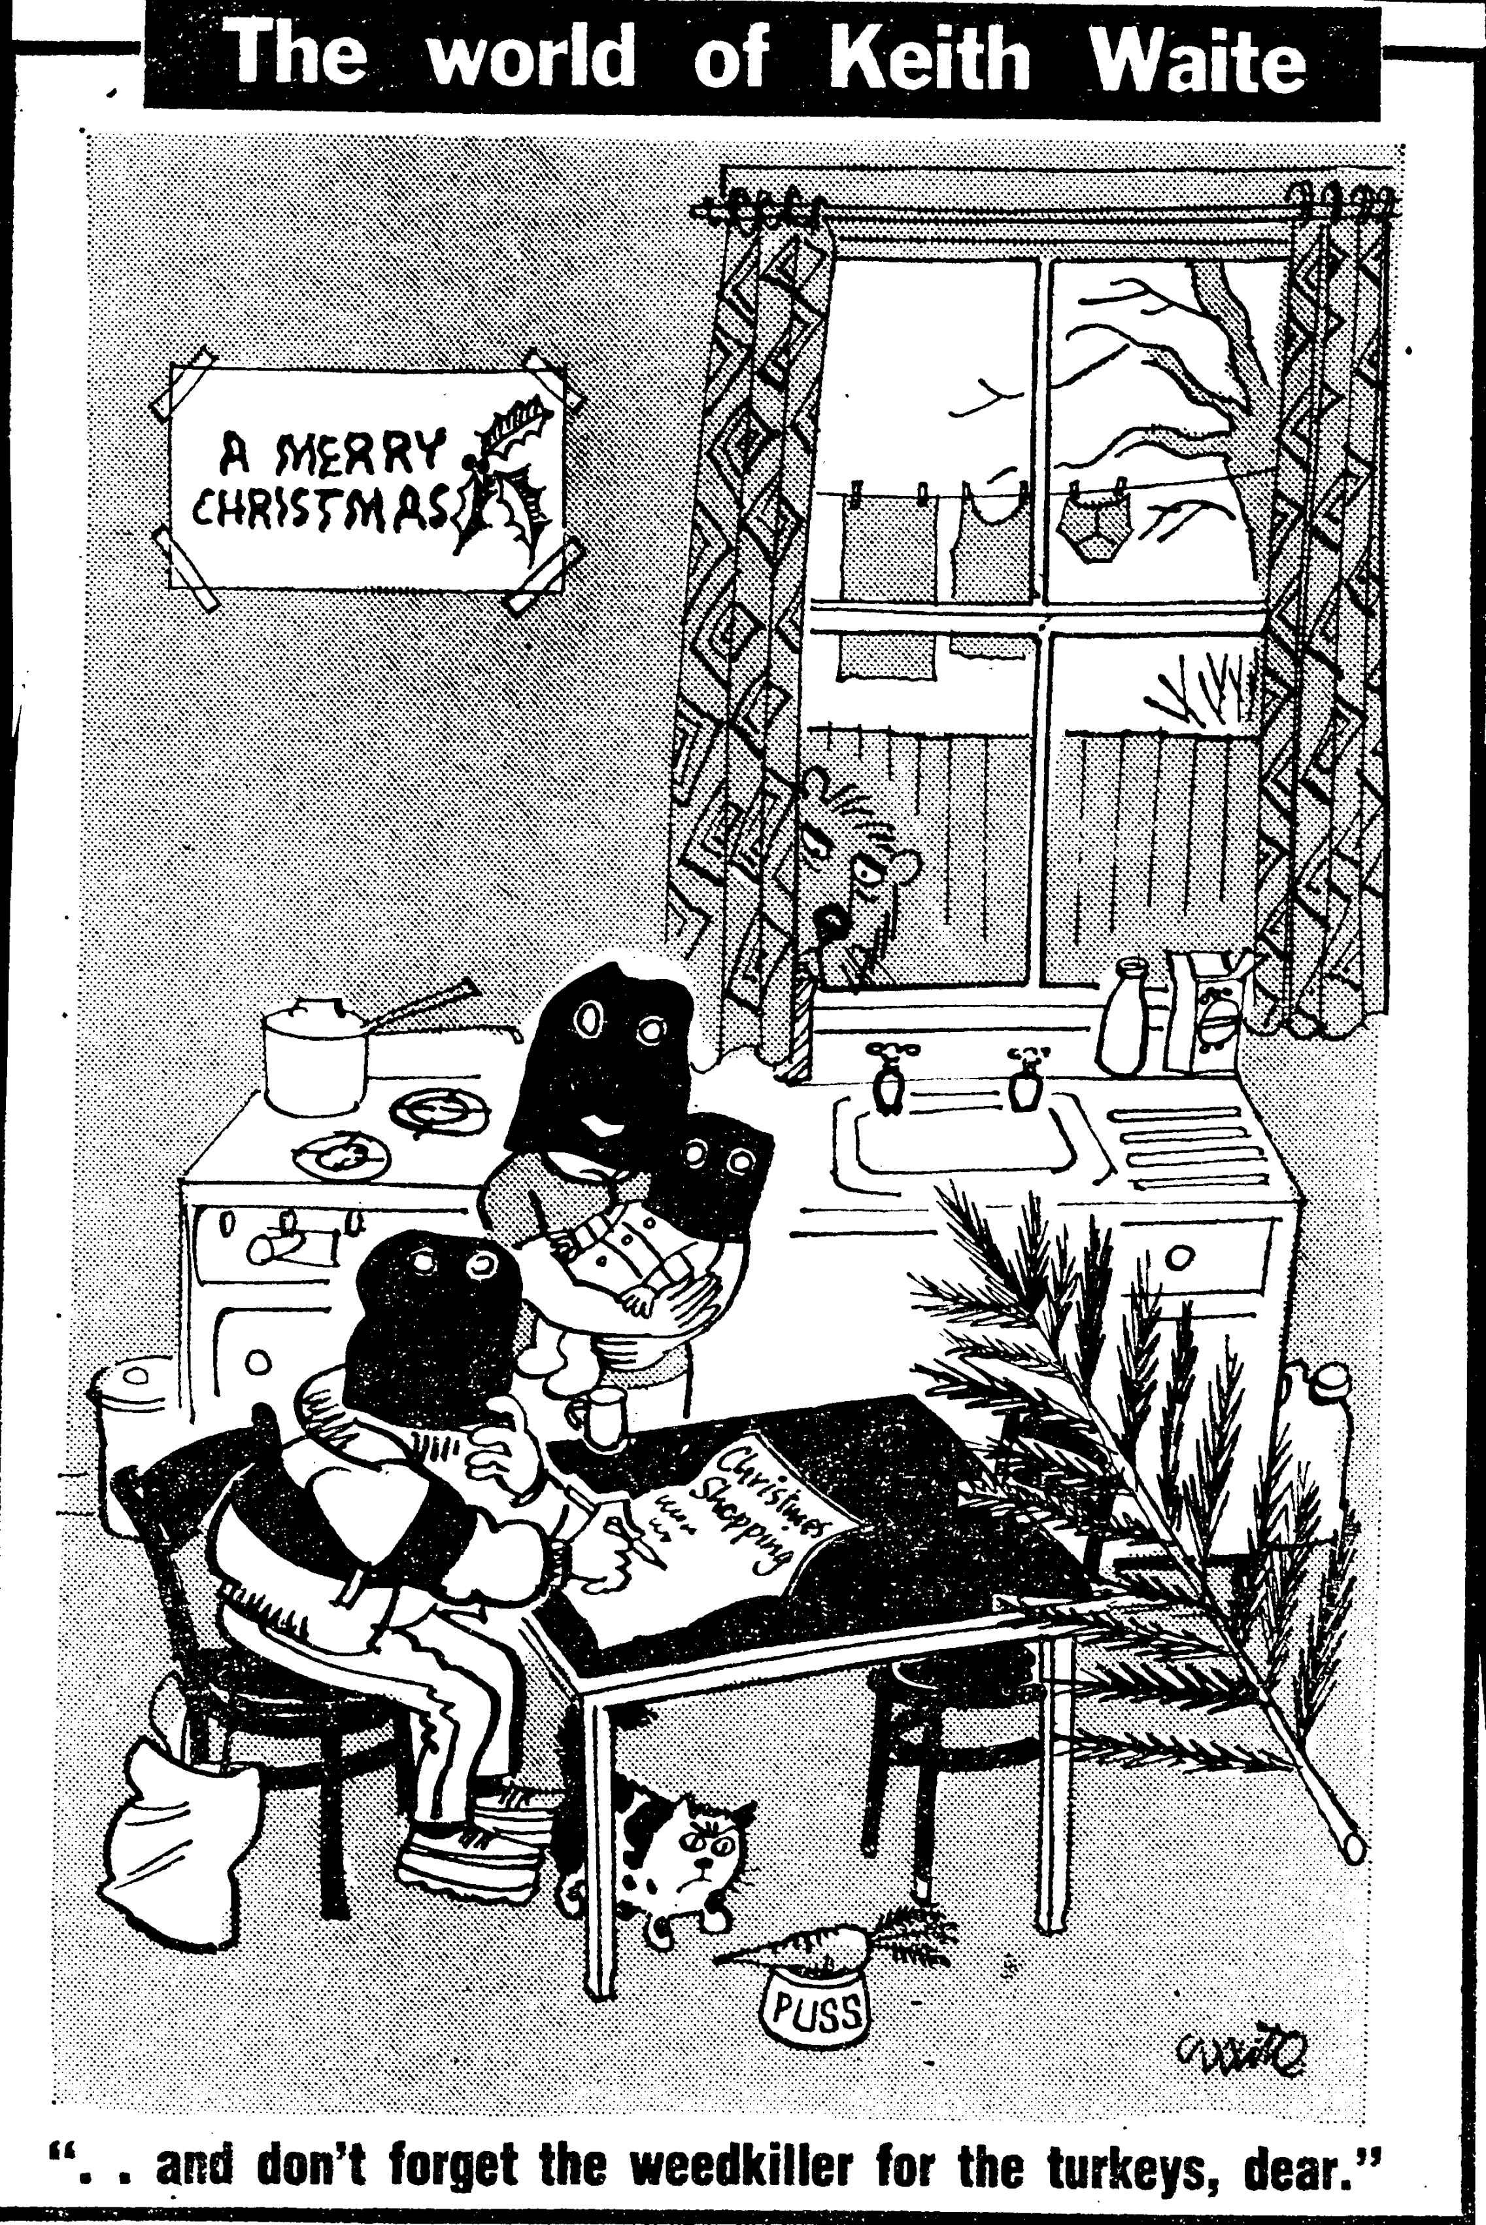Illustration 5: (c) Keith Waite, British Cartoon Archive, University of Kent, Keith Waite, Daily Mirror, 17 December 1984

Political cartoonist Keith Waite made the story into the subject of one of his sketches, caricaturing the absurdist situation in his depiction of balaclava-clad terrorists from the ALF writing a shopping list at home (see illustration). Ultimately no paraquat was found in any meat, but the withdrawal of turkeys from sale, and the anxiety it caused customers show that the threats were taken seriously. Shoppers at Safeway supermarkets were the target of product tampering in 1981 and 1987. In an attempt to deny the blackmailers the satisfaction of attention, a media blackout was imposed while the police and the supermarkets worked on the issue. The supermarket users were surprisingly tolerant of the risk, citing their prior experiences with bomb threats and explosions. Some declared that by continuing to shop there, they were defeating the extortionist’s aim of disruption. Shoppers also trusted the vigilance of supermarket employees and their own ability to spot tampered packaging. The blackmailer operating in 1974 was certainly at an advantage for novelty but that year a stenching agent was added to Gramoxone which could have tipped off recipients of their poisoned food. These events showed that like sodium chlorate, paraquat could be misused to terrorise people.

Public Warnings about Paraquat
Paraquat's sinister reputation was elevated and perpetuated by public warnings in relation to loss or suspected theft of Gramoxone, as well as the normal application of paraquat. Police broadcast warnings with loudspeakers or went door to door to announce the presence of rogue paraquat, and therefore the possibility of a rogue (mis)user, in the residents' locality. Examples included containers going missing from the back of a truck, being stolen from a locked garage, and containers of paraquat getting swept overboard from a container ship with the possibility of them being found washed up on a beach. Local warnings were issued in cases of paraquat use demonstrating the fever pitch surrounding the dangers associated with paraquat, for instance a plant nursery sprayed their property and the spray drifted onto residents gardens, and yet another when a bramble patch was treated and children were discovered to have eaten the blackberries.

The possibility of large containers of concentrate being unaccounted for and in the hands of potential misusers, is understandably troubling, but warnings issued following the use of diluted paraquat seem to be an over-reaction. When diluted according to the instructions, the concentration would not be expected to be harmful to humans. Therefore, these warnings could have stirred up unnecessary alarm. Neither did warnings improve the distinction between agricultural and domestic products, of the low concentration that paraquat was applied at, best practices of application, or the circumstances when it really was harmful. In the desire to protect the wider public through these dramatic methods, the warnings were potentially scaremongering for those who received them.

The Daily Mail took a particularly active role in educating readers about the dangers of paraquat, and routinely contacted the Home Office for the latest comment on regulation. Civil servants’ reactions to this show a mixture of relief that the paper was getting across information about storing chemicals safely and following instructions for safe use, in fact so effectively that civil servant RA Kendall wondered "whether there is much scope for useful Government publicity on top of all the educative publicity already given by the newspapers to paraquat accidents".

This issue of not creating a distinction between Gramoxone and Weedol by referring simply to the active chemical paraquat is hard to explain. Avoiding the brand name would not achieve the same level of anonymity as a product that was made by lots of different companies, for example "bleach" as opposed to "Domestos". If the papers had been trying to avoid singling out an ICI product as related to horrific poisoning cases to protect themselves from being accused of tarnishing the company's reputation or campaigning against them, they were inconsistent, because sometimes it was necessary to use the brand names Weedol or Gramoxone. Worse still was misnaming Weedol instead of Gramoxone when reporting on a poisoning.

Reassuring Users and Non Users
Profile boosting adverts were a staple feature of ICI's communication with the general public about their work and public relations for the chemical industry in general. ICI used these adverts to reassure users and non users that ICI products were of great benefit to their quality of everyday life. When Gramoxone was first launched, ICI's promised that paraquat would boost the nation's total area of agriculturally productive land, improving Britain's self sufficiency regarding its food supply, and when paraquat was exported, it was set to guarantee riches to the UK's chemical industry. In post-war Britain which was rebuilding its economy and anxious about reliance on imports, this was an encouraging message.

Later, as paraquat poisonings accumulated and the United Kingdom suffered in a recession in the 1970s, ICI ran a series of half page adverts to demonstrate the company's contributions to everyday life and the British economy. "Ideas in Action from ICI" (1974) showcased three of their revolutionary products, with Gramoxone listed with, and therefore as beneficial as"Halodane, the world's most widely used anaesthetic" and BCF liquified gas to put out fires "saving precious seconds, precious lives." In these adverts, their message was summed up "Changes for the better, world wide". In addition, ICI spelled out how much money the company was making, investing and recirculating through using "35 000 suppliers" in the UK, very much effort to show the importance of the company when the country was in recession.

This profile raising activity ran for the duration of nearly two weeks of daily court reports of the first murder case involving Gramoxone poisoning. I wonder if this was deliberate, an exercise in damage limitation, in which they aimed to reinforce the positive benefits brought by paraquat when properly used as agricultural chemical. This tactic is only successful where people pay attention to advertisements, which in this case was not measured. This public relations exercise did not extend to encouraging newspapers to expand on the social usefulness of paraquat, although articles concerning the murder trial did contain information about the proper segregation of Gramoxone as only for professional use.

The agricultural background that MPs and Peers came from personally, or represented constitutionally, were important in their arguments, as was the ability of Britain to produce enough affordable, safe food for a growing population. Also included in those who needed reassurance about paraquat were those who made the chemical, and those who lived in those vicinity of chemical plants. Personal safety of manufacturing plant workers was dealt with on a relatively private level, when protective clothing and ventilation were discussed at Poisonous Substances subcommittee meetings. Chemical industry workers used their MP to voice concerns about their economic safety, when calls for further sales restrictions or revoking of its approval by the PSPS and withdrawal of paraquat were debated in parliament.

Those who lived near chemical plants and saw (and smelt) ominous-looking, unknown vapours wafting into the sky, were treated to another interesting act of public reassurance following a fire at a warehouse which stored the chemical. This was the deliberate, public ingestion of homegrown vegetables believed by local gardeners and allotment holders to be contaminated by paraquat, but there is not evidence of the "paraquat pie" being particularly well known. Locals of Woodkirk, West Yorkshire baked the pie containing rhubarb from allotments affected by a fire at a warehouse, which contained a number of different herbicides including paraquat. Vegetation in the area had died and fish in streams were poisoned. Here the concerned local people used contaminated rhubarb as a signal of their distress at living in an environment where they felt unsafe, specifically, where they perceived that chemical and allied industries, such as warehouses to store the products, were allowed to operate without consulting or informing the residents. The pie-eating politicians used paraquat's reputation as deadly, as the ultimate demonstration of "putting their health where their mouth is", even if they did not have to live full-time in the worrying, polluted environment.

Preventing Misuse
As poisonings started to mount up, the problem of misuse was exacerbated by newspaper stories which derailed the correct uses of paraquat that had been carefully modelled through images in advertising, on pack instructions, and through gardening media. When misuse was reported on, the possibilities beyond killing weeds laid out and would-be misusers were provided with very detailed information. ICI had considered the consequences of By demanding that something should be done, a question was posed regarding how far the company should go in protecting people who did not follow instructions for safe use. In this section, we will look at a variety of solutions that were proposed to avoid poisonings.

Restricting availability of drinks bottles
An alternative approach suggested by Scottish Medical Officer of Health (MOH) involved criminalising individuals who used soft drink bottles for the storage of anything other than soft drinks, through the amendment of the Soft Drinks Regulations. In the 1960s cash deposits on glass bottles caused the MOH concern that bottles which had been used to store noxious household or garden chemicals would then be returned tainted with residue. However, this was considered unnecessary by at those in London, as the Poisons Law already covered this the sale of poisons, but that it would be impossible to control how people use bottles. Even though the aim of eliminating accidental poisonings is honourable, administering and enforcing any such scheme would be cumbersome as well as ineffectual. If mystery poisonings traceable to bottles which had been through the returns system had not been a noticeable problem before paraquat, then fears of residue contamination would not have been something to worry about.

Although general advice to gardeners using chemicals in their garden was to buy chemicals only when needed and use them up to avoid storing chemicals and remove the possibility of accidental poisoning, this recommendation was perhaps undermined by special price offers on garden chemicals, including Weedol. Price reductions run by both ICI and individual retailers as part of wider seasonal promotions, as well as to promote the new formulation which contained diquat, but the discounts also be seen as a response to claims made by gardeners that they found the high prices of garden chemicals a deterrent to using them. Although people could buy what they required at this lower price, it could provide temptation to stock up and therefore store the product, making it available in the household for unintended users, and uses.

Changes to formulation
When domestic users were assumed by experts on the PSPS committees to be incompetent to handle a concentrated liquid, the problem they considered was splashes and spills of a caustic substance, not accidental consumption. When it appeared that amateur gardeners did want to use highly effective, revolutionary Gramoxone, rather than tame, expensive Weedol, and so they illicitly decanted the concentrate into an inappropriately labeled bottle, the suggestion that ICI should offer small bottles of Gramoxone in order to reduce accidental poisoning seemed to make sense. While this might have eliminated mistaken identity, smaller bottles as were sold in Japan where most farmers operated on a scale that demanded this change, turned out to be almost an invitation to suicide. Despite the reported problems of home Gramoxone use all relating to consumption, the original decision about paraquat's causticity was not revisited. This reluctance to approach user safety from the liquid to solid angle, may have been related to ICI's revolutionary new system of agriculture being reliant on new equipment to apply liquid rather than powders or prills. This meant that farmers worldwide were locked in to a mode of delivery that demanded liquid, where the consequences of an incompletely dissolved particle blocking a sprayer were far more infuriating and expensive than an amateur gardener's blocked a sprinkler bar on a watering can. Farmers' investment in kit meant that Gramoxone could not be reformulated to a far bulkier and more awkward, but safer solid. ICI's research into making the liquid formulation thicker, so it would be harder to swallow, or into a jelly-like formula were also options can be seen as attempting to work out a compromise that could accommodate their professional and amateur paraquat users. I strongly suspect that if a Gramoxone jelly had been marketed, it would have shifted the problem from bottles to those other readily available domestic containers, jars.

Although it had been suggested that certain poisons be highly coloured, this most often related to how white powders were sold by pharmacists and mistakes made with their storage and labelling, rather than for consumer-ready products. ICI had been extremely resistant to requests that the labelling move beyond "Caution", so to include precautionary measures from the very beginning would have have signalled that they expected there to be trouble. Ultimately, although the very small minority of misusers were predictable, their actions were hard to control. The relatively low incidence of serious misuse, despite its high profile, and the utility of the agrochemical meant that the majority of obedient users outweighed the misusers.

Although company and MAFF representatives put full responsibility for accidents on the chemical users, and insisted that when the instructions were followed paraquat was safe, it would have been a public relations disaster for ICI if they could not be shown to have responded with some positive actions. Company spokespeople were readily contactable by journalists, who were able to portray the chemical company positively, as working hard to make the formulation of the very effective and valuable herbicide safer, and investing in research to find better treatments for poisoning.

Despite an assumption that “those who drank paraquat in mistake for something else tended in any case to swig their drink back, without stopping to savour the bouquet" the addition of a stenching agent was one of the first changes to Gramoxone's formulation, despite initial concerns that it would affect the herbicidal efficacy. The off-putting smell was expected to be alert the user to the noxious nature of liquid if it was decanted into a different container. If the stenching agent had not deterred the drinker, another line of protection was added by addition of another of ICI's discoveries, a triazolopyridine referred to as PP-797 made by FL Rose and ICI colleagues. From 1977 PP-796 was added to both Weedol and Gramoxone to make people vomit and reduce the amount of paraquat that could be absorbed. From 1980 Bitrex, as an increasingly prevalent and high profile proprietary additive in a variety of household chemicals, so had been publicly raised as an option for making paraquat preparations safer. However, ICI had investigated this and decided against including it as paraquat was already unpalatable, so Bitrex, which they would have to licence or buy at additional cost, would not make their products any safer to use.

The issue of Gramoxone being mistaken for dark coloured drinks presented a target for change, but a difficult one to achieve. In a parliamentary debate on the Farm and Garden Chemicals Act, it was proposed that manufacturers of any garden chemical should strongly consider the appearance of their products, using the example of Gramoxone's visual similarity to cola. This echoed old arguments about colouring poisonous chemicals, for instance giving normally white arsenic and strychnine formulations unmistakably vivid colours in order to avoid accidental poisoning. However, in the case of Gramoxone which was a dark liquid, it was much harder to add a colour that would stand out.

After paraquat
Following the drama of paraquat poisonings in the preceding years, some new garden weedkillers were put onto the market with the specific claim that they did not contain paraquat. This can be interpreted as a reaction against the perceived danger of paraquat and fulfilling a desire among gardeners for an alternative product, and we can see a parallel with the adverts for products in the 1930s that stated that they were as effective as arsenic but not poisonous. In 1981, new amateur or domestic weedkillers named DeeWeed and Leroco were advertised with the claim that they did not contain paraquat or sodium chlorate. The fact that the effect would last at least 3 years confirms that it would not be a direct competitor to paraquat really, but the assertion that it is neither of these well known chemicals is striking. Leroco took some cues from Weedol by offering ready-weighed sachets to be dissolved in 2 gallon watering can, indicating that this delivery method must have been deemed worthwhile by users and manufacturers.

These products were more likely to have been designed to cater for the user keen to keep a low maintenance patio or drive barren, "property owners" were addressed, not the gardeners that Weedol targeted. By the nature of the type of gardening featured in Weedol adverts, rose gardens, flower beds and vegetable plots, a degree of long-term investment in the activity is supposed, which means that those at least some of the those same gardeners are likely to be property owners too. Addressing "owners" excludes tenants, who may also be keen to keep the outside areas of the property they inhabit tidy, but maybe this presumed economically lowly group of renters are not seen as reliable enough either weed regularly or handle chemical weedkillers.

Thanks to paraquat's inactivation by soil and gardeners weed killing situations continued to call for a contact herbicide, where gardeners could rely on the soil being suitable to plant in immediately Weedol was not immediately displaced from its position in the market and continued to be available. It also shows that a significant majority of users who bought and used the herbicide were not shaken by the negative publicity that paraquat as an active ingredient received. ICI had been able to reassure users that their welfare was a concern by changing the formula, and by being involved in the development of treatment for poisoning victims. The amount of paraquat in Weedol was reduced by replacing half with diquat, but because of the niche it occupied when considered how it would be used in the garden, paraquat was not pushed off the shelves by other products. Eventually, both diquat and paraquat were replaced in Weedol by glyphosate, another example of retaining the strength of brand recognition that we saw earlier in Hayward and Tomlinson's Eureka weedkiller. The demand from users for a herbicide that would break down rapidly in the soil paved the way for glyphosate. Glyphosate products such as Murphy's Tumbleweed which came onto the amateur gardening market in the 1980s did not define themselves in relation to paraquat, as Leroco or DeeWeed did. Neither did they allude to backache, as one of the forms that the product came in was a gel to be painted on to individual weeds, a laborious if precise application method that certainly involved getting up close with the weed.

Conclusions
Paraquat was certainly extremely effective at killing plants and this primary function won favour with agricultural and domestic users alike. All bodies involved in safety regulations made a judgement that all users would follow the instructions provided. This required domestic users to take responsibility for their safety and to treat the products as potent killers, to remain safe by following carefully crafted instructions.

I have shown that users shunned the demarcations set by Plant Protection Limited for two preparations of paraquat weedkiller, for two different user groups. The agricultural Gramoxone was invited into some private homes and garden, although it was never intended by the manufacturers for domestic use. Unfortunately this sometimes resulted in fatal poisoning, largely due to user error relating to reusing a beverage bottle, an explicitly prohibited action.

Users were not always as obedient, careful or competent as PPL hoped they would be. Retail was certainly a weak link in the chain, and provided an opportunity for domestic users to obtain possession of a substance that ICI and the expert committees had declared unsuitable for them. Enforcing the appropriate retail of poisonous substances was, and continues to be, difficult as both the purchaser and vendor can be motivated to get around restrictions.

Although the first accidental ingestions with Gramoxone were related to people using the herbicide as part of their work (though generally the poisoning did not take place at work), after Weedol was widely marketed to home gardeners, both in display adverts and in garden advice columns, accidental poisonings with Gramoxone spread to people who did not work with the chemical. I argue that referring to the active chemical “paraquat” in advice columns created a desire for paraquat rather than the branded product Weedol, and that their inconsistent use of the brand name contributed to a lack of awareness about the distinction between the agricultural and domestic variants. Some domestic users were not willing to pay more for a safer product designed especially for them. Some professional users of Gramoxone also had domestic needs for a similar product and judged that their workplace experiences enabled them to safely disregard the agricultural-domestic division preferred by ICI and MAFF. Some domestic users of Gramoxone must have used it successfully for its herbicidal purpose because the number of accidental poisonings was quite low, so it was not inevitable that it would wreak destruction outside of the boundaries that had been set for it. Bringing agricultural chemicals into the domestic environment potentially exposed Gramoxone to a group who had been designated by ICI and the expert committees specifically as non-users, to be kept separate from all paraquat products. Children were believed to be particularly at risk of accidental poisonings, even though the actual numbers of accidental poisoning of adults and children were not very different.

Users of paraquat based herbicides who did not follow the strict instruction to keep the chemical in its original packaging, put themselves and others (who would not have known of the instructions associated with the concentrate) at risk of mistakenly using the weedkiller as a drink, brought the chemical to wider attention. Focusing on these relatively rare incidents, inevitably made the problem appear more prevalent than it was. The seriousness of the outcome overshadowed the low likelihood of it actually happening, despite the “it could happen to anyone” angle that was taken by campaigners for stricter safety.

Those calling for the complete withdrawal of paraquat were not the legitimate, agricultural users of the strong products. Farmers wanted more comprehensive labelling, but they did not want their access to the very effective herbicide impeded. Domestic users of Gramoxone, who knowingly transgressed the boundaries set by ICI and clearly violated the multiple instructions for safe use, tended not to be among the voices calling for bans. When accidental poisoning with the concentrate occurred, generally the way that the misuser had come to have a prohibited bottle of herbicide meant that they were aware that what they were doing was proscribed. They did not call for, or seem to expect absolute safety. Those who used Weedol, and conformed to the user categories as agreed by PPL and ICI in negotiation with PSPS committees, appear untroubled by the presence of a poison in their preparation because this poison was what made the chemical effective, and trusting of the manufacturer to provide a product that would not ordinarily harm their customers. However, the appearance of products that were specifically marketed as not containing paraquat perhaps indicate that the manufacturers of those preparations had found that some gardeners considered paraquat to be a fearsome thing to be avoided. Where inactivation by soil was applicable to the users' gardening situation, Weedol continued to be relevant, so relevant that the product did not change its name when paraquat was completely ousted from the formula.

The focus on user behaviour, rather than than the withdrawal of the product or changes that could be made to the product, the Publicising the danger of breaking down bulk agricultural chemicals

Overall, the number of UK deaths in relation to the total volume of paraquat sold and used was very small, the safety precautions were easily followed by the majority of users and the herbicide was extremely effective. This meant that ICI and regulatory government committees could not seriously contemplate a ban, although ICI were directed to, and did, investigate and implement a variety of changes to the formulation. It also shows that while some letters received by papers and MAFF from members of the public called for the chemical to be banned or withdrawn from sale, their very most of the users were confident that they could use the chemical appropriately and safely, so continued to buy and apply it.

Linking sentence goes here. The imagined incompetence of domestic users to handle a liquid preparation of Weedol, even though it was a lower concentration than the agricultural variant, led to its granulation. The actual misuses of agricultural and domestic paraquat preparations led to substantial changes in the formulation and presentation of both products, but not their revocation of safety approval or withdrawal. Paraquat was considered far too valuable an agricultural chemical to entertain thoughts of a full ban on its use at this time. Those determined to misuse the products still circumvented the conditions of sale, went against the continually reviewed and revised instructions.

Through their attention to users, as well as their reformulation efforts, ICI were seen to be acting to prevent accidents and their ready availability to comment on poisonings and the proper use of their chemicals, along with their public relations address made the company feel approachable and accountable. It could be asked why the company did not make their paraquat products stinky and unpalatable from the start, if they suspected that some people would try to misuse them. I would answer that other poisonous garden chemicals did not have these safety features either, and there was nothing to mark out paraquat as needing special treatment. When decisions were being made about the formulation, the chemical was believed to be, on the basis of rodent tests, “moderately toxic orally” and “mildly irritant to the skin and mucous membranes”. It was through the media furore around deaths of children that paraquat acquired such a sinister reputation. Death by any other agrochemical was equally tragic, but it was the emotive stories, the incredible repetition of very similar accidents and the science fiction effects on the lungs which propelled paraquat as a poison into the public eye.

In this chapter, we have looked at who used weedkillers. While women were shown using them in a very limited medium and no doubt used them in the garden, men and even more specifically, white men, are shown as the main herbicide users in advertising and in news about accidents or incidents. Men were more likely to die through accidental or deliberate poisoning with herbicides, which also reflected their greater likelihood of working with them, either at home or in their employment. Sodium chlorate and paraquat were the top two pesticides involved in deaths from acute poisoning between 1945 and 1989.

Gardeners' letters published in Practical Gardening did not generally show evidence of unbranded chemicals becoming harder to get, but they demonstrated frustration at not being able to find, as well as their high cost, natural products such as dried blood, for use as a fertilising agent, which disappeared from the market in 1975, or the chrysanthemum-based insecticide pyrethrum. This suggests that synthetic garden chemicals were dominant, that at least branded, ready compounded products were readily available. The explanation such as when products were not "big-sellers" they got pushed to the back of the shelf, but there were still available. This seems to paint a picture where the users who wanted to buy ingredients to mix their own preparations were in a minority, the products they wanted were outnumbered and made easy to miss by the much greater number of complex, branded preparations.
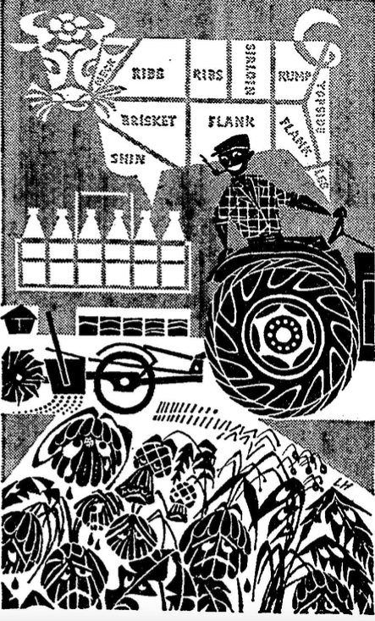Illustration 6: One of ICI's profile raising advert, promoting the benefits of their work "Research: the Springboard of Progress" (1964) depicted these sad weeds being sprayed with Gramoxone by a grinning farmer.
The war against weeds, despite using herbicides, was never referred to as chemical warfare. Herbicides were described as part of the arsenal, or as ammunition, involved in skirmishes and sieges against weeds and other pests set up as as the enemy, but invoking the horror and mass destruction wrought by chemicals used in actual war was avoided in editorials and advertising. While ICI's sprayed weeds looked sad, the control and the power was all in the hands of the user. The chemicals studied in this chapter were mainly untarnished through their extra-garden uses. It appeared impossible to come to harm through misusing sulphate of ammonia, sodium chlorate did not become demonised through its use by terrorists in the 1970s, but through its misusers paraquat was. What was different? Although homes and their inhabitants were affected, such as those who lived above and near pubs that were bombed with sodium chlorate devices and mortars, being attacked is different to inviting a chemical into your home and expecting to be able to control it. Gardeners who used sodium chlorate for gardening were not waiting for sodium chlorate to attack them, Weedol using and probably the careful Gramoxone users were not at risk from paraquat attack. The only thing that could lead to harm using paraquat was not following the instructions. Paraquat cannot be thought of as attacking, except at the bidding of a murderer Perhaps the home makes paraquat misuse stand out, this was where mistaken identities occurred, where paraquat was swigged or taken deliberately. In combination with it's status as a newly synthesised chemical, marketed only by one large company, compared to sodium chlorate as a well established, relatively simple chemical made by many smaller chemical companies.

Gardeners must think about the future, imagining and looking forward to when their planting schemes reach maturity. The need to balance immediate with future needs is played out in weeding.

Weeding and success in using weedkiller hinges on correctly identifying the weed and then selecting the correct herbicide for both the situation and the plant, followed by applying it correctly. An example of how the first hurdle must be cleared can be seen in the case of a gardener who sent in a sample of problem "moss" from their lawn, and asked for advice to treat it. They were told that it was in fact chickweed, which explained why moss killer had been ineffective, and directed to the appropriate weedkiller. Using herbicides requires intellectual work, even if the following physical work is less arduous than weeding purely by hand. Like choosing chemicals for cleaning the home, the gardener must be able to select the right one for the job. By adding this layer of skill, understanding which chemical to select, on top of identifying the weeds, a menial task becomes one for an expert. This use of chemical products can be thought of thought of as a way of engaging with the wider world of scientific research and development, of modernising one's practices and keeping up with the times, if not the neighbours. Betty Frieden used this argument in her discussion of women and consumption, particularly regarding the proliferation of household cleaning products in the 1950s, but it can be applied equally well to garden chemical users, and users of photographic chemicals, of any gender, throughout the entire period that this thesis examines.

Using weedkiller for human harm was not unique to paraquat herbicides, as we saw in the earlier part of this chapter. The deliberate ingestion of weedkillers that were specifically marketed as harmless, such as sodium chlorate and Weedol, shows how any chemical is a candidate for this particular misuse. Sensationalised news reports about the severity of paraquats effects on the human body gave the chemical a notoriety which facilitated its use to end lives, which made it threatening enough to be used as an agent of saboteurs and blackmailers. Correct uses of garden chemicals were modelled in advertisements as well as garden advice columns, magazines and books. Misuses which were reported following accidents educated others about the dangers of garden chemicals and in some cases motivated users to improve their own methods of storage to ensure safety. However, they also acted as inspiration to misuse, by providing a primer on how much would be fatal, by showing how easy supposedly restricted substances could be obtained or through guaranteed media attention when a notorious poison was (threatened to be) involved.

Casey, P., and J.A. Vale. "Deaths from Pesticides Poisoning in England and Wales: 1945 - 1989." Human & Experimental Toxicology 13, no. 2 (1994): 95-101.
MAF284/307, 2, PS427 SC 1175, Scientific Subcommittee on Poisonous Substances used in Agriculture and Food Storage, “First Report on Paraquat”, 23.03.62
Howard, 1982, Paraquat: Uses and Misuses, MD thesis, University of Edinburgh, p2.
“Improved Type of Weed Killer” The Times, 23.08.62, p10.; “Farewell to the plough” Daily Mail, 29.08.62
Bradbury, McCarthy and Suckling, “Patterns of Innovation Part III – The bipyridyl herbicides, Chemistry and Industry, 4 March 1972,
DA Schon, 1963, "Champions for Radical New Inventions", Harvard Business Review pp77-86, p84
Bradbury, McCarthy and Suckling, “Patterns of Innovation Part III – The bipyridyl herbicides, Chemistry and Industry, 4 March 1972, p195;
Wain, p.139
Kennedy, p146
Stout, Ruth, and Richard V. Clemence. The Ruth Stout No-Work Garden Book. Emmaus, Pa.,: Rodale Press, 1971.
SC 2376 Weedol Co-operator Trials
Gramoxone Data Sheet, SC 1174, 3 pages.
"Extracts from Minutes: Advisory Committee on Poisonous Substances Used in Agriculture and Food Storage 20/03/62." National Archives, Kew, 1962.
Gramoxone W label HO 305/32, National Archives, Kew.
Pl/w, SW 1169, Paraquat SC1174 draft SC1175 Advisory Committee on Poisonous Substances Used in Agriculture and Food Storage 2 pages. 20.03.62 (IMG_3002 and 3003 in my files)
Howard, (1982)
MAF 284/307 "Extracts from Minutes: Advisory Committee on Poisonous Substances Used in Agriculture and Food Storage stamped 20/03/62." National Archives, Kew, 1962.
MAF 284/289 "[Extracts] Minutes of 89 Meeting 28 April '64 (SC1850): Scientific SubCommittee Advisory Committee on Poisonous Substances Used in Agriculture and Food Storage" National Archives, Kew, 1964.
MAF 284/307 "SC1174: Gramoxone Data Sheet." MAF 284/307 National Archives, Kew, 1962.
SC 2376 Weedol Co-operator Trials
SC 2376 Weedol Co-operator Trials Summary of Information obtained from questionnaires p3
"Coroners and the Public Interest." The British Medical Journal 3, no. 5927 (1974): 374
"Ends the work of weeding" Daily Express, 03.04.65 p14; "My Dad's a Weedol weeder" Daily Mirror, 06.05.67, p21
Howard, p13.
“Information On Poisons” The British Medical Journal , Vol. 1, No. 5339 (May 4, 1963), p. 1220
“Weedkiller Warning”, Peter Bullen, Daily Mail, 25.05.68, p4
Swan, A. A. B. "Letter to F. Stewart 13 May 1968." National Archives, Kew.
Holloway, G. R. "Letter to F. Stewart: Paraquat 12 March 1968." National Archives, Kew.
Plant Protection Limited. "Sc1174: Gramoxone Data Sheet." MAF 284/307 National Archives, Kew, 1962.
MAF 284/307, 149, p4 Letter from AAB Swan (Plant Protection Ltd) to F Stuart (Poisons Board) 16.02.68, National Archives, Kew
MAF 284/307, 149, p3 Letter from AAB Swan (Plant Protection Ltd) to F Stuart (Poisons Board) 16.02.68, National Archives, Kew
MAF 284/307, 199-201 Letter from CE Rabington (MAFF Regional Safety Inspector) to J Rowe (MAFF Deputy Chief Inspector) giving details of article in Cambridge Daily News, 09.11.68 “Label on bottle of weed killer said 'Lemonade'”
MAF 305/32 Letter from Stewart, P. to Holloway 30 April 1969 "Paraquat" National Archives, Kew
MAF 305/32 Holloway, G. R. "Letter to Bates, 25th October 1968." National Archives, Kew..
MAF 305/32 Letter from Stewart, F. to Holloway G.R. 30 April 1969, Letter from Holloway, G. R. to Stewart, F. 06 June 1969", "Extract from Minutes of the 86th Meeting of Adivisory Committee on Pesticides and Other Toxic Chemicals Held 15/01/70." National Archives, Kew, 1970.
Buton, John. "Report by the Coroner on the Inquest Upon Robert Staples." In Control of Paraquat: National Archives, Kew, 1971.
Staples, Gordon. "Letter from Mr Staples to Mr Onslow." 6. In Control of Paraquat: National Archives, Kew, 1971.
Buton, John. "Report by the Coroner on the Inquest Upon Robert Staples." In Control of Paraquat: National Archives, Kew, 1971.
"New Coroners Rules." The British Medical Journal 1, no. 4809 (1953): 554-55.
Pilling, H. H. "Coroners' Jurisdiction." The British Medical Journal 3, no. 5558 (1967): 179.
"New Coroners Rules." The British Medical Journal 1, no. 4809 (1953): 554-55.
Carlisle, Mark. "Letter to Cranley Onslow, MP, from Mark Carlisle." National Archives, Kew, 1971; Stewart, F. "Letter to DH Morpeth from F Stewart: Paraquat 01 December 1971." National Archives, Kew, 1971.
B&Q advert, Daily Mail, 25.05.88, p11
Boots advert, 25% off all garden chemicals, Daily Mail, 19.05.79, p30
“Super Summer” Timothy Whites advert, Daily Express, 17.05.68
Woolworths advert, Daily Mail, 27.05.87, p17
"Don't waste time with weeds"
MAF 284/307, 61, Letter from Labrum to Wiseman (PPL) 02 August 1965, National Archives, Kew.
"Killer chemical goes on Poisons List", Daily Mail, 09.09.68 p6
'Poison death: Firm rapped', Daily Mirror, 31.10.72, p9
“Killer chemical goes on Poisons List” Daily Mail 09.09.68, p6
“Should this killer be allowed?” DM, 30.08.72, p6
Easton, P. H. "Regulations on the Sale of Paraquat."HO305/32: National Archives, Kew, 1973.
"Now paraquat must carry poison label", Daily Mail, 02.02.74, p11
Memo from DA Wrigley, 18.10.72
"Paraquat's toll of 97 victims" Daily Express, 13.07.74 (mentions murderer Jennifer Kenyon using a false name)
“Should this killer be allowed?” DM, 30.08.72, p6
“My stupid little wife” Daily Mail, 07.01.75, p11
HO 305/32, Letter from R Kendall to GR Waters, 22.01.74
“Strict controls imposed on paraquat weedkiller” The Times, 02.02.74, p2; “Now paraquat must carry poison label” Daily Mail, 02.02.74 p11.
“Worth the extra pound or two” The Times, 07.09.68, p22.
Weedol: Public Warning, HL Deb 02.06.80, vol 409 cc1104-6;
'Gramoxone'w. The Times (London, England), Monday, Dec 07, 1964; pg. ii; Issue 56188.
Herbert, DWM. "Paraquat." In HO305/32, MAFF: National Archives, Kew, 1973.
"First in the Field" Plant Protection. The Times (London, England), Monday, Dec 02, 1963; pg. v; Issue 55873.
MAF 284/307 Bureau of Commercial Research Ltd (Research Division of Erwin Wasey, Ruthrauff and Ryan Ltd). "Report of a Placement Test for Weedol Weedkiller October 1964." National Archives, Kew, 1964.
“Don't waste time with weeds”, Spring 1967 Campaign. The Times 10 June 1967, p8.
“Amazing new weeder discovery ENDS THE WORK OF WEEDING” Spring 1965, Daily Express, 03 April 1965, p14;“End the work of weeding with Weedol” Weedol advertisement, Spring 1966 Campaign, Daily Mail, 16 April 1966.
"Weedol kills weeds without killing the soil (or your back)" The Daily Mail 24 March 1970, p3
"Stand up to weeds!" Daily Mirror, 13 April 1968, p20
"Tudor 'Weedol' Applicator Made to Make 'Weedol' Weeding Easier Still." The Daily Mail, 18 May 1968, 6.
Turner, W. "Safer Weed-Killer Spraying." Practical Gardening, October 1966, p65.
du Boton, Roger. "Doomwatch Checks Chemical Safety." Practical Gardening, 1971, 69; Lawrence, Bill. "Shock Tactics a Special Report on Weed Control." Practical Gardening, March 1981, 54-54.
Prosser, Alf. "Growing Prices." Practical Gardening, 1980, p7.
“Amazing new weeder discovery ENDS THE WORK OF WEEDING” Spring 1965, Daily Express, 03.04.65, p14 as first instance. Alternated each week between Express and the Mirror until mid May. Did not appear in the Mail or the Times.
MAF 284/307 Bureau of Commercial Research Ltd (Research Division of Erwin Wasey, Ruthrauff and Ryan Ltd). "Report of a Placement Test for Weedol Weedkiller October 1964." National Archives, Kew, 1964.
“End the work of weeding with Weedol” Weedol advertisement, Spring 1966 Campaign, Daily Mail, 16.04.66. This advert appeared in the Mirror and Express, but not the Times.
“My dad's a Weedol weeder!” Weedol advertisement, Spring 1967 Campaign, Daily Mirror 24.04.67, p21 was the first instance of this advert. There were two image variants, using the same text, which were run each weekend for a month (until 25.05.67).
“Don't waste time with weeds”, Spring 1967 Campaign. The Times 10.06.67, p8. On this date the same advert also appeared in the Express and Mirror
“Super Summer” Timothy Whites advert, Daily Express, 17.05.68
Hilton, Matthew. Smoking in British Popular Culture, 1800-2000 : Perfect Pleasures. Studies in Popular Culture. Manchester, UK ; p119
"Your garden pin-up" Amateur Gardening Annual, 1970, p78. This immediately preceded an article "Chemicals: where do we stand?"
"Stop weeds going to bed with your flowers", Spring 1978 campaign, Daily Mail, 08.04.78, p32
“To get plenty of vegetables, I give them plenty of help” ICI Garden Products Even the greenest fingers need a little help, Daily Express, 04.09.77, p22. This advert featured soil conditioner (mulch), granulated fertiliser, and Weedol. ; "Fast and easy. That's how I get rid of weeds" Daily Mail, 16.04.77 p31. Advert for Weedol and Pathclear. In both adverts, Percy is shown holding his pipe
Timothy O'Sullivan, ‘Thrower, Percy John (1913–1988)’, rev. Oxford Dictionary of National Biography, Oxford
"Gardening" The Times, 16.05.70, p26; "Gardening" The Times, 04.07.70 p23
Take the backbreak out of weeding' Roy Hay, The Times, 17.06.67, p6
'Take the backbreak out of weeding' Roy Hay, The Times, 17.06.67, p6 (this article predominantly about ground cover was adjacent to a Weedol advert); 'A case for ground cover.' Times [London, England] 1 June 1974: 13, Roy Hay. 'Covering a lot of ground.' Times [London, England] 15 June 1974: 12.
"Gardening" The Times, 10.05.67, p5
Howard, p92, 113
Howard, 216
Smith, L.L. "Mechanisms of Paraquat Toxicity in Lung and Its Relevance to Treatment." Human & Experimental Toxicology 6, no. 1 (1987): 31-36.
Howard, p162
“Paraquat poisoning Treated by forced diuresis” F. Kerr et al (1968), BMJ, vol 3, No. 5613, pp. 290-291
Howard, p30 (oxygen), p169 (forced diruresis)
Vale et al, 1987
Kennedy, p.148
HO305/32, Extract from minutes of 66th Meeting of the Poisons Board, 23.2.73
“Child died from weed killer” The Times, 14.08.68, p2
P. Meara, Personal communication, email 28.01.14
SW 1169, 182, PNM Moore documenting a telephone conversation with Holloway 26.6.68, National Archives, Kew
MAF 284/307 Bureau of Commercial Research Ltd (Research Division of Erwin Wasey, Ruthrauff and Ryan Ltd). "Report of a Placement Test for Weedol Weedkiller October 1964." National Archives, Kew, 1964.
Look for the bit in Practical Gardening
Hawkes, Nigel, and Jane Edgington. "Ban This Poison." The Observer, 25 March 1973, 44-45.
“The boy who thought he'd had a drink of pop”, Jane Gaskell, The Daily Mail, 24.06.71, p6.
SC3078 Paraquat and diquat liquid formulations summary of experience of human exposure December 1965 – May 1967, National Archives; “Girl drinks first and dies” Daily Mail, 30.09.72
“Children steal deadly weedkiller” Daily Mail, 30.08.72, p3
“The killer inside the bottle” Daily Mail, 08.07.72, p20; “Doctors save paraquat toddler” Daily Mail, 18.11.72, p3; “Alive! The boy who drank paraquat” Daily Mail, 06.08.82, p1
“Bottle said lemonade but it killed Beverley” Daily Mail 14.08.68 (clipping from paper, no page, 'Poison tragedy of a gardener' Daily Express, 30.09.72, p15
'Poison tragedy of a gardener' Daily Express, 30.09.72, p15
Swan, A. A. B. "Letter to F. Stewart, Poisons Board." National Archives, Kew, 1968.
“Boy and Girl in lung-swop operation” Daily Mail, 13.05.68, p1
SC3078 Paraquat and diquat liquid formulations summary of experience of human exposure December 1965 – May 1967; “Man drank weedkiller by mistake” The Times, 11.12.69, p 5;
SC3078, Paraquat and Diquat liquid formulations summary of experience of human exposure December 1965 - May 1967
“Poison husband's grief”, Daily Mail, 23.11.77, p11
'Weedkiller was nice, dying child whispered' The Times, 19.07.72, p2
“Lung Transplant in Edinburgh”, Glasgow Herald, 17.05.68, p1
“Boy and Girl in lung-swop operation” Daily Mail, 13.05.68 , p1; “Lung boy sits up for icecream”, Daily Mail, 18.05.68, p1; “Lung transplant boy dies” Daily Mail, 29.05.68, p1
“Boy with new lung winks at father” The Times, 18.05.68, p10
Matthew et al, BMJ Vol 3, no 5621, pp 759-763 759
Scientific Subcommittee on Poisonous Substances Used in Agriculture and Food Storage
'Poison death: Firm rapped', Daily Mirror, 31.10.72, p9
“Should this killer be allowed?” Daily Mail, 30.08.72, p6;
“Man drank weedkiller by mistake”, The Times, 11.12.69, p.5
“Peril of poison in a pop bottle”, Daily Mirror, 16.11.72, p22
“Girl drinks first and dies”, Daily Mail, 30.09.72, p9
Handyman Which?, Feburary 1973, p57
Fifth report on paraquat - Home Garden Use, MAF 284 307, doc 108 {IMG_2917}
“Read the label”, Letter from TRL Waring ICI Plant Protection, Daily Express, 06.08.74, p3
“Read the label”, Letter from TRL Waring ICI Plant Protection, Daily Express, 06.08.74, p3; 'Why they died' Letter from AI Allen Press Officer ICI, Daily Express, 02.12.72, p16
Clarke (1993), p271
Scientific Subcommittee on Poisonous Substances used in Agriculture and Food Storage, "Fifth Report on Paraquat - Home Garden Use." National Archives, Kew
Howard 1982 p184
Millard (2012)
“Paraquat: Firm urged to act”, Daily Mail, 31.10.72, p11
“Should this killer be allowed?” DM, 30.08.72, p6;
Howard (1982), p177 -183
Extract from minutes of 66th Meeting of the Poisons Board, held on 23.2.73, Paraquat PB 998 IMG_2643 - check Kew sequence to find file name
Weedkiller was nice, dying child whispered' The Times, 19.07.72, p2
Arsenic, King of Poisons?
Colling, Keith. "The Couple Who Nearly Got Away with Murder." The Daily Mail, 03 July 1974, 23.
Smith, Ian. "Husband Aids Police in Poison Case." The Daily Mail, 31 October 1973, 13
"Wife Accused of Poison Killing." The Daily Mail, 12 December 1973, 11.
Watson, Katherine. Poisoned Lives : English Poisoners and Their Victims. London ; New York: Hambledon and London, 2004.
"Stop weeds going to bed with your flowers", Spring 1978 campaign, Daily Mail, 08.04.78, p32
''I'll pole-axe you' a mother's shout at murder case', Daily Mail, 05.07.74, p13; “Poison stew wife is jailed for life” Daily Mail, 10.01.75, p3
“Jail for Coke blackmailer”, The Times, 23.11.74 p3
“Anger over 'poisoned turkeys'” Daily Mail, 20.12.82, p10
“Another turkey alarm”, Daily Mail, 21.12.82 p22
“More poisoned food may be lying in shops” The Times, 08.05.81 (front page leader, article p7); “Safeway food poison dose 'not lethal'”, The Times, 09.05.81, p2.
“Poisoner hits supermarket shelves”, Daily Mail, 22.06.87, p2
“Poison food threat”, Daily Mail, 15.08.87, p2
“Safeway counts cost of scare” Daily Mail, 09.05.81, p2.
“Paraquat drums lost from lorry”, The Times, 28.03.74, p2
“Children steal deadly weedkiller” DM, 30.08.72, p3
“Poison overboard!” DM, 06 April 1973, p17; "Coast Alert on Lost Weedkiller." The Guardian, 06 April 1973, 1.
“Deadly shower” DM, 25.08.80, p11
“Children eat poison spray blackberries” DM, 25.08.73 p13
Howard, p65.
Kendall, R. "Letter to J Harrison from R Kendall." 27 March 1973 HO305/32, National Archives, Kew.
“Research the Springboard of Progress” The Times, 18.12.63, p.9
“'Paraquat pie' eaters surprise village” The Times, 22.05.82, p4 Woodkirk can be considered on the edge of Yorkshire's Rhubarb Triangle, so the choice of rhubarb pie is particularly significant for locals.
HO305/32, Letter from Mr Mathewson, 30.01.73
HO305/32, Letter from JL Gilloran, 02.03.73
HO305/32, Letters from R. Kendall to Mathewson, 14.02.73, and 13.03.73
Handyman Which? February 1973, p9
Hawkes, Nigel, and Jane Edgington. "Ban This Poison." The Observer, 25 March 1973, 44-45.
Howard p147
Morpeth, D. H. "Paraquat." HO305/32: National Archives, Kew, 11 October 1972; Kendall, R. "Poisons Board: Paraquat." HO305/32: National Archives, 07 February 1973.
“Should this killer be allowed?” DM, 30.08.72, p6; “Paraquat: Treatment for a lethal dose” The Times, 11.12.74, p18
HO305/32, Extract from minutes of 66th Meeting of the Poisons Board, 23.2.73
Meredith, T.J., and J.A. Vale. "Treatment of Paraquat Poisoning in Man: Methods to Prevent Absorption." Human & Experimental Toxicology 6, no. 1 (1987): 49-55.
Tesco took out full page advertisements to announce that their household products contained the additive. Tesco. "We're Hoping Our Latest Innovation Will Be Hard to Swallow." The Daily Mail, 1988, 21.
Farm and Garden Chemicals, HC Deb 20.07.71, vol 821 cc1395-407
Price, TH. "Colouring of Liquid Arsenical Weedkillers." National Archives, Kew, 1922.
Deeweed advert, Daily Mail, 04.07.81, p27
Leroco advert, Daily Mail, 12.05.84, p20
Handyman Which?, February 1973, p57
First Report on Paraquat, Scientific Subcommittee on Poisonous Substances Used in Agriculture and Food Storage, PS 427 SC 1175, 23.03.62
Wears, J. "Lawn Feed." Practical Gardening, April 1975, p7.
Wilds, B.F. "Hasn't Disappeared." Practical Gardening, July 1971, p7.
Goatley, Martin. "Nitro-Chalk." Practical Gardening, August 1980, p7.
"Can We Help You? Mossy Lawn." Practical Gardening 7, no. 2 (May 1966): 25.
Frieden, B. The Feminine Mystique p.174, p.182

