This chapter focuses on chemicals used in the house, principally considered the domain of women. While cleaning makes up the bulk of this chapter, I am not going to retread the ground covered by scholars of soaps and detergents. Instead, I will examine sodas which despite their position in the foundation of much of the chemical industry, their uses in the home has been overlooked despite their applicability to hard surfaces and textiles alike. Looking beyond textiles to another surface, the porcelain WC bowl provides another chemical case study which also draws on the desire to reduce work, while caring for the health of the household. Regarded as an unpleasant, tough, tedious task, household chemicals and branded products have been readily employed to aid the housewife's performance here and Harpic is one of the best known. Labour saving is a common theme of this chapter, and carbon tetrachloride grease spot removal treatments are one way that to avoid laundering whole garments, where Thawpit acts as an example of a brand. In compiling these case studies, fire protection emerged as another domestic use of chemicals so this will also be covered.

Household manuals, such as Mrs Beeton, prescribed timetables for efficient work and provided shopping lists of a vast array of different cleaning cloths and brushes, even diagrams of how to store them but the near absence of branded goods and a relatively low profile of chemicals in the general cleaning cupboard was striking. The stain removal sections of household manuals detail the types of activities and materials experienced in the home and how they changed over time. Knowledge about fabric composition, being able to discriminate between natural fibres, of plant or fruit based stains was supplemented by a working understanding of an increasingly confusing array of combinations of synthetic fibres, and a new barrage of stains from processed foods and work-related tasks. Entries for carbon paper and mimeographic correction fluid, indelible pencils and a variety of inks; indian, marking (based on either silver nitrate based or aniline), printing, writing and ballpoint trace a history of office work. Fashions in medicine can be traced too from inclusions and disappearance of iodine, mercurochrome, cod liver oil. These catalogues of messy mistakes made in daily life were especially important when laundering a whole garment was difficult and time consuming or otherwise expensive, essentially spot cleaning was a labour saving activity as the lengthy sequence of manually involved processes involved in cleaning entire items could be sidestepped or at least delayed. As plumbed-in automatic washing machines became increasingly available and synthetic detergents developed to cope with an array of stains at lower temperatures, attitudes to laundry changed. Cowan and others have argued that improvements in washing machines and access to them did not necessarily reduce the total amount of housework, instead causing whole garment laundering to be done more frequently. Thinking about stain removal in particular, machines and increasingly complex detergents were delegated the bulk of the work, reducing the operator's involvement in stain removal to first aid before laundering.

While it is tempting to firmly tie increased textile variety and therefore complexity of fabric care straightforwardly to an increased variety of branded stain removal chemicals, this is not necessarily true. After all, plain old clean water was consistently recommended as the starting point for treating all stains, especially fresh ones. Plus, users could simply avoid fabrics with demanding care requirements, or even discover through disobeying the laundering instructions that they were actually flexible. Nevertheless, there do seem to have been some users who took pride in understanding how to treat stains and in perpetuating the publication of exhaustive tables of advice. The motivation for sustaining this expertise was usually framed in terms of simple economics, as saving the cost (and effort) of taking stained items to professionals, rather than necessarily elevating the person doing this task at home to that of professional. The emphasis on cost may have influenced how 'proprietary products' were vaguely referred to, but changes in retail can also be seen in this. Where once a store keeper could have discussed individually which proprietary product an article probably referred to, self service shopping changed the relationship between customer and shop staff as well as the knowledge that both were expected to have about products.

In fact, the recommendations for stain removal remained remarkably consistent and the greatest changes in the chemicals that might be kept in people's homes were better traced through the ubiquitous 'poisons and antidotes' table in the household medicine chapter, rather than the pages which laid out best cleaning practices. While the poisoning treatments might not explain what useful purpose the potentially harmful chemicals were kept in the house for, they also represented the dominant form of feared interaction with chemicals, that of acute and fatal poisoning through ingestion. The preoccupation of users and non-users with acute poisoning recurs throughout this thesis, and overshadows any murky, hard to pin down toxic effects from the long-term, low-level exposure to chemicals. Where the poisons were not also medicines at a lower dose, they most often reappeared in the domestic manual as a way to remove stains, either from textiles or hard surfaces.
While the bulk of housework was undertaken using innocuous water, soap, soda and simple elbow grease, concern about the control of other potentially dangerous household chemicals has been longstanding. In 1926 E.T. Neathercoat, a former president of the Pharmaceutical Society of Great Britain, opined that 'However drastic our poison regulations they will never be fool-proof'. The impetus for his commentary was the Poisons Law newly enacted that year which prevented poisons being sold by chemists unless they were clearly labelled as such. Neathercoat welcomed the sentiment behind improved labelling, but worried about the 'ignorance and carelessness' of domestic users, of the 'despairing' and about 'inquisitive children'. His concern lay chiefly with acids: carbolic, oxalic (salts of lemon), hydrochloric (spirits of salts), sulphuric (vitriol) and nitric. He expressed a view that was published surprisingly rarely, that 'If effective for the purposes for which they are sold, all of them are virulent poisons of causing an agonising death'. Neathercoat did not expound upon what exactly was being done in people's homes with these chemicals, why people chose to keep these potentially harmful chemicals in their possession, how they knew about them or the variety of places other than reputable, responsible chemists that people could obtain them. Other than suicidal users, Neathercoat did not mention other forms of deliberate misuse, despite the high profile (if not frequency) of acid attacks. Neathercoat's article identified categories of user which reappear throughout this thesis, though I separate 'ignorant' from 'careless', taking these to mean not-knowing and inattentive respectively, I keep his 'despairing' as well as 'inquisitive children'. User categories get further discussion in their own chapter once we have explored more situations and exposed further groupings. In this chapter, I will compile case studies of chemicals used for general cleaning and stain removal, looking at how they were advertised, recommended and used.

First I will address the family of sodas. Sodas span some of the most innocuous and the most dangerous of chemicals used at home, that is washing soda and baking soda, and caustic soda. Table 1 lays out some of the different uses of these chemicals, and shows how caustic soda was used rarely in comparison to the gentler sodas. Bicarbonate of soda was able to take the place of washing soda, and while washing soda could be ingested in small amounts without harm, it generally was not substituted deliberately for baking soda. Very often in household manuals, the type of soda recommended was unspecified, which required those undertaking the housework to simply know through experience and common sense, that they should use washing soda, or sodium carbonate. If nothing else it was a process of elimination and the clue was given in the names of the other sodas, that caustic soda was too strong and inappropriate, and that baking was strictly for culinary purposes.

On the other hand, Alma Chesnut Moore's book How to Clean Everything outlined the whole 'sodium family' and suggested even more soda types that a housewife could ask her chemist for, including TSP (trisodium phosphate) and sodium perborate, neither of which I have seen mentioned as available alone rather than combined with a laundry detergent in any other publication. In the British home washing soda was the versatile workhorse until the 1950s, when other more specialised products came to dominate the domestic cleaning landscape. Washing soda did not disappear from the housekeeper's options, but as shall be shown in this chapter, a combination of supply-side influences meant it receded from first choice, to be later reinvented by both users and manufacturers as an alternative option to the complex cleaning formulations available.
Date | Caustic | Washing | Bicarbonate
1890s |  |  | Medicine cabinet
1920s |  | Make Javelle water  Clean and stiffen household brushes, clean range and gas cooker
1930s | Kill tree stumps, even oak | kill dandelion  Mixed with copper sulphate to treat plant rust, esp snapdragons | Influence conception: have a boy
1930s | remove old paint from furniture | Combat bed-bug infestation | Clean vacuum flask
1930s | neutralise acid from the "wireless accumulator" to stop it burning a hole in the carpet | soothe sore eyes from over-chlorinated swimming pools. | Remove iodine stains
1930s | Offensive chemical attack – property, | remove smoke stains underneath mantlepiece | Remove scorch marks textiles
1930s | Offensive chemical attack – property, | Slow coal burning, save fuel  Clean oven, save fuel  Soften water, save soap | Rinse eyes after mustard gas  Remove grass stains from textiles  Clean silk stockings
1930s | Offensive chemical attack – property, |  | Homemade cleaner inc meths, paraffin, ammonia, borax.
1930s | Offensive chemical attack – property, |  | Treat mildewed plants "Russian method"
1930s | Offensive chemical attack – property, |  | Essential larder item  Use less sugar to sweeten fruit  Cook legumes, save meat  First aid kit
1940s | Offensive chemical attack – person, | Mixed with copper sulphate to prevent sand bags rotting | Fire extinguisher
1940s | Winter wash for trees | Make tea appear stronger | Fire extinguisher
1950s | Offensive chemical attack – animal
1950s | A 'last resort' for drains
1960s |  |  | Clean refrigerator  Clean melamine, cheaper than Vim
1970s |  |  | Clean freezer
1980s | Contaminate baby food
1990 |  | 'environmentally friendly'
Table 1: Showing uses as they were recommended and misused.
Very often no precise measurement was given for the amount of soda to be used, nor were any ratios given for the volume of crystals with respect to the volume of solvent. Descriptions such as handfuls, 'a little soda' or 'a tiny knob' abound, meaning that each person's experience depended on their personal interpretation of the instruction. Sometimes more precise detail was provided about the amount which should be used for successful results, as in these examples where the lump of washing soda was described as 'about the size of a sixpenny piece', or 'about the size of a walnut'. Good results were therefore very closely linked to the experience and knowledge of the user.
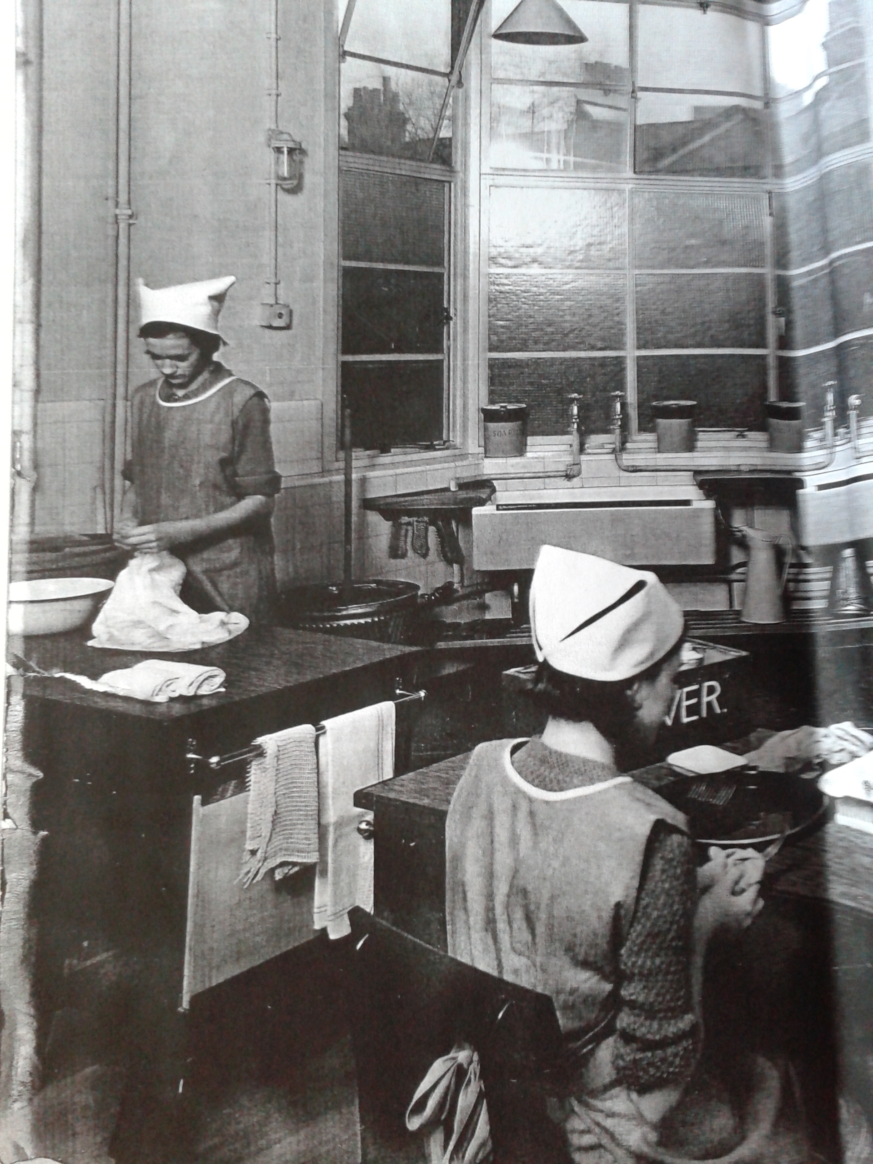Illustration 1: Scene from a home economics class at the West Kensington Central School, 1930s, where on the windowsill are three large containers. The one on the right hand side is labelled "SODA" Institute of Education Archives, Newsam Library, BF1/1/33

An example of the physical experiences relating to soda can be shown in the photographs from home economics lessons. Illustration 1 shows soda stored into large stoneware storage jars, separated from any branding it might have had, kept on the windowsill in easy reach in 1930. The large cannister reinforces the idea that washing soda was bought and used in bulk. Social worker and documentarian Reeves recorded the quantities that women would routinely buy, often 7 pounds at a time and 3d was a usual price for this amount, making it popular with working class women as it was cheap, and 'made to do a great deal' including children's baths and hair washing.

This bulk was steadily reduced over time, with 2lb packs becoming the dominant way that soda could be bought. However, an advert placed by ICI announced that in response to the 1940 paper control order they would forego all prepacking and therefore branding until they could box their soda crystals in cardboard of appropriate quality. The aim of the advert was to reassure soda users that although they could not buy branded boxes, the loose soda they would buy from their grocer was the same ICI quality. During World War Two, soda was frequently promoted through household hints in newspaper articles, because unlike soap soda was not rationed. Familiar household sodas also featured in ICI's profile raising, morale boosting and educational advert series 'In the services of an Industry'. These adverts were produced to impress upon the general populace that the chemical industry was integral to everyday life, and ICI chemists were the heroes behind such useful items.
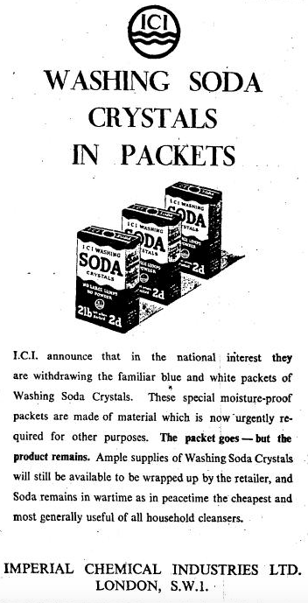Illustration 2: Advert placed to reassure users that while the branded box was gone, the soda itself was still on sale.
The return of prepackaged soda was not heralded by a similar advertisement from the manufacturer, and housewives had found any kind of washing soda increasingly difficult to get towards the end of 1949. However, other than an occasional letter expressing annoyance at traipsing around town looking for an elusive product, there was little other evidence of discontent with the soda situation. In early 1950 Olby's store located in Dover saw fit to advertise in the local paper the arrival of a 'large consignment of ICI washing Soda : 2lb cartons 4d'. Declaring the branding ICI communicated to readers the trusted quality of the product, indicating that the shopkeeper knew that customers cared about this detail. This also marks the point when announcements about soda were taken over by retailers, rather than the manufacturer.

From here on retailers like Olby's, rather than manufacturers ICI, publicised soda for sale and later adverts tended to include soda alongside other household cleaning products, such as in a full page Woolworths adverts that promoted a variety of special offers. 'Quality washing soda' was offered, showing a picture of the box without any visible distinguishing brand names or manufacturer. The advert continued 'You can't get better value anywhere – Woolworths washing soda', suggesting that the soda was good enough to be branded with the familiar Woolworths brand and therefore the 'quality' of the product could be trusted. In 1965, another Woolworth's advert gave the majority of the full page to images of premium branded cleaning products; Ajax, Brillo, Scotchbrite and Jeyes but listed a selection of further offers in the bottom right corner which included less lucrative branded items Winfield washing soda and Thawzone bleach.

The increasingly lowly position of washing soda can be illustrated in further detail through examining the situation faced by Boots the chemist. They experienced both reduced demand from users, as well as pressures from manufacturers relating to increased costs associated with production and distribution of washing soda. Reluctant to raise the price of such a basic good, this situation forced Boots to question whether it was worth continuing to sell loose soda at all, as it was more convenient to sell prepackaged 2lb cartons. In 1967, following further price increases from ICI, Boots chose to forego the loose soda, making this effectively unavailable to domestic users. While their suppliers ICI and Thawpit did not directly substitute more complex products in place of soda, the prepackaged branded soda had to compete with and was out-shadowed by the sheer number of alternative, novel products available. Boot's own household products surveys did not even include soda in 1968, focussing exclusively on detergents, soaps and dedicated products such as oven cleaner and toilet cleanser, all identified to be growth areas.
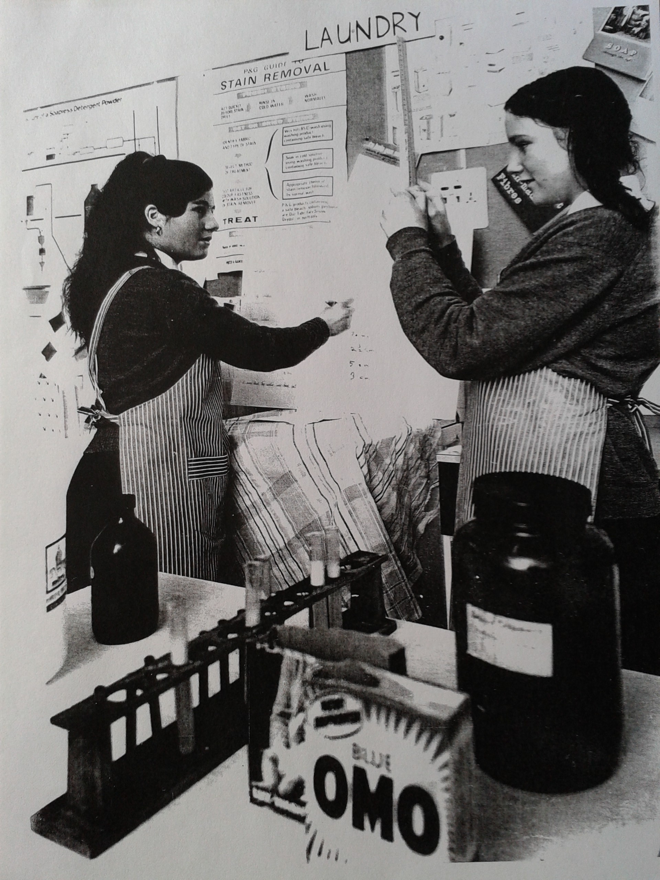Illustration 3: Photograph of a domestic science lesson in 1968. The pupils are measuring the amount of foam produced from detergents, and the effect of water hardness adjusted by sodium carbonate on this. On the classroom wall behind them is a poster "P&G [Proctor & Gamble] guide to stain removal, demonstrating the brand education of young consumers.

In keeping with this reduced profile of washing soda and in contrast to the large jars of soda from the 1930s classroom, Illustration 3 shows a scene from a lesson in 1968 and shows that the nature of how soda was experienced had changed considerably. Soda was retrieved from a brown glass chemical jar in a precise manner by spatula, rather than grabbed by the handful from a jar as it had previously. While the pupils learned that technically soda softens water and enhances the work of detergent, measured by the height of detergent foam in their tried and tested experiment, they were becoming distanced from the bulk, everyday use of multipurpose washing soda and the domestic measurements it was described in. Washing soda was transformed into a carefully handled experimental chemical, sodium carbonate.

Washing soda is closely related to caustic soda and bicarbonate of soda, with soda ash being the basis of production for all three. Soda ash requires common salt and limestone as raw materials. Although soda ash was historically produced by the Leblanc method, the Solvay method also known as the ammoniated brine process, was the principal means of soda production in Britain between the 1930s and the 1980s, and is still in use today. This process was developed in the 1860s by Brunner Mond who built a large plant in Winnington, Cheshire, making use of the natural salt deposits in that geographical area which could be extracted as brine. During the process, brine was mixed with carbon dioxide generated from the heating of limestone. To ensure a supply of limestone for soda ash production, Brunner Mond acquired shares in the Buxton Lime Firm, Derbyshire and that company became part of ICI in 1926, forming the foundation of the Lime Division. There were soda plants elsewhere, such as Thawpit's in High Wycombe, which as well as being a recognisable brand of household chemicals in their own right, also supplied Boots the Chemist shops with loose, unbranded soda.

By making up different strength washing soda solutions and by using soda water at different temperatures, this soda was made to shoulder the bulk of domestic cleaning work, from cleaning pans and cookers, saving soap by softening water, it was used on floors and other surfaces as well as to sanitise the brushes, cloths and sponges used to clean them, clearing blocked drains. However, the profile of soda declined when most authors of household manuals ceased to recommend it, instead they suggested detergents and specialised (but often unnamed) proprietary products. Nevertheless, even this was not the only story that can be told about soda, as paralleling the surge in variety, stemming from environmental concern and financial stresses in the 1970s advice and books about housework demonstrated a renewed interest in washing soda as a frugal and general purpose alternative to convenient but expensive branded preparations in economically difficult times, as well as hailing the comparatively simple and familiar chemical as a 'green' option. The transformation from ubiquitous everyday use, to rebuilding a reputation of environmental friendliness, so long as the energy costs of producing washing soda were ignored, has so far been a topic overlooked by historians of all disciplines.

While newspapers occasionally carried adverts for washing soda, readers of women's magazines were even less likely to see adverts for this product, despite the suggestions that were routinely found in women's magazines routine to use washing soda. This suggests that advertising budgets were thought to work harder promoting formulated and therefore more expensive cleansers, a hypothesis which is supported the by the presence of adverts for branded household ammonias, which suggests that added complexity through added ingredients meant column inches in the case of Sprim Blue Ammonia (Illustration 5). This was advertised as containing two additional products 'Vitalised Blue' and 'Sta-Byx' that were evidently known and desired additives or products in their own right which therefore made Sprim more attractive to users. Without such additions, well known, ubiquitous washing soda was not ordinarily worth advertising.
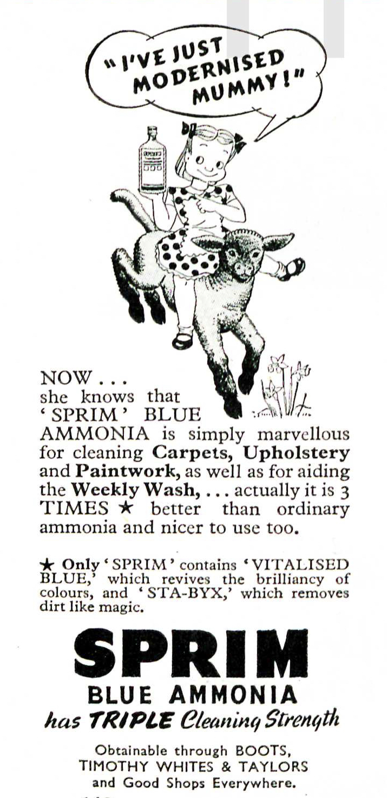Illustration 1: Sprim ammonia advert, from Good Housekeeping Magazine April 1950 p142
From the 1950s branded cleaning products had increasingly been recommended by name in newspaper and magazine articles, as opposed to simply referring to 'a proprietary product'. Apparently taking a cue from the successes of consumer magazines such as Which? most newspapers began to run a column that advised on household products. Trialling new products at home was part of Heather Standring's work as a consumer affairs columnist. She wrote sceptically about dedicated products which offered ever easier cleaning and instead recommended multipurpose products such as 1001 cleaner, or chemicals including washing soda, and extolled the virtues of elbow grease. Sometimes she demystified products and provided warnings that were not emphasised as strongly as she felt should be, as in the case of Easy-Off oven cleaner warned readers that it contained caustic soda and that they should wear rubber gloves.

While washing soda was certainly multipurpose, it was not noxious enough to be involved in accidents or serious misuses. Table 1 gave the example that it was added to tea, to make it appear darker and stronger without ill effect. Harold Wilson admitted to mistakenly adding washing soda to cabbage in place of bicarbonate of soda, much to the dismay of his scout troop for whom the now foul-tasting vegetable was destined. That said, when washing or bicarbonate of soda was used in the homemade cleaning preparation known as Javelle water (soda, water, chloride of lime), mistaken ingestion of this concoction could prove fatal. The soda generally responsible for harming users, or rather unwitting users, was caustic soda, also known by its proper chemical name sodium hydroxide.

Caustic soda
Caustic soda is a strong alkali and can burn living tissue if it is not neutralised or rinsed off immediately. This requires care to be exercised in both its retail, as it was included on the Poisons List meaning it must carry an address label from where it was sold. Domestic users were instructed to wear gloves when handling caustic or its solutions. The dangers associated with this chemical being 'at large' in the domestic environment had been long known; household advice from 1843 had advised never to keep 'vitriol, soda, nor pearl ash' in the kitchen. Although it burns in the mouth, in practice this sensation does not always lead to it being spat out, as a reflex swallow is the alternative response, with dire consequences.

This appears to have been well heeded, at least at during the period with which this thesis is concerned, as reported incidents occurring in the British home were rare. It was responsible for 7 deaths in children under 10 years old between 1931 and 1935, with the chemical being classed as a 'corrosive', joining cresol, phenol and unspecified acids to kill a total of 16 children between 1958 and 1977. These figures also show a decreased prevalence of poisoning with caustic soda, from nearly 2 each year, to averaging 1 every three years. While the number of fatal cases decreased, nonfatal accidents involving caustic soda flakes continued to be reported sporadically in newspapers and acted as cautionary examples. Even through these short news pieces did not elaborate on the responsibility to store these chemicals properly, the readers could fill in this detail themselves.
Nevertheless, even if individual households practiced safer storage this did not necessarily extend to beyond their own private walls, as Scott Budfield (age 3), Julia Carter (age 5) and Kim Tyler (age 7) discovered, when a jug that they found outside their block of flats did not contain dried coconut as they first thought, but caustic soda flakes. Following another incident, police warned residents in Barnsley about the dangers of caustic soda after a group of children explored a house due for demolition and found a tin, which the inquisitive young people opened and resulted in several being treated at hospital for chemical burns.
Table 1 showed the use of sodas, and only caustic soda could be used for vandalism and deliberate harm. The corrosive chemical was employed in disfiguring attacks on people typically following the pattern of a spurned lover attacking the object of their desire. While technically an alkali, people were familiar with the crime of acid throwing, which covered all corrosives and correspondingly caustic soda was often referred to as acid by both the misuser and by journalists. When John Lloyd threw caustic soda over his wife in their scullery he told her 'That's acid. It will kill you' although claimed in court that he only wanted to 'frighten' her and 'did not think it would cause such an injury'. While also disfiguring but used with a different motivation, caustic soda was sprayed by anti-racism protestors during a clash between police and protestors following a National Front march in Lewisham, 1977. While not always taking place at a home, these actions involved premeditation and preparation at home, for instance making up a solution from crystals and putting it into a container to use later, or buying a ready to use product and taking it to an event.
An element of fearfulness was associated with caustic soda which pushed some domestic users towards other dedicated products. While removing paint with hot caustic soda solution might be suitable for professionals, a lifestyle journalist wrote in 1967 'we would be terrified to get within smelling distance', and instead recommended several branded paint strippers. These were at least as corrosive in order to remove the paint, not to mention odiferous, but the domestic users of these products divested a certain amount of difficulty and inconvenience associated with the process of heating up and possibly transporting a corrosive solution.

Bicarbonate of soda
Moving on to the gentlest of sodas, demonstrated as such in Table 1 by its presence in first aid kits and simple home remedies, the compilation of recommendations relating to this soda also show that between the 1930s and 80s in Britain cleaning uses were restricted to the body (face washes, dentifrice) and delicate stain removal from textiles, or specific tasks such as cleaning a thermos flask or refrigerator where an odourless cleaning agent was preferable. The recommendations to use bicarbonate were very numerous during the 1930s and 1940s but they dried up in the 1950s, appearing once more in the 1960s when the cleaning properties were rediscovered in the context of caring for fridges and freezers composed of mixed materials which might need different care like plastics, metal and rubber. New plastics and composite hard furnishing materials were often promoted as only requiring soap and water to clean them so as to not deter purchasers who might worry about providing special care for these untested materials. Although new materials were far easier to sanitise than wood and were embraced by housewives keen to save labour, baking soda became an ideal compromise when traditional scouring powders and the culture of scrubbing that was associated with cleanliness were not suitable for use softer plastics easily damaged by gritty powders and made more prone to picking up dirt.

In contrast to the UK, baking soda was heavily promoted as a far more versatile domestic chemical in the USA through adverts and booklets produced by manufacturers Church & Dwight, a practice simply not seen in the UK. In Britain, promotional materials were less strident and single minded. For instance, the Harpic Home Book incorporated suggestions to use unbranded chemicals as well as those produced by Harpic, and similarly in the CWS Household Hints booklet there were always alternatives to the CWS products it aimed to promote. Potatoes were touted as a starting point to fix all sorts of household problems. Church & Dwight produced a selection of booklets, starting with their 1933 A friend in need booklet which concentrated on bicarbonate's medicinal uses. Two years later It's all in knowing how promised 'new uses' for baking soda included cleaning all kinds of surfaces, as well as the suggestion to keep a box of bicarb handy in the kitchen, workshop and car glove compartment to put out fires as the powder would smother the flames. In 1952 a comic book-style booklet showed a family appreciating soda's usefulness, but without any new uses aside from being applied to new consumer goods such as coffee makers.In these scenarios there were no alternatives, baking soda was the only solution to all challenges that might be encountered in the house, garden, garage or farm. It was the only chemical that was needed, not combined with anything else.

The expansion from only health and cooking uses in the 1930s matched that of the UK and it is hard to say why or how this change was made, or on which side of the Atlantic it occurred first. It does not appear to be related to the American's trona mines, as until 1948 all soda produced in the States still used the Solvay process. Mining the mineral trona meant that the energy-hungry, synthetic Solvay processes could be abandoned in favour of simpler methods of carbonate production. However, the abundance of trona and the cost savings that it facilitated could have impacted the British producers of soda by increasing competition through cheaper soda, which is a factor to consider in the apparently sudden increases in costs of production that ICI declared themselves to be facing. What is more likely to have been highly influential on the division of labour between washing and baking soda in Britain were the socially held beliefs that as bicarbonate of soda was for medication, and it should be purchased in small quantities in order to not allow it to deteriorate, which was also vital to its leavening ability. While the presence of sodium bicarbonate in the home as a medicament meant that it was then available for other uses, the small quantities it was stored in and used as well as the name, strictly separated it from washing soda. Bicarbonate was advertised as 'indispensable for medical and culinary purposes', but its multitude of other household uses in cleaning were not mentioned.

One recommendation in particular that would have required a sizable quantity, indeed a boxful, was to extinguish a fire by dumping bicarbonate of soda onto it. This was safety tip was not replicated in contemporary UK media, it simply did not match up with the small quantities generally found in the home. Nevertheless, this did not mean that sodium bicarbonate could not be used as a fire extinguisher in the British home. The Selfac fire extinguisher available to British householders in the 1940s incorporated an explosive charge triggered by heat which automatically ruptured the container which released the powder to cover and smother the fire. Nothing about the name indicated that the agent involved would be common baking soda. Other bicarbonate based fire extinguishers were also marketed, both dry powder and a liquid bicarbonate solutions, of varying degrees of effectiveness. A powder bicarb fire extinguisher was even implicated in a robbery when it was allegedly discharged by the perpetrators to temporarily incapacitate the guard while the theft occurred.
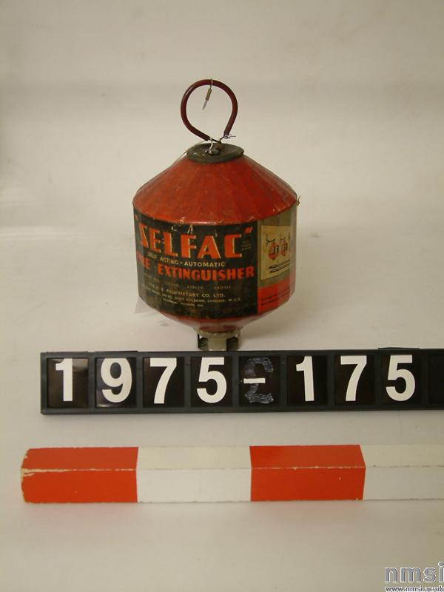Illustration 2: Selfac fire extinguisher in the collection Science Museum, London. The catalogue lists the materials making up the body of the object, but does not mention the bicarbonate of soda.
The innocuous kitchen chemical cropped up in political news stories when baking soda solution was supped by Irish prisoners in the Maze when on hunger strike and used to soothe eyes of rioters affected by tear gas deployed in Bogside, a practice that recalled the advice given to civilians in the approach to the Second World War in case mustard gas was used (see Table 1). Later, journalists appeared fixated by the juxtaposition of criminality and domesticity in the use of baking soda in the production of crack cocaine, not an everyday use by any means, but the chemical's role became a consistent feature in reports on the novel drug. There were no calls to attempt to control bicarb's availability because of its part in this criminal activity, which would have been futile.

What has been noticeably absent from much of this discussion so far, has been branded goods. Baking soda in the USA was promoted by Church & Dwight as either Arm & Hammer or Cow brands, but there was not a similar strong brand identity in Britain. Baking powder, a pre-prepared mixture of soda and cream of tartar, on which bakers reputation could be made or broken was a different matter. We saw that ICI branded washing soda was believed to be well regarded enough to warrant advertising to explain the disappearance of the brand, but the same kind of branding or loyalty was not seen with caustic or bicarbonate sodas. While Alma Chesnut Moore hinted that soda compounds were the basis of favourite household cleansers, she did not illuminate her audience by naming them. In research trips to museums and in searching for evidence of branded goods, these domestic chemicals are very evasive amongst the ranks of household objects collected for posterity.

Harpic
One product that was very much in evidence in these collections was Harpic, along with other cleaning agents usually gritty scourers packed in cylindrical tubes. Harpic was not an abrasive product and it was developed to do away with scrubbing one particular household object, the porcelain toilet bowl. As water closets moved into the house, bringing their associated wastes and germs further into the home, the responsibility to keep them clean grew stronger which meant an eager set of users for Harpic. Washing soda was one of many household chemicals used to clean toilet bowls, and even to scrub the wooden seat snowy white but Harpic became so widely used, it even advertised the fact that it was found in 5 out of 10 WCs. Harpic was not based on washing soda, and it was not based on a chemical that could readily be bought in a generic, unbranded form from the chemist. Harpic was a powder of acid sodium sulphate and when dissolved in the toilet bowl it gave a solution of sulphuric acid. This was particularly effective at removing limescale, which dulled the porcelain bowl and provided a rough surface for dirt to cling to. By removing the limescale, the acid was more effective than bleach, which might temporarily whiten the dingy finish but would not solve the problem of limescale and dirt's affinity for it. This information was not related to the user in adverts, which did not mention Harpic's relationship to sulphuric acid, or even its particular action on limescale, only that it reached into the bend where the toilet brush cannot and that simply leaving it to work, without scrubbing or effort, will result in a glistening, deodorised and disinfected toilet bowl. The Harpic Home Book described 'foreign incrustations' rather than limescale and assured readers that it 'contains no scheduled poison and is therefore perfectly safe' as opposed to the 'dangerous acids' employed before Harpic was available. That in 1966 the ingredients and actions of the cleanser were explained by manufacturers Reckitt & Sons to the advertising agency JWT in a confidential letter suggests that the general public were in the dark about the active ingredient of Harpic.

Harpic was introduced to the market in 1921 by the Harpic Co., initially selling the powder in cardboard cylinders which were degraded by the acid product. This was quickly rectified by using metal cannisters instead. In 1924, Reckitt's & Sons attempted to purchase the company, but considered the asking price too high. Harpic Co. changed the lid to a sprinkler in 1925, to control the flow of the powder and appear less wasteful. By 1932, Reckitt development chemists had reverse engineered a potential competitor which placed the company in a position to negotiate a more appealing price to buy Harpic Co. For the entire duration of the period this thesis is concerned with, the 1930s to the 1980s, Harpic has been owned by Reckitt's & Sons, later Reckitt's & Colman, and has been a staple product in the domestic bathroom. Harpic advertising changed very little between the 1930s and the 1980s, using highly focused campaigns which concentrated on toilet bowl cleanliness. This specificity was directly related to the chemical composition of Harpic, the acidity of the which rendered it suitable only for cleaning 'lavatories, or other porcelain or vitreous china articles'.

Despite this acidic property, Harpic was never named as used in malicious attacks, perhaps not being employed due to the low profile of the nature of the active chemical in this product. Would this state of ignorance have left the user vulnerable to effects resulting from mixing household chemicals? It is unlikely that knowing what the active ingredient was, without the benefit of a solid chemical education, would have prevented the practice carried out be some users who believed their combinations made the products work better, the eye-watering fumes that came off signifying their strength and therefore effectiveness. In fact, this potential danger was one of the few that actually affected the intended user, rather than someone who accidentally encountered the chemical.

While most users would have been expected to quickly notice and avoid noxious gases, all users are different. In 1945, a Birmingham housewife with a damaged sense of smell who, while cleaning her bath mixed half a pint of Parazone with a generous 2oz Harpic, only narrowly escaped serious harm, prompting her doctors to experiment with that mixture to observe the evolution of the poisonous gas. They did not call for any further labelling or other action, suggesting that the warnings might be considered reasonable. Yet still this type of accident continued. In 1963, of 33 accidental gassings that were recorded by the National Poisons Information Centre (NPIC) at Guy's Hospital, most of the household cases were from mixing Harpic with a bleach. The incidence did not decrease, with 40 out of 45 inhalation incidents reported to the NPIC between 1974-75 relating to liquid bleaches and lavatory cleaners, alone or in combination. The relatively high frequency of domestic chlorine gassing prompted a group of epidemiologists to survey the information given on domestic lavatory cleaners, who found that all twelve different brands in their local shop instructed users not to mix cleaning chemicals, but only two (Domestos and Vortex) explained the consequences of mixing.' Mixing was not always accidental, as the case of a 41 year old electrician demonstrated who after several months of inhaling chlorine for what he described as its pleasurable effects, he presented himself at the doctors with severely reduced lung function, worse than was even seen in workers chronically exposed to chlorine. Despite the potential for fatal effects, during the period that this thesis is concerned with, it appears not to have been used for that end deliberately.
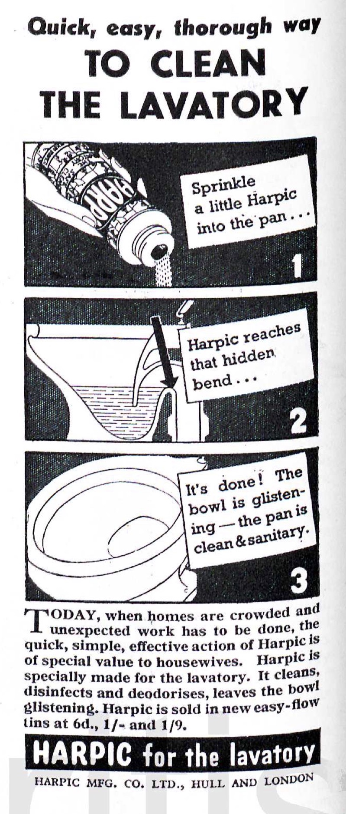Illustration 3: 1940 advert Harpic as labour saving
This information about using Harpic alone was reserved for Harpic's packaging and not mentioned at all in its advertising (see Illustrations 3 and 4 as examples), which emphasised that it was the 'safe' cleaner. While the accompanying images and exact text varied a little, the adverts always informed the user to expect a 'glistening' 'shining' 'scrupulously clean' 'safer than ever' toilet bowl, to use Harpic daily, while emphasising that it was easy and fast to use. The technical drawing of the toilet showing the hidden bend was a staple feature of the adverts which lent them aura of scientific credibility. In 1950 perfume was added, though existing users were reassured that they could still get the 'familiar kind'. Safety of the product user was not mentioned and the manicured hand holding the cannister was not sheathed in a rubber glove, but the safety of the porcelain and the future safety of bathroom users through the disinfectant properties of Harpic were noted.

The user imagined by Reckitts was the housewife, explicitly stated in 1940, reinforced in their adverts by an image of a feminine hand sprinkling the product into the offending toilet, and the notion of one person in charge of enforcing standards and shopping. Extensive advertising in women's magazines such as Good Housekeeping magazine and daily newspapers such as the Daily Herald ensured that messages about Harpic reached a wide variety of women. In the 1950s, advertisements showed a smiling hulk-like man holding the cannister of Harpic, but it was not an indication of who would do the work, only that Harpic was as strong as this man with enormous biceps.
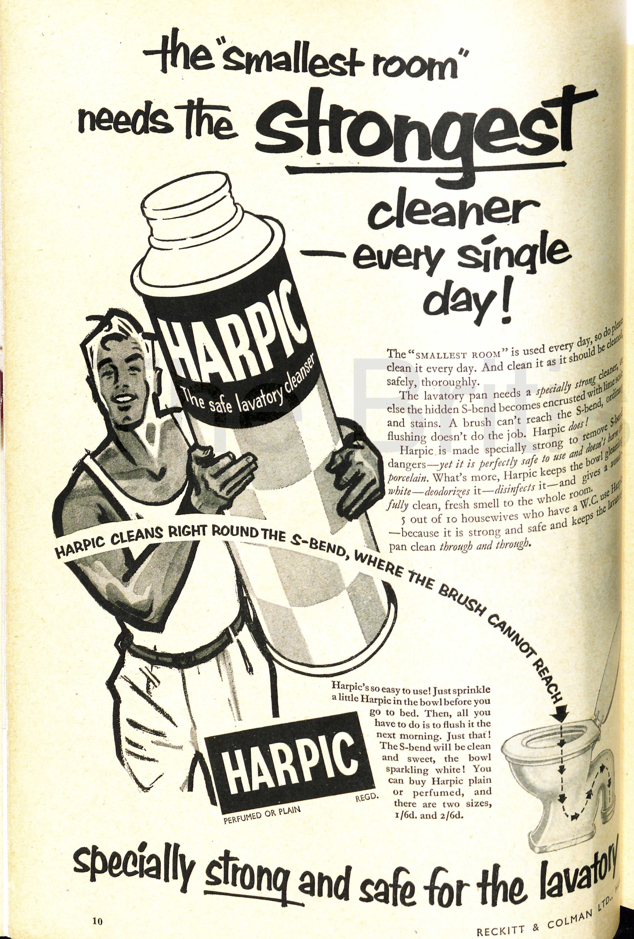Illustration 4: The strength of Harpic is depicted by the image of the strong man, 1955 GH magazine.
While schoolboys might not be the usual audience for toilet cleaner advertising they certainly picked up the gist, and the brand name became an unkind nickname for comedian Simon Fanshaw's teacher: 'We called him Harpic for the simple reason he drove you clean round the bend'. By the 1980s, Harpic was very much a household name in Britain, and used as shorthand for disinfectant or indeed almost any cleaning product, rather than any great understanding of its properties or best uses. Writer Robert Nye recalled his mother in the 1950s wiping down books from the public library with a handkerchief rubbed in Harpic. This snapshot of Mrs Nye who, at least in the eyes of her son, used Harpic not only for cleaning her home in the conventional methods, but also in a way that she believed protected her home, and her family within it, from germs shed by unknown people and their potentially grimy homes that could be borne by the library book. Harpic was evoked when tasting unpleasant foods, and when describing a not very good wine 'Jacob's Creek … could to be to wine what Harpic is to toilets'.

The ubiquity of Harpic meant that when Reckitt & Colman were mentioned in media reports of the company's activities, Harpic was routinely given as an example of one of their products that the audience would recognise. Harpic was deemed an anomaly, along with the company's other household cleaning products like Brasso and Windolene, that went against economic theorists' predictions for product life-cycles as it continued to sell well from the 1930s into the 1980s. What these economic theorists perhaps did not take into account was Reckitt's commitment to understanding their product users.

This can be seen in their choice of advertising agency, JWT, who had a well established research department. By the 1950s Reckitt & Colman were serious enough about the benefits of market research that they had their own unit, one of the very few industrial ones. Users and non-users were surveyed extensively, considering age, family composition, economic status, housekeeping habits and where applicable which competitor or alternative products were used instead of Harpic and why. When Reckitt & Colman recruited for their Commercial Research Department in 1964, the department was described as having its own nation-wide team of interviewers and modern data processing equipment. Their highly gendered person specifications indicate that Reckitt's valued women's communicative ability to draw out useful information from housewives. Reckitt's connection with their product users should be considered an important factor in the successes of the company to develop and market a range of household chemical products that were very well received.

Carbon Tetrachloride
Carbon tetrachloride (CTC) has been chosen for a case study because it was available from before 1930 as both an unbranded product obtained from a pharmaceutical chemist as well the 'active' ingredient in a number of branded consumer products, Thawpit cleaning fluid being our principal example in this chapter. Carbon tetrachloride was first synthesised in 1839, by the French chemist Henri Victor Regnault through reacting chloroform with chlorine, which made the chemicial of interest to historians of medicine. Historians of chemistry have tended to focus on the changes to CTC's nomenclature, and its role in exercises to develop organic chemistry. This is the first time a history of CTC from the view of the domestic user has been attempted, although there has been comprehensive studies of military and industrial uses of the chemical.

When CTC was manufactured on a much larger scale as a result of chemical companies searching for an outlet for an excess of chlorine from around 1910, the clear, colourless liquid with a characteristic sweet smell became more widely used in domestic settings. As this thesis is concerned with the period between the 1930s and the 1980s, the status of CTC in the 1930s as a domestic chemical can be considered established, like washing soda and Harpic, but unlike these chemicals, the story of CTC ends with it being actually removed, not just displaced from the domestic market. CTC had been embraced by domestic users as an effective grease remover, promoted as a safer option to using benzine, as it would not catch fire. The vapours were initially described as no more dangerous than benzine, or could make the user 'drowsy' but by the 1970s CTC was considered the most toxic option of the cleaning fluids then available. The discovery and marketing of other newly synthesised chemicals that were less poisonous, not flammable and highly efficient stain removers began to replace CTC and in addition to this functional replacement, global regulatory systems meant that from the 1970s CTC began to be formally phased out of consumer products to protect the ozone layer, groundwater and human health. CTC has been demonstrated to be carcinogenic in experimental animals, although occupational and population studies of humans are inconclusive, so as a precaution it is considered a potential human carcinogen. Along with other chlorinated halogens CTC was implicated in the depletion of the Earth's ozone layer and since 2002 it has been banned from consumer products.

Although this chapter is mainly about housework, CTC provides the opportunity to look some other uses of this chemical in the British home. From 1903 CTC found favour among fashionistas who freshened their hairstyles with the chemical, initially at the hands of professionals in environment of the hairdressing salon, but then also at home by themselves. This makes it one of the earliest uses of CTC in the home. Exactly how the notion of using CTC for cleaning human hair came about has not been forthcoming, it was not recommended in Thawpit's promotional leaflet though an extrapolation from caring for fur coats and stoles could lead an imaginative user to try it on human hair. Avoiding a full wet wash which before the widespread installation of domestic plumbing and reliable hot water systems might necessitate heating, transporting and disposing of water, as well as the subsequent potentially chilly drying period would certainly have been a benefit of using CTC.

However, the nature of the chemical and its interaction with human physiology meant that this was a fairly short lived use. In response to an accidental death on their premises in 1909, Harrods hairdressers stated that they had been using CTC without incident for six years, which they estimated to be a total of "20 or 30 000" dry shampoos over this period. This was clearly an expert space, yet when referring to the fatal accident involving the dry shampoo, the hairdressers were framed by medical doctors as non-experts. While the hairdressers may have known how to get results that pleased their clients, they did not have the same level of chemical knowledge as the medics. This was highlighted in how they attempted to treat the client who was overcome during her hair wash, by lying her on the ground to recover. To the scientific men who understood that CTC vapour sunk to the ground, this was the worse possible place to put the patient, who would then surely be further exposed to the suffocating substance.

There was no indication of the prevalence of this as a domestic practice but by 1934 the British Medical Journal was able to report that dry shampooing with CTC had stopped as other, safer products had become available. However, it was still employed to clean removable hair pieces worn for personal or social reasons: to hide thinning, balding or alopecia, religious choices made by Orthodox Jewish women, and switches simply worn for styling variety and fun. Dipping the hair into a small saucer of CTC was far safer than having it poured over the scalp, which gave a peculiar cold sensation and it reduced the user's close contact with the chemical which can be absorbed through the skin, as well as inhaled with sedative, depressive effects. Additionally the users' active physical position and ability to control the ventilation of the space where they worked, as well as the volume employed all meant that wig cleaning users were less prone to the vapours produced.

The proposed removal of CTC and CTC based products from the market does not have appeared to have publicly disturbed the wig using population; there were no comments about alternatives or concern about what people were exposing themselves to and theatre manuals continued to recommend cleaning wigs by dipping them into large containers of CTC well into the 1980s, without warnings about ventilation or toxicity. Surprisingly, a recently revised edition of Science for Hairdressing Students listed CTC as a grease solvent which might be encountered, though it warned that all solvents should be treated with respect and used 'in plenty of space'. Some wig sellers provide aftercare services allowing users to divest themselves of the question of cleaning and restyling, but the mass production of synthetic wigs was accompanied by care regimes that involved dunking in a gentle detergent shampoos rather than dry cleaning methods, as well as introducing a sense of disposability to a previously expensive investment that had to last a significant length of time.

Fire extinguishers
The other example of this chemical in the home contained within fire extinguishers, where more often than not it was hoped to never actually be used. The same property of CTC vapour being heavier than air which could be fatal to humans also meant that it was fatal to fire. As a liquid, CTC cooled the fire and also denied it oxygen, plus as a heavier than air vapour it blanketed the fire and further starved it of oxygen. Extinguishing devices came in a variety of forms, including the now familiar pressurised extinguishers form, produced by various manufacturers from the 1918. When Thorpe explained Thawpit to JWT, he told them that it was the same chemical in extinguishers. These brass cannisters were also joined by fire grenades, in which the chemical was visible in glass balls or tubes, often hung on the wall in a purpose-built bracket. They were quite plain globes, or aesthetically pleasing, which has ensured that some have been collected by enthusiasts. Vogue magazine carried a photograph and description of a swan-shaped grenade in 1947.
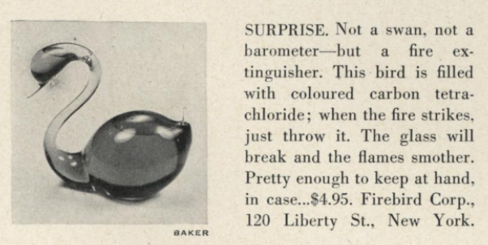Illustration 5: Fire grenade pictured in US Vogue 1947
The grenades were sealed shut, preventing evaporation of the volatile chemical, but also ensuring that the CTC was only used for fire prevention rather than extracted from the grenade for any other domestic purpose. These sealed glass vessels were intended to be thrown at the base of a fire, breaking the glass and releasing the liquid. Alternatively, automatic versions could be installed which dropped the globe when heat destroyed a component of the holder. From the number available in British museums, other collections or second hand, CTC grenades do not appear to have been as popular in Britain as they were in the USA.

CTC could be used to put out any kind of fire, which was useful in the rapidly modernising British home which was at risk from fires started by candles and oil lamps, solid fuel fires or gas, electricity, or even incendiary bombs dropped by enemy aircraft. Due to its non-conductive nature it was particularly useful for electrical fires, although CTC extinguishers have not featured in histories of domestic electrical technologies. Historian Emily Hankin's work on domesticating electricity as the National Grid expanded covered tripping over flexes and electrocution, but did not raise the concept of electrical fire risk in the home, for instance from overloaded sockets. Graeme Gooday's work on the history of electric lighting explains that the electrical companies' focus on the safety and lack of worry compared to the fire risks associated when gas was used in the home led electrical fires in the home to be downplayed, as not requiring a special technology to deal with them. This should not be surprising, as the emphasis on safety of electricity does not lend itself to thinking about the terrifying damage that an electrically started fire can wreak, or the problems associated with treating it like a normal fire. The following illustration is one of Pyrene's early British adverts from 1919, when they specifically highlighted homes containing children as requiring protection. The fire extinguishing liquid was not named, but neither was it obfuscated by any other terms or descriptions. The user was assured that it would not damage fabric or furniture when the efficient and easy to use extinguisher put out the fire.
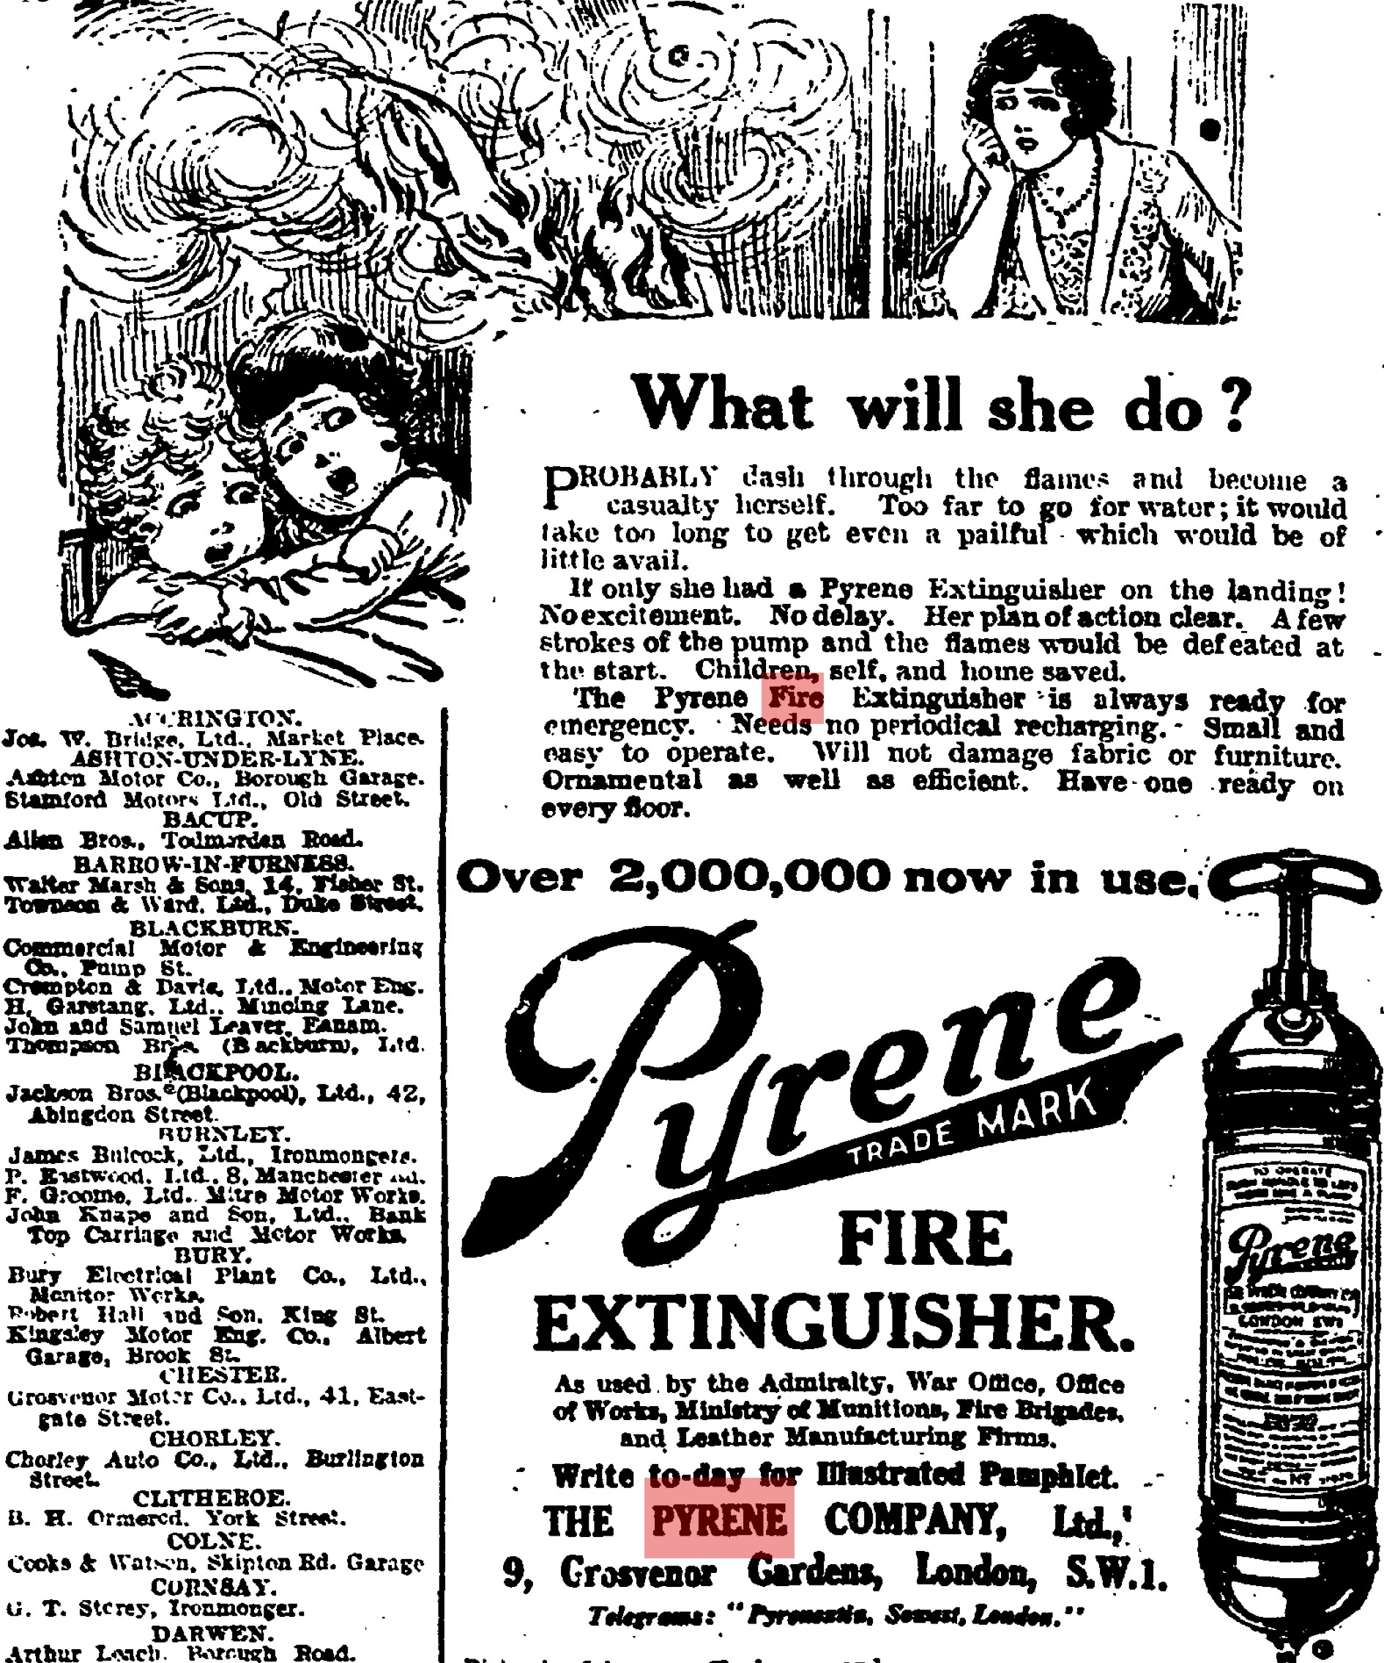Illustration 6: A domestic scene where the mother could use the extinguisher to save her children, self and home.
A letter to The Times shows that CTC extinguishers were not regarded by users as completely trouble-free. Alexander Duckham wrote in 1934 that his experience as a chemist meant that after waking feeling unwell, he could identify the smell in his bedroom in which he hung 'a standard type of car fire extinguisher' as CTC. This phrasing confirms that the active ingredient of the fire extinguisher was not made obvious to the user on the object itself, and that someone without a similar training in chemistry would not be able to locate the source of the problem as the fire extinguisher, so Duckham took on the duty to translate his experience for people with less chemical expertise than himself. He does not consider that people may have encountered CTC outside a chemical laboratory, and although 1934 was fairly early in CTC's domestic grease solvent, it was quite possible for more non-chemists to have become familiar with the chemical through products such as Thawpit. No further comment was made on the incongruity of a product which promised to protect material objects potentially poisoning the user.

By the 1930s Pyrene's British promotional material ignored the domestic aspects of fire prevention and focused instead on the material and financial aspects of cars and property, rather than lives or a sense of security. Although air raids in the First World War stimulated the promotion of Pyrene extinguishers for domestic use, this was not repeated in the following conflict in the face of greater devastation wrought by more powerful bombs, and recurrent raids and associated fires which made water and a stirrup pump a more convenient, cheaper option to recharge when repeatedly faced with fires. Pyrene's later British advertising pamphlets focused on non-domestic masculine images, depicting fire extinguishers in soldiers' vehicles, in military aircraft, in racing cars, and called on the authority given to the extinguishers by their visible presence in public institutions and on public transport (see illustration below).
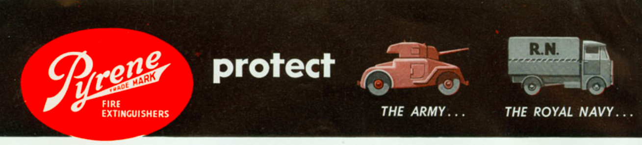
Illustration 7: A header and footer from a promotional Pyrene pamphlet, 'An investment into peace of mind' 1950s, which focussed on vehicles but left the option open for home use.
Pyrene instructed users to immediately refill the extinguisher even if the fire was put out in two or three strokes of the extinguisher. The user was instructed to refill, rather than to take the product to a specialist to be refilled, the 1950s pamphlet indicates that CTC was sold to domestic users for this purpose. However, in these advertisements the chemical name is never given and instead refers to the 'special liquid' or 'fire killing liquid'. This is gap in knowledge would invariably be filled by the Pyrene sales representative, as not all users could be expected to work out from the description that it is safe for use on electrical fires, that it is non-conductive and will not freeze, as well as should not be used in a confined space that these are all clues to this mystical 'fire extinguishing liquid' being CTC.

It eventually became evident that CTC was not appropriate to use in all fire situations, because when in contact with hot metal, it produced phosgene gas and chlorine. Although this was reported in the medical press from 1946, it was not picked up on in the mainstream press, and therefore the general user population, until many years later. Newspapers reported on industrial accidents where this happened in the 1960s, such as those at a Sheffield steel mill and Leeds engineering works. These incidents were not explicitly linked to to domestic fire extinguishers, although it was hinted at by the definition of a confined space being given as "a cellar or living room" and saying that there are a million of this type of extinguisher in use throughout Britain, which suggests their presence in private homes as well as in public transport and industrial situations. The generation of phosgene in a domestic fire was probably far less likely than in an industrial situation, but the presence of CTC vapour in a confined space was also dangerous.

Household cleaning
In comparison to these uses, advice to use CTC for household cleaning became widespread somewhat later, between the mid to late 1920s and the early 1930s. That CTC was not very widely used is confirmed by its absence from 5th edition of Wynter Blyth's book on poisons published in 1920 which contained many other poisons commonly found in the British home. This can be related back to the mass production of CTC discussed briefly at the start of this section, and that it would only be used for household cleaning once it was manufactured at a volume that made generally more available and at a suitable cost for regular use. Unbranded CTC was presented in 1926 as 'readily procurable' but without indication of from where, though we can suppose that people were familiar with asking their chemist for such items.

Thawpit was created by Captain Thomas Thorpe in the 1920s. Although 'BMG' in Somerset wondered whether the name Thawpit stemmed from 'thawsty', a dialect word meaning nauseatingly dirty, it is likely that the product was more ego-centrically named for its similarity to Thorpe. Indeed, Thorpe-it sounds very similar to Thawpit, which was what adverts in 1928 encouraged users to do: 'Thawpit your ties and suits', using the very brandname as a verb. In 1934 Thorpe engaged advertising agency J. Walter Thompson (JWT) in 1934 to handle promotion and labelling of the brand.

Although Thawpit's labelling and informational leaflets did not state what the cleaner actually was, the characteristic odour, qualities and precautions to take when using it identified it to a chemically knowledgable user as being CTC based. Letters between Thomas Thorpe and JWT reveal that Thawpit cleaner contained CTC made by Albright & Wilson. Thawpit was pure CTC, unlike other CTC based products which contained detergent, or were a mixture of solvents. In buying a bottle of Thawpit, the user also bought a great deal of information about how to best use it packaged with the product. It is interesting that household hints articles and manuals continually referred to CTC, or unnamed proprietary chemicals, rather than brandnames such as Thawpit. These articles sought to educate their readers to make economical choices, whereas the reader of Thawpit's promotional material would have been left in the dark about the identity of the miraculous fluid, but well informed of its function as a grease remover and the scenarios in which it could be used. This also demonstrates how users were expected to be curious about new products and able to assimilate information from multiple places, joining the dots and filling in the gaps for themselves to work out what was in proprietary products. When The Teesdale Mercury recommended Thawpit by name in 1933, they did not mention what the functional ingredient in it was. Instead, their 'Mainly for Women' page hailed it as a 'reliable home cleaning liquid' able to remove grease, that should be on hand to keep clothes looking good.

Undated leaflets produced by Thawpitn probably in the 1920s set out the ways that the solvent could be used as a multipurpose grease remover. The leaflet extolled the potential for general household uses including 'removing verdigris from geysers', as well as the masculine cleaning activities of polishing car headlights and removing tar from car bodies or tobacco pipes. This multipurpose appeal could be expected to sell Thawpit to a wide range of users, who would rapidly use up the product if they were to follow the advice in the leaflet that it could be used in all these situations. No doubt CTC was effective at these tasks, but when compared to other more readily available, cheaper alternatives that were as effective, it is perhaps not surprising that its use on textiles for stain removal, or spot cleaning, developed as a major domestic use of CTC.

In contrast, household hints columns concentrated on the uses for textiles and never presented the chemical as the only option, in fact often only as the final solution when the mark did not succumb to more common treatments of soap or ammonia. The prioritisation of simpler, more readily available methods in these recommendations also show that older methods were not rejected or even fully replaced when a new product became available to domestic users. Getting a mark out quickly, possibly with something already to hand was of more importance than exactly what chemical was used to remove it. Cost was another factor which writers of these tips columns took into account, offering petrol and benzine as cheaper, although flammable alternatives. The ready availability of petrol, either sold in tubes from tobacco kiosks at least into the 1940s, or obtained from cars meant that Thawpit had to be as easy to obtain in order to compete. Availability of petrol, or rather its rationing meant that Thawpit was promoted as the ideal replacement. Not only that, but it helped extend the life of clothing which was also rationed. JWT's advertising also emphasised the lack of smell and absence of fire risk inherent in using the cleaner, properties that without out actually naming petrol referred to the drawbacks of that option. British media do not show any signs that access to CTC was restricted during wartime, which is the opposite to the situation in the USA. Civilian supplies were severely restricted so that barely sufficient volumes could be used industrially and militarily.

Looking to maximise the volume of Thawpit that would be used, JWT believed that they should understand the existing users, so they instigated regular market surveys related to product usage on textiles, as well as to general grease removal. JWT found that very few users cleaned whole garments at home, using Thawpit just for spot cleaning, generally buying it when they needed it or slowly using a bottle they kept on hand. Their research suggested that focusing on textiles, rather than all the other household uses for Thawpit, would be beneficial. Broader market research carried out in both in the UK and US on dry cleaning revealed that most domestic users did not realise the process involved total immersion in a liquid and did not know that this liquid could be reused after the removed dirt settled as sediment.

JWT aimed to increase the frequency of cleaning, and the rate that CTC was used up, by moving away from only removing stains to encouraging users to give a 'going over' to a garment before it got really dirty, which meant being ready to refresh the whole surface, but paying particular attention to high-wear areas such as collars, cuffs and shirt fronts. After a very utilitarian campaign which showed either a men's suit or a women's outfit on a hanger (Illustration 8), JWT developed a campaign that added an emotional aspect to the previously purely factual content of Thawpit advertising. 'X marked the spot' showed a man aghast after noticing dirt on his date's clothing, leading to Cupid being defeated (Illustration 9). This campaign capitalised on social anxiety and used the well-established advertising trope of suggesting that others will scrutinise and rapidly judge you on the state of your attire. In the adverts included here the distinctive hexagonal bottle was shown, along with the description of how to apply it using a piece of fabric, which was described as a rag in the advert directed at men's suits and as a clean cloth in the advert which directly addressed women.
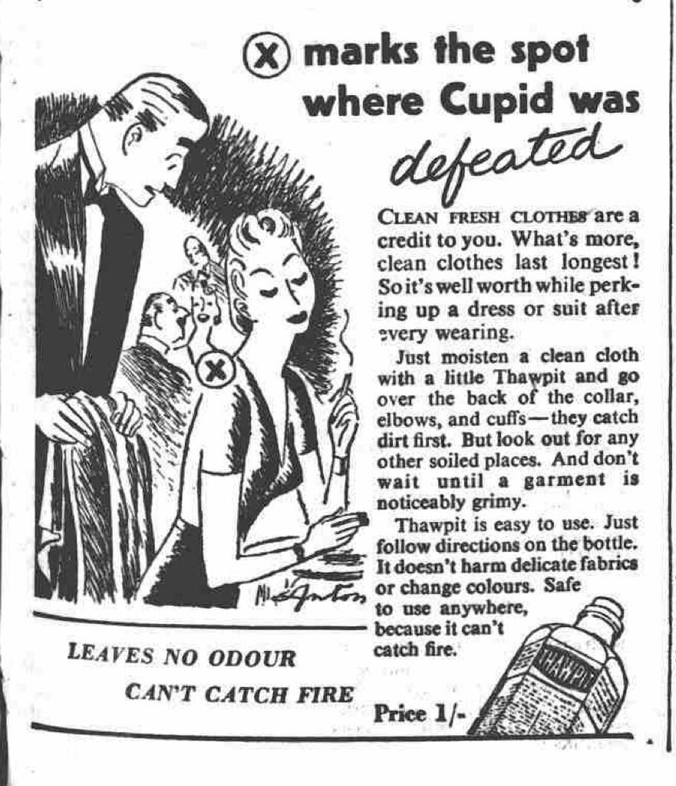Illustration 9: Emotional appeal to women - social pressure to keep clothes clean, one of a series of adverts 1946-47
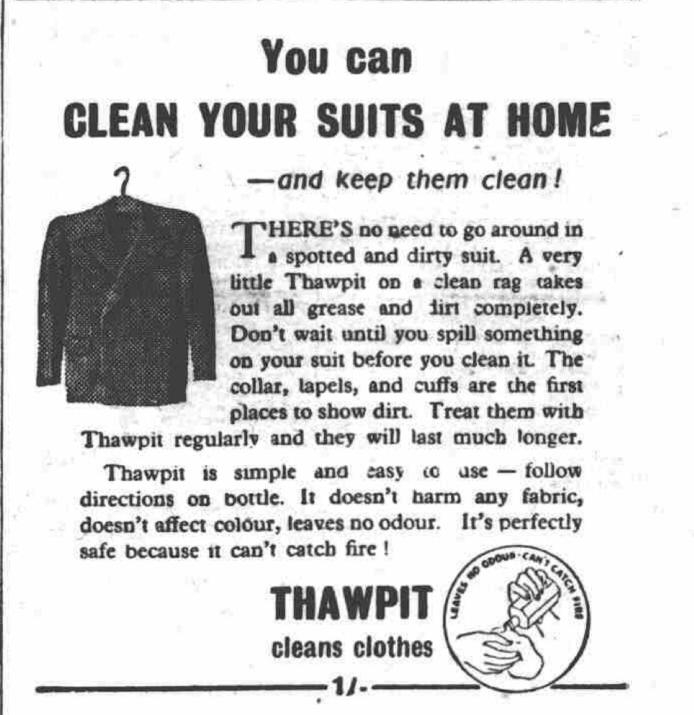Illustration 8: Functional, factual and directed to both male and female users, 1944.

The containers that Thawpit was sold in also determined how the product was used at home. Illustrations 8 and 9 above include an image of the bottle, which was glass, colourless, clear, and distinctively hexagonal, stopped with a cork. The cork was later replaced by a screw top. Two sides of the bottle were ridged, a well established tactile and visual signal used on bottles containing poisons and this message was reaffirmed by the embossed phrase 'Not to be taken'. A warning to not breathe the vapours was included on the paper label fixed to the remaining three smooth sides of the bottle, which instructed users to keep the bottle tightly corked (in order to prevent evaporation and wastage) and to avoid using it in confined or unventilated places. The presentation of the solvent in a volume that facilitated meagre usage, rather than encouraging immersion of an object and reuse of the solvent, made hard by the narrow neck of the bottle would not be easy to return the liquid to. Nevertheless, this simple bottle afforded users more freedom to use the solvent in ways that they wanted to.
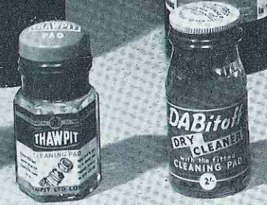

Illustration 9: Taken from an internal Boots magazine (1954), this image shows Thawpit altered packaging to clean directly with the pad attached to the bottle, but retained its recognisable hexagonal shape.

This can be compared to applicator tips on dry cleaning solvent containers, a packaging innovation that reinforced a single use for the product, that it should be applied to spots on clothes, rather than applied to a cloth or emptied into another container (Illustration 9). Both activities combined with inattention or carelessness had been associated with fatal accidents. If a user accidentally knocked over a bottle of solvent, the applicator pads also stopped so much from escaping. Competing brands had pads fixed to the top of their bottles while Thawpit sold applicator tips separately. In an internal Boots catalogue which promoted the idea that shops should assemble Spring Cleaning displays, the price of Thawpit was listed as 1/9, or 6 shillings for a larger size, with the separate cleaning pad to fit the small bottle as 1/3 and 2 shillings for the large one. Competitor Dabitoff, with its built in cleaning pad was priced at 2 shillings sixpence. This presentation and price differential allowed Thawpit to appeal to users who either did not want or need an applicator pad, or were able to reuse them. The choice of an applicator pad or not meant that more options in how Thawpit could be used and for what, rather than only being for removing grease spots on textiles, was left open for the user to decide.

Knowing about, selecting and being able to obtain a new chemical was not enough for domestic users. For best results, CTC had to be applied in a particular way, to mitigate the development of a ring around the stain. The method of applying CTC could determine whether a user was satisfied or not with the result, which meant that manufacturers of proprietary dry cleaners worked hard to provide comprehensive instructions on the correct techniques to use. Explanatory booklets full of diagrams accompanied their products and the same textual information appeared in these household tips columns. This meant that instructions that accompanied branded goods were not necessarily the only way to become informed about how best to use it CTC. Nevertheless, satisfaction with the end result was a major concern to keep users loyal to Thawpit, and instructions were regularly revised in light of information from users.

As well as stain removal, Thawpit was involved in a very large variety of alternative uses albeit by a minority of users. During JWT's market research users volunteered that they used it to remove tar and grease from skin, but also to remove nail polish, to prevent chilblains, or if they were walking a lot they rubbed it on the soles of their feet, plus it was used as a garden spray and on windows to keep flies away. No rationales accompanied these insights into these imaginative users, so the logic of preventing chilblains remains a mystery. Although these off-label uses remained strictly as curiosities and were not encouraged or perpetuated through any promotional work, JWT's survey revealed the diversity of methods and products that people employed to remove grease marks and other stains at home (see Table 2). Market research, as well as less formal 'asking round the office' also repeatedly found that Thawpit's main competitors were ammonia and petrol, rather than similar branded CT-based products, such as Beaucaire. There was some frustration and incredulity that housewives had not picked up on the non-inflamability of Thawpit, but excused by their personal experiences of having not caught fire before, or that they 'do not hanker to clean near a naked flame'. The lack of awareness of Thawpit's main benefit indicates that reducing fire risk was not the housewives' main reason for choosing it. Being able to get the product at a number of different shops and being satisfied with the results were more of a priority than fire safety.

Other agents or methods mentioned by respondents used to remove grease in 1950
Chemical | Branded product | Other methods
Ammonia  benzine  carbon tetrachloride  chloroform  oxalic acid  paraffin  petrol (including lighter petrol)  pine and ammonia  powdered magnesia  methylated spirits  salt  spirits of salts  turpentine  vinegar  water | Beaucaire  Cleenitoff  Clensel  Dettol  Domestos  Dry Magic  Eukleen  Goddard's Dry Process Cloth Ball  Hedley's Cleaner  Inaflash  John Lewis cleaner  Kenmal  Kleenit  Kleneze  Klenox  Klengene  Klo  Klosklene  Liquid Glass  Little Old Chap  Mel  Milton  Modene  Moval  Neufaline  Octin  Parazone  Persil  Renu  Restatus  Revyvit  Sisipinda  Spectoral  Spik  Sprim  Sposs  Susie  Triko  Vim  Woolworths cleaner  Zodil | Blue water  boiled ivy leaves  brown paper and hot iron  carpet soap  cloth ball  cold tea  dried bread crumbs  French chalk  Fuller's Earth  hot bran  tea leaves
Table 2: The number of branded products is greater than both the unbranded chemicals and other methods using household items.

Table 3 is taken from a six page guide to stain removal in a 1975 Good Housekeeping (GH) magazine, here the grease-related items have been extracted. Articles like this were regular features in GH and other women's magazines, and each gives a snapshot of the materials, knowledge and activities that might be be found in the British home. Twelve branded grease solvents were named, along with four unbranded options. These were French chalk, talc or Fuller's earth, suggested as absorbent agents, and the plant-based eucalyptus oil. These natural substances were not further explained, while the branded, chemically synthesised, solvents were accompanied by warnings. However, natural-ness was not an issue that was singled out in this encyclopedic approach, and neither was any anti-chemical attitude apparent. Household chemicals were to be treated carefully and respectfully, as useful aids 'handy to have around' to the housekeeper devoted to a stain-free life.

While Thawpit would have recommended their product as appropriate for all the situations listed, the tests run by the GH team meant that they only chose to name Thawpit for a limited number of scenarios. It was deemed particularly suitable for treating Dralon fabrics, an acrylic textile popular since the 1950s. The fibre composition of 'unwashables', such as tents and camping equipment or beachwear are not mentioned, which is a departure from the detailed knowledge about textiles that those in charge of household laundry appeared to be expected to have. Articles like this, with their exhaustive breakdown of stain scenarios, the varied approaches and the almost overwhelming visual effect of the sheer volume of information laid out in column inches, act as a proof of the complexity of ordinary, everyday domestic situations that a user would face. Succeeding in this complex arena with so many 'wrong' choices to be made would give the user of domestic chemicals a sense of satisfaction.
Scenario: Grease, Fats, Oils | Method or Proprietary Product
Table linen | Blot, wash at high temp
Other washables | Scrape, wash at high temp or use grease solvent.  Polyclens Plus or Swarfega Hand Cleanser
Upholstery/non washables | French chalk, talc or starch alternatively  Dabitoff Spray Spot Remover, K2R, Polyclens Plus
Flat woven and velvet pile Dralon | Thawpit
Not Dralon or pile | Warm iron then e.g. Beaucaire
Leather shoes | Meltonian stain remover, or Meltonian Mel Grease and Tar Remover
Suede shoes | Meltonian Mel Grease and Tar Remover
Suede coats | Delu Suede cleaning cloth (do not use liquids)
Wallpaper | Warm iron over blotting paper followed by, eg K2R
Hessian | Aerosol grease solvent, sparingly
Carpets | Blot/scrape, then Polyclens Plus, Goddard's Dry Clean or Beaucaire
Tents and camping gear | GoPro Tent Cleaner
Beachwear | Eucalyptus oil or Targon
Hair oil on upholstered headboard | Dralons respond best to Thawpit or Goddards Dry Clean
Table 3: This shows the continued proliferation of branded grease removers and that one product was not considered applicable to all grease removal situations. Thawpit was specifically recommended in only two scenarios, with eleven other branded alternatives named.

Although GH did not sanction it, even in 1971 petrol was still being used for domestic cleaning despite its economic advantage over branded products being 'doubtful'. From a report compiled on the explosives accidents which included the inevitable accidental fires associated with using such a substance in the home, the gender of those involved in petrol related domestic cleaning accidents was reported ambiguously, through the use of words such as 'occupier' and 'user'. This is in stark contrast to the abundant masculine descriptors employed when reporting petrol related accidents in the workplace. Domestic accidents were recorded tersely: 'occupier attempted to clean tar off a pair of trousers with petrol. Trousers were left near gas water heater. Petrol vapour was ignited by pilot light'. 'Petroleum spirit used for cleaning interior of motor vehicle. User lit a cigarette and petrol vapour ignited.' However, the compilation of mishaps provided an example of a man undertaking cleaning the carpets in his kitchen and had been seriously injured when the gas pilot light ignited the vapours. In all these cases, the users had diligently been working to clean up but had not fully thought through their whole situation, so had not noticed or not connected the presence of flames or fire with the possibility of petrol vapour ignition. It is interesting that no rationale, other than economic, was conjectured or sought from the users involved in these accidents. JWT's market research showed that even in households with low income Thawpit was used, so this cannot have been the only reason. The way that Thawpit advertising principally targeted women could perhaps have been a factor if it meant that petrol was more likely to be used by men. Maybe these petrol users were trying to avoid what they perceived as the drawbacks of using CTC, such as the harmfulness of vapours in enclosed spaces and its increasingly dubious status as benign as it became suspected as a carcinogen.

After Thawpit's emotional X Marks the Spot campaign, women continued to be the main target of Thawpit advertising when in 1951 JWT launched a huge print advertising campaign and even placed an advert in the Chemist & Druggist to prepare its readers, the sellers of Thawpit, for the increased demand that widespread advertising was hoped to generate which urged them to keep the grease remover on display. They described the breadth of the advertising coverage as "7 national daily newspapers, 6 national Sunday newspapers, 3 London evening newspapers, 5 leading provincial newspapers, the Radio Times, 12 women's weekly magazines, 11 women's monthly magazines." This blanket coverage was comprehensively inclusive, set to reach almost every segment of the printed media perusing public.

This strategy continued in 1966 when magazines including Woman, Woman's Own, Woman's Realm, Woman's Weekly and Reader's Digest were targeted as Thawpit released a new design of bottle that incorporated a cleaning pad. The selection of magazines clearly shows that the advertising agency and manufacturer identified middle and working class women as important in the decision to purchase and use Thawpit, especially with the improved functional packaging. By March 1973, Thawpit was promoted as a budget-friendly alternative to sending garments out for dry cleaning and Thawpit adverts made 74 million 'opportunities for sales' through the News of the World alone. This newspaper was founded with the intention of appealing to a large readership through its low price, meaning it achieved massive circulation and reached many working class potential users.

Relative safety
CTC vapours had initially been deemed no more harmful than benzine, which professional dry cleaners understood to be a potent nerve toxin, but this was outweighed by the advantage of not being susceptible to catching fire. Likewise for domestic users, who may not have been quite so well informed as the professionals, any dangers inherent in using the chemical were outweighed by its effectiveness at removing grease and the dirt carried with it. They wanted the promise of clean, long lasting clothes and so appear to have accepted the negatives along with the cons. The consequences of not following any warnings about ventilation and vapours were not spelled out to the domestic user. That users were capable of estimating that the consequences would be severe from the shorthand warnings not to take the chemical was demonstrated when CTC was deliberately ingested or inhaled in suicides. CTC was not classed as a 'favourite' poison, only as a less common option and by the mid 1960s a 'perhaps diminishing' choice. In these examples, it is interesting to note that despite being generally described as a cleaning fluid in these incidents, those who engaged CTC with suicidal intent at home were male, a group typically thought of as using more violent methods, rather than domestic and therefore feminised household cleaning chemicals.

CTC's lethality even inspired fiction and an example of this can be found in Leslie Charteris' short mystery story A Cleaner Cure, where the lethal effects of this common, household chemical were put to use. A medical doctor discussed CTC with the protagonist, The Saint, who expressed surprise at such a widely used chemical: 'Why aren't people dropping dead all the time?. The fictional medic conceded that 'It's a wonder it doesn't happen more often. Everyone thinks carbon tet is harmless, but that's because it doesn't catch fire or explode'. The Saint mused about CTC as a murder weapon, and the medic pointed out that its use would be detected by visible effects on internal body fat. In practice pathologists tended to first pick up on CTC's involvement by its characteristic smell, but the appearance of CTC as a fictional murder weapon in shows that tensions regarding utility and lethality were perceived.
Fortunately, CTC seems only to have been used in anger against plants, rather than to deliberately harm other people. A local flower show in Macclesfield came to national attention when one of the competitors found the chrysanthemums he had been growing for the occasion poisoned by CTC fumes and suspected sabotage from a chemically knowledgeable opponent, as this flower appeared to be uniquely susceptible to the chemical vapours. CTC was described as an 'everyday chemical' which was widely used in the town's silk industry, but did not mention any other possible sources of the chemical, raising suspicions that it was someone connected with the textile trade.

These warnings did not always translate to avoiding accidental poisoning, because users could store the small bottle wherever they chose at home, they could handle it carelessly, or for whatever reason, they may decant it into another container. In reports of accidental poisoning, it was often noted that the victim had also drunk alcohol either previously or afterwards, and this exacerbated CTC 's damaging effects on the liver and kidneys. Nevertheless, improved labelling of CTC cleaning fluids was discussed in the Houses of Parliament in 1965, which appears to have been a turning point in British awareness about the safety of CTC despite the long precedence of incidents and evidence of dangers associated with the chemical. It also seems to have been the only attempt to influence this set of household chemicals, which were not subject to any other formal regulation with regards to their composition. Consumers demanded an end to deceptive packaging sizes and clarity on weights and measures so that they could be certain of value for money, but safety of the products contained with in was not so much of an issue. The Home Department requested that the labels on this type of cleaning fluid added the advice to keep out of reach of children and that most manufacturers already carried warnings against inhaling the vapour or using it in a confined space. Still, in the 1970s, not all manufacturers listed the ingredients of cleaning fluids, leading Moore to stress to users that they should pay attention to descriptions of nonflammable or flammable, then to treat any nonflammable solvents as CTC, that is, with the 'utmost care'.

There was barely any discussion until the 1980s about the wider shared environmental potential problems with CTC in British newspapers or magazines, which neither called for, supported or bemoaned any proposed removal of CTC specific products, although it did occasionally report their disappearance. Where CTC was classed as a pollutant, it was only ever in terms of industrial discharge, rather than connected to domestic use. The view on domestic safety of chemical products seems focussed on the individual, where CTC users appeared to shoulder the responsibility for safety, stoically accepting that if they contravened the manufacturers' or suppliers' warnings, then they were responsible for making the choice to use it unsafely. Only in regard to deliberate solvent abuse has evidence surfaced of awareness raising campaigns led by the press, or letters to MPs from bereaved family members, despite the regularity that fatal accidents from normal use occurred. Pressure from the USA over uncertainty regarding the possible long term environmental risks associated with CTC's persistence in the atmosphere and damage to the ozone layer, it's presence in ground water and possible cancer risks associated with exposure, stimulated the withdrawal of CTC but these were not concerns aired amongst British users or consumer reviewers. Ambivalence amongst users to its withdrawal or increasing unavailability was perhaps to be expected when there were so many alternative products and methods at their disposal.

Conclusions
This chapter has shown that safety has been promoted by manufacturers to influence the use of unbranded chemicals and provision of proprietary chemical products. In contrast, it was not unusual for those chemical users to be ignorant of the associated safety benefits of their choice or to use the product in a way that made it unsafe. By no means was this concept of safety absolute, but it was relative to other chemicals. Harpic was developed specifically for domestic users, who could choose it as an alternative to using and storing dangerous liquid acids in the home. However, safety was not entirely altruistic, because it meant that product that was not restricted by poisons regulations, it was readily available on the shelves of many kinds of retailer, which meant the company could potentially sell more of it.

As well as the development of products for the domestic market, we also saw CTC transition from a chemical that was used professionally by hairdressers and dry cleaners, to one that was also used in the domestic sphere. It provided, and proprietary versions were marketed as, an alternative to flammable grease solvents such as benzene or petrol, but other than packaging, no changes were made to the chemical itself to make it safer for domestic users. The benefits of buying a branded product such as Thawpit was that it came with instructions on how to use it, whereas a bottle of CTC from a chemist would not. Surveys of Thawpit users and non users did not identify unbranded CTC as a main competitor, indicating that Thawpit users did not switch once they became familiar with the product. Thawpit could be sold at many outlets, conveniently picked off the shelf, without the need to queue and interact with a retail chemist as it was decanted and labeled.

Occurring before any systematic regulatory procedures were in place to test product safety, CTC and related products were sold as other pharmaceutical products might be, warning users of its potential toxicity through the established but vague shorthand 'not to be taken' in combination with safe storage suggestions. The consequences of not following these instruction were not spelled out, leaving users to fill in the gaps themselves, and be haphazardly educated through the presentation of mishaps and fatal accidents in newspapers. The absence of explanation about why specific chemical products should not be used in combination with Harpic no doubt contributed to mixing, and subsequent harm. The insistence of users combining products like this, interpreting the eye-watering fumes as indicative of having created a strong and effective cleaning agent shows that they are willing to experiment, even though they do not claim to understand the chemical basis for the product choice.

This type of user behaviour is very difficult to control, even when instructions have been very carefully crafted. Sometimes making packaging a key feature in the successful use of a branded product, the example of CTC-based products applicator tips was given in this chapter, can direct or encourage users into desired behaviours. This chapter also showed the polar opposite of presentation of soda crystals and bicarbonate of soda and unrestricted user behaviour. The principal constraints were conceptually linked to the common names, washing soda and baking soda, but users were able to make up the strength of solution that they wished or to combine it with other products and to use on any surface or object that they desired, without ill effect. Harpic users were given less freedom than soda users, though they could still use more to make a stronger solution, or mix it with other chemicals, but there did not seem to be an issue with decanting the powder or mistaking its identity.

Moore, Alma Chesnut. How to Clean Everything: An Encyclopedia of What to Use and How to Use It. London: T Werner Laurie Ltd, 1954.
Neathercoat, E.T. "Poisons in the Home." The Daily Mail, 02 January 1926, 6.
Moore, Alma Chesnut. How to Clean Everything: An Encyclopedia of What to Use and How to Use It. London: T Werner Laurie Ltd, 1954
"Spots and Stains." The Manchester Guardian (1901-1959), 1927 Jun 15 1927, 8.
Beeton, Isabella. Mrs. Beeton's Hints to Housewives; with Sections on Labour-Saving, Household Work, Servants' Duties, Shopping, Table Service, Etiquette, and First Aid. 1928, p41
Duckham, Alexander. "Removing Stumps of Oaks." The Times (28/07/1930 1930): 18.
"Dandelions." The Manchester Guardian, 01/07/1936 1936.
"An Antirrhinum Menace: How Gardeners Should Combat It." The Manchester Guardian, 21/03/1936 1936.
Lucio. "Miscellany." The Manchester Guardian (1901-1959), 1930 Feb 26 1930, 9.
"The Monster: A Kitchen Transformation." The Manchester Guardian, 02/11/1932 1932.
"Infested New Houses: Salford's Measures National Campaign Possible." The Manchester Guardian, 12/12/1933.
"Vacuum Flasks." The Manchester Guardian (1901-1959), 1932 Jun 16 1932, 6.
"Science and Housekeeping: Some Small Points." The Manchester Guardian, 27/08/1935 1935
"Science and Housekeeping: Some Small Points." The Manchester Guardian, 27/08/1935 1935.
"Iodine Stains." The Manchester Guardian (1901-1959), 1933 Jul 10 1933, 6.
"'Jews Keep out' Sign on Links." Daily Express, 11 July 1938, 1.
"Mantlepiece Stains." The Manchester Guardian, 08/11/1934 1934.
"Scorch Marks." The Manchester Guardian (1901-1959), 1934 Feb 22 1934, 6.
"Saving Fuel." The Manchester Guardian (1901-1959), 1939 Sep 21 1939, 4.
"Cooking Economies." The Manchester Guardian (1901-1959), 1939 Nov 02 1939, 4.
L, M. "Economies in the Kitchen." The Manchester Guardian (1901-1959), 1940 Jul 24 1940, 3.
"Reducing the Effect of Poison Gases." The Times, 07.01.1935 1935, 9.
"Summer Stains." The Manchester Guardian (1901-1959), 1935 May 22 1935, 6.
"Stockings." The Manchester Guardian (1901-1959), 1935 Jun 13 1935, 6.
"Washday Hints." The Manchester Guardian (1901-1959), 1937 Jun 30 1937, 8.
"The Garden in August." The Manchester Guardian (1901-1959), 1938 Jul 23 1938, 8.
"Stocking A.R.P. Larder." The Manchester Guardian (1901-1959), 1939 Jul 14 1939, 15.
"The Ministry of Food." The Times (06 November 1941): 7.
"The Ministry of Food." The Times (04 April 1944): 3.
Settle, Alison. "Women and the Raids." The Observer (1901- 2003), 1940 Oct 06 1940, 2.
"The Manchester Assizes: A Lover's "Brutal Revenge"." The Manchester Guardian, 24/04/1940 1940, 10;
"Imperial Chemical Industries Limited." The Times, 27/06/1941 1941, 3.
"Bomb disposal team destroys World War II extinguisher in Longniddry" 04 June 2013 http://www.bbc.co.uk/news/uk-scotland-edinburgh-east-fife-22775253
"Winter Spraying: Fruit and Other Trees." The Manchester Guardian, 30/11/1940 1940.
"Any Questions?". British Medical Journal 1, no. 4607 (23 April 1949): 734-36.
"Put Caustic Soda in Fish Tanks." The Manchester Guardian (1901-1959), 1953 Nov 27 1953, 4.
Moore, Alma Chesnut. How to Clean Everything: An Encyclopedia of What to Use and How to Use It. London: T Werner Laurie Ltd, 1954 p43
A "Practical Householder" Handbook. London: George Newnes, 1962.
"New Lines." The Guardian (1959-2003), 1963 Apr 15 1963, 4.
Hilary, Gelson. "Cool Calm and Collected." The Times (09 July 1970): 8+.
Boseley, Sarah. "Blackmailers Spiked Baby Food." The Guardian (1959-2003), 1989 Apr 27 1989, 1.
Erlichman, James "ICI Admits Green Labels Were Wrong." The Guardian (1959-2003), 1990 Jun 07 1990, 2.
L, M. "Economies in the Kitchen." The Manchester Guardian (1901-1959), 1940 Jul 24 1940, 3.
"Shoes at the Seaside." The Manchester Guardian, 07/08/1934 p6
Dixon, Joan, and Kathleen E. Fletcher. 3rd ed. London: Pitman, 1974.
Reeves, Pember. Round About a Pound a Week. The English Working Class. New York: Garland Pub., 1980. (p60)
Reeves p61
"Where's All the Soda?". Daily Express, 05 October 1949, 3.
"Soda." Dover Express, 10 February 1950, 16.
Woolworth's. "Woolworths." Daily Express, 06 February 1959, 11.
Woolworth's. "Woolworth's." Daily Express, 25 February 1965, 6.
Davies, P. "Letter from Drugs Buying Office, to D.H. Moore Retail Price Department - Re. Thawpit, Ici." edited by Boots the Chemist, 2: Boots, 1964.
Boots. "Household Products Survey: Trends in and the Future for Household Cleaning Products." edited by Boots: Boots, 1968.
"The Parent Company and Its Interests in the United Kingdom." edited by Imperial Chemical Industries: Catalyst, 1950.
Letter from Davies, P. "Thawpit, Ici." Boots, 1964.
Conran, Shirley. Superwoman : Everywoman's Book of Household Management. 2 vols London: Sidgwick and Jackson, 1975.
Nuttall, Nick. "Ici Accused of 'Green' Deception." The Times, 07 June 1990, 6.
Standring, Heather. "It Pays to Clean Thoroughly." The Observer (1901- 2003), 1966 Mar 27 1966, 28.
Standring, Heather. "The Pleasures for Smoking." The Observer (1901- 2003), 1965 Dec 05 1965, 31.
Philip, Howard. "Camping as Life of Luxury with Inflatable Furniture and Ingenious Gadgets." The Times (1972/01/27/)
Wynter Blyth, Alexander , and Meredith Wynter Blyth. Poisons: Their Effects and Detection. 5th ed. London: C. Griffin & Company, 1920. p128
"He Went to Buy Bicarb - Got Caustic Soda Instead." Daily Mirror, 24 June 1949,
Pharmacy & Poisons Act, 1933
Miss Leslie's Magazine, quoted in Crinolines and Crimping Irons p 32
Pearn, J., J. Nixon, A. Ansford, and A. Corcoran. "Accidental Poisoning in Childhood : Five Year Urban Population Study with 15 Year Analysis of Fatality." British Medical Journal 288, no. 6410 (1984): 44-46.
Craig, J. O. "Emergencies in General Practice: Poisons Children Swallow." The British Medical Journal 2, no. 4954 (1955): 1496-98.
Fraser, Neil C. "Accidental Poisoning Deaths in British Children 1958-77." The British Medical Journal 280, no. 6231 (1980): 1595-98.
"Ten Calls for Ambulance: Bolton's Bad Night." The Manchester Guardian, 04/08/1937.
"Children Burned by Caustic Soda." Daily Mirror, 10 July 1969 1969, 1.
"Boy, 3, Ate Caustic Soda." The Guardian (1959-2003), 1963 Jun 25 1963, 16.
Watson, Katherine "Loss of Face - Vitriol Throwing in Nineteenth- and Twentieth-Century Britain" paper delivered at Crime and Legal History Seminar, Oxford Brookes, 27 March 2013
"Woman Burned by Acid." The Manchester Guardian (1901-1959), 1949 Jan 14 1949, 8.
Trace, T. "Personal View." The British Medical Journal 2, no. 6090 (1977): 825.
"You Too Can Be a Stripper." The Observer (1901- 2003), 1967 Apr 23 1967, 32.
Fisher, Tom. "A World of Colour and Bright Shining Surfaces: Experiences of Plastics after the Second World War." Journal of Design History 26, no. 3 (2013): 285-303.
Horsfield, Margaret. Biting the Dust: The Joys of Housework. Palgrave Macmillan, 1999.
Harpic. The Harpic Home Book. London: Harpic Manufacturing Company 1928; C.W.S. Household Hints. CWS publishing company limited, 1930s.
It's All in Knowing How. USA: Church & Dwight, 1935. promotional booklet.
The Usefulness of Soda. USA Church &Dwight, 1952. promotional booklet.
Bureau of Land Management "Trona." US Department of the Interior http://www.blm.gov/wy/st/en/field_offices/Rock_Springs/minerals/trona.html.; Coalition, Minerals Education. "Sodium Carbonate (Soda Ash or Trona)." https://www.mineralseducationcoalition.org/minerals/sodium-carbonate-soda-ash-or-trona.
"At Home or Away Boots Helps You Save." Hartlepool Mail, 14 August 1953.
Scottish Fire and Rescue Service "Museum of Fire: Historic Firefighting Equipment 1940s." http://www.firescotland.gov.uk/museum-of-fire/historic-firefighting-equipment/1940s.aspx.
"Man Charged with Wages Theft: Guard Says He Was Sprayed with Powder." The Guardian (1959-2003), 16 Jan 1963, 22.
Niesewand, Peter. "Hard and Last Rules." The Guardian (1959-2003), 1981 Jul 14 1981, 17.
Jackson, Harold. "Police in Derry Use Tear Gas and Armour." The Guardian (1959-2003), 1969 Aug 13 1969, 1.
Browne, David. "Crack." The Observer, 24 July 1988, 15.; Dudman, Graham, and Sue Johnson. "Crack Peril Hits Britain." The Daily Express, 23 January 1989, 2.
Moore, Alma Chesnut. How to Clean Everything. London: Tom Stacey Ltd., 1972.
Harpic. The Harpic Home Book. London: Harpic Manufacturing Company 1928.
Richardson, G.D. "Harpic Formula." 2: History of Advertising Trust, 1966. HAT 50/1/147/3/2/7
Reckitt, Basil N. The History of Reckitt and Sons Limited. London and Hull: A Brown and Sons Limited, 1951.
JWT 5/9/1, HAT Archive.
Malone, I. J. S. D., and J. F. Warin. "A Domestic Case of Chlorine-Gas Poisoning." British Medical Journal 1, no. 4383 (1945): 14.
Crook, J. C. "Some Hazards of Accidental Gassing." Medicine, Science and the Law 6, no. 1 (1966): 29-36.
Goulding, Roy, G. K. Ashforth, and H. Jenkins. "Household Products and Poisoning." The British Medical Journal 1, no. 6108 (1978): 286-87.
Philip, Robin, Caroline Shepherd, Fiona Fawthrop, and Bill Poulsom. "Domestic Chlorine Poisoning." The Lancet, no. 31 August (1985): 495.
Rafferty, P. "Voluntary Chlorine Inhalation: A New Form of Self-Abuse?". British Medical Journal 281, no. 6249 (1980): 1178-79.
Fanshawe, Simon. "Grouchy Harpic and Cha-Cha... And Me." The Guardian, 29 August 1990, 32.
Nye, Robert. "A Literary Goldmine Behind the Men's Socks." The Times, 10 July 1970, 8.
Downing, Beryl. "Experts Expound on the Proof of Puddings." The Times, 10 December 1983, 15.
Daniel, John. "Chateau Oz Comes of Age." The Guardian, Mar 25 1989, 11.
Cowe, Roger. "Mustard Men Turn Hot-Foot to Their Strongest Tradition." The Guardian (1959-2003), 1988 Apr 08 1988, 16.
Reckitt & Colman, "Market Research Officer." The Observer, 11 October 1964, 17.
Reckitt & Colman, "Market Research Supervisor." The Guardian, 12 November 1968, 11.
McKenzie, A. G. "Carbon Tetrachloride as an Anaesthetic." In History of Anaesthesia Society Autumn Scientific Meeting, 7-11. Chequer Mead Arts Centre, East Grinstead, 2003.
Ihde, Aaron J. The Development of Modern Chemistry. Courier Dover Publications, 1970. p217-218; Rocke, Alan J. The Quiet Revolution: Herman Kolbe and the Science of Organic Chemistry. University of California Press, 1993.
Morrison, Robert D., and Brian L. Murphy. Chlorinated Solvents: A Forensic Evaluation. Royal Society of Chemistry, 2013; Smith, Mark G. "Preliminary Study of Sources of Carbon Tetrachloride Final Report." 233: GCA Corporation GCA / Technology Division, 1983. 2-5; Doherty, Richard E. "The Manufacture, Use and Supply of Chlorinated Solvents in the United States During World War Ii." Environmental Forensics 13, no. 1 (2012): 7-26.
Aftalion, Fred. A History of the International Chemical Industry. Chemical Heritage Foundation, 2001. p117; Morrison, Robert D., and Brian L. Murphy. Chlorinated Solvents: A Forensic Evaluation. Royal Society of Chemistry, 2013. p160; "Proposed processes" DIC/BM 20/150/31 1903-1907 ICI; Archives of Brunner, Mond and Company Ltd and its subsidiaries, Cheshire and Chester Archives and Local Study Services.; Podger, Hugh. Albright & Wilson: The Last 50 Years. Sudley: Brewin Books Ltd, 2002. p3
Smith, Mark G. "Preliminary Study of Sources of Carbon Tetrachloride Final Report." 233: GCA Corporation GCA / Technology Division, 1983. 2-5
Brannt, William. The Practical Dry Cleaner, Scourer and Garment Dyer. 4th ed. Philadelphia: Henry Carey Baird & Co, 1911, p19; HAT 50/1/175/2 memo by GA Holdsworth 19th March 1935; Moore, Alma Chesnut. How to Clean Everything. London: Tom Stacey Ltd., 1972, p173.
Toxicology Department. "Carbon Tetrachloride - General Information." Public Health England, 3, 2009.
"An Anaesthetic Shampoo." The British Medical Journal 2, no. 2438 (1907): 764-65.
"The Dangers of the 'Dry Shampoo'." The Times (25/08/1909): 2.
"Carbon Tetrachloride Poisoning." The British Medical Journal 1, no. 3829: 953-54.
"Four Heads on One Girl." The Daily Mail, 05 December 1964, 7.
Young, Douglas. Create Your Own Stage Faces. Prentice-Hall Trade, 1985.
Lee, CM, and JK Inglis. Science for Hairdressing Students. 3rd ed.: Elsevier, 2014.p62
Baker, Patricia. Wigs and Make-up for Theatre, Tv and Film. Routledge, 2012; Valmor. "Advertisement: Valmor High Fashion Wigs." Ebony, June 1973.
HAT 50/1/175/2 memo by GA Holdsworth 19th March 1935
"Shop Hound: Marksman." Vogue, 1947 Sep 15 1947, 119
Our Insurance, Correspondent. "Fire Prevention." The Times, 14/06/1933, 11.
Hankin, Emily. "Buying Modernity? The Consumer Experience of Domestic Electricity in the Era of the Grid." University of Manchester, thesis, 2012.
Gooday, Graeme. Domesticating Electricity: Technology, Uncertainty and Gender 1880-1914. Pickering and Chatto, 2008.
"Advertisement: Pyrene Fire Extinguisher." The Manchester Guardian, 12 December 1919, 12.
Duckham, Alexander "Fire Extinguishers Indoors." The Times (13/04/1934): 10.
"Zeppelin Raids." Derby Daily Telegraph, 23 September 1915, 1.
"An Investment into Peace of Mind." The Pyrene Company Ltd, 1950s.
"Poison in Fire Extinguishers." The British Medical Journal 1, no. 4768 (1952): 1122-23. This refers to van Oettingen, Nat. Inst. Hlth. Bull No. 185 discrediting CTC as a fire extinguisher.
"Firemen Give a Killer Gas Warning." The Daily Mirror, 1965, 3.
"Gas Fumes Put 71 in Hospital." The Daily Express, 1960, 1.
"Firemen Give a Killer Gas Warning." The Daily Mirror, 1965, 3.
Wynter Blyth, Alexander , and Meredith Wynter Blyth. Poisons: Their Effects and Detection. 5th ed. London: C. Griffin & Company, 1920.
"Spots and Stains." The Manchester Guardian (1901-1959), 1926 Jan 01 1926, 6.
BMG. "Queries." Somerset County Herald, 23 November 1944, 2.
Thawpit advert, Western Daily Press, Bristol, June 15 1928, p5.
HAT 50/1/175 Sub-series description in Admin History.
HAT 50/1/175/1 Advance material for Thawpit Review Board 31st December 1951 (meeting 7th January)
Polson, C. J. . "The Role of the Pathologist in the Investigation of Fatal Poisoning." Medicine, Science and the Law 5, no. 4 (1965): 203-10; Moore, Alma Chesnut. How to Clean Everything. (1972) p174
"That Well-Groomed Air." The Teesdale Mercury, 13/12/1933, 8.
"Autumn and the Furniture." The Manchester Guardian (1901-1959), 1926 Nov 18 1926, 6.
"An Oil Remover." The Manchester Guardian (1901-1959), 1930 Oct 16 1930, 8.
HAT 50/1/175/2 Questions on Thawpit, 18 Sept 1941; Letter from ME Mackendrick to Mr Boulter, Mr Hinks, Mr Stansbury 10 March 1942
Doherty, Richard E. "The Manufacture, Use and Supply of Chlorinated Solvents in the United States During World War Ii." Environmental Forensics 13, no. 1 (2012): 7-26.
"The Home Market for Fabric Tints and Dyes, Spot Cleaners, Rug and Upholstery Cleaners." In Thawpit, edited by McCall Corporation: History of Advertising Trust, 1951.
JWT. "You Can Clean Your Suits at Home." Northern Daily Mail, July 24 1945, 6.
JWT. "X Marks the Spot." Northern Daily Mail, 16 June 1946, 7.
Foxell, A.W.H. "Three Cases of Carbon Tetrachloride Poisoning with One Fatality." The British Medical Journal 1, no. 4703 (1951): 397; "Deadly Duster Kills a Girl." The Daily Express, 15 May 1958.; "Smell Kills Boy Aged 6." The Daily Mail, 20 October 1962, 6.
"Stain Removers." Which?, February 1964, 61-64.
Boots. "Spring Cleaning Products." edited by Boots. Nottingham: Boots Company Archives, c.1954.
HAT 50/1/175/2 notes on report AW Parker 11May 1951
HAT 50/1/175/3 Thawpit Consumer Investigation 1945, British Market Research Bureau Limited
HAT 50/1/175/2 Letter from ME Mackendrick to Mr Boulter, Mr Hinks, Mr Stansbury 10 March 1942; HAT 50/1/175/1 Market Research Report 1950
HAT 50/1/175/2 Market Research report 3 May 1951, notes on report AW Parker 11May 1951
HAT 50/1/175/1 Market Research Report 1950
Kent, Cassandra, and Gillian Smedley. "Out, Damned Spot! GHI's Guide to Stain Removal." Good Housekeeping Magazine, September 1975.
Kent, Cassandra, and Gillian Smedley. "Out, Damned Spot! GHI's Guide to Stain Removal." Good Housekeeping Magazine, September 1975.
"Report of Her Majesty's Inspectors of Explosives for the Year Ended 31st December 1970." London: Home Office, 1971. p41
"Get Set to Clean up with Thawpit!". Chemist and Druggist (01 September 1951): 2.
"Press and Publicity." Chemist and Druggist (11 June 1966): 599.
Advertisement, Chemist & Druggist 10 March 1973, 297.
Brannt, William. The Practical Dry Cleaner, Scourer and Garment Dyer. 4th ed. Philadelphia: Henry Carey Baird & Co, 1911.
"Today's Drugs: Treatment of Acute Poisoning: 1." The British Medical Journal 2, no. 5414 (1964): 927-29.
Charteris, Leslie. Trust the Saint. The Saint. London: Hodder and Stoughton, 1962. (Thanks to M. Rowland for this tip)
Polson, C. J. . "The Role of the Pathologist in the Investigation of Fatal Poisoning." Medicine, Science and the Law 5, no. 4 (1965): 203-10; "Tent of Death." The Guardian (1959-2003), 1984 Jan 21 1984, 2.
"Prize Flowers Poisoned." The Daily Mail, 03 November 1947, 3.
Smith, D.H.K. "Carbon Tetrachloride Toxicity." The British Medical Journal 2, no. 5475 (1965): 1434.
Foxell, A.W.H. "Three Cases of Carbon Tetrachloride Poisoning with One Fatality." The British Medical Journal 1, no. 4703 (1951): 397.
HC Deb 26 April 1965 vol 711 cc20-1W
Moore, Alma Chesnut. How to Clean Everything. London: Tom Stacey Ltd., 1972.
"'Glitter' Chemical Banned." The Guardian (1959-2003), Aug 14 1979, 2.
Elkington, John. "Chemistry's Peaceful Solution." The Guardian (1959-2003), Dec 03 1981, 15; Brown, Paul. "Chemicals in Water Linked to Harwell." The Guardian (1959-2003), 1990 Mar 23 1990, 3.

