Look at hazards books

- What dangers, if any, are associated with storing or using them?
Shearcroft stresses using dedicated equipment, not reused from kitchen duty and certainly not "chemically filthy" hands. However, this is all with an eye to achieving the best possible results, rather than ensuring the comfort or safety of user (and those he shared the domestic space with). Clear labelling of the contents of bottles was also paramount in Shearcroft's instruction, although he did not elaborate on why, leaving this perhaps as self evident that the user should be able to quickly select the correct materials needed for photography, but not considering the non-users in the household and their curiosity or assumptions about the contents.
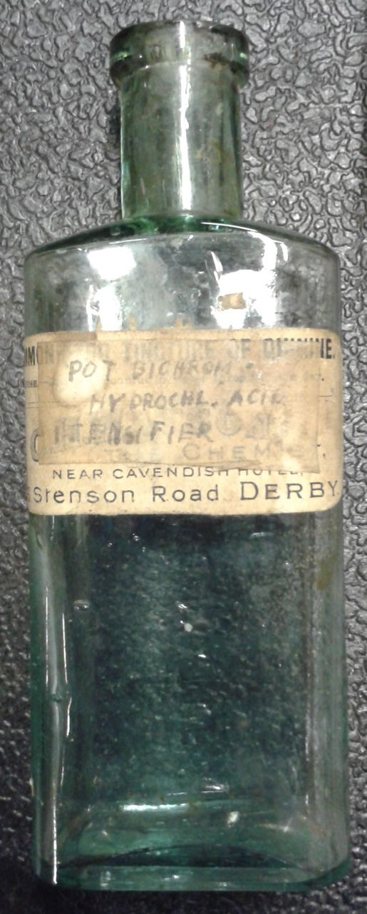Although particular types of bottle, Winchesters, were recommended in some manuals to be obtained from chemists, others suggested jam jars, gin bottles and other drinks bottles. Gin was suggested for the tendency for it to be packaged in squared bottles, allowing to be easily distinguished by touch in dim light. It was interesting to not that that particular author added a disclaimer that it was not his fault if people drank from the bottle, which should be clearly relabelled. Not everyone diligently followed this advice, as an example of a bottle kept at MOSI shows. The reverse of the bottle is embossed with "chest and lung mixture" and the chemists original label of tincture of quinine is still partially visible under the added label and faded pen inscription of "Pot. Bichrom, Hydrochlo. Acid Intensifier".
Having highlighted the potential for accidental poisoning through mistaken contents, this type of mishap did not get reported in national newspapers, unlike the cleaning products and herbicides we have looked at previously. The specialist photographic journals carried news of accidents, as way of informing their the likely users, but the absence of concern in mainstream newspapers suggests that this domestic use of chemicals was not a considered a serious problem that the media were trying to educate or mobilise their readers about. This fits with the idea that photographic chemicals were only a hazard to the small number of people using them, that collateral damage or criminal misuse was not believed to be a problem.
Although photographic magazines had run editorials and articles about the dangers of photographic chemicals since the 1860s, and photographers had been connecting a variety of physical symptoms and general discomfort with their use of chemicals, generally in less than ideally ventilated rooms, methods of safe handling and use of these chemicals are generally not discussed in manuals from the 1930s to the 1960s. A topic that was raised often was the disposal of spent or contaminated solutions, which routinely got special mention due to the tendency to lurk in U-bends and mix to form toxic xxxxx gas which escaped into the darkroom and poisoned careless enthusiasts. The common-sense solution to this problem was to flush the chemicals away with plenty of water. When users were alerted their need for responsibility and care when handling the chemicals, such as to not smoke, eat or drink in the darkroom, to wash one's hands well, these were all dealt with in terms of obtaining decent photographic results rather than personal safety.
In the correspondence from readers responding to articles about chemical dangers, Jayon detected hypochondria, as well as a tendency for the photographers to become very involved in their work, spending overly long hours in stuffy spaces. Despite the regular appearance of health concerns in these publications, voiced by chemical users as well as magazine editors, they have been given only passing mention in books from the 1930 to the 1970s. Black and white processors were regarded as being more likely to "slosh about" in metol, notorious for causing dermatitis, whereas colour processors could not indulge in "such light hearted frivolity" as the chemicals required more respect and certainly the use of rubber gloves.
Despite this seemingly laissez-faire attitude in instructional books, the manufacturers of photographic chemicals were interested in their users' safety. This can be demonstrated by the availability of company representatives to advise by telephone or letter, as well as to learn from their users' actions and to feed back any relevant findings to improve warnings to other users. This was especially relevant when experimental or creative users mixed media, causing unanticipated chemical reactions.
In the 1970s, evidence of greater concern about photographic chemicals can be seen, when they are compared and found equivalent to other household chemicals and hair dyes. However, the replacement of certain chemicals with others is probably a better indication of concerns about safety, as harm to health was certainly a consideration for some products that were introduced to amateurs and professionals. Although longitudinal studies of photographic development workers, exposed daily and for longer periods of time than domestic users were likely to be, did not show any marked susceptibility for cancers, or other afflictions, there is a more generalised caution about the use of chemicals, especially those that smell strong, or have visible effects on skin. The replacement of meritol with ascorbic acid was described in terms of environmentally friendliness, rather than personal harm. Margaret Hardman's life was ended in 1970, when she was 61, by breast cancer, is there any mention of any pondered connection in any of the documents? The collection of interviews conducted for the British Library's Oral History of British Photography documents experiences of cancers and leukaemia, but although some artists attributed their susceptibility to disease to long hours and hard work, photographic chemical exposure does not seem to have been singled out as a contributory or aggravating problem.
Photography enthusiast Paul Godfrey reminisced about his experiences with flash powder in the 1970s. Though a network of contacts, he was given a Horlicks jar of flash powder made up by an industrial chemist who worked at an oil company. He and other enthusiasts at an adult evening class had fun trying out the flash powder, but later panicked about keeping a jar of chemicals that he believed could spontaneously combust. In an effort to safely dispose of it, he tried to wash the powder down the sink, which clogged, and he subsequently found out that damp powder was more dangerous than it was when it was dry. Indeed, historian of photography Bill Jayon wrote that it was not just amateurs who could become nervous about keeping such chemicals, as a fatal industrial accident was caused by flash powder manufacturers washing their chemicals down the drain, in an attempt to rapidly dispose of them. Although the incident Jayon recounted occurred in 1889, both accounts show that the users' partial understanding of the chemistry caused worry and the desire to no longer have or to use those chemicals. As in the use of any domestically employed chemical product, there is no requirement for the user to fully understand how it works in order to get satisfactory results, but a more complete understanding may help people to avoid accidents.
Would this be anything to do with the masculinity and invincibility of young men? If more women were pursing this hobby, would there have been a different emphasis on personal health effects?
Was this danger removed or reduced by the development of kits or readymade solutions?
In fact, in NMeM's Kodak gallery flash powder and magnesium are the only photographic chemicals displayed from the period 1930s to the 1980s. The packaging in the shop front of the dispensing chemist, dealer in photographic materials and pure chemicals, shows only films, papers and cameras. Off public display, but still available to visitors to the Insight collections centre, designed to make accessible the vast number of items that are not displayed in galleries, are samples of packaging for developer and fixers, along with bottles that once contained chemicals such as pyrogallic acid, displayed in a cabinet in one of the object stores.
A visit to a locked chemical cabinet in another museum 's storage area revealed several bulging tins, taped shut, apparently as a demonstration of why photographic chemicals tend to be disposed of and the only the packaging, inert accessories such as scoops and measures and instructional inserts retained. However, powders and solids such as developer, flash powder and magnesium appear to be less threatening and therefore retained, yet their catalogue records list their hazards as "unknown", "environmental", "oxidising" and "explosive".
Dr Richard Henry typifies the response of a laboratory trained chemist to concerns from non-specialists about chemical risks. His 1986 second edition of his re-investigation of the fundamentals of black and white photography included a new chapter, or rather a tirade, rubbishing a number of publications from the 1980s concerned with the potential hazards of photographic chemicals. His attitude was that safe laboratory practice was sufficient protection from harm, which for a book that was not necessarily targeted at only laboratory workers is unfair to his readers without this formal training. He suggested that women could wear labcoats or aprons if they wanted to, without going further into why they would require different protection from that used by men, presumably they were imagined to be more fashion conscious than men and might wish to protect their clothes.

