VANISH
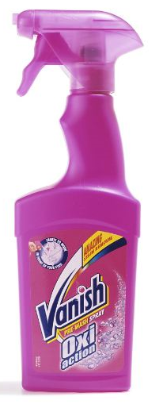
Figure 1: Example of a product from the Vanish range
Rarely a day goes by without some incident involving a stain, from a blob of ink on a shirt to a glass of red wind spilt on a brand new white tablecloth. Some stains can be removed simply with soap and water but others are more problematic.
There is a vast folklore of tips and tricks for stain removal with everyday substances – some of which work and others which are just old wives’ tales (see www.chemistry.co.nz/stain_frame.htm). Does methylated spirits really remove biro ink and, if so, why? Does pouring salt on a red wine stain really help or does it just give the illusion of doing something with a substance that is handily placed on the table?
Nowadays there are a variety of products on the market that help remove stains. Here we will look at the chemistry behind some of the Vanish range made by Reckitt Benckiser. Like many products, Vanish stain remover is a brand rather than a single product. Different stains have different chemical make-ups and therefore need different methods of removal - there is no universal stain remover.

Types of stain
Table 1 shows a way of classifying stain types with some examples.
Enzymatic | Oxidisable | Greasy | Particulate
Blood  Egg  Grass | Tea  Coffee  Red wine | Olive oil  Dripping  Cuff and collar stains (on shirts)  Motor oil  Butter | Clay  Mud  Ground in dirt
Table 1: Classification of stains

- Enzymatic stains: these stains are removed with the help of enzymes.
- Oxidisable stains: these stains are removed with an oxidizing agent, bleach, and are also called bleachable stains.
- Greasy stains: these stains are removed with the use of surfactants.
- Particulate stains; these are best removed by chemicals called builders (see Finish).
However, real life is usually more complex than this simple scheme. A stain can have two or more of these characteristics because it is a complex chemical matrix. Think about a food stain like a fruit juice: this will have a bleachable part (the pigments which usually give the colour), the greasy part of the fruit pulp and the enzymatic part due to the proteins. Most Vanish products are a blend of chemical agents including bleach, surfactants and enzymes.
Vanish products are normally used in addition to normal cleaning - sometimes as an additive to washing powder or liquid in a machine, sometimes as a pre-treatment of a stain. Pre-treatment products may be soap bars or sprays. Despite the product format (powder, liquid or spray) the chemistry behind the product is similar.
Here we will concentrate on bleach-based and enzyme-based methods of removing soiling. The use of surfactants to remove greasy stains is covered briefly here but in more detail in Finish.
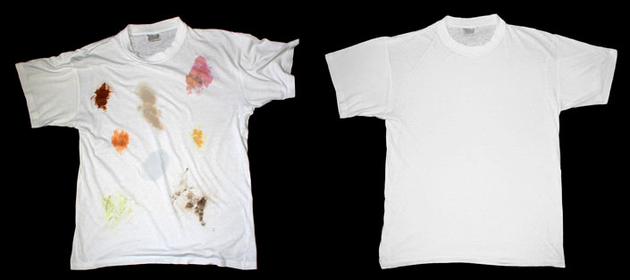
Figure 2: T-shirt covered in fabric stains

Bleach-based stain removers
Colour in the dyes and pigments of stains is caused when molecules absorb light. Light is absorbed by molecules which have sections called chromophores. Often, chromophores are organic compounds with systems of alternating double and single carbon-carbon bonds. These are called conjugated systems. The electrons in the π-orbitals of the double bonds overlap, creating a system of delocalised electrons across a large part of the molecule. The colour is caused by light absorbed when electron transitions occur within this system. Breaking or shortening this delocalised system destroys the colour.
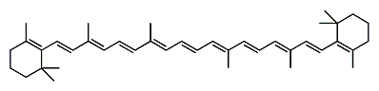
Figure 3: β-carotene. Note the delocalised system of 11 alternating double and single bonds
One example of a coloured molecule with a delocalised system is β-carotene, Figure 3 and 3D model below. In the 3D representation, carbon atoms are coloured grey and hydrogen white.

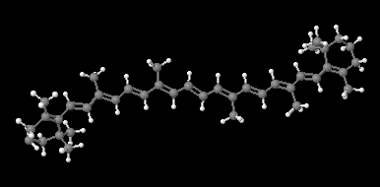
Figure 4: 3D representation of β-carotene
This is the orange pigment that is responsible for the colour of carrots (and also flamingos).
Did you know?
Flamingos in zoos are sometimes fed carotene in their food to enhance their pink colour.
Bleaches are used to oxidise coloured substances to colourless ones. They do this by breaking bonds within the chromophore to produce smaller fragments which do not absorb light (at least in the visible region of the electromagnetic spectrum). These fragments are also generally more soluble in washing water than the original stain and are therefore more easily removed.
Two types of bleach are used in household cleaning agents - oxygen-based and chlorine-based.

Oxygen-based bleaches (1 of 2)
Oxygen bleaches are based on sodium percarbonate, Figure 5. This is a white powder of formula 2Na₂CO₃.3H₂O₂.
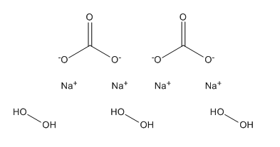
Figure 5: Structure of sodium percarbonate
In water it breaks down into sodium carbonate and hydrogen peroxide.
2Na₂CO₃.3H₂O_{2(aq)} → 2Na₂CO_{3(aq)} + 3H₂O_{2(aq)}
Hydrogen peroxide is the active oxidising agent as it in turn breaks down to oxygen and water. The beauty of this system is that the starting material is a relatively stable powder (although it obviously must be kept dry) and the by-products (sodium carbonate and water) are harmless.
Question 1
a) Write an equation for hydrogen peroxide decomposing to oxygen and water
b) Use this and the equation 2Na₂CO₃3H₂O_{2(aq)} 2Na₂CO_{3(aq)} + 3H₂O_{2(aq)}
to work out how many moles of oxygen can be obtained from 2 moles of sodium percarbonate.
c) Now work out these quantities in terms of grams of sodium percarbonate and oxygen.
d) One commercial specification for sodium percarbonate www.fao.org/ag/agn/jecfa-additives/specs/Monograph1/Additive-418.pdf guarantees ‘not less than 13% active oxygen’. From your calculation above, is this realistic?
e) What is the oxidation number (oxidation state) of the oxygen atoms in
- hydrogen peroxide
- water
- oxygen?
f) What type of reaction is this?

Oxygen-based bleaches (2 of 2)
Activating the bleach
Although hydrogen peroxide is a good bleach, it is not particularly effective below about 40 °C. This is not a problem in products used in washing machines where the temperature can be easily raised. However most stain removal products need to work at room temperature, around 25 °C. This problem is solved by using a bleach activator which is in effect a booster for the bleaching process. The substance used is tetraacetylethylenediamine (TAED), Figure 6.

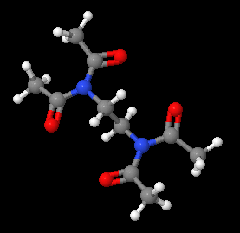
Figure 6: 3D representation of TAED
In the 3D representation, carbon atoms are coloured grey, oxygen red, hydrogen white and nitrogen blue. You may find it helpful to make a model of TAED using a ball and stick modelling kit such as Molymod™.

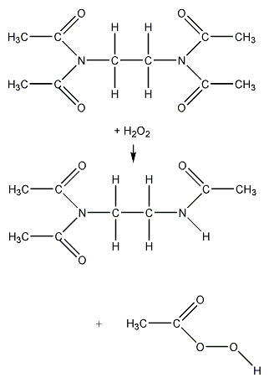
(Tetraacetylethylenediamine, TAED)
Figure 7: The reaction of TAED with hydrogen peroxide
TAED reacts with the hydrogen peroxide released by the sodium percarbonate to produce peroxyacetic acid (peracetic acid, perethanoic acid), Figure 7, which is a better bleach than hydrogen peroxide itself. Even if TAED boosts the oxidation reaction, it is not a catalyst because TAED is consumed during the oxidation process. One molecule of TAED reacts with two molecules of peroxide leading to two molecules of peracetic acid and a molecule of DAED (DiAcetylEthyleneDiamine) which is no longer reactive. Peroxyacetic acid, CH₃COOOH, has a peroxide, O-O bond.
Activators help the bleaches work. They speed up the bleaching reaction so that it can take place effectively at lower temperatures than without them. This makes the bleaches more compatible with the enzymes in the stain removal formulation.
Question 2
Explain the phrase ‘This makes the bleaches more compatible with the enzymes.’

Chlorine-based bleaches
The other bleaching system used in some household products, such as the bleach used in toilet cleaners, is based on sodium hypochlorite (NaClO).
Question 3
What is the systematic name for sodium hypochlorite? Hint, work out the oxidation number (oxidation state) of the chlorine atom.

+1 is an unusually high oxidation state for chlorine - it is normally -1 in its compounds. This means that sodium chlorate(I) can act as an oxidising agent, oxidising other species as it itself drops in oxidation state. This is how it bleaches and kills germs.
The actual active ingredient is chloric(I) acid, HOCl, formed by the reaction
NaClO_{(aq)} + H₂O_{(l)} Na⁺_{(aq)} +OH⁻_{(aq)} + HOCl_{(aq)}

Sodium chlorate(I) is formed by the reaction of chlorine with sodium hydroxide
Cl_{2(g)} + 2NaOH_{(aq)} NaClO_{(aq)} + NaCl_{(aq)} + H₂O_{(l)}


Sodium chlorate(I), NaClO
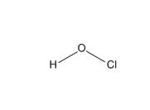
Chloric(I) acid, HOCl
Figure 8: Structures of sodium chlorate(I) and chloric(I) acid
Chlorine-based bleaches are not used in stain removers because they are more powerfully oxidising than oxygen-based bleaches and are liable to bleach the dyes in fabrics and even damage the fabrics themselves. Compared with chlorine bleach, sodium percarbonate-based oxygen bleach has the following advantages for stain removers:
- No environmental hazards - it breaks down to oxygen, water and sodium carbonate in the wash water
- Effective in a broad range of water temperatures
- Fabric safe: does not weaken the strength of cotton fibres

Moreover there is an extra effect when percarbonate is used in combination with other compounds, like optical brighteners, builders and polymers, so:
- It can be safely used on a wide range of coloured garments
- Brightens colours and avoid colour transfer within the clothes
- Prevents fabric from becoming yellowed or darkened

Enzymes (1 of 2)
These are sometimes referred to a biosubstances. They include proteases to help break down proteins, amylases to help break down starches and lipases to break down fats.
Question 4
Suggest foods that are based on
a) proteins
b) starches
c) fats

Proteases decompose big, water-insoluble protein molecules into small soluble units by breaking the amide (peptide) bonds between amino acids.
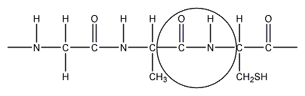
Figure 9: Part of a protein molecule
Amylases decompose big, water-insoluble starch molecules into small soluble units by breaking the ester bonds between sugars in starch.
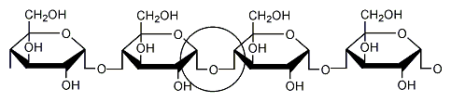
Figure 10: Part of a starch molecule
Lipases break the ester bonds in fatty acids. In each case the reaction is a hydrolysis (reaction with water).
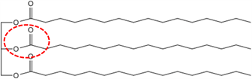
Figure 11: A fat molecule

Question 5
Look at the structures in Figures 9-11. Each has one of the linkages where hydrolysis takes place circled. Draw the products after hydrolysis has taken place for
a) Part of a protein molecule
b) Part of a starch molecule
c) A fat molecule

Enzymes (2 of 2)
Enzymes are delicate molecules. Their action depends strongly on their shape, which is held together largely by hydrogen bonds. These can be affected by temperature, pH and other chemical action.
Moreover enzymes cannot be mixed with any raw materials: enzymes are usually not stable in oxidising conditions, this is why the products in liquid form that contain bleaches usually do not contain enzymes, unless special techniques are used, like dual chamber bottles to keep the enzyme and the bleach separate. An enzyme in a bleaching environment will last for 15 to 20 minutes: enough for a wash but not for a laundry product that will stay on a shelf for several days or months.
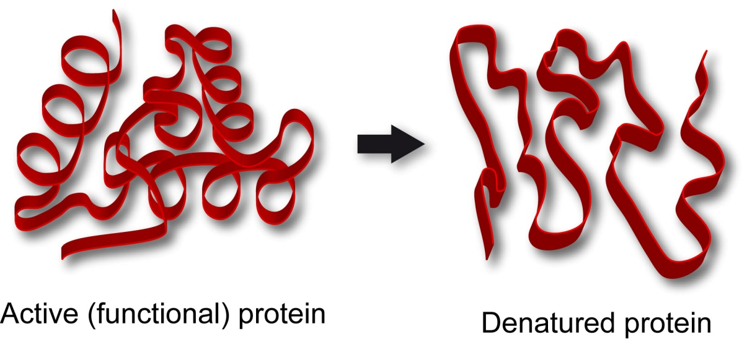
Figure 12: Enzymes are denatured by a change in temperature, pH or chemical action
For powder-based products it is different. Percarbonate and enzymes are coated. This means that the active raw materials are covered with a soluble surface that keeps the two ingredients separate. Once in the washing machine the protective layer will dissolve and the enzyme will start to act until it will also be degraded by the bleach.
Since enzymes are themselves proteins, it is also worth considering why proteases do not denature each other. This is possible, but the enzymes are deactivated inside the formula and they activate once in the washing machine. In the washing liquid, the stain concentration is much higher than the enzymes' concentration, so 'enzyme cannibalism' is avoided just because there is a lot of stain to 'eat'! However, protease-containing products should not be used on those natural fibres, like wool or silk, which are protein-based.

Greasy stains
Most cleaning is done with water and the problem with greasy stains is that they do not mix with water. This is because the main interactions between water molecules are hydrogen bonding and those between molecules of oils and fats (which constitute grease) are van der Waals forces.
To get water and grease to mix we use molecules called surfactants or detergents. These two terms refer to essentially the same thing - molecules that are 'tadpole shaped' in that they have a non-polar 'tail' and a polar or ionic 'head'. The 'tail' can form van der Waals bonds with non-polar grease molecules whilst the 'head' can form hydrogen bonds with water. This is an example of the 'like dissolves like' rule.
There are essentially three types of surfactants - anionic, cationic and non-ionic. The ones which are used in Vanish are anionics and non-ionics.
Anionic surfactants have a negatively charged head group. Common types include soaps and alkylbenzene sulfonates.
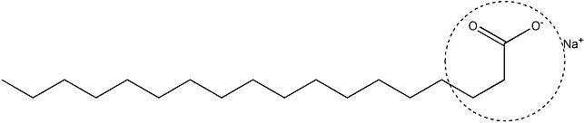
Figure 13: Sodium stearate (a soap) – an anionic surfactant

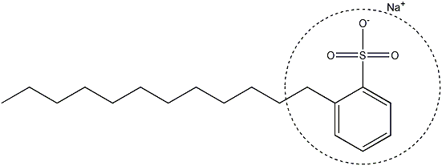
Figure 14: Sodium dodecylbenzene sulfonate – an anionic surfactant
Cationic surfactants have a positively charged head. Common types include alkyl ammonium chlorides.
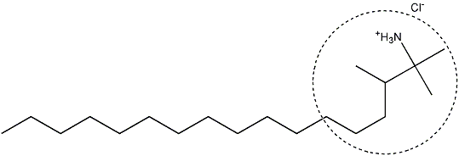
Figure 15: Trimethylhexadecyl ammonium chloride – a cationic surfactant

Non-ionic surfactants have a polar, but uncharged, head. Common types include polyethylene ethoxylates.

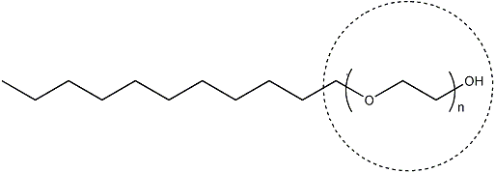
Figure 16: A polyethylene ethoxylate – a non-ionic detergent
Question 6
In Figures 13-16, explain why the heads are polar and the tails non-polar.

When dissolved in water, surfactants tend to cluster at the surface (hence the name), so that their non-polar tails can stick out of the water. Surfactant molecules can form structures called micelles: these are small spheres made of surfactant that trap oil molecules and enable them to dissolve in the water. One of the best known and used surfactants is soap.

Other ingredients
There are many other chemicals inside Vanish which do not have a main role in removing stains but have other benefits. The most common are:
- optical brightener for enhancing or recovering white colour
- dye transfer inhibitor
- anti-fading agents to protect the colours.

Optical brighteners are dyes that absorb light in the ultraviolet and violet region (usually 340-370 nm) of the electromagnetic spectrum and re-emit light in the blue region (typically 420-470 nm). They are used to make fabric appear brighter and whiter, making materials look less yellow. A white surface treated with an optical brightener emits more visible light than that which shines on it, making it appear brighter. You may have noticed this effect in a disco when shirts washed with optical brightener glow in the dark.
Dye transfer inhibitor (DTI) are polymers which are able to entrap the fugitive dyes in the washing liquor. If a garment loses some of the dye it is coloured with, this will stay in the washing liquor until it will stick to another garment. This action is called "colour transfer" and usually happens when garments with different colours are washed together. From a chemical point of view, DTIs are polymers mainly derived from pyrrolidone, Figure 17.
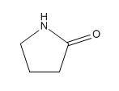
Figure 17: Structure of pyrrolidone

Anti-fading agents are molecules that should avoid the "dye fading" effect by fixing the dye molecule on the fabric. They usually have a cationic charge and are derived from ammonium.
All the three products above are usually used in very low amount: below 0.5% or even lower. Despite the very low concentration, it is more than enough to ensure their action.
There are also other ingredients which are needed for the formula itself, to ensure chemical stability (shelf life) or for aesthetics - to make the product look and smell right. These are usually polymers, builders, dyes, fragrances and fillers.

Application methods
The way Vanish products are applied changes according to product type. We can divide the product range basically into three categories:
- Products which are intended to be used during the wash in a washing machine: these are normally in the form of powders. A scoop of product is added in the washing machine drawer together with the usual detergent. Some products can be added directly in the washing machine drum: an example for this is the Vanish dye magnet. In this case the product is contained in a sachet that slowly delivers the active ingredients during the wash.
- Products that can be used in the wash and as pre-treaters: these are usually liquid formulations. The liquid can be added in the washing machine drawer, together with the detergent. Usually liquid products are supplied with a dosing cup or other device to allow them to be put in the drum. Clearly, in this case, the active ingredients are considerably diluted by the washing water.
- Products that can be used as pretreaters: To pretreat a stain, the liquid is usually poured directly on the stain. In this case there is no dilution of the active ingredients, and this will enhance the performance of the product. Products that are intended to be used as pretreaters only are usually applied using trigger sprays, aerosols or soap bars to apply the product directly to the stain before the wash.

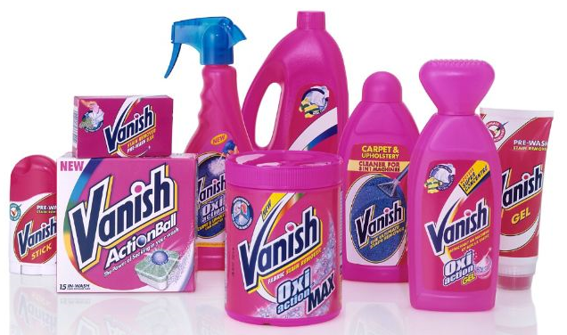
Figure 18: Part of the Vanish range of products showing different methods of application

Further information
Vanish is sold in the UK by Reckitt Benckiser (www.vanish.co.uk). There are other branded products which work in a similar way.

Acknowledgements
The Royal Society of Chemistry wishes to thank Chris Jones and Fabio D’Amico of Reckitt Benckiser for help in preparing this material.

QUESTIONS AND ANSWERS
Question 1
a) Write an equation for hydrogen peroxide decomposing to oxygen and water
2H₂O₂ → 2H₂O + O₂
b) Use this and the equation
2Na₂CO₃3H₂O_{2(aq)} 2Na₂CO_{3(aq)} + 3H₂O_{2(aq)}
to work out how many moles of oxygen can be obtained from 2 moles of sodium percarbonate.
2 mol sodium percarbonate produces 3 mol hydrogen peroxide, which would produce 3/2 mol oxygen.
c) Now work out these quantities in terms of grams of sodium percarbonate and oxygen.
2 mol sodium percarbonate has a mass of 314 g
3/2 mol oxygen has a mass of 48 g
d) One commercial specification for sodium percarbonate www.fao.org/ag/agn/jecfa-additives/specs/Monograph1/Additive-418.pdf guarantees ‘not less than 13% active oxygen’. From your calculation above, is this realistic?
(48/ 314) x 100 = 15.3%, so the specification is realistic.

e) What is the oxidation number (oxidation state) of the oxygen atoms in
- hydrogen peroxide
-1
- water
-2
- oxygen?
0
f) What type of reaction is this?
It is a disproportionation reaction as the oxidation state of some atoms of oxygen goes up and that of others goes down.
Question 2
Explain the phrase ‘This makes the bleaches more compatible with the enzymes.’
Enzymes have an optimum temperature, usually a little above room temperature, while bleaches work better at higher temperatures. Use of an activator speeds up the bleaching reaction so that it is effective around room temperature.
Question 3
What is the systematic name for sodium hypochlorite? Hint, work out the oxidation number (oxidation state) of the chlorine atom.
Sodium chlorate(I). The oxidation number of the sodium is +1 and that of the oxygen is –2. So to keep the sum of the oxidation numbers in a neutral compound equal to zero, that of the chlorine must be +1. Hint ‘ate’ in a chemical name usually means ‘and oxygen as well’.
Question 4
Suggest foods that are based on
a) proteins
Meats, cheese, egg etc
b) starches
Bread, pasta, rice etc
c) fats
Butter, oils etc

Question 5
Look at the structures in Figures 9-11. Each has one of the linkages where hydrolysis takes place circled. Draw the products after hydrolysis has taken place for
a) Part of a protein molecule
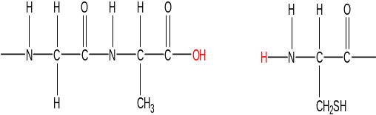
b) Part of a starch molecule
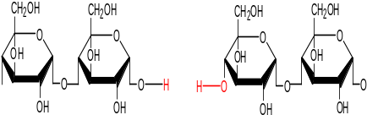
c) A fat molecule
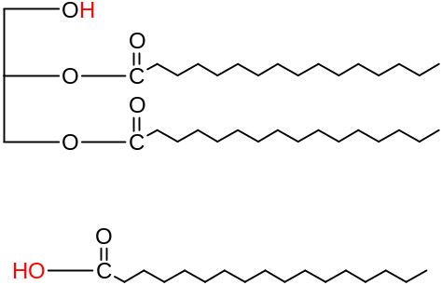

Question 6
In Figures 13-16, explain why the heads are polar and the tails non-polar.
In each case, the head contains electronegative atoms which can participate in hydrogen bonding with water. In the first three cases, the heads have ionic charges. The tails consist of hydrocarbon chains which cannot form hydrogen bonds.

